English | Year 9/10
1.2 Nationality and citizenship
____________________________________________________________________________________________________

Focus 4: The role of citizenship in Australian society

Lesson overview

This lesson sequence explores citizenship, nationality, and multiculturalism in Australia, focusing on how language in official texts shapes national identity and promotes inclusivity. Through practical activities, text analysis, and personal reflection, students examine shared values, responsibilities, and the role of diversity in building a cohesive society.

Cultural safety considerations
The cultural safety of Aboriginal and Torres Strait Islander students, and culturally and linguistically diverse (CaLD) students must be a priority when planning and delivering these lessons.
Teachers are expected to establish a learning environment that is culturally, psychologically, spiritually, physically, and emotionally safe for all students, particularly for Aboriginal and CaLD students. Culturally responsive teaching practices should aim to create the conditions for students, staff, and families to experience cultural safety in schools and remove and minimise harmful experiences, such as racism in all its forms. Teachers should remain mindful of assumptions, stereotypes and unconscious biases and apply strategies to mitigate them.
Engaging in meaningful teaching and learning about multiculturalism and anti-racism requires teachers to create the conditions for cultural safety in the planning, delivery and assessment of lessons. This includes:
- knowing students’ cultural backgrounds and understanding how this may be relevant to (or impact) the learning environment
- letting students and families know about the planned content and resources in advance so that they can prepare for the learning, and contribute where safe to do so
- knowing any cultural protocols in advance that may impact the lesson (for example, using a disclaimer at the start of a film about people who may have passed away)
- knowing the sensitive language that may cause harm (for example, removing racial slurs or hate speech in films)
- not assuming that students or staff will want to share their cultural backgrounds and lived experiences with their peers during the lesson
- not calling on students during lessons without warning about content that has the potential to make them feel uncomfortable or singled out
- allowing for students, staff and families to provide input and feedback when they feel cultural safety in the planning, delivery and evaluation of lessons
- where possible, checking in with students and seeking their feedback on the activities and learning, if they feel culturally safe to do so.

Curriculum content
Year 9 | Year 10
Literacy: Analysing, interpreting and evaluating
Use comprehension strategies, such as visualising, predicting, connecting, summarising, monitoring, questioning and inferring, to compare and contrast ideas and opinions in and between texts when listening, reading and viewing  WA9ELYA3 | Integrate comprehension strategies, such as visualising, predicting, connecting, summarising, monitoring, questioning and inferring, to analyse and interpret complex and abstract ideas when listening, reading and viewing WA10ELYA3
Language: Language for expressing and developing ideas | Language: Language for interacting with others
Analyse how vocabulary choices contribute to style, mood and tone WA9ELALA4 | Understand how language can have inclusive and exclusive social effects and can empower or disempower people  WA10ELAI1

Learning intention
Students will learn how the structures and language features of information texts can be inclusive or exclusive and are used to represent concepts of nationality and citizenship. By recognising this, students will understand that Australian identity is rooted in multiculturalism.
Success criteria
Students will:
- explain their understanding of citizenship, nationality and multiculturalism
- discuss how citizenship, nationality and multiculturalism contribute to a cohesive and inclusive society
- identify language that promotes inclusivity and a sense of belonging
- reflect on their own nationality, citizenship and cultural background
- articulate Australian shared values
- compare their own cultural background with their peers.

Key terminology
- Citizenship – is being a member of a country with rights and responsibilities in that community.
- Multiculturalism – is a term used to describe the recognition of cultural and ethnic diversity. In Western Australia, it means all Western Australians are entitled to exercise their rights and participate fully in society, regardless of their different linguistic, religious, racial and ethnic backgrounds. Australia is a majority migrant nation and one of the most successful and cohesive multicultural societies in the world, building on over 60,000 years of First Nations culture. Culturally and linguistically diverse (CaLD) communities are integral to our vibrant society.

Suggested discussion
- What does it mean to be an Australian?
- What does being an Australian citizen mean to you personally?
- What are values shared by Australians?
- How are the values of Australians represented in the resource?
- How does a citizenship ceremony create a more inclusive society?

Activity 1: Becoming an Australian - Citizenships tests

Resources required:
- Student access to the Australian Citizenship guide for teacher to read introductory paragraph (optional)
- Student access to the Australian citizenship practice test.

- State that to become a citizen of Australia, people must pass the national citizenship test.

- Introduce the Australian Citizen guide and read the introductory paragraph: The Australian citizenship test is designed to assess whether a person has adequate knowledge of Australia, its democratic system, beliefs and values, and the responsibilities and privileges of citizenship.

- Ask students what the purpose of a citizenship test is. What does it promote?

- Direct students to take the Australian citizenship practice test. There are 20 questions in the practise test. Students should record their results.

- Discuss any insights that may have arisen from the test results. For example:
- Was it too easy or too hard?
- Why do you think these questions were chosen?
- Does being able to answer these questions make you Australian? Why?

Activity 2: Understanding nationality, citizenship and multiculturalism
In this activity students will define key terminology and introduce the following vocabulary: citizenship, nationality and multiculturalism.

Resources required:
- Access to smartboard/projector to screen Reflections video
- Appendix Resource #1 What is an Australian?

- Instruct students to write citizenship, nationality and multiculturalism on blank paper, leaving space between words. Ask students to write definitions for each term. If students can’t think of a definition, encourage them to write comments or associated words.
  - Direct students to pair up and share their definitions with a partner.
  - Have students swap their notes again and share their definitions with another new partner.
  - Repeat the process until most students have swapped the notes at least 3 times.

- Conduct a class callout of the final notes to refine the definition for each word and create a class glossary (refer to Key terminology definitions).

- Ask students to explore their own citizenship (i.e. granted to an individual by a government), nationality (i.e. birthplace) and cultural background (i.e. the cultural environment and traditions that shape identity, including language, customs, beliefs, and values) by noting their own examples for each category.

- Watch the Reflections video as a class.

- Provide students with Resource #1 and direct them to fill in the Y chart (in groups or individually) considering:
  - What does an Australian look like?
  - What does an Australian sound like?
  - What does it feel like to be an Australian?

- Ask students to compare their Y charts, discussing similarities and differences.
  - Students should attempt their own definition of what ‘it means to be Australian’ in the centre of the worksheet.
  - Link to the quote from the video by Linda Burney: “The notion that you can be Australian, but you can also proudly, and without fear, maintain, retain and celebrate in your cultural heritage – be it Aboriginal, Cambodian or Korean.” Ask students to complete the two reflection questions on the handout. Discuss the answers as a class.

Activity 3: Unpacking the Resource - Australian Citizenship: Our Common bond

Resources required:
- Student access to ‘A message to you’ in Australian Citizenship: Our Common Bond.
- Appendix Resource #2 Comprehending and analysing ‘A message to you’
- Appendix Resource #3 Comprehending and analysing ‘A message to you’ TEACHER COPY.

- Show the pledge that all people participating in the citizenship ceremony must commit to:
  - From this time forward, under God*, I pledge my loyalty to Australia and its people, whose democratic beliefs I share, whose rights and liberties I respect, and whose laws I will uphold and obey.
    - *A person may choose whether to use the words ‘under God”

- Explain to students that they are going to analyse the introductory page of ‘A message to you’. The purpose of this activity is to identify what it means to be an Australian, in accordance with the citizenship process.

- Display and/or distribute ‘A message to you’, the opening address to Australian Citizenship: Our Common Bond.
  - Ask students who is ‘you’ referring to in the title? Have students identify the purpose and audience of this text.

- Read the text to students.
  - Once finished, engage in a quick discussion summarising the most important key points:
    - Australia values unity and diversity
    - Citizenship comes with responsibilities and privileges
    - Democratic values and the rule of law guide Australia
    - New citizens pledge loyalty to Australia’s values and laws.

- Distribute Resource #2 to students. Use the ‘gradual release of responsibility’ teaching strategy to support students through the activity (I do, we do, you do).
  - Place students into groups of 4. Assign 2 students to work together to complete the ‘key messages’ section and the other two students complete the ‘analysis’ section.
  - When the pairs are finished, tell them to share their answers with their group, swap answers and record. Then, discuss as a whole class.
    - Resource #3 is a teacher copy.

Reflection
  - Students create a new test or ceremony that promotes a more multicultural Australia.
  - Use the resource for Australian Citizenship: Our Common Bond to unpack the values and beliefs of Australian. How could it be strengthened?

Resource #1 What is an Australian?

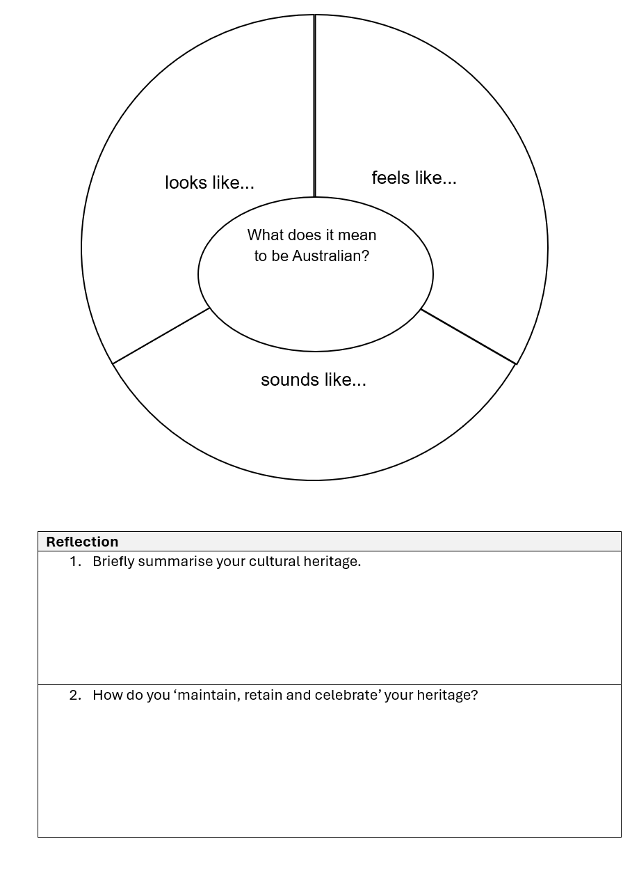

Resource #2 Comprehending and analysing ‘A message to you’
Instructions: Use the A message to you’ page to complete the following questions.

Key messages
Paragraph 2
Australian citizenship is an important step in your migration story. Becoming an Australian citizen means that you are making an ongoing commitment to Australia and our shared values. It is also the beginning of your formal membership of the Australian community. It is the step that will enable you to say, ‘I am Australian.

1. What are the shared values mentioned in this paragraph? Why are they important for new citizens to embrace?

Paragraph 3
Australian citizenship is a privilege offering enormous rewards. By becoming an Australian citizen, you are joining a unique national community. Our country has been built on the contributions of our Aboriginal and Torres Strait Islander peoples, the democratic institutions we inherited from Britain, and migrants from all over the world. We celebrate our diversity, and at the same time strive for a unified and harmonious nation.

2. How does the mention of Aboriginal and Torres Strait Islander peoples, British democratic institutions, and migrants highlight the historical context of Australia?

Paragraph 4
A strength of the Australian community is that we work together to solve problems and shape Australia’s future. We have a stable system of government, and Australians respect the authority and laws of the government. Our stability, our culture, and our laws have been shaped by our history. By joining the Australian community, you will add to Australia’s story and you will be in a position to help shape it.

3. How does the phrase you will add to Australia’s story encourage new citizens to contribute?

4. What is your story? How can you add to Australian culture?

Paragraph 6
People from more than 200 countries have made Australia their home. As a result, our society is one of the most diverse in the world. Australia successfully combines ethnic and cultural diversity with national unity. Citizenship is the common bond uniting us all.

5. List the diversity of countries that make up your classroom.

Paragraph 7:

“Australia is a democracy. Citizenship gives you the opportunity to participate fully in building our democratic nation. It means that you are ready to fulfil your responsibilities as a formal member of the Australian community. Australians believe in shared values such as the dignity and freedom of each person, equal opportunity for men and women, and the Rule of Law. Australian citizenship is about living out these values in everyday life.”

6. Explain how you live out the values in your daily life.

Monitoring
7. While reading the message, identify any parts that were confusing or difficult to understand. What strategies did you use to clarify these parts?

Questioning
8. What questions do you have after reading the message? What more would you like to know about Australian citizenship or the values mentioned?

Summary
9. Summarise the main points of the message in your own words. What are the key ideas the message is trying to convey?

Analysis

10. Identify the positive language and devices within the text by highlighting and annotating them. You may identify devices such as positive tone, repetition, inclusive language, etc.

Vocabulary choices
Analyse how vocabulary choices contribute to style, mood, and tone.
11. How do the words courage, endeavour, and commitment in the first paragraph contribute to the tone of the message? What mood do these words create?

12. What effect does the use of the word privilege in the third paragraph have on the reader's perception of Australian citizenship?

Sentence structures
Analyse and evaluate the effectiveness of particular sentence structures to express and craft ideas.
13. Evaluate the effectiveness of the sentence: Australian citizenship is a privilege offering enormous rewards. How does the use of a simple sentence structure with a noun phrase a privilege offering enormous rewards, emphasise the benefits of citizenship?

14. How does the sentence: It is the step that will enable you to say, I am Australian, effectively convey the significance of becoming a citizen? Consider the use of the relative clause that will enable you to say and its impact on the reader?

Creative sentence structures

Identify how authors vary sentence structures creatively for effects, such as intentionally using a dependent clause on its own or a sentence fragment.
15. Identify and analyse the effect of the sentence structure in: Australia is an ancient land. It is vast and unique. How does the use of short, simple sentences impact the reader?

16. How does the sentence: We are also a young nation; a nation of migrants. Use a semicolon to create a specific effect? What is the impact of this structure?

Inclusive and exclusive language
Understand how language can have inclusive and exclusive social effects and can empower or disempower people.
17. How does the phrase We value your contribution to our peaceful and democratic society, create an inclusive effect? Who is being empowered by this language?

18. Analyse the inclusive effect of the sentence: Citizenship is the common bond uniting us all. How does this language promote a sense of unity?

Reflection

19. Our classrooms and our country are diverse. What is the common bond uniting all people?

20. Choose 2 of the following questions to respond to (highlight or circle your choices) and write your answers in the space below.
- What does it mean to be an Australian?
- What does being an Australin citizen mean to you personally?
- What are values shared by Australian?
- How are the values of Australians represented in the resource?
- How does a citizenship ceremony create a more inclusive society?
- What are the values of Australia presented in the resource?
- How are the values presented in the resource reflected in everyday life?

Resource #3 Comprehending and analysing ‘A message to you’ TEACHER COPY
Gradual release of responsibility - modelling support
Teaching note: Below are sample answers teachers may choose to utilise to scaffold the activities in Resource #7 through using a gradual release of responsibility teaching strategy. These answers provide one way to answer the questions, and other responses are equally as valid.

Key messages
Paragraph 2:
1. What are the "shared values" mentioned in this paragraph? Why are they important for new citizens to embrace?
The shared values mentioned in this paragraph refer to the common principles and beliefs that Australians hold. These values include things like respect for the law, equality, freedom, and a sense of community. They are important for new citizens to embrace because they help create a unified and harmonious society. When everyone shares these values, it makes it easier for people from different backgrounds to live together peacefully and work towards common goals. By committing to these values, new citizens show that they are ready to be part of the Australian community and contribute to its future.

Paragraph 3:
2. How does the mention of Aboriginal and Torres Strait Islander peoples, British democratic institutions, and migrants highlight the historical context of Australia?
The mention of Aboriginal and Torres Strait Islander peoples, British democratic institutions, and migrants highlights Australia's rich and diverse history. It shows that Australia's foundation includes the ancient cultures of Indigenous peoples, the democratic systems brought by British settlers, and the ongoing contributions of migrants from around the world. This historical context explains how Australia has developed into a multicultural society. Recognising these diverse influences helps us understand the importance of unity and harmony in the nation.

Analysis
3. Identify the positive language and devices within the text by highlighting and annotating them. You may identify devices such as positive tone, repetition, inclusive language, etc.
Responses may include:
Positive vocabulary:
- Ongoing commitment
- Shared values
- Courage, endeavour, and commitment
- Privilege offering enormous rewards
Inclusive Language:
- You will add to Australia’s story
- Unique national community
- Celebrate our diversity
Repetition:
- The phrase It is the step
- Community

© Department of Education Western Australia 2025.This product has been generated or modified using artificial intelligence and to the extent that copyright subsists in it, the copyright is retained by the Department of Education Western Australia.

