English | Year 7/8

1.3 Aboriginal and Torres Strait Islander Peoples as the First Peoples of Australia
____________________________________________________________________________________________________

Focus 5: The power of voice

Lesson overview
This lesson sequence helps students understand how racism is described and challenged through different texts, focusing on how language and literary devices express strong emotions and ideas. Students will identify examples of interpersonal and systemic racism, analyse protest messages, and explore how texts can influence change and convey justice. Through activities like poetry analysis and discussion of the Black Lives Matter movement, students develop awareness of racism’s impact and ways to respond effectively.

Teaching note
These activities are designed to take place over several lessons. Teachers may choose to condense or expand the activities, dependent on time constraints. They may also be directly linked to the Year 7/8 1.3 HASS lesson sequence.

Cultural safety considerations
The cultural safety of Aboriginal and Torres Strait Islander students, and culturally and linguistically diverse (CaLD) students must be a priority when planning and delivering these lessons.
Teachers are expected to establish a learning environment that is culturally, psychologically, spiritually, physically, and emotionally safe for all students, particularly for Aboriginal and CaLD students. Culturally responsive teaching practices should aim to create the conditions for students, staff, and families to experience cultural safety in schools and remove and minimise harmful experiences, such as racism in all its forms. Teachers should remain mindful of assumptions, stereotypes and unconscious biases and apply strategies to mitigate them.

Engaging in meaningful teaching and learning about multiculturalism and anti-racism requires teachers to create the conditions for cultural safety in the planning, delivery and assessment of lessons. This includes:
- knowing students’ cultural backgrounds and understanding how this may be relevant to (or impact) the learning environment
- letting students and families know about the planned content and resources in advance so that they can prepare for the learning, and contribute where safe to do so
- knowing any cultural protocols in advance that may impact the lesson (for example, using a disclaimer at the start of a film about people who may have passed away)
- knowing the sensitive language that may cause harm (for example, removing racial slurs or hate speech in films)
- not assuming that students or staff will want to share their cultural backgrounds and lived experiences with their peers during the lesson
- not calling on students during lessons without warning about content that has the potential to make them feel uncomfortable or singled out
- allowing for students, staff and families to provide input and feedback when they feel cultural safety in the planning, delivery and evaluation of lessons
- where possible, checking in with students and seeking their feedback on the activities and learning, if they feel culturally safe to do so.

Other considerations
Cultural sensitivity: Deceased persons
In some Aboriginal and Torres Strait Islander communities, hearing recordings, seeing images or the names of deceased persons may cause sadness or distress and, in some cases, offend against strongly held cultural prohibitions. For Activity 3: Black Lives Matter, please check with families of Aboriginal and Torres Strait Islander students whether they are related or connected to any of the deceased Aboriginal people identified in this lesson and be responsive to their advice.

Curriculum content
Year 7 | Year 8
Literature: Literature and contexts
Identify and explore ideas, perspectives, characters, events and/or issues in literary texts drawn from historical, social and/or cultural contexts by Aboriginal and Torres Strait Islander, wide-ranging Australian and world authors and creators WA7ELICO1 | Explain the ways that ideas and perspectives may represent the values of individuals and groups in literary texts drawn from historical, social and cultural contexts by Aboriginal and Torres Strait Islander, wide-ranging Australian and world authors and creators WA8ELICO1
Literature: Examining literature | Language: Language for interacting with others
Identify and explain how literary devices create layers of meaning in texts, including poetry WA7ELIEX2 | Understand how layers of meaning can be created within a text by using literary devices, such as simile and metaphor to evaluate WA8ELAI2

Learning intention
Students are learning how racism is described and challenged in different kinds of texts and how language and literary devices are used to share strong emotions and ideas.

Success criteria
Students will:
- describe what racism is and how it impacts people
- classify examples of racism as interpersonal or systemic racism
- explain why people protest and analyse their messages.

Key terminology
- Acknowledge – to recognise or show awareness of something, often indicating understanding or acceptance.
- Justice – the quality of being just. The concept of justice is based upon many differing viewpoints but ultimately states that people and society should behave in a way that is fair, equal and balanced for all.
- Protest – including rallies and marches are referred to as 'public meetings', 'processions' or 'assemblies' in Australian laws. A public meeting is defined as an assembly of 3 or more persons where members of the public in general are invited, induced or permitted to attend, held for the purpose of:
- communicating a view or opinion to the public
- ascertaining the view of the public or a section of the public.
- Racism – is more than just prejudice in thought or action. There are many definitions of racism. For the purposes of this set of resources, racism is defined as the process by which systems and policies, actions and attitudes create inequitable opportunities and outcomes for people based on race. It occurs when this prejudice, whether individual or institutional, is accompanied by the power to discriminate against, oppress or limit the rights of others. Any individual action or institutional practice which treats people differently because of their colour or ethnicity. This distinction is often used to justify discrimination.

Suggested discussion
- How can texts be used to influence change?
- How can texts convey emotions?
- What is the purpose of protesting?

Activity 1: Defining racism - the importance of defining and acknowledging racism

Resources required:
- Post-It notes (optional)

- Direct students to a Think-Pair-Share using Post-Its (or alternative) to answer:
  - What do you already know about racism?
  - What comes to mind when you hear the word racism?
  - Where have you seen or heard this word? (e.g. TV, books, social media, school)

- Collect responses and select relevant/appropriate examples to share on the board.
  - It is likely that student responses will favour notions of interpersonal racism (i.e. racism that happens between people). If students have not identified systemic racism, introduce them to the concept (i.e. racism that is built into laws, policies or institutions).

- Ask students to participate in a class call out and classify some of the statements as interpersonal or systemic racism, selecting examples that are appropriate for your classroom context:
- Teachers assuming what a student can or can’t do based on their cultural background (interpersonal)
- A student being punished more harshly because of their cultural/ethnic background (interpersonal)
- Someone missing out on a job because an employer makes unfair assumptions about their race (systemic)
- A teacher expecting an Aboriginal student to speak for all Aboriginal people and explain their culture to the class (interpersonal)
- Students from certain cultural backgrounds being suspended or excluded more often than others (systemic)
- Rarely having people from different cultural backgrounds in leadership or high-level jobs (systemic)
- People writing negative graffiti or online posts that are directed at people from certain cultural or ethnic backgrounds (interpersonal)
- A parent picking up/dropping off their child to kindergarten and only speaking to the white staff (interpersonal)
- A family leaving a playground because another family from a different ethic or cultural background arrived and assuming it was unsafe when they arrived (interpersonal)
- A school expecting a First Nations students to always do the Acknowledgement of Country at assemblies (systemic)
- A taxi/Uber not picking up a person of a certain ethnicity (interpersonal)
- School ignoring racism and not taking reports of racism seriously (systemic)
- Nasty jokes or comments are spread through the school about people from a particular culture (interpersonal)
- Disapproving looks and using body language that make people feel excluded or saying things that make people feel that their experiences or feelings don't matter (interpersonal)
- Dress code rules that stop students from expressing their cultural identity, including religious clothing and symbols (e.g. hijab) or hairstyles (systemic)
- Security following people in shops/aisles of supermarkets assuming they are stealing (interpersonal)
- Curriculum that focuses on teaching European history, perspectives and ideas while ignoring Aboriginal and Torres Strait Islander knowledges, cultures and histories (systemic)

- Use classroom discussion to gently correct misunderstandings and come to a consensus of a class definition of ‘racism’ using answers from the first task and knowledge of systemic/interpersonal racism. Refine ideas and write a shared definition (see glossary). Ask students to record the definitions in their workbooks.
  - Highlighting that acknowledging racism (by naming, recognising, and discussing it openly) is the first step toward change, as it allows individuals and communities to address injustices rather than ignore or minimise them.
  - Explain that acknowledging racism, privately and publicly, is a crucial to making change, as it recognises harm, starts conversations, and creates space for healing and action.
  - Prompt students to share real-life examples of acknowledgment, such as Acknowledgement of Country ceremonies, public apologies for past government actions, and national campaigns (like "Racism! It Stops with Me") to show how these help combat racism to create more just and inclusive communities.
  - Direct students to record examples in their workbooks.

Activity 2: An Acknowledgement Of
Analyse how poetry can create an emotional response and, consequently, help fight racism.

Resources required:
- Appendix Resource #1 An Acknowledgement Of by Stephen Oliver, personal response
  - Appendix Resource #2 An Acknowledgement Of analysis
  - Appendix Resource #3 An Acknowledgement Of analysis TEACHER COPY

- Show students a video of Stephen Oliver performing the poem ‘An Acknowledgement Of’, which he performed to close the final episode of Q+A for 2022.
  - Note: Steven Oliver is a descendant of the Kuku-Yalanji, Waanyi, Gangalidda, Woppaburra, Bundjalung and Biripi peoples. He was born in Cloncurry in Northwest Queensland and grew up in Townsville before moving to Perth to study performing arts. The theme of this episode was ‘Respect and Understanding’.

- After viewing, ask students what Stephen Oliver is acknowledging in the poem. Encourage students to recognise that he is acknowledging:
  - the deep pain and impact of Australia’s colonial history
  - ongoing injustice against indigenous peoples
  - the emotional wounds carried by generations
  - hope for healing and connection moving forward.

- Provide students with Resource #1 and play the video a second time. While viewing, have students tick their individual responses to each stanza with the correlating emoji. After viewing, direct students to:
  - connect the marked boxes/emojis and note the variations in their response throughout the poem
  - respond to the following with a think-pair-share:
  - What personal responses to stanzas were similar or different?
  - Which stanzas evoked the strongest reactions?
  - If you had to articulate your overall response in a single emoji, what would it be?

- Provide students with Resource #2. Using the 3 emoji prompts, students should transcribe the stanza/lines of the poem that evoked the strongest ‘uplifted,’ ‘saddened’ or ‘uneasy’ responses into the appropriate boxes.
  - Direct students to identify the poetic techniques that Stephen Oliver used to present his message and explain how the techniques shaped their personal response.

- The final stanza of a poem is often the most impactful as it is meant to leave a lasting impression on the reader. Direct students to the second activity in Resource #2 and, as a class, discuss the meaning and impact of the final lines of the poem.
  - The poetic techniques have been identified on the worksheet.
  - Resource #3 is a teacher copy.

- Summarise the key messages of Oliver’s poem:
  - Acknowledging racism and our colonial history is important and helps support victims of racism.
  - We can use language to help others feel seen, understood, and respected.
  - Words are powerful. Language can be used to divide but also to unite us.

Activity 3: Black Lives Matter
Learn how people speak up for justice, through poems, protests, signs and speeches.

Before commencing this lesson, consider the cultural safety considerations outlined at the beginning of this document, paying special attention to the ‘other considerations’.

Resources required:
  - Appendix Resource #4 Black Lives Matter worksheet
  - Appendix Resource #5 Protest Images station activity.

- Distribute Resource #4 to students and read the first background prompt.

- Play the BTN video Australian Black Lives Matter and discuss the questions after viewing:
  - What were people in the video protesting about?
  - Why were they saying, “enough is enough”?
  - How has racism affected Aboriginal and Torres Strait Islander people in the past and today?
  - How were these protests in Australia connected to the protests in the United States of America and around the world?

- Read the second background prompt in Resource #4 to students.

- Play the video of the Black Lives Matter rally in Geraldton and ask students to reflect by responding to the following questions:
  - What emotions did you feel listening to Ms Dhu’s story?
  - Why do you think people held rallies to remember her as part of Black Lives Matter?

- Read the third background prompt in Resource #4 to students.

- Distribute Resource #5 around the classroom as a station activity. Direct students to write their answers to the 2 questions at each station:
  - What does this quote/slogan mean?
  - What do the protestors hope will change?
    - Optional: show the original image of the 2020 Perth protest before starting this activity.

- Ask students how protest messages like these can help change peoples’ thinking. Facilitate class discussion for students to share their ideas.

Activity 3: Calling out racism
Students consider how they can fight against interpersonal and systemic racism.

Resources required:
  - Appendix Resource #6 Calling out racism in my circles

- Remind students that in the BTN Black Lives Matter video from Activity 2, Kartanya Maynard said:
  - “Call out racism, call out ignorance, call out unjustifiable behaviour, even if they're your family, because that's where it starts - at home, that's what you can control in your little circle.”
  - Explain that the final activity encourages students to think about ways they can ‘call out racism’ when they see or hear it.

- Distribute Resource #6 to students, organised in pairs or small groups.
  - Direct groups to brainstorm and record ideas about calling out racism.
  - Facilitate a class discussion to share responses.

Reflection
Provide an opportunity for student agency and voice by posing the following question:
- How can you influence or create change for the things that matter to you?

Resource #1 An Acknowledgement Of, by Stephen Oliver - personal response

Steven Oliver - An Acknowledgement Of | Live on Q+A |   anger |   sadness |   unease |   surprise |   happy |   hopeful
I wish I had infinite wisdom,
Something meaningful I could impart —
Like knowledge that's passed through an unbroken chain,
So long we don't know where it starts.
Or maybe compassion that's not dealt in rations,
But comes from a heart overflowing.
For compassion is wise,
It sees without eyes,
It grants us a depth to our knowing.
Loss can be said
In hundreds of ways —
But is felt only in one.
And the love that we feel for the ones in our heart
Doesn't feel like the love for our mums.
Colour won't change how our skin feels the rain,
And after it's all said and done,
Our stories are different,
But they're also the same —
We all need love from someone.
And sure, that's cliché.
We all can relate —
We all have some story about a terrible first date,
Or maybe that potential that's now Facebook banned
Because they wouldn't try and listen or try to understand.
Because you see, understanding means
Feeling it first.
And we're not good at feeling,
So we hit that reverse.
We don't want to get close 'cause we're told not to care.
Looking out for yourself is what gets you somewhere.
And then what the heck should we even be feeling?
And does this feel right?
'Cause it don't feel like healing.
And so we stop short at the blame or the shame,
Not wanting to know how another feels pain.
And we lose in that moment what may be the key —
The act of acknowledging, of saying I see.
Because there in that moment, what has just been?
Someone, for the first time, felt they were seen.
So now I acknowledge this country's deep pain.
I acknowledge the stains left by many blood reigns.
I acknowledge the lost, the uncountable costs.
I acknowledge the tears children shed for a cross.
I acknowledge the rights still often denied.
I acknowledge the chants that my Elders have cried.
I acknowledge that I can't acknowledge it all —
So I acknowledge the tears that to this day fall.
And now I acknowledge all those who believe
That a goodness of spirit is there to retrieve.
I acknowledge the caring, compassionate ways
That help with the healing towards better days.
I acknowledge the listening that allows us to see
The much-needed connection that acknowledges we.
For we must acknowledge that where we all stand
Is a place in which each of us all have a hand —
To either reach out, to touch and to heal,
To teach and support, to help others feel —
That sees us acknowledge the truth of this Earth,
So we then may acknowledge the truth of its worth.
And maybe we'll find that in doing so,
That wealth isn't the thing that we need to grow —
That what makes us richer is a deeper respect,
A felt understanding of how we connect.
Colour won't change how our skin feels the rain,
Or the warmth we all feel from one sun.
Our stories are different, but they're also the same —
Inevitably,
Our story
Is one.

Resource #2 – An Acknowledgement Of analysis

Personal Response Analysis | Link to specific phrases/lines from the poem | Poetic technique/s used? Explain effect.

Uplifted

Saddened

Uneasy
Final stanza analysis | Technique | Meaning/Effect
Colour won't change how our skin feels the rain, | Metaphor
Or the warmth we all feel from one sun. | Metaphor
Our stories are different, but they're also the same — | Paradox/contrast
Inevitably,  Our story  Is one | Enjambment  Inclusive language  Short line
Resource #3 An Acknowledgement Of analysis – TEACHER COPY

Personal Response | Link to specific phrases/lines from the poem | Poetic technique/s used? Explain effect.
Uplifted
Saddened
Uneasy
Final stanza analysis | Technique | Meaning/Effect
Colour won't change how our skin feels the rain, | Metaphor | Shows that skin colour doesn’t affect how we feel inside; we all experience life in similar ways.
Or the warmth we all feel from one sun. | Metaphor | Suggests that everyone shares the same warmth or kindness, no matter their background.
Our stories are different, but they're also the same — | Paradox/contrast | Helps us see that while everyone’s story is unique, we also share common feelings and experiences.
Inevitably,  Our story  Is one | Enjambment  Inclusive language  Short line | Continuing from one line to the next without a pause or punctuation creates a sense of flow and continuity, emphasising that the "story" is ongoing and unbroken.  “our story” emphasises collective identity  Ends poem with strong, clear message that we are all connected and there is hope for unity.

Appendix #4 Black Lives Matter worksheet

Background
  - The Black Lives Matter (BLM) movement started in the United States to protest against racism and unfair treatment of Black people, especially by police. It became well known around the world after the death of George Floyd in 2020.
  - In Australia, people joined the movement to show support and also to raise awareness about how Aboriginal and Torres Strait Islander people have been treated unfairly, including in the legal system. Many people marched to call for justice, equality, and an end to racism, both in Australia and overseas.

BTN video Australian Black Lives Matter – questions to think about while watching:
  - What were people in the video protesting about?
  - Why were they saying, “enough is enough”?
  - How has racism affected Aboriginal and Torres Strait Islander people in the past and today?
  - How were these protests in Australia connected to the protests in the United States of America and around the world?

Background continued…
  - Comparisons were made between deaths in custody, violence, and racism that happened in the United States and in Australia. In Australia, the deaths of Elijah Dougherty, Ms Dhu, Tanya Day, and David Dungay Jr are among many who were remembered at Black Lives Matters rallies around the country.
  - In 2014, Ms Dhu, a 22-year-old Yamatji woman living on Kariyarra Country in Marapikurrinya (Port Hedland), called police for help after experiencing domestic violence. Instead of helping her, WA Police arrested her for unpaid fines and put her in prison. Ms Dhu became sick and asked for medical help many times. She was taken to hospital twice but wasn’t treated and was sent back to prison. While in prison, she was mocked, ignored and dismissed. The third time she went to hospital, Ms Dhu was found to be extremely sick and died of an infection caused by untreated rib fractures.
  - Ms Dhu’s tragic story and passing was critical to instigating the Black Lives Matter rallies and movement. This story helps us understand why people are asking for change to how Aboriginal people are treated by police and in custody.

Watch the video of the Black Lives Matter rally in Geraldton.
What emotions did you feel listening to Ms Dhu’s story?

Why do you think people held rallies to remember her as part of Black Lives Matter?

Background continued…
  - Rallies and protests are when people come together in public to speak out about something they care about. They might march, hold signs, chant messages, or give speeches to ask for change.
  - People protest when they feel something is unfair, unsafe, or needs to improve—like when people speak out about racism, climate change, or equal rights.
  - In Australia, peaceful protest is a legal right. This means people are allowed to gather and speak up about issues that matter to them, as long as they follow the law and stay non-violent.
  - Protests are one way that people can make their voices heard and help create a fairer, better world. People express powerful messages at protests through posters, chants, poems and speeches. These messages use emotional and persuasive language to create change.
Resource #5 Protest Images station activity

BA2493/2973: Protesters march along Wellington Street in front of the Perth Rail Station during the 3rd BLM rally on 4th July 2020
Photo is from the WA State Library.
Individual station images are cropped from the original.

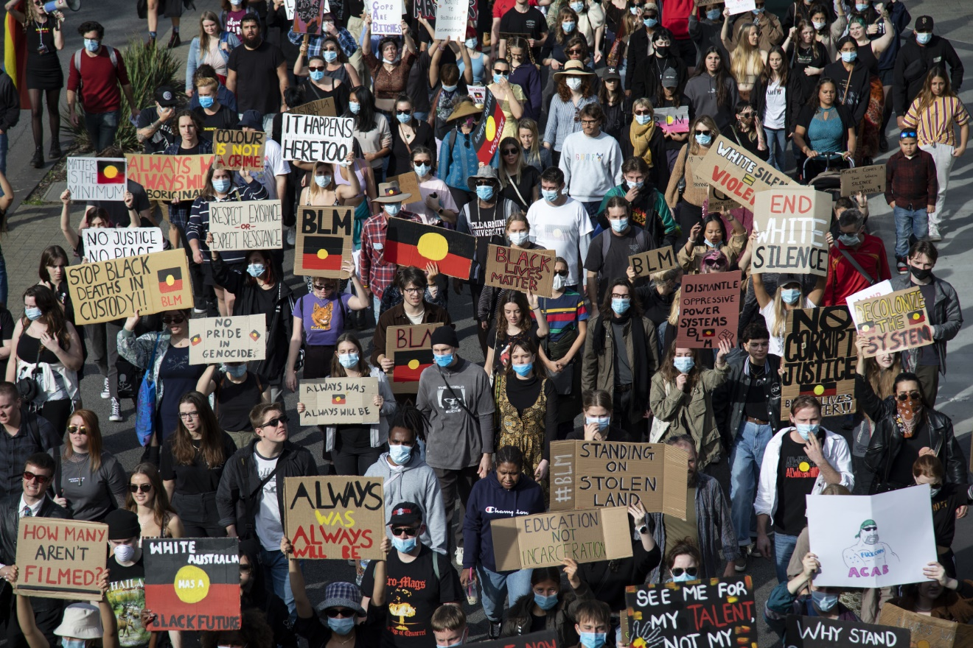

Station 1

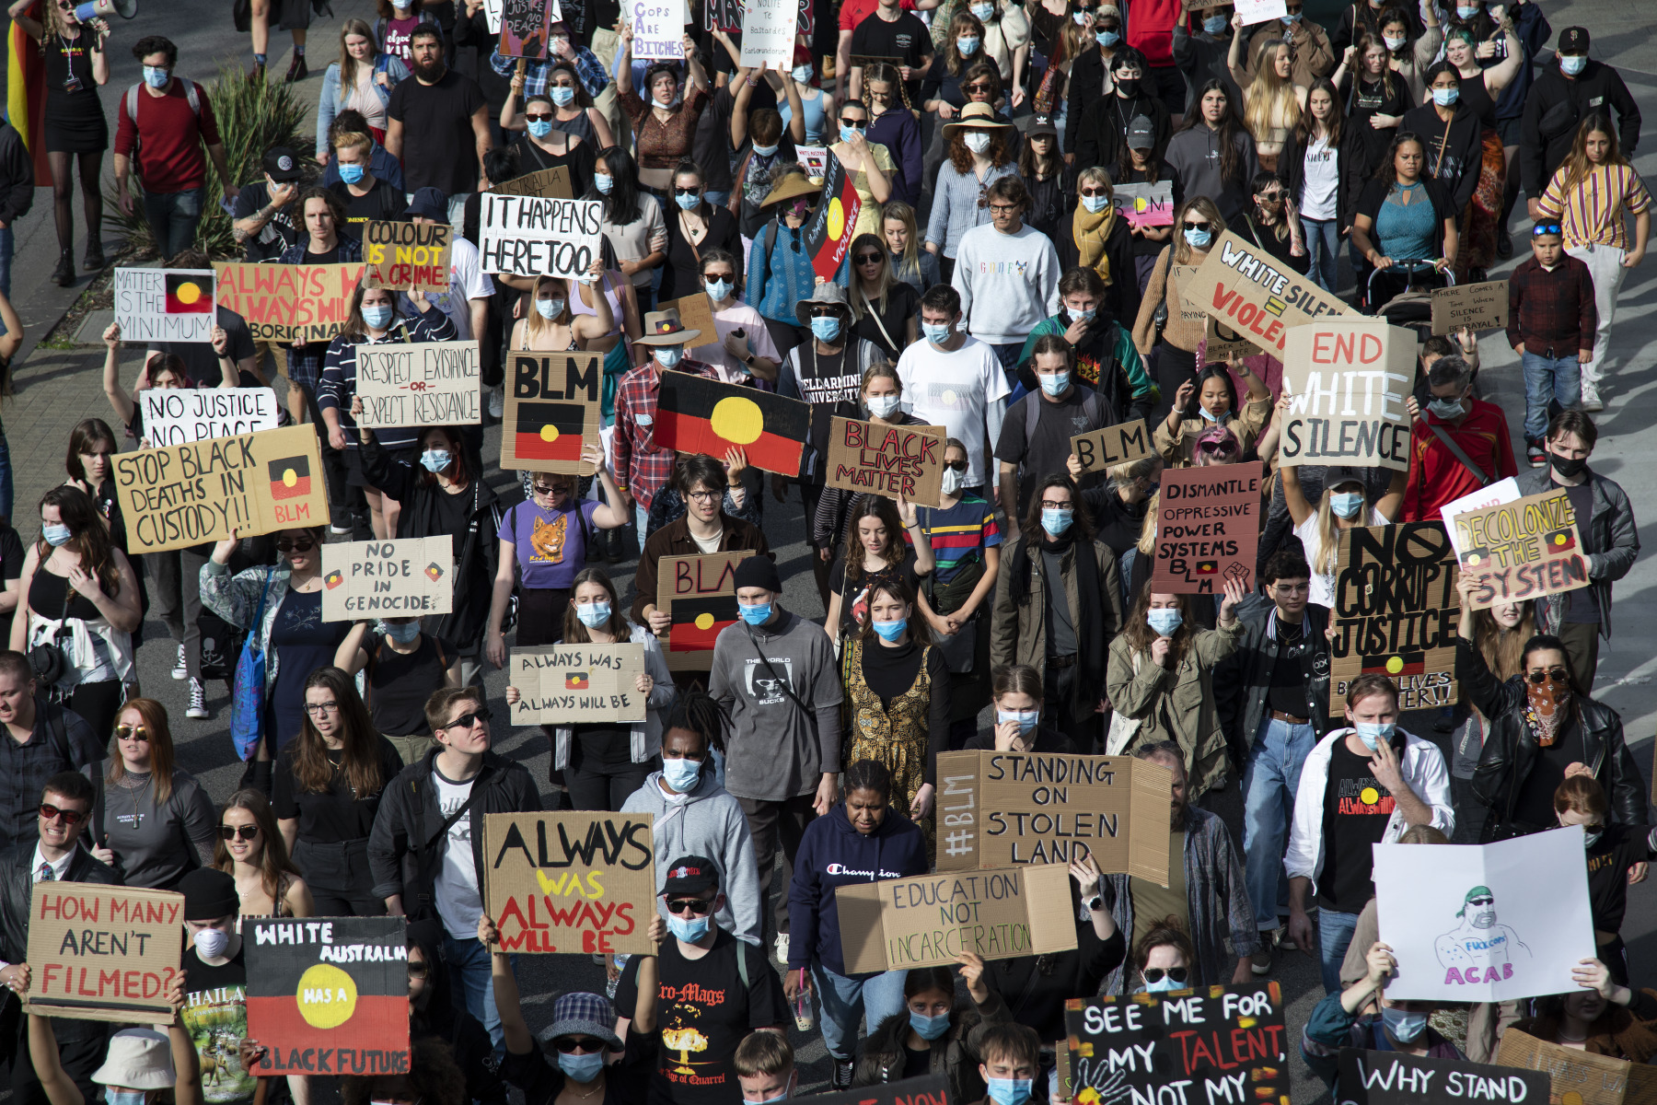
  - What does this quote/slogan mean?

  - What do the protestors hope will change?

Station 2

What does this quote/slogan mean?

What do the protestors hope will change?

Station 3

What does this quote/slogan mean?

What do the protestors hope will change?

Station 4

What does this quote/slogan mean?

What do the protestors hope will change?

Station 5

What do these quotes/slogans mean?

What do the protestors hope will change?

Resource #6 Calling out racism in my circles

What are some ways we can help stop racism when we see or hear it? Fill the circles with some ideas for how you could take action to call out racism.

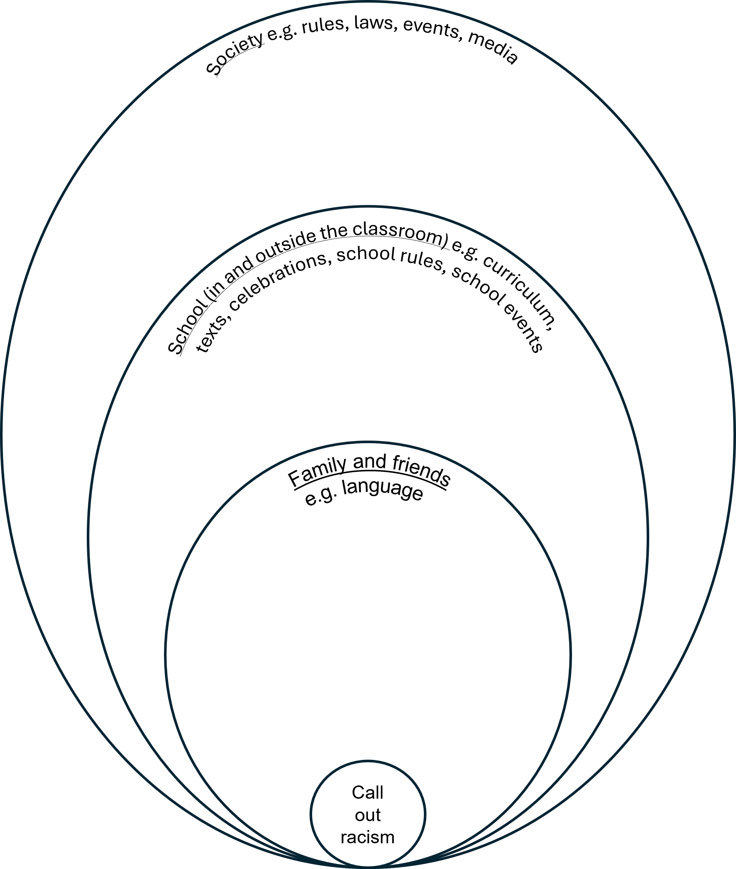

© Department of Education Western Australia 2025.This product has been generated or modified using artificial intelligence and to the extent that copyright subsists in it, the copyright is retained by the Department of Education Western Australia.

