English | Year 7/8

1.4 Australians from Culturally and Linguistically Diverse (CaLD) backgrounds
____________________________________________________________________________________________________

Focus 7: Aussie words uncovered

Lesson overview

This lesson explores the unique nature of Australian English as a hybridised language shaped by centuries of migration, Indigenous heritage, and global influences. Students investigate the origins and evolution of English, discover the multicultural and Aboriginal roots of everyday Australian words, and conduct their own etymological research. Through activities and class discussions, students gain a deeper appreciation of Australia’s rich linguistic diversity and how language reflects the nation’s multicultural identity.
Teaching note
These activities are designed to take place over 2 lessons. Teachers may choose to condense or expand the activities, dependent on time constraints.

Cultural safety considerations
The cultural safety of Aboriginal and Torres Strait Islander students, and culturally and linguistically diverse (CaLD) students must be a priority when planning and delivering these lessons.
Teachers are expected to establish a learning environment that is culturally, psychologically, spiritually, physically, and emotionally safe for all students, particularly for Aboriginal and CaLD students. Culturally responsive teaching practices should aim to create the conditions for students, staff, and families to experience cultural safety in schools and remove and minimise harmful experiences, such as racism in all its forms. Teachers should remain mindful of assumptions, stereotypes and unconscious biases and apply strategies to mitigate them.
Engaging in meaningful teaching and learning about multiculturalism and anti-racism requires teachers to create the conditions for cultural safety in the planning, delivery and assessment of lessons. This includes:
- knowing students’ cultural backgrounds and understanding how this may be relevant to (or impact) the learning environment
- letting students and families know about the planned content and resources in advance so that they can prepare for the learning, and contribute where safe to do so
- knowing any cultural protocols in advance that may impact the lesson (for example, using a disclaimer at the start of a film about people who may have passed away)
- knowing the sensitive language that may cause harm (for example, removing racial slurs or hate speech in films)
- not assuming that students or staff will want to share their cultural backgrounds and lived experiences with their peers during the lesson
- not calling on students during lessons without warning about content that has the potential to make them feel uncomfortable or singled out
- allowing for students, staff and families to provide input and feedback when they feel cultural safety in the planning, delivery and evaluation of lessons
- where possible, checking in with students and seeking their feedback on the activities and learning, if they feel culturally safe to do so.

Curriculum content

Year 7 | Year 8

Language: Language for interacting with others
Understand how language expresses and creates personal and social identities WA7ELAI1 | Recognise how language shapes relationships and roles WA8ELAI1

Learning intention
Students are learning the origins and meanings of familiar Australian English words.
Success criteria
Students will:
- research and explain in writing the origins and meanings of Australian English words, including those from Aboriginal and migrant languages
- investigate 2 words linked to their specific cultural background
- contribute to a classroom resource which illustrates Australia’s cultural and linguistic diversity.

Key terminology
- Etymology - knowledge of the origins and development of the forms and meanings of words and how meanings and forms have changed over time.
- Hybridised - made by combining or blending different elements, such as languages or cultures, to create something new and mixed.
- Linguistic - relating to language or the study of language, including how it is structured, used, or understood.

Suggested discussion
- How do you think the words spoken by Indigenous Australians and migrants have influenced Australian English?
- Why is it important to learn about the origins of words we use every day?
- How can understanding the history of our language help us understand Australian culture and identity?
- Do you think everyone’s cultural background influences the way they speak?

Activity 1: Introduction to Australia’s hybridised language

Resources required:
- Whiteboard and markers for morpheme breakdowns, class brainstorming, and language lists

- Begin by asking students the name of the official language spoken in Australia. The answer, of course, is English.
  - Explain that Australia is a culturally and linguistically diverse nation and our language history has been shaped by centuries of migration, intercultural exchange and Indigenous heritage.
  - Ask students how old the English language is. Approximately 1,575 years old.

- Ask students to consider the origins of the word ‘English.’ Our language reflects our colonial roots and ties to England.
  - The word, ‘English’ is derived from Germanic roots. Break down the word into morphemes Eng/lish on the board. The morpheme:
    - ‘Eng’ can be seen as a shortened form of ‘England’
    - ‘ish’ is a suffix which suggests something ‘from or belonging to.’

- Explain that England was originally called ‘Englaland’ or ‘land of the Angles’ after the tribes of Germanic people (‘Angles’ later known as ‘Anglo-Saxons’) who migrated in the 5th century.
  - Old English is very different to modern English because language evolves over time.
  - Australian English is a ‘hybridised language,’ meaning it is a blended language.

- Ask students, how:
  - many Australians were born overseas, or had a parent who was? Around 50%
  - many languages are spoken in Australian homes? More than 300
  - many Aboriginal and Torres Strait Islander Dialects are there? Over 800
  - old are the oldest Aboriginal and Torres Strait Islander languages? Over 50,000 years old.
    - This diversity and long history have led to our unique way of speaking that is distinct from British or American English.
    - Optional: On the board, create a class list of languages spoken by students and their families thus further demonstrating current linguistic diversity in Australia.

Activity 2: Aussie Bingo
Recognise and appreciate the influence of Aboriginal languages in daily conversation.

Resources required:
- Appendix Resource #1 Australian English words - Bingo cards
- Appendix Resource #2 Bingo clue/definition list TEACHER COPY

- Explain that students must listen to the clues/definitions for words that will be read out. Explain they are Australian English words with links to Aboriginal languages. Students will work in pairs to decide if they have the matching term on their bingo card.
  - Distribute Resource #1 to students (in pairs)
  - Read terms from Resource #2. The first student pair to complete a row, column or diagonal shouts, ‘Bingo!’ and reads out their winning words.

- After reading the terms, ask the class to consider the history of the words.
  - Do they originate from England?
  - Students should make links to their origins in different Aboriginal languages. This may require research.

- Ask students:
  - Which words were new to you?
  - Why is it important to acknowledge the Aboriginal origins of these words?
  - How do these words enrich Australian English?
  - Do we speak England’s English?
    - Lead discussions to the conclusion that we speak ‘Australian English’ which is a hybridisation of English, Aboriginal and international languages.

Activity 3: Global roots
Uncover the multicultural origins of classic Australian words.

Resources required:
- Student access to Appendix Resource #3 Global roots words list
- Appendix Resource #4 Global roots words list TEACHER COPY

- Show students the words from Resource #3 and ask if each is ‘Australian’. Students could respond by putting their hands up for yes or moving to one side of the room. Reveal that all these words originated in a variety of very different countries using Resource #4.

- After discussing all words, consolidate the idea that investigating etymology reveals the rich linguistic tapestry of Australia’s multicultural past and present. Reinforce that ‘Australian English’ is linguistically diverse.

Activity 4: Word detectives
Students will further investigate the diverse etymology of Australia’s language.
Resources required:
- Appendix Resource #5 Word list
- Appendix Resource #6 Global roots worksheet
- Student access to the internet.

- Either randomly allocated 10 words from Resource #5 to students, or provide them with access to the words and ask them to randomly generate 10 words each.
  - The 10 words should be added to Resource #6.
  - Ask students:
    - to fill out the second column with their ‘context guess’
    - where they think this word originated? Why?

- Direct students to research the words to complete the table and share their answers
  - Students should identify and research 2 additional ‘Australian English’ words which have roots to their own cultural heritage. They may need to consult with family members for homework or conduct their own research.
  - Invite each student to select one word from their research that they found the most interesting or surprising and share their findings. Discuss:
    - What patterns students noticed about where our words come from?
    - How do these words reflect Australia’s multicultural society?
    - Did the etymological research reveal any surprises? Why?

- Optional: Share the collated multicultural words with the school community to promote intercultural understanding and pride in Australia’s culturally diverse linguistic history.

Reflection
How did the investigation into the origins of Australian words enhance your appreciation of Australia’s unique cultural identity?

Resource #1 Australian English words - bingo cards
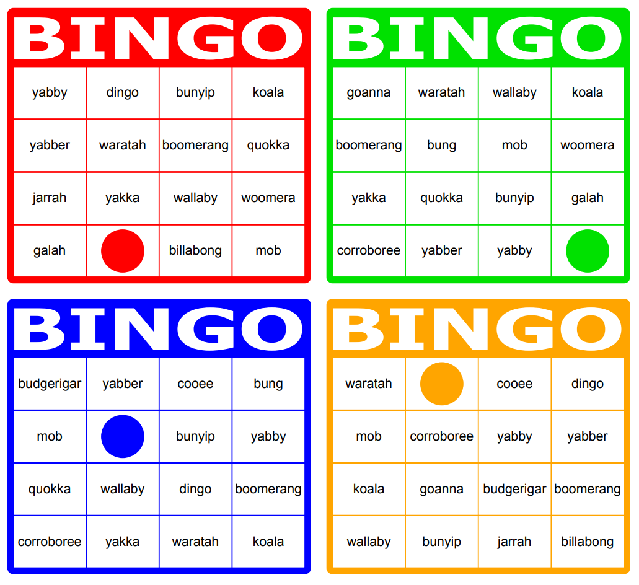
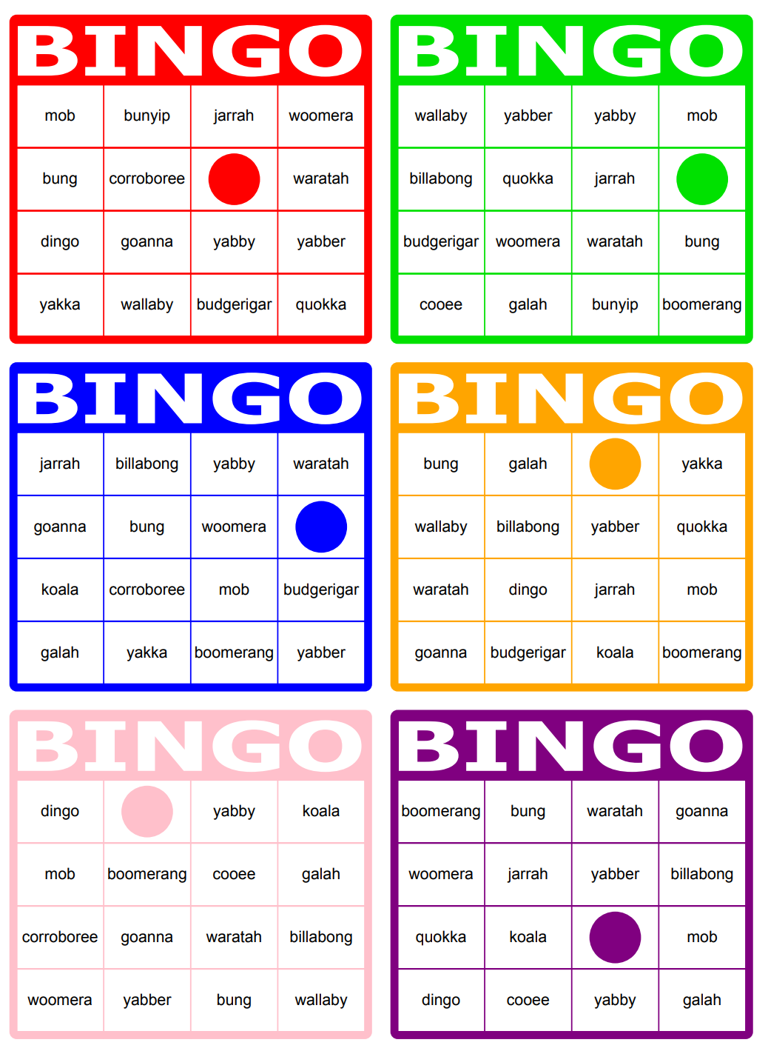

Resource #2 Bingo clue/definition list TEACHER COPY
Word | Clue/ Definition
yabby | A freshwater crayfish often found in Australian rivers and creeks
boomerang | A curved throwing tool that returns to the thrower when thrown correctly
billabong | A stagnant waterhole often found in the Australian outback
wallaby | A smaller relative of the kangaroo, common in Australian bushland
dingo | A wild Australian dog native to the continent
woomera | A spear-throwing device used to increase the distance of a spear throw
bunyip | A mythical creature said to lurk in Australian swamps and billabongs
galah | A pink and grey cockatoo known for its cheeky behaviour and loud calls
goanna | A large Australian monitor lizard found in many habitats
koala | A tree-dwelling marsupial famous for eating eucalyptus leaves
waratah | A bright red Australian native flower and the floral emblem of NSW
corroboree | A ceremonial gathering or dance performed by Aboriginal Australians
yakka | Hard work or effort; often used in the phrase “hard yakka”
yabber | To talk or chatter a lot, sometimes endlessly
jarrah | A type of strong, durable eucalyptus tree native to Western Australia
budgerigar | A small, colourful Australian parakeet often kept as a pet
cooee | A loud call used to attract attention or signal over long distances
mob | A group or family, often referring to kangaroos or Aboriginal communities
quokka | A small, friendly marsupial known for its “smiling” face, native to southwestern Australia
bung | Broken, not working, or useless; also can mean “to stuff or block”

Resource #3 Global roots words list
Barbecue

Mate

Eucalyptus

Creek

Banjo

Bush

Dunny

Swag

Resource #4 Global roots words list TEACHER COPY
Barbecue
Derived from Spanish word ‘barbacoa,’ itself from the Taino (Caribbean language) word for a framework of sticks for cooking meat
Mate
Usage comes from British English where “mate” referred to a companion and was popularised in Australia through convict culture
Eucalyptus
Scientific name for a native Australian plant was coined in 1788 by a French botanist (Charles Louis L’Heritier de Brutelle) from Greek ‘eu’ (well) and kalyptos (covered’) describing the flower bud’s cap
Creek
Comes from Middle English ‘creke,’ influenced by Scandinavian Old Norse language ‘kriki’ (nook/corner) and its meaning in Australia was influenced by North American English
Banjo
The musical instrument’s name was derived from West Africa, brought to America by enslaved Africans, and later adopted into English
Bush
Comes from Dutch ‘bosch’ (meaning forest or wood) adopted into English where it refers to rural, undeveloped land
Dunny
Traces back to British dialect word, ‘dunniken’ itself a compound word formed from ‘danna’ (dung) and ‘ken’ (house). Used in Australia since early 1800s in its shortened version to describe both indoor and outdoor toilets
Swag
Traces back to early 19th Century Britain where ‘swag’ was a criminal slang term for a load of stolen goods. By 1830s Australia the expression had shifted to a bag carried by bushman and itinerant workers containing their daily necessities

Resource #5 Word list

- alcohol
- magazine
- zero
- lemon
- cotton
- sofa
- mattress
- karaoke
- zen
- tycoon
- boutique
- facade
- genre
- cliche
- graffiti
- fiasco
- villa
- solo
- mosquito
- patio
- cargo
- yacht
- boss
- dock
- typhoon
- wok
- boomerang
- kangaroo
- bung
- billabong
- bung
- paddock
- fossick
- bonnet
- nappy
- pram
- rubbish
- okay
- guys
- kindergarten
- angst
- uber
- blitz
- banana
- jazz
- jumbo
- mammoth
- robot
- schmooze
- pyjama
- cummerbund
- shampoo
- loot
- thug
- democracy
- harmony
- zone
- canoe

Resource #6 Global roots worksheet

Word | Context Guess (explain) | Etymology | Australian context | Interesting fact
Word | Personal link | Etymology | Australian context | Interesting fact
11.
12.

© Department of Education Western Australia 2025.This product has been generated or modified using artificial intelligence and to the extent that copyright subsists in it, the copyright is retained by the Department of Education Western Australia.

