English | Year 7/8

1.5 Diaspora and third culture generations: Culture and multiculturalism

____________________________________________________________________________________________________

Focus 9: Cultural fusion

Lesson overview
The following sequence of activities is based on an abridged extract from The Exotic Rissole, a memoir by Tanveer Ahmed. In this autobiographical text Tanveer, a child of Bangladeshi migrant parents, recounts the importance of his friendship with an Australian classmate and its role in his emerging identity as a blend of both his parents’ culture and the Australian culture of his childhood experiences.

Teacher notes
This activity requires access to The Exotic Rissole, which can be purchased online as an eBook or print edition.
The activities are intended to take place over 1-3 lessons. Teachers may condense or expand the activities according to their student needs and time constraints.

Cultural safety considerations
The cultural safety of Aboriginal and Torres Strait Islander students, and culturally and linguistically diverse (CaLD) students must be a priority when planning and delivering these lessons.
Teachers are expected to establish a learning environment that is culturally, psychologically, spiritually, physically, and emotionally safe for all students, particularly for Aboriginal and CaLD students. Culturally responsive teaching practices should aim to create the conditions for students, staff, and families to experience cultural safety in schools and remove and minimise harmful experiences, such as racism in all its forms. Teachers should remain mindful of assumptions, stereotypes and unconscious biases and apply strategies to mitigate them.
Engaging in meaningful teaching and learning about multiculturalism and anti-racism requires teachers to create the conditions for cultural safety in the planning, delivery and assessment of lessons. This includes:
- knowing students’ cultural backgrounds and understanding how this may be relevant to (or impact) the learning environment
- letting students and families know about the planned content and resources in advance so that they can prepare for the learning, and contribute where safe to do so
- knowing any cultural protocols in advance that may impact the lesson (for example, using a disclaimer at the start of a film about people who may have passed away)
- knowing the sensitive language that may cause harm (for example, removing racial slurs or hate speech in films)
- not assuming that students or staff will want to share their cultural backgrounds and lived experiences with their peers during the lesson
- not calling on students during lessons without warning about content that has the potential to make them feel uncomfortable or singled out
- allowing for students, staff and families to provide input and feedback when they feel cultural safety in the planning, delivery and evaluation of lessons
- where possible, checking in with students and seeking their feedback on the activities and learning, if they feel culturally safe to do so.

Curriculum content
Year 7 | Year 8
Literature: Literature in context
Identify and explore ideas, perspectives, characters, events and/or issues in literary texts drawn from historical, social and/or cultural contexts by Aboriginal and Torres Strait Islander, wide-ranging Australian and world authors and creators WA7ELICO1 | Explain the ways that ideas and perspectives may represent the values of individuals and groups in literary texts drawn from historical, social and cultural contexts by Aboriginal and Torres Strait Islander, wide-ranging Australian and world authors and creators WA8ELIOCO1
Literature: Engaging with and responding to literature
Form an opinion about characters, settings and events in texts, identifying areas of agreement and difference with others’ opinions and justifying a response WA7ELIEN1 | Share opinions about the language features, literary devices and text structures that contribute to the styles of literary texts WA8ELIEN1
Literacy: Analysing, interpreting and evaluating
Use comprehension strategies, such as visualising, predicting, connecting, summarising, monitoring, questioning and inferring, to analyse and summarise information and ideas when listening, reading and viewing WA7ELYA3 | Use comprehension strategies, such as visualising, predicting, connecting, summarising, monitoring, questioning and inferring, to interpret and evaluate ideas when listening, reading and viewing WA8ELYA3

Learning intention
Students are learning how the ideas and perspectives of diverse individuals and cultural groups are represented in literary texts.

Success criteria
Students will:
- construct a Venn diagram to represent the individual and cultural similarities and differences between characters and families represented in a text
- visualise and draw scenes that represent the connection between characters from different cultural backgrounds in a text
- summarise, in writing, how the scenes communicate a key idea about growing up in Australia as a third culture child
- write a text providing the alternative perspective of a character.

Key terminology
- Diaspora - a scattered population with a common origin in a smaller geographical area.
- Third cultural generations - people whose families have lived in a culture different from their country of origin for 2 or more generations, forming a unique cultural identity.
- Third culture kids - children who grow up in a culture different from the one or both of their parents' home cultures, often adapting to multiple cultural influences.

Activity 1: Exploring hybrid identity
In this activity students will be reading the text and examining the way that it is structured using contrasts and comparisons to represent the fusion of cultures of Tanveer’s childhood.

Resources required:
- Student access to ‘Exotic Rissole’ by Tanveer Ahmed
- Appendix Resource #1 Comparing characters and cultures
- Appendix Resource #2 Comparing characters and cultures TEACHER COPY
- Student access to the internet (optional).

- Discuss the title Exotic Rissole with students, ask:
- What do these words mean?
  - Exotic: “unusual and exciting because of coming (or seeming to come) from far away, especially a tropical country” (Cambridge University Press)
  - Rissole: “a type of food made from meat or vegetables cut into small pieces and then pressed together and cooked in fat” (Cambridge University Press).
- Are these words nouns, verbs, pronouns, adjectives etc?
  - Exotic is an adjective
  - Rissole is the noun.
- Why would a rissole be described as ‘exotic,’ who might describe it that way?
- What do you think the story will be about?
- Who do you think will be telling the story?

- In pairs, provide students with Resource #1.
- Students will:
  - read a story about a friendship between Tanveer, whose parents migrated to Australia from Bangladesh, and Daryl, an Australian born classmate.
  - consider the following while reading:
  - Cultural values and customs
  - Family roles and relationships
  - Individual interests, pastimes and attitudes
  - complete a Venn diagram to record the similarities and differences between the families and individuals in the story.
- Resource #2 is a teacher copy.

- Place students into groups to compare their Venn diagrams to discuss and share ideas, including the questions in Resource #1.
  - Why do you think Tanveer Ahmed recounts events that highlight the similarities and differences between the 2 families?
  - Outline examples of a blending of cultures which influence some of Tanveer’s actions and how he interacts with others.
  - Explain the importance of the title ‘Exotic Rissoles’ in showing Tanveer’s sense of identity.
  - Introduce the term ‘third culture kid’ to support students to answer the questions.
    - someone whose identity is a fusion of both the culture in which they have grown up and the culture of their parents’ heritage.

Optional: students could use the SBS - Cultural Atlas to explore Tanveer’s Bangladeshi heritage and culture in more detail, which can be added to the Venn diagram.

Activity 2: Bridging differences
In this activity students are encouraged to ‘step inside’ the world of the text to visualise and recreate key moments in the boy’s friendship and explore how each may have felt at the time.

Resources required:
- Student access to ‘Exotic Rissole’ by Tanveer Ahmed
- Appendix Resource #3 Bridging differences image (printed or projected)
- Appendix Resource #4 Bridging their differences worksheet.

- Project image Resource #3 and ask students what they think it means, through a think, pair, share.

- Revisit the story Exotic Rissole and discuss the following with students:
- Tanveer Ahmed has said that his friendship with Daryl Lynch helped ‘bridge his sense of difference.’
  - What are some of the lessons Tanveer learned from Daryl that helped him ‘fit in’?
- Tanveer recounts many of the events in the story in a humorous manner. However, at the time, there may have been times when he may have felt uncomfortable or ‘put down’– such as when Daryl makes fun of his haircut.
  - Can you think of other instances in the story where he may have felt embarrassed or uncomfortable? Why would he have felt this way?
  - How do you think the boys were able to find a connection that bridged their differences?
- Answers may include:
  - accepting each other despite differences
  - finding common interests, values or experiences
  - listening to each other and reducing prejudice
  - being open to other cultures or experiences
  - sharing basic needs and values
  - seeking to understand the experience and point of view of the other person.

- Provide students with Resource #4 and instruct them to decide on the most important ‘moments frozen in time’ that represent the idea of the boys ‘bridging their differences.’
- Students will individually draw 3-4 significant scenes from the story as photographs for Tanveer’s album. Students should:
- consider the details that should be in each photograph, including:
  - settings, objects, gestures, expressions that represent the characters and the situation.
  - the foreground and background (how will characters appear in relation to each other,
  - how characters appear in relation to each other – height, distance?
  - a caption that summarises the main idea captured in the scene
- write an explanation of the significance of these moments for both boys.

- Direct students to compare their drawings and responses, and to answer the following:
- What is one important message Tanveer Ahmed wants us to know about how we can help someone from a different cultural background feel like they belong in Australia?

Activity 3: Lynchy’s perspective
Explore and respond to Lynchy’s perspective through creative writing.

Resources required:
- Student access to ‘Exotic Rissole’ by Tanveer Ahmed.

    - Explain to students that there are several references in Exotic Rissole that suggest Daryl was quietly resisting the prejudices of his father and wider Australian society. Ask students if they can think of any examples. Answers may include:
- Lynchy would always make excuses about why he did not have Tanny in his home, he says his parents didn’t like having guests or blaming his sister. However, he does receive an invitation once Daryl’s parents’ divorce.
- When Tanveer does visit, Daryl’s mum, shows interest in his family and origins in Bangladesh and tells him ‘Daryl’s father never had any interest in the world beyond his tools.’

    - Direct students to explore Lynchy’s perspective and context in more detail by completing the following activities:
- imagine Daryl has been teased and ridiculed by a classmate for being friends with Tanveer. Write how Daryl might respond to their comments, explaining:
  - how they became friends
  - why he enjoys hanging out with Tanveer
  - what he has learned from Tanveer and his family?
- write a conversation between Daryl and his mother set before the visit where he explains why he wants Tanny over now and had not asked before.

Optional: teachers may only require students to complete one of the above activities.

Reflection
- Who are third culture kids?
- How might their experience of living in a new country differ from their parents?
- What are the some of the challenges and benefits of growing up with influences from multiple cultures?
- Have you ever felt like you belong to more than one group or culture? How did you navigate that experience? What may have made it easier?
- Do you know a diaspora child? What have you learned from them?

Resource #1 Comparing characters and cultures
As you read the story, Exotic Rissoles, record the similarities and differences between the families and individuals.
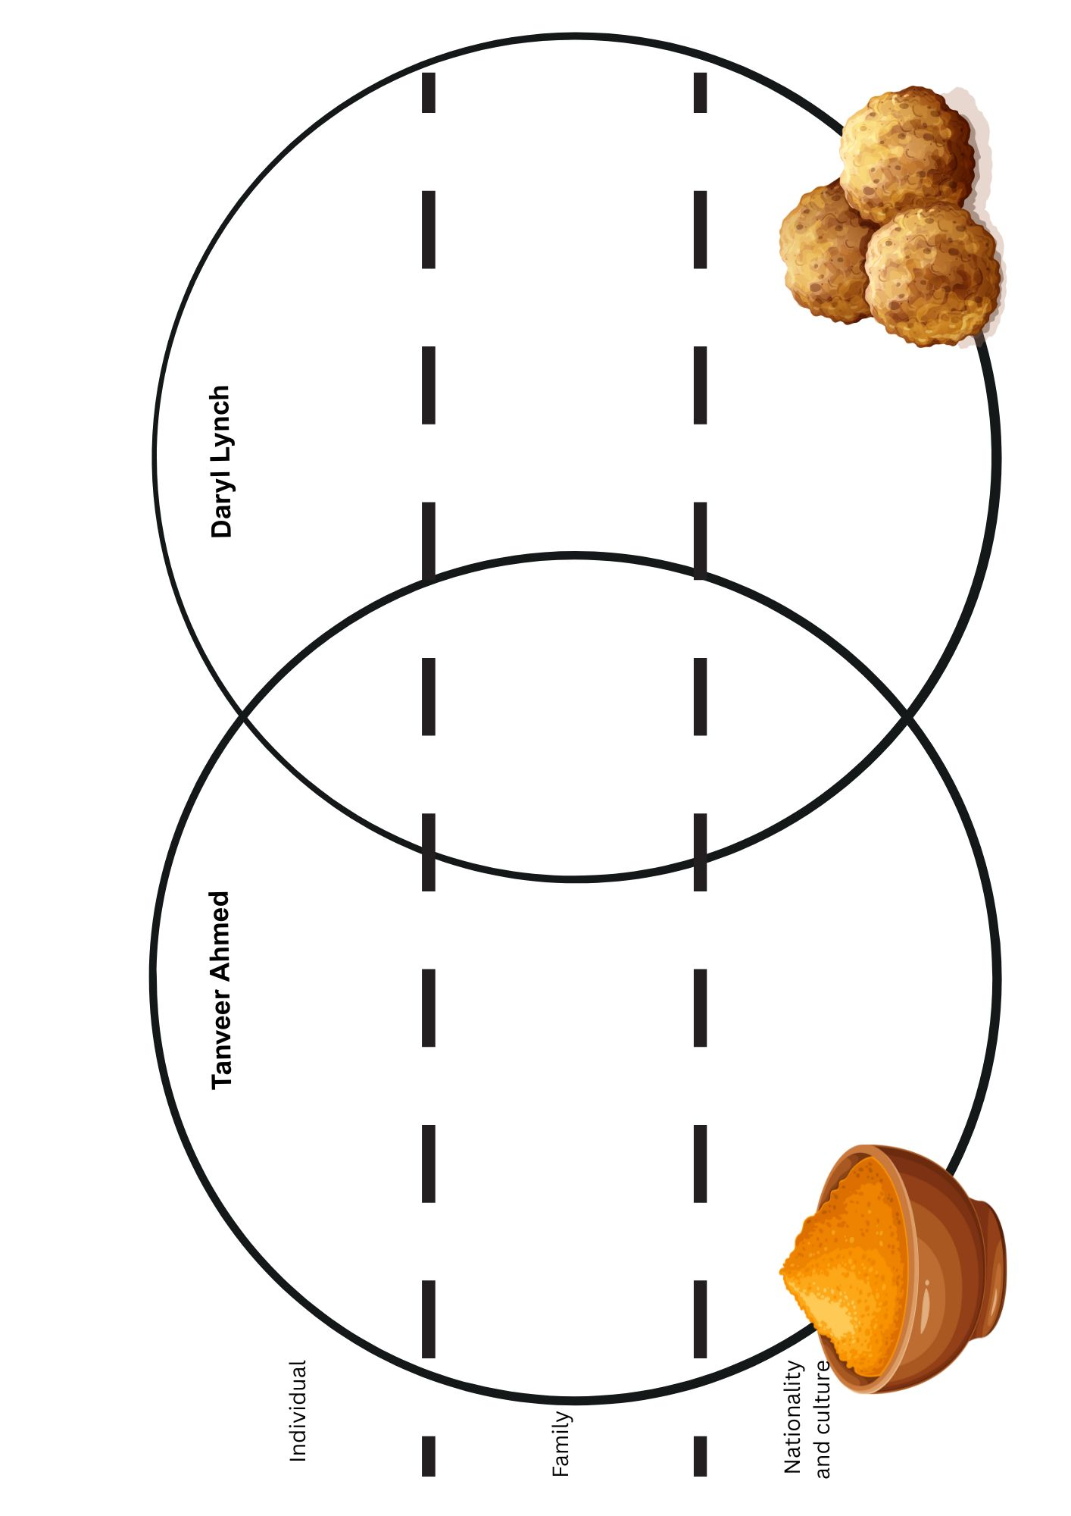
    - Why do you think Tanveer Ahmed recounts events that highlight the similarities and differences between the 2 families?

    - Outline examples of a blending of cultures which influence some of Tanveer’s actions and how he interacts with others.

    - Explain the importance of the title ‘Exotic Rissoles’ in showing Tanveer’s sense of identity.

Resource #2 Comparing characters and cultures TEACHER COPY
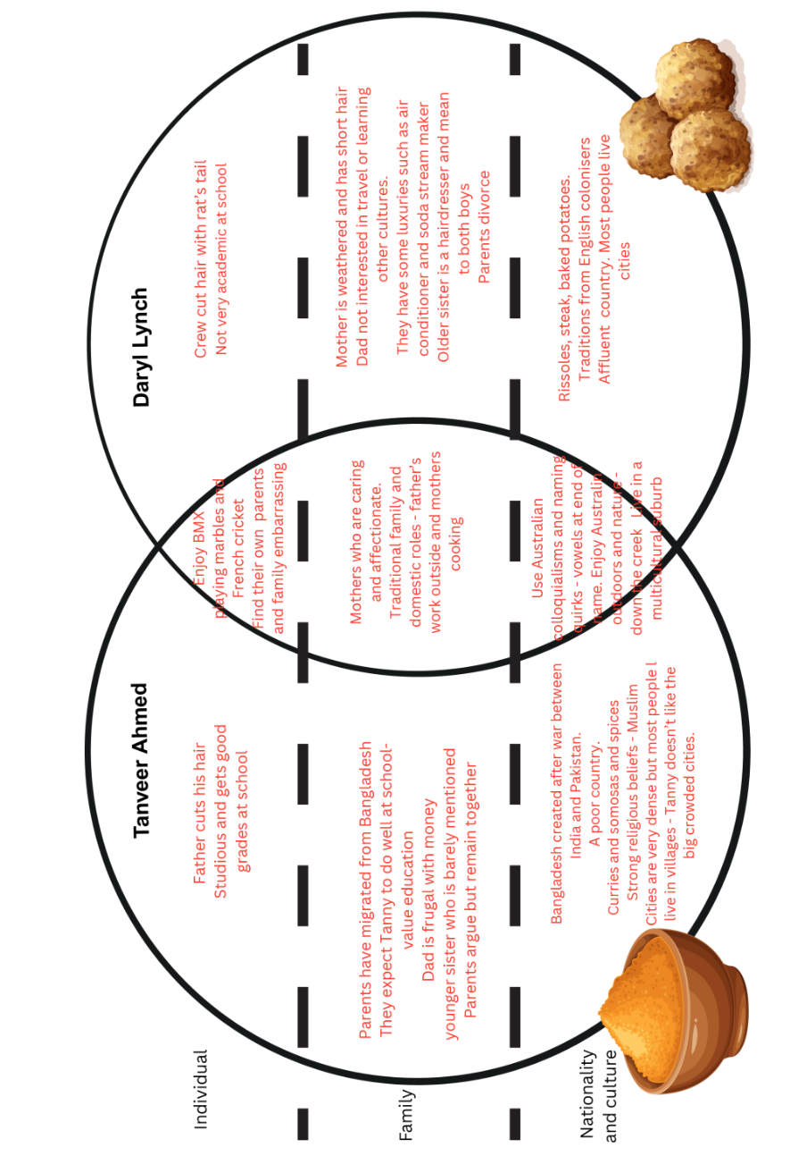

Resource #3 Bridging differences
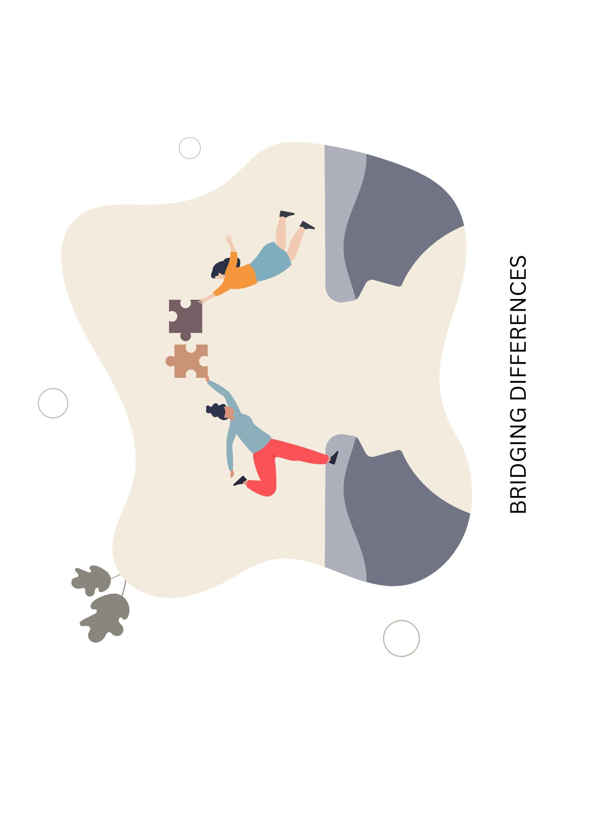
Resource #4 Bridging their differences worksheet
Tanveer is sorting through old photos from his childhood. Draw significant scenes from the story that show how he and Lynchy were able to ‘bridge their differences’ and add a caption to each.


© Department of Education Western Australia 2025.This product has been generated or modified using artificial intelligence and to the extent that copyright subsists in it, the copyright is retained by the Department of Education Western Australia.

