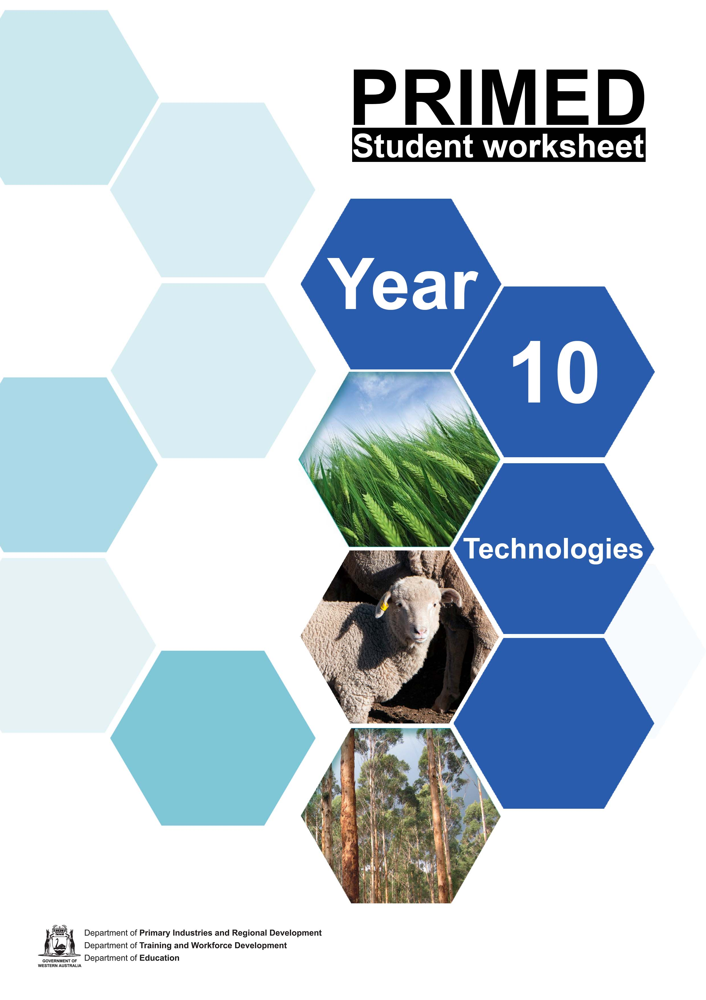

Student worksheet 1.1
Then, now and into the future
For thousands of years, Aboriginal and Torres Strait Islander people have worked closely with the land and they know how to harvest food sustainably. Before colonisation, Aboriginal people were not simply hunters and gathers, there is evidence that Aboriginal people manipulated the land, planted and harvested seeds and stored the surplus for future consumption.

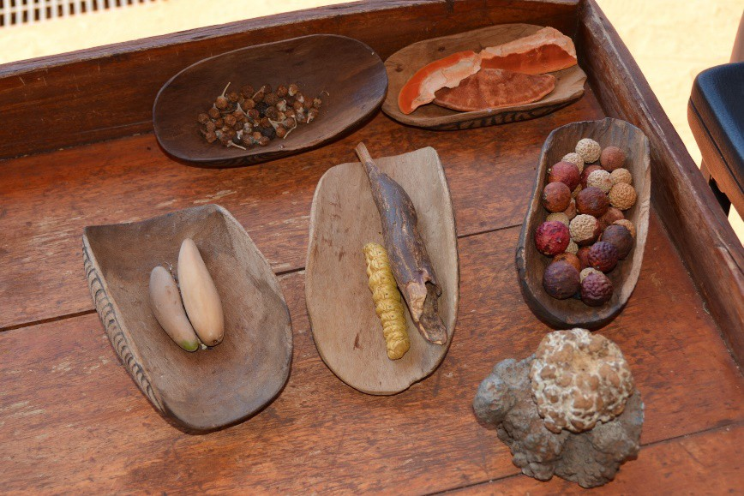

Image 1.1.1 Desert Bush Tucker

Reflect on what you know about Aboriginal and Torres Strait Islander food and agriculture. List your knowledge as a mind map.

Why do you think early European settlers believed that Aboriginal and Torres Strait Islanders lived a nomadic life? Do you think this is true?

Conduct a web search to find out more about Aboriginal and Torres Strait Islander food and agricultural practices. Write notes on what you find below:

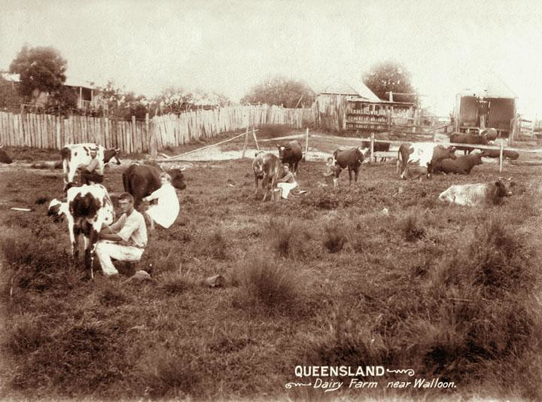
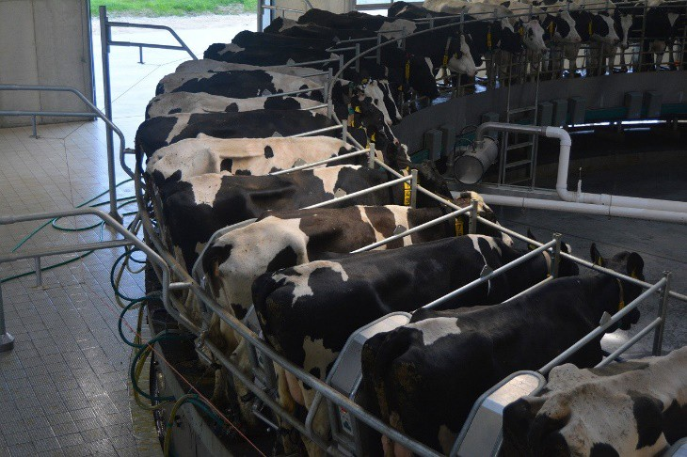
Modern day agriculture
Technology in agriculture has evolved over the past 100 years and will continue to do so into the future. Consider the images below:

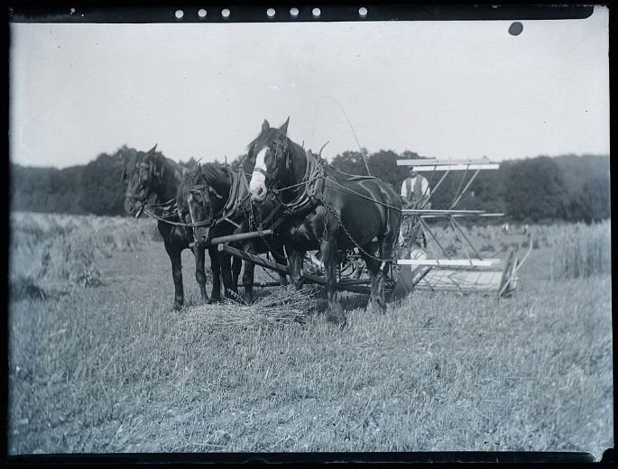Image 1.1.2 Early 1900s farming – horse drawn reaper/harvester | 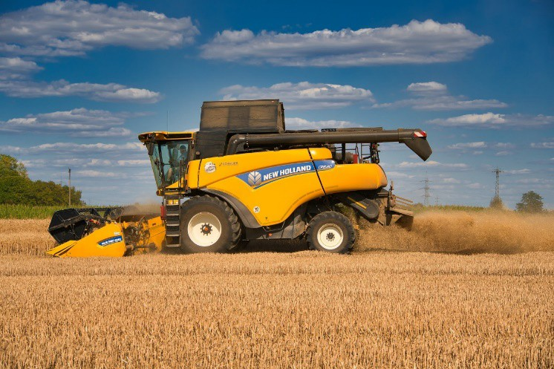  Image 1.1.3 Modern day combine harvester
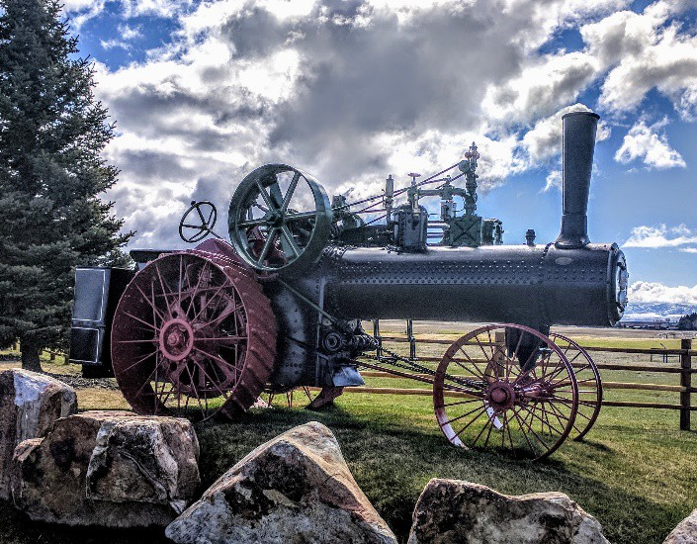  Image 1.1.4 Steam tractor | 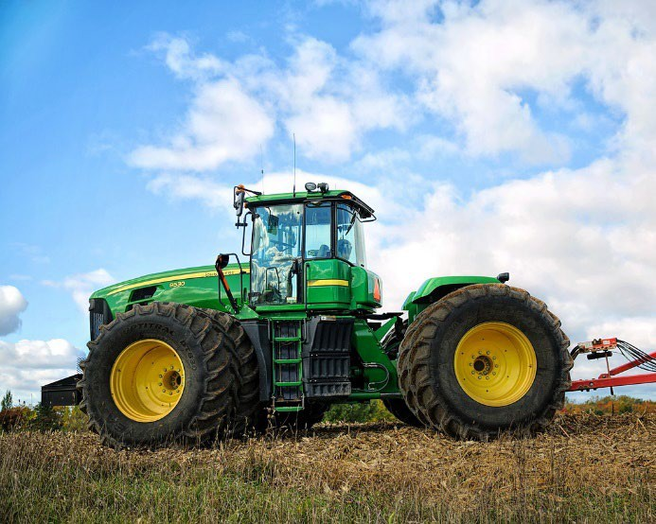  Image 1.1.5 Modern day tractor
Image 1.1.6 Hand-milking at a dairy farm near Walloon, c 1898 | Image 1.1.7 Dairy farm milking

Reflect on these images and write down what you See, Think and Wonder.

See
What did you see in the photos?
Think
What did this make you think about?
Wonder
What did this make you wonder?
Do you have some questions?

Class discussion:

How do you think technology has changed the way we practice agriculture? How has technology changed the types of jobs people do in agriculture?

Agriculture developed approximately 12 000 years ago when humans began to domesticate plants and animals. This changed the way humans lived, switching from nomadic hunter-gatherer lifestyles to permanent settlements and farming.
During the 18th and 19th Century in Europe, a period of technological improvement and increased crop productivity occurred. This period of agricultural evolution is known as the Agricultural Revolution. It created major changes to world economy, the environment and society.
Watch: The Agricultural Revolution: Crash Course World History #1 Complete a PMI summary of the impacts of agriculture.
Plus | Minus | Interesting

Consider research you have done and review the similarities and differences between Aboriginal and Torres Strait Islander agricultural practices and industrial agricultural practices and record them below.
Deadly Story – Food and Agriculture website has additional information on Aboriginal and Torres Strait Islander information.

Aboriginal and Torres Strait Islander agricultural practices
Torres Strait Islander

Similarities

Torres Strait Islander

Industrial agricultural practices

We can learn a lot from the past. What do you think we have learnt from past agricultural practices that can improve the future of agriculture?
Think about what the future of food and fibre consumption and production could look like.
Complete an image search of future agriculture and produce an image collage to summarise your findings. Write a summary statement about what you discovered.

Acknowledgements
References
National Geographic (19 August 2019) ‘The Development of Agriculture’ available at:
<https://www.nationalgeographic.org/article/development-agriculture/> accessed 3 September 2021
CrashCourse (27 January 2012), ‘The Agricultural Revolution: Crash Course World History #1’, Video, available at < https://www.youtube.com/watch?v=Yocja_N5s1I&list=RDLVYocja_N5s1I&start_radio=1&rv=Yocja
_N5s1I&t=41 >, accessed on 6 September 2021

Deadly Story (n.d) ‘Food and Agriculture’ available at:
<https://www.deadlystory.com/page/culture/Life_Lore/Food> accessed 25 October 2021

Images
Image 1.1.1 ‘Desert bush tucker’ from pxfuel, available at <https://www.pxfuel.com/en/free-photo- jawbj> accessed on 12 October 2021
Image 1.1.2 ‘Early 1900s farming – horse drawn reaper/harvester’ “whatsthatpicture” from Hanwell, London, UK, CC BY 2.0, via Wikimedia Commons, available at
<https://commons.wikimedia.org/wiki/File:Early_1900s_farming_scene_-_horse_drawn_reaper_-
_harvester_(5107417674).jpg> accessed on 6 September 2021

Image 1.1.3 ‘Modern day combine harvester ‘ by Anrita1705 from Pixabay, available at
<https://pixabay.com/photos/combine-harvester-agriculture-5401538/> accessed on 6 September 2021
Image 1.1.4 ‘Image 1.1.4 Steam tractor’ by Bryce Miles from Pixabay, available at < https://pixabay.com/photos/tractor-steam-case-farming-1900-2953569/ > accessed on 12 October 2021
Image 1.1.5 ‘Modern day tractor’ by Jill Wellington from Pixabay, available at < https://pixabay.com/photos/tractor-farming-farm-green-1815232/ > accessed on 12 October 2021
Image 1.1.6 ‘Hand-milking at a dairy farm near Walloon, c 1898’ Queensland State Archives from flicker, available at
<https://www.flickr.com/photos/queenslandstatearchives/8279681500/in/photostream/> accessed on 12 October 2021
Image 1.1.7 ‘Dairy farm milking’ by ursulahuman from Pixabay, available at < https://pixabay.com/photos/dairy-cow-dairy-dairy-farm-milking-5054736/ > accessed on 20 October 2021

Student worksheet 1.2

Future food systems
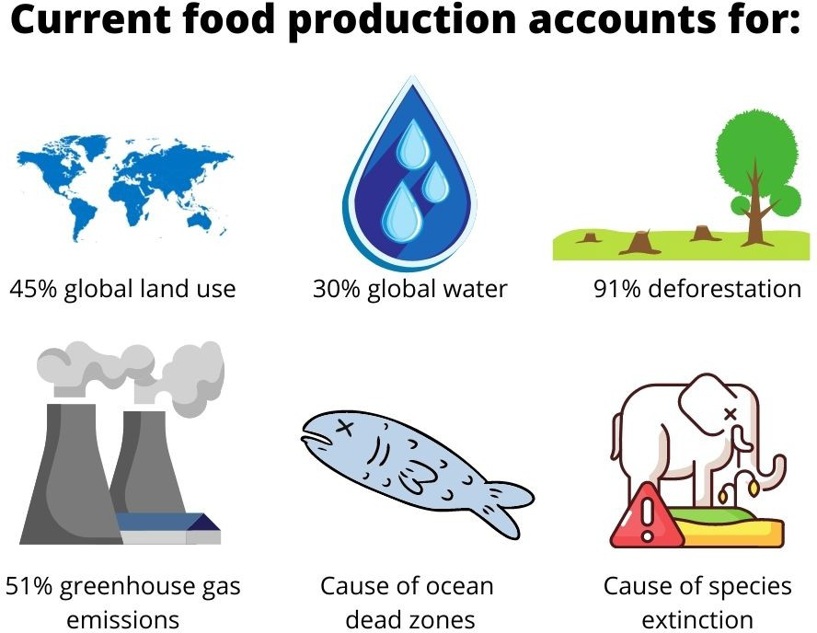
Image 1.2.1 Adapted from Myers.P Urban Farming: Fixing the broken food system & improving

Sustainable food systems should aim for:

- enough food for all
- healthy diets for all But also need to protect:
- biodiversity and ecosystems
- human well-being and social equity
- cultural diversity
- economic viability

- Consider what we could do to ensure future food and fibre production is secure, ethical and sustainable for all. Explain your thoughts below.

- Watch: Urban Farming: Fixing the broken food system & improving health | Paul Myers | TEDxLiverpool

What problems with the food system has Paul identified?
Describe what Paul created to help address these problems.
Explain how this design addresses some of the problems we face with traditional farming systems.

Acknowledgements
Reference
Tedx Talks (21 July 2016) ‘Urban Farming: Fixing the broken food systems & improving health I Paul Myers I TedxLiverpool’, YouTube, available at
<https://www.youtube.com/watch?app=desktop&v=5AcjM5BKfRQ> accessed 27 August 2021

International Center for Tropical Agriculture (n.d) ‘Sustainable Food Systems’ available at:
<https://ciat.cgiar.org/about/strategy/sustainable-food-systems/>, accessed on 14 September 2021

Images
Image 1 Department of Education.

Student worksheet 3.1
The Design Thinking Process
Watch the Video Future Food and Fibre Solutions. Using your knowledge of the design thinking process, write down how the project in this video used a design approach to create a solution.
Empathise
Define
Ideate
Prototype
Test

Student worksheet 3.2 Article review
Read the article Is this the future of food? As you read the article, add notes about the information you find on each topic in the boxes below.

Article Title | Author | Date

Foods of the future | Organisations mentioned | People mentioned | Changing trends in food consumption
Technology | WA companies | International companies | Foods of the future

1. Write a summary statement that explains what this article is about.
2. What are your thoughts about the examples of future foods provided in the article? Are these food items you have tried? Would you like to eat these future foods?
3. Consider the different technologies outlined in the article. What role do you think technology will play in the future of food production?

Student worksheets 4.1 Genetic modification
Genetically modified organisms can be defined as organisms where the genetic material has been altered in a way that does not occur naturally. It allows selected individual genes to be transferred from one organism into another, also between nonrelated species. Food and fibre products produced from or using “genetic engineering” are often referred to as GM foods or fibres.

Why is GM used in the production of food and fibre?
GM technology is used in food and fibre production because there is some perceived advantage to either the producer or the customer of these products. For example, lower costs, greater benefit (in terms of durability or nutritional value), higher yields, resistance against plant diseases and pests, and increased tolerance towards herbicides. GM allows scientist to develop new varieties of crops with specific traits.
Genetic modifications are playing an increasingly important role in crop science with larger areas of GM crops being planted in over 25 countries around the world, including Australia.

GM around the World
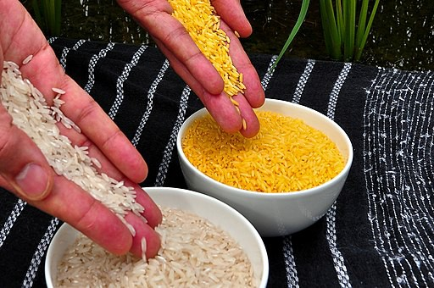
Most of the world’s widely grown GM crops, include soybean, corn, and cotton. One commonly known example of GM food is Golden Rice.

Conduct online research into Golden Rice and find out –
- How does Golden Rice differ to other rice varieties?
- The advantages and disadvantages of Golden Rice.

GM in Western Australia (WA)
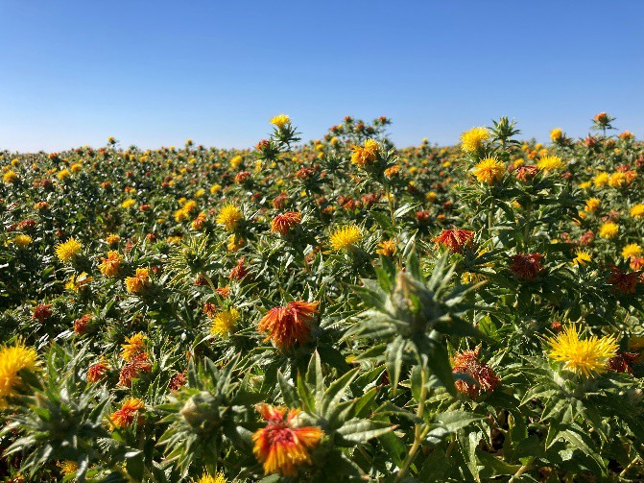
Image 4.1.2 Safflower trial in the Kimberley
lower and higher rainfall environments of WA.
4.1.1 Golden Rice compared to white rice

Currently in WA GM cotton, GM canola and GM safflower are the only commercially planted GM crops. The Office of Gene Technology Regulator (OGTR) oversees the commercial growing of GM crops in Australia to ensure it is safe for human health and the environment. There are numerous controlled research trials for new GM crops taking place at the New Genes for New Environments (NGNE) facilities at Merredin and Katanning in WA. The facilities enable the evaluation of GM plant traits to take place under field conditions in two contrasting locations.
These locations were selected as they represent

GM cotton is currently being growing in the Ord River Irrigation Area. Previously, traditional cotton varieties failed to grow successfully due to infestation of pests. Since the introduction of pest

resistant GM cotton in 2016 the growing of cotton in WA has become viable and is now a rapidly growing industry.
Other GM crops being developed and trialled around Australia (but not yet commercially available) include sugarcane, banana, wheat, barley and white clover.

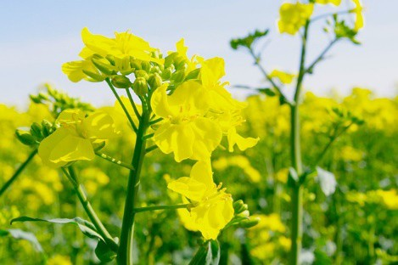
What GM foods are available in Australia?

There are no GM animals or fish grown or raised for food in Australia; however, meat, dairy and eggs from animals fed using imported GM feedstock are available to consumers in Australia.
The Commonwealth Scientific and Industrial Research Organisation (CSIRO) has developed a GM canola with higher levels of omega-3 fatty acids, which are considered ‘healthy oils’.

Image 4.1.3 GM Canola

Read the article ‘Our reliance on fish stocks for omega-3’

Describe the reason why the CSIRO developed this GM canola and what it is intended to be used for.

Did you know?
Many of the processed foods in our Australian stores include imported GM ingredients.

Examples of GM foods in Australia
GM ingredient | Foods they are commonly found in
GM canola | Oil, fried foods, baked goods and snack foods.
Cottonseed oil from GM cotton | Commercial frying of food (eg fish and chips), smallgoods, snack foods, baked goods, mayonnaise and salad dressings.
Imported GM soya | Potato chips, margarine, mayonnaise, crackers, soy, tofu, soy milk and flour, pastries and chocolate.
Imported GM corn | Corn chips, corn oil, cornflour, corn syrup. Processed corn starch as a sweetener in drinks, lollies, bread, cakes, breakfast cereals, sauces, gravy mixes and syrups.
Imported GM potatoes | Potatoes in snack foods, processed potato products and other processed food.

Would you eat GM fish or animals?

Read the article ‘Genetically modified salmon approval reignites GM food debate’ 26 November 2015
Ethical problems require critical and creative thinking.

- What are your thoughts on consuming GM fish or animal products?
- Could you convince other people to see your point of view on this topic? Write a persuasive statement about your view on this topic. Provide reasons and suggestions for or against GM fish and animal products.

Career Exploration:

Many people are involved in the process of creating GM products but is starts with genetic scientists and technicians working in research laboratories to develop new plant varieties.
Conduct a web search on how to become a plant geneticist. What experience or study is required?

Acknowledgements

References
Government of Western Australia, DPIRD, (13 July 2020) ‘Genetically modified crops in Western Australia’ available at < https://www.agric.wa.gov.au/genetic-modification/genetically-modified- crops-western-australia > accessed on 9 August 2021
Australian Government Department of Health, Office of the Gene Technology Regulator (no date)
<http://www.ogtr.gov.au/> accessed on 9 August 2021

Government of Western Australia, DPIRD, (29 November 2017) ‘Grains research facilities: New Genes for New Environments’ available at: <https://www.agric.wa.gov.au/genetic- modification/grains-research-facilities-new-genes-new-environments> Accessed 9 August 2021
World Health Organisation (1 May 2014) ‘Food, genetically modified’ available at: https://www.who.int/news-room/q-a-detail/food-genetically-modified accessed 9 August 2021
E.Stokstad (4 November 2019) ‘New genetically modified corn produces up to 10% more than similar types’ available at https://www.sciencemag.org/news/2019/11/new-genetically-modified- corn-produces-10-more-similar-types accessed 10 August 2021
Choice (26 November 2015) ‘Genetically modifies salmon approval reignites GM food debate’ Author Unknown https://www.choice.com.au/food-and-drink/meat-fish-and- eggs/fish/articles/genetically-modified-salmon-261115 accessed 10 August 2021
Clemons, R and Potter, A (17 November 2016) ‘Are you eating genetically modified food?’< https://www.choice.com.au/food-and-drink/food-warnings-and-safety/food-safety/articles/are-you- eating-gm-food>, accessed 10 August 2021

Images
Investigate Icon Image by Memed_Nurrohmad from Pixabay , available at <
<https://pixabay.com/vectors/magnify-loupe-investigation-5118694/ > accessed 10 August 2021

Image 1 International Rice Research Institute (IRRI) (15 February 2011) CC BY 2.0 available at <https://commons.wikimedia.org/wiki/File:Golden_Rice.jpg > accessed 10 August 2021
Image 2 by May_hokkaido from Pixabay, available at < https://pixabay.com/photos/canola-flower- yellow-may-field-5183809/ > accessed 10 August 2021

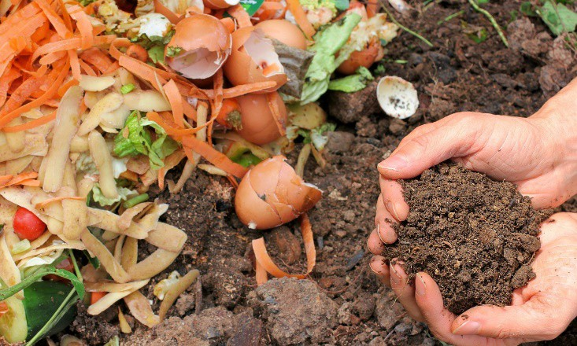
Student worksheet 4.2

Tackling Australia’s food waste

Think about the process our food goes through from production to consumption. How much waste do
you think occurs throughout this process?

Image 4.2.1 Compost
Food waste, whether it be food that never leaves the farm, food that is lost in transportation or food that is wasted from the hospitality sector and in our home, results in significant economic and environmental impact.

According to the Australian Government – Department of Agriculture, Water, and the Environment:

- One third of the world's food is wasted.
- 25 per cent of water used in agriculture is used to grow food that is ultimately wasted.
- Food waste produces eight per cent of global greenhouse gas emissions.

If food waste was a country, it would be the third largest greenhouse gas emitter, behind the USA and China.
Food waste is also a major problem in Australia:

- Food waste costs the economy around $20 billion each year.
- Each year we waste around 7.3 million tonnes of food – this wastage equals about 300 kg per person or one in five bags of groceries.
- Food waste accounts for more than five per cent of Australia’s greenhouse gas emissions.

Review the Situational snapshot on page 4 and 5 of the A Roadmap for reducing Australia’s food waste by half by 2030.

How does the amount of food waste from primary productions compare with households? Consider the type of waste, quantity, the percentage and the cost.

Provide your opinion:
- Do you think this level of food waste within Australia is acceptable? Justify your response.
- What impact does this food waste have on our environment, economy, and our people?
- If you could change one thing about the amount of food wasted in Australia, what would it be?
- Who do you think should be responsible for reducing Australia’s food waste and what could they do to make a change?

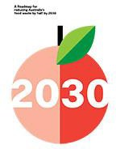
What is the Australian government doing to reduce food waste?
Food waste is a global challenge that has impacts on our environment, economy and our people. In 2017, the Australian Government committed to halving food waste in Australia by 2030.
Explore the Fact sheet available at Working together to reduce food waste in Australia.
Discuss:
•
The link Australia’s National Food Waste Strategy has with the United Nations Sustainable Development Goal Number 12.
The role of each stakeholder involved in this
strategy.
Image 4.2.2
•

Review the infographic How food waste is managed in Australia. Summarise the food waste strategies below.

Strategy | Key Players (Who is involved) | Description

Examples of food waste management in Western Australia (WA)
There are many great initiatives in WA that are working towards reducing food waste. Some of these are new and emerging projects, others are established programs that are already helping our community to reduce and manage waste.
Read about the following waste reducing projects here in WA.

Foody Bag: New app helps Perth bakeries win battle against food waste Meet the giant mechanical stomach turning food waste into electricity Handasydes freeze-dried strawberries

- Explain which of these you consider to be an example of a new and emerging waste management initiative.

- What are the strengths and weaknesses of each of these programs?

 | Strengths | Weaknesses
Foody Bag
Anaerobic digester
Freeze-dried produce

- Propose a simple solution which could help manage the food waste at your school from either the canteen, the food room or from lunch boxes.

- Write out the steps that would need to be done to make your solution work effectively.

- If you had a team of three people working on this project, what job roles could these three people do?
  - create three job titles
  - list the job roles of the process each person would do
  - list the skills needed to complete these job roles

Job title: | Job title: | Job title:
Job roles: | Job roles: | Job roles:
Skills needed: | Skills needed: | Skills needed:

Acknowledgements

References
Department of Agriculture, Water and the Environment (n.d) ‘Tackling Australia’s food waste’ available at: <https://www.environment.gov.au/protection/waste/food-waste> accessed 7 September 2021
Department of Agriculture, Water and the Environment (n.d) ‘Resources for implementing the National Food Waste Strategy’ available at:
<https://www.environment.gov.au/protection/waste/publications/resources-implementing-national- food-waste-strategy> accessed 7 September 2021
Department of Agriculture, Water and the Environment (November 2017) ‘How food waste is managed in Australia’ available at:
<https://www.environment.gov.au/protection/waste/publications/infographic-how-food-wate-is- managed-in-australia> accessed 7 September 2021
Department of Agriculture, Water and the Environment (2020) ‘A Roadmap for reducing Australia’s food waste by half by 2030’ available at:
<https://www.environment.gov.au/protection/waste/publications/roadmap-reducing-food-waste> accessed 7 September 2021
Department of Agriculture, Water and the Environment (2017) ‘Working together to reduce food waste in Australia’ available at:
<https://www.environment.gov.au/protection/waste/publications/food-waste-factsheet> accessed 7
September 2021

The Food and Agribusiness Growth Centre (n.d) <Reducing Australia’s Food Waste by half by 2030’ available at: <https://www.fial.com.au/sharing-knowledge/food-waste> accessed 7
September 2021

Amos. A (May 24 2021) ‘Foody Bag: Mew App helps Perth bakeries win battle against food waste’, Perth Now <https://www.perthnow.com.au/community-news/eastern-reporter/foody-bag-new-app- helps-perth-bakeries-win-battle-against-food-waste-c-2918770> accessed 31 August 2021
De Poloni. G (28 March 2021) Meet the giant mechanical stomach turning food waste into electricit’, ABC News<https://www.abc.net.au/news/2021-03-28/meet-the-mechanical-stomach- turning-food-waste-into-electricity/100032660> accessed 31 August 2021
Handasydes Strawberries Website (2021) <https://handasydestrawberries.com.au/freeze-drying/> accessed 31 August 2021
Fight Food Waste Cooperative Research Centre (12 March 2020) ‘Food: Too Good to Waste’ available at: <https://afccc.org.au/images/news,%20crc/AFCCC%20General%20Meeting%20-
%20Food%20-%20Too%20Good%20To%20Waste%20%20-%2012%20March%202020.pdf>
[PDF 5.0 MB] accessed 31 August 2021

Australian food cold chain council (n.d) ‘Resources’ available at:
<https://afccc.org.au/resources.html> accessed 31 August 2021

Images
Image 4.2.1 ‘Compost’ by melGreen from Pixabay, available at
<https://pixabay.com/tr/photos/organik-g%c3%bcbre-ekoloji-at%c4%b1k-bah%c3%a7e-6053136/>

Image 4.2.2 ‘Astronaut Strawberries’ Savant-fou CC BY-SA 3.0, via Wikimedia Commons available at <https://commons.wikimedia.org/wiki/File:Astronaut_Strawberries_10.jpg>

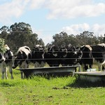
Student worksheet 4.3

More than milk
Cows for milking were recorded as part of the first animal inventory in 1829 as part of the colonial settlement in Western Australia (WA). While over the first few decades of settlement cattle herds gradually increased, a strong industry was not established until the later years of the nineteenth century, and it was not until the twentieth century that rapid expansion of the industry took place.
Image 4.3.1 The New Bovines

Most dairy farms were located on the Swan coastal plain but as the Perth population grew, dairy farms gave way to suburbia. Production moved mainly to areas further south where higher rainfall and irrigation of pastures was possible. Dairy became the principal agricultural industry in the areas of Harvey, Pinjarra, Bunbury, Capel, Busselton and Margaret River from the 1920s to the 1970s. Increasing land values and competition with vineyards has forced the relocation of dairy production since the 1980s.
Today, the WA dairy industry is in the South West of the state, mainly Harvey, Margaret River and Denmark. There are approximately 135 dairy farms, and a herd size of approximately 54 000 cows. WA produces 364 million litres of milk per year, which is approximately four per cent of Australia’s total milk production.
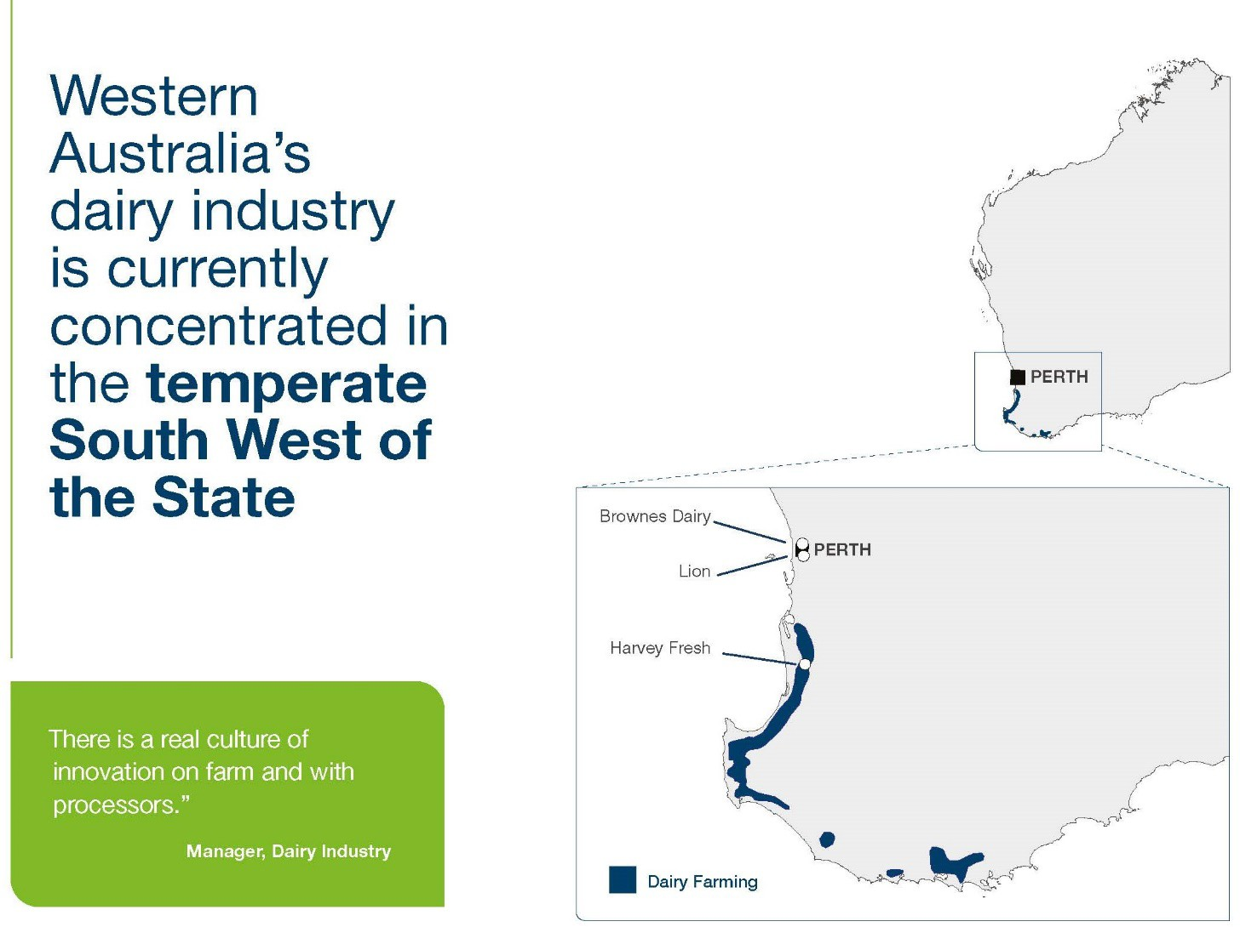

Image 4.3.2 Industry snapshot – Dairy

What do you think are some of the challenges faced by dairy farmers today?
Read Industry Challenges, available on the Dairy Australia website, summarise the challenges identified and categorise them into environmental, economic and social factors.
Add any other factors that you think could be a challenge for Western Australian dairy farmers.

Environmental Economic

Social

Alternative milk products

The consumer demand for alternative milk products has increased. Can you think of any reasons why this demand has occurred?

Dairy milk now has a range of other products competing on the milk shelf of our supermarkets.

Search your local store (online) and record all the milk varieties and alternatives available to consumers.
- Why do you believe some people choose alternative milk products?
- Do you believe these products should be able to be called milk? Explain your opinion.
- What do you think the dairy industry’s opinion is on calling these alternative milk products ‘milk’?
Read this comment from Dairy Australia about the use of the name milk for plant based beverages.
- If you were able to change the label of these products what alternative name would you give these non-dairy products?

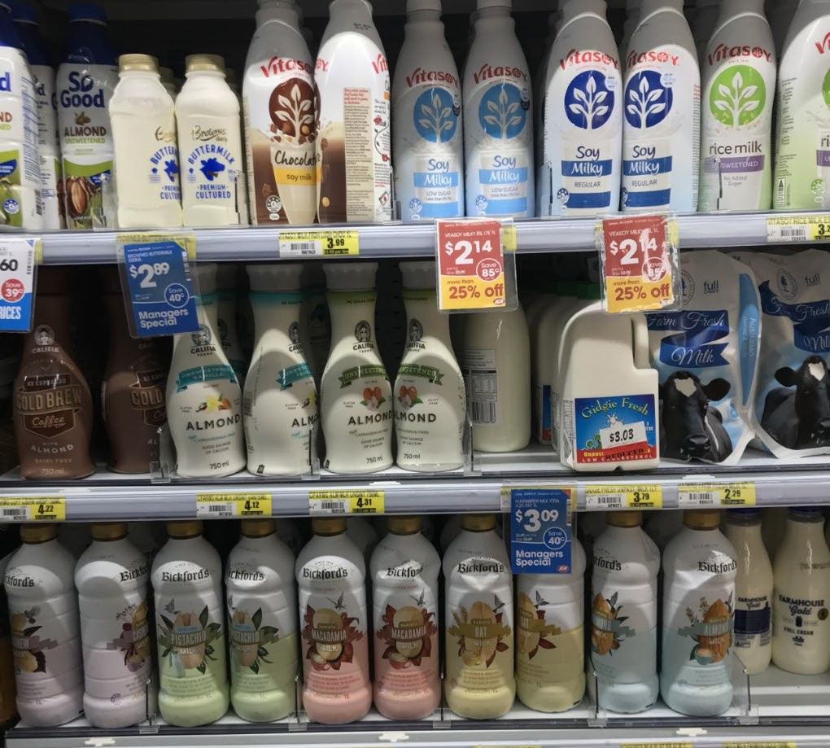
Image 4.3.3 Milk in the shop

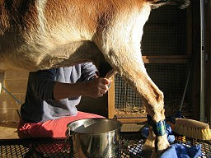
Other milk available in WA
The niche market of camel, goat and sheep milk have grown in the past few years and demand for these alternative dairy products has increased. Farmers have responded and WA now has a range of locally produced milk alternatives.
Complete a web search about camel, goats and sheep dairies in WA and provide a summary of these businesses.

Image 4.4.4 Goat milking
HINT: Suggested sources of information includes the Department of Primary Industries and Regional Development website, specific business websites, relevant newspaper articles or media releases showcasing these businesses.

 | Business name and location | Types of product produced | Interesting facts
Camel
Goat
Sheep

Is animal free milk the future of milk alternatives?

How could you make milk without an animal?

Start-up company Eden Milk have been working with the Commonwealth Scientific and Industrial Research Organisation (CSIRO) researchers to develop an animal-free milk which is set to replace plant milk alternatives.

Read the following article to find out more:
Dairy without the cow
Reflect on what you have learnt about the development of the animal free milk and arrange your thoughts into the PMI chart below.

Plus | Minus | Interesting

Would you, as a consumer, be happy purchasing this new milk alternative? Justify your reasons.

Acknowledgements
References
WA Farmers (2018) ‘Dairy’ available at: <https://wafarmers.org.au/what-we-do/dairy/> accessed 30 August 2021
Dr Lindsay and Martin, Graeme (January 2009) ‘Dairying (History in Western Australia)’ University of Western Australia Press available at:
<https://www.researchgate.net/publication/233727691_Dairying_History_in_Western_Australia> accessed 30 August 2021
Dairy Australia (30 April 2021) ‘Industry Challenges’ available at
<https://www.dairyaustralia.com.au/strategic-plan-2020-25/situation-analysis/industry- challenges#.YYCn121ByUl> accessed 13 October 2021
Dairy Australia (30 April 2021) ‘Why do you allow non-dairy milks (almond, soy etc) to still be called milk?’ available at: <https://www.dairy.com.au/dairy-matters/you-ask-we-answer/why-do-you-allow- non-dairy-milks-to-still-be-called-milk> accessed 30 August 2021

Images
Image 4.3.1 ‘The New Bovines’ by Brett and Sue Coulstock, CC BY 2.0, via flickr available at
<https://www.flickr.com/photos/redmoonsanctuary/9333334328/>
Image 4.3.2 ‘Industry snapshot – Dairy’ Department of Primary Industries and Regional Development DPIRD Industry Snapshot - Dairy available at
<https://www.agric.wa.gov.au/WAindustrysnapshots> Image 4.3.3 ‘Milk in the shop’, Department of Education
Image 4.3.4 ‘Goat milking’ Olaf Gradin from Gainesville, GA, USA, CC BY-SA 2.0, via Wikimedia Commons available at < https://commons.wikimedia.org/wiki/File:Goat_Milking.jpg >

Student worksheet 4.4

Different grains

Do you know?
What grains are grown in Western Australia (WA)?

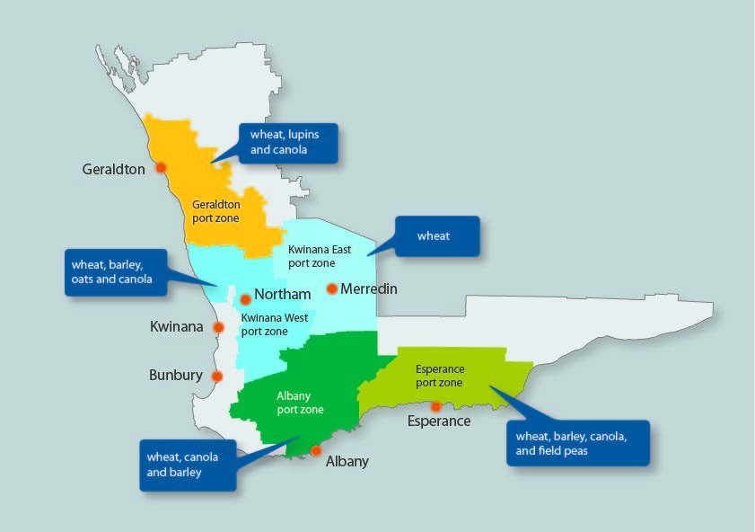
Image 4.4.1 Western Australian grain growing regions and port zones (©2021 dafwa)

1. From the map above, list the grains that are commonly produced in WA and explain what they are used for.

Grains research & development
The Department of Primary Industries and Regional Development (DPIRD) has grains research and development connections across Australia and with more than 25 countries worldwide – ranging from collaboration with Japanese flour millers involved with the udon noodle industry through to seeking out barley genes tolerant of acid soils on the Tibetan Plateau. Each year the department coordinates and delivers on more than $20 million worth of grains research, development and extension projects

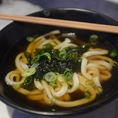
Image 4.4.2 Udons

Listen to the ABC news report Australian wheat the key ingredient in Japan's famous udon noodles and describe the ideal characteristics needed to make the perfect udon noodle.

DPIRD oversees annual crop trials carried out all the way from Kununurra in the north of the state through to Esperance in the south. These locations were selected as they represent lower and higher rainfall environments of W.
The Grains Research and Development Corporation (GRDC) – a national organisation coordinating research and development on behalf of Australian grain growers is a key funder of the department's grain research, development and extension activities.
Constant research is being done to secure the future production of grains like wheat in WA. With changing climatic and soils conditions, researchers use techniques like selective breeding to produce seed that will thrive in the changing growing conditions. For example, there are wheat varieties that have been developed for arid soils and others developed for acidic or saline soils.

Examples of other grain production in WA

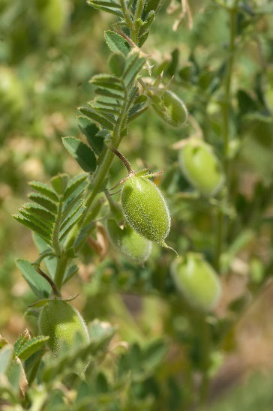
Pulses
What are pulses?

Use the DPIRD website to identify the types of pulse crops grown in WA and what they are used for.
Why do you think pulse crops could be a developing future market for Australian agriculture?

Image 4.4.3 Chickpea crop with ripening pods. (©2021 DPIRD)

Lupins
Lupins are a legume and have traditionally been grown to help improve soil conditions, and generally used for livestock feed. Western Australia is the world’s largest producer and exporter of lupins with the majority exported as animal feed to the European Union, Japan and Korea.

More recently the health benefits of lupins have been identified in medical studies and lupins have been found to be beneficial in combating high blood sugar, heart disease and obesity.
Look into what these three WA companies are doing with lupins.

- The Lupin Co
- Pinarie Foods
- My Provincial Kitchen

How could the innovation of these primary producers and the way they are using lupins benefit all lupin growers?

Emerging grain crops in WA
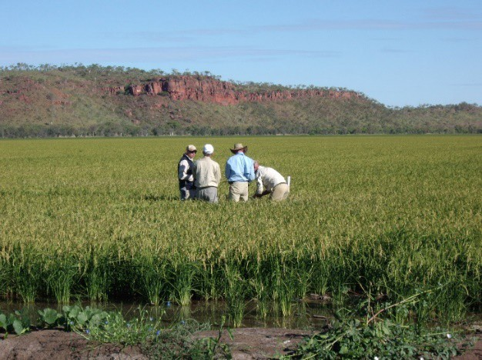
There is constant research and trails taking place in WA, which explores different cropping options. Here are three niche crops being successfully grown in WA, two in the Ord River Irrigation Area (ORIA), hemp and rice and the third in the wheatbelt, quinoa.

There has been increasing interest in growing industrial hemp, which is not intoxicating but high in protein and omegas 3 and 6, for use as a flour, seed, protein and oil, in bread, cereals, milk and dairy products.
Rice traditionally has not been grown in WA as it is a crop that requires large amounts of water for irrigation.

Image 4.4.4 Commercial rice crop grown in the Ord River Irrigation Area. (©2010 DAFWA)

Suitable soil types, a warm climate, and availability of irrigation water make the Ord River Irrigation Area (ORIA) in Western Australia’s East Kimberley ideal for growing rice.
Most quinoa purchased locally is imported, but trials on the ORIA and the wheatbelt indicate that it could be grown successfully in WA. Quinoa is recognised to have great health benefits and the market demand for the grain has increased rapidly in recent years.

How would the increased production of these three niche grains benefit WA’s agricultural industry?
Read about the Three Farmers group who are successfully filling a market gap by providing WA-grown quinoa to supermarket shelves.
Explain how Three Farmers are sustainably growing quinoa.

What are the economic, environmental and social benefits of growing this ancient grain here in WA?

Native Australian grains
Native millet (Panicum decompositum) grows extensively throughout the Western Australian rangelands. The growth of native millet indicates that pasture condition is good, and the grass is most commonly used as pasture feed for livestock.
Native millet, however, does produce a seed/grain. It is understood that Aboriginal people living in arid Australia harvested millet and ground it into a flour to make fire roasted-bread (dhuwarr).

Complete a Webquest and see what you can find out about Australian native grains and seeds.
- List the names of native grains you can find information on.
- Where are these grains grown?
- Why are these grains not grown commercially?
- What could be some of the benefits of having a commercal crop of these native grains?
- What are the challenges in getting a commercial crop of these grains growing?

Acknowledgements
References
Department of Primary Industries and Regional Development (n.d) ‘Grains research and development’ Government of Western Australia available at:
<https://www.agric.wa.gov.au/crops/grains/grains-research-development accessed 2 September 2021

Fitzgerald, Bridget (15 October 2019) ‘Australian wheat the key ingredient in Japan’s famous udon noodles’ available at: <https://www.abc.net.au/radio/programs/am/australian-wheat-key-ingredient- in-japans-famous-udon-noodles/11602512> accessed 22 September 2021
Department of Primary Industries and Regional Development (25 March 2021) ‘Hemp seed trials take off’ Government of Western Australia available at: <https://www.agric.wa.gov.au/news/media- releases/hemp-seed-trials-take> accessed 2 September 2021
Department of Primary Industries and Regional Development (8 March 2017) ‘Rice in the Ord River Irrigation Area’ available at: <https://www.agric.wa.gov.au/grains-research-development/rice- ord-river-irrigation-area> accessed 2 September 2021

Three Farmers (2021) ‘Our Beginnings’ available at: <https://www.threefarmersquinoa.com.au/> accessed on 2 September 2021
The Lupin Co (2021) ‘The Lupin Co’ available at: <https://thelupinco.com.au/> accessed on 22 September 2021
Pinarie Foods (2021) ‘Pinarie Foods’ available at: <https://pinariefoods.com.au/> accessed on 22 September 2021
My Provincial Kitchen (2021) ‘My Provincial Kitchen’ available at:
<https://myprovincialkitchen.com.au/> accessed on 22 September 2021

Allam L (2020) ‘Australian researchers find native grasses could be grown for mass consumptions’ The Guardian available at: <https://www.theguardian.com/australia-news/2020/nov/10/australian- researchers-find-native-grasses-could-be-grown-for-human-consumption> accessed 13 October 2021
Monroe MH (2009) ‘Mill Harvesters’ Australia: The Land Where Time Began available at:
<https://austhrutime.com/millet_harvesters.htm> accessed 13 October 2021

The Department of Primary Industries and Regional Development (7 July 2021) ‘Native millet (Pancium decompositum) in Western Australia rangelands’ available at:
<https://www.agric.wa.gov.au/rangelands/native-millet-panicum-decompositum-western-australian- rangelands> accessed 13 October 2021
Images
    - ‘Grain production Western Australia Map’ the Department of Primary Industries and Regional Development (2020) available at: <https://www.agric.wa.gov.au/wheat/grain-production-western- australia-map> accessed on 14 October 2021
    - ‘Udons’ by Flickr, CC BY-NC 2.0, available at
<https://www.flickr.com/photos/avlxyz/27864829249 > accessed on 22 September 2021

    - ‘Chickpea crop with ripening pods’ by the Department of Primary Industries and Regional Development (2019) available at: <https://www.agric.wa.gov.au/chickpeas/neelam-desi-chickpea- southern-australia?nopaging=1> accessed 22 September 2021
    - ‘Commercial rice crop grown in the Ord River Irrigation Area’ by the Department of Primary Industries and Regional Development (Rice in the Ord River Irrigation Area’ available at:
<https://www.agric.wa.gov.au/grains-research-development/rice-ord-river-irrigation-area> accessed 22 October 2021

Student worksheet 4.5

Selective breeding in agriculture

Do you know?
What do you think the term selective breeding means? Can you think of an example?

Selective breeding began about 10 000 year ago. Hunter-gatherers began to keep herds of animals and to cultivate cereals and other plants. Unlike natural selection which is sometimes summed up by the phrase “survival of the fittest”, selective breeding requires human interference. Once humans started cultivating plants and rearing animals we begun to recognise desirable traits, for example preferred size or colour of fruit and desired quality of wool from sheep.
Watch the video: Foods That Originally Looked Totally Different.

This video provides a number of examples of how fruit and vegetables have evolved, due to selective breeding, into the food items we know today.
- As you watch the video complete the See Think Wonder chart below.

See  What did you see in the video? | Think  What did this make you think about? | Wonder  What did this make you wonder?

Selective breeding enlarged desired traits of the wild mustard plant (Brassica oleracea) over hundreds of years, resulting in dozens of today's agricultural crops. Cabbage, kale, broccoli, and cauliflower are all cultivars of this plant.
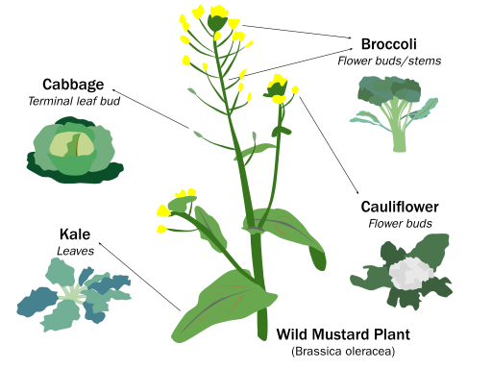
Image 4.5.1 Selective breeding of wild

How are selective breeding practices being used in Western Australia (WA) agriculture today?
Selective breeding can be done:

      - on farm by farmers with the support of industry experts, for example stock agents, veterinarians, agronomists and horticulturists.
      - in research facilities, such as Grain Research Development Corporation (GRDC), Department of Agriculture and the Commonwealth Science and Industrial Research Organisation (CSIRO) by agricultural scientists and trialled in various WA locations.
Wool and sheep breeding quality programs are one example of selective genetic breeding actively practiced in WA agriculture. The Australian Sheep Breeding Values (ASBVs) are a prediction of an animal’s genetic merit for a particular trait and can be used by producers to select breeding stock to genetically improve their herds.
Watch the video: What are Australian Sheep Breeding Values?

- List five different traits ASBVs record.
- Why would a farmer benefit from using ASBVs to select their breeding stock, rather than just rely on visual presentation of the sheep?

Selective breeding can also be used to develop desirable traits in plants. Let’s have a look at some recent research into improving wheat and barley varieties.
There is still a lot we don’t know about grains and every year a lot of research goes into developing new varieties of commonly consumed grains. There are many reasons why scientist work to develop new varieties. For example, improved health benefits, meeting consumer demand, adaptation for climatic conditions and economic targets.

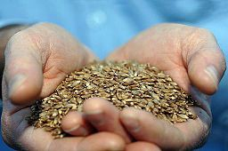
Case Study: BARLEYmax

Read the article and watch the video about BARLEYmax, and answer the following questions.

- What research institute developed BARLEYmax?
Image 4.5.2 BARLEYmax

- Explain the challenge that inspired the development of BARLEYmax.
- Write a series of steps that explains how BARLEYmax was produced, trialled and eventually sold to consumers.
- What have the benefits of BARLEYmax been for consumers and growers?
- Explain how BARLEYmax is an example of an innovative solution which is helping to address real world problems.
- Would you happily purchase and consume BARLEYmax products? Justify your answer.

Acknowledgements

References
Be Amazed (17 December 2017) ‘Foods That Originally Looked Totally Different’, YouTube, available at: <https://www.youtube.com/watch?v=M5Qly-VQfbo> accessed 1 September 2021
Meatandlivestock (31 May 2019) ‘What are Australian Sheep Breeding Values’, YouTube, available at: <https://www.youtube.com/watch?v=E1NJhiwChCQ> accessed 1 September 2021
CSIRO (n.d) ‘BARLEYmax’ available at:
<https://www.csiro.au/en/research/production/food/barleymax-bucase-study> accessed 6
September 2021

Images
Image 1: Liwnoc, CC BY-SA 4.0, via Wikimedia Commons, available at < https://commons.wikimedia.org/wiki/File:Wild_Mustard_Plant_Selective_Breeding.svg >, accessed on 2 September 2021
Image 2 CSIRO, CC BY 3.0, via Wikimedia Commons, available at < https://commons.wikimedia.org/wiki/File:CSIRO_ScienceImage_10909_BARLEYmax_grain.jpg >, accessed on 2 September 2021

Student Worksheet 4.6

Growing fibre in WA
Fibre comes from both plants and animals. In Western Australia (WA), the largest fibre industry is sheep’s wool. There are some small producers of alpaca wool, and mohair and cashmere from goats, as well as fibre plants, such as projects exploring the growing of cotton and hemp crops.

Do you know?
Which breed of sheep produces most of Australia’s wool?

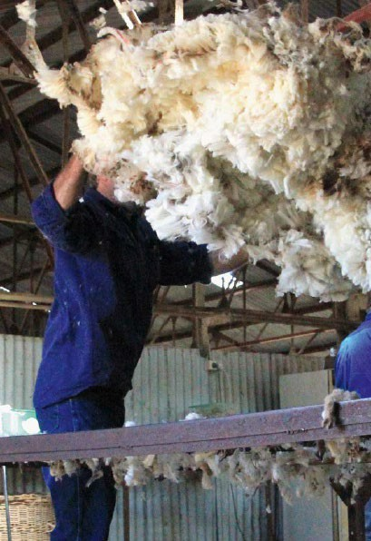
Image 4.6.1 Sheep Shearing

Explore the Defining Moments – Merino Sheep Introduced from the National Museum Australia and learn about the history of Australia’s wool industry.
Complete these questions:
- When sheep were first introduced to Australia where were they from?
- Describe the challenges the wool industry has faced over the past 200 years?

Wool production today
According to the Department of Agriculture, Water and the Environment:
“Australia is one of the world’s largest wool producers, producing around 25 per cent of greasy wool sold on the world market. The value of Australian wool exports in 2016-17 is estimated to be around $3.615 billion; this reflects the continuing strong global demand for Australia’s wool, which is regarded as among the world’s best.”
The Department of Primary Industries and Regional Development (DPIRD) states in the Western Australia’s Agrifood, Fibre, Fisheries and Forestry Industries 2018 document that:
      - There are around 14.2 million sheep and lambs in Western Australia, including 7.6 million breeding ewes run by 4500 sheep producers.
      - The breeding ewe population is made up of 81% merino ewes, reflecting the importance of the wool enterprise to the state’s sheep industry.
      - More than 95% of wool production in Western Australia is merino wool measuring less than
24.5 micron. Super fine wool (under 19.5 micron) accounted for 41% of Western Australian wool production in 2016/17.
      - The value of wool production in Western Australia was $826 million in 2016/17, a year-on- year increase of 25%.
      - The Western Australian wool clip is exported or transported interstate for processing. Western Australia’s major wool markets in 2016/17 were mainland China (83%), India (8%) and the Czech Republic (4%).

      - Western Australia remains internationally cost competitive in wool production, handling and delivery. The local sheep industry maintains world-class animal health and welfare standards.

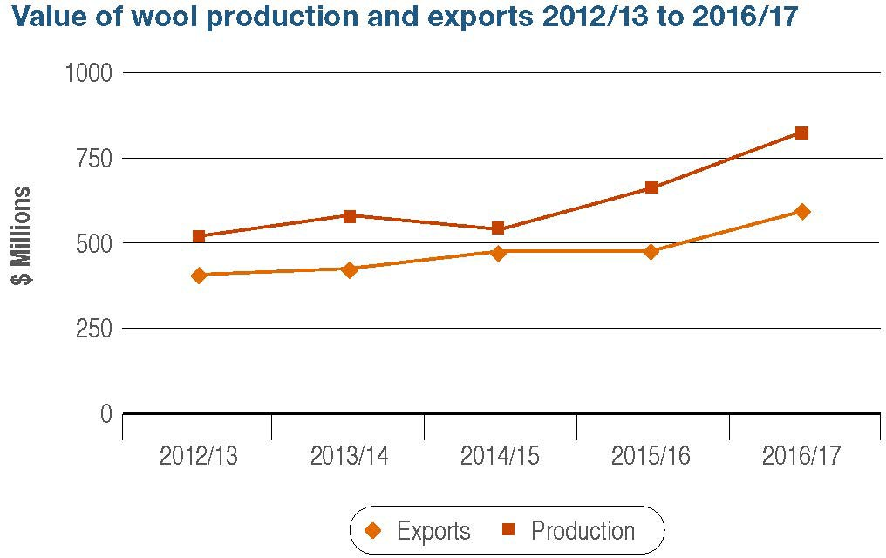

Image 4.6.2 Value of wool production and exports 2012/213 to 2016/17
- What is the value of WA’s wool industry?
- Which are the three largest export markets for WA wool?
- Research Wool processing innovation and describe the new products being produced using wool.
- Describe the features of wool which makes it such a versatile fibre.

Fibre production research and development in WA
In recent years the amount of industrial hemp and cotton grown in WA has increased. Trials of both have been conducted by DPIRD. These crops require irrigated cropping systems and trials have been successful in the Ord River Irrigation Area (ORIA).

Industrial hemp
The approval of low-THC hemp seed products to be used as a food additive by Food Standards Australia and New Zealand (FSANZ) in November 2017 has opened up opportunities for the developing hemp industry.
Industrial hemp is a versatile crop which can be grown for both food (seed production) and fibre. Fibre can be extracted from the stem, and seeds can be hulled and eaten, or pressed for omega-rich oil and protein-rich powder.

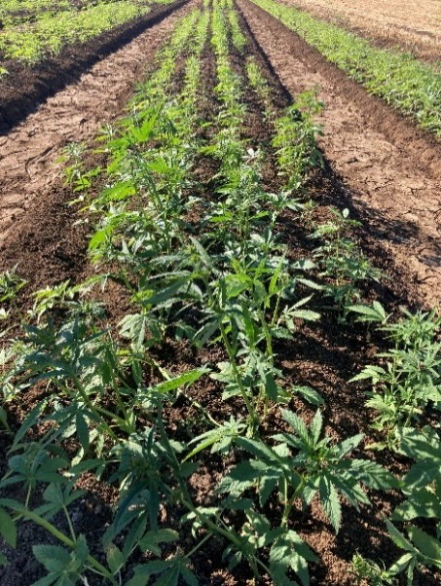

Image 4.6.3 Industrial Hemp Trail

Opportunities for hemp products include:

      - textiles
      - rope
      - animal bedding
      - building materials
      - oil and food.

The Department of Primary Industries and Regional Development acts as the registrar for the Industrial Hemp Act 2004. This legislation enables licensees to cultivate, harvest and process industrial hemp on a commercial scale.

Cotton

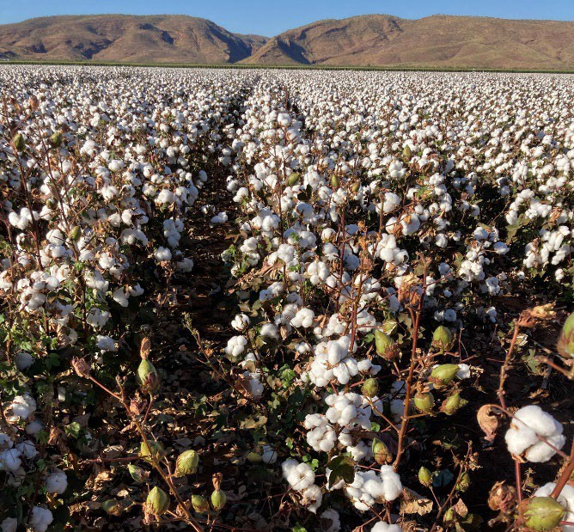
Cotton was first commercially grown in the Ord River Irrigation Area between 1964 and 1974. Production was not successful due to an inability to control major pest damage, resulting in poor yields.
Research into better farming systems and pest resistant genetically modified (GM) varieties of cotton began in 1996. In 2016, GM cotton variety, Bollgard 3® was registered for use in Australia and has reinspired the potential of cotton growing in WA.
Limitations of growing cotton in the ORIA is the lack of processing infrastructure in the area. Currently cotton grown in WA has to be transported to New South Wales for processing at a gin. The Western Australian Government can see great potential in the
cotton industry in the ORIA and are committing funds to establish a cotton gin in the Kimberley. Read the media

Image 4.6.4 Ord River Cotton

statement Kimberley cotton gin one step closer to reality to find out more.
Image 4

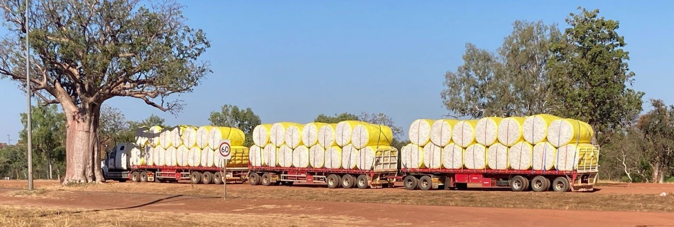
Image 4.6.5 Ord River cotton ready for transport

WATCH: The Ginning Process

- List and describe the five stages in the ginning process.

Global future fibre production
The Food and Agriculture Organisation of the United Nations (FAO) has identified four natural fibres which could meet the growing consumer demand for sustainable, ethical and economic demands for natural fibres.
Read Why fibres of the future?

      - Summarise the driving trends which are steering the market away from synthetic fibres to natural fibres.

The textiles industry is always evolving, and sustainably conscious consumers are creating a demand for alternative textile products.
Select one of the four fibres identified by the FAO (Abaca, Coir, Sisal, Jute) to research and complete the table below.
Read Food waste to fashion: 9 Sustainable fabrics that could help save the planet, select one of the textile items to research and complete the table below.

Fibre/Textile name
Where is it produced?
How is it produced?
What is the textile used for?
How is it environmentally sustainable?
How is it economically viable?

As a consumer, do you ever look at your clothing labels to see what fibres were used to make what you are buying?
Do you ever consider the country of origin of your clothes?

What can we do as consumers to ensure our clothes are ethically and sustainably produced?

Acknowledgements
References
National Museum Australia (n.d) ‘Defining moments – Merino Sheep Introduced’ available at:
<https://www.nma.gov.au/defining-moments/resources/merino-sheep-introduced> accessed 6
September 2021
Department of Agriculture, Water and the Environment (16 October 2020) ‘Wool’ Australian Government available at; <https://www.agriculture.gov.au/ag-farm-food/meat-wool-dairy/wool> accessed 6 September 2021
Australian Wool Testing Authority (n.d) ‘Greasy Wool’ available at:
<https://www.awtawooltesting.com.au/index.php/en/resources/glossary-of-terms/greasy-wool> accessed 6 September 2021
Department of Primary Industries and Regional Development (27 November 2019) ‘Western Australia’s Agrifood, Fibre, Fisheries and Forestry Industries 2018’ Government of Western Australia available at: <https://www.agric.wa.gov.au/food-export-investment/western- australia%E2%80%99s-agrifood-fibre-fisheries-and-forestry-industries-2018> accessed 6
September 2021
Australian Wool Innovation Limited (n.d) ‘Wool Processing Innovation’ available at:
<https://www.wool.com/supply-chain/processing-innovation/> accessed 6 September 2021
Department of Primary Industries and Regional Development (15 July 2021) ‘Ord River development and irrigated agriculture, Western Australia’ Government of Western Australia available at: <https://www.agric.wa.gov.au/assessment-agricultural-expansion/ord-river- development-and-irrigated-agriculture-western-australia> accessed 15 September 2021
Government of Western Australia (15 September 2021) ‘Kimberley cotton gin one step closer to reality’ available at:
<https://www.mediastatements.wa.gov.au/Pages/McGowan/2021/09/Kimberley-cotton-gin-one- step-closer-to-reality.aspx> accessed 15 September 2021
Southern Cotton (19 February 2015) ‘The Ginning Process’, YouTube, available at:
<https://www.youtube.com/watch?v=hCAsg4iUkVQ> accessed 15 September 2021
Food and Agriculture Organization of the United Nations (2021) ‘Why Fibres of the Future?’ available at: <http://www.fao.org/economic/futurefibres/home/why/en/> accessed 15 September 2021
Kong, Joan (20 March 2017) ‘Food Waste to Fashion: 9 Sustainable fabrics that could help save the planet’ Buro available at: <https://www.buro247.my/fashion/buro-loves/sustainable-fabrics- recycled-food-waste-you-need.html> accessed 15 September 2021
Images
Image 4.6.1 ‘Sheep Shearing’ Department of Primary Industries and Regional Development (27 November 2019) ‘Western Australia’s Agrifood, Fibre, Fisheries and Forestry Industries 2018’ Government of Western Australia available at: <https://www.agric.wa.gov.au/food-export- investment/western-australia%E2%80%99s-agrifood-fibre-fisheries-and-forestry-industries-2018> accessed 6 October 2021
Image 4.6.2 ‘Value of wool production and exports 2012/213 to 2016/17’ Department of Primary Industries and Regional Development (27 November 2019) ‘Western Australia’s Agrifood, Fibre, Fisheries and Forestry Industries 2018’ Government of Western Australia available at:

<https://www.agric.wa.gov.au/food-export-investment/western-australia%E2%80%99s-agrifood- fibre-fisheries-and-forestry-industries-2018> accessed 6 October 2021
Image 4.6.3 ‘Industrial Hemp Trail’ Department of Primary Industries and Regional Development (27 November 2019) ‘Western Australia’s Agrifood, Fibre, Fisheries and Forestry Industries 2018’ Government of Western Australia available at: <https://www.agric.wa.gov.au/food-export- investment/western-australia%E2%80%99s-agrifood-fibre-fisheries-and-forestry-industries-2018> accessed 6 October 2021
Image 4.6.4 ‘Ord River Cotton’ by the Department of Education

Image 4.6.5 ‘Ord River cotton ready for transport’ by the Department of Education

Student worksheet 4.7

Agricultural systems
A farm, like many businesses, can be classified as a system; a series of interconnected components that are linked and rely on each other to function.

Inputs |  | Processes |  | Outputs
Physical  Human | Human  Labour | Arable | Pastoral | Crops
 |  | Ploughing | Grazing | Animals
Soil | Market demand | Harvesting | Sharing | Animal products
Seed
 | Cost of land | Weeding | Milking
Livestock
Water | Knowledge and understanding | Pest control | Breeding

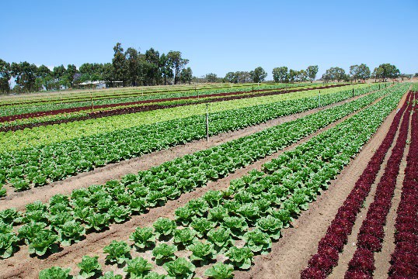
Agriculture plays a vital role in Australia, contributing to our economic, social and environmental sustainability. To achieve optimum productivity, a farm must balance economic, social and environmental factors.

What do you know?
List the types of agriculture you know are practiced in Western Australia (WA).

Image 4.7.1 Vegetables in Western Australia

What questions do you have about farming/agricultural practices in WA?

Classifications of agricultural practices
Throughout Australia, there are many different ways of practicing agriculture, from intensive to extensive farming, from commercial to subsistence farming.
Conduct some research to define the following farming practices.

 | Define and explain | Provide a WA example
Intensive
Extensive
Irrigation
Aquaculture
Pastoral
Arable
Commercial
Subsistence
Wild caught or harvested

Are some of these practices more ethical or environmentally friendly than others? Explain any ethical or environmental concerns you have about any of these farming practices.

Ethical and sustainable agricultural practices
Agricultural practices are ever evolving and to ensure they remain competitive and productive farmers must continue to adapt their farming practices to meet the demand of consumers.
Changes in customers buying decisions impacts the demand of the food and fibre grown by farmers.
According to the Ethical Foods: International situation Assessment, opportunities and threats report published by the Australian Government:
Drivers for ethical food consumption include:

− Better informed consumers
− Rising first world incomes
− Health concerns and
− The desire for a better world.

In more recent years, we have seen the increased demand from consumers for food and fibre commodities that have been produced sustainably using organic, biodynamic or regenerative agricultural practices. Explain these practices below.
Organic

Biodynamic

Regenerative

What would you say if a person asked you which of these three agricultural practices you believe is the best?

Discuss with a group: What do people think about when making choices about the food and fibre products they buy?
- Develop a list of criteria that summaries the factors people might consider when purchasing produce at a shop.

Certification

Image 4.7.2 Certified label
As the demand for ethical food and fibre products by consumers has increased, the need to regulate the food labelling of products has evolved.
We can now see many claims on the labels of the products we purchase, but what do they mean and can we assure they are accurate?
Certifiers can licence their logo or trademark to businesses that meet given
standards, thereby confirming that products bearing the mark possess the marketed attributes. These can include qualities such as:
- nutrition (eg National Heart Foundation tick of approval)
- product origin (eg 'Australian Made Australian Grown')
- environmental sustainability (eg dolphin-friendly tuna)
- animal welfare (eg RSPCA approved)
- compatibility with religious belief systems (eg halal, kosher)
- dietary choice (eg organic)
- ethical sourcing (eg fair trade)

Food Standards Australian and New Zealand and Australian Competition & Consumer Commission are the peak bodies that work towards ensuring no false or misleading information is allowed on the packaging and labelling of products in Australia. Often certification claims/labels are regulated by third parties/private companies and while each type of certification does have set criteria of eligibility, they are not legal regulations.

Have you seen other claims on product labels you have purchased?

Do you agree or disagree that claims on labels should be regulated by the government?

Certification investigation
Investigate the RSPCA’s Approved Farming program.

      - Explain what this certification is.

      - Outline what the assessment process includes. What impact do you think this has on the farmer?

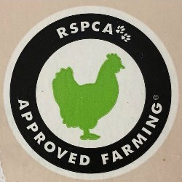
Image 4.7.3 RSPCA
approved farming

      - Summarise the welfare standards for each of the RSPCA approved animals.

Layer Hens
Pigs
Chickens
Turkeys
Salmon
Dairy Calves

- Why do you think some people would only purchase RSPCA Approved products?
- Do you think RSPCA approved means free range? Explain.
- Why doesn’t the RSPCA Approval scheme include cattle and sheep?

What do you think?

WATCH: Delish - Linley Valley Pork

What are your thoughts and feelings about the pig farm shown in this video?
WATCH: Inside China's 'hog hotel'

What are your thoughts and feelings about the pig farm shown in this video?

Collect the evidence:

 | Advantages | Disadvantages
Linley Valley
Hog Hotel

Acknowledgements
References
Australian Competition & Consumer Commission (n.d) ‘Advertising and selling guide’ available at:
<https://www.accc.gov.au/publications/advertising-selling/advertising-and-selling- guide/introduction> accessed 17 September 2021
RSPCA (2021) ‘RSPCA’s Approved Farming’ available at: <https://rspcaapproved.org.au/> accessed 17 September 2021
Delish Hotel (9 July 2017) ‘Delish – Linley Valley Pork’, YouTube, available at:
<https://www.youtube.com/watch?v=is7xlltv4wE> accessed 17 September 2021

South China Morning Post (16 May 2018) ‘Inside China’s “Hog Hotel”’ available at:
<https://www.youtube.com/watch?v=liM4QzSFEEA> accessed 17 September 2021

Images
Image 4.7.1 ‘Vegetables in Western Australia’ Department of Primary Industries and Regional Development (2019) < https://www.agric.wa.gov.au/vegetables/vegetables-western-australia > accessed 17 September 2021
Image 4.7.2 ‘Certified Label’ Brandon Connel (n.d) <https://www.pexels.com/vi-vn/anh/con-tem-gi- i-th-ng-on-t-p-ph-m-ch-t-3259836/> accessed 17 September 2021
Image 4.7.3 CC BY-NC-ND 4.0 ‘RSPCA Approved Farming’ (2021) RSPCA
<https://kb.rspca.org.au/knowledge-base/where-can-i-buy-rspca-approved-chicken-eggs-pork-and- turkey/> accessed 17 September 2021

Student worksheet 4.8

Emerging markets for Australian bushfoods
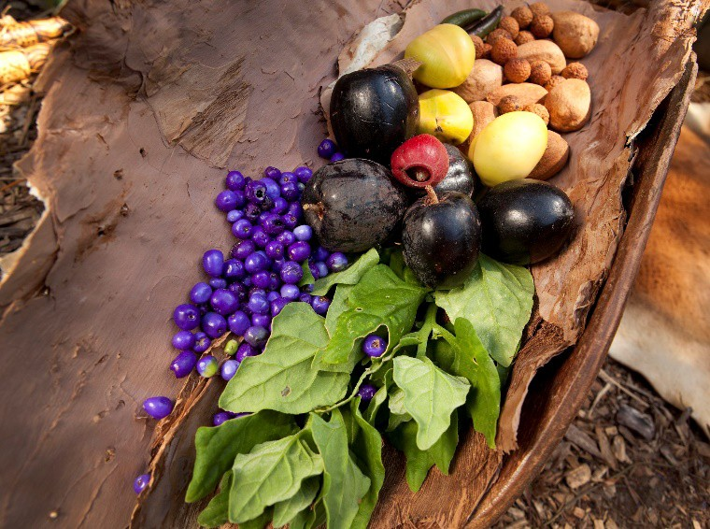
The bushfood industry includes products from native Australian plant and animal species. Since the 1980s, there has been a slow but steady increase in the global demand for Australian bushfoods. There have been difficulties to commercialise bushfoods because they are ‘new’ crops (in terms of commercial production) and don’t have the benefit of existing established production systems, skills, knowledge and reliable
plant material. They have also been difficult to commercialise in the marketplace because they are innovative products without an established market or general consumer knowledge. Many bushfoods that are sold commercially rely on wild catch/harvest rather than farmed supplies.

Do you know?
List the names of any bushfoods that you know.
Image 4.8.1 Bush tucker
While native plants and animals thrive in the Australian climate and conditions, very few opportunities have emerged for the commercial growth of bushfoods. Clearing of natural bush lands for commercial agriculture has reduced the amount of land available for native plants and animals. Today, we understand the value of our native bushlands and the government has regulations in place to protect the unique plants and animals of Western Australia (WA).

Emerging native bushfood production
Many people in WA are working hard to increase consumer awareness of bushfoods and support companies in the production of bushfoods for commercial sale, for example the Aboriginal Economic Development (AED) program within the Department of Primary Industries and Regional Development (DPIRD) aims to build local capacity and support new business and jobs for Aboriginal people through primary industries and strategic regional projects.

Examples of emerging bushfood production in WA

Salt bush

Moojepin Foods are using modern traditional horticultural knowledge and innovative technologies to grow saltbush for human consumption. More information can be found on the Katanning Landca re website.

Visit the Moojepin Foods website and list the types of salt bush they are growing.
Watch the interview under the Our Vision tab on the website.

Explain the economic, environmental and social advantages this project has for farmers and the local community.

Wattleseed

Commonly recognised by its yellow bloom during the Noongar season of Djilba (August – September), the wattle tree produces a seed which was traditionally ground and used to make a type of flour. Today, Wattleseed is dried and roasted, similar to coffee, and then ground and crushed to create a powder. It is very versatile and has a nutty, chocolaty flavour.

WATCH Destinations WA – Roelands Village and READ the article Bush food strong demand helps curb Indigenous unemployment in WA's South West
Explain the economic, environmental and social advantages this project has for the local community.

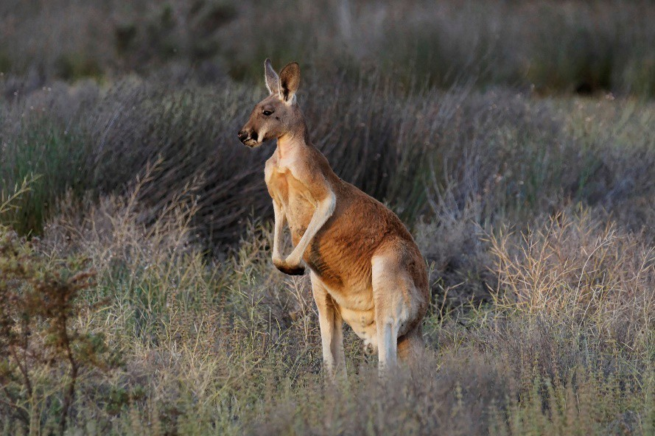
Kangaroo meat

Have you eaten kangaroo? Would you like to try it?

According to AgriFutures Australia, Australia’s commercial kangaroo harvest industry is one of the most sustainable wild harvest operations in the world.
AgriFutures facilitates a Kangaroo Program which focuses on research, development and extension (RD&E) projects that will benefit the industry.

Define the term wild harvest.
Image 4.8.2 Red Kangaroo

The Australian kangaroo industry currently harvests four species for commercial export:

      - Red Kangaroo
      - Eastern Grey Kangaroo
      - Western Grey
      - Common Wallaroo or Euro

All these species are common, and none are listed as threatened species.

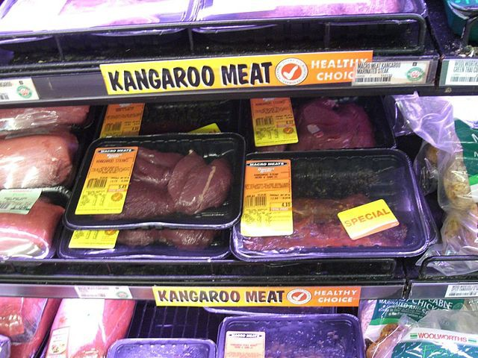
The wild harvest kangaroo industry is highly regulated and operates under a quota system, which is administered by state and federal governments. Limits are set to ensure sustainability of the industry as well as animal welfare. All ‘harvesters’ must be accredited and licenced by state government and must operate under strict hygiene and animal welfare practices. A large proportion of human consumption kangaroo meat is exported to 55 countries around the

Image 4.8.3 Kangaroo meat
world.

Use the AgriFutures Kangaroo and Department of Agriculture Exporting kangaroo meat websites to research the Australian kangaroo meat industry and compare the Positive, Minuses and Interesting points about the environmental impact, economic value, ethical considerations and the nutritional value on kangaroo harvesting.

PMI
 | Plus | Minus | Interesting
Environmental impact
Economic value
Ethical considerations
Nutritional value

Why do you think some people don’t like the idea of eating kangaroo meat compared to other animal products?
Should more kangaroo meat be consumed in Australia? Justify your answer by providing examples and explaining your argument.

Find out more about WA bushfoods
Conduct a Webquest and discover more about the people working to provide
bushfood products and experiences in WA.
Select one company that is working in this space and create a flyer that promotes their work/business.
Your flyer should include:

- business name
- summary of their purpose, the services and products they provide
- who is behind the company; introduce the people working in the business
- explain how the business uses bushfoods
- ensure the flyer is presented professionally including images, clear titles and text.

Acknowledgements

References
Department of Primary Industries and Regional Development (n.d) ‘Aboriginal Economic Development’ Government of Western Australia available at:
<https://www.agric.wa.gov.au/aboriginal-business-development-0> accessed 13 September 2021

Katanning Landcare (n.d) ‘National Landcare Program Bush Tucker Project’ available at:
<https://katanninglandcare.org.au/nlpbushtucker/> accessed 13 September 2021

Moojepins Foods (n.d) ‘Growing Native Saline Foods Western Australia’ available at:
<https://www.moojepinfoods.com/> accessed 13 September 2021

Destination WA (4 February 2019) ‘Destination WA – Roelands Village’, Youtube, available at:
<https://www.youtube.com/watch?v=l2WNJ3krFu4&t=2s> accessed 13 September 2021

Lynch, Jaqueline and Pancia, Anthony (22 November 2020) ‘Bush food strong demand helps curb Indigenous unemployment in WA’s South West’ ABC available at:
<https://www.abc.net.au/news/2020-11-22/bush-food-demand-helps-curb-indigenous- unemployment/12896372> accessed 13 September 2021
AgriFutures Australia (n.d) ‘AgriFutures Kangaroo’ available at:
<https://www.agrifutures.com.au/rural-industries/kangaroo/> accessed 13 September 2021

Department of Agriculture, Water and the Environment (1 December 2020) ‘Exporting kangaroo meat’ Australian Government available at: <https://www.agriculture.gov.au/export/controlled- goods/kangaroo> accessed 13 September 2021

Images
    - ‘Bush tucker’ by Royal Botanic Garden Sydney, Licensed CC BY-NC-ND 2.0, available at < https://www.flickr.com/photos/botanic-gardens-sydney/37581368371/in/photostream/ >
    - ‘Red kangaroo ( Macropus rufus)’ by Darryl Kirby, Licensed CC BY-NC-SA 2.0, available at
<https://www.flickr.com/photos/darrylkirbyimages/34502056764 >

    - ‘Kangaroo meat’, Licensed CC BY-SA 3.0, available at < https://commons.wikimedia.org/wiki/File:Kangaroo_meat_supermarket.JPG >

Student worksheet 6.1 Reflection

Image 6.1.1 Customer rating
Reflect on what you have learnt throughout this unit of work.

      - Why is it important that we know about the challenges facing future food and fibre production?

      - Identify the people/organisations who are working towards providing a better future. Provide examples of projects that are working towards sustainable food and fibre production.

3. Time to think about the future!

This concept is called futuring. A futurist is a person who actively explores predictions and possibilities about the future based on current trends.
What will food and fibre production look like in the future?

Prepare an academic scrapbook of images and ideas that summarises your understandings of future food and fibre production. You can view an example and explanation of an academic scrapbook at Academic Digital Scrapbooking.

- Go back to Student worksheet 1.1 and review the image collage you created about future food and fibre.
How does your original image collage compare to your final scrapbook page?

What additional knowledge have you gained about the challenges we face with future food and fibre production?

What examples of emerging research and technology do you now know are being practiced in Western Australia?

- Considering what you now know about future food and fibre production, what future job opportunities do you think are available related to the agricultural industry?
Produce an infographic flyer which showcases the wide and varied types of jobs available in Australian agriculture.
The Job Outlook – Agriculture, Forestry, Fishing website will assist you if you need help identifying job opportunities

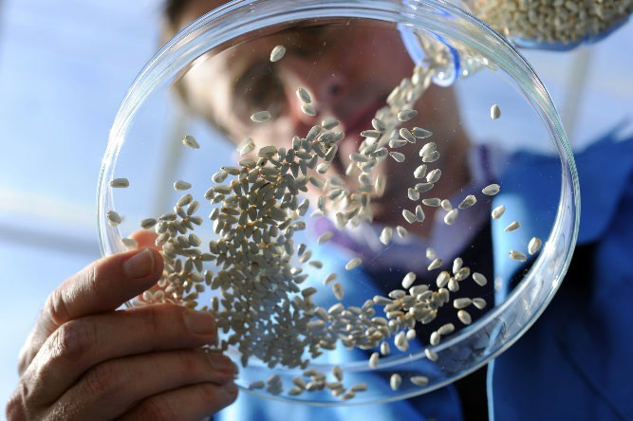
Image 6.1.2 Seed being poured into a petri dish
(©2021 DPIRD)

Acknowledgements

References
Encyclopedia.com (n.d) ‘Futuring’ available at: < https://www.encyclopedia.com/management/encyclopedias-almanacs-transcripts-and- maps/futuring > accessed on 21 June 2021
Macneil, Susan (15 October 2020) ‘Academic Digital Scrapbooking’ Profweb available at
<https://www.profweb.ca/en/publications/articles/academic-digital-scrapbooking,> accessed on 21 June 2021
Job Outlook – Agriculture, Forestry, Fishing

Images
Image 6.1.1 ‘Customer rating’ by Shari Jo from Pixabay, available at
<https://pixabay.com/illustrations/customer-review-customer-rating-4319316/>

Image 6.1.2 DPIRD, Available at < https://www.agric.wa.gov.au/grains-research- development/grains-industry-national-rde-strategy >

Student worksheet 6.2 Skills and attributes
Below are a list of desirable skills and attributes for employees. Circle which ones you think are
applicable to people working in the agriculture industry in Australia.

understand spoken information | observant | management
listen to others | care and respect for animals | adaptability
ask questions. | problem-solving | technology literate
speak clearly | sales skills | farm operations
analyse ideas | computer skills | teamwork
self-motivated | mechanical and repairing | interpersonal skills
use reasoning to discover answers to problems | interpersonal | versatility
interest in biology | interest in botany | interest in technology
follow guidelines | time management | organised
operate and control equipment | physical stamina | creativity
good communicator | manual labour | dependability
assertiveness | live/work in regional and remote areas | research skills
interest in food production | interest in science | mathematical skills
flexibility | live/work in the city | technical skills
leadership | drive heavy machinery | work with livestock
enjoy being outdoors | live/work overseas | finance/accounting
Marketing | promotion | work indoors

Reflect on the skills and attributes you have circled and write a statement that summarises the opportunities for people working in the agriculture industry.

