English | Year 9/10

2.1 Diversity and stereotype
____________________________________________________________________________________________________

Focus 12: Representations of people and culture

Lesson overview
In this lesson sequence, students will learn that simplistic representations of people and cultures leads to reductive thinking about others. Through analysis of Chimamanda Ngoze Adiche’s TED Talk ‘The Danger of a Single Story,’ they will understand the importance of diverse and multifaceted representations for a more inclusive society.

Teaching note
The activities are designed to take place over 2-4 lessons. Teachers may choose to condense or expand the activities, dependent on student needs and time constraints.

Cultural safety considerations
The cultural safety of Aboriginal and Torres Strait Islander students, and culturally and linguistically diverse (CaLD) students must be a priority when planning and delivering these lessons.
Teachers are expected to establish a learning environment that is culturally, psychologically, spiritually, physically, and emotionally safe for all students, particularly for Aboriginal and CaLD students. Culturally responsive teaching practices should aim to create the conditions for students, staff, and families to experience cultural safety in schools and remove and minimise harmful experiences, such as racism in all its forms. Teachers should remain mindful of assumptions, stereotypes and unconscious biases and apply strategies to mitigate them.
Engaging in meaningful teaching and learning about multiculturalism and anti-racism requires teachers to create the conditions for cultural safety in the planning, delivery and assessment of lessons. This includes:
- knowing students’ cultural backgrounds and understanding how this may be relevant to (or impact) the learning environment
- letting students and families know about the planned content and resources in advance so that they can prepare for the learning, and contribute where safe to do so
- knowing any cultural protocols in advance that may impact the lesson (for example, using a disclaimer at the start of a film about people who may have passed away)
- knowing the sensitive language that may cause harm (for example, removing racial slurs or hate speech in films)
- not assuming that students or staff will want to share their cultural backgrounds and lived experiences with their peers during the lesson
- not calling on students during lessons without warning about content that has the potential to make them feel uncomfortable or singled out
- allowing for students, staff and families to provide input and feedback when they feel cultural safety in the planning, delivery and evaluation of lessons
- where possible, checking in with students and seeking their feedback on the activities and learning, if they feel culturally safe to do so.

Curriculum content
Year 9 | Year 10
Literacy: Texts in context
Analyse how representations of people, places, events and concepts relate to contexts  WA9ELYT1 | Analyse and evaluate how people, places, events and concepts are represented in texts and relate to contexts WA10ELYT1
Literacy: Analysing, interpreting and evaluating
Analyse the use of text structures within paragraphs and extended texts, and evaluate their impact on ideas and meaning WA9ELYA2 | Analyse and evaluate how authors and creators use text structures to organise ideas and achieve a purpose WA10ELYA2

Learning intention
Students are learning the limitations of stereotypes and their representations of people and culture.
Success criteria
Students will:
- explain why stereotypes can be a limiting representation of people or culture
- discuss and evaluate the key messages of speech and how they resonate today
- identify structural features and rhetorical devices in texts
- analyse the use of these features and devices to understand their effect on the audience
- reflect on and articulate the impact of stereotyping in their daily lives through written or verbal responses.

Key terminology
- Assumption - something you believe to be true without having all the facts.
- Culture - the characteristics and knowledge of a particular group of people, encompassing shared values, beliefs, expectations, attitudes, assumptions and norms formed through similar experiences. Culture is not just about ethnicity. It is dynamic and constantly changing. It is the shared system of learned and shared values, beliefs and rules of conduct that make people behave in a certain way. It is a process for perceiving, believing, evaluating and acting. It is a lens through which we view the world.
- Discrimination - treating someone unfairly because of their race, gender, religion, or other personal characteristics.
- Diversity - encompasses the range of visible and invisible attributes, experiences and identities that shape each individual. Diversity includes all human differences including but not limited to ethnicity, sex, gender, gender identity, sexual orientation, age, social class, physical ability or attributes, religious or ethical values system and national origin.
- Identity - a person’s conception and expression of individuality or group affiliation, self-concept and self-representation. Identity is closely connected to both culture and language. Thinking and talking about the self is influenced by the cultural frames, which are offered by different languages and cultural systems. Identity is not fixed. Second language learners’ experience with different linguistic and cultural systems introduces them to alternative ways of considering the nature and the possibilities associated with identity.
- Multifaceted - having many different sides, features, or aspects.
- Prejudice - a negative opinion about someone or something that is formed without enough knowledge or experience.
- Reductive - oversimplifying something so much that important details are lost.
- Representation - representation refers to the way people, events, issues or subjects are presented in a text. The term implies that texts are not mirrors of the real world; texts are constructions of reality in the sense that they re-present aspects of the world. These constructions are partially shaped through the writer’s use of conventions and techniques.
- Stereotype - when a person or thing is judged to be the same as all others of its type. Stereotypes are usually formulaic and oversimplified.

Suggested discussion
These are examples of questions that will be used throughout the activities. Select those that are appropriate to the context of your students and school.
- What is identity? How would you describe your own identity? What makes it unique?
- What is diversity? In what ways do you see diversity in your community or school? How does this diversity enrich our lives?
- What is culture? How do we define culture?
- Why is it important to recognize and challenge stereotypes? How can doing so create a more inclusive environment?
- How do perceptions and stereotypes affect the way people from other cultures are viewed and treated?
- What influence does stereotyping have on discrimination and prejudice against particular groups?
- Why does representation of diverse voices matter?

Activity 1: Concept introduction
Assumptions of people, places or events may be inaccurate or unreliable because they are based on limited information.

Resources required:
- Appendix Resource #1 Incomplete pictures
- Appendix Resource #2 Incomplete pictures revealed.

- Choose one of the following approaches to introduce the concept of a single story, according to the context of your students and school.
- Distribute or project Resource #1, a series of incomplete pictures that have a small portion showing. Ask students to individually examine and describe what each image is a picture of.
- Distribute or project the Resource #2, revealing the full images so they can check the accuracy of their guesses.
- Whole class discussion:
- Why was it difficult to accurately describe each picture?
- How accurate were your guesses?
- What is the problem with making assumptions when you only have a small piece of information?

Activity 2: The Danger of a Single Story
Danger of a Single Story is a 19-minute TED Talk presented by Chimamanda Ngoze Adiche. It communicates the idea that a single narrative about a person, culture, or country can lead to misunderstanding, stereotypes, and a limited perspective.
Resources required:
- Student access to Danger of a Single Story (19-minute TED talk)
- Appendix Resource #3 Viewing comprehension.

- Distribute Resource #3 to students and direct students to complete the pre-viewing questions. Discuss and explicitly define the terms stereotype and identity (Key terminology).

- Play The Danger of a Single Story for students and instruct them to complete the viewing questions as they watch.
- It is advised that the TED Talk, is played with subtitles to support students with diverse learning needs.
- Discuss the main ideas and messages in the TED Talk after viewing. Teachers may like to list the speaker’s main points on the board and/or discuss the answers to the viewing questions on the worksheet.

- Complete a check for student understanding of the key ideas and messages.
- Instruct students to answer the post-viewing questions.
- Discuss student responses.

Activity 3: Analysing the structures and language features of the Danger of a Single Story

Resources required:
- Student access to The Danger of a Single Story transcript
- Appendix Resource #4 Language and structural features matching activity
- Appendix Resource #5 Language and structural features matching activity – Examples.

- Explicitly teach/revise the concept of structural features; this may be taught as the way in which a text is organised and put together.

- Provide students with individual copies of Resource #4 and ensure they have access to The Danger of a Single Story transcript. Direct students to complete the matching exercise worksheet through a gradual release of responsibility.
- Model how to identify and locate relevant examples of a structural feature that may be quite difficult for students.
  - Resource #5 is a teacher resource with examples. Contrasts are when the speaker highlights differences between 2 ideas or ‘things’, i.e. in number 8 “Adichie differentiates the single story of Africa as a place of catastrophe with the reality of its diverse cultures and experiences.”
  - This contrasts people’s idea of Africa (a singular disaster) with another reality (it has diverse cultures and experiences – not all bad or dysfunctional).
- Work with students on another feature, checking that they understand how to use the definitions to help them to locate the relevant example. Clarify the definitions where required.
- Allow students to work in pairs to complete the remainder of the sheet, also considering the intended effect of each specific example on the audience.
- Place students into small groups to compare their answers.

- Facilitate a discussion, and ask:
- which techniques were most effective in challenging your thinking about the kinds of stories we tell about social and cultural groups and how these impact others?

Activity 4: Applying a single story to Australian identity
Explore stereotypes and reframe them to create multifaceted representations of Australian identity.

Resources required:
- Appendix Resource #6 Australian stereotypes - the whole story.

- Show students the first image in Resource #6 of a typical Aussie surfer. Guide the class through the ‘single story’ that is often presented about this kind of stereotype – in this case, that all surfers are laid-back, carefree, happy and connected to nature.
- Then guide students through the ‘whole story’ which presents him with multidimensional character and challenges pre-existing notions about Australian masculinity and surfers (i.e. he is a city kid, he has struggled with his mental health, he has felt isolated, he is academic and wants to join the medical field).

- Split class into small groups and provide each group with Resource #6. Ask students to discuss the following questions within their group:
- What stereotype do the images show?
- What ‘single stories’ are being told?
- What other stories might be behind this image?
- Which stereotypical traits can we challenge?

- Students should then write down the ‘single story’ and ‘whole story’ for their assigned image/stereotype in dot points.
- Direct students to choose one ‘whole story’ and complete an extended, persuasive writing task which incorporates their answers from Resource #6, and persuasive language features explored in Adiche’s TED Talk.
- They should collaboratively write a short persuasive speech in the voice of their Australian that convinces people to look beyond traditional national stereotypes and embraces a more complete story of Australian identity.
- Scaffold for students:
  - Hook: start with a striking statement, anecdote or rhetorical question
    - People always say surfers are just laid-back beach bums, always chasing the next perfect wave, living a carefree life under the sun. But that’s only part of the story.
  - Challenge the stereotype: explain why it is incomplete or misleading
    - That single story paints us as nothing more than happy-go-lucky wave riders, but the reality is much richer - and sometimes darker. I’m a city kid, battling my own storms off the shore, including mental health struggles and feelings of isolation.
  - Present your version: give vivid, specific examples
    - Surfing isn’t just sunshine and salty hair; it’s my escape, my therapy, the rhythm that keeps me steady when life gets rough. I’m studying hard, determined to become a doctor—someone who helps others heal, just like the ocean helps me heal. So yes, I’m a surfer, but I’m also a thinker, a struggler, and a fighter.
  - Call to action: tell the audience what they should think, feel, or do differently
    - Before you decide what a surfer—or an Australian—is, don’t settle for the single, simple story. Look beneath the waves. See the full picture. Real people, real struggles, real dreams. Let’s challenge the stereotype, embrace the complexity, and celebrate the true diversity of Australian identity.
- Remind students to incorporate the persuasive language features examined in Adiche’s TED Talk to help convince their audience.

Note: This is designed to be a short task with speedy output from students. Once sufficient time has been given to complete a short speech, groups can select an orator to deliver their speech to the class.

Reflection
End the lesson with one of the following activities:
- Return to the ‘incomplete pictures’ activity. For instance, if you chose Option 2, ask students to write down as much information about themselves as they can. Ask them to swap with a partner again and read out the information. Discuss how a multifaceted representation is much more accurate than a single fact or story. Connect a single fact about someone to the reductive nature of stereotypes.
- Encourage students to apply the message of the TED Talk to their own lives by posing the following questions and encouraging them to complete as a journal reflection:
  - Can you think of a time when you believed in a single story about a person or culture?
  - How did your perspective change after learning more?
  - How can learning about the dangers of single stories help us become more inclusive and understanding individuals?
- Reword some of the success criteria as questions and call on students to answer the questions.

Resource #1 Incomplete Pictures
- Display the 4 photographs below. Show these covered versions and ask students to guess what they think the picture is.
- At the end, reveal the pictures on the subsequent page. Check the accuracy of students’ answers and discuss. Ask students questions such as:
  - Why was it difficult? Were your guesses accurate? Why or why not? What is the problem about making assumptions when you only have a small piece of information?



Resource #2 Incomplete pictures revealed


Resource #3 Viewing comprehension

Pre-Viewing Questions
What is identity? How would you describe your own identity? What makes it unique?

What is a stereotype? Are stereotypes problematic?

Viewing Questions – Focus on content and structure
Who is Chimamanda Ngozi Adichie, and what is her background?

What does Chimamanda Ngozi Adichie mean by "a single story," and how does it impact our understanding of people and cultures?

What examples does Adichie provide of single stories she encountered in her life, and how did these single stories affect her perception of others and how others perceived her?

The speaker states: “The problem with stereotypes is not that they are inaccurate, but that they are incomplete.” Discuss what you think this means.

According to Adichie, what are the consequences of believing in a single story, and how can single stories contribute to stereotypes and misunderstandings?

Post-Viewing questions and evaluation
Chimamanda Ngozi Adichie delivered this TED Talk in 2009. Is it still relevant and resonant? Why or why not?

Resource #4 Language and structural features glossary matching activity
Using the examples provided on the next page, categorise them according to their language/structural feature.
Consider the specific effect of these language features and structural features on the audience.
Feature | Definition | Example from The Danger of a Single Story | Effect
Anecdotes | A short personal story used to illustrate a point
Repetition | Repeating words or phrases for emphasis
Contrast | Highlighting differences between  two ideas or things
Chronological  Structure | Organising content in the order of time
Circular Structure | Ending the speech by referring back to the beginning
Climax | Building up to the most important point
Humour | Using jokes or amusing anecdotes to engage the audience
Imagery | Using descriptive language to create vivid pictures

Resource #5 Language and structural features glossary matching activity - Examples

Examples from The Danger of a Single Story
1. Adichie outlines her personal journey from childhood to adulthood, describing how her understanding of stories and stereotypes evolved over time. | 5. Adichie builds her argument by presenting smaller points about the impact of single stories, leading up to the main argument about the need for multiple stories.
2. Adichie continually uses the phrase "single story" to emphasise the dangers of a single narrative. | 6. Adichie challenges the single story of Africa as a place of catastrophe with the reality of its diverse cultures and experiences.
3. Adichie talks about her roommate's surprise that she could use a stove, which helps to engage the audience and make her point more relatable. | 7. Adichie describes the vibrant and bustling streets of Lagos, Nigeria, with its colourful markets, diverse people, and rich cultural heritage, challenging the single story of Africa as a place of poverty and despair.
4. Adichie starts and ends her speech with personal stories about her experiences with single stories, creating a sense of closure. | 8. Adichie shares her experience of reading British and American children's books and how they shaped her early writing.

Resource #6 Australian stereotypes - the whole story
 | My single story is…I am a classic Aussie surfer with a laid-back attitude, blonde hair, tanned skin and carefree lifestyle.  Here is the whole story…I am a city-kid who only started surfing in my late teens after a life-changing trip to Queensland. Surfing is more than a hobby, it helps me cope with anxiety and depression. I want to be a psychologist specialising in sport and mental wellbeing helping others to use surfing as a tool for healing and personal growth.
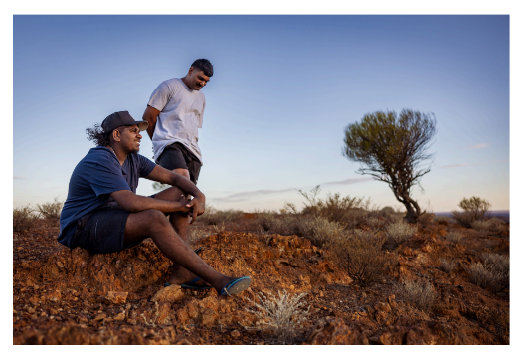 | Their single story is…  Here is the whole story…
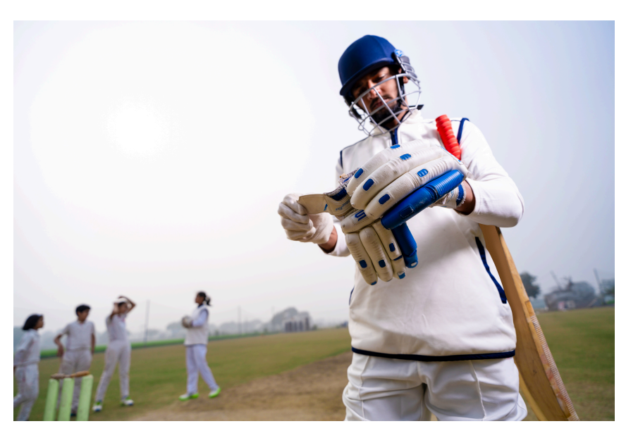 | My single story is…  Here is the whole story…
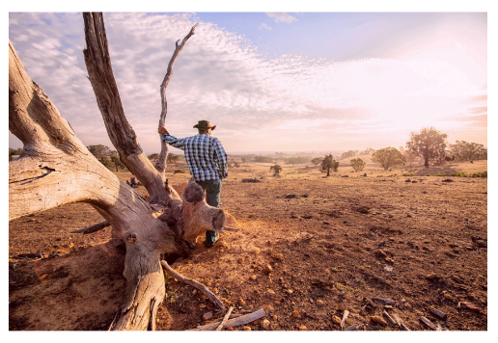 | My single story is…  Here is the whole story…
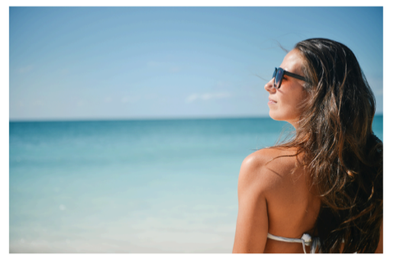 | My single story is…  Here is the whole story…
© Department of Education Western Australia 2025.This product has been generated or modified using artificial intelligence and to the extent that copyright subsists in it, the copyright is retained by the Department of Education Western Australia.

