English | Year 9/10

2.2 Challenging Perceptions – sense of belonging and cultural identity
____________________________________________________________________________________________________

Focus 14: Uncovering identity: erasing the past, revealing the present

Lesson overview
In this lesson sequence, students transform historical texts into original erasure poems to explore and assert contemporary themes of belonging and cultural identity in Australia, developing creative and critical thinking as they recontextualise language and engage with concepts of multiculturalism and inclusiveness.
Teaching note
These activities are designed to take place over 2-3 lessons. Teachers may choose to condense or expand the activities, dependent on student needs and time constraints.

Cultural safety considerations
The cultural safety of Aboriginal and Torres Strait Islander students, and culturally and linguistically diverse (CaLD) students must be a priority when planning and delivering these lessons.
Teachers are expected to establish a learning environment that is culturally, psychologically, spiritually, physically, and emotionally safe for all students, particularly for Aboriginal and CaLD students. Culturally responsive teaching practices should aim to create the conditions for students, staff, and families to experience cultural safety in schools and remove and minimise harmful experiences, such as racism in all its forms. Teachers should remain mindful of assumptions, stereotypes and unconscious biases and apply strategies to mitigate them.
Engaging in meaningful teaching and learning about multiculturalism and anti-racism requires teachers to create the conditions for cultural safety in the planning, delivery and assessment of lessons. This includes:
- knowing students’ cultural backgrounds and understanding how this may be relevant to (or impact) the learning environment
- letting students and families know about the planned content and resources in advance so that they can prepare for the learning, and contribute where safe to do so
- knowing any cultural protocols in advance that may impact the lesson (for example, using a disclaimer at the start of a film about people who may have passed away)
- knowing the sensitive language that may cause harm (for example, removing racial slurs or hate speech in films)
- not assuming that students or staff will want to share their cultural backgrounds and lived experiences with their peers during the lesson
- not calling on students during lessons without warning about content that has the potential to make them feel uncomfortable or singled out
- allowing for students, staff and families to provide input and feedback when they feel cultural safety in the planning, delivery and evaluation of lessons
- where possible, checking in with students and seeking their feedback on the activities and learning, if they feel culturally safe to do so.

Curriculum content
Year 9 | Year 10
Language: Language for interacting with others
Recognise how language empowers relationships and roles WA9ELAI1 | Understand how language can have inclusive and exclusive social effects, and can empower or disempower people WA10ELAI1
Language: Text structure organisation and features
Examine how authors and creators adapt text structures and language features by experimenting with spoken, written, visual and multimodal elements and their combination  WA9ELAT1 | Understand how paragraph structure can be varied to create cohesion, and paragraphs and visual features can be integrated for different purposes WA10ELAT2

Literature: Creating literature
Create and edit literary texts, which may be hybrid, that experiment with text structures, language features and literary devices for purposes and audiences WA9ELICR1 | Create and edit literary texts with a sustained ‘voice,’ selecting and adapting text structures, literary devices, and language, auditory and visual features for purposes and audiences  WA10ELICR1

Learning intention
Students will create erasure poetry from historical texts to assert contemporary themes of belonging and cultural identity in Australia.

Success criteria
Students will:
- create erasure poetry that recontextualises meaning
- select key language from an historical text and create meaningful connections between words
- evidence creative and critical thinking in their approach to transforming historical texts into original poetry.

Key terminology
- Belonging - feeling accepted, included, and connected as part of a group or community.
- Identity - a person’s conception and expression of individuality or group affiliation, self-concept and self-representation. Identity is closely connected to both culture and language. Thinking and talking about the self is influenced by the cultural frames, which are offered by different languages and cultural systems. Identity is not fixed. Second language learners’ experience with different linguistic and cultural systems introduces them to alternative ways of considering the nature and the possibilities associated with identity.
- Inclusion - occurs when people feel, and are, valued and respected regardless of their personal characteristic or circumstance, and where they:
- have the opportunity to fulfil their individual and combined potential
- have access to opportunities and resources
- can contribute their personal best in every encounter
- can contribute their perspectives and talents to improve their organisation
- can bring far more of themselves to their jobs
- have a sense of belonging.
- Multiculturalism - is a term used to describe the recognition of cultural and ethnic diversity. In Western Australia, it means all Western Australians are entitled to exercise their rights and participate fully in society, regardless of their different linguistic, religious, racial and ethnic backgrounds. Australia is a majority migrant nation and one of the most successful and cohesive multicultural societies in the world, building on over 60,000 years of First Nations culture. Culturally and linguistically diverse (CaLD) communities are integral to our vibrant society.
- Recontextualisation - taking something (like text or ideas) out of its original setting and placing it into a new context, which can change its meaning or how it is understood

Suggested discussion
- What does ‘multicultural national identity’ mean?
- How can poetry be used to challenge Australia’s racial history?
- Have you encountered any poems or artworks that challenged your perspectives on cultural identity or belonging?

Activity 1: Erasure poetry

Resources required:
- Appendix Resource #1 Erasure poetry examples.

- Discuss the concept of erasure poetry, a genre of Found Poetry created by erasing words from an existing text, leaving behind a new poem with new meanings.
- Explain that students will be attempting this genre of poetry to explore ideas about ‘belonging’ in contemporary Australia which support our multicultural identity as a nation.
- Show Resource #1 to the class and discuss the different techniques used, such as blackout, cross-out, patterns, collage and digital erasure.
  - State that the creation of erasure poems can be a process that is both poetic and visual.
  - The creation of erasure poems requires abstract thinking and a creative approach.

- Working in small groups, ask students to take a deeper look at some of the examples provided in Resource #1 and consider the following:
- What may have been the original text?
- What is being erased?
- What remains?

- Collate the insights through classroom discussion to further refine the concept of erasure poetry.

Activity 2: Jazz Money’s erasure poetry
How erasure poetry can challenge colonial narratives and reclaim power.

- Introduce poet Jazz Money, a Perth-born visual artist and poet Jazz Money
- She is a Wiradjuri poet and artist now based in Sydney who has published 2 books of poetry and regularly exhibits her written word art installations in prestigious Australian galleries.
- In 2023 she exhibited her project, ‘With Textual Consent’ where she applied pigments traditionally used in aboriginal artworks to erase words from 19th century texts in the Sandhurst Collection which contained problematic colonial content.

- Explain that Money recontextualises texts, which means she takes texts and adapts them into a new context (in her case, one that is more inclusive of Aboriginality and minorities) and subsequently changes their meaning.
- Show an example from With Textural Consent.
- Explain that Money engages in what she described to La Trobe University as "an excavation of the layers of colonial myth-making," meaning she ‘digs’ through historical texts and recontextualises selected language to create something new.
- These new poems honour her sense of belonging to her Aboriginal heritage and they work to create a new and more inclusive cultural identity for Australia.
- Ask students to discuss their thoughts on this work and why it is significant.
- Optional: Examine Jazz’s erasure work in her exhibition for Bathurst Regional Art Gallery, “Remains of context” (2003). These works recontextualise a newspaper article from 1824 reporting of a “state-sanctioned massacre” to “reveal alternative readings.”

Activity 3: Beginning to erase and recreate
Scaffolding the creation of erasure poems.

Resources required:
- Student access to ‘Alfred Deakin’ 1901 quote
- Appendix Resource #2 Excerpt from Speech Alfred Deakin, Attorney General TEACHER COPY.

- Inform students that they are going to create their first erasure poem. Project an excerpt from the second Prime Minister of Australia, Alfred Deakin.
  - Read the excerpt aloud and offer insight to its historical context. Explain to students that:
    - they are going to challenge the intended meaning of the original text.
    - this excerpt is from his 1901 speech shortly before the introduction of Australia’s Immigration Restriction Act.

- Ask students to identify words or phrases that would create a more inclusive multicultural Australian national identity within the quote, e.g. hand in hand, immigration, just, reasonable.
  - Encourage students to recognise unexpected connections between words, or combinations of words that are not next to each other.
- Provide students with their access to the quote, or facilitate as a whole class activity, ask students to ‘black out’ words that they do not want to include.
  - Once the class reaches a consensus, ask whether the text now conveys a message of inclusiveness? Is it reflective of our multicultural national identity?
  - Optional: Teacher may wish to demonstrate how the poem could be arranged using traditional poem structure, taking enjambment and punctuation choices into account.
  - Resource #2 is a teacher copy with examples.

Activity 4: Group work
Fostering confidence in the erasure poetry process.

Resources required:
- Student access to Prospectus for pro-White Australia policy publication 'Australia unlimited' | naa.gov.au.

- Explain that there is no ‘right’ way to create erasure poetry. Students need to trust their instincts and treat their base texts like a word puzzle to be solved.

- Organise students in small groups and provide each with access to one of the pages from the 1901 publication ‘Australia Unlimited: Prospectus for Pro-White Policy’.
  - Explain that this pamphlet was created within the context of the White Australia Policy which was created to promote White Australia policy.

- Ask students to work through the text using the same steps completed previously as a class to create an erasure poem. Their mission is to challenge the meaning of the original text and create a new text that promotes a sense of belonging and multicultural identity.
  - Provide appropriate time to refine ideas and create their erasure poems.
  - Once completed, direct groups to ‘tour’ the classroom and review each other’s poems, noting the selective choices made.

Activity 5: Individual creation of erasure poem

Resources required:
- Student access to Keep Australia white: Australia's song.
- Appendix Resource #1 Erasure poetry examples.

- Provide students with access to Keep Australia white: Australia's song.
  - Explain the context to students; this song was created as a mode of support for the White Australia Policy and the Immigration Restriction Act in the early 1900s.

- Direct students to apply the erasure process to draft an erasure poem of the song. They also need to:
  - choose a new title for their adapted poem.
  - work on artistic presentation of their erasure poems after drafting the words
    - Resource #1 could be used as inspiration.
  - provide a rationale, outlining some of their key creative choices (inclusions and erasures)
  - include an explanation of the intended meanings within their poem.
  - consider whether their poem now reflects multicultural ideologies in 2025.

Reflection
- How does erasure poetry relate to the concept of recontextualisation?
- In what ways can erasure poetry be used to critique or comment on society?
- What surprised you the most about the process of erasure poetry writing?

Resource #1 Erasure poetry examples
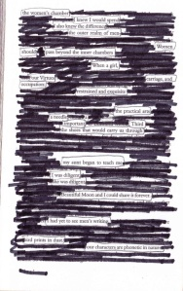 | 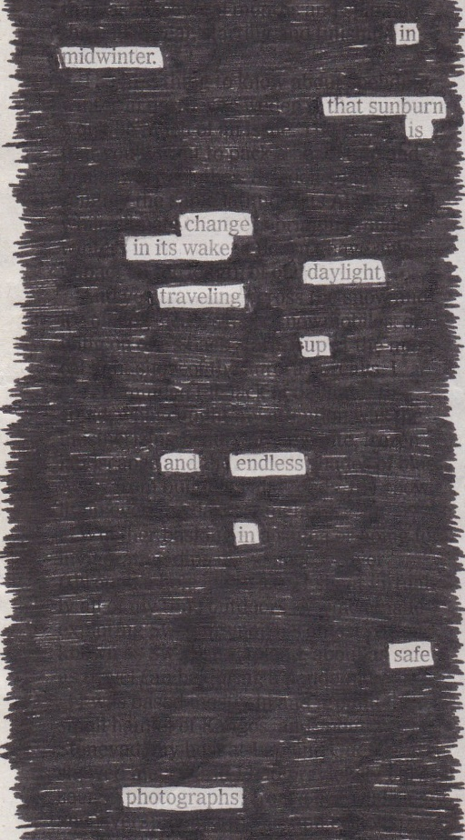
Eface, Explore, Expand: Erasure Poetry | HINGED | Erasure Poetry At Home - The New York Times
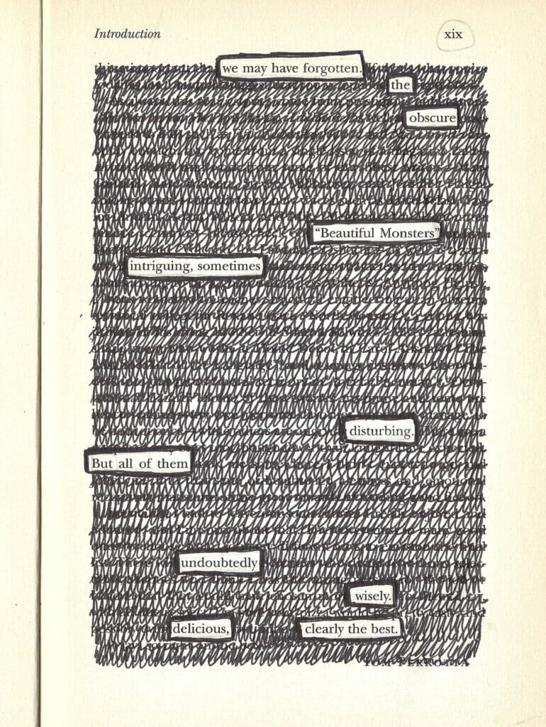 | 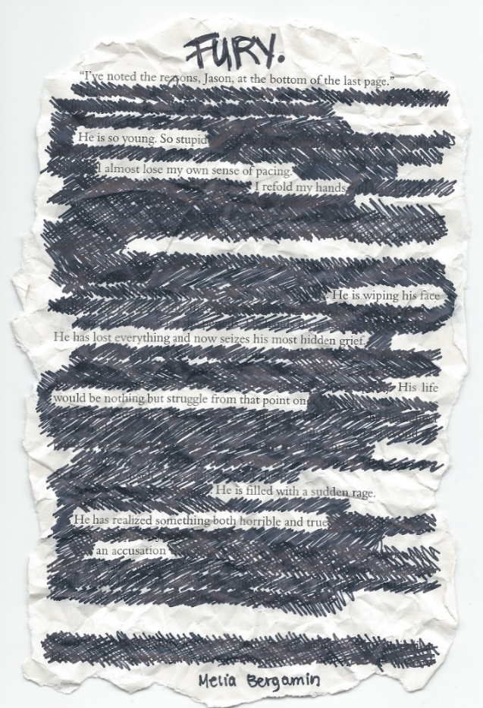
What's Blackout Poetry? How to Use Erasure Verse in Your Art | Explorations | SPACE
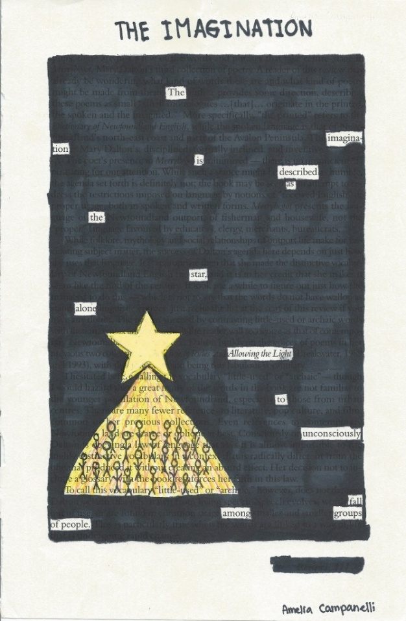 | 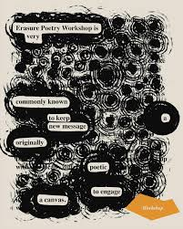
Explorations | SPACE | Bayt AlMamzar | Workshop: Erasure Poetry with Nada AlMosa (@nadawiyadotcom)
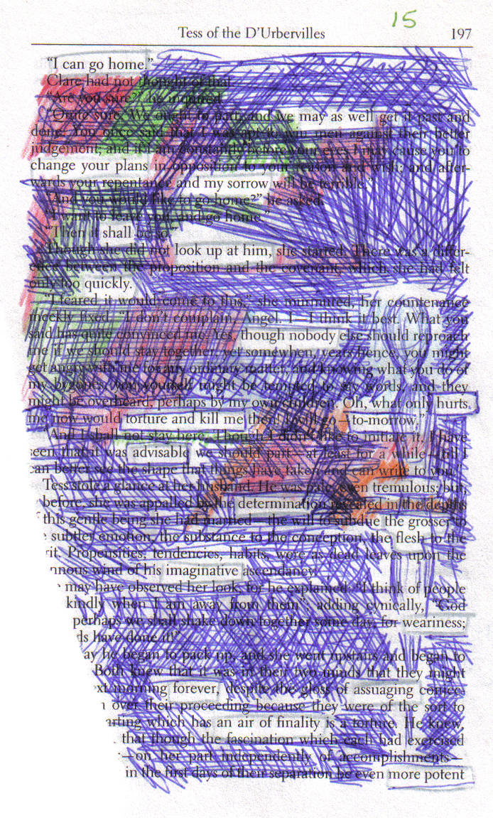 | 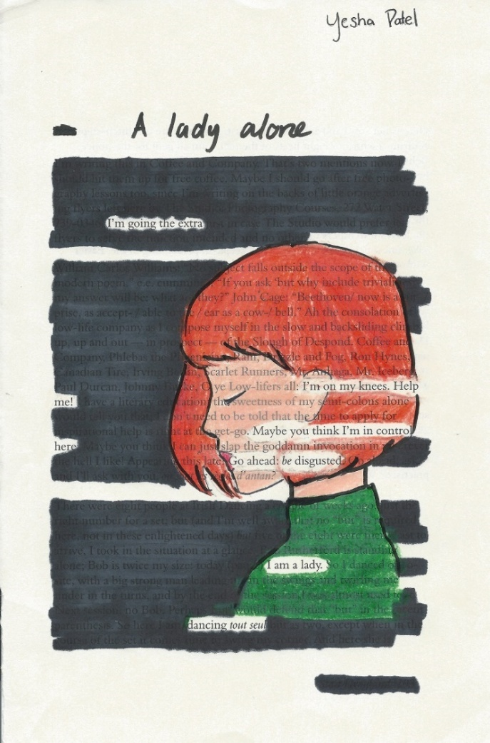
Experimental Erasure Poetry 1 by Yelshua on DeviantArt | Explorations | SPACE

Resource #2 Excerpt from Speech Alfred Deakin, Attorney General TEACHER COPY
White Australia policy | National Museum of Australia
Attorney-General Alfred Deakin, 12 September 1901:

That end, put in plain and unequivocal terms … means the prohibition of all alien-coloured immigration, and more, it means at the earliest time, by reasonable and just means, the deportation or reduction of the number of aliens now in our midst. The two things go hand in hand and are the necessary complement of a single policy – the policy of securing a ‘white Australia.’

Erasure example
That end, put in plain and unequivocal terms … means the prohibition of all alien-coloured immigration, and more, it means at the earliest time, by reasonable and just means, the deportation or reduction of the number of aliens now in our midst. The two things go hand in hand, and are the necessary complement of a single policy – the policy of securing a ‘white Australia’

Traditional poetry formatting example
Unequivocal terms.
All coloured immigration
and more
Reasonable and just in our midst.
Things go hand in hand,
and are necessary.
The policy of Australia.

© Department of Education Western Australia 2025.This product has been generated or modified using artificial intelligence and to the extent that copyright subsists in it, the copyright is retained by the Department of Education Western Australia.

