English | Year 9/10

2.3 Complexity of identity and international diversity ____________________________________________________________________________________________________

Focus 16: Reflecting on Australian identity

Lesson overview

This lesson sequence introduces students to traditional and contemporary representations of Australian cultural identity. They will explore and evaluate stereotypes, understand their origins and limitations, and recognise Australia’s multicultural reality. Through group work and discussion, students will analyse iconic Australian stereotypes, reflect on their impact, and collaboratively update an Australian cultural etiquette guide to better reflect today’s diverse society, supporting a more inclusive and complex view of national identity.
Teaching note
These activities are designed to take place over 3-4 lessons. Teachers may choose to condense or expand the activities, dependent on time constraints.

Cultural safety considerations
The cultural safety of Aboriginal and Torres Strait Islander students, and culturally and linguistically diverse (CaLD) students must be a priority when planning and delivering these lessons.
Teachers are expected to establish a learning environment that is culturally, psychologically, spiritually, physically, and emotionally safe for all students, particularly for Aboriginal and CaLD students. Culturally responsive teaching practices should aim to create the conditions for students, staff, and families to experience cultural safety in schools and remove and minimise harmful experiences, such as racism in all its forms. Teachers should remain mindful of assumptions, stereotypes and unconscious biases and apply strategies to mitigate them.
Engaging in meaningful teaching and learning about multiculturalism and anti-racism requires teachers to create the conditions for cultural safety in the planning, delivery and assessment of lessons. This includes:
- knowing students’ cultural backgrounds and understanding how this may be relevant to (or impact) the learning environment
- letting students and families know about the planned content and resources in advance so that they can prepare for the learning, and contribute where safe to do so
- knowing any cultural protocols in advance that may impact the lesson (for example, using a disclaimer at the start of a film about people who may have passed away)
- knowing the sensitive language that may cause harm (for example, removing racial slurs or hate speech in films)
- not assuming that students or staff will want to share their cultural backgrounds and lived experiences with their peers during the lesson
- not calling on students during lessons without warning about content that has the potential to make them feel uncomfortable or singled out
- allowing for students, staff and families to provide input and feedback when they feel cultural safety in the planning, delivery and evaluation of lessons
- where possible, checking in with students and seeking their feedback on the activities and learning, if they feel culturally safe to do so.

Lesson specific consideration
As stated on the Cultural Atlas site, it is important for teachers to emphasise that, “every society contains many microcultures that may differ from the cultural mainstream in identifying characteristics. People’s experience within a culture may also vary on a personal basis, depending on one’s age, ethnicity, religion, gender, sexuality or other factors.”

Curriculum content
Year 9 | Year 10
Literacy: Texts in Context
Analyse how representations of people, places, events and concepts relate to contexts  WA9ELYT1 | Analyse and evaluate how people, places, events and concepts are represented in texts and relate to contexts WA10ELYT1
Literacy: Analysing Interpreting and Evaluating
Use comprehension strategies, such as visualising, predicting, connecting, summarising, monitoring, questioning and inferring, to compare and contrast ideas and opinions in and between texts when listening, reading and viewing WA9ELYA3 | Integrate comprehension strategies, such as visualising, predicting, connecting, summarising, monitoring, questioning and inferring, to analyse and interpret complex and abstract ideas when listening, reading and viewing WA10ELYA3
Literacy: Creating Texts
Plan, create, edit and publish written and multimodal texts, organising, expanding and developing ideas, and selecting text structures, language features, literary devices and multimodal features for purposes and audiences in ways that may be imaginative, reflective, informative, persuasive, analytical and/or critical WA9ELYC1 | Plan, create, edit and publish written and multimodal texts, organising, expanding and developing ideas through experimenting with text structures, language features, literary devices and multimodal features for specific purposes and audiences in ways that may be imaginative, reflective, informative, persuasive, analytical and/or critical WA10ELYC1

Learning intention
Students are learning about traditional and current representations of Australia’s cultural identity. They will evaluate and update these representations to reflect a more complex understanding of Australia’s multicultural landscape.

Success criteria
Students will:
- define ‘cultural identity’
- identify cultural stereotypes and generalisations about Australians
- list the origins of traditional representations of Australian identity
- discuss how these traditional representations can be problematic
- evaluate current cultural assumptions about Australians
- create an updated version of the eDiplomat Guide to Australian Cultural Etiquette.

Key terminology
- Culture – the characteristics and knowledge of a particular group of people, encompassing shared values, beliefs, expectations, attitudes, assumptions and norms formed through similar experiences. Culture is not just about ethnicity. It is dynamic and constantly changing. It is the shared system of learned and shared values, beliefs and rules of conduct that make people behave in a certain way. It is a process for perceiving, believing, evaluating and acting. It is a lens through which we view the world.
- Evaluative language – positive, negative or neutral language that judges the worth of something. It includes language to express feelings and opinions, make judgements and assess the quality of objects, ideas and features of texts.
- Identity – a person’s conception and expression of individuality or group affiliation, self-concept and self-representation. Identity is closely connected to both culture and language. Thinking and talking about the self is influenced by the cultural frames, which are offered by different languages and cultural systems. Identity is not fixed. Second language learners’ experience with different linguistic and cultural systems introduces them to alternative ways of considering the nature and the possibilities associated with identity.
  - Cultural identity: A person’s sense of belonging to a particular culture, expressed through shared language, values, beliefs, and customs.
  - National identity: A sense of belonging to a nation, shaped by shared history, symbols, values, and traditions that distinguish one country from others.
- Representation – refers to the way people, events, issues or subjects are presented in a text. The term implies that texts are not mirrors of the real world; texts are constructions of reality in the sense that they re-present aspects of the world. These constructions are partially shaped through the writer’s use of conventions and techniques.
- Stereotypes – when a person or thing is judged to be the same as all others of its type. Stereotypes are usually formulaic and oversimplified.

Suggested discussion
- Is our cultural identity fixed, or is it fluid and changing? Explain.
- What are some of the positives and/or drawbacks of having a strong cultural identity?
- How can examination of different cultural identities promote inclusivity and celebrate diversity?
- How can a single, cohesive national cultural identity be accurately represented, given our multicultural diversity?

Activity 1: Introduction to identity
Considering cultural identity and notions of Australia’s national identity.

Resources required:
- A3 paper for all students
- Appendix Resource #1 Cultural stereotypes (printed in A3).

- Distribute A3 paper to students and instruct them to draw a circle in the centre with their name.
- Student should add (at least) 8 spokes from the circle. On each spoke, students should map their cultural identity, including family background, ethnic heritage, languages spoken, beliefs and values, traditions and customs.
- They should add personal factors that are important to their identity such as age, personality traits, sporting interests, whether they live in urban/suburban/regional setting, schooling, arts/music and hobbies of significance, and cultural icons.
  - This is their personal context which shapes their cultural identity.

- Write Identity and Culture on the board. Ask students to add their own definitions or ideas for culture and identity to their mind maps.
- Once completed, discuss responses and refine them until the class reaches a consensus.
- Ask students to update their definitions and to think about the concepts cultural identity and national identity.
- Define each concept and ask students to add them to their mind maps (see Key terminology).

- Teachers may carefully facilitate a class discussion and encourage any migrant students to share their preconceptions about Australians before they moved to Australia, asking:
- What key characteristics stood out to them? Were they positive? Negative? How were these formed?
- Alternatively, students who have travelled internationally can share their experiences about the reputation/perception of Australians by foreigners.

- Explain that different countries have over-simplified generalisations or stereotypes which influence their national identity. Distribute A3 copies of Resource #1 ask student groups to list positive and negative stereotypes linked to Australia’s national identity.
- With appropriate revision of the cultural safety considerations (page 1), ask students to fill out the positive/negative stereotypes for the remaining countries on Resource #1 (USA, UK and China).
- Conclude by explaining that all nationalities are represented stereotypically - whether they are grounded in truth or not.

Activity 2: Myth-busting Australian stereotypes
Investigating the origin of Australian stereotypes.

- Instead of directly presenting stereotypes, frame the lesson as a myth-busting activity.
- Present students with the following common Australian stereotypes to consider and coordinate an ‘agree/disagree’ activity where students move to designated sides of the classroom on a spectrum from ‘strongly disagree/agree/neutral/disagree/strongly disagree’ depending on their personal stance on each given stereotype:
  - Everyone in Australia is connected to the beach and the outback
  - Australians drink excessive amounts of alcohol
  - Australians only eat Vegemite and BBQs
  - All Australians are laid-back and easy-going
  - Australians don’t take themselves seriously and have a good sense of humour
  - All Australians love sport
  - Australians don’t believe in class systems
  - Australians embrace multiculturalism.
- Encourage a healthy evidence-based debate from either side.
- This activity can also be framed as a class discussion or conducted as an online poll.

- Teacher will now lead a post-activity class discussion:
- Were students surprised by the findings?
- How do these stereotypes work together to contribute to Australia’s national identity?
- How can these stereotypes become problematic?
- Importantly, who is excluded from these traditional stereotypes? First Nations peoples/minority groups/people with disabilities, women.

Activity 3: Examining traditional representations of Australian identity
Voicing stereotypes and considering their effects

Resources required:
- Appendix Resource #2 Traditional Australian stereotypes
- Appendix Resource #3 Traditional Australian stereotype TEACHER COPY
- Student access to online resource Cultural Atlas.

- Recap the ideas from Activity 2 - simplified generalisations lead to stereotypes which become synonymous with representations of Australian cultural identity on the world stage.

- Distribute Resource #2 to students in pairs or small groups and guide them to create a first-person point of view statement of each stereotype’s key personality traits.
- The selected images will investigate cultural figures such as the Bush Hero, the Sports Hero, the Outback Hero the Larrikin, the Battler and the Digger.
- The first example, the Larrikin, has been provided with positive and negative effects of this stereotype on our national identity.
- Work collaboratively with students to voice the Bush Hero stereotype.
  - Consideration of the positive and negative impacts on our national identity should be straightforward. Though it is a romanticised image of a brave, pioneering figure with a strong appreciation of Australia’s natural landscape, it is also a limiting stereotype that focuses on white masculinity and stoicism/strength, reinforcing outdated gender stereotypes and historical injustices.
- Ask leading questions such as:
  - What famous texts feature this kind of character? Where do you know him from?
  - What qualities do you think makes someone a Bush Hero?
  - What is their relationship to the Australian landscape?
  - How does this person treat the people around him?
  - What do you think is valuable to this kind of character?
- Ask student partners/groups to attempt their first person-POV statements for each stereotype, asking similar questions again regarding the stereotype’s history/traits/values.
- Once completed, discuss finding as a class and ask students to consider how much they think Australia’s national identity is still rooted in these stereotypes.
- Resource #3 is a teacher copy.

- Direct students to the Australian - Core Concepts - Cultural Atlas. This site provides contemporary and up-to-date information and cultural insights of Australia’s population.
- Instruct students to take bullet-point notes for each sub-section of the Cultural Atlas in their workbooks:
  - Australian Culture
  - Egalitarianism
  - Relationships
  - Rules and Relaxation
  - Aboriginal and Torres Strait Islander Experiences
  - Multiculturalism in Australia.

- Lead a class discussion, asking students to consider how traditional stereotypes still inform our cultural identity. Ask them to offer some insights how the Cultural Atlas offers a more inclusive understanding of our current national identity.

Optional: To evidence student knowledge, set a short, written response task which asks students to consolidate their notetaking and research. The task should demonstrate their understanding of the key traits currently considered representative of ‘Australian’ identity in 2025.

Activity 4: Evaluating Australia’s cultural identity for an international audience

Resources required:
- Appendix Resource #4 eDiplomat Cultural Etiquette Guide worksheet
- Student notes from Activity 3 - Core Concepts from the Cultural Atlas.

- Discuss the terms etiquette and cultural guides and how they can help navigate new cultures or expectations.
- Introduce students to the eDiplomat, a website that aims to “raise awareness” of other cultures and encourage smooth interactions amongst diplomats around the world.

Note: the eDiplomat site has been chosen specifically because it has outdated and often inaccurate insights into Australian culture.

- Show students the Australian etiquette guide on the eDiplomat website and discuss initial reactions.
- Organise students into small groups and provide each with Resource #4.
- Explain that students need to evaluate and, if required, update the guide to reflect our nation’s complex identity.
- Each revision, unchanged point and/or point removal must be justified with a short explanation which considers the Core Concepts from the Cultural Atlas in Activity 3.
- Optional: Allocate some of the etiquette statements to each group, or direct them to respond to all statements in Resource #4.

Optional: Play the short clip - Reach Out: Learning to Navigate your Cultural Identity.
- This video emphasises that everyone’s personal cultural identity is complex and constructed by many contextual factors. It offers positive representations of Australian citizens from internationally diverse backgrounds who have embraced their multicultural Australian identity.

- After students have updated the cultural guide, they should respond to this statement:
- Defining Australian identity is complex because…

Reflection
- What aspect/s of Australian cultural identity do you think is essential for international visitors to know?
- How can acknowledging and respecting different cultures contribute to a more positive experience for Australians and international visitors?
- Did this project change your perspective on Australia’s cultural identity in any way? Explain your answer.

Resource #1 Cultural stereotypes

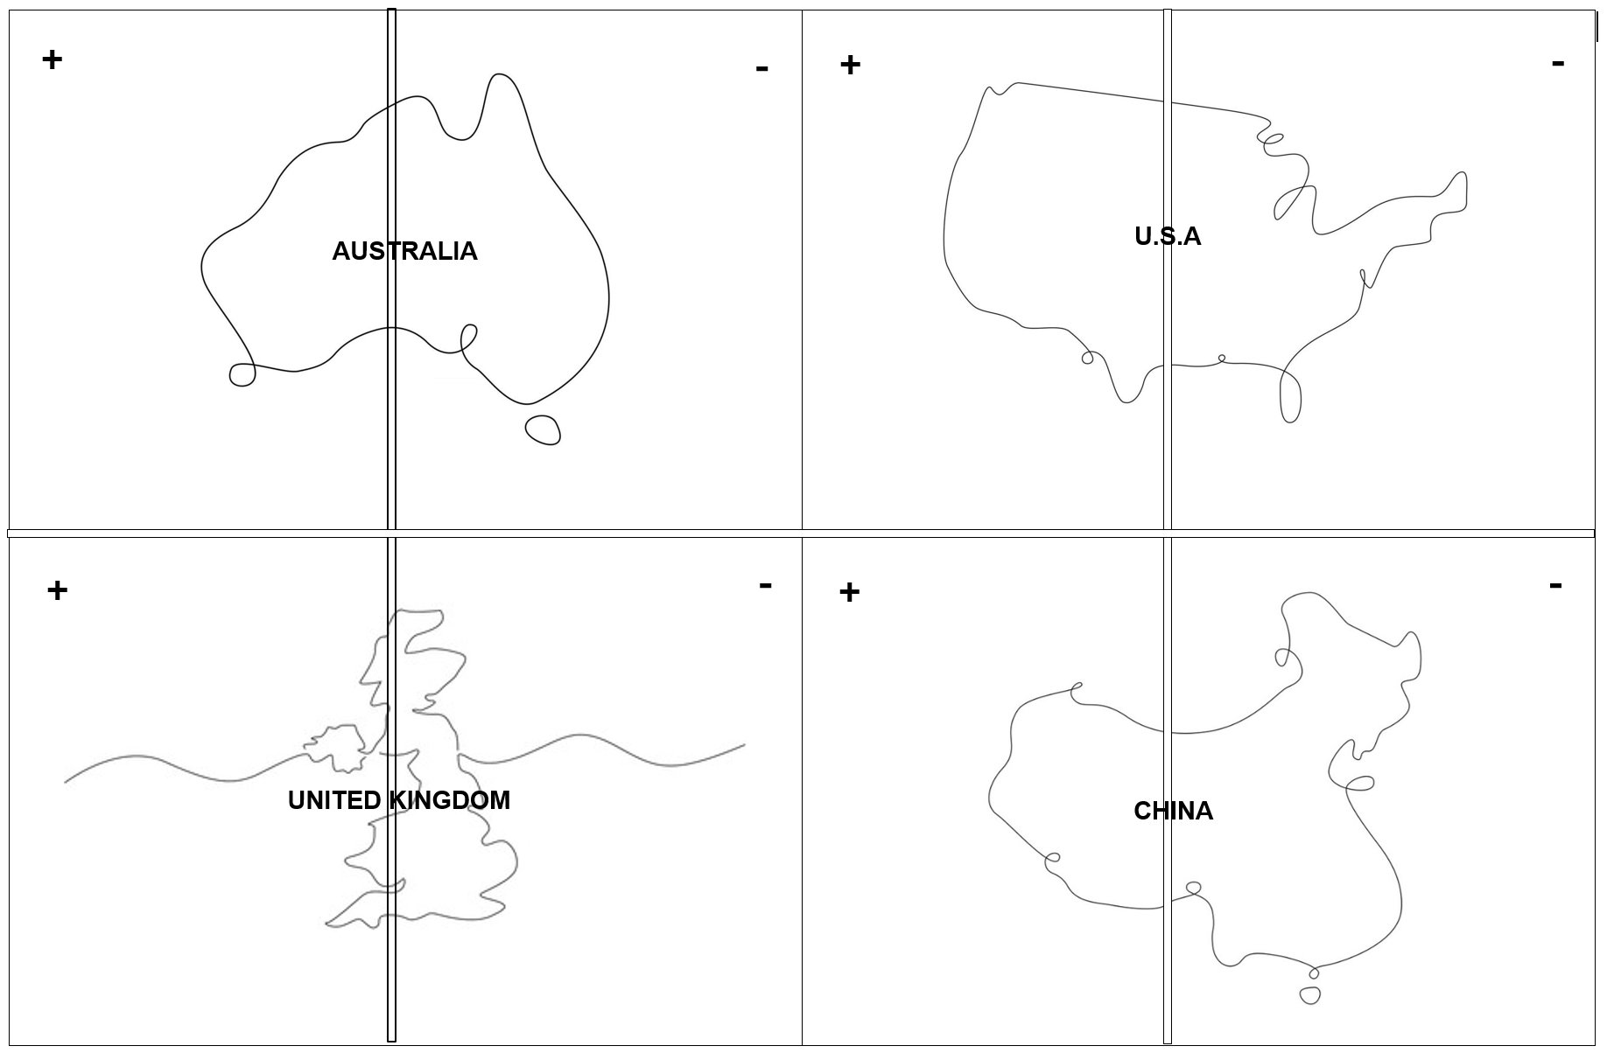

Resource #2 Traditional Australian stereotypes
Match the stereotype to the image and identify positive and negative impacts of each stereotype on Australia’s national identify.
Stereotypes: Battler, Bush hero, Digger, Larrikin, Outback hero, Sports hero,
 | Which Australian stereotype am I?  I am a fun-loving bloke who loves kicking back at the pub with mates, sinking a few cold ones, having a laugh and getting rowdy. Beer is more than just a drink, it’s a way to bond with my friends and be part of a laid-back Aussie lifestyle.  Positive impact on our national identity?  - Australians are recognised for their strong sense of mateship and sociable nature.  - Australians considered easy-going and relaxed.  - Beer is recognised as a cultural icon.  Negative impact on our national identity?  - Promotes excessive alcohol consumption as a national pastime.  - Strengthens Australian identity as masculine and working class (therefore excluding huge sections of the population).
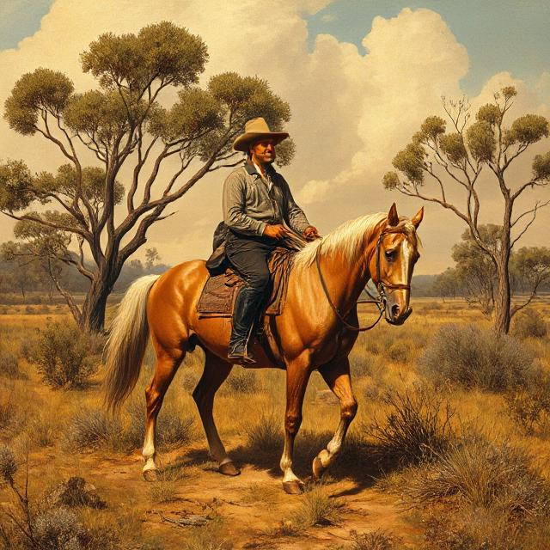 | Which Australian stereotype am I? Bush Hero
 | Which Australian stereotype am I? Sports Hero
 | Which Australian stereotype am I? Outback Hero
 | Which Australian stereotype am I? Battler
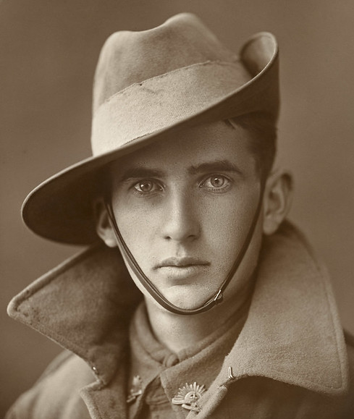 | Which Australian stereotype am I? Digger

Resource #3 Traditional Australian stereotypes TEACHER COPY
Which Australian stereotype am I? Larrikin
I am a fun-loving bloke who loves kicking back at the pub with mates, sinking a few cold ones, having a laugh and getting rowdy. Beer is more than just a drink, it’s a way to bond with my friends and be part of a laid-back Aussie lifestyle.

Positive impact on our national identity?
- Australians are recognised for their strong sense of mateship and sociable nature.
- Australians considered easy-going and relaxed.
- Beer is recognised as a cultural icon.

Negative impact on our national identity?
- Promotes excessive alcohol consumption as a national pastime.
- Strengthens Australian identity as masculine and working class (therefore excluding huge sections of the population).

Which Australian stereotype am I? Bush Hero
I'm a bushman from the high country, shaped by rugged mountains and the wild land. Bravery and skill are part of my bones—I’m known for staying calm and resourceful, even when the going gets tough. My days are spent on horseback, handling whatever nature throws my way. I don't seek attention; I'd rather let my actions speak for themselves, showing quiet heroism and stoic resolve when others might turn back. Loyalty to the land and hard work define me, as does a deep respect for Australia’s natural beauty. While I might not say much, I always stay true to my principles and help where I’m needed—letting courage and dignity mark my path through life."

Which Australian stereotype am I? Sports Hero
I’m the sort of bloke who lives for the thrill of the game, whether it’s cricket, footy, or any sport that brings mates together. Hard work, determination, and never backing down are part of who I am—I play not just for myself, but for my team and the pride of Australia. No matter the odds, I give everything I’ve got, pushing through with grit and that never-say-die attitude Aussies are known for. Camaraderie and mateship mean everything to me; Staying humble, playing fair, and showing respect for the game and my opponents is just how I do things. To many, I’m a role model on and off the field, and I always try to live up to the values that make sport such a big part of our national character.
Which Australian stereotype am I? Outback Hero
I’m most at home when I’m tracking game, wrangling crocs, or fixing up camp, I’ve got the skills to handle anything that comes my way.I’m laid-back, quick with a joke, and not afraid to stir the pot. I stand up for my mates and reckon true hospitality means respecting everyone, across cultures and across this ancient land. I reckon I’m at home where the land stretches wild, from red deserts to lush billabongs. I’ve learnt that true bush skills mean knowing how to listen to the land and understanding its stories, many of which come from Aboriginal people whose connection runs deep, going back thousands of years.
Which Australian stereotype am I? Battler
I’m an ordinary Aussie just trying to get by, rolling my sleeves up every morning and working hard. Life throws its fair share of curveballs—low pay, tough times, and everyday struggles—but I stick at it, grit my teeth, and keep moving forward, never asking for handouts or making a fuss. What matters most is putting my family first, helping my mates, and fighting for a fair go. My pride comes from standing up tall, facing hardship with courage, and showing there’s no shame in battling—just plenty of heart, honesty, and persistence. I’m not after glory or riches; just earning an honest living and keeping my chin up.
Which Australian stereotype am I? Digger
I’m one of the diggers, forged in the fierce heat of battle and bound by mateship that’s thicker than blood. Tough as nails and quick on my feet, I face danger with a grin, knowing the courage to keep going isn’t just about me, but about the bloke beside me. I don’t bother much with rank or fancy orders—I believe in a fair go for all, no matter your background. Out here, humour is my shield and loyalty my sword; I endure hardship with stoic resolve and a bit of cheeky larrikin spirit, standing tall for Australia and the mates I fight alongside. I’m proud to carry the ANZAC legacy—strong, brave, and humble—a symbol of endurance and sacrifice that’s woven deep into the heart of our nation.

Resource #4 eDiplomat Cultural Etiquette Guide worksheet
Statement | Keep | Change | Remove | Amended point | Justification
The People

Home to nearly five million immigrants from 160 countries, Australia is rich in cultural diversity. Australians, or "Aussies," enjoy an easy-going lifestyle and are generally friendly and relaxed. Modesty and equality are valued.
Meeting and Greeting

Shake hands with everyone present upon meeting and before leaving. Allow women to offer their hands first.

Women generally do not shake hands with other women.

Australians generally move to a first-name basis quickly. Still, wait to use first names until invited to do so.

Body language

To beckon a waiter, use a quiet hand motion.

Winking at women is considered rude.

The "V" sign (made with index and middle fingers, palm facing inward) is a very vulgar gesture. The thumbs up gesture is also considered obscene.
Corporate Culture

Australians take punctuality seriously. If possible, arrive fifteen minutes early for a business meeting.

Australians dislike one-upmanship. Don’t overplay qualifications, rank or titles.

Negotiations proceed quickly. Bargaining is not customary. Proposals should be presented with acceptable terms. Leave some allowance for some give and take.
Dining and Entertainment

Always arrive on time or a few minutes early for a dinner.

The person who makes the invitation generally pays the bill in restaurants. However, it isn't unusual for friends to split the bill.

Australians follow continental-style dining etiquette (fork held in the left hand; knife in right).

Barbecues -- very informal cook outs -- are popular in Australia. Sometimes guests bring their own meat or other items.

The guest of honour is generally seated to the right of host.

Soup should be eaten by moving the spoon away from you, not toward you.

Keep your hands above the table and elbows off the table.

Offer to help with meal preparation and clean-up when being entertained in a home.

Do not say "I'm stuffed" after a meal. This means you are pregnant.
Dress

Australians wear fashions similar those worn in Europe and USA

For business, men should wear conservative jackets and ties. During the summer months, jackets are often removed. Women should wear skirts and blouses or dresses.
Gifts

It is not customary to exchange business gifts during initial meetings.

When invited to an Australian’s home, bring a small gift (flowers, chocolates, or books about your home country or region) for your hosts.
Helpful Hints

Aussies dislike class distinctions and have a history of "cutting down the tall poppy." This grew out of the Australian prisoners' hatred of their British overseers. Many Australian politicians have declined the designation of knighthood for fear of alienating their constituents.

Australians sit in the front seat of a taxi/limousine. A single passenger sitting in the back seat is viewed as "putting on airs."

Australians respect people with strong opinions, even if they don't agree.

Don’t comment on anyone's accent. Accents often distinguish social class.

If you are teased, you are expected to reply in kind, with good humour. Such self-confidence will increase an Australian's respect for you. They do not admire a subservient attitude.

Do not sniff or blow your nose in public.
© Department of Education Western Australia 2025.This product has been generated or modified using artificial intelligence and to the extent that copyright subsists in it, the copyright is retained by the Department of Education Western Australia.

