English | Year 7/8

3.1 Attitudes and perspectives: Representations of ideologies and attitudes ____________________________________________________________________________________________________

Focus 17: Multicultural menagerie

Lesson overview

This lesson sequence introduces students to Aesop’s fables as moral storytelling, guiding them to analyse how fables reflect social values and connect to modern multicultural ideologies, while also developing visual literacy and creative storytelling through picture book creation. Students will explore ideological messages in fables, examine morals through listening and discussion, collaboratively construct narratives for visual texts, and ultimately produce their own Aesop-inspired picture books that promote acceptance, harmony, and anti-prejudice values.

Teaching note
These activities are designed to take place over 4-5 lessons. Teachers may choose to condense or expand the activities, dependent on time constraints and should select stories that are appropriate to the context of your students and school.

Cultural safety considerations
The cultural safety of Aboriginal and Torres Strait Islander students, and culturally and linguistically diverse (CaLD) students must be a priority when planning and delivering these lessons.
Teachers are expected to establish a learning environment that is culturally, psychologically, spiritually, physically, and emotionally safe for all students, particularly for Aboriginal and CaLD students. Culturally responsive teaching practices should aim to create the conditions for students, staff, and families to experience cultural safety in schools and remove and minimise harmful experiences, such as racism in all its forms. Teachers should remain mindful of assumptions, stereotypes and unconscious biases and apply strategies to mitigate them.
Engaging in meaningful teaching and learning about multiculturalism and anti-racism requires teachers to create the conditions for cultural safety in the planning, delivery and assessment of lessons. This includes:
- knowing students’ cultural backgrounds and understanding how this may be relevant to (or impact) the learning environment
- letting students and families know about the planned content and resources in advance so that they can prepare for the learning, and contribute where safe to do so
- knowing any cultural protocols in advance that may impact the lesson (for example, using a disclaimer at the start of a film about people who may have passed away)
- knowing the sensitive language that may cause harm (for example, removing racial slurs or hate speech in films)
- not assuming that students or staff will want to share their cultural backgrounds and lived experiences with their peers during the lesson
- not calling on students during lessons without warning about content that has the potential to make them feel uncomfortable or singled out
- allowing for students, staff and families to provide input and feedback when they feel cultural safety in the planning, delivery and evaluation of lessons
- where possible, checking in with students and seeking their feedback on the activities and learning, if they feel culturally safe to do so.

Curriculum content
Year 7 | Year 8
Language: Language for expressing and developing ideas  Analyse how techniques, such as vectors, angle and/or framing in visual and multimodal texts can be used to create a perspective  WA7ELALA3 | Literature: Literature and contexts  Explain the ways that ideas and perspectives may represent the values of individuals and groups in literary texts drawn from historical, social and cultural contexts by Aboriginal and Torres Strait Islander, wide-ranging Australian and world authors and creators WA8ELICO1
Literature: Engaging with and responding to literature
Discuss the aesthetic and social value of literary texts using relevant and appropriate metalanguage WA7ELIEN3 | Explain how language and/or visual and audio features in texts position listeners, readers and viewers to respond and form perspectives  WA8ELIEN2
Literacy: Creating Texts
Plan, create, edit and publish written and multimodal texts, selecting subject matter, and using text structures, language features, literary devices and visual features as appropriate to convey information, ideas and opinions in ways that may be imaginative, reflective, informative, persuasive and/or analytical WA7ELYC1 | Plan, create, edit and publish written and multimodal texts, organising and expanding ideas, and selecting text structures, language features, literary devices and visual features for purposes and audiences in ways that may be imaginative, reflective, informative, persuasive and/or analytical WA8ELYC1

Learning intention
Students will explore how Aesop’s stories convey social values and intersect with modern multicultural ideologies whilst also developing understanding of storytelling techniques and visual literacy through analysis and creation of fables.

Success criteria
Students will:
- explain the ideologies explored in Aesop fables
- write narrative text which synthesises with picture book images provided by teacher
- create an Aesop-inspired picture book (with adapted text and images) which supports an anti-prejudice message and multicultural harmony
- recognise and apply knowledge of visual language features to their picture book.

Key terminology
- Anthropomorphism - a literary technique where human characteristics, feelings, or behaviours are given to animals, objects, or non-human entities.
- Ideology - a system or group of beliefs, values, or ideas that shapes the way a group or individual views the world and influences their actions and attitudes.
- Moral perspective – A personal perspective or position regarding what is right or wrong.
- Multiculturalism – is a term used to describe the recognition of cultural and ethnic diversity. In Western Australia, it means all Western Australians are entitled to exercise their rights and participate fully in society, regardless of their different linguistic, religious, racial and ethnic backgrounds. The principles of Multiculturalism, as stated in the Western Australian Charter of Multiculturalism, Australia is a majority migrant nation and one of the most successful and cohesive multicultural societies in the world, building on over 60,000 years of First Nations culture. CaLD communities are integral to our vibrant society.

Suggested discussion
- What is an ideology?
- What multicultural ideologies are promoted in Australia?
- How do you think stories can help us understand and appreciate different cultures?
- What are important morals that you think are essential for living in a harmonious society?
- How can illustrations enhance the storytelling of a picture book?

Activity 1: Aesop’s animal antics

Resources required:
- Teacher familiarity with Aesop’s fables.

- Ask students to think about why we tell stories to children, in a think, pair, share.
  - Guide a class discussion and explain that stories help children understand language and culture. They give moral instruction and help children learn values.

- Ask students what they know about Aesop’s fables and if they can name any.
  - Explain that Aesop was a Greek storyteller who lived around 620BCE; his fables have been teaching children moral lessons for 2,500 years. His anthropomorphic stories have been adapted globally across many time periods and cultures and continue to provide moral guidance.
  - Some of the most well-known fables include the:
  - Hare and the Tortoise
  - Shepherd Boy and the Wolf (also known as The Boy Who Cried Wolf)
  - Wolf in Sheep’s Clothing.

- Ask students what they know about Aesop’s fables and the moral values promoted within them. Collate a list of examples of student answers on the board. For example:

  - acceptance
  - caution
  - cooperation
  - equality
  - honesty
  - kindness
  - perseverance
  - respect
  - self-reliance
  - tolerance
  - wisdom.

- Explain the concept of ‘ideology’ (a group of ideas or beliefs that shape how people think about the world and how society should be organised).
  - Explain that Aesop’s ideologies primarily promote a worldview that values ethical behaviour and harmonious social interactions.
  - Circle all the words on the whiteboard to visually represent the notion of ‘ideology’ as a group or framework of ideas.

- Draw a large circle on the board and invite students to brainstorm the values/ideas that fit within Australia’s multicultural ideology. Words may include:

  - acceptance
  - compassion
  - democracy
  - diversity
  - equality
  - fairness
  - freedom
  - inclusion
  - justice
  - liberty
  - peace
  - respect
  - unity.

- Encourage students to recognise that, like our national multicultural ideals, Aesop’s fables also endorse understanding, diversity, freedom, inclusion and peace.

Optional: create a Venn diagram to see how these ideas overlap.

Activity 2: Fables in focus

Resources required:
- Printed copies of The Lion and the Mouse and The Fox and the Stork (optional)
- Appendix Resource #1 Understanding Aesop’s Fables
- Appendix Resource #2 Understanding Aesop’s Fables TEACHER COPY.

- Distribute Resource #1 to students and the audio and/or printed version of The Lion and the Mouse (1:12) and The Fox and the Stork (1:13).
  - Allow students time to complete Resource #1.
  - Review student answers as a class to discuss the moral lessons within each story.
    - Resource #2 is a teacher copy.
  - Optional: each fable has a downloadable student activity.

Activity 3: Drawn to stories
Fill in the blanks of an Aesop-inspired fable.

Resources required:
- Appendix Resource #3 Picture book fable template
- Student access to Josef Lee’s ‘When a wolf in sheep’s skin meets a sheep in wolf’s skin’ (digital or printed)

- Explain that students will write an Aesop-style story that matches the illustrations in a picture book with the words removed. This is an opportunity to express creativity and imagination and demonstrate an understanding of the conventions of fables and multicultural ideologies.

- Distribute Resource #3 to students (individually or in small groups) and ask them to reflect on the title and any clues that might help to create their own version of the fable.

- As a class, review through the entire book together to get a sense of the story's progression.
  - Encourage students to look at each illustration and think about what might be happening, paying attention to setting, background details, body language and facial expressions of the characters.

- Direct students to create text for each illustration which teaches children a lesson about friendship and accepting difference.
  - Encourage students to consider their version’s beginning, middle and end (resolution) and how they will reinforce the values in their fable?
  - Allow adequate time to create, refine and record their ideas.
  - Once completed, groups could share their version with each other to compare approaches.

- Share the original version of When a Wolf in Sheep’s Skin Meets a Sheep in Wolf’s Skin with students.
  - Optional: assess which group’s version was the closest to the original text.
  - Note: Author of ‘When a Wolf in Sheep’s Skin Meets a Sheep in Wolf’s Skin’ Josef Lee’s website House of Mini Picture Books has a variety of picture books for teacher’s seeking similar resources.

Activity 4: Picture this
Craft your own Aesop adventure.

Resources required:
- Appendix Resource #4 Fable prompts (printed or digital)
- Appendix Resource #5 Fable planning sheet
- Student access to devices or A3 paper and appropriate supplies to draw
- Appendix Resource #6 Drawing facial expressions (optional).

Note: This activity could be completed by hand or using an digital storyboard program.

- Direct students to choose one of the 4 examples in Resource #4.
  - Optional: for students who need extension, encourage them to adapt a more complex Aesop fable into a picture book rather than devise their own.

- Direct students to identify the moral less in their chosen fable and note this in their planning sheet (Resource #5).
  - Allow time for students to draft their storyboards. Resource #5 provides a drafting template with twelve ‘pages’ for them to populate their fable. Remind them to experiment with the balance between text and image and to try different layouts.
  - Provide feedback before students proceed to their final copy. This may also be facilitated through a peer review activity.
  - Optional: Play a drawing tutorial video (3:57) and distribute Resource #6 as a complementary activity to mitigate student concerns about artistic ability impacting the quality of their picture book creations by providing guidance on how to express facial expressions.

- Allow time for students to produce their finalised picture books in an appropriate format.

Reflection
- How do Aesop’s fables relate to modern multicultural ideologies?
- In what ways can storytelling, like Aesop’s fables, be an effective tool for teaching moral lessons and promoting cultural understanding?
- If you were to create a new fable for today’s multicultural world, what moral lesson would you want to convey and why?

Resource #1 Aesop’s Fables activity
The Lion and the Mouse
Main characters

Conflict

Resolution

Moral or lesson

Links to multicultural ideologies

The Fox and the Stork
Main characters

Conflict

Resolution

Moral or lesson

.

Link to multicultural ideologies

Resource #2 Aesop’s Fables activity TEACHER COPY
The Lion and the Mouse
Main characters

mouse, lion

Conflict

the lion threatens to eat the mouse for disturbing him

Resolution

the lion spares the mouse, and, in turn, the mouse later saves the lion by freeing him from a trap

Moral or lesson

everyone, regardless of size or status, has value and can make a difference
kindness is rewarded

Links to multicultural ideologies

Promotes helping others despite differences
Emphasises that cooperation leads to harmony
Promotes peaceful co-existence in diverse society

The Fox and the Stork
Main characters

fox, stork

Conflict

The fox invites the stork to dinner and serves food in a shallow dish, which only the fox can eat from

Resolution

The stork returns the favour by serving food in a tall, narrow jar therefor teaching him a lesson

Moral or lesson

Treat others the way you want to be treated

Links to multicultural ideologies

We should appreciate people’s differences rather than exploit them,

We should approach interactions with empathy, fairness and respect

Resource #3 Picture book fable template

When A Wolf In Sheep's Skin Meets A Sheep In Wolf's Skin, by Josef Lee
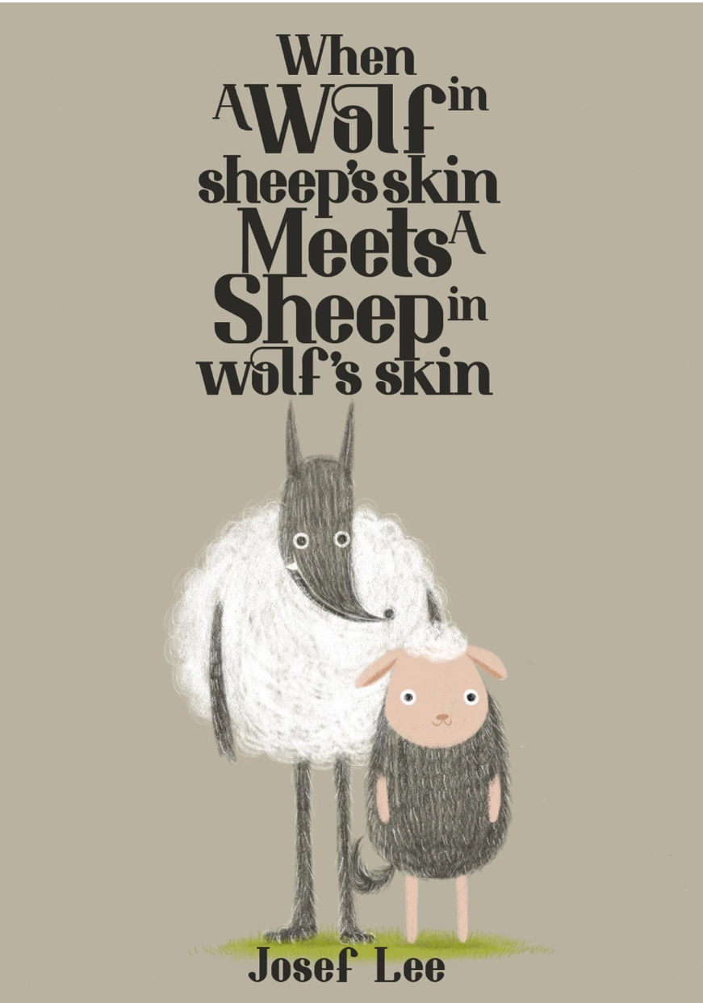
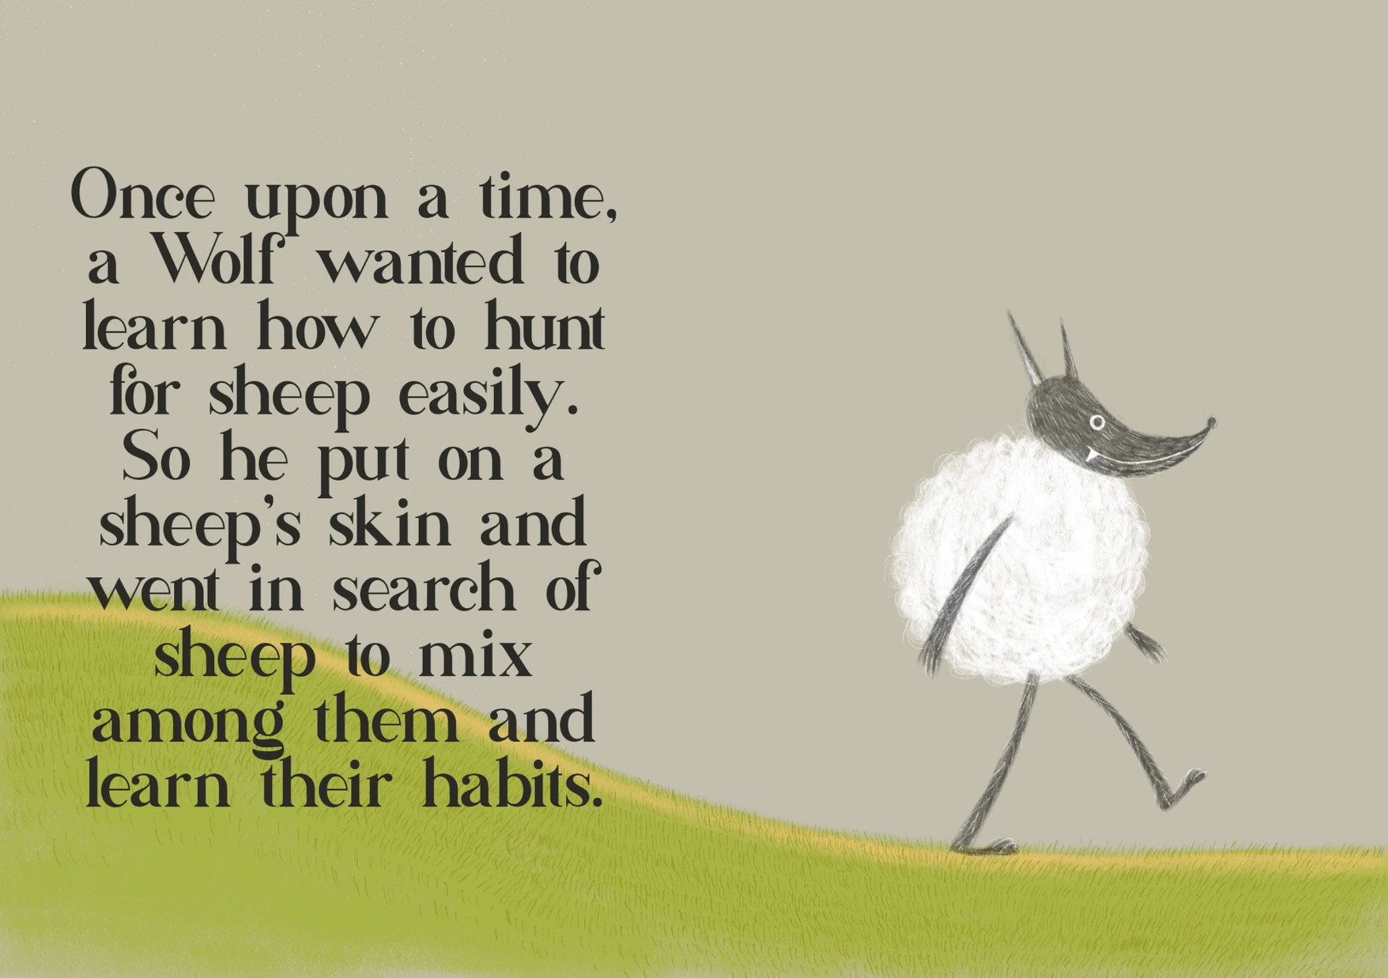

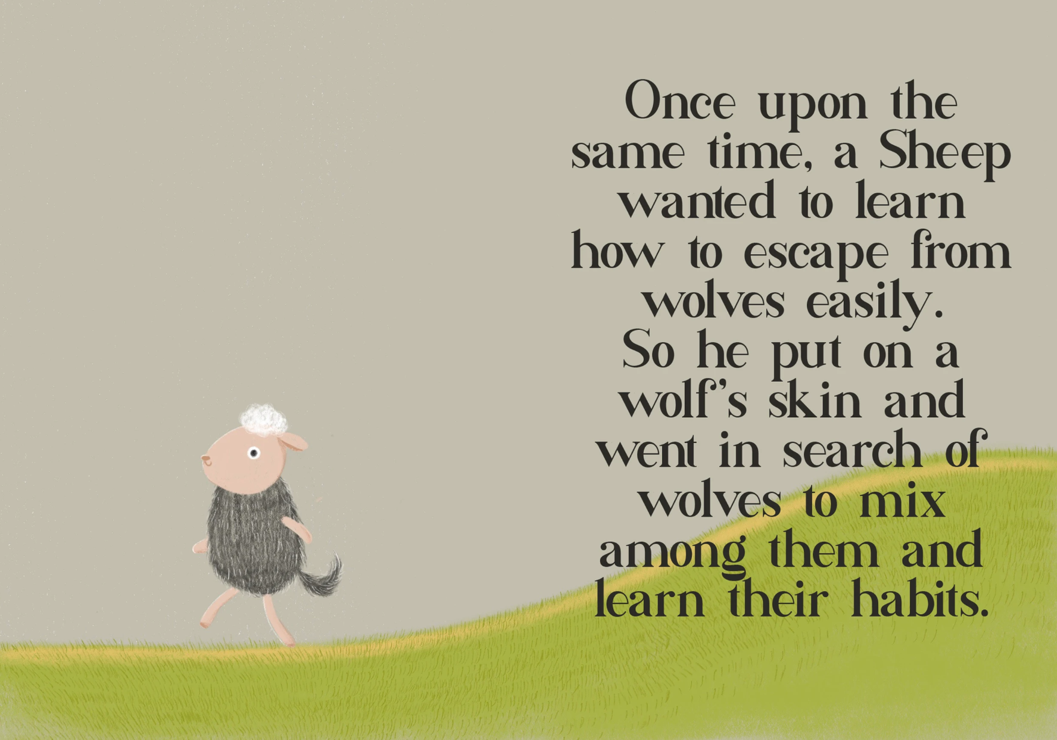

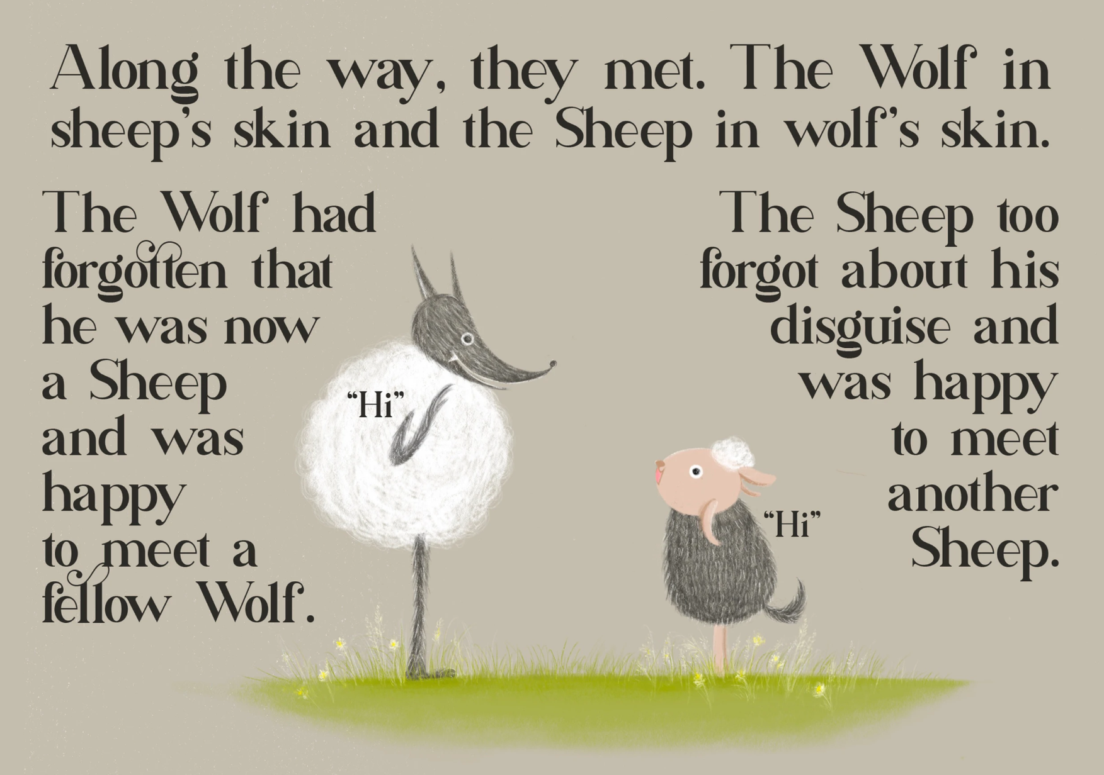

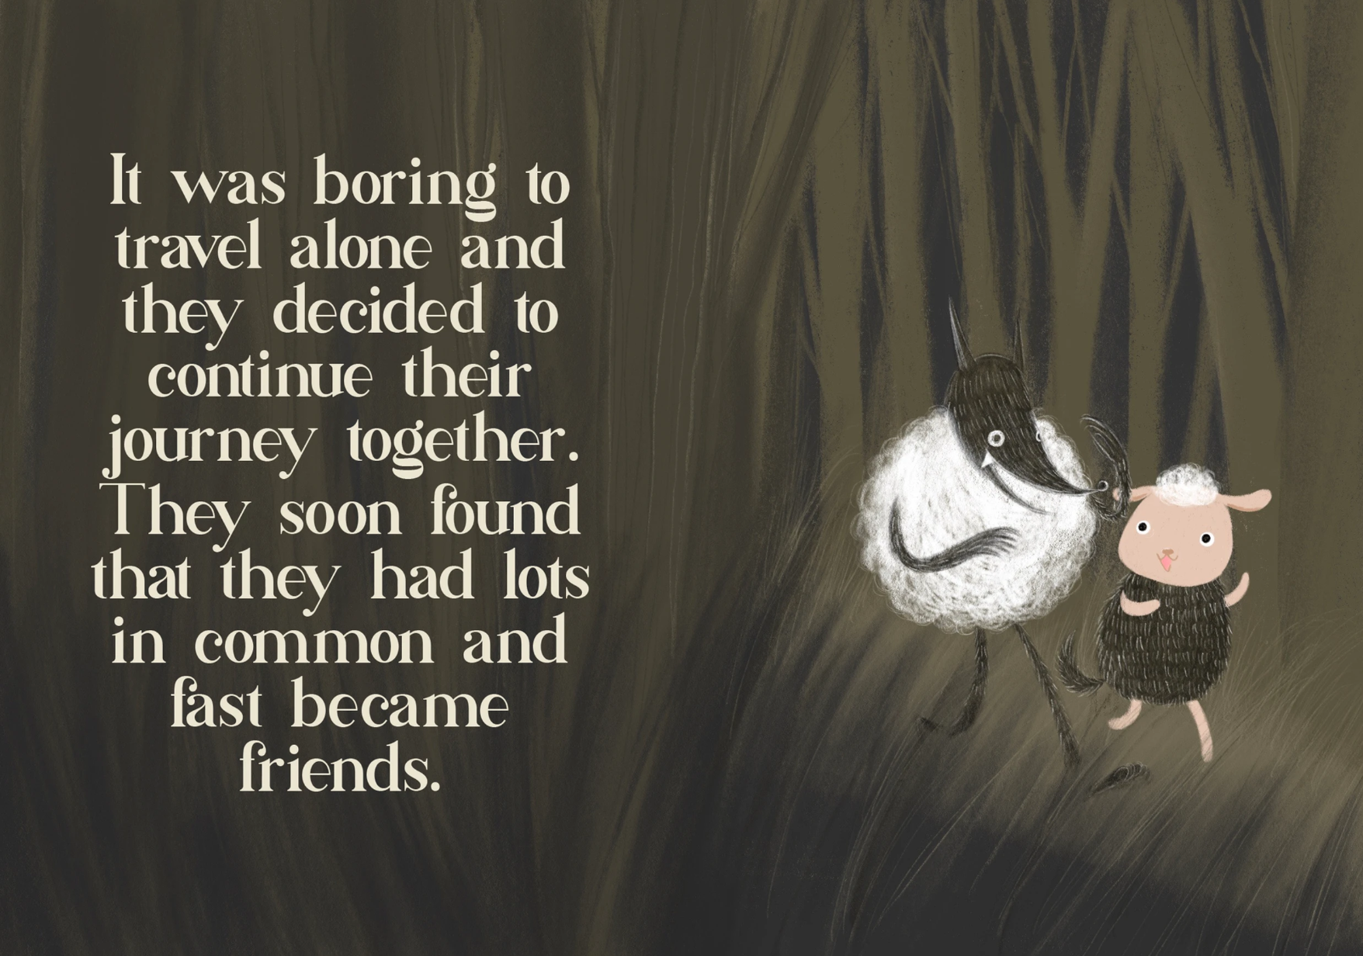

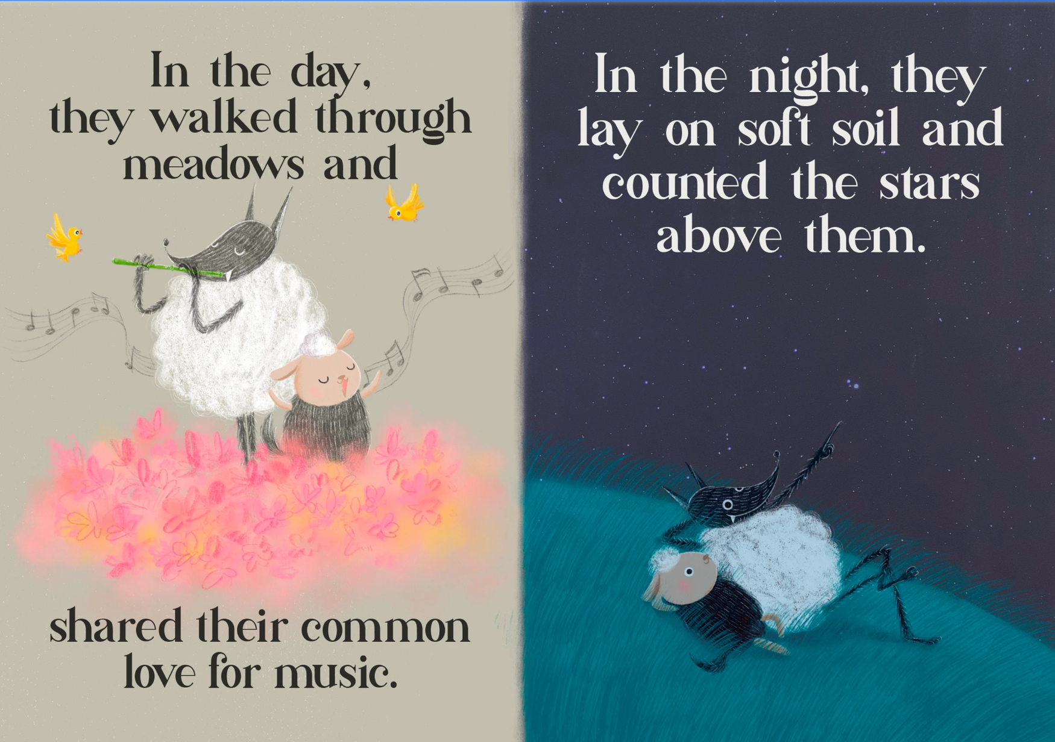

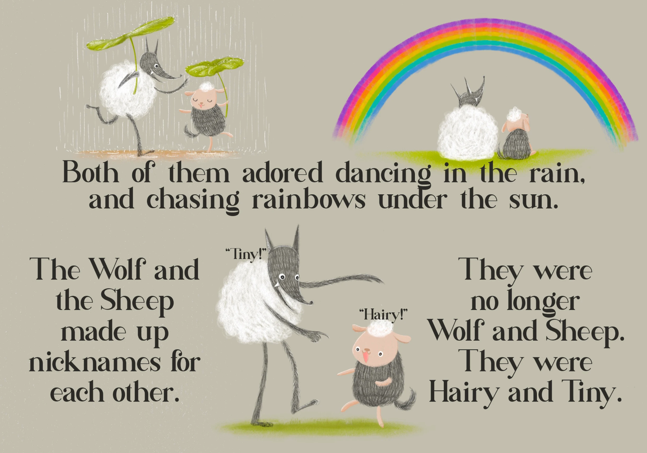

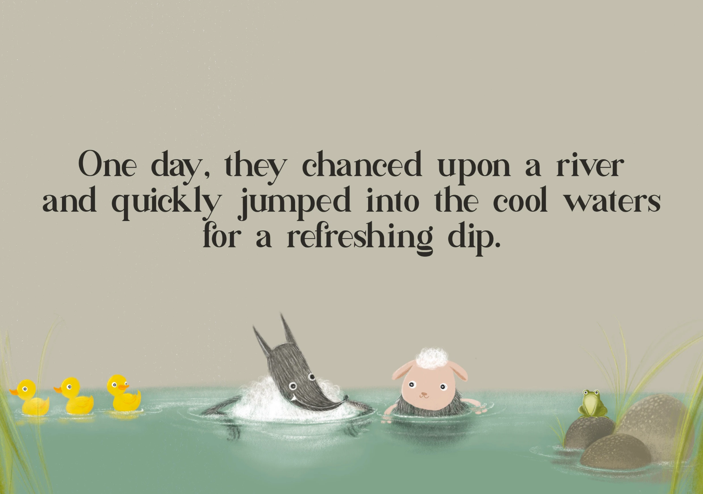

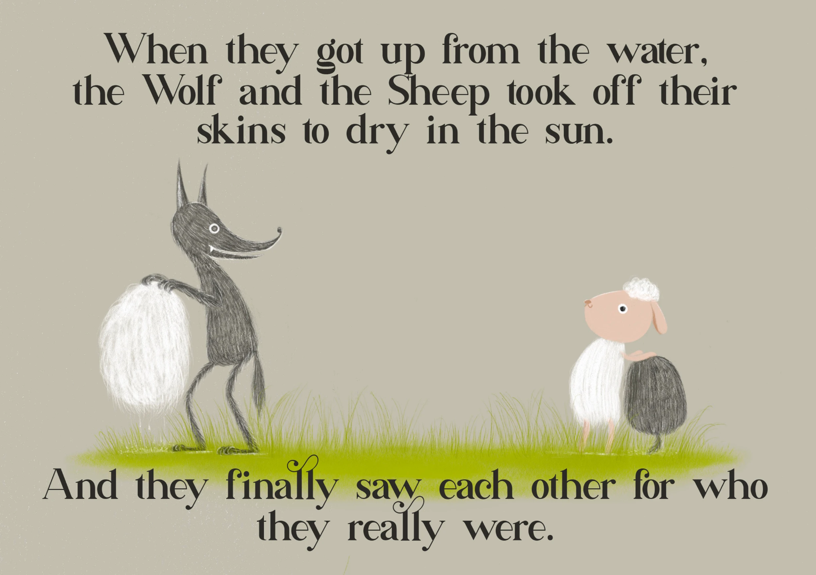

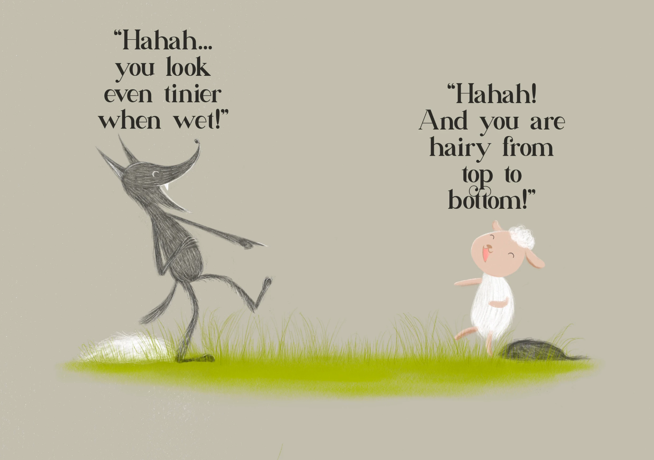

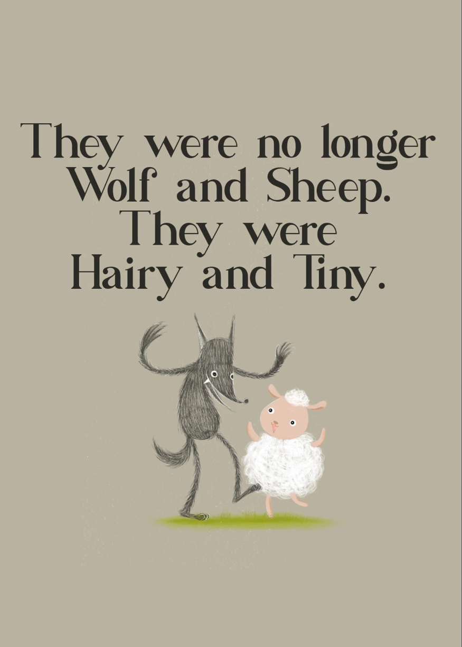

Resource #4 Fable prompts

The Spotted Frog and the Green Frog  In a pond, a green frog lived happily. One day, a spotted frog moved in. The green frog avoided the spotted frog, thinking his spots were strange.  During a drought, the pond began to dry up. The second frog’s spots helped him blend with the muddy bottom, hiding from predators. He showed the green frog how to do the same, saving both their lives.  The green frog realised the spotted frog’s difference was actually a gift. They became close friends. | The Garden of Different Blooms  In a garden, a group of roses prided themselves on their beauty and fragrance, believing they were the only flowers worthy of admiration. They excluded other flowers like sunflowers, daisies, and lilies from the garden's grand display. One day, a curious rose decided to invite these other flowers to join them.  Together, they created a vibrant array of colours and scents that attracted more bees, butterflies, and visitors than ever before.
The Forest Orchestra  In a forest where birds sang sweet melodies but excluded frogs from joining in because of their croaks, one bird decided to invite them anyway.  Together, they created an orchestra with diverse sounds that became more beautiful than ever before. | The Patchwork Butterfly  In a garden, a butterfly felt ashamed of her mismatched wings, each wing was a different colour. The other butterflies teased her, saying she didn't fit in.  One day, a strong wind blew, scattering petals from various flowers. The butterfly’s unique wings allowed her to blend with the colourful petals, hiding her from predators. From then on, the other butterflies never teased her again.

Resource #5 Fable planning sheet

My fable is…  Characters…  Setting… | Exposition…  Conflict…  Climax…  Resolution… | Multicultural moral promoted:
Planning my story:
Drafting my shots/angles/layout/text placement

Resource #6 Drawing facial expressions
How To Draw Manga/Cartoon Facial Expressions - YouTube (3min 57sec)

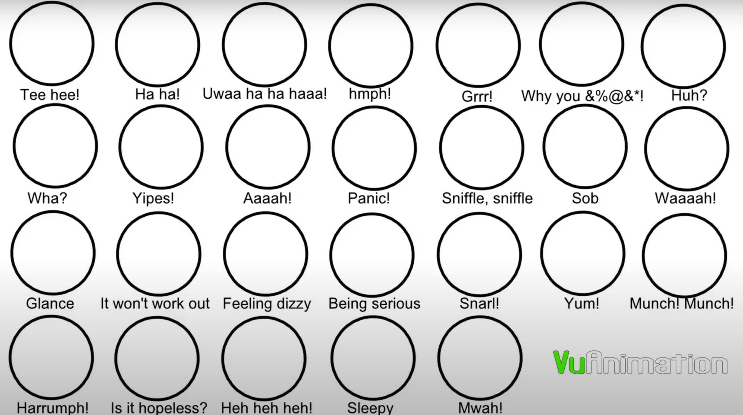

© Department of Education Western Australia 2025.This product has been generated or modified using artificial intelligence and to the extent that copyright subsists in it, the copyright is retained by the Department of Education Western Australia.

