English | Year 9/10
3.1 Representations of ideologies and attitudes
____________________________________________________________________________________________________

Focus 18: Representation, attitudes and identity

Lesson overview

This lesson introduces students to the Black Lives Matter movement and its significance within both global and Australian contexts, focusing on how racism is represented across various text types. Through activities involving image analysis, media representations, slam poetry and personal reflections, students will explore how texts shape beliefs, values, and attitudes towards people and groups. They will develop skills in identifying key messages, analysing literary and visual techniques, and writing a thoughtful personal response that reflects on social justice issues and the importance of challenging systemic racism.
Teaching note
Activities 1 and 2 will take 1-2 lessons to complete. Activity 3 could be used as a formative or summative task, depending on time constraints and relevance to teaching and learning programs. The task may take up to a week to complete.

Cultural safety considerations
The cultural safety of Aboriginal and Torres Strait Islander students, and culturally and linguistically diverse (CaLD) students must be a priority when planning and delivering these lessons.
Teachers are expected to establish a learning environment that is culturally, psychologically, spiritually, physically, and emotionally safe for all students, particularly for Aboriginal and CaLD students. Culturally responsive teaching practices should aim to create the conditions for students, staff, and families to experience cultural safety in schools and remove and minimise harmful experiences, such as racism in all its forms. Teachers should remain mindful of assumptions, stereotypes and unconscious biases and apply strategies to mitigate them.
Engaging in meaningful teaching and learning about multiculturalism and anti-racism requires teachers to create the conditions for cultural safety in the planning, delivery and assessment of lessons. This includes:
- knowing students’ cultural backgrounds and understanding how this may be relevant to (or impact) the learning environment
- letting students and families know about the planned content and resources in advance so that they can prepare for the learning, and contribute where safe to do so
- knowing any cultural protocols in advance that may impact the lesson (for example, using a disclaimer at the start of a film about people who may have passed away)
- knowing the sensitive language that may cause harm (for example, removing racial slurs or hate speech in films)
- not assuming that students or staff will want to share their cultural backgrounds and lived experiences with their peers during the lesson
- not calling on students during lessons without warning about content that has the potential to make them feel uncomfortable or singled out
- allowing for students, staff and families to provide input and feedback when they feel cultural safety in the planning, delivery and evaluation of lessons
- where possible, checking in with students and seeking their feedback on the activities and learning, if they feel culturally safe to do so.

Curriculum content
Year 9 | Year 10
Language: Language for interacting with others
Recognise how language empowers relationships and roles WA9ELAI1 | Understand how language can have inclusive and exclusive social effects, and can empower or disempower people WA10ELAI1
Literacy: Creating texts
Plan, create, edit and publish written and multimodal texts, organising, expanding and developing ideas, and selecting text structures, language features, literary devices and multimodal features for purposes and audiences in ways that may be imaginative, reflective, informative, persuasive, analytical and/or critical WA9ELYC1 | Plan, create, edit and publish written and multimodal texts, organising, expanding and developing ideas through experimenting with text structures, language features, literary devices and multimodal features for specific purposes and audiences in ways that may be imaginative, reflective, informative, persuasive, analytical and/or critical WA10ELYC1
Literature: Examining literature  Analyse the effect of text structures, language features and literary devices, such as extended metaphor, metonymy, allegory, symbolism and intertextual references WA9ELIEX2 | Literature: Engaging with and responding to literature  Evaluate the social, moral or ethical perspectives represented in literary texts WA10ELIEN3

Learning intention
Students will learn about the Black Lives Matter movement and how racism is represented in a variety of text types. Students will write a personal response that reflects on how texts represent people and groups, and shape beliefs, values and attitudes.

Success criteria
Students will:
- explain what the Black Lives Matter movement is and how it relates to Australia
- identify the key message of a variety of text types
- articulate the effect of literary devices on meaning and response to texts
- create a personal response that reflects on how texts represent people and groups and shape values, attitudes and beliefs.

Key terminology
- Attitude - an outlook or a specific feeling about something. Our values and beliefs underlie our attitudes. Attitudes can be expressed by what we say, do and think.
- Identity - a person’s conception and expression of individuality or group affiliation, self-concept and self-representation. Identity is closely connected to both culture and language. Thinking and talking about the self is influenced by the cultural frames, which are offered by different languages and cultural systems. Identity is not fixed. Second language learners’ experience with different linguistic and cultural systems introduces them to alternative ways of considering the nature and the possibilities associated with identity.
- Ideology - a system of ideas and beliefs that shapes how a person or group views the world and influences their actions.
- Perspective - the viewpoint from which the author/creator has chosen to perceive the world, or the viewpoint from which the reader or viewer perceives the world and understands a text. People and characters may have different perspectives on events or issues due to (for example) their age, gender, social position and beliefs and values.
- Racism - is more than just prejudice in thought or action. There are many definitions of racism. For the purposes of this set of resources, racism is defined as the process by which systems and policies, actions and attitudes create inequitable opportunities and outcomes for people based on race. It occurs when this prejudice - whether individual or institutional -is accompanied by the power to discriminate against, oppress or limit the rights of others. Any individual action or institutional practice which treats people differently because of their colour or ethnicity. This distinction is often used to justify discrimination.
- Social justice - the idea that all individuals should have equal rights, opportunities, and fair treatment in society, addressing inequalities and promoting inclusion.

Suggested discussion
These are examples of questions that will be used throughout the activities. Select those that are appropriate to the context of your students and school.
- How did the Black Lives Matter movement start, and what impact has it had in Australia and globally?
- How do different forms of media (news articles, images, literature) shape our understanding of social justice issues like racism?
- What are some effective ways individuals and communities can actively participate in combating systemic racism?
- How can personal narratives and creative expressions, like slam poetry, help in addressing and overcoming stereotypes and misconceptions?
- How can individuals and communities break the cycle of silence and take action against systemic racism?

Activity 1 - Exploring representations

Resources required:
- Appendix Resource #1 Y Chart
- Appendix Resource #2 Image analysis (printed in colour if possible).

- Display and distribute Resource #1. Ask students to complete a Y chart which breaks down the phrase ‘silence is violence’.
- Guide students to think about what this looks like, sounds like and feels like.
- Depending on the cohort, teachers may choose to do this through a gradual release of responsibility teaching strategy.

- When students have finished, collate the answers on the board and discuss, by asking the following:
- How does the bystander effect relate to the idea that ‘silence is violence’?
  - The bystander effect is when people don't help in an emergency because they think someone else will.
  - ‘Silence is violence’ means not speaking up against wrongdoings can allow them to continue.
- What are examples of any historical or recent events where silence has perpetuated injustice or violence?
  - Historical: During the Holocaust, many people stayed silent while millions of Jews were persecuted.
  - Recent: In cases of bullying, when bystanders don't intervene, the bullying can continue and worsen.

- Distribute Resource #2 to students and direct them to complete Step 1 only.
- Step 1. Record your initial impression of the image. You might consider the ideas it conveys, the issues it relates to, the perspective presented, the beliefs, values or attitudes represented, or your own personal response.
- This activity should be completed with little or no teacher prompting.
- Resource #2 will be revisited in Activity 3 to complete Step 2.

Activity 2 - Exploring representations of the Black Lives Matter movement in popular culture

Resources required:
- Appendix Resource #3 Representations of the Black Lives Matter movement in popular culture.

Note: This activity focuses on the Black Lives Matter movement and its representation. Teachers should determine the Depending on the context and background knowledge of your students on this topic. Britannica Kids may be used as a reference to provide background information on the origins of the movement and its global impact.

- Distribute and/or display Resource #3. Read the instructions and comic strip with students.

- Use the gradual release of responsibility strategy and model the answer to the first question.
- Q1. Identify the purpose of a comic strip (e.g. to inform, entertain, interpret, etc.).
- Answers may include:
  - To entertain through the use of humour, satire or absurdity
  - To provide commentary on current events, politics or social issues
  - Aesthetic: a form of visual art that expresses creativity.

- Complete the second question together as a class.
- Q2. Summarise the message of the comic strip.
- Answers may include:
  - language that appears neutral - like “All Houses Matter” - can exclude and disempower by ignoring those in crisis
  - the comic uses a metaphor to show unfair treatment in society. It shows that ignoring people who are suffering isn’t fair to them
  - the comic critiques the moral perspective that treating everyone the same is always fair, challenging readers to consider equity over equality.

- Direct students to complete the remaining questions on their own.
- Share Nic Naitanui’s tweet with students for the Perspective B in Resource #3.
- Provide students with time to complete all tasks and review answers as a class.

Activity 3 - Exploring representation through images

Resources required:
- Student copies of Resource #2 Image analysis started in Activity 1
- Appendix Resource #3 Visual and written features glossary.

  - Direct students to access Resource #2 which they started in Activity 1 and distribute Resource #3.
- Using the knowledge they have gained in Activity 1 and Activity 2; students should analyse the images in more detail.
- Teachers should use the gradual release of responsibility teaching strategy to scaffold the analysis of each image, focusing on visual features and the effect of the features in shaping our understanding of key concepts such as ideology, perspective and attitudes.
- Provide students with access to Resource #3.

  - Model how to analyse the first image, analyse the second image as a class and direct students to analyse the third image.

  - Discuss how the Black Lives Matter movement is represented in the images, by compiling answers as a class, for example:
- a powerful force for social justice and equality
- a grassroots movement driven by community activism
- a cultural phenomenon influencing art, music and literature
- a symbol of resistance.

Activity 4 - Exploring perspective in slam poetry, through Steven Oliver’s I’m a Blackfella

Resources required:
- Appendix Resource #4 KWL chart
- Appendix Resource #5 I’m a Blackfella poem analysis.

Note: Teachers should read the cultural safety considerations on page 1 carefully and apply when delivering this activity, which centres on the poem I’m a Blackfella by Aboriginal poet Steven Oliver. Teachers should communicate to students that the term ‘blackfella’ is only to be used by Aboriginal people, as it can cause offense when used in a derogatory manner. Teachers should screen Oliver’s performance of the spoken word poem, rather than reading it aloud.

  - Distribute Resource #4 to students and ask them to complete the KWL chart for the topic of slam poetry, leaving the “What I learned” column blank.

  - Collect student responses. You may choose to collate answers on the board.
- If required, provide background information on slam poetry to consolidate learning.

  - Distribute Resource #5 and play the video of Steven Oliver performing his poem I’m a Blackfella.
- Direct students to answer the questions while watching. Teachers should pause the video where appropriate to support students to complete the questions.
- A transcript is available under the video description on YouTube.

Activity 5 - Reflecting on the Black Lives Matter movement

Resources required:
- Appendix Resource #6 Writing a personal reflection
- Student access to resources used throughout this lesson (images, poem, comic).

- Distribute Resource #6 and inform students they will now take time to think about what they have watched and learned in all activities in this lesson by creating their own reflective piece.
- Read through the resource with students, answering any questions that arise.

- Provide time for students to work through the task, filling out each section to inform planning.
- Note: This could be used as a formative or summative task, depending on time constraints and relevance to teaching and learning programs. The task may take up to a week to complete.

Reflection
End the lesson sequence by choosing one of the following:
- Ask students to return to the KWL chart (Resource #5) and fill out the final column, detailing what they have learned.
- Direct students to the key terminology in this lesson. Ask them to focus on 1-2 terms and explain how their understanding of one or more of these concepts has changed after completing the activities.
- Ask student volunteers to share some or their reflective pieces.

Resource #1 Y chart
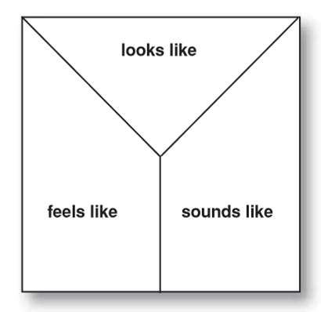

Silence is Violence

Resource #2 Image analysis
Image 1
Instructions
  - Record your initial impression of each image. You might consider the ideas it conveys, the issues it relates to, the perspective presented, the beliefs, values or attitudes represented, or your own personal response.
  - Annotate the image, paying close attention to visual features and their effect. Add to or modify your initial notes if you interpretation has changed.

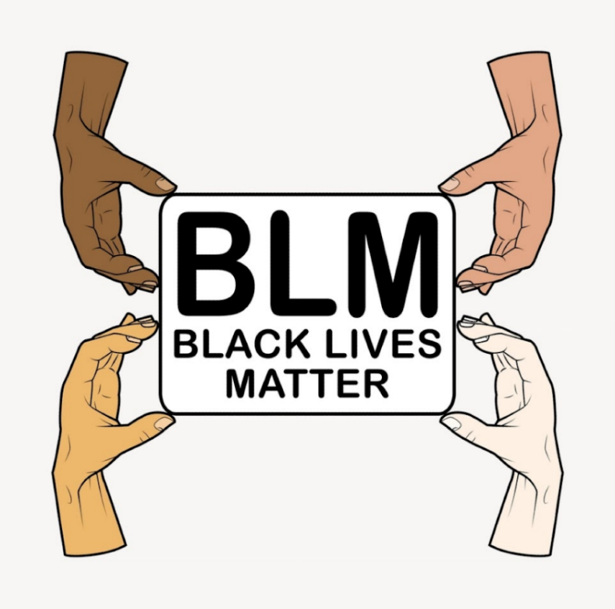

Image 2

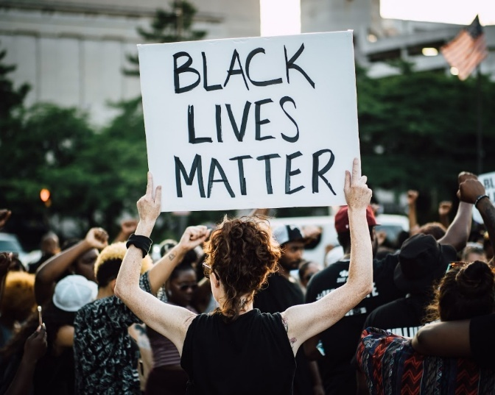

Image 3

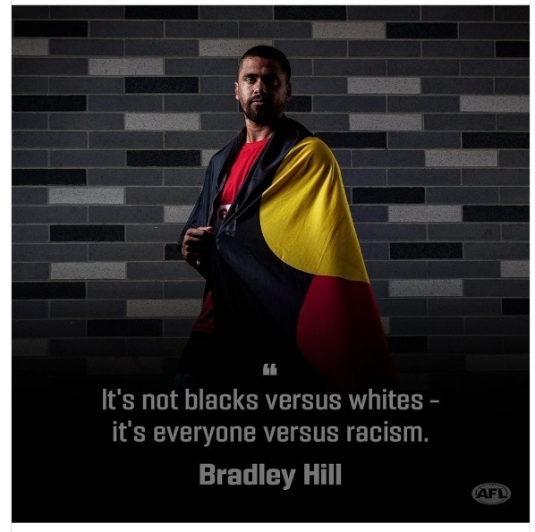

Image courtesy AFL Photos. © AFL Photos. All rights reserved

Resource #3 Representations of the Black Lives Matter movement in popular culture
Instructions
- View the comic strip, considering the effect of the words and images.
- Answer the following questions.
- Write down the Nic Naitanui tweet, then answer the proceeding questions.

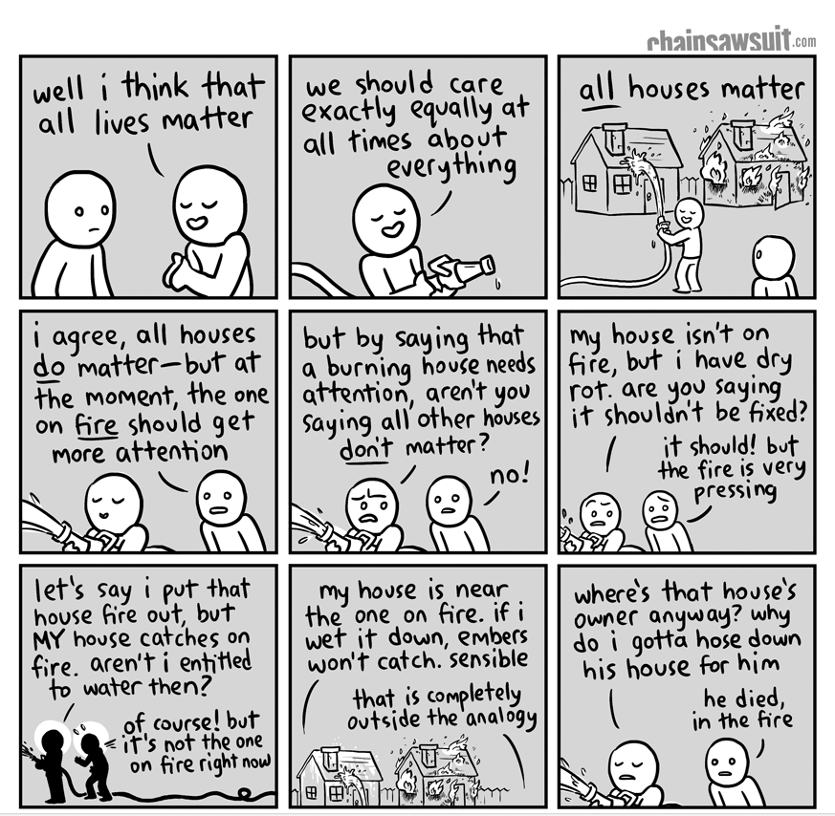
Perspective A: ‘All Things Considered’ – online comic strip by Kris Straub

Critical thinking questions

- Identify the purpose of a comic strip (e.g. to inform, entertain, interpret, etc.).

- Summarise the message of the comic strip.

- Is the phrase “all houses matter” inclusive or exclusive? Explain.

- Explain how the comic strip represents the Black Lives Matter movement.

- Evaluate the use of humour. Provide examples of how it functions. Is it effective in conveying a message about this topic?

Perspective B: Nic Naitanui tweet
- Write the tweet in full:

- Explain the purpose of the tweet (e.g. to inform, entertain, persuade, etc.)?

- In your own words, identify the perspective embedded in the tweet.

- Evaluate whether you think the perspective is effective. You might like to consider the context of the writer, the intended audience and the purpose.

Reflection
- Has either text (A or B) changed your perspective on the Black Lives Matter movement? Explain why or why not.

Resource #4 Visual and written features glossary

Visual Features

Term | Definition | Possible Effects
Colour | The use of different hues in an image. | Colours can evoke emotions (e.g., red for passion or danger, blue for calmness), highlight important elements, and create a mood or atmosphere.
Lighting | The way light is used in an image, including its source, intensity, and direction. | Lighting can create shadows, highlight certain areas, and influence the mood (e.g., bright light for happiness, dim light for mystery).
Composition | The arrangement of elements within an image. | Good composition can guide the viewer's eye, create balance or tension, and emphasize the main subject.
Framing | A way in which elements in a still or moving image are enclosed to create a specific interpretation of a whole. | Strong framing creates a sense of enclosure; weak framing creates a sense of openness.
Angle | The position from which the image is taken (e.g., high angle, low angle). | Angles can influence how the subject is perceived (e.g., a low angle can make a subject look powerful, a high angle can make it look vulnerable).
Focus | The clarity or sharpness of an image or part of an image. | Focus can draw attention to specific details, create a sense of importance, and blur out distractions.
Contrast | The difference between light and dark areas in an image. | High contrast can create drama and highlight differences, while low contrast can create a softer, more harmonious look.
Texture | The surface quality of an object in an image (e.g., rough, smooth). | Texture can make an image feel more realistic and tactile and can add interest and detail.
Symbolism | The use of one object, person or situation to signify or represent another, by giving them meanings that are different from their literal sense. | Symbols can convey deeper meanings and connect the image to broader themes or messages.
Body Language | The posture, gestures, and facial expressions of people in an image. | Body language can communicate emotions, attitudes, and relationships between subjects.
Proximity | The distance between elements in an image. | Proximity can suggest relationships, create a sense of unity or separation, and influence the overall composition.
Scale | The size of objects in relation to each other. | Scale can emphasise importance, create a sense of depth, and affect the viewer's perception of the scene.
Salience | A strategy of emphasis, highlighting what is important in a text. In images, it is achieved through strategies, such as the placement of an item in the foreground, size and contrast in tone or colour. | Highlights key elements, draws attention, and emphasises importance.
Vector | The path that the viewer's eye takes through a visual composition, often created by lines, shapes, or the arrangement of elements. | Creates flow and connects elements.
Leading Lines | Lines within an image that lead the viewer's eye to a particular point of interest, creating a sense of direction and focus. | Directs attention, creates depth, and enhances focus on key areas.
Types of angles
Different camera angles used to create various effects and perspectives.
High Angle | A shot taken from above the subject. | Creates a sense of vulnerability, diminishes power, and makes the subject appear smaller or weaker.
Low Angle | A shot taken from below the subject. | Enhances power, creates dominance, emphasise importance, makes the subject appear larger.
Eye Level | A shot taken at the subject's eye level, creating a neutral and balanced perspective. | Creates equality, fosters connection, and provides a natural viewpoint.
Dutch Angle | A tilted shot. | Creates a sense of unease, tension, or disorientation.
Types of Shots
Different shot sizes used to convey various effects and focus.
Close-Up | A shot that tightly frames a subject. | Highlights emotions, emphasises details, and creates intimacy.
Medium Shot | A shot that shows the subject from the waist up. | Balances subject and background, provides context, and maintains focus.
Long Shot | A shot that shows the subject in its entirety along with the surrounding  Environment. | Establishes setting, shows scale, and provides context.
Extreme Close-Up | A shot that focuses on a very small detail of the subject. | Highlights minute details, creates intensity, and draws attention to specifics.
Wide Shot | A shot that shows a broad view of the scene. | Provides an overview, establishes context, and shows scale.

Written features
Term | Definition | Possible Effects
Slogan | A short, memorable phrase used to  convey an idea or promote a product. | Creates a lasting impression;  reinforces the message;  encourages recall.
Headline | The main title or heading of a poster  or image. | Captures attention,  summarises the main idea, and draws the viewer in.
Subheading | A secondary heading that provides  more detail about the main headline. | Adds context, breaks up text,  and guides the viewer's  understanding.
Call to Action | A statement that encourages the  audience to take a specific action. | Motivates the viewer to act,  such as visiting a website,  making a purchase or joining  an event.
Typography | The style, arrangement, and appearance of text. | Influences readability, sets the  tone and can evoke emotions.
Colour Scheme | The selection of colours used in the  text and background. | Creates mood, highlights  important information, and  enhances visual appeal.
Font Style | The design of the text, including  typeface, size, and weight. | Conveys tone, emphasises key points, and affects readability.
Layout | A spatial arrangement of print and graphics on a page or screen, including text size, font, positioning of illustrations, captions, labels, headings, dot points, borders and text boxes. | Guides the viewer's eye,  creates balance and improves  readability.
Repetition | A word, phrase, full sentence or  poetic line repeated to emphasise its significance. Repetition is a language feature and a cohesive device. | Reinforces the message,  creates rhythm and makes the content more memorable.

Resource #5 KWL chart
Slam Poetry
What I know | What I wonder | What I learned

Resource #5 I’m a Blackfella poem analysis
Steven Oliver: I'm a Blackfella
Comprehension
- Identify and describe stereotypes mentioned by Steven Oliver in his poem.

- Explain how the speaker describes his identity in contrast to these stereotypes.

- Explain what the speaker means by "I just don’t condone silence".

Analysis
- Outline how Steven Oliver uses tone and volume to emphasise key points in the poem.

- Identify and explain the use of any metaphors or similes in the poem.

- Using examples, describe how the pacing of the poem changes throughout the performance and explain the effect this has on the audience.

- Discuss the impact of Oliver's body language and facial expressions during his performance. How do these elements enhance the meaning of the poem?

Reflection
- Describe how the poem makes you feel. Why do you think you had this reaction?

- Outline steps individuals and communities can take to challenge and change the stereotypes and misconceptions addressed in the poem.

Resource #6 Writing a personal reflection

Objective

Create a personal response that reflects on how the various texts represent people and groups, and shape values, attitudes and beliefs.

Due Date: ___________________________

Steps:

Summarise your learning

Respond to each text

Write your reflective piece

Reviewing and editing.

Planning Booklet

Step 1. Summarise your learning
What was your view of the Black Lives Matter movement before completing the activities?
What is your view now? Fill in the table below to track any changes.

Before | Now

Step 2. Respond to each text
Revisit the questions and analysis you completed for each of the texts. If you left any questions blank, complete them now. You may also like to expand or add to your answers.

Step 3. Write your reflective piece

Structure:
1. Introduction
Outline the Black Lives Matter movement and the describe texts you studied

State the purpose of your reflective piece

2. Body:
Paragraph 1: Comic strip
Summarise the message of the comic

Describe how the comic represents people and groups

Discuss how the comic shapes beliefs, values, and/or attitudes, using examples

Paragraph 2: Images
Describe the key visual elements in the images

Explain how the images represent the Black Lives Matter movement

Discuss how the images shape beliefs, values, and/or attitudes, using examples

Paragraph 3: Poem
Summarise the perspective and messages of the poem

Describe how the poem represents the identity and experiences of Aboriginal people

Discuss how the poem shapes beliefs, values, and/or attitudes, using examples.

3. Conclusion
Discuss the overall impact of the texts on your understanding of social justice and equality

Step 4: Reviewing and editing
Checklist:
- Have you answered all the guiding questions?
- Is your reflective piece well-organised and clear?
- Optional: Have you typed your reflective piece or written a final copy?
- Have you used specific examples from the texts to support your reflections?
- Have you checked your work for spelling and grammar mistakes?

© Department of Education Western Australia 2025.This product has been generated or modified using artificial intelligence and to the extent that copyright subsists in it, the copyright is retained by the Department of Education Western Australia.

