English | Year 7/8
3.2 Attitudes and perspectives: Mutual respect, Civic values, fairness, equality and participations
____________________________________________________________________________________________________

Focus 19: The rights of children

Lesson overview

In this lesson sequence, students will explore the United Nations Convention on the Rights of the Child and examine how children’s rights are represented in multimedia texts. Through class debates, collaborative activities, and critical analysis of the "Seeking Refuge" episode, students will identify key human rights for children, analyse how literary and visual features communicate perspectives, and connect the narrative to broader global principles of fairness and equality. This approach encourages students to consider multiple viewpoints and the significance of human rights, particularly in the experiences of child refugees.

Cultural safety considerations
The cultural safety of Aboriginal and Torres Strait Islander students, and culturally and linguistically diverse (CaLD) students must be a priority when planning and delivering these lessons.
Teachers are expected to establish a learning environment that is culturally, psychologically, spiritually, physically, and emotionally safe for all students, particularly for Aboriginal and CaLD students. Culturally responsive teaching practices should aim to create the conditions for students, staff, and families to experience cultural safety in schools and remove and minimise harmful experiences, such as racism in all its forms. Teachers should remain mindful of assumptions, stereotypes and unconscious biases and apply strategies to mitigate them.
Engaging in meaningful teaching and learning about multiculturalism and anti-racism requires teachers to create the conditions for cultural safety in the planning, delivery and assessment of lessons. This includes:
- knowing students’ cultural backgrounds and understanding how this may be relevant to (or impact) the learning environment
- letting students and families know about the planned content and resources in advance so that they can prepare for the learning, and contribute where safe to do so
- knowing any cultural protocols in advance that may impact the lesson (for example, using a disclaimer at the start of a film about people who may have passed away)
- knowing the sensitive language that may cause harm (for example, removing racial slurs or hate speech in films)
- not assuming that students or staff will want to share their cultural backgrounds and lived experiences with their peers during the lesson
- not calling on students during lessons without warning about content that has the potential to make them feel uncomfortable or singled out
- allowing for students, staff and families to provide input and feedback when they feel cultural safety in the planning, delivery and evaluation of lessons
- where possible, checking in with students and seeking their feedback on the activities and learning, if they feel culturally safe to do so.

Lesson specific considerations
Activity 2 contains a video told from the perspective of a child refugee and details the trauma of dislocation. Teachers should view this resource prior to commencing the lesson to determine its appropriateness to the context of their students and school.

Curriculum content
Year 7 | Year 8
Literature: Engaging with and responding to literature
Explain the ways that literary devices and language features, such as dialogue, and visual and audio features are used to create character, and to influence emotions and opinions in different types of texts WA7ELIEN1 | Explain how language and/or visual and audio features in texts position listeners, readers and viewers to respond and form perspectives  WA8ELIEN1
Language: Language for expressing and developing ideas | Language: Text structure, organisation and features
Analyse how techniques, such as vectors, angle and/or framing in visual and multimodal texts can be used to create a perspective WA7ELALA3 | Explain how text structures and language features vary depending on their purpose, recognising that some texts are hybrids that combine different genres or elements of different genres  WA8ELAT1

Learning intention
Students will learn about the United Nations Convention on the Rights of the Child and how these rights are represented and explored in multimedia texts.

Success criteria
Students will:
- identify and explain the basic human rights all children are entitled to
- analyse the use of literary devices and visual/audio features in the Seeking Refuge episode
- connect the perspective of the episode to the United Nations Convention on the Rights of the Child.

Key terminology
- Asylum seeker - a person who has left their own country and applied for protection as a refugee but whose claim has not yet been determined.
- Human rights - the basic rights and freedoms that belong to every person, such as equality, freedom, and dignity.
- Multimodal - involving or combining two or more modes of communication, such as written, spoken, visual, or digital forms.
- Perspective - the viewpoint from which the author/creator has chosen to perceive the world, or the viewpoint from which the reader or viewer perceives the world and understands a text. People and characters may have different perspectives on events or issues due to (for example) their age, gender, social position and beliefs and values.
- Refugee - a person who flees their country due to war, persecution, or disaster, seeking safety elsewhere.
- Signify - to be a sign of something or to represent or express a particular meaning.
- United Nations - an international organisation established to promote peace, cooperation, and human rights among countries.
- Values - ideas that individuals and groups regard as being worthwhile and important. Our beliefs influence our values.

Suggested discussion
- What basic human rights are all children entitled to?
- In what ways do the rights outlined in the United Nations Convention on the Rights of the Child promote fairness and equality for all children?
- What does the perspective of a child teach us about mutual respect and fairness?
- How can understanding the rights of children and the experiences of child refugees influence our attitudes and actions towards promoting participation and equality for all children?

Activity 1: Exploring the United Nations Convention on the Rights of the Child

Resources required:
- Appendix Resource #1 Four corners debate signs
- Student access to The United Nations Convention on the Rights of the Child (children’s version) (printed or digital).

- Print Resource #1 and display one sign in each corner of the room.

- Read out the following statements and direct students to move to the corner of the room that best aligns with their opinion for each one:
- Every child should have the right to free education.
- Children should have the right to express their opinions freely.
- All children should have access to healthcare, regardless of their family's income.
- Children should be protected from all forms of violence and abuse.
- Children should be allowed to work if they want to earn money.
- Every child should have the right to play and leisure.
- Children should be involved in decisions that affect their lives.
- Children should be required to do chores at home to learn responsibility.
- All children should have the right to practice their own culture, religion, and language.
- Children should not be allowed to stay up past 9 PM on school nights.

Optional: Call on one or 2 students to justify their opinions to each statement.

- On the board, write the following statement: “Children should have the right to…”
- Ask students to list of all the rights they think children are entitled to (e.g. food, clean water, education).
- Call on students to share what they have written and compile a class list.

- Introduce the key terminology: values and human rights and provide students access to The United Nations Convention on the Rights of the Child (children’s version).

- Read through the document and facilitate a discussion, asking students to return to the list of rights and compare to the Convention on the Rights of the Child. Ask students to add these to their lists.

- After reading, discuss the following:
- What basic human rights are all children entitled to?
- In what ways do the rights outlined in the UN Convention promote fairness and equality for all children?

Activity 2: Examining a child refugees’ perspective

Resources required:
- Appendix Resource #2 Viewing comprehension
- Appendix Resource #3 Glossary table for analysing Seeking Refuge
- Appendix Resource #4 Seeking Refuge video analysis.

- Distribute Resource #2 and direct students to complete the viewing questions while watching Seeking Refuge: From A to B and Back Again (this video can be accessed through ClickView From A to B and Back Again Video & Resources | ClickView or Mosaic Films https://www.mosaicfilms.com/film-and-tv/bbc-seeking-refuge or Animated Minds https://www.animatedminds.com/seeking-refuge).
- When the video has finished, ask students to complete the post-viewing questions and facilitate a class discussion of the answers.

- Distribute Resource #4 and Resource #5. Support students by modelling an answer to one of the questions. Allow time to complete the video analysis and review answers.

Reflection
Conclude by linking the activities to each other and to the topic by posing the following questions:
- What human rights are represented in the video?
- What does the perspective of the child teach us about mutual respect and fairness?
- Reflecting on both activities, how can understanding the rights of children and the experiences of child refugees influence our attitudes and actions towards promoting participation and equality for all children?

Resource #1 Four corners debate signs

Strongly
Agree

Agree

Disagree

Strongly Disagree

Resource #2 Viewing comprehension

Viewing questions
- Describe the main challenges faced by the child in the video.

- Summarise how the child feels about leaving their home country.

- Outline the emotions expressed by the child throughout the video.

- Explain how the child's journey impacts their sense of identity and belonging.

Post-viewing questions
- Explain how the child's experiences in the video highlight the importance of certain rights, using examples.

- Explain how the challenges faced by the child in the video relate to the rights outlined in the UN Convention.

Resource #3 Glossary table for analysing Seeking Refuge

Visual Features

Term | Definition
Placement | The arrangement of visual elements in a frame to create meaning or  focus attention.
Salience | The prominence or importance given to certain elements in a visual text,  making them stand out to the viewer.
Framing | The way visual elements are positioned within the boundaries of a  frame to create a specific perspective or focus.
Representation of Action or Reaction | How actions or reactions are depicted visually to convey meaning or  emotion.
Shot Size | The distance between the camera and the subject, ranging from  close-ups to long shots, affecting how much of the subject and  background is visible.
Camera Angle | The angle at which the camera is positioned relative to the subject,  influencing the viewer's perception and interpretation of the scene.
Vector | The path that the viewer's eye takes through a visual composition, often created by lines, shapes, or the arrangement of elements.
Leading Lines | Lines within an image that lead the viewer's eye to a particular point of  interest, creating a sense of direction and focus.
Kinetic  Typography | The use of animated text to convey meaning, emotion, or emphasis,  often by moving, changing, or interacting with other visual elements.
Symbols | Objects, characters, or images that stand for larger ideas or concepts,  often using colour to convey additional meaning or emotion.
Motifs | Recurring elements that have symbolic significance in the  narrative.
Types of Angles
Different camera angles used to create various effects and perspectives.
High Angle | A shot taken from above the subject, making the subject appear  smaller, weaker, or more vulnerable.
Low Angle | A shot taken from below the subject, making the subject appear larger, stronger, or more powerful.
Eye Level | A shot taken at the subject's eye level, creating a neutral and balanced perspective.
Dutch Angle | A tilted shot that creates a sense of unease, tension, or disorientation.
Types of Shots
Different shot sizes used to convey various effects and focus.
Close-Up | A shot that tightly frames a subject, often used to show detail or  emotion.
Medium Shot | A shot that shows the subject from the waist up, balancing detail and  context.
Long Shot | A shot that shows the subject in its entirety along with the surrounding  environment, providing context and setting.
Extreme Close-Up | A shot that focuses on a very small detail of the subject, emphasising its importance or creating an intense effect.
Wide Shot | A shot that shows a broad view of the scene, often used to establish the setting or show the scale of the environment.

Audio Features

Term | Definition
Music | Background music used to enhance the mood, atmosphere, or emotional impact of a scene.
Sound Effects | Artificially created or enhanced sounds used to emphasise  actions, create atmosphere, or convey information.
Diegetic  Sounds | Sounds that originate from within the world of the film, such as dialogue, footsteps or ambient noise.
Voice Over | Narration provided by an off-screen voice, often used to provide  context, commentary, or insight.
Dialogue | Spoken exchanges between characters, used to convey information,  develop relationships or advance the plot.

Written Features

Term | Definition
Captions | Text displayed on the screen to provide additional information, such as  translations, explanations, or descriptions.
Titles | Text that introduces sections of the documentary, provides context, or  highlights key points.
Signs and  Labels | Text within the film's environment, such as street signs, posters, or  product labels, which provide context or contribute to the narrative.

Resource #4 Seeking Refuge video analysis
1. What are the connotations of the title Seeking Refuge? Does this have different implications to the word refugee? Why or why not?

__________________________________________________________________________________________________________________________________________________________________________________________________________________________________________
______________________________________________________________________________

2. The narration is told from the first-person perspective of a child. What is the effect of this? Is it more impactful that she is telling her own story versus another person or an unnamed narrator?

__________________________________________________________________________________________________________________________________________________________________________________________________________________________________________
______________________________________________________________________________

3. 0:51 - A shot of the UK is shown with four different symbols. What do these symbols represent? What is the purpose of this shot?

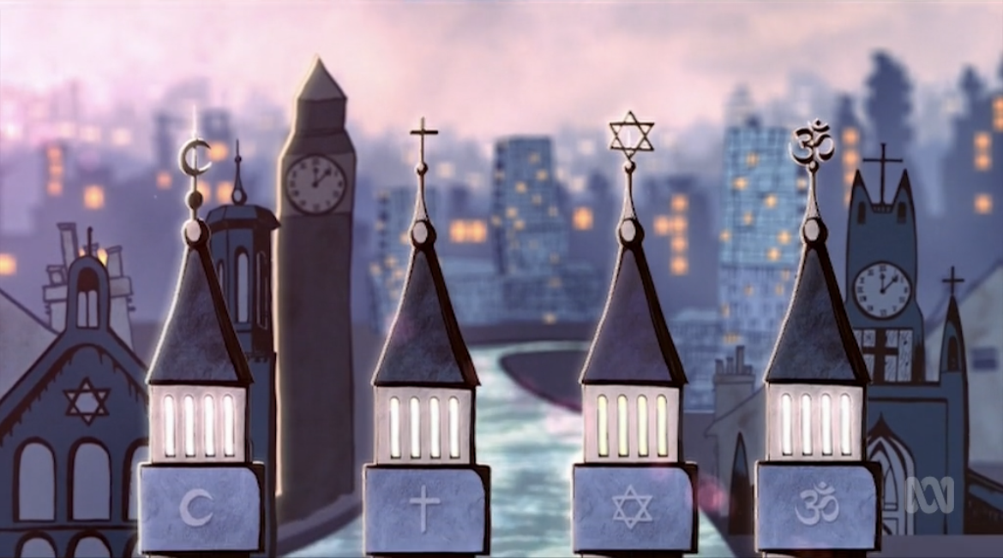

__________________________________________________________________________________________________________________________________________________________________________________________________________________________________________
______________________________________________________________________________

4. 1:02 - What is the purpose of the shadows? What do they symbolise?

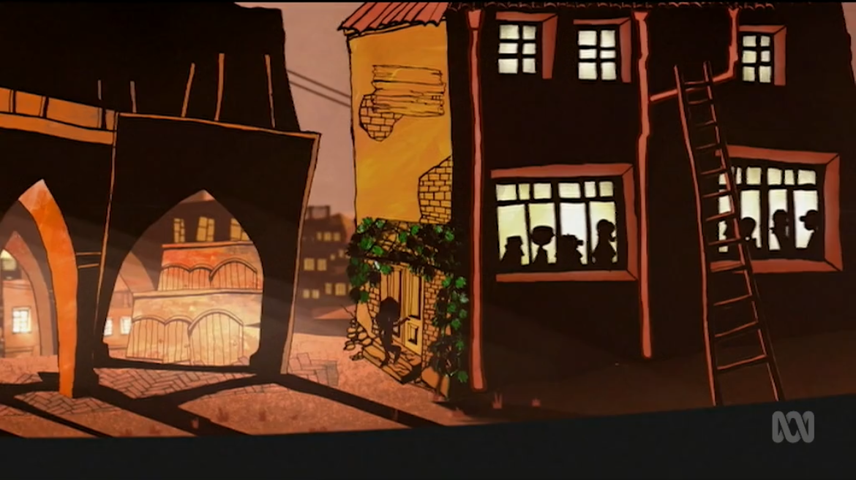

_________________________________________________________________________________________________________________________________________________________________________________________________________________________________________
______________________________________________________________________________
5. 1:12 - Pay attention to the framing of this shot. Describe the vector. What elements serve as leading lines? Where is your eye drawn in this shot and what is the effect?

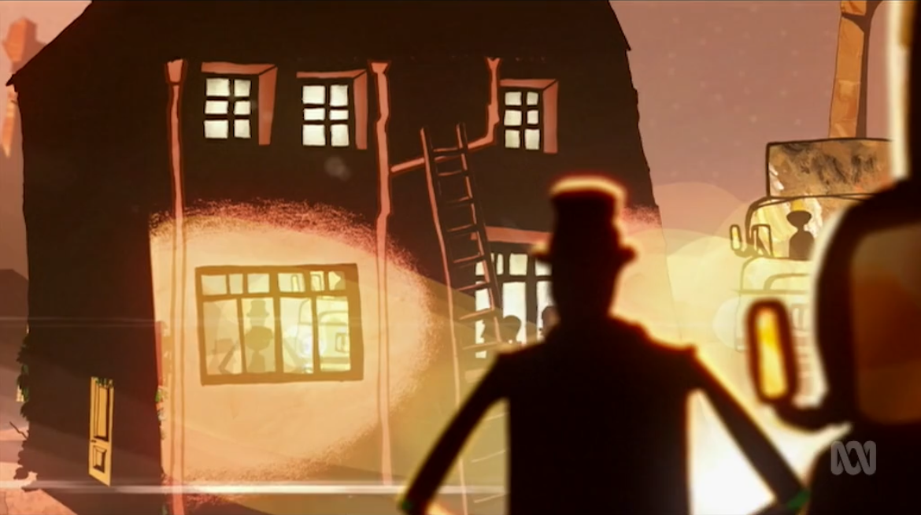

__________________________________________________________________________________________________________________________________________________________________________________________________________________________________________
______________________________________________________________________________

6. 1:58 - Describe the vector. What is the significance of the leading lines? What does the light symbolise?

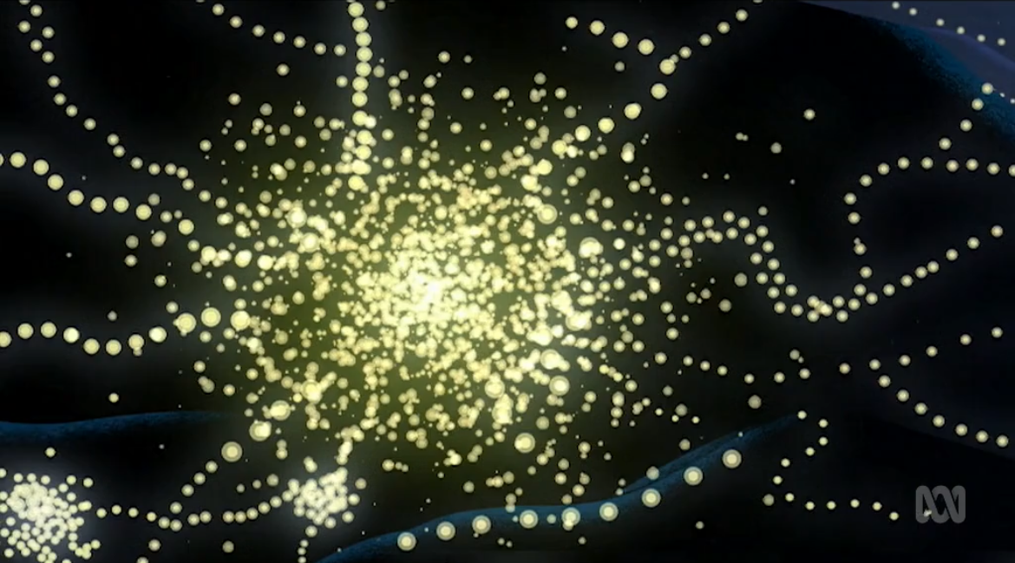

__________________________________________________________________________________________________________________________________________________________________________________________________________________________________________
______________________________________________________________________________

7. 1:59-2:10 - What is the significance of light and music? How does this create a contrast with previous shots and lighting? What meaning is created here?

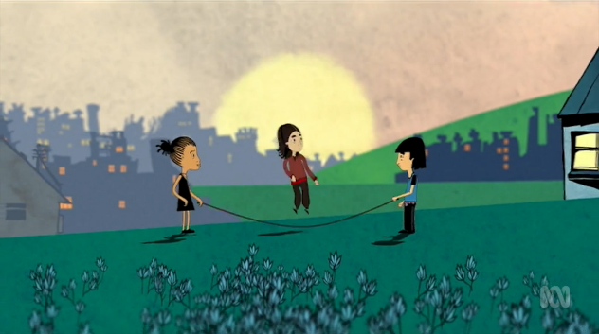
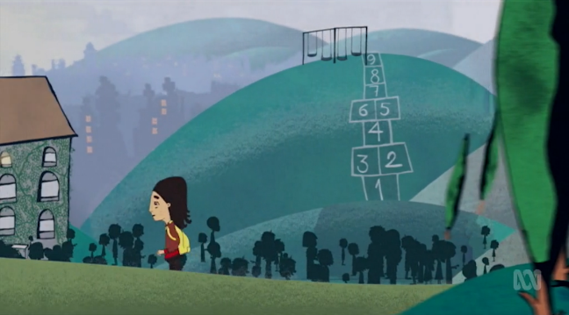

__________________________________________________________________________________________________________________________________________________________________________________________________________________________________________
______________________________________________________________________________

8. 2:11-2:19 - The words on the letter of rejection fall down and fall apart (kinetic typography). What does this signify?

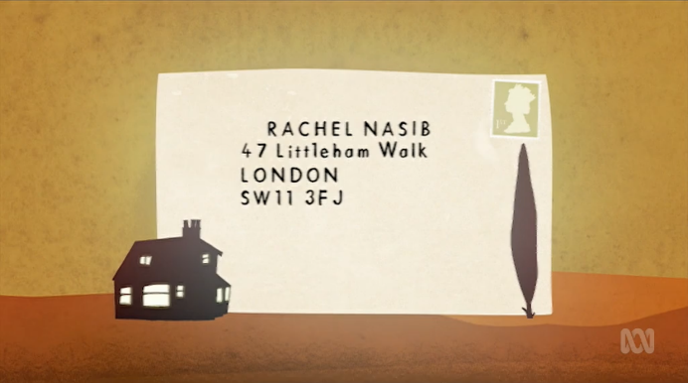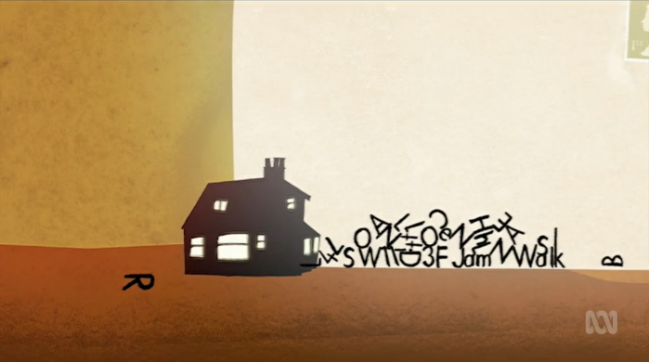

__________________________________________________________________________________________________________________________________________________________________________________________________________________________________________
______________________________________________________________________________

9. 2:25-2:27 - What is the effect of the low camera angle in these shots, combined with the music used?
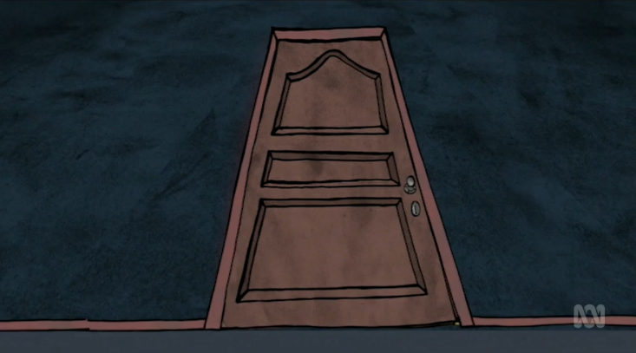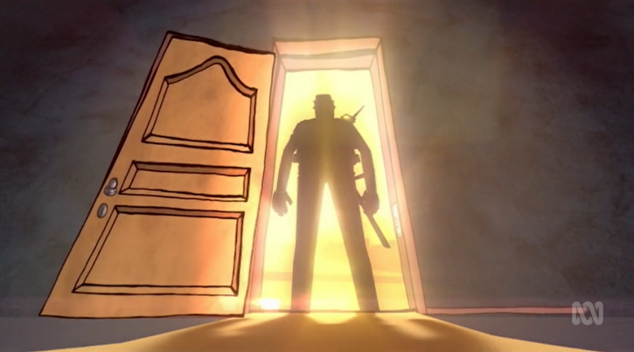

__________________________________________________________________________________________________________________________________________________________________________________________________________________________________________
______________________________________________________________________________

10. 2:46 - This shot shows the detention centre. What is the effect of the framing and placement here? Consider the lighting, shadow, objects, colour, etc.
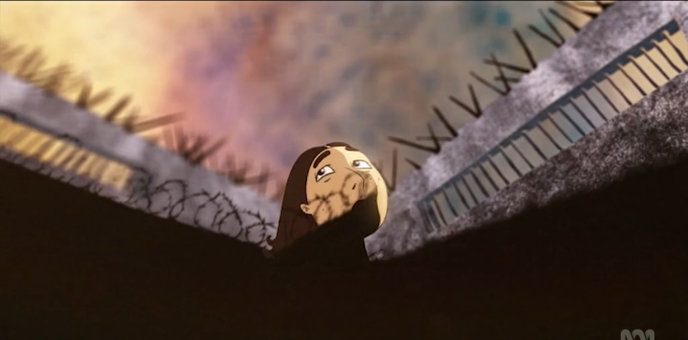

__________________________________________________________________________________________________________________________________________________________________________________________________________________________________________
______________________________________________________________________________

11. 2:54 - In this sequence a mid-shot is used that zooms out to an extreme long shot. How do you respond to this?

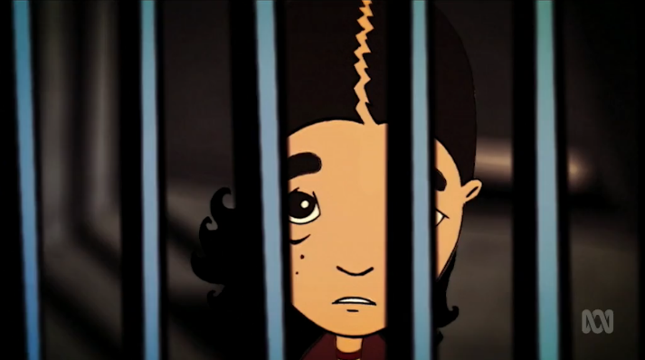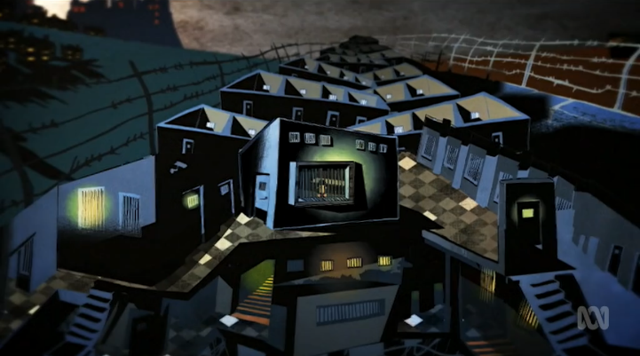

__________________________________________________________________________________________________________________________________________________________________________________________________________________________________________
______________________________________________________________________________

12. 3:50 - What does the movement in these shots convey about the family?
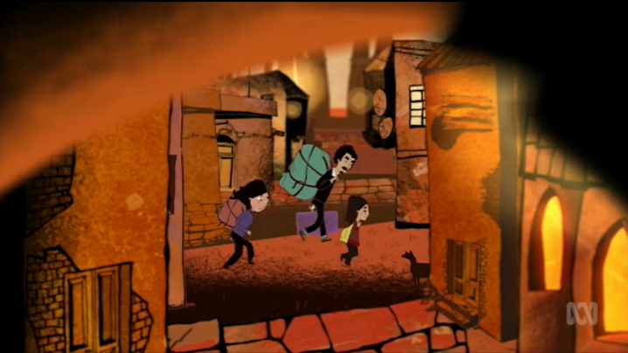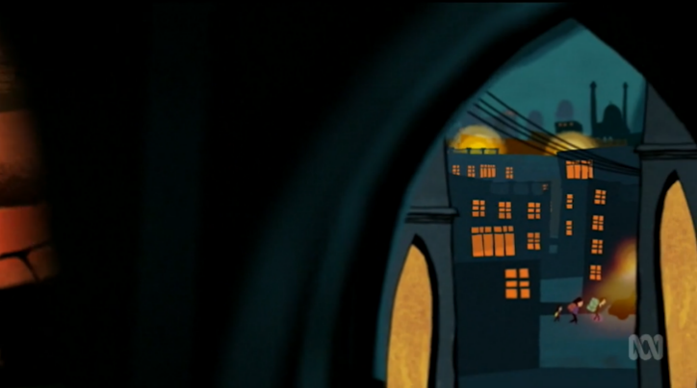

__________________________________________________________________________________________________________________________________________________________________________________________________________________________________________
______________________________________________________________________________

13. Describe the music and lighting at the end of the film. What does this represent? How does it contrast earlier scenes?

__________________________________________________________________________________________________________________________________________________________________________________________________________________________________________
______________________________________________________________________________

14. Has the film altered your perspective of asylum seekers and refugees in any way? Explain.
__________________________________________________________________________________________________________________________________________________________________________________________________________________________________________
______________________________________________________________________________

15. What features (visual, audio, written, etc.) of the film did you find most impactful and why? You may consider any features that affected your perspective.
__________________________________________________________________________________________________________________________________________________________________________________________________________________________________________
______________________________________________________________________________

© Department of Education Western Australia 2025.This product has been generated or modified using artificial intelligence and to the extent that copyright subsists in it, the copyright is retained by the Department of Education Western Australia.

