English | Year 9/10

3.2 Attitudes and perspectives: Mutual respect, civic values, fairness, equality and participations
____________________________________________________________________________________________

Focus 20: Principles of multiculturalism and active citizenship

Lesson Overview

This lesson sequence introduces students to the key principles of the Western Australian Multicultural Policy Framework and asks them to consider on how these values are reflected within their school. Through discussion, research, and formal letter writing, students will explore ways to promote inclusivity and active citizenship in their school community.

Teaching note

These activities are designed to take place over 1-2 lessons. Teachers may choose to condense or expand the activities, dependent on student needs and time constraints.

Cultural safety considerations
The cultural safety of Aboriginal and Torres Strait Islander students, and culturally and linguistically diverse (CaLD) students must be a priority when planning and delivering these lessons.
Teachers are expected to establish a learning environment that is culturally, psychologically, spiritually, physically, and emotionally safe for all students, particularly for Aboriginal and CaLD students. Culturally responsive teaching practices should aim to create the conditions for students, staff, and families to experience cultural safety in schools and remove and minimise harmful experiences, such as racism in all its forms. Teachers should remain mindful of assumptions, stereotypes and unconscious biases and apply strategies to mitigate them.
Engaging in meaningful teaching and learning about multiculturalism and anti-racism requires teachers to create the conditions for cultural safety in the planning, delivery and assessment of lessons. This includes:
- knowing students’ cultural backgrounds and understanding how this may be relevant to (or impact) the learning environment
- letting students and families know about the planned content and resources in advance so that they can prepare for the learning, and contribute where safe to do so
- knowing any cultural protocols in advance that may impact the lesson (for example, using a disclaimer at the start of a film about people who may have passed away)
- knowing the sensitive language that may cause harm (for example, removing racial slurs or hate speech in films)
- not assuming that students or staff will want to share their cultural backgrounds and lived experiences with their peers during the lesson
- not calling on students during lessons without warning about content that has the potential to make them feel uncomfortable or singled out
- allowing for students, staff and families to provide input and feedback when they feel cultural safety in the planning, delivery and evaluation of lessons
- where possible, checking in with students and seeking their feedback on the activities and learning, if they feel culturally safe to do so.

Curriculum content
Year 9 | Year 10
Language: Language for interacting with others
Recognise how language empowers relationships and roles WA9ELAI1 | Understand how language can have inclusive and exclusive social effects, and can empower or disempower people WA10ELAI1
Literacy: Creating texts
Plan, create, edit and publish written and multimodal texts, organising, expanding and developing ideas, and selecting text structures, language features, literary devices and multimodal features for purposes and audiences in ways that may be imaginative, reflective, informative, persuasive, analytical and/or critical WA9ELYC1 | Plan, create, edit and publish written and multimodal texts, organising, expanding and developing ideas through experimenting with text structures, language features, literary devices and multimodal features for specific purposes and audiences in ways that may be imaginative, reflective, informative, persuasive, analytical and/or critical WA10ELYC1

Learning intention
Students are learning about the principles embedded in the Western Australian Multicultural Policy Framework (2020) and how these translate to their school context.

Success criteria
Students will:
- list the four key values of the framework
- examine ways in which their school embodies the values of the framework and opportunities to strengthen multiculturalism on campus
- draft and write a letter to the principal outlining opportunities to promote multiculturalism.

Key terminology
- Citizen - a person who legally belongs to a country and has certain rights and responsibilities within it.
- Civic values - shared beliefs and principles that guide people to act responsibly and respectfully as members of a community.
- Formal language - a style of communication that is more structured, polite, and precise, often used in academic or professional settings.
- Inclusion - occurs when people feel, and are, valued and respected regardless of their personal characteristic or circumstance, and where they:
- have the opportunity to fulfil their individual and combined potential
- have access to opportunities and resources
- can contribute their personal best in every encounter
- can contribute their perspectives and talents to improve their organisation
- can bring far more of themselves to their jobs
- have a sense of belonging.
- Social cohesion - the sense of trust, connection, and cooperation that keeps a community or society united.
- Policy framework - a set of rules and guidelines that governments or organisations use to shape decisions and actions.

Suggested discussion
- What is multiculturalism?
- What is the WA Charter of Multiculturalism?
- What do the principles of civic values, fairness, equality and participation mean?
- What is social cohesion and how does it connect to multiculturalism?
- What could be included in a charter of multiculturalism at our school?
Activity 1 - Examining the WA Charter of Multiculturalism

Resources required:
- Student access to devices
- Student access to the WA Charter of Multiculturalism (digital or printed)
- Appendix Resource #1 Student worksheet: Charter rationale.

- Ask students what the word ‘citizen’ means and where they hear the word citizen.
- For example: Citizen Kane, Citizen watches, citizenship tests, senior citizens, citizen’s arrest, citizenship awards.
- Instruct students to write down their definition of the word ‘citizen’
- Discuss responses as a whole class, then offer a formal definition (a citizen is a person who legally belongs to a country and has the rights and protection of that country.)

- Explain that it is the role of government is to ensure that all its citizens are offered the rights and protection of their country.
- Facilitate a discussion by asking: In multicultural countries such as Australia, what do you think these rights and protections might look like?
- The WA Charter of Multiculturalism, created in 2004 explicitly recognises that the people of Western Australia are of different linguistic, religious, racial and ethnic backgrounds, and to promote their participation in democratic governance within an inclusive society.
- Discuss and clarify students’ understanding of the term charter and ask them to predict what they expect will be in the WA Charter of Multiculturalism.
  - Teacher may provide the following definition A charter is a contract by which a body such as a city, company, or school is founded or its rights and privileges defined.

- Instruct students to complete quick research to answer the following questions and report back to the class:
- How many different cultures are there currently in WA?
- Has this demographic changed significantly from 2004?
- Is this diversity reflected within our own school?

- Provide students the WA Charter of Multiculturalism as a handout (or electronically) and Resource #1.
- Read former WA Premier Geoff Gallop’s introduction and ask: What is the ultimate goal of the Charter? (i.e. to achieve equality for all).
- Focus on Gallop’s statement, “In a democracy such as ours, citizenship refers to a practice as well as a status”.

- Work with the class to complete the brainstorm in Step 1 of the Resource #1.
- Through discussion, encourage students to recognise small-scale and larger scale examples of active citizenship such as:
  - participating in community life & decision-making
  - engaging in everyday practices of listening, negotiating and compromise
  - contesting examples of inequality
  - contributing to shaping future of community.
- Further clarify the intentions of the charter by reading the remainder of the Rationale Statement together and encourage students to simplify into their own words.
- Direct students to fill out their response on Step 2 of Resource #1.
- Note: the WA Charter of Multiculturalism informed the WA Multiculturalism Framework (2022) which provides guidance and structure for agencies to achieve the Government’s vision for multiculturalism.

Activity 2 - Advocating for inclusivity
Write a persuasive letter to the principal to promote citizenship and multiculturalism

Resources required:
- Appendix Resource #2 Student worksheet: Infographic (A3 preferred)
- Appendix Resource #3 Scaffold for writing: school context example
- Appendix Resource #4 Teacher letter exemplar
- Envelopes for students to post letters (optional).

- Explain to students that they will write a formal letter to advocate for greater inclusivity, according to the principles outlined in the WA Charter for Multiculturalism.
- This will be a demonstration of active citizenship.
- They will plan, create, edit and may choose to send a letter using formal letter writing conventions and appropriate language.

- Provide students with Resource #2 to brainstorm solutions and/or ideas for strengthening multicultural principles within their chosen context (i.e. school, sports club, community group).
- Note: Resource #2 is scaffolded for a school context.
- Allow time for students to investigate and evaluate their adherence to these 4 principles using their own anecdotes and research.
- If choosing the school, this research may include a review of the school’s website, or informal discussions with fellow students - both inside and outside the classroom.
- Research can also be undertaken to devise new initiatives they might like to suggest.
- Peer discussion or a teacher check-in may be valuable upon completion of the worksheet to ensure student ideas are logical and workable before progressing to drafting stage.

- Distribute Resource #3 to explain the specific requirements of this letter writing task.
- Students should have a minimum of 2 main body paragraphs which reflect 2 of the multiculturalism principles and their ideas to support multiculturalism.
- Australia Post’s letter sample shows appropriate formatting for a formal letter.
- Resource #4 is an example of how the letter should look and sound for students.
  - Draw attention to how it adheres to the suggested structure, has a consistent formal tone and engages with the Multiculturalism Charter.
- Provide students with time to individually review, organise ideas and draft a letter.

- Once drafts are completed, encourage students to complete an individual or peer review and edit. This editing process may include:
- Step 1 - replacing contractions with formal equivalents (don’t vs do not)
- Step 2 – inserting 3x words from the class ‘transitions cloud’ into their letter
- Step 3 – reading letter aloud to editing partner to recognise awkward phrasing
- Step 4 – correcting grammatical and spelling errors highlighted in Word
- Step 5 – referencing task sheet/rubric (if using) to ensure key criteria has been considered

- Encourage students to print out letters and handwrite the address on an envelope.
- Congratulate students on their active citizenship and efforts to promote inclusivity.

Reflection
- Outline ways you can assert your citizenship in other ways that may benefit the school and/or the community?
- Explain how this task has or has not changed your understanding of, and approaches to, multiculturalism.
- How can you approach issues surrounding multiculturalism from a position of fairness and equality?

Resource #1 Student worksheet: Charter rationale

STEP 1:
“In a democracy such as ours, citizenship refers to a practice as well as a status.”

How can I practice citizenship?

STEP 2:
How do these emboldened ‘considerations’ enable multicultural civilians to practice citizenship?

In pursuing the goals of democratic citizenship, the Government of Western Australia recognises the need to individualise service delivery if it is to guarantee equitable treatment for all. It recognises that universalist provision of services in the public sector may obscure the distinctive needs of minority communities and cultures. At the core of its policy of enabling Western Australians to practise a democratic citizenship, the State is committed to recognising the diversity present within its population, and to retain a respect for difference in the planning and delivery of services.

Resource #2 Student worksheet: infographic
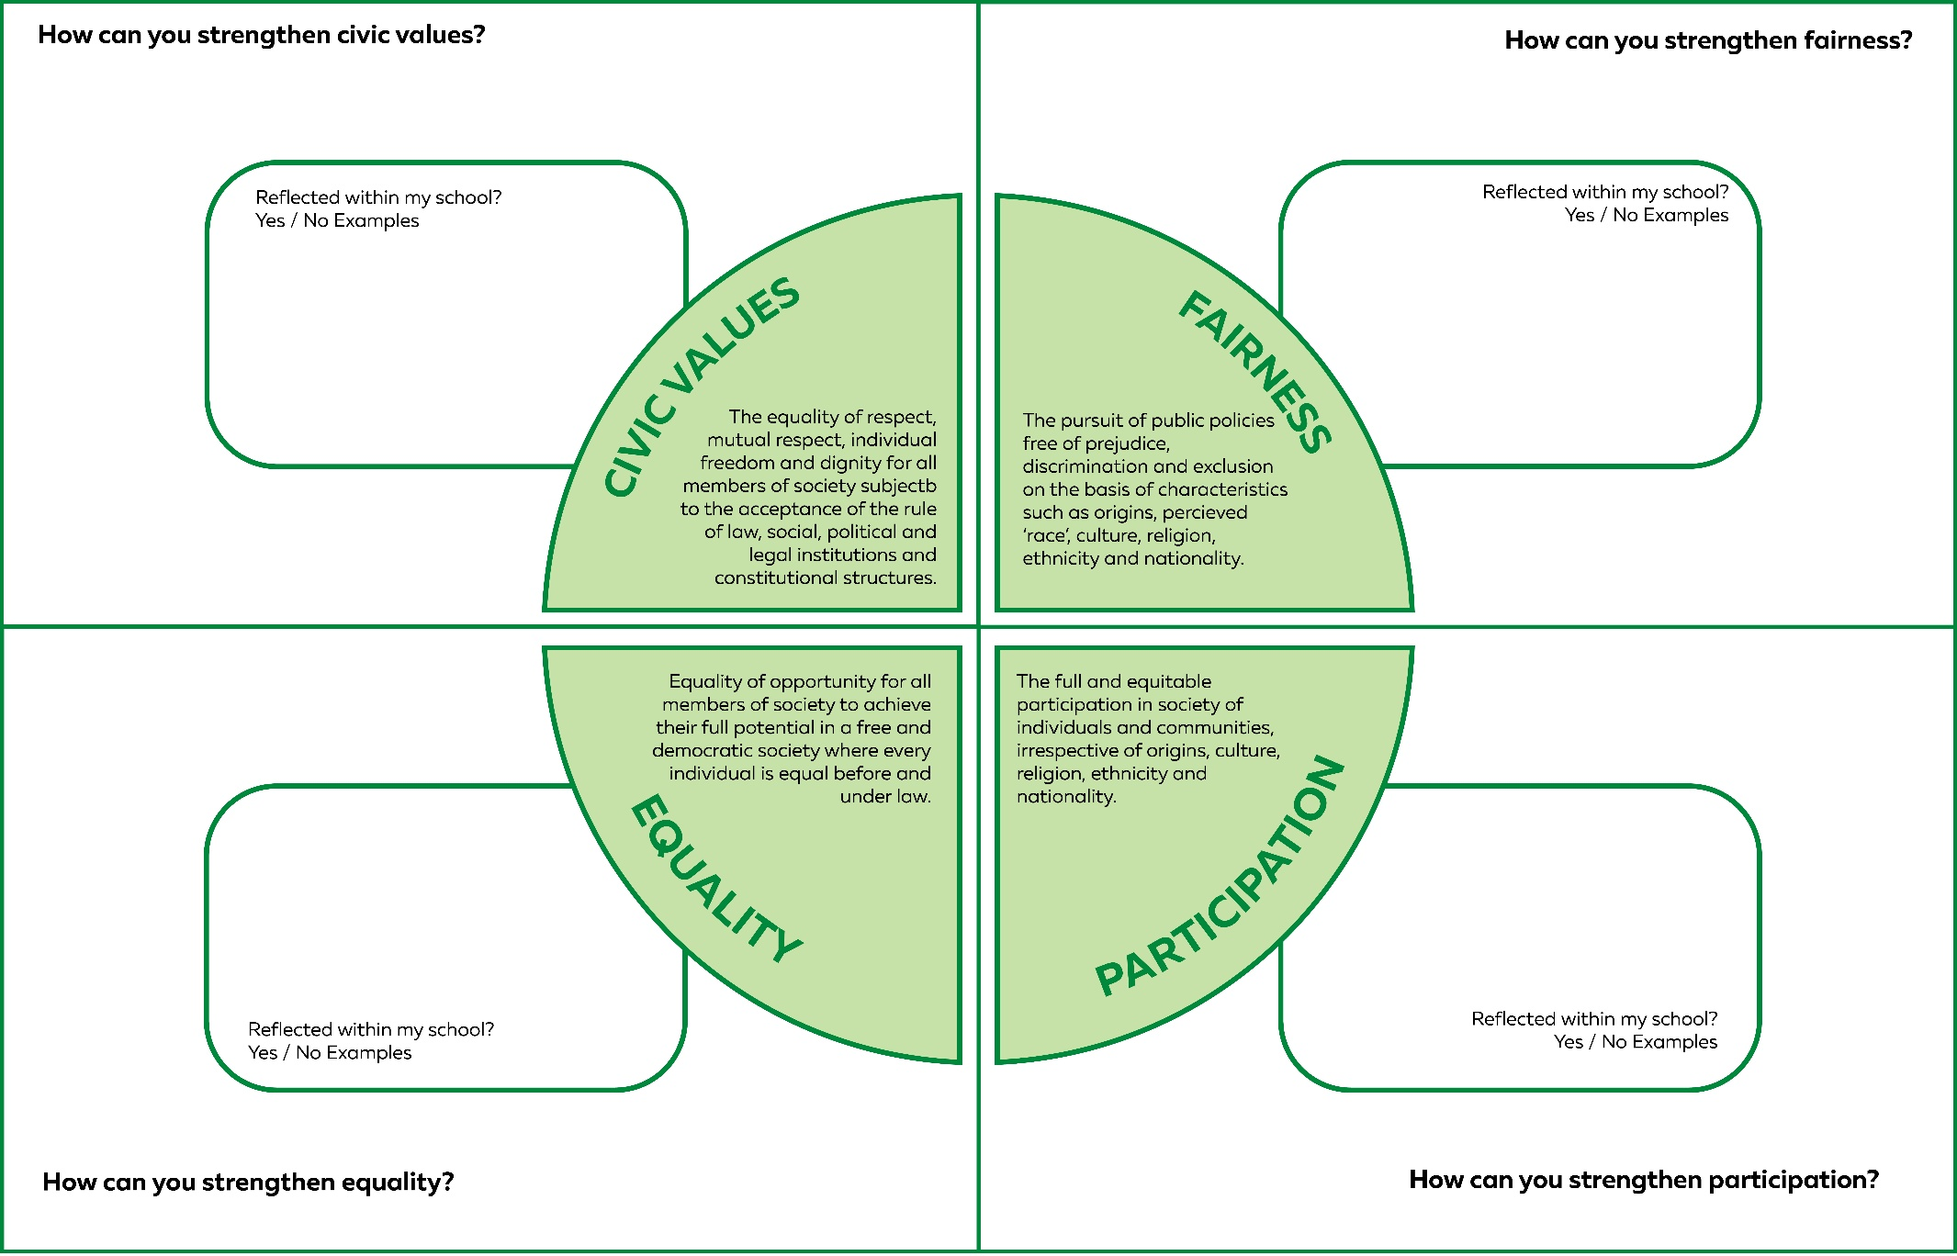

Resource #3 Scaffold for writing: school context example

Sender Address
Name
Street Address
Suburb, Postcode
SPACE
Date

SPACE
Recipient address
Name
Position
School name
Street Address
Suburb, Postcode
SPACE
Greeting/salutation

SPACE
Introduction – clearly state the purpose of your letter

SPACE
Paragraph One:
- Introduce your first multiculturalism PRINCIPLE (i.e. Civic Values, Fairness, Equality, Participation)
- How is your school demonstrating this principle?
- How could your school strengthen this principle?
SPACE
Paragraph 2
- Introduce your second multiculturalism PRINCIPLE (i.e. Civic Values, Fairness, Equality, Participation)
- How is your school demonstrating this principle?
- How could your school strengthen this principle?
SPACE
Paragraph 3 (optional)
- As above
SPACE
Paragraph 4 (optional)
- As above
SPACE
Summarise and include a uniting call-to-action
SPACE
Sign off

Signature

Resource #4 Teacher letter exemplar
Name
Street Address
Suburb, Postcode
01/01/2026

Mr. John Smith
Principal
Sunrise High School
123 Education Lane
Perth, WA 6000

Dear Mr. Smith,

I am writing to share my thoughts on how our school supports the values of the Western Australian Multiculturalism Charter and to suggest some ideas to make our school even more welcoming to everyone.

First, the principle of Civic Values is important because it teaches us respect and fairness for all people, no matter where they come from. Our school shows this by encouraging students to celebrate different cultures through events and assemblies. To improve, we could introduce a community service program where students volunteer in local projects like park clean-ups or helping at senior centres, which would help them understand the importance of being active and responsible members of our community.

Second, the principle of Fairness is about making sure everyone is treated equally and without discrimination. Our school supports this by having clear policies against bullying and by celebrating diversity. One way we could do better is by creating a peer-support group or buddy system that helps new students from different cultural backgrounds feel included and supported, especially those who might feel left out.

In conclusion, I believe our school is doing a great job embracing multicultural values, but there is always a chance to learn and grow. I encourage the school community to keep working together to make everyone feel included and respected.

Yours sincerely,
[Signature]
Name
© Department of Education Western Australia 2025.This product has been generated or modified using artificial intelligence and to the extent that copyright subsists in it, the copyright is retained by the Department of Education Western Australia.

