Humanities and Social Sciences | Year 7/8
3.1 Representations of ideologies and attitudes
____________________________________________________________________________________________________

Focus: Democracy and change

Lesson overview
This lesson considers the freedoms that exist in Australia and why they are important by looking at case studies. Students will examine the process to change the Constitution and consider how the outcomes of referendums reflect Australia’s attitudes towards freedoms and multiculturalism.

Cultural safety considerations
The cultural safety of Aboriginal and Torres Strait Islander students, and culturally and linguistically diverse (CaLD) students must be a priority when planning and delivering these lessons. Teachers are expected to establish a learning environment that is culturally, psychologically, spiritually, physically, and emotionally safe for all students, particularly for Aboriginal and CaLD students.
Culturally responsive teaching practices should aim to create the conditions for students, staff, and families to experience cultural safety in schools and remove and minimise harmful experiences, such as racism in all its forms.
Engaging in meaningful teaching and learning about multiculturalism and anti-racism requires teachers to create the conditions for cultural safety in the planning, delivery and assessment of lessons. This includes:
- knowing students’ cultural backgrounds and understanding how this may be relevant to (or impact) the learning environment
- letting students and families know about the planned content and resources in advance so that they can prepare for the learning, and contribute where safe to do so
- knowing any cultural protocols in advance that may impact the lesson (for example, using a disclaimer at the start of a film about people who may have passed away)
- knowing the sensitive language that may cause harm (for example, removing racial slurs or hate speech in films)
- not assuming that students or staff will want to share their cultural backgrounds and lived experiences with their peers during the lesson
- not calling on students during lessons without warning about content that has the potential to make them feel uncomfortable or singled out
- allowing for students, staff and families to provide input and feedback when they feel cultural safety in the planning, delivery and evaluation of lessons
- where possible, checking in with students and seeking their feedback on the activities and learning, if they feel culturally safe to do so.

Lesson specific considerations
Many freedoms are interpreted differently in different countries and cultures. It is important that teachers prioritise safety and understanding with students when exploring this lesson

Curriculum content
Civics and Citizenship
Year 7 | Year 8
The process for constitutional change through a referendum and examples of attempts to change the Australian Constitution by referendum. | The freedoms that enable active participation in Australia’s democracy within the bounds of the law, including freedom of speech, association, assembly, religion and movement.

Learning intention
Students will learn the democratic freedoms that exist in Australia and why they are important. They will learn how the outcomes of referendums reflect the ideologies and attitudes of Australians and the process to change the Constitution through a referendum.

Success criteria
Students will:
- explain the role of democratic freedoms in promoting an inclusive society
- define and differentiate between a referendum and a plebiscite
- explain the impact of these referendums on Australian society, particularly in relation to multiculturalism and democratic freedoms.

Key terminology
- Constitution - the fundamental principles on which a state or other organisation (such as a club) is governed. Usually this takes the form of a legal document setting out specific powers for the government or governing of that entity.
- Democracy - a system of government based on the people of an entity, that is, ‘government by the people;’ a form of government where the supreme power is vested in the people and exercised directly by them or by their elected representatives under a free and fair electoral system.
- Human rights - the rights that come from being human. That is, the basic rights and freedoms to which all humans are entitled, often held to include the right to life and liberty; freedom of thought and expression; and equality before the law.
- Multiculturalism - a term used to describe the recognition of cultural and ethnic diversity. In Western Australia, it means all Western Australians are entitled to exercise their rights and participate fully in society, regardless of their different linguistic, religious, racial and ethnic backgrounds. The principles of Multiculturalism, as stated in the Western Australian Charter of Multiculturalism, Australia is a majority migrant nation and one of the most successful and cohesive multicultural societies in the world, building on over 60,000 years of First Nations culture. CALD communities are integral to our vibrant society.
- Referendum - the principle or practice of referring measures proposed or passed by a legislative body to the vote of the electorate for approval or rejection. In Australia, a referendum is a vote of the Australian electors on a proposed change to the Constitution by the Commonwealth Parliament that must be approved by a majority of the aggregate of all voters from each state and territory, and also by a majority of voters in a majority (four) of the 6 states.
- Rights and responsibilities - in Civics and Citizenship refers to the entitlements and obligations that are associated with citizenship. Rights and responsibilities are a cornerstone of modern democracies. While there are many rights a citizen may enjoy (freedom of speech, the right to vote) there are also responsibilities of citizenship (to vote in elections, pay taxes, perform jury service).

Suggested discussion
- How do the 5 fundamental freedoms benefit our multicultural society?
- How can citizens participate in the democratic process to bring about change?
- How has the constitution been changed to be more inclusive of citizens?

Activity 1: Australia’s freedoms

Resources required:
- Appendix Resource #1 Fundamental freedoms worksheet
- Appendix Resource #2 Case study: the restriction of freedoms
- Appendix Resource #3 Case study: the restriction of freedoms TEACHER COPY
- Student access to devices (optional) – offline version requires 2 resources (1965 Freedom Ride and Mosque opening in Bendigo).

- Provide students with Resource #1. Set a timer for one minute and ask students to write down what types of things they enjoy or like to do. Alternatively, teachers could write up the group headings on the board and collect student ideas instead.
  - Direct students to name groups and clubs they know of locally or in Australia. Suggested examples:
    - religious groups e.g. Sikh Association of WA, Hindu Council of Australia – WA Chapter
    - community groups e.g. surf lifesaving, volunteer groups, local fire brigades
    - sporting groups e.g. local football club, martial arts
    - special interest groups e.g. theatre, choir, book clubs
    - place-based groups e.g. local park conservation groups, suburb-based/local government resident associations
    - political/social change groups e.g. environmental advocacy group, refugee support networks
    - clubs e.g. bushwalking, car enthusiasts
    - other e.g. Men’s Shed, Country Women’s Association, Toastmasters.
  - Ask students why these groups are important and why there are so many. Make a link to the diversity in Australia and the importance of belonging.

- Explain to students that Australia recognises 5 fundamental freedoms which are protected in the Constitution.
  - Name the 5 freedoms in alphabetical order (assembly, association, movement, religion, speech) and ask students to match them to the correct description in the table in Resource #1, which are in this order for students:
    - Freedom of Speech: Australians can express their opinions freely, within the bounds of the law, without fear of censorship or punishment.
    - Freedom of Association: Individuals are free to join or form groups, such as political parties or trade unions, as long as these groups are legal.
    - Freedom of Assembly: People can gather in public or private spaces for social, political, or other purposes, provided they do so peacefully and legal.
    - Freedom of Religion: Australians can practice any religion or choose not to follow any religion, without interference from the government.
    - Freedom of Movement: Citizens can move freely within the country and travel abroad without undue restrictions.

  - Facilitate a discussion about what the freedoms mean in practice and why they are important. Instruct students to fill in the relevant column in Resource #1 with their answers.
  - Ask students to rank the freedoms according to which one is most important to them, to least important and compare with the class.
  - Direct students to discuss the following questions in pairs:
    - Why did you rank the freedoms in this order?
    - How might other people rank them? What factors might affect their decision?
    - Which freedoms are more relevant to you?
    - Why are these freedoms important values in a democratic society?
  - Note: Access the Australian Human Rights Commission website for more information on the freedoms.

- Organise students into pairs and provide them with the case studies from Resource #2. Each pair should look at one of the 2 case studies and share their answers with their partner and reflect on the questions together. Resource #3 is a teacher copy.
  - Teachers can either print the 2 sources or provide students access to devices:
    - Case Study 1: The 1965 Freedom Ride – Moree
    - Case Study 2: Bendigo mosque opposition.
  - Facilitate a discussion about the 2 case studies using the reflection questions in Resource #2.

Activity 2: Referendums and plebiscites

Resources required:
- Appendix Resource #4 Changing the Constitution
- Student access to devices.

- Show students an image of the Constitution and ask them to share what they know about it to understand prior knowledge.
  - Explain to students that Chapter 8 of the Constitution outlines how it can be changed
  - Optional: show students the Parliamentary Education Office’s short video on the Constitution, or run the Constitution quiz or Kahoot! with students.
  - Note: The Museum of Australian Democracy has developed 6 visual pages which to summarise the Constitution and how it changed.

- Inform students that the Australians have been asked 45 times if they would like to change the constitution. Ask them how many times they think Australians have agreed (or voted yes). Answer: 8 times.
  - Ask students to name any referendums they know of.
    - Note: all referendums are on the AEC’s website.
  - Play students the ABC Behind the News 1967 Referendum video as an introduction to the next activity on how the Constitution is changed.
    - After watching, ask students why the 1967 referendum was held, and what the outcome was.

- Provide students Resource #4. Teachers can teach this content through direct explicit instruction or as a student activity. Students will need access to the Parliamentary Education Office’s referendums and plebiscites webpage and the MOAD website on the 1988 Referendum.
  - The 1988 referendum was a proposal to alter the Constitution to extend the right to trial by jury, to extend freedom of religion, and to ensure fair terms for persons whose property is acquired by any government.
  - This referendum had the highest number of No votes of any referendum.
  - Note: the AEC developed a referendum factsheet which could be shared.

- After students have finished, discuss their answers and check for understanding. Ask:
  - Why do you think the 1988 referendum achieved such a high ‘no’ vote?
  - What do the processes to change the Constitution, and the outcomes of referendums tell us about Australia’s ideology and attitudes to freedoms?

Reflection
- What are the 5 freedoms that are core values in our democracy and how do these relate to multiculturalism? Answers may include:
- people of all faiths can practice their beliefs without fear.
- the freedoms create the legal and social conditions for multiculturalism to thrive.
- they allow people of all backgrounds to contribute meaningfully to Australian society.
- Reflect on the results of the 1967 and 1988 referendums and the number of times referendums have passed throughout Australia’s history. What does that tell us about attitudes to multiculturalism and freedoms?

Resource #1 Fundamental freedoms worksheet

Write down what you enjoy or like to do:

List groups or clubs you know of that match the categories.
Group/club | Examples
Religious groups
Community groups
Sporting groups
Special interest groups
Place-based groups
Political/social change groups
Clubs
Other

Why do you think there are so many different types of groups or clubs? Is this a good thing?

Why is it important to be able to join or access these groups?

Your task
  - Match the correct freedoms to their description (Assembly, association, movement, religion, speech)
  - Explain why they are important.
  - Rank the freedoms from 1 to 5 based on which is the most important or relevant to you (#1 to) to least (#5).

Freedom of: | Description | Why is it important? | Rank
 | Australians can express their opinions freely, within the bounds of the law, without fear of censorship or punishment.
 | Individuals are free to join or form groups, such as political parties or trade unions, as long as these groups are legal.
 | People can gather in public or private spaces for social, political, or other purposes, provided they do so peacefully and legal.
 | Australians can practice any religion or choose not to follow any religion, without interference from the government.
 | Citizens can move freely within the country and travel abroad without undue restrictions

Why are these freedoms important values in a democratic society?

Are any more important or relevant than others? Why?

Resource #2 Case study: the restriction of freedoms

Case Study 1: The 1965 Freedom Ride – Moree
Answer the questions using this website: https://indigenousrights.net.au/civil_rights/freedom_ride,_1965
- Summarise the case study (who, when, where, what).

- Outline which freedom(s) were restricted.

- Identify the groups who were affected.

- Describe the justification for restricting the freedom.

- Explain the response to this restriction and the outcome.

Reflection
- What risks did the Freedom Riders face, and what does this reveal about standing up for others’ rights?
- Do you think the protest at Moree was successful? Why or why not?
- Why is it important to learn about acts of protest like the Freedom Ride in understanding democracy and civil rights in Australia?

Case Study 2: Bendigo mosque opposition
Answer the questions using this website:
https://www.abc.net.au/news/2025-09-29/mosque-opening-protest-anniversary-bendigo-/105693360
- Summarise the case study (who, when, where, what)

- Outline which freedom(s) were restricted

- Identify the groups who were affected

- Describe the justification for restricting the freedom

- Explain the response to this restriction and the outcome.

Reflection
- How can fear and misinformation lead to restrictions on others’ rights?
- Why is interfaith dialogue important in a multicultural society?
- What lessons can be learned about tolerance and resilience from this case?

Resource #3 Case study: the restriction of freedoms TEACHER COPY
Case study: 1965 Freedom Ride – Moree

- Summarise the case study
- In February 1965, a group of University of Sydney students (Student Action for Aborigines, SAFA) toured western and coastal New South Wales towns (e.g. Walgett, Moree, Kempsey, Bowraville)
- Their goal was to expose segregation, poor health, housing and education conditions, and to press for change
- In Moree they tried to assist Aboriginal children from a nearby reserve to enter the local swimming pool that had excluded them

- Identify which freedom(s) were restricted
- Freedom of movement (Aboriginal people barred from entering public facilities such as the swimming pool)
- Freedom of association (being excluded from social/civic spaces, clubs, hotels)

- Identify the groups who were affected
- Aboriginal people in the towns visited, particularly Aboriginal children, families and community members
- The students and activists (SAFA) attempting to challenge the segregation

- Outline the justification for restricting this freedom
- Local councils, townspeople and institutions enforced segregation and claimed Aboriginal people were not permitted in certain clubs, hotels, pools, and services
- The justification was racially discriminatory: that these places were “for whites,” that integration would disrupt social order, that Aboriginal visitors were undesirable

- Explain the response to this restriction and the outcome
- The Freedom Rides used protest, media, and direct challenge (e.g. attempting to take Aboriginal children into the pool)
- The publicity forced some local policy changes (e.g. Moree’s pool ban was challenged, councils announced investment in housing)
- The Freedom Ride created national awareness of racial inequality, added momentum to Indigenous rights movements, and influenced later reforms (legislative and social)

Case Study: Bendigo Mosque opposition
- Summarise the case study (who, when, where, what):
- Local Muslims, represented by the Bendigo Islamic Association, sought to establish a mosque to provide a place of worship and promote interfaith understanding in 2014-15.
- There were protests, violent demonstrations and a coordinated campaign by anti-Islam groups.

- Identify which freedom was restricted:
- Freedom of religion - the right to practise and establish places of worship was obstructed by community opposition, protests, and misinformation campaigns

- Identify the groups who were affected:
- The Muslim community in Bendigo was directly affected, as their ability to freely practise and express their faith was challenged. The broader Bendigo community also experienced division and tension as a result of the protests and misinformation

- Outline the justification for restricting this freedom:
- Opponents often claimed concerns about “traffic,” “noise,” and “foreign influence,” but much of the opposition was Islamophobic attitudes and fear campaigns. These justifications were not based on evidence but on prejudice and misinformation about Islam
- Explain the response to this restriction and the outcome:
- Local leaders defended the right to religious freedom and spoke out against intolerance Over time, public opinion shifted, and the project went ahead
- The mosque opened in 2025, symbolising resilience and reconciliation

Resource #4 Changing the Constitution
Answer the questions using this website:
https://peo.gov.au/understand-our-parliament/having-your-say/elections-and-voting/referendums-and-plebiscites

- Explain what a referendum is.

- Section _______of the Constitution explains the referendum process and rules.

- Outline the 6-step process to change the Constitution. Note: if you click on the picture and scroll down, you can see the steps.
Step | Description
1.
2.
3.
4.
5.
6.

- After a bill is passed, how long until a referendum is held? __________________________

- Explain the ‘arguments for and against’ step. Why are they an important step in this process?

- Explain how the votes from the ACT, NT and other territories are counted in a referendum.

See next page
- Label the 2 maps of Australia below to explain what a double majority is and what it means.
The Constitution can only be changed with the support of…

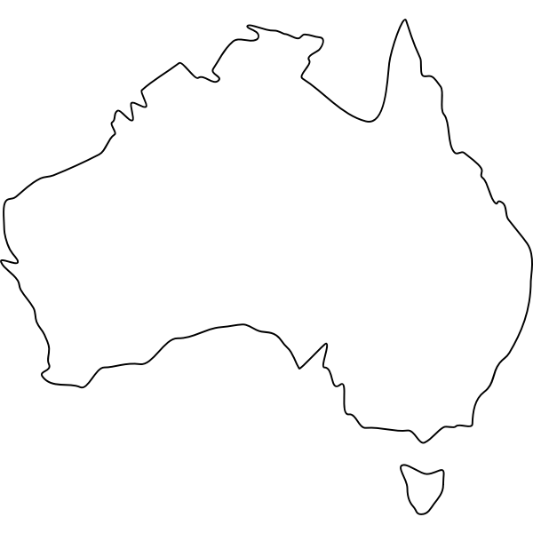 | 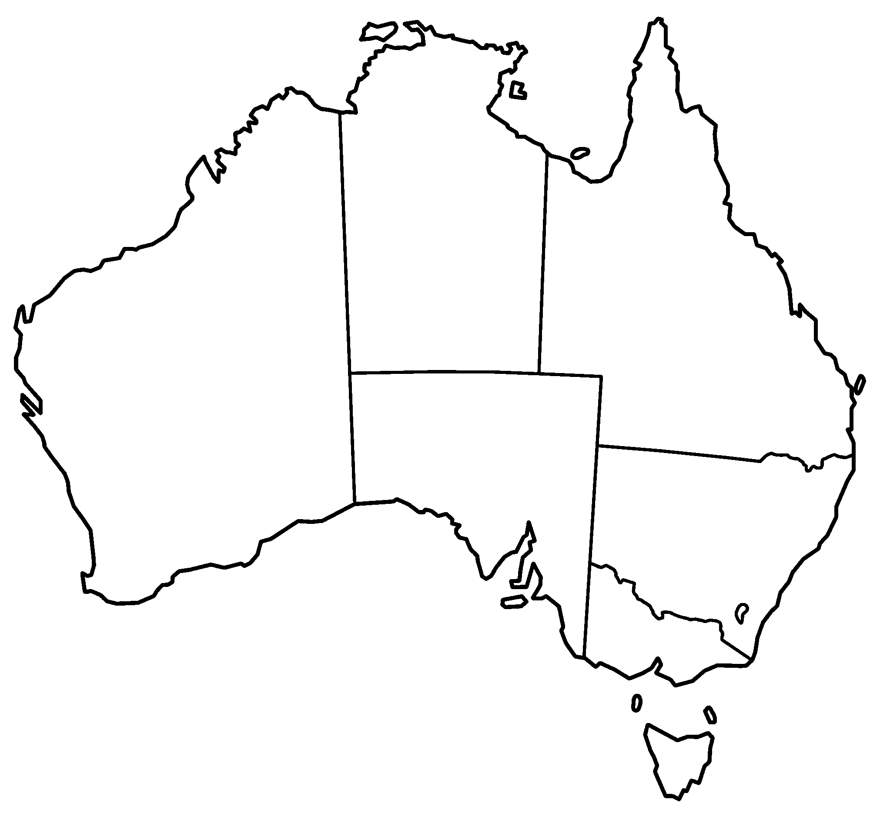

- Describe the difference between a referendum and a plebiscite.

- Explain why the government might hold a plebiscite, using 2 examples.

- Why do you think so few referendums have passed?

Your task
Use the Museum of Australian Democracy’s website to complete these questions about the 1988 referendum: https://moadoph.gov.au/explore/democracy/1988-rights-and-freedoms
Referendum title
Date
Question
Overall vote
WA results (%) | Yes: No:
Total for Australia (%) | Yes: No:

- List or summarise 3 of the ‘Yes’ arguments.

1.
2.
3.

- List or summarise 3 of the ‘No’ arguments.

1.
2.
3.

© Department of Education Western Australia 2025.This product has been generated or modified using artificial intelligence and to the extent that copyright subsists in it, the copyright is retained by the Department of Education Western Australia.

