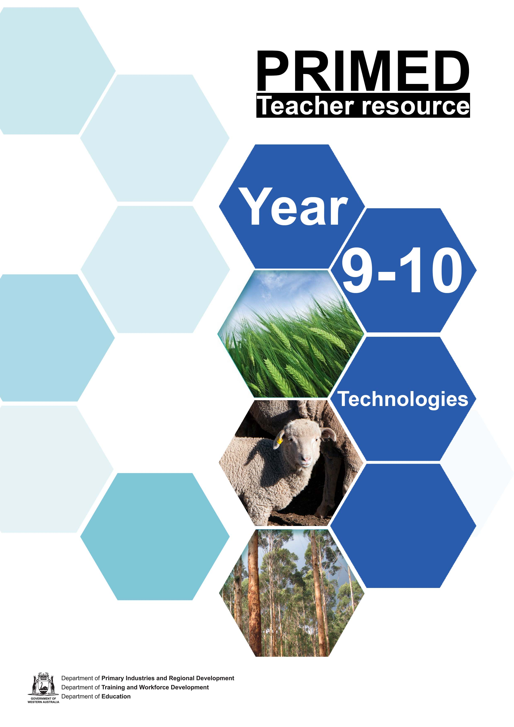

Teaching guide: Rethinking timber waste

Resources overview

PRIMED mission
To increase student understanding of agriculture, fisheries, fibre, forestry and food (primary industries) careers to enable Year 7–12 students to make informed career-pathway choices.

About the resource set
This resource addresses aspects of the Western Australian Curriculum – Design and Technologies within a primary industries context. Students work through a guided design process to solve a sustainability problem and design a product. Through research, they learn about current industry innovation and processes and make connections to situations experienced at a school level.

Curriculum links
This resource provides a learning pathway for students to develop their understanding of the Western Australian Curriculum - Design and Technologies Year 9 and 10 content descriptions:

Technologies context:
- Materials and technologies specialisations
  - Characteristics and properties of materials, systems, components, tools and equipment used to create designed solutions ACTDEK046
  - Technologies can be combined and used to create designed solutions ACTDEK047

Knowledge and understandings:
- Technologies and society
  - Social, ethical and sustainability considerations that impact on designed solutions ACTDEK040
  - Development of products, services and environments, with consideration of economic, environmental and social sustainability ACTDEK041

Processes and production skills:
- Investigating and defining

  - WATPPS54 (9)
  - WATPPS55 (9)
  - WATPPS61 (10)
  - WATPPS62 (10)
  - WATPPS63 (10)

- Designing

  - WATPPS56 (9)
  - WATPPS57 (9)
  - WATPPS64 (10)
  - WATPPS65 (10)

- Producing and implementing

  - WATPPS58 (9)
  - WATPPS66 (10)

- Evaluating

  - WATPPS59 (9)
  - WATPPS67 (10)

- Collaborating and managing

  - WATPPS60 (9)
  - WATPPS68 (10)

Resource structure
The resource consists primarily of a traditional design process in the context of addressing an environmental issue that exists at an industry level. Students learn about the processes involved in timber milling and describe issues surrounding waste material and by-products. They gain an understanding of non-traditional ways that forest products can be used through research into locally manufactured engineered timber products and industry innovation.
Informed by their research, students follow a clear design process to devise ways to use waste timber from their school wood workshop and create a simple product with this material. Process stages are characterised below:
DEFINE A
PROBLEM
INVESTIGATE
DEVISE
SOLUTIONS
PRESENT
SOLUTIONS
EVALUATE
This structure is derived from Design and Technology design portfolio requirements, and is for use in a mid-secondary Design and Technologies context. For use in STEM contexts, this can be adapted to a “design thinking” model (ie discovery-interpretation-ideation-experimentation-evolution) with minimal modification.
Most student worksheets included are written to be non-specific, and can be used for other design tasks without modification. Blank drawing and writing templates are also included. It is intended that the worksheets from this package are printed and distributed to students one-by-one. Completed worksheets can be kept in a display book to form a clear design portfolio.
 | Teaching and learning focus  Students will: | Resources
Define a problem | Module 1: Introduction  - Describe the process for the production of timber  - Identify sources of waste/by-products  - Define an issue relating to waste in the production of timber  - Characterise qualities of an effective solution and develop specific criteria for the success of the project | PowerPoint presentation:  - Rethinking timber waste  Online video:  - Timber production process  Student worksheets:  - 1.1 – The IPO model  - 1.2 – The timber production process  - 1.3 – Defining a problem
Investigate | Module 2: Research and analysis  - Explore factors affecting designed solutions  - Identify and characterise enquiry questions to guide research  - Investigate existing industry solutions and processes  - Draw connections to local contexts  - Test and evaluate possible materials solutions  - Investigate existing products and identify important features | Online resources:  - Video: “Manufactured Wood Products - FWPAFWPA” (YouTube)  - Video: "Factory Tour - Wesbeam"  - Assorted local manufacturers – web research  Student worksheets:  - 2.1 – Analysing the problem  - 2.2 – Investigating existing materials  - 2.3 – Investigating existing products  - 2.4 – Testing materials
Devise solutions | Module 3: Concepts and development  - Propose a range of possible solutions  - Critically assess the suitability of solution concepts  - Develop solutions based on task requirements | Student worksheets:  - 3.1 – Creating an idea  - 3.2 – Gathering feedback about an idea  - 3.3.1 – Developing an idea (or)  (Component method)  - 3.3.2 – Developing an idea  (Evolution method)
Present Solutions | Module 4: Justification and solution  - Produce context-appropriate working drawings of designed solutions  - Justify designed solutions against previously identified task requirements | Student worksheets:  - 4.1.1 – Solution checklist  - 4.1.2 – Justifying a solution  - 4.2.1 – Presenting a solution (or)  - 4.2.2 – Presenting a solution
Evaluate | Module 5: Evaluating a solution  - Critically analyse and evaluate design processes against student-defined criteria | Student worksheets:  - 5.1 – Evaluating a solution
Additional | Module 6:  - Blank templates for additional writing and drawing space | Student worksheets:  - 6.1 – Blank drawing page  - 6.2 – Blank writing page

Learning resources and sequence

Module 1: Introduction (approximately 2-4 hours)
DEFINE A
PROBLEM
INVESTIGATE
DEVISE
SOLUTIONS
PRESENT
SOLUTIONS
EVALUATE

Learning intentions
Students will be able to:
- Describe the process for the production of timber
- Identify sources of waste/by-products
- Define an issue relating to waste in the production of timber
- Characterise qualities of an effective solution and develop specific criteria for the success of the project

Background information
Timber conversion rates (recovered sectional timber produced vs total volume of forest products consumed) are between 47-49 per cent for plantation-grown softwood, and around 36 per cent for hardwoods (Forest and Wood Products Australia, 2012). Less than half of harvested forest products end up as dimensional timber.
Focus question: Where does the remainder of the material go?
There are a number of by-products of the timber production processes, and producers attempt to re-use as much material as possible. Some by-products are used on-site to improve productivity and efficiency (ie burning dust/chips as a heat source for kiln drying timber), while some material is processed into secondary wood products. A local example of this can be found at Wespine Industries in Dardanup. Chips and sawdust not used by the plant itself is transported to the nearby Laminex facility to be used in the production of Medium Density Fibreboard (MDF).
Timber products not suitable for dimensional timber can be used to produce a number of secondary products, including:

- wood pellets and briquettes
- heat and electricity production
- biofuels including ethanol and syndiesel
- biochemicals
- landscaping products and animal bedding
- pulp and paper
- engineered timber products including particleboard, MDF and composites

There are a number of engineered timber manufacturers in Western Australia. These include:
- Wesbeam (Laminated Veneer Lumber – LVL)
- Laminex (Medium Density Fibreboard – MDF)
- CrossLam (Cross Laminated Timber – CLT)
- Lifewood (engineered timber flooring)

Resources
- PowerPoint presentation: Rethinking timber waste
- Video: The timber production process
- Student worksheet 1.1 – The IPO model
- Student worksheet 1.2 – The timber production process
- Student worksheet 1.3 – Defining a problem

Instructions for suggested activities

Introducing the task
This task requires students to design a simple product to be made from scraps, waste and offcuts available in their wood workshop. The project is essentially a product design task, with additional materials research and testing that would not typically be conducted at this level.
Students learn about ways that waste and non-ideal timber products are used at an industry level and apply this knowledge to design a solution to the problem of timber waste in their own school workshop.
The task begins with the PowerPoint presentation “Rethinking timber waste”. This provides the framework for introducing the project and guides students through the initial stages of the task. Over the course of 2-3 lessons, students learn how timber is produced, and define the problem of timber waste in their own school context. They then investigate a number of ways that waste and low-grade timber is used on an industrial scale, making connections with their task.
Before students are able to design their product, they need to understand the properties, advantages and disadvantages of the material they will create. While this could be considered to simply be part of the “investigating” phase, it is best communicated to students as a two-stage process:
- Devise a way to make waste timber material into a useable form
- Design a product to be made from this material.
Separating these concepts ensure accessibility to a broad range of ability levels. It may be desirable in older/more capable classes to combine the concepts as one less specific task, and allow/guide students to identify the need for materials research themselves. Likewise, younger/lower ability classes may require extra scaffolding to conduct each stage of the project. Many stages in this project can be omitted or expanded upon as required.
Before beginning to deliver this module, you will need to decide on the type of product your students will design – suitability will vary depending on a number of factors, such as school resourcing, types of waste available, intended production methods and more.
Ideally, the product should be one that is relatively simple/time-efficient to produce, as the additional research and design components in this resource require longer to complete than would typically be allocated at this level.
Suggested products include:
- kitchen item/utensil (be aware of food safety of glues, water resistance etc.)
- window sill herb/succulent planter box
- shelf/wall ornament
- candle/tea light holder
- desktop stationary organiser
- photo frame
You may choose to inform students of the product type at the same time as the materials problem (ie during the PowerPoint presentation) or wait until materials research and testing is complete. While letting students know what they will be making early on may assist with student buy-in and engagement, it may also affect the quality and direction of their materials investigation. Modify the sequence of Module 2 as required.

Suggested progression
- Begin with PowerPoint presentation. Provide limited task information to students at this stage.
- Distribute Student worksheet 1.1 and work through associated slides with students. If printing volumes are a concern, you may wish to print only page 2 of this document and display the examples via a data projector. If further clarification is necessary, provide relatable examples of simple processes. These could include making toast, building a sandcastle or drawing a picture. Ensure students have a clear grasp of the concept, as it will be used in the next worksheet.
- Discuss and ensure clear student understandings of “waste” and “by-product”.
- Distribute Student worksheet 1.2 and play video “The timber production process”. Students complete worksheet based on information in video. While viewing the video, student identify and record as many key steps in the process as possible. Once complete, they use the template.
- Recap and discuss sources and types of waste from production of timber.
- Introduce the design problem (Devising a solution to school-based timber waste) and distribute Student worksheet 1.3. You may wish to use an instructional strategy (placemat or similar) to address the five defining questions (in PowerPoint and on page 1 of Student worksheet 1.3)
- Formulate a problem statement – choose context appropriate method (group, on board, individual etc.).
- Discuss success criteria and guide students to complete worksheet.

The way this module is delivered will set the tone and direction of the project. It is important that prior to beginning this task with students, you have a clear picture of how this project will progress in your specific context. Modifications and contextual differentiation will be required in most situations.

Module 2: Research and analysis (approximately 6-8 hours)
DEFINE A
PROBLEM
INVESTIGATE
DEVISE
SOLUTIONS
PRESENT
SOLUTIONS
EVALUATE

Learning intentions
Students will be able to:
- Explore factors affecting designed solutions
- Identify and characterise enquiry questions to guide research
- Investigate existing industry solutions and processes
- Draw connections to local contexts
- Test and evaluate possible materials solutions
- Investigate existing products and identify important features
In the investigate phase, students will:
- analyse the problem to determine relevant factors influencing design
- investigate existing materials produced with industrial processes
- investigate products similar to their design task
- test material production processes
- describe properties of materials and relate these to their design task

Resources and equipment
- Student worksheet 2.1
- Student worksheet 2.2
  - data projector/devices and headphones to view Manufactured Wood Products - FWPAFWPA and "Factory Tour - Wesbeam" videos
- Student worksheet 2.3
  - images of existing products similar to the item that students will be asked to design
(optional – students can be asked to select these images if ability level is sufficient)
- Student worksheet 2.4
  - timber scraps in various forms
  - adhesives/resins
  - tools – saws, clamps etc.
  - a plan of how you intend to produce several different materials (based on engineered timbers) using available resources (see below for suggestions)

Instructions for suggested activities

Analysing the problem (Student worksheet 2.1)
When analysing a design problem, students need to look at all the factors influencing the final product. A mind map is provided in Student worksheet 2.1 to assist. (Note: this student document is generic and can be used for other tasks). Not all factors will apply to this task, and this will depend on how you phrase the “product design” aspect of the task. The factors are drawn from the SCSA Materials, Design and Technology Year 11 General syllabus, a pathway that many students in Year 9/10 Woodwork specialty Design and Technology classes are likely to follow.
Students will create a mind map, demonstrating an understanding of factors influencing design. For Year 10 students, the example included in the worksheet will likely suffice, whereas Year 9 students may require more support. This could be done by identifying relevant factors as a class, then having students individually elaborate on these, or by having students work in groups.

After creating their mind maps, students identify three inquiry questions to guide their research. You may choose to omit this section for Year 9 students (or lower ability Year 10s). Inquiry questions guide the research phase and should be clear and focused without limiting options.
This section is best completed as a class. Guide students to suggest inquiry questions addressing research topics that are relevant to your school’s context and your planned project pathway.
Suggested questions include:
Topic | Question | Related research task
Material | How is timber waste re-used in industry? | Student worksheet 2.2 – Existing materials
 | What materials can be made from timber waste? | Student worksheet 2.2 – Existing materials
 | How can industry processes be modified for the school workshop? | Student worksheet 2.2 – Existing materials  Student worksheet 2.4 – Testing materials
 | What materials are available in our workshop? | (alternative task– no Student worksheet included)  Surveying/counting/identifying quantities and types of timber waste (suit younger students)
Product | What similar products already exist? | Student worksheet 2.3 – Existing products
 | What makes a good [insert product type]? | Student worksheet 2.3 – Existing products
 | What features are required for [insert product type]? | Student worksheet 2.3 – Existing products
 | How does the shape of [product] relate to its functionality? | Student worksheet 2.3 – Existing products

Investigating existing materials (Student worksheet 2.2)
Student worksheet 2.2 introduces the topic of engineered timber with the video Manufactured Wood Products - FWPAFWPA. Higher ability Year 10 classes may not require this; however, it does provide a good overview of the main types of engineered timber produced today. Students identify the six types of engineered timber listed in the video and choose three to research further.
To promote Western Australian industry connections, mention should be made of the following businesses involved in producing engineered timbers. Students may find information available on these websites useful in this research phase.
Company | Product
Wesbeam | LVL
CrossLam | CLT
Laminex | MDF
It may be helpful to complete the research into the first material as a class. This will ensure students understand what is expected and how information should be presented. A good source of information is the Wesbeam LVL “Factory tour” video and associated information, found on their website. LVL is a good material choice to research in a whole class setting. When printing this worksheet, include duplicates of page 2 for as many different materials as are to be researched.

Investigating existing products (Student worksheet 2.3)
In this worksheet, students analyse images of products similar to the one they will design, identifying key features and factors. Depending on the logistics of your class, you may wish to complete this digitally or have a number of images printed out for students to glue into the worksheet. This activity could also be completed using catalogues or magazines, depending on the type of product that you have selected.
Testing materials (Student worksheet 2.4)
This activity requires the use of tools and equipment.
The process for testing materials will vary significantly, depending on the context and capabilities of your school workshop. You will first need to identify at least two engineered timber products (ideally three or more) that you will use as the conceptual basis for your materials. The suitability of each product will vary depending on a number of factors, including the types of timber waste present, tools and equipment available, and resource budget.
Example – LVL inspired material
If you do a significant amount of ripping of timber, you will likely have accesss to thin strips of timber in the form of offcuts. This is ideal for manufacturing a LVL-like material, as shown in the images below. You can also cut larger sectional offcuts into strips for this process.
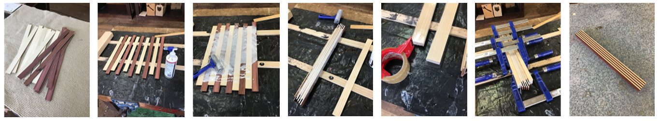
Images TG1-TG7: Example of LVL style material glue-up
In this example, offcut strips of radiata pine (Pinus radiata) and jarrah (Eucalyptus marginata) are cut to a roughly uniform length. These strips are of equal thickness, but this is not essential. The strips are arranged to form an alternating pattern (aesthetic purposes only) and glue is spread across the top faces. The strips are stacked together, then clamped together. It is advisable to make use of cauls covered with packing tape to avoid sticking. In this case, 42x19 pine has been used for this purpose. Once cured (~24 hrs), the material can be removed from clamps and docked/dressed to a uniform shape, ready to be used in the manufacture of a product.
Other suggested materials include:
MDF/OSB/Particleboard – Sawdust and wood shavings can be mixed with a variety of adhesives and shaped in a mould. Be aware that PVA glue requires the evaporation/absorption of moisture in order to cure – as such, this may take an excessively long time if fully contained in a mould. Alternatives include polyurethanes, cyanoacrylates and epoxies. This provides a wide scope for materials testing, as each adhesive will induce different properties in the finished material. If your final product is to be turned on a lathe, epoxy is an excellent option - however this may be cost prohibitive.
Depending on the composition of your material, a press, vacuum or pressure chamber may be beneficial to avoid air inclusions and increase uniformity.
CLT/Plywood – Scrap timber can be glued together to form larger pieces. This could include veneer offcuts if available.

It is unlikely that your workshop will have sufficient resources for each student to complete this material testing (and the later production of materials) individually, so it is suggested that you separate the class into groups, with each group producing one type of material to test. Research can then be presented or shared as you see fit.

Note: This activity can be completed in a “discovery learning” style, where students try a number of methods to settle on the most effective, however this is likely to be very
teacher-intensive. It is recommended that you prepare instruction/guidance sheets for each material to encourage students to work independently.

Suggested progression
- Complete Student worksheet 2.1 – Analysing the problem
- Watch video Manufactured Wood Products - FWPAFWPA
- Complete page 1 of Student worksheet 2.2 – Investigating existing materials
- Watch video Factory Tour
- Complete LVL research as a class
- Students complete remainder of Student worksheet 2.2 individually
- Complete Student worksheet 2.3
- Begin preparing for materials testing – collect materials, plan methods etc.
- Test materials and share results
- Complete Student worksheet 2.4

Module 3: Concepts and Development (approximately 2 hours)
DEFINE A
PROBLEM
INVESTIGATE
DEVISE
SOLUTIONS
PRESENT
SOLUTIONS
EVALUATE

Learning intentions
Students will be able to:
- Devise ideas using hand-sketching techniques
- Analyse concepts based on requirements of the task
- Gather and provide feedback about ideas
- Develop solutions to a given problem

Resources and equipment
- Student worksheet 3.1 – Creating an idea
- Student worksheet 3.2 – Gathering feedback about an idea
- Student worksheet 3.3.1 OR Student worksheet 3.3.2 – Developing an idea
- Drawing equipment – pencils, erasers, rules etc.

Instructions for suggested activities
In the “devising” phase, students propose a number of ideas for their product, then develop these based on their research.

Creating an idea (Student worksheet 3.1)
Students use the worksheet to create four different concept drawings for their product. These can be quick sketches or detailed drawings, depending on the ability of the class.
Annotations should be made for each drawing indicating materials used, tools, and labelling key features.

Gathering feedback on an idea (Student worksheet 3.2)
This task is optional, allowing students to gather feedback on their concepts from their peers. Students choose one of their concept drawings and seek feedback from a small group of classmates. Each group member comments on the concept presented and passes it to the next person, until each member has commented on each concept. This is particularly useful in situations where students appear to be struggling to create original ideas. By drawing upon thoughts from their peers, they are able to identify a number of possible modifications to take forward into the development phase.

Developing an idea (Student worksheet 3.3.1 and 3.3.2)
In the development stage, students take an idea formed in the concept drawing phase and refine it into a more effective solution to the given problem. This involves identifying areas for improvement and making modifications to achieve a higher quality final product.
A good concept development must show the evolution of the concept, from initial idea to viable solution. There are several ways to demonstrate this, and different tasks/concepts/ideas are better suited to certain approaches.
Two techniques are detailed below:

Component method (Student worksheet 3.3.1)
The component-based approach involved identifying key features, then suggesting and analysing alternative options.

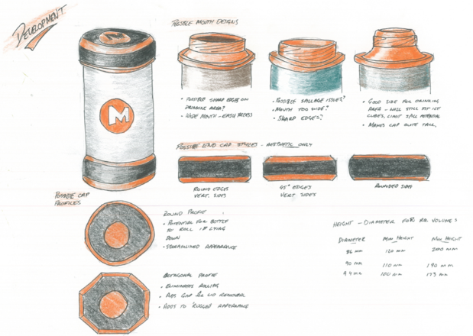
In the water bottle development shown on the left, key features identified were the mouthpiece, end design and the profile of the end caps. Possible alternatives were then suggested for each aspect, with notes made on the suitability of the design.
This method is particularly useful for concepts where small modifications do not drastically affect the overall design but could be changed in several ways. This means that exploring possible modifications does not require students to redraw the entire concept over and over again for one small aspect.
Image TG8: Component-style concept development

Evolution method (Student worksheet 3.3.2)
Using the evolution method to develop a concept involves selecting an idea, identifying areas for improvement, and making several small changes in order to arrive at a solution.
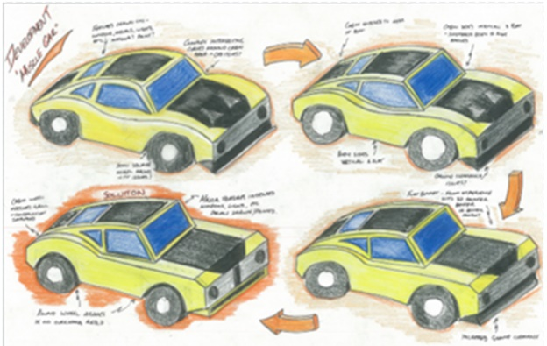
First, students redraw their chosen concept exactly as it appears on the concepts page (Student worksheet 3.1). They identify areas for improvement, based on existing product research and annotations from original concepts. These could relate to aesthetics, materials, function, production techniques etc.
Next, a small change is made to address an identified issue. The concept is redrawn, and notes/annotations are added to show the change made and the reason behind it.
Image TG9: Evolution-style concept development
This process is repeated until all possible issues are addressed and the student is satisfied with the final result (at least three stages of modification). Ensure that students are not making too many changes on a single drawing – they need to clearly show how the initial design evolved into the finished solution.
This method is useful when identified areas of improvement require the entire design to be modified in order to address issues.
Suggested progression
- Complete Student worksheet 3.1 – Creating an idea
- Complete Student worksheet 3.3.1 OR Student worksheet 3.3.2 – Developing an idea

Module 4: Presenting Solutions (approximately 2 hours)
DEFINE A
PROBLEM
INVESTIGATE
DEVISE
SOLUTIONS
PRESENT
SOLUTIONS
EVALUATE

Learning intentions
Students will be able to:
- Explain why they have made specific design choices
- Construct an orthographic drawing of their proposed product

Resources and equipment
- Student worksheet 4.1.1 OR 4.1.2 – Solution checklist/Justifying a solution
- Student worksheet 4.2.1 OR 4.2.2 – Presenting a solution
- Drawing equipment – pencils, rules, squares erasers etc.

Instructions for suggested activities

Justifying a solution (Student worksheet 4.1.1 and Student worksheet 4.1.2)
It is intended that students complete either Student worksheet 4.1.1 OR Student worksheet 4.1.2, depending on ability level
Student worksheet 4.1.1 checklist allows students to “prove” that their solution meets design requirements. Key requirements are identified and marked as either included or missing from the final design. Students can refer to their Student worksheet 2.1 (Analysing a problem) for assistance with these key requirements, which will be similar in nature to the identified performance criteria.
Student worksheet 4.1.2 is essentially a blank writing space, allowing students the ability to demonstrate clear understandings of the ideas being discussed. This is most suitable for higher ability Year 10 classes. Students explain why they have made specific design choices, with reference to the design problem and their research. This may include comments about material properties, production methods, existing products and task requirements.

Presenting a solution (Student worksheet 4.2.1 and 4.2.2)
This is a space for an orthographic drawing of the final product – Both 1 cm grid and blank options are provided. Additional drawing sheets without instructional text are included in Module 6 of this resource.
Suggested progression
- Complete Student worksheet 4.1.1 OR Student worksheet 4.1.2 – Justifying a solution (optional)
- Demonstrate/revise orthographic drawings – as required
- Complete Student worksheet 4.2.1 OR Student worksheet 4.2.2 – Presenting a solution
- Manufacture the product

Manufacturing the product
Once students have completed working drawings of their solution, they may begin the manufacturing process using available resources.
You may wish to have students using similar materials working together in the initial stages of this production process, in the interest of saving time and maximising resource efficiency (clamps etc.)
Prior to beginning practical production of this task, ensure all students have received training and completed a written test assessing competency as required by the Department of Education.

Module 5: Evaluating a solution (approximately 1 hour)
DEFINE A
PROBLEM
INVESTIGATE
DEVISE
SOLUTIONS
PRESENT
SOLUTIONS
EVALUATE

Learning intentions
Students will be able to:
- Make judgements about the success of their project
- Identify areas for improvement in their own process and practices

Resources and equipment
- Student worksheet 5.1 – Evaluation a solution

Instructions for suggested activities

Evaluating a solution (Student worksheet 5.1)
After manufacture, students use the success criteria created in Student worksheet 1.2 to evaluate their product. By addressing each criterion, and scoring themselves, students gain a clear picture of the success of their project.
They also answer questions about the process involved in their task, including safety, time management and problem solving.

Module 6: Additional Templates
This module contains templates to be used or modified as required, in order to maintain consistency of appearance in student portfolios.

Resources provided
- Student worksheet 6.1 – Blank drawing template
- Student worksheet 6.2 – Blank lined template

Acknowledgement

References
Forest & Wood Products Australia (2021) ‘Australian Secondary Wood Products and Their Markets’ available at: <https://www.fwpa.com.au/about/corporate-documents/60-australian-secondary-wood-products-and-their-markets.html> accessed 30 July 2021
Fwpafwpa (8 March 2013) ‘Manufactured Wood Products – YouTube’ YouTube available at:
<https://www.youtube.com/watch?v=-dcUw9FYMI4> accessed 20 August 2021
Wesbeam (2018) ‘Building better wood’ available at: <https://www.youtube.com/watch?v=1gWTce1D8BU> accessed 10 August 2021
Wesbeam (2018) ‘Factory Tour’ available at: <https://wesbeam.com/about/factory-tour> accessed 28 July 2021
Crosslam Australia (2016) ‘Crosslam Australia’ available at: <http://www.crosslamaustralia.com.au/> accessed 28 July 2021
Laminex (n.d) ‘Laminex’ available at: <https://www.laminex.com.au/> accessed 30 July 2021
School Curriculum and Standards Authority (n.d) ‘Years 11 and 12 | Materials Design and Technology’ Government of Western Australia available at: <https://senior-secondary.scsa.wa.edu.au/syllabus-and-support-materials/technologies/materials-design-and-technology > accessed 12 August 2021
Department of Education, Ikon (11 October 2021) ‘Assess student understanding of design and technology machinery use’ Government of Western Australia available at: <https://ikon.education.wa.edu.au/-/assess-student-competency-in-machinery-use-for-design-and-technology> accessed 18 October 2021

Images
Images TG1-TG7: (2021) “Example of LVL style material glue-up”, Government of Western Australia, Department of Education
Image TG8: “Component-style concept development” by R. Winfield (2015) Permission given to use in this publication only
Image TG9: “Evolution-style concept development” by R. Winfield (2015) Permission given to use in this publication only

