Humanities and Social Sciences | Year 9/10

1.5 Australian diaspora and third culture generations
____________________________________________________________________________________________________

Focus: Diversity in Australian Citizenship

Lesson overview
This lesson sequence examines Australia’s cultural identities and how the sharing and blending of these cultures is part of a greater shared Australian culture.

Cultural safety considerations
The cultural safety of Aboriginal and Torres Strait Islander students, and culturally and linguistically diverse (CaLD) students must be a priority when planning and delivering this lesson.
Teachers are expected to establish a learning environment that is culturally, psychologically, spiritually, physically, and emotionally safe for all students, particularly for Aboriginal and CaLD students. Culturally responsive teaching practices should aim to create the conditions for students, staff, and families to experience cultural safety in schools and remove and minimise harmful experiences, such as racism in all its forms. Teachers should remain mindful of assumptions, stereotypes and unconscious biases and apply strategies to mitigate them.

Engaging in meaningful teaching and learning about multiculturalism and anti-racism requires teachers to create the conditions for cultural safety in the planning, delivery and assessment of lessons. This includes:
- knowing students’ cultural backgrounds and understanding how this may be relevant to (or impact) the learning environment
- letting students and families know about the planned content and resources in advance so that they can prepare for the learning, and contribute where safe to do so
- knowing any cultural protocols in advance that may impact the lesson (for example, using a disclaimer at the start of a film about people who may have passed away)
- knowing the sensitive language that may cause harm (for example, removing racial slurs or hate speech in films)
- not assuming that students or staff will want to share their cultural backgrounds and lived experiences with their peers during the lesson
- not calling on students during lessons without warning about content that has the potential to make them feel uncomfortable or singled out
- allowing for students, staff and families to provide input and feedback when they feel cultural safety in the planning, delivery and evaluation of lessons
- where possible, checking in with students and seeking their feedback on the activities and learning, if they feel culturally safe to do so.

Curriculum content
Year 9
Geography
The perceptions people have of place, and how this influences their connections to different places.
The effects of people’s travel, recreation, cultural or leisure choices on places, and the implications for the sustainability of these places.

Learning intention
Students will build intercultural understanding as they learn how cultural identities are shaped, the variable and changing nature of culture and how engaging with diverse cultures, and recognising commonalities and differences, can create connections with others and cultivate mutual respect.

Success criteria
Students will:
- define and explain the term of ‘cultural identity’
- describe the cultural diversity of Australia’s population
- explain how citizens in Australia share cultures and the benefits of the blending of cultures.

Key terminology
- Culture - is the characteristics and knowledge of a particular group of people, encompassing shared values, beliefs, expectations, attitudes, assumptions and norms formed through similar experiences. Culture is not just about ethnicity. It is the shared system of learned and shared values, beliefs and rules of conduct that make people behave in a certain way. It is a process for perceiving, believing, evaluating and acting. It is a lens through which we view the world
- Identity (cultural identity) - A person’s conception and expression of their individuality or association with a group. In this curriculum, identity refers to a person's sense of belonging to a culture or to a state or nation, a region or at a global level. It is a feeling one shares with a group of people, regardless of one's citizenship status
- Multiculturalism - is a term used to describe the recognition of cultural and ethnic diversity. In Western Australia, it means all Western Australians are entitled to exercise their rights and participate fully in society, regardless of their different linguistic, religious, racial and ethnic backgrounds. Australia is a majority migrant nation and one of the most successful and cohesive multicultural societies in the world, building on over 60,000 years of First Nations culture. CaLD communities are integral to our vibrant society.

Activity 1: Defining cultural identity and connection
Students will engage with the concept of cultural identity and connections to Australia, through prior knowledge and prompts.

Resources required:
- Accompanying PowerPoint: 1.5.1 9_10 HASS Australia diaspora and third culture generations
- Appendix Resource #1 Connections to Australia

PPT slides: 1-2
- Discuss how people's perceptions of places are shaped by their experiences, media, and societal influences. Understanding these perceptions can help us recognise biases, connections and similarities to others.

- Play the Tourism Australia video ‘Signature experiences of Australia’.
    - Ask students to think about places they have been, seen before, they want to visit or that they want to learn more about after watching the video.
    - Ask what the video suggests about Australia? E.g. identity, diversity and culture.
PPT slide: 3
- Provide students with Resource #1 and ask them to mark places on the map they feel a strong connection to. This could be places they've lived, visited, have family ties to or know about.
    - Students should use different colours to indicate different types of connections (e.g., red for family, blue for travel, green for media influence).
    - Ask students to choose 4 of these places and explain why they feel connected to these places.
    - Encourage students to consider how media representations and personal experiences have shaped their perceptions (this could be positive or negative, for example holiday destinations, or certain areas that they may not want to visit).
- Ask students:
    - How have your experiences influenced your perception of different places?
    - In what ways have media representations shaped or influenced your views of places you've never been to?
    - How could the media shape your perceptions of people you haven’t met?

PPT slides: 4-5
- Direct students to create a mind map with cultural identity in the centre and to add the words or ideas that come to mind when they hear culture and cultural identity.
  - Prompt students with the definitions on slide 5 and encourage them to discuss their ideas with a partner and add to their own mind map.
  - Note: The ‘give one, get one’ strategy, could be used here. This is when students give an answer to their partner and get one from their partner.

PPT slide: 6
- Show students the video ‘Learning to navigate your cultural identity | ReachOut Australia’.
    - Discuss what students thought about the video after watching and ask if there was anything they hadn’t thought about before, could relate to, or empathise with.
    - Direct students to add or change their mind maps after watching the clip.

Activity 2: Australia’s changing cultural diversity and experiences
This lesson encourages students to think about changes to migration throughout Australia’s history and the experiences of migrants.
Resources required:
- Accompanying PowerPoint: 1.5.1 9_10 HASS Australia diaspora and third culture generations
- Appendix Resource #2 Experiences of Australian migrants

PPT slides: 7-8
- Ask students if they know what the following terms mean, and if they fit into any of these groups:
    - First generation Australians are people living in Australia who were born overseas.
    - Second generation Australians are Australian-born people living in Australia, with at least one parent born overseas.
    - Third-plus generation Australian are Australian-born people whose parents were both born in Australia. One or more of their grandparents may have been born overseas or they may have many generations of ancestors born in Australia.

PPT slides: 9-10
- Talk students through the brief history of migration in Australia from the slides and provide them with Resource #2 to complete throughout this activity.
    - Ask them to guess the percentage of Australians born overseas (June 2024) or had a parent born overseas (2021 Census).
  - Answer: 31.5% and inform them that in June 2024, over 31.5% of Australia’s population was born overseas and in 2021 at the Census, 48% of Australians had a parent born overseas (this will appear on slide 10 after a click).
    - Ask students how many of them or their family members were born overseas
  - If appropriate, this could lead to a discussion where students share their experiences, or how the class compares to the national average.

- Australia is a very culturally diverse country. This means that the population is made up of many different cultural groups. Students will examine what multiculturalism is in more detail and why Australia’s is a strength.
    - One element of cultural identity that is important to how people see themselves and influences their sense of belonging and identity, is where they are born.
    - Explain to students they are going to watch 2 clips which show the experiences of Australians from different cultures migrating to, and living in, Australia.
    - While watching, encourage students to think about:
  - how each person’s experience was similar or different
  - what helped them settle and feel a sense of belonging
  - how their cultures have blended and contributed to Australia’s cultural identity.

PPT slide: 11
- The ABC’s ‘Journeys of Hope’ series includes a video of Peter, a Holocaust survivor who fled the former Czechoslovakia to escape Communist totalitarianism under Joseph Stalin with his family. Show students the video; allow time to consider the final questions after watching and before sharing.
    - Identify the "push" and “pull” factors that influenced Peter's family to migrate to Australia.
    - As someone new to Australia, how did Peter become part of a community? Why was it important?

Citizenship is a significant milestone in the life of someone who has migrated to Australia.
    - Ask students: To what extent do you agree with this statement?
    - Assess the extent to which Peter's migration experience was mutually beneficial for him and for Australia:
  - What did Peter gain? What did Australia gain?
  - How can Australia benefit from the lessons and legacy of Peter's experiences?

PPT slide: 12
- Show students the source of ‘Australian Residents by Country of Birth 2021 Census.
    - Discuss how this source differs from the countries they identified.
    - Ask students to describe the distribution of Australian residents by country of birth using evidence from the source.
    - Answers should name specific countries and use data, for example:
  - The distribution of Australian residents by country of birth is largest in China, India, New Zealand and the United Kingdom (with over 500,000 people from each of these countries). There are many residents who were born in Asia, the United States, South Africa and parts of Europe, such as Italy, which range between 100,000 – 499,999 residents. In South America, Central America and Africa, there are under 49,999 residents (with most countries less than 10,000 or no data), except for South Africa.

PPT slide: 13
- Show students the You can’t ask that segment from the ABC’s Experiences of African Australians.
    - Note: this version has been tailored for classrooms. You may want to show a shorter segment to suit your class.
    - Ask students:
  - What new information did you learn from watching this video?
  - How were your preconceived ideas about Africa and African Australians challenged or reinforced?
  - Are any of you dual citizens?
  - What benefits of being a dual citizen were mentioned in the video? Can you think of any others?

Reflection
Explain that Australia’s population is very culturally diverse. This comes with many positives, however, it may pose challenges at times for individuals and for society as a whole.
  - Lead students in a discussion of what they believe citizens can do so that cultures in Australia can blend in a cohesive and enriching way.
  - Ask students to describe what the term cultural identity means to them.

Optional activities
  - The ABS has Census related resources and worksheets for teachers that could be used as extension or additional activities for this topic
  - The SBS has an interactive Census Explorer that could be used to examine census data in more detail in a student friendly and visual way. Search results can be narrowed down by language or location and compared to other places

Resource #1 Connections to Australia
Mark places on the map that you feel a connection to. This could be places you’ve lived, visited, have family ties to or have seen on tv or other media.
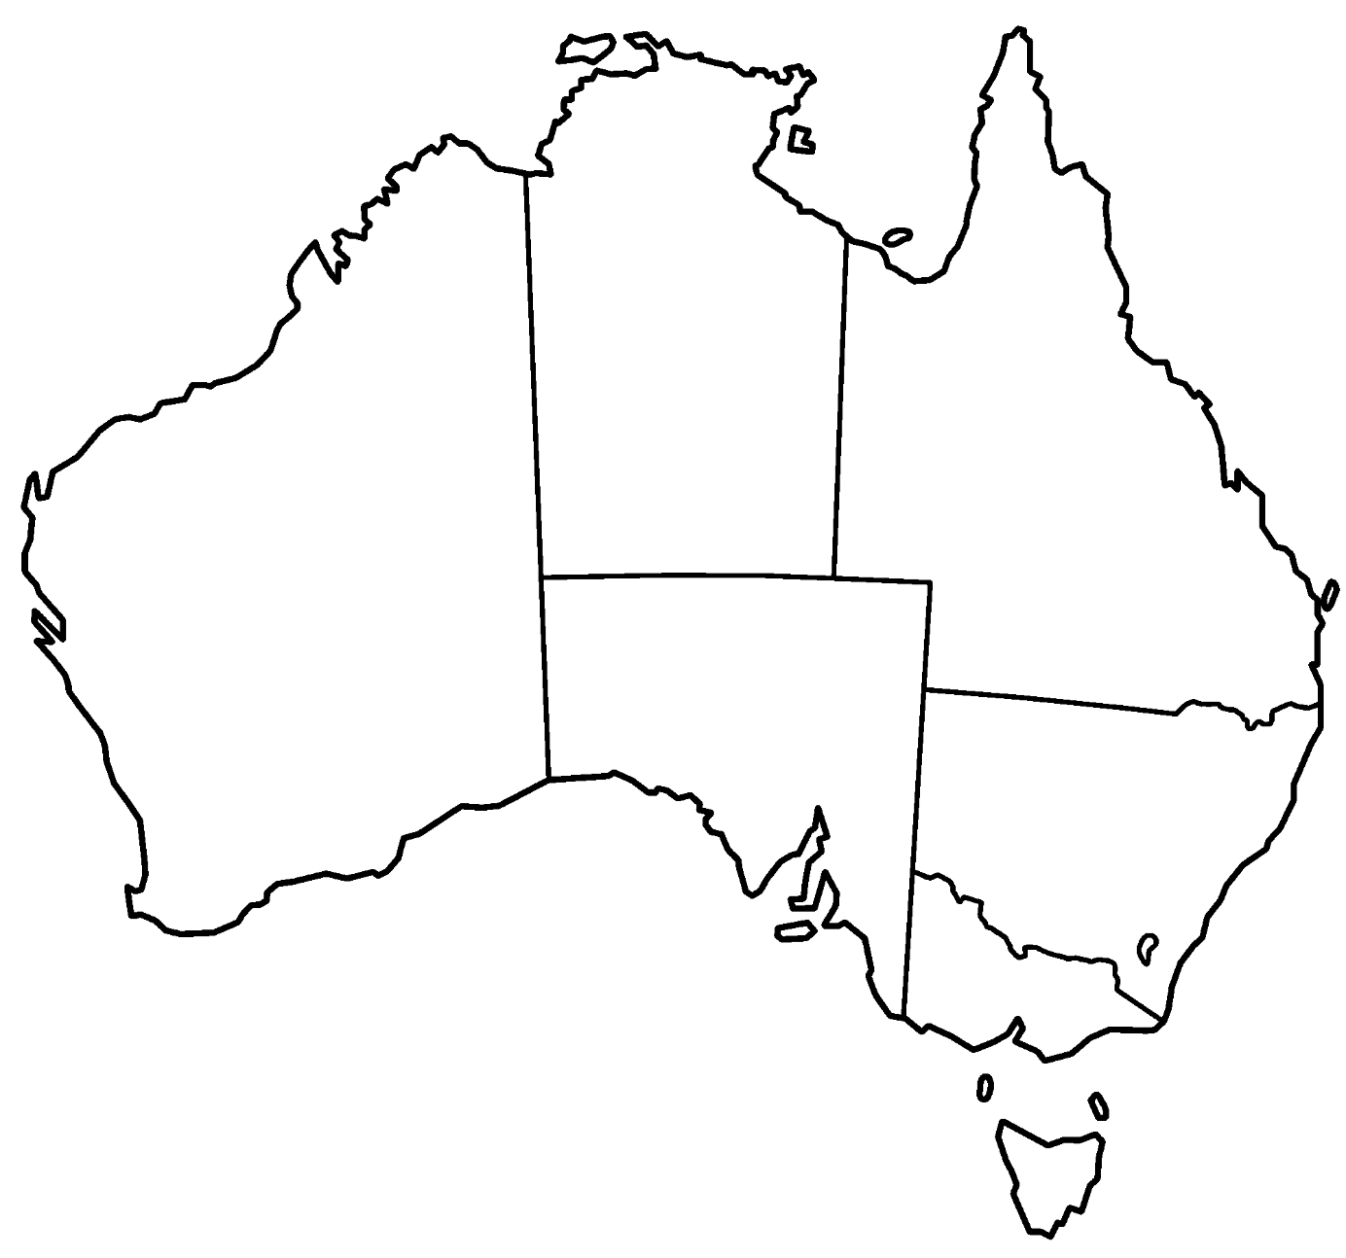
Highlight or use different colours for the reasons for your connections and label them in the table. Two suggestions have been added for you.

Connection | Colour
Family
Media

- Explain why you feel connected to 4 of these places
Place | Connection

Resource #2 The experiences of Australian migrants

Migration in Australia
- In June 2024 ______% of Australia’s population was born overseas, and at the 2021 Census ______% of Australians had a parent born overseas.

Video: Journeys of Hope – Peter’s Story
- Identify the push and pull factors that influenced Peter's family to migrate to Australia.

Push | Pull

- As someone new to Australia, how did Peter become part of a community? Why was it important?

- Citizenship is a significant milestone in the life of someone who has migrated to Australia. To what extent do you agree with this statement?

- Assess the extent to which Peter's migration experience was mutually beneficial for him and for Australia.

Video: Refugee experiences upon arriving in Australia
- Compare the experiences shown in this video to Peter’s experience in the previous video.

- Describe the distribution of Australian residents by country of birth using evidence from the source.

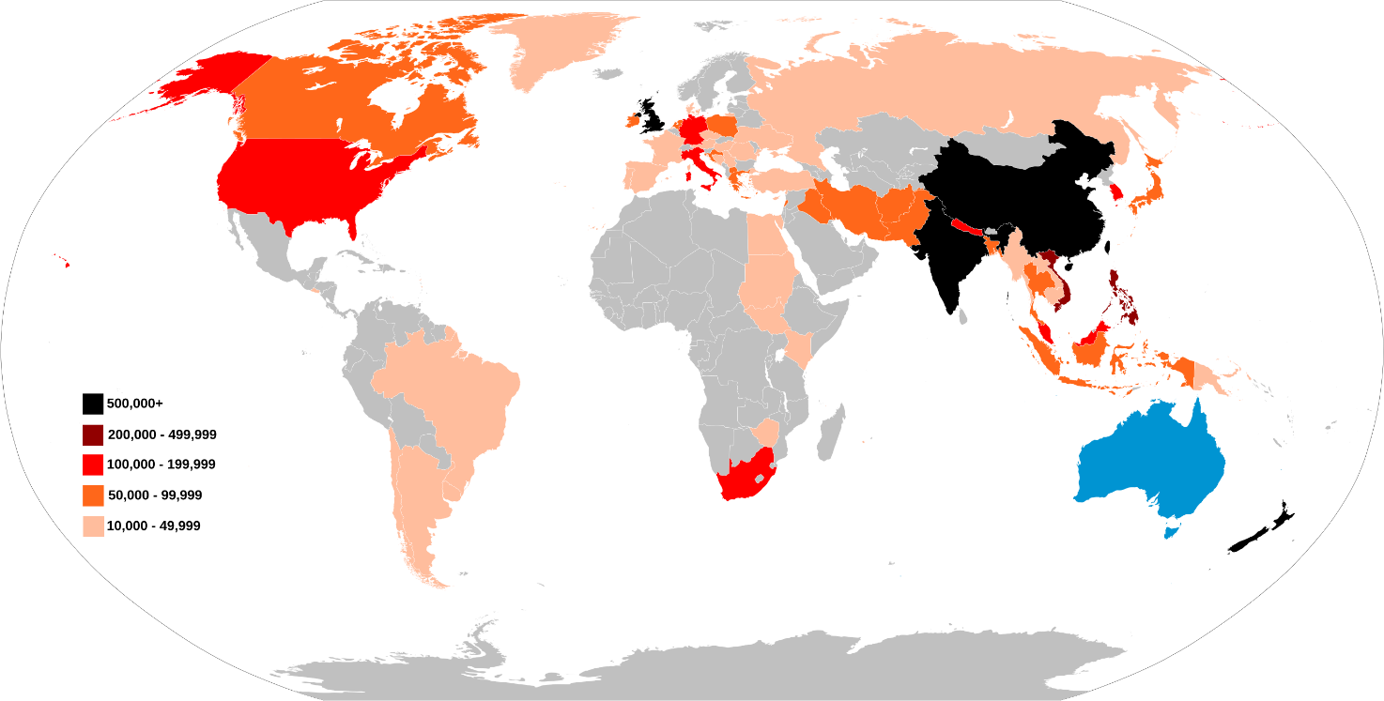
Source: Australian Residents by Country of Birth 2021 Census

Video: You can’t ask that
- What new information did you learn from watching this video?

- How were your preconceived ideas about Africa and African Australians challenged or reinforced?

- What are the benefits of challenging pre-conceptions?

© Department of Education Western Australia 2025. This product has been generated or modified using artificial intelligence and to the extent that copyright subsists in it, the copyright is retained by the Department of Education Western Australia.

