ACTIVITY COMPLETION REPORTS
A completion report is required within 14 days of the end of the activity. To complete the report:
- Log-in and Click on the Actions icon related to your recently completed activity.

- Select Activities.

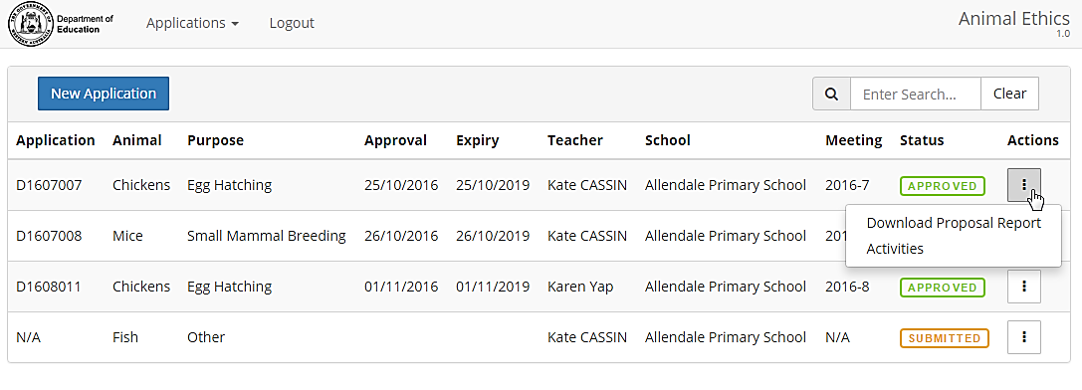
- Your current activity will appear and a required completion report is indicated by
a red cross.

- Click on Actions and select Completion Report.

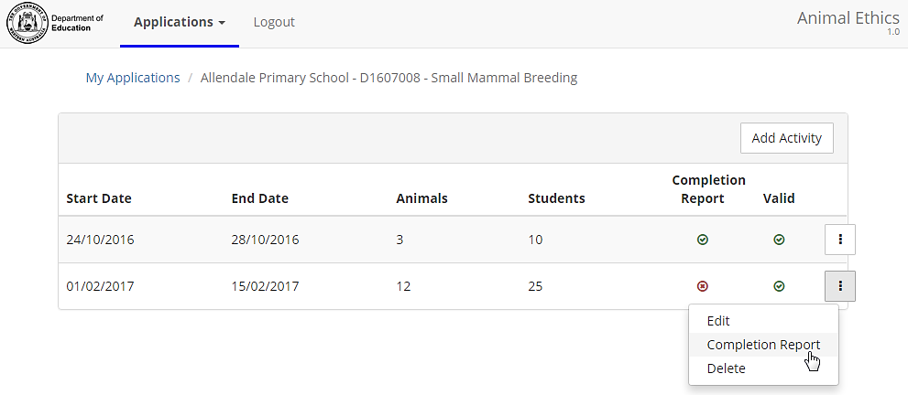

- Click anywhere on the row next to the animal name to edit the activity details. Editing is required if you used more or less animals than planned or if there were any deaths.

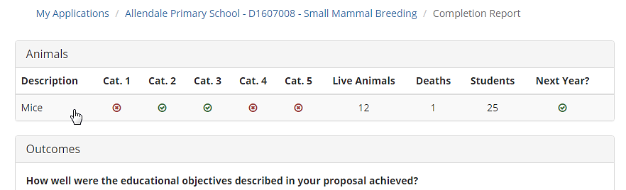

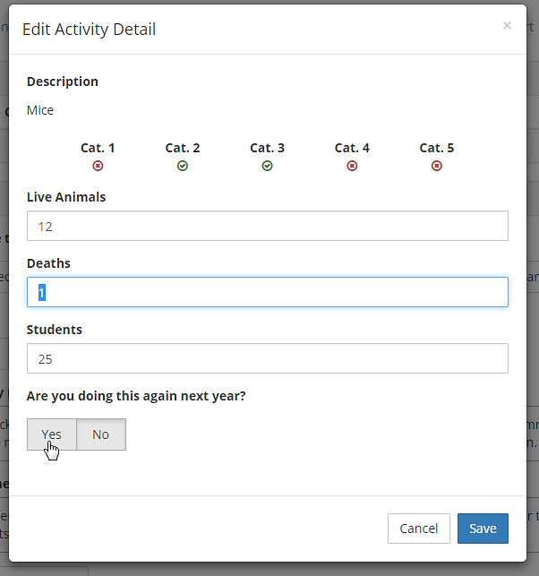

- Enter comments in relation to any issues encountered or general comments and Submit.

Note: All activity completion reports are tabled at Schools Animal Ethics Committee meetings.

