ADDING THE NEXT YEAR’S ACTIVITY TO A THREE YEAR APPROVAL
A three year approval for an activity means that you may undertake that activity again over the next two years without having to seek approval from the Schools Animal Ethics Committee (SAEC) each time. However, you must advise the SAEC each time you undertake the activity by adding a new activity into the system. This will ensure that the activity appears on your school’s Annual Report each year.
- Log-in to the Animal Ethics system and click on the Actions icon next to the current proposal with the activity that you want to undertake again this year.

- Select Activities for your approved application.
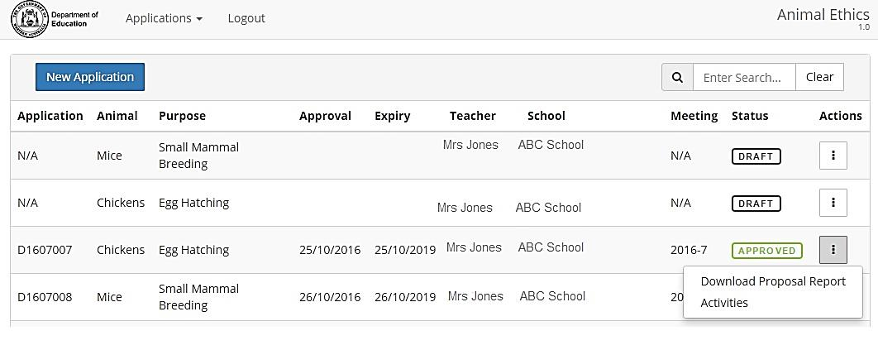
- You will now see a list of the previous activities undertaken under this approval.
Select Add Activity
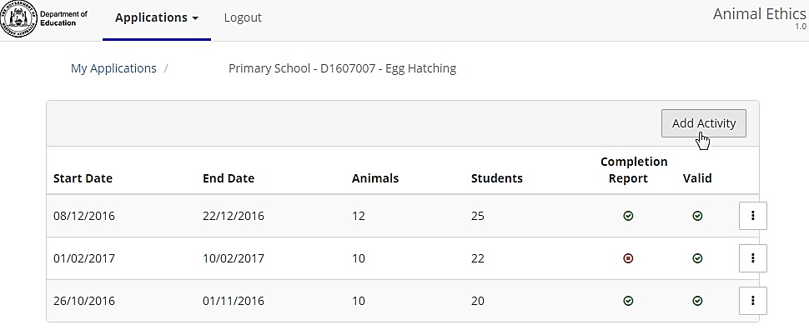
- Enter the required information for the current year’s activity and click on Create Activity.
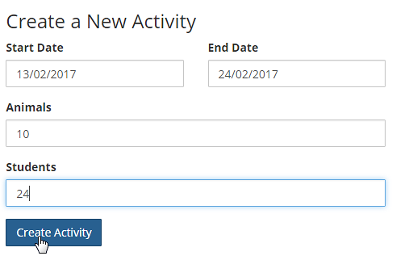
Note: The activity will now appear at the top of the list of activities for this approval so that:
- you will be able to submit an activity completion report; and
- the animals used in this activity will automatically appear on the school’s Annual Report.
