INFORMATION FOR PRINCIPALS USING THE ANIMAL ETHICS SYSTEM

The Principal is responsible for ensuring that teachers adhere to the requirements of the Schools Animal Ethics Committee (SAEC) which, in turn, ensures compliance with the Australian code of practice for the care and use of animals for scientific purposes.

The Principal must understand the teacher’s application and their declaration: The Principal is ultimately responsible to ensure the welfare of the animals and is required to declare that staff members are competent to care for the animals, not just competent to teach.

Support may be required: Teachers often can’t leave the classroom, so if an animal becomes sick is there someone who can take it to a vet? If the teacher must come in to the school over the week-end to care for the animals, will they need special security access? Is there someone else who is competent to care for the animals if the teacher is unexpectedly absent during the period of the activity?

Breaches of the Code must be reported to the Department of Primary Industries and Regional Development (DPIRD) as the regulator for the Animal Welfare Act 2002.
- Any school that commences an activity before approval is received from the SAEC commits a breach of the Code that must be reported in the annual Animal Use Report to DPIRD.
- If the licence and approval documents are not on display this is technically a breach of the Code.
- Any change to the activity that is not approved may be a breach of the Code. For example, taking the animals home over the week-end when the approved application states they will stay on school grounds is a breach of the Code.
- Contact the SAEC Executive Officer if you wish to change the application as some amendments can be approved quickly.

Your school may receive a visit: The SAEC is required to inspect a number of activities each term and any school with an approved activity may be visited.

- Email notification: Principals receive an email when a teacher has prepared and finalised an application to use animals. The principal or deputy principal are the only people who can submit an application to the SAEC. This function is linked to their log-in and password.

- Log on to view your applications here: https://apps.det.wa.edu.au/ane/login

- Applications requiring your approval have a Status of ‘Waiting’. You can either click on the ‘Waiting’ icon to go directly to the online application or you can click on the Actions button and download the report to printout and read in hard copy.
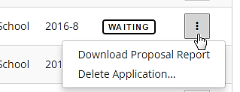

- To check the application online, read through each section of the application by clicking on the tabs across the top of the screen. A red dot indicates the area that requires your action.
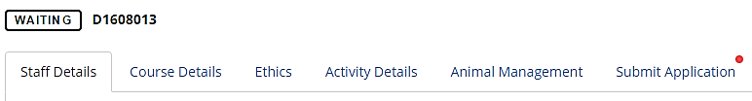

Note: You must know which staff members are involved in the activity, how they intend to care for the animals and what they have proposed to do with the animals because you are required to certify that they are competent. You should also be prepared to provide support if needed.

- Select the Submit Application tab. Before submitting the application, you must view and agree with two declarations – the staff member’s declaration and the principal’s.

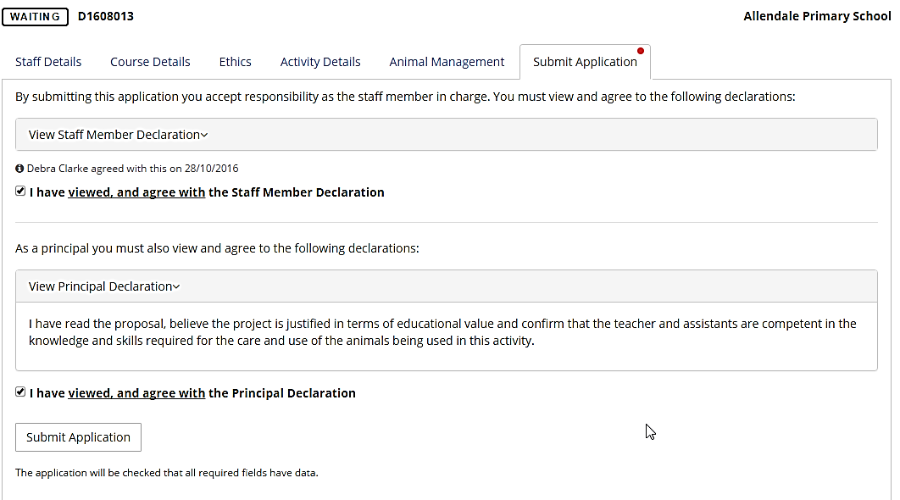

- If successful, you will see the following message: This application has been submitted to the Schools Animal Ethics Committee for consideration.

REPORTS
Activity Completion Reports
Teachers are required to submit an Activity Completion Report within 14 days of the end of the activity. The information is then automatically reflected in the school’s Annual Report.
Annual Reports
- To submit an Annual Report, go to the ‘Reports’ menu item.

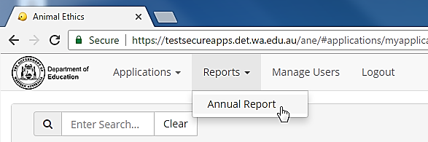

- The principal can add, delete or edit the pre-populated information on the report.

- To finalise the report, click on the ‘Submit Annual Report’ button.

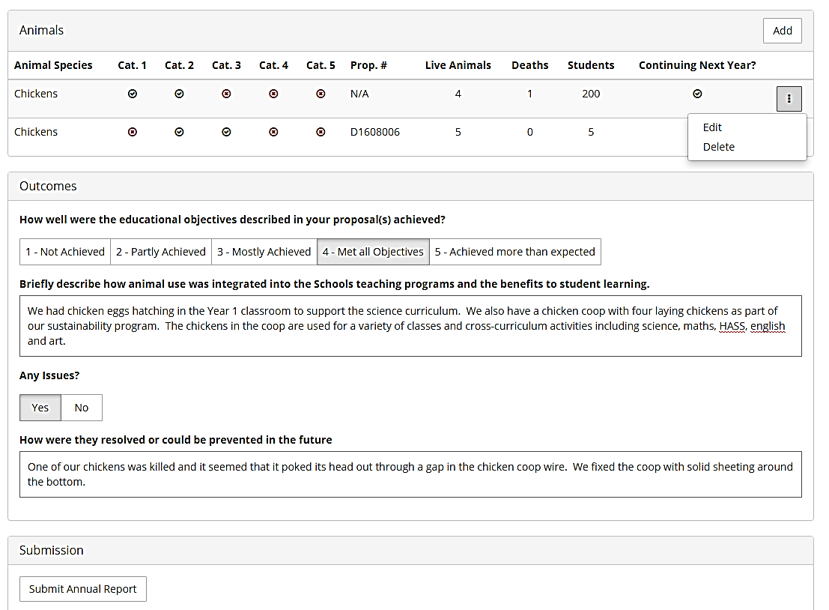

Circumstances where the principal may choose to add extra rows to the Annual Report include:
- Animals used for scientific purposes for observation activities that do not require SAEC approval (e.g. reptiles, amphibians or fish in tanks in the science class).
- Animals used in sustainability activities (e.g. laying chickens) may be reported but this is not a mandatory requirement.

Rules related to Annual Reports:
- Only the Principal or Deputy Principal can submit an Annual Report.
- Only one report can be submitted for each school, each year. All animal use activities for the school should be shown on one report.
- Only animals that are on the Animal Species drop-down list or fit within one of the categories in that list should be included (e.g. Axolotls are not listed but they fit within the category of Amphibian).
- If teachers have submitted their Activity Completion Reports as required, that data will be pre-populated in the report. Contact the teacher to submit their Activity Completion Report if their data does not appear on the Annual Report.

