**Animal Ethics System **

**CATHOLIC SCHOOLS**

**USER MANUAL**

Contents

ANIMAL ETHICS - OVERVIEW 2

Why Schools Must Apply To Use Animals 2

LOG ON 3

TEACHER ROLE 4

1 New Applications 4

2 Staff Details 5

3 Course Details 5

4 Ethics 8

5 Activity Details 9

6 Animal Management 11

7 Submit Application 12

8 Cannot Submit Application Errors 13

9 Activity Completion Reports 14

10 Adding The Next Year’s Activity To A Three Year Approval 16

PRINCIPAL ROLE 18

11 Principal’s Responsibilities 18

12 Submitting Applications 18

REPORTS 20

13 Activity Completion Reports 20

14 Annual Reports 20

# ANIMAL ETHICS - OVERVIEW

## Why Schools Must Apply To Use Animals

Estimates indicate that Western Australian schools use in excess of 20,000 animals each year in both science and agricultural activities. The Animal Ethics System is a web-based, software application designed to reduce the time and effort required for schools to create and lodge applications and submit reports to the Schools Animal Ethics Committee (SAEC).

All schools must apply to the SAEC to use animals for scientific activities because it is required by law. The SAEC has been established by the Department of Education in conjunction with the Catholic Education Office and the Association of Independent Schools WA to provide services to all public schools, Catholic schools, independent schools and WA TAFE colleges to support them to meet their legislative responsibilities and demonstrate best practice animal care for their students.

In WA the welfare of all animals is regulated by the *Animal Welfare Act 2002* (the Act) which is most commonly associated with the RSPCA rescuing abused animals and prosecuting offenders. However, this legislation also regulates the use of animals for scientific testing and experiments by private companies, hospitals, laboratories, universities and schools. The Act requires that anyone using animals for scientific purposes (including teaching activities in schools) must adhere to the [*Australian code for the care and use of animals for scientific purposes*](https://www.nhmrc.gov.au/about-us/publications/australian-code-care-and-use-animals-scientific-purposes) (the Code).

The Code requires that all schools, universities and colleges must obtain the approval of an Animal Ethics Committee before using animals for any scientific teaching activity. The Code also specifies detailed requirements for standards of care, staff competency, accountability and reporting. Every procedure and reporting requirement stipulated by the SAEC directly corresponds with a requirement of the Code. Both the Animal Ethics System and this manual are designed to support schools and provide guidance about these requirements as the teacher and principal progress through the application and reporting processes.

# C:\Users\E0032206\Desktop\Animal Ethics\chicken.pngLOG ON

**How to log on to the Animal Ethics Management System**

1. **Go to the Department of Education Animal Ethics webpage.**

**<https://myresources.education.wa.edu.au/programs/animal-ethics/animal-ethics-system>**

1. **Select Animal Ethics Management System from the link on the page.**
2. **Log on to the portal.**

1. Make sure that you and your principal are aware of the application cut-off dates for each Schools Animal Ethics Committee (SAEC) meeting.
2. You must wait to receive the approval notice after the SAEC meeting before you commence an activity.
3. Approval can only be granted at the meetings held in week 3 and week 8 of each public school term.

***Late applications***: If applications have closed but the meeting has not yet been held, contact the Executive Officer to discuss your situation. There is some leeway to accept applications after the cut-off date, in certain circumstances.

# C:\Users\E0032206\Desktop\Animal Ethics\chicken.pngTEACHER ROLE

## New Applications

* 1. **If this is your first time using the system** you will see the **Create a New Application** screen. Select from the drop-down boxes:

1. **Activity Type –** these are a number of common activities undertaken in schools. The templates provide example responses to assist you with the application. If your activity isn’t listed, select ‘Other’.
2. **Animal –** you must select from this list. If your animal is not listed, contact the SAEC Executive Officer to discuss whether you are required to submit an application.
3. **Create Application –** takes you to the first screen of the process – Staff Details.

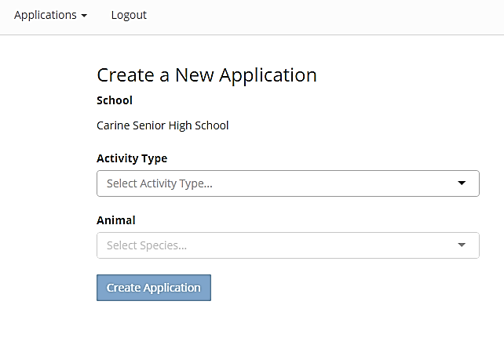

**c)**

**b)**

**a)**

* 1. **If you have used this system before** the log-in screen lists your current applications. To start a new application, use the New Application button on the top-right hand of the screen.
  2. **To complete an application,** work through each of the tabs across the top of the screen. It is not necessary to do all sections at once, the system will save a draft application and you can return to it later. Sections 2 to 7 of this Manual provide instructions for each part of the process.



## Staff Details

**The details and experience of all staff working with animals must be recorded.**

* 1. **Course Coordinator** is the teacher responsible for the activity.
  2. **Experience with Animals** is the information used to determine whether the person is experienced and competent to care for the welfare of the animals. It does not necessarily refer to teaching experience.
  3. **Other staff** includes other teachers, teacher’s assistants or Lab Assistants who may handle or care for the animals. This list may include any number of people.

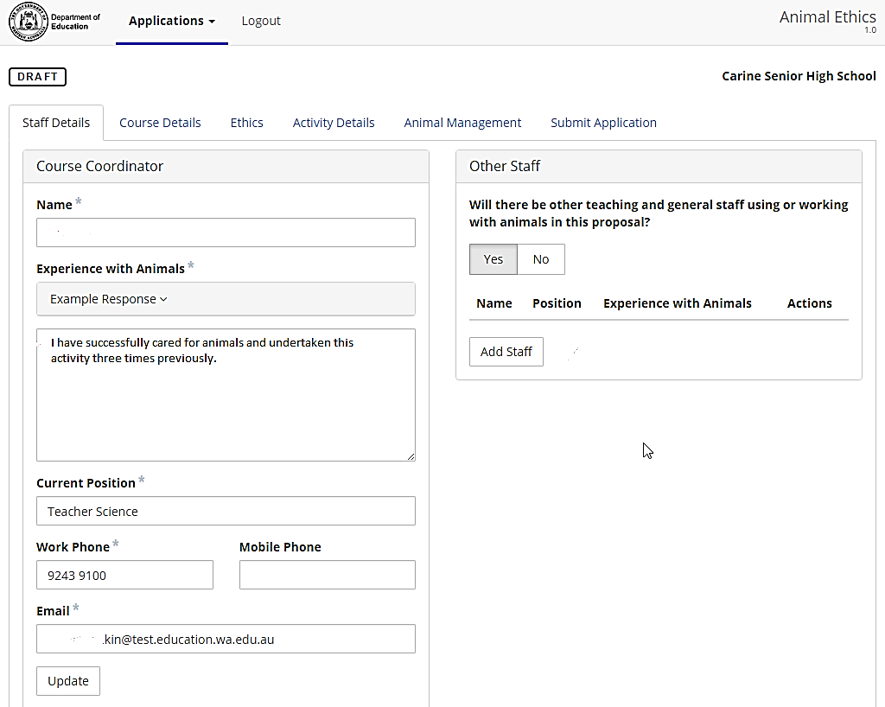

**2.3**

**2.1**

**2.2**

## Course Details

Only teaching activities under the Science strand require approval. Therefore the **Learning Area** is always Science and the **Content Strand** is always Science Understanding: Biological Science. If you are not doing an activity under the Science strand then logout – approval is not required.

***Important to Note*:**

* Each field in the **Course Details** screen must be completed.
* **Approval Period** – approval can be given for one, two or three years. It is important to note that you will be expected to report for the entire approval period. If you only undertake the activity in the first year and don’t do it again, you will still receive reminders and be required to submit annual reports for three years.
* **Animals used again?** Only answer ‘Yes’ if the same animals will be used more than once each year or used in more than one type of activity e.g. “Bessie” the female rat will be used for a breeding activity for Year 7 in Term 1 and then again for Year 11 Biology in Term 3.

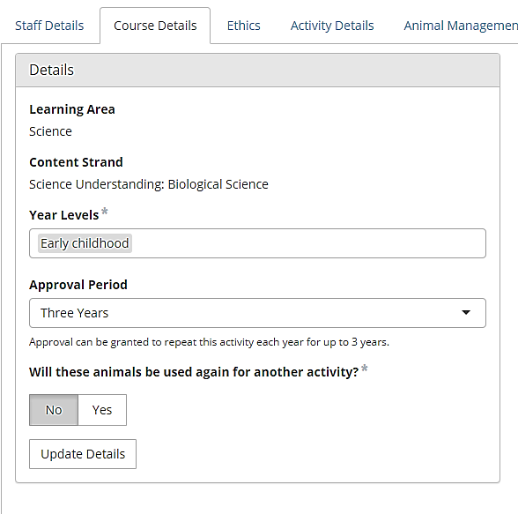

* The supplier details must be entered before an application can be completed.

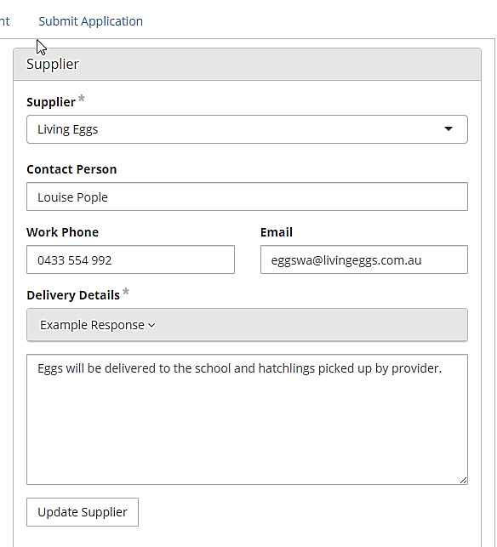

* Course Content must be relevant to the year group. The default content is relevant to early childhood year groups but you can edit, delete or add content for older year groups.

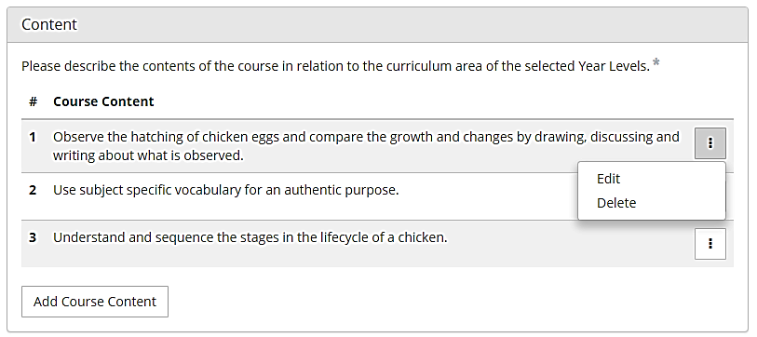

## Ethics

Enter the number of animals you intend to use and the ethical justification for using these animals. If this is a breeding activity you should include an estimate of the number of offspring. E.g. For a chicken hatching activity you will order ten eggs – the number is 10. For a guinea pig breeding activity you will use a male and a female plus you could expect as many as 5 pups – the number is 7.

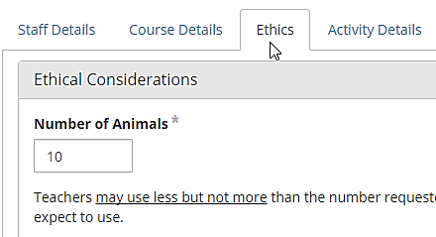

**The 3 R’s are a fundamental concept in animal ethics.** Any proposal for the scientific use of animals in Australia for education or research is required, by law, to prove that the 3 R’s have been considered.

To consider the three R’s ask:

* Could you teach this component of the curriculum just as well without using live animals? (**R**eplacement)
* Have you **R**educed the numbers to the absolute minimum necessary to achieve the educational outcomes?
* Can you further **R**efine the activity to minimise the impact on the animals?

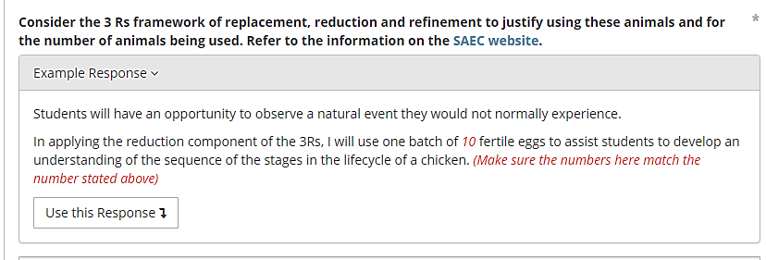

***Important to Note*:** When you use the example response, the instructions in red italics convert to normal text. Remember to edit and delete the text that was in red italics. If you do not, then the SAEC members may question whether you considered your responses.

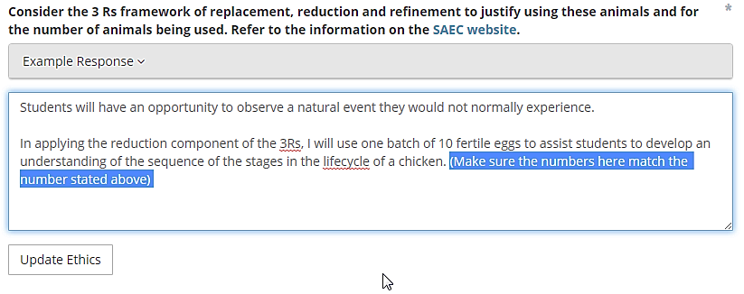

***Remember to delete the instructions.***

## Activity Details

Click on the first row to Edit and complete the activity details: Start, End, Students.

*Note:* The number of animals will already be entered if you correctly completed the previous Ethics screen.

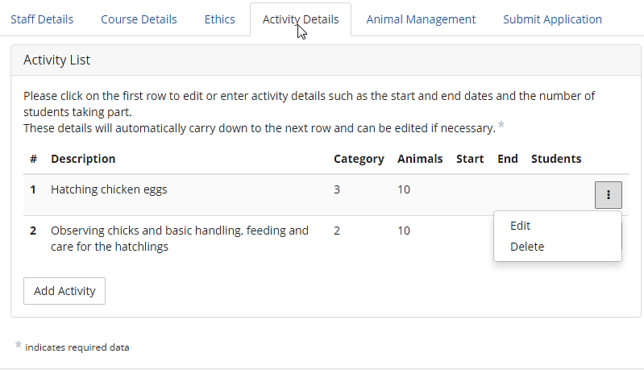

* Once entered, the activity details automatically carry down to the next row so that you do not have to enter the same details twice. However, each row can be edited if a project has separate activities, phases that do not run concurrently or involve different numbers of students.
* Note: It is usual for an egg hatching project to commence on a Monday and continue until the following Friday which is 12 days including the weekend.

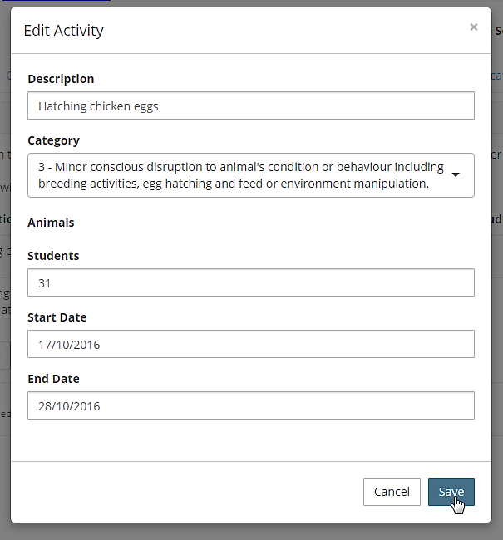

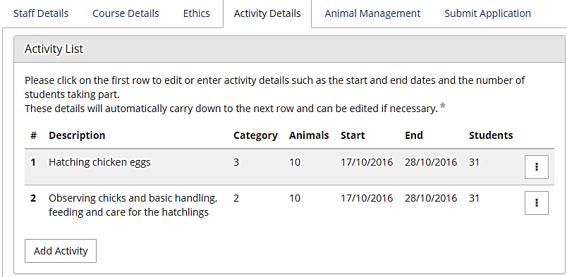

***All details automatically carry down but can be edited by clicking on the row.***

## Animal Management

Good animal management practices are essential for the health and wellbeing of animals. The members of the SAEC carefully consider the details in this section of the proposal to ensure that teachers will care for the animals appropriately.

* A considered response is mandatory for every question.
* Actions described here form an essential part of the approved activity.
* Contact the Executive Officer if you need to change any aspect of the proposal after approval is given. For example, if the proposal states that animals are to be kept at school over the weekend, then you do not have approval to take them home instead.



**Example responses are a guide only.** Teachers are expected to add or delete information to provide a considered response that reflects their activity. See the instance below where the Example Response has been edited to reflect the individual situation.

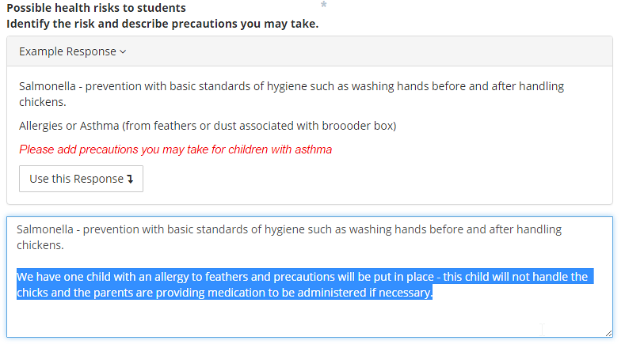

***Replace the example response with information relevant to your*** ***activity.***

## Submit Application

* Click on View Staff Member Declaration and read the six points.
* Tick the “I have viewed and agree with the **Staff Member Declaration** box
* **Submit Application**

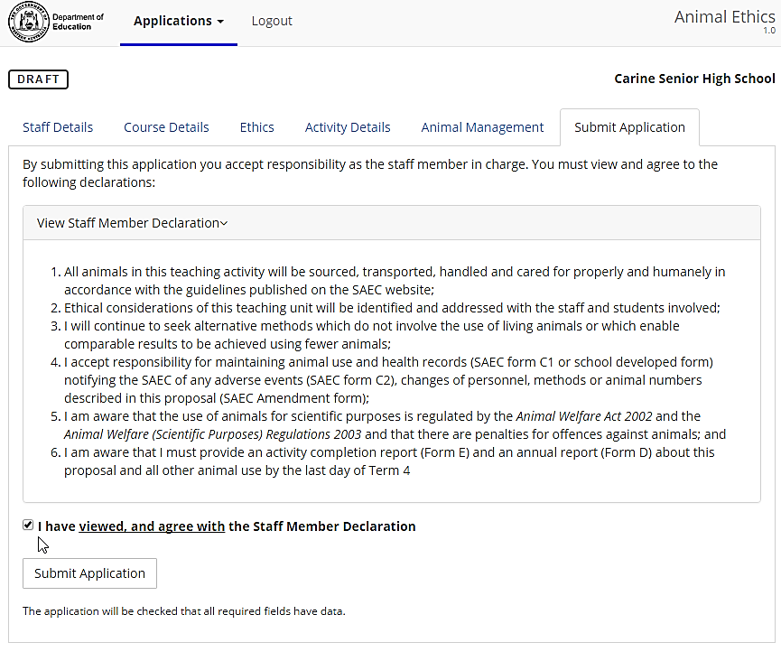

**Completion**

If you see the following message then you have completed the process and your principal will receive an email notifying them of the application requiring approval.

**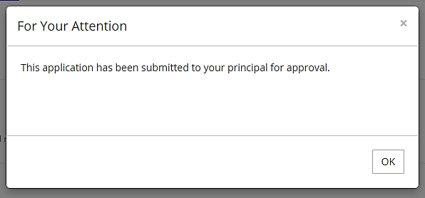*Note:***

**Principals receive a lot of emails, so it is worthwhile mentioning this application to them, in person, to ensure they don’t miss the deadline for submission to SAEC meetings.**

C:\Users\E0032206\Desktop\Animal Ethics\Waiting.png

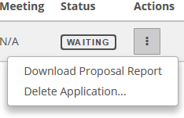**A successfully submitted application is listed as:**

While an application is ‘Waiting’ you can still delete it by clicking on the Actions button. You can also download the application as a PDF file which can be printed out. A printed copy may be kept on file or provided to your Principal if they prefer to see a hard copy before approving it online.

## Cannot Submit Application Errors

If you have not completed all required data you will receive a ‘Cannot Submit’ message.

* The message provides the Tab (e.g. Animal Management) and the section ( e.g. Transport and Handling) where information is missing. Go to the section.
* Enter the details required.
* Update the section
* Go directly back to Submit Application and repeat that process.

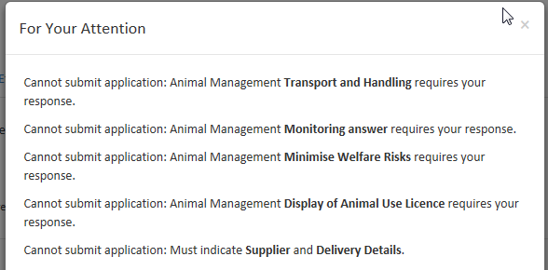

## Activity Completion Reports

A completion report is required within 14 days of the end of the activity. To complete the report:

1. Log-in and Click on the Actions icon related to your recently completed activity.
2. Select Activities

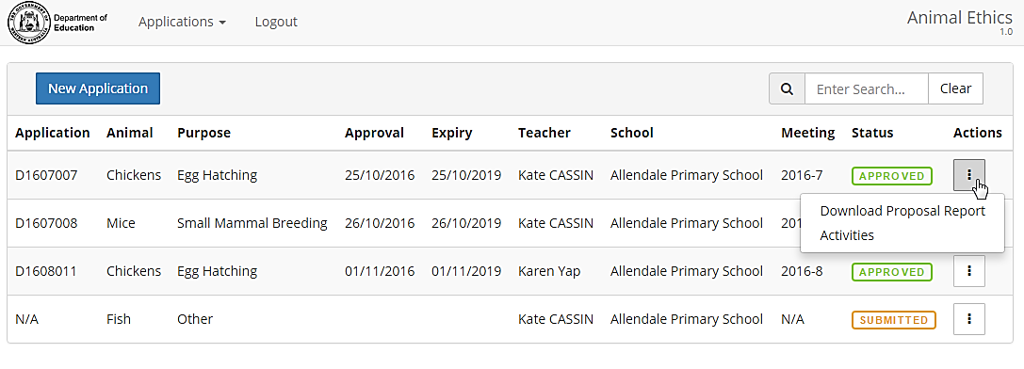

1. Your current activity will appear as a row with a start and end date, number of animals and students. A required completion report is indicated by a red cross.
2. Click on the Actions icon and select Completion Report.

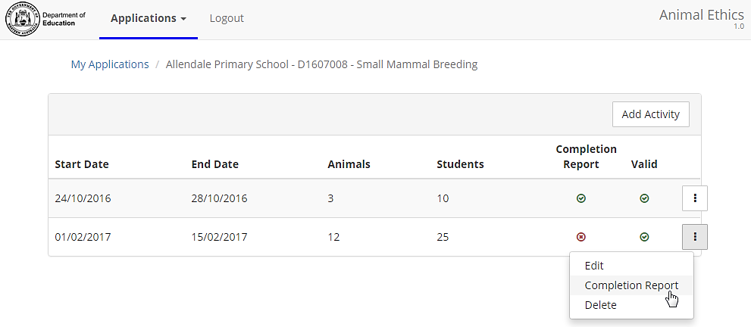

1. Click anywhere on the row next to the animal name to edit the activity details. Editing is required if you used more or less animals than planned or if there were any deaths.

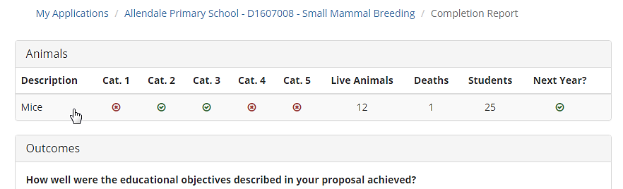

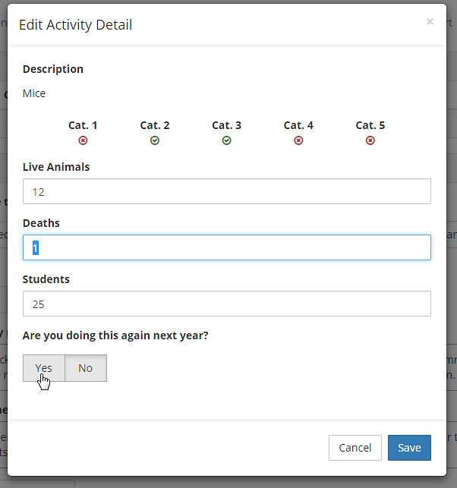

1. Enter comments in relation to any issues encountered or general comments and Submit.

***Important to Note:*** All activity completion reports are tabled at SAEC meetings.

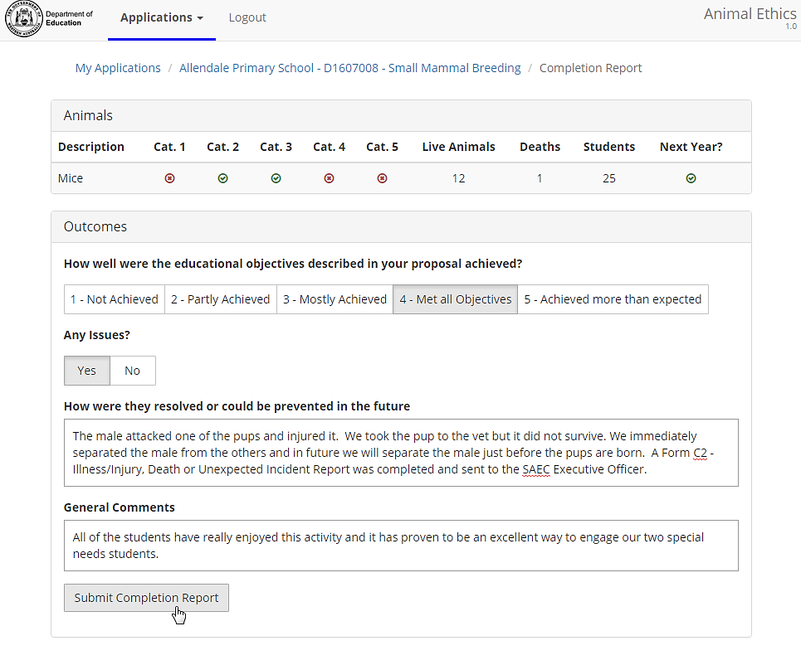

## Adding The Next Year’s Activity To A Three Year Approval

A three year approval for an activity means that you may undertake that activity again over the next two years without having to seek approval from the SAEC each time. However, you must advise the SAEC each time you undertake the activity by adding a new activity into the system. This will ensure that the activity appears on your school’s Annual Report each year.

**10.1** Log-in to the system and click on the **Actions** icon next to the current proposal with the activity that you want to undertake again this year.

* 1. Select **Activities**.

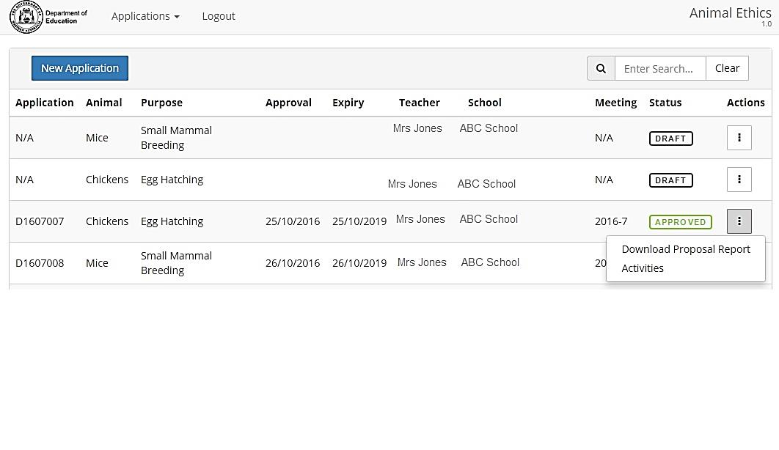

* 1. You will now see a list of the previous activities undertaken under this approval.   
     Select **Add Activity**

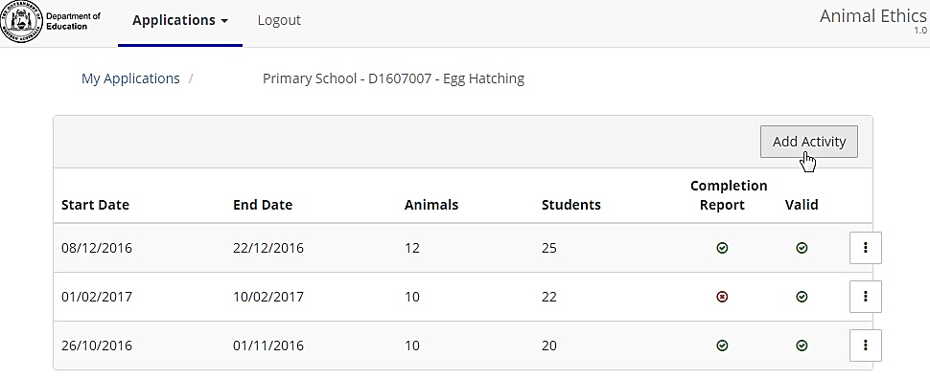

* 1. Enter the required information for the current year’s activity and click on **Create Activity**.

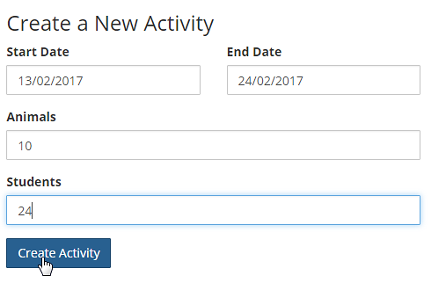

* 1. The activity will now appear at the top of the list of activities for this approval so that:
     + - you will be able to submit an activity completion report; and
       - the animals used in this activity will automatically appear on the school’s Annual Report.

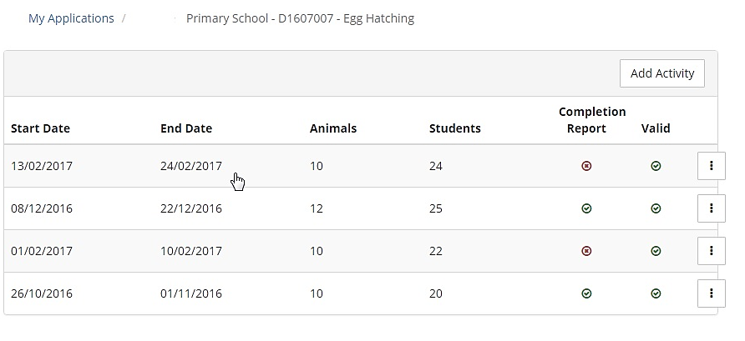

# PRINCIPAL ROLE

## Principal’s Responsibilities

* **THE PRINCIPAL IS RESPONSIBLE** for ensuring that teachers adhere to the requirements of the Schools Animal Ethics Committee (SAEC) which, in turn, ensures compliance with the *Australian code of practice for the care and use of animals for scientific purposes*.
* **THE PRINCIPAL MUST UNDERSTAND THE TEACHER’S PROPOSAL AND THEIR DECLARATION.** The Principal is ultimately responsible to ensure the welfare of the animals and is required to declare that staff members are competent to care for the animals, not just competent to teach.
* **SUPPORT MAY BE REQUIRED.** Teachers can’t usually leave the classroom, so if an animal becomes sick is there someone who can take it to a vet? If the teacher must come in to the school over the week-end to care for the animals, will they need special security access? Is there someone else who is competent to care for the animals if the teacher is unexpectedly absent during the period of the activity?
* **BREACHES OF THE CODE MUST BE REPORTED** to the Department of Primary Industries and Regional Development (DPIRD) as the regulator for the *Animal Welfare Act 2002*.
  + Any school that commences an activity before approval is received from the SAEC commits a breach of the Code that must be reported in the annual Animal Use Report to DPIRD.
  + If the licence and approval documents are not on display this is technically a breach of the Code.
  + Any change to the activity that is not approved may be a breach of the Code. For example, taking the animals home over the week-end when the approved application states they will stay on school grounds is technically a breach of the Code.
  + Contact the SAEC Executive Officer if you wish to change the application as some amendments can be approved quickly.
* **YOUR SCHOOL MAY BE VISITED**. The Schools Animal Ethics Committee is required to inspect a number of activities each term and any school with an approved activity may be visited.

## Submitting Applications

* 1. **Email notification:** Principals receive an email when a teacher has prepared and finalised an application to use animals. The principal is the only person who can submit an application to the SAEC. This function is linked to their log-in and password.
  2. **Log-in** to view your applications here: <https://apps.det.wa.edu.au/ane/login>
  3. Applications requiring your approval have a Status of ‘Waiting’. You can either click on the ‘Waiting’ icon to go directly to the online application *OR* you can click on the Actions button and download the report to printout and read in hard copy.

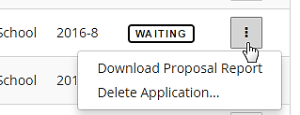

*Click here to go to the online application*

* 1. To check the proposal online, read through each section of the application by clicking on the tabs across the top of the screen. A red dot indicates the area that requires your action.





You must know which staff members are involved in the activity, how they intend to care for the animals and what they have proposed to do with the animals because you are required to certify that they are competent. You should also be prepared to provide support if needed.

12.5 Select the **Submit Application** tab. Before you can submit the application you must view and agree with two declarations – the staff member’s declaration and the principal’s.

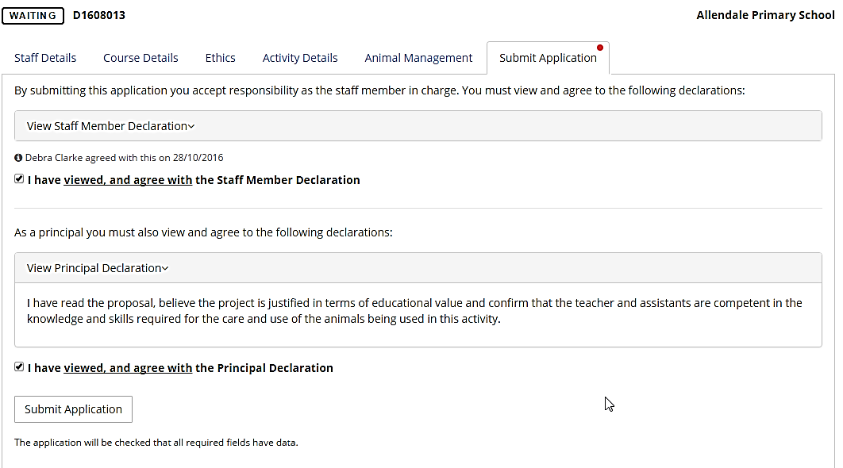

12.6 If successful you will see the following message: This application has been submitted to the Schools Animal Ethics Committee for consideration.

# REPORTS

## Activity Completion Reports

Teachers are required to submit an Activity Completion Report within 14 days of the end of the activity (See Section 9 p14). The information is then automatically reflected in the school’s Annual Report.

## Annual Reports

* 1. To submit an Annual Report go to the ‘Reports’ menu item.

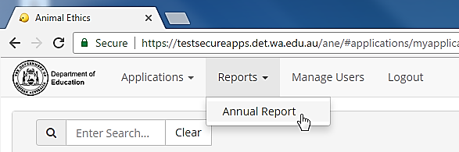

* 1. The principal can add, delete or edit the pre-populated information on the report.
  2. To finalise the report click on the “Submit Annual Report” button.

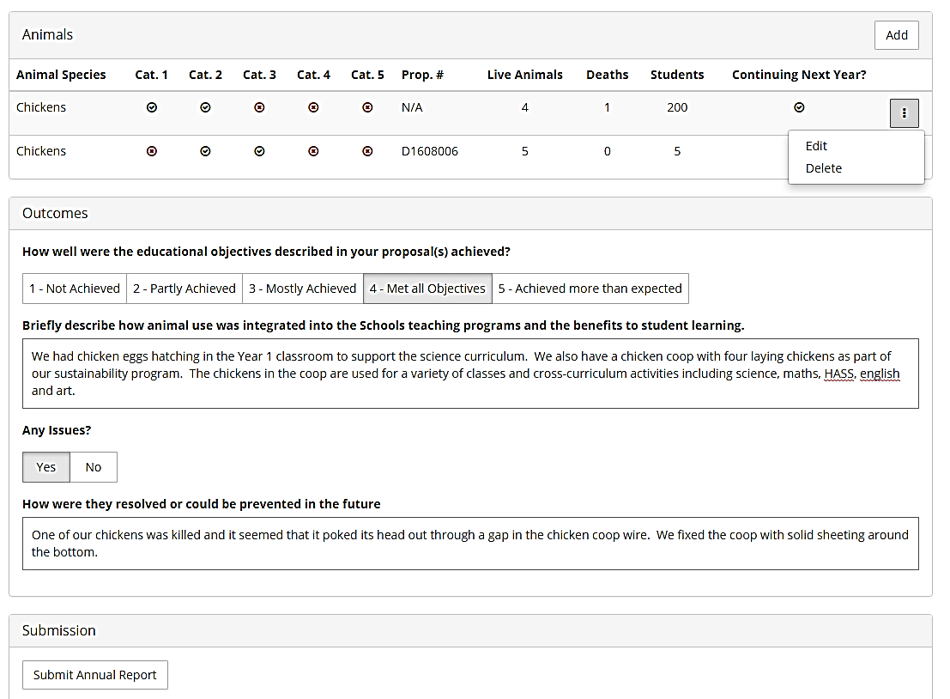

*Click Here to Submit*

***The chickens in the first row of this report would need to be added by the principal as they did not require SAEC approval****.*

* 1. Circumstances where the principal may choose to add extra rows to the Annual Report include:
     + Animals used for scientific purposes for observation activities that do not require SAEC approval (e.g. reptiles, amphibians or fish in tanks in the science class).
     + Animals used in sustainability activities (e.g. laying chickens) may be reported but this is not a mandatory requirement.
  2. Rules related to Annual Reports:
* Only the Principal can submit an Annual Report.
* Only one report can be submitted for each school, each year. All animal use activities for the school should be shown on one report.
* Only animals that are on the Animal Species drop-down list or fit within one of the categories in that list should be included (e.g. Axolotls are not listed but they fit within the category of Amphibian).
* If teachers have submitted their Activity Completion Reports as required, that data will be pre-populated in the report. Contact the teacher to submit their Activity Completion Report if their data does not appear on the Annual Report.

# Support Contact

SAEC Executive Officer

Catholic Education Western Australia

Telephone: 9380 1729

Email: [animalethics@cewa.edu.au](mailto:animalethics@cewa.edu.au)