Schools Animal Ethics Committee (SAEC)
2024 SAEC Membership Package

CONTENTS
SAEC Definitions 3
TERMS OF REFERENCE 4
1. Scope of responsibilities 4
2. Institutional Accountability 5
3. Mechanisms for reporting 5
4. Membership of the SAEC (2.2.4) 5
OPERATING PROCEDURES 6
1. Introduction 6
2. Provisions of the Code 6
3. Additional appointments 6
4. Meeting procedures (2.2.25 to 2.2.26) 7
5. Non-compliance (2.2.29) 8
6. Appointment of an Executive (2.2.23) 9
7. Communication (2.2.27) 9
8. Records (2.2.30) 9
9. Administrative processes (2.2.24) 9
10. Documentation (2.2.32) 9
11. Conflict of Interest (2.2.21) 9
12. Confidentiality (2.2.22) 10
13. Complaints (2.2.29) 10
14. Member appointments, retirement, roles and responsibilities 10
COMPLAINTS AND GRIEVANCE PROCESSES 12
1. Schools and General Public 12
2. Serious Disagreements Between Members of the SAEC. 13
COMMITTEE MEMBERSHIP 14
STANDARD MEETING SCHEDULE 16
2024 SAEC MEETING DATES 17
SAEC EXPENSES REIMBURSEMENT CLAIMS 18
SAEC EXPENSES CLAIM FORM 19
ANIMAL ETHICS SYSTEM GUIDE FOR COMMITTEE MEMBERS 20

SAEC Definitions

3Rs:
Reduction alternatives: methods for obtaining comparable levels of information from the use of fewer animals in scientific procedures or for obtaining more information from the same number of animals.

Refinement alternatives: methods that alleviate or minimise potential pain and distress and enhance animal wellbeing.

Replacement alternatives: methods that permit a given purpose of an activity or project to be achieved without the use of animals.

Animal: any live non-human vertebrate (that is, fish, amphibians, reptiles, birds and mammals, encompassing domestic animals, purpose-bred animals, livestock, wildlife) and cephalopods.

Institution: any organisation or agency involved in the care and use of animals for scientific purposes, including universities, hospitals, research institutes, government departments, teaching organisations (including schools and colleges), vocational training organisations, agricultural organisations, commercial companies, and organisations involved in animal breeding and supply.

Science: The Western Australian Curriculum: Science has 3 interrelated strands: Science Understanding, Science as a Human Endeavour and Science Inquiry Skills. Together, the 3 strands of the science curriculum provide students with understanding, knowledge and skills through which they can develop a scientific view of the world.

Teaching activity: any action or group of actions undertaken with the aim of achieving a scientific purpose, where the scientific purpose is imparting or demonstrating knowledge or techniques to achieve an educational outcome in science, as specified in the relevant curriculum or competency requirements.

The Act: the Animal Welfare Act 2002 (WA).

The Code: the NHMRC Australian code for the care and use of animals for scientific purposes, 8th Edition 2013 (updated 2021).

TERMS OF REFERENCE
The Schools Animal Ethics Committee (SAEC) acts as the animal ethics committee for all licensed schools in Western Australia. The SAEC is owned by the Department of Education (The Department) and holds formal agreements to service Catholic Education Western Australia Limited (CEWA) and schools associated with the Association of Independent Schools of Western Australia (AISWA).

The SAEC is responsible for ensuring that the use of animals in schools for scientific purposes complies with the Animal Welfare Act (2002; the Act) and the National Health and Medical Research Council’s Australian code for the care and use of animals for scientific purposes, 8th Edition 2013 (Updated 2021; the Code).

The role of the SAEC is to ensure that the use of animals for scientific purposes is justified, provides for the welfare of those animals and incorporates the principles of Replacement, Reduction and Refinement.

Scope of responsibilities
  - Ethical review
- An application to use animals for teaching scientific outcomes is deemed ethically acceptable only if harm to the animal is minimised and a high standard of animal welfare is maintained.
- The judgement must take into account the application of the 3Rs of Replacement, Reduction and Refinement.
- The decision must balance whether the potential effects on the wellbeing of the animals involved is justified by the potential scientific educational benefits of the activity.

  - Approval
- The SAEC will only approve activities that are ethically acceptable and conform to the requirements of the Code.
- An application may be approved without conditions, deferred subject to modification, or not approved.
- Decisions will be based on a thorough, fair and inclusive process of discussion and deliberation by SAEC members, and should be made on the basis of consensus only by those present throughout the discussion.
- The SAEC must follow-up approved activities annually by reviewing completion and annual reports and only allow the continuation of approval for only those projects and activities that are ethically acceptable and conform to the requirements of the Code.

  - Monitoring animal care and use
The SAEC monitors the care and use of animals including their acquisition, transportation, production, housing, care, use and fate by:
- Ensuring applications comply with the Act, the Code and any other guidelines, including standard operating procedures for the ethical treatment of animals.
- Monitoring activity completion reports and annual reports.
- Carrying out inspections of school sites and activities deemed as high risk by the SAEC. The inspection team will prepare a written report for the SAEC following inspections. Should the written report include recommendations, schools will be requested to respond to the report.
- Selecting schools to submit photographic evidence in lieu of a physical inspection in certain circumstances such as those with time constraints, regional or remote geographical location or government mandated stay at home orders. Photographic inspections will be evaluated by the SAEC at the next quorum meeting.
- Commenting on the standard of the facilities/infrastructure, animal management and staff competencies and make recommendations where appropriate.
- Authorising delegates to inspect sites and monitor projects on behalf of the SAEC. Delegates must prepare written reports for the SAEC following inspections (2.3.23).
- Whenever possible, ensuring a Category C or D member participate in inspections (2.3.20).
- Assisting in the development of any new SAEC Standard Operating Procedures and reviewing and approving existing SAEC Standard Operating Procedures on a 3 year cycle.
- Receiving reports and advising on unexpected adverse effects that impact on the welfare of animals used for scientific purposes.
- Collecting and reviewing completion and annual reports on all activities to confirm that animal use and post-activity fate was consistent and in accord with the approved activity application.

Institutional Accountability
- The SAEC is accountable to the Scientific Licensing Unit (SLU) at the Department of Primary Industries and Regional Development (DPIRD).
- All institutions are accountable to the SAEC and their licence holder.

Mechanisms for reporting
- Each institution that uses the SAEC must submit a written Annual Animal Use Report on its operations annually to the SLU, DPIRD following their supplied template.

Membership of the SAEC (2.2.4)
- For the meeting to be quorum, SAEC membership will consist of at 1 - 3 person/s in:
- Category A: a person with qualifications in veterinary science that are recognised for registration as a veterinary surgeon in Australia, and with experience relevant to the institution’s activities or the ability to acquire relevant knowledge.
- Category B: a teacher with substantial and recent experience in the use of animals for scientific purposes relevant to the institution and the business of the AEC
- Category C: a person with demonstrable commitment to, and established experience in, furthering the welfare of animals, who is not employed by or otherwise associated with the institution, and who is not currently involved in the care and use of animals for scientific purposes
- Category D: a person not employed by or otherwise associated with the institution and who has never been involved in the use of animals in scientific or teaching activities, either in their employment or beyond their undergraduate education.
- The SAEC may appoint reserve members for each category for the purpose of ensuring a quorum when regular members are unable to attend. Reserve members will meet the criteria for membership of the relevant category, and will only attend meetings when the regular members in their category is unable to attend.
- The person appointed to the position of chair of the SAEC must hold a senior position within the Department under Clause 2.2.2 of the Code.
- Each sector must appoint an Executive Officer (EO) as a non-voting member to:
  - act as the liaison between SAEC and the teachers at their schools
  - support the Chair in administering their role
  - record and track agreed actions and communicate actions and information to the relevant parties.
The SAEC may invite other people to attend individual meetings to provide expert opinions to assist deliberations.

The Terms of Reference should be considered in conjunction with the SAEC Operating Procedures. The Terms of Reference may be amended, varied or modified in writing after consultation and agreement by the SAEC, and must be reviewed following a change of legislation.

OPERATING PROCEDURES

Introduction
The SAEC has developed these Operating Procedures in accordance with Section 2.2.1 (iv) of the Code to enable compliance with the provisions of the Code and the relevant policies of the institutions it serves.

Provisions of the Code
Provisions of the Code apply to the establishment of the SAEC, the composition and governance of the committee as well as the responsibilities of the SAEC regarding ethical review, approval and monitoring of animal care and use.

Where a provision of the Code has not been included in these Operating Procedures it is assumed to apply. Should an instruction in these Operating Procedures be deemed to be inconsistent with the Code, the provisions of the Code supersede.

Additional appointments
  - SAEC Chair
- The Chair is a mandatory appointment under Clause 2.2.2 of the Code and is specifically appointed by the Department to Director, Agricultural Education.
- The Chair must ensure that the SAEC operates in accordance with the Code, the relevant institutional policies and the agreed SAEC procedures, and that applications are considered by the SAEC and the outcomes are conveyed to the activity leaders in a timely fashion.
- The Chair will act as the SAEC representative in negotiations with the institution’s management and advise them of the level of resourcing required by the SAEC.
- The Chair will oversee the requirements of the SAEC to report and review its operation as outlined in the Code.
- The Chair will ensure that SAEC records are maintained and made available for review by the institutions.
- The SAEC may appoint a Deputy Chair to cover short-term absences by the Chair. This person may be appointed in addition to Category A to D members, in which case they would not have counted, for the purposes of determining a quorum except when acting as the Chair.

  - SAEC Executive Officer
- Each sector (The Department, CEWA and AISWA) will appoint a SAEC Executive Officer (EOs) to act as the first point of contact for teachers wishing to access the SAEC and the liaison between the parties. EOs are non-voting members of the SAEC.
- The EOs will assist the Chair with efficient operation of the SAEC by:
- Compiling items for the agenda
- Reviewing applications and providing feedback to course coordinators
- Organising the distribution of information to members
- Scheduling meetings and monitoring sessions
- Monitoring and following up on activity records
- Record keeping for their sector’s schools and
- Providing management reports.
- CEWA and AISWA EOs will provide additional information regarding applications from their schools, inspection reports and instances of non-compliance or unexpected adverse events to the Department EO to include in the agenda and meeting bundle.
- The Department EO will take the minutes of each meeting recording decisions and other aspects of SAEC business.

Meeting procedures (2.2.25 to 2.2.26)
- SAEC meetings are held twice each school term on the Tuesday of week 3 and week 8. In exceptional circumstances, an extraordinary meeting may be called.
- The meeting will be hosted by the Department, CEWA and AISWA on a rotating schedule. The host sector will provide catering for the meeting.
- Documents will be distributed to SAEC members via the meeting bundle in the Animal Ethics System the Friday before the meeting allowing reasonable time for members to read, consider and prepare questions.
- Minutes of each meeting will be distributed to SAEC members in the following meeting’s pre-reading bundle. Meeting minutes will clearly state actions required from the previous meeting.
- The Chair will guide the meeting through a standard agenda covering:
  - declaration of any conflicts of interest
  - confirmation of the previous minutes
  - action items and ratification from the previous meeting
  - major correspondence
  - assessments of applications and amendments
  - project monitoring including completion and annual reports, unexpected adverse events and non-compliance
  - school visits and photo inspections and
  - general business, such as approval of SOPs and other documents.
- Each meeting must be quorate with at least one member from each of the membership categories A, B, C and D present.
- If there are more than 4 members present, Category C and D members together must represent no less than one third of the members present at a meeting.
- Members unable to attend will provide adequate notice to ensure a quorum will be met.
- Members may participate in a meeting via a teleconferencing or videoconferencing link if it is not possible and/or practical to attend the meeting in person. The electronic link must utilise a conferencing feature so that all participating members can hear each other during the meeting discussions and decision making.
- Participation of a member via teleconferencing or videoconferencing must be clearly noted in the minutes and the member may authorise the Chair to record their support on the application.

  - Assessment of Applications
- All activities that use animals with the aim of achieving a scientific purpose, where the scientific purpose is imparting or demonstrating knowledge or techniques to achieve an educational outcome in science, as specified in the relevant curriculum or competency requirements, require an application to be submitted and approved by the SAEC prior to commencement of the activity.
- The SAEC can only approve activities that conform to the Code’s requirements and for which animal use is essential and justified, taking factors including ethics, the impact on the animal/s and the anticipated scientific educational value into consideration.
- The SAEC will examine and either approve, approve subject to modification, or reject written applications relevant to the use of animals for scientific purposes.
- New applications may only be considered at a quorate meeting of the SAEC.
- Decisions are made on the basis of consensus and confirmed verbally. Where consensus cannot be reached after reasonable effort to resolve differences, the SAEC should explore with the applicant(s) ways of modifying the project that may lead to consensus. The SAEC should consider face-to-face meetings with applicants to resolve issues.
- If consensus is still unachievable, the SAEC should only proceed to a majority decision after members have been allowed a period of time to review their positions, followed by further discussion.
- If the SAEC deem an application to have insufficient information to make an informed decision, the application will be returned outlining the information and/or changes required. The SAEC may authorise the EO to provide approval if the response provided meets the requirements. These applications will be ratified at the next SAEC meeting.
- Applications may be approved for a maximum of 3 years, allowing for the approved number of animals to be used in each of the approved years under the conditions of the approved application, i.e. the number of animals approved for use is per year of approval.
- The activity will expire on 31 December of the final year of approval, allowing the course coordinator to run the activity 1, 2 or 3 times annually based on the number of years they applied for. Schools will only submit a maximum of 3 annual reports for a given approval number.
- During the deliberation of applications, the SAEC will determine which schools will be subject to an inspection as they deem necessary.
- Following the SAEC meeting, a Certificate of Approval, Animal Use and Health Records, the sector specific Licence (CEWA & the Department only, AISWA schools must obtain their own licence) and relevant standard operating procedures are emailed by the sector EO to the course coordinator and principal informing them that the application was approved.

  - Assessment of Amendments
- Amendments are classified as either:
  - major, which must be approved by SAEC at a meeting
  - minor (ethical) which must be approved by a SAEC Executive or
  - minor (administrative) which can be approved by the SAEC EO.
- Major amendments are changes that can impact animal welfare, including but not limited to:
  - changes to staff
  - extending the activity by changing the end date
  - increasing the number of animals where another set of equipment is required
  - changes to housing
  - changes to weekend care
  - changes to the fate of the animal
  - changes to species
  - changes to an unknown supplier
  - when there are multiple changes required to an application.
- The following are considered minor ethical amendments:
  - increasing the number of animals used from 10 – 12 eggs and
  - in the event that eggs do not hatch or the chicks that hatch do not survive, the substitution of eggs or chicks equal to the number of animals in the approved application.
- The following are minor administrative amendments:
  - changing the start and end date of the activity, where the duration stays the same and
  - changing from a known supplier to another known supplier where the eggs and equipment are supplied.
- All minor amendments must be ratified by SAEC at the next meeting.

Non-compliance (2.2.29)
- Any event deemed to be a matter of non-compliance with the Code or the Act must be reported to the Chair and the SAEC at the following meeting.
- Where an instance of non-compliance with the Code is detected the SAEC will advise the course coordinator who is responsible for the activity and the school principal a letter. The letter will outline the non-compliance, inform of the sections of the Code or the Act that were breached, and outline ways to prevent the non-compliance happening again.
- Where non-compliance with the Code is detected that may compromise the welfare of animals, the SAEC will ensure that such activities cease immediately and that corrective action is taken. Significant instances of non-compliance will be further investigated by the relevant EO on behalf of the Chair and reported to the SAEC, and may be referred to the institution to be dealt with by the institution’s internal processes.
- Instances of non-compliance will be added to a register that will be monitored for repeat offenders. Repeat offenders may receive a short-term ban on activities using animals.
- Instances of non-compliance are reported to the regulator through the Annual Animal Use Report completed by each licence holder using the SAEC.

Appointment of an Executive (2.2.23)
- If established, an Executive may be formed by the Chair (or Deputy Chair) and at least one member from Category C or D to:
    - approve minor ethical amendments to projects and
    - specify emergent or alternative action required in response to reports of adverse events.
- An Executive must not approve new applications.
- An Executive may make decisions by meeting in person, via teleconference or via email communications.
- If the Executive fail to reach consensus, the decision must be referred to the full SAEC at the next meeting.
- Decisions and recommendations made by an Executive must be reviewed by a quorate meeting of the SAEC. If the SAEC rejects the Executive decision, the SAEC will provide direction regarding how the matter will be handled.

Communication (2.2.27)
- The SAEC must clearly communicate its decisions, the reasons for its decisions and any conditions attached to an approval to investigators in writing as promptly as possible. This task is delegated to the relevant sector’s EO.

Records (2.2.30)
- All records relating to SAEC business must be maintained by each sector’s EO including:
  - a register of all applications, both approved and rejected, to the SAEC including the outcomes of deliberations
  - minutes that record decisions and other aspects of the operation of SAEC
  - records of inspections conducted by the SAEC.

Administrative processes (2.2.24)
- Procedures for the submission, receipt and processing of applications and submitting completion and annual reports are available on the SAEC public facing website.

Documentation (2.2.32)
- The Department, in consultation with the SAEC, including the CEWA and AISWA EOs has developed documentation for:
  - applying for approval from SAEC using the animal ethics system
  - applying for an amendment to an approved application
  - submitting competition and annual reports using the animal ethics system and
  - reporting an unexpected adverse event.
- The documentation is available on the public facing Animal Ethics website.

Conflict of Interest (2.2.21)
- A SAEC member must declare all real or potential conflicts of interest and the nature of that interest to either the chair or an EO of the SAEC as soon as is reasonable after they become aware of the conflict.
- A conflict of interest may arise where a SAEC member:
  - has his or her own application being considered
  - has an interest in an external provider of a product or service
  - has an interest or relationship with a teacher with an application being considered.
- A member who has declared a conflict of interest must refrain from joining in the discussion, providing an opinion or casting a vote the matter.
- All conflicts of interest are recorded in the minutes.

Confidentiality (2.2.22)
- New members will sign a confidentiality agreement prior to their appointment on the SAEC which prohibits the disclosure of project-specific information, conversations, deliberations or decisions and details about other Committee members outside of the SAEC itself.

Complaints (2.2.29)
- In the event that an applicant is dissatisfied with either the SAEC's procedures or any decision relating to any application, monitoring and/or evaluation they will be referred to the SAEC’s Complaints Process.
- The school community and general public will be able to access these processes on the public facing Animal Ethics website.

Member appointments, retirement, roles and responsibilities
  - Appointing new SAEC members
- SAEC Members are recruited and appointed as vacancies arise.
- Category A, C and D vacancies are filled by the Department EO through recommendations or an advertisement. Interested applicants are invited to apply in writing to the SAEC EO providing a brief CV with evidence of their appropriateness for the role.
- The SAEC Chair will present recommendations to the SAEC for endorsement.
The Department, CEWA and AISWA will each appoint a Category B member that meets the requirements of Clause 2.2.4 (ii) of the Code. The SAEC Chair will be informed in writing about the appointment of an institution Category B representative.
- The Department EO will notify prospective members of their appointment or rejection in writing.
- Prior to their appointment, new members must complete a SAEC Confidentiality Agreement to acknowledge and accept the Terms of Reference and Operating Procedure and agree to maintain confidentiality of all committee matters and declare any conflict of interest.
- The Department EO will be responsible for the induction of new members except for the Category B representatives for the CEWA and AISWA schools, which will be the responsibility of their respective EOs. The induction process involves a phone call running through the operation of SAEC and structure of a meeting. The new member will attend their first meeting as an observer only.
- Appointments will be reviewed every 3 years but may continue by agreement of both parties.

  - Resignation
- Any member wishing to voluntarily resign from the SAEC will inform the Department EO in writing, who will inform the Chair.
- Category B members will also inform their relevant sector EO.
- The SAEC chair will thank the retiring SAEC member in writing.
- Following recommendations from SAEC members, any member can be informed by the SAEC Chair that their participation is no longer required.
- A SAEC member may be removed if the member:
  - Has a conflict of interest, real or apparent, with the interests of SAEC
  - Behaves in a way which may bring disrepute to SAEC
  - Hinders SAEC from fulfilling its Terms of Reference
  - Engages in misconduct or incurs termination of employment due to misconduct
  - Is found to have breached their confidentiality agreement
  - Consistently attends the meeting unprepared, having not read the meeting bundle
  - Uses information for purposes other than those intended
  - Behaves in a way that impairs the effectiveness of SAEC
  - Demonstrates mental or physical incompetence.
- The member will be notified of the termination of their membership in writing and will have the right to appeal that decision to the Deputy General (the Department) whose decision shall be final.

COMPLAINTS AND GRIEVANCE PROCESSES

Schools and General Public
For complaints and grievances regarding use of animals for scientific purposes, the school must give priority consideration to the well-being of the animals and ensure the activities with the potential to adversely affect animal well-being cease immediately. The principal will ensure fair, prompt, timely, effective, confidential processes that accord with procedural fairness and the principals of natural justice.

The following flowchart assumes schools are using a:
- complaints handling process.
- incident notification and response process.

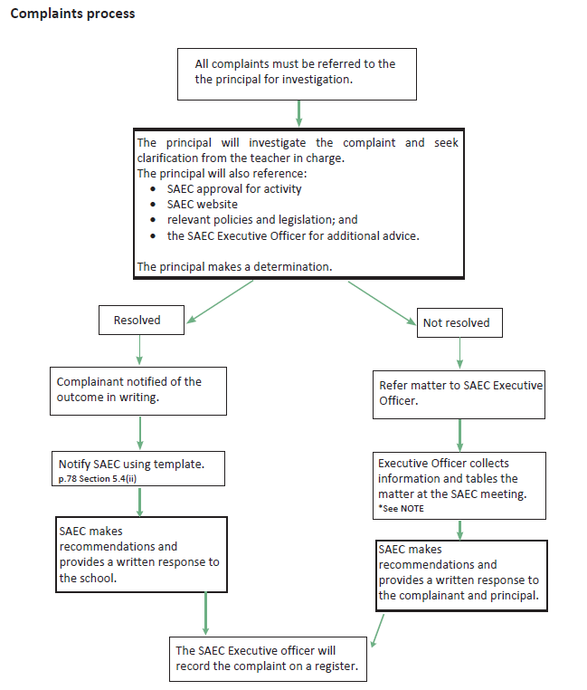

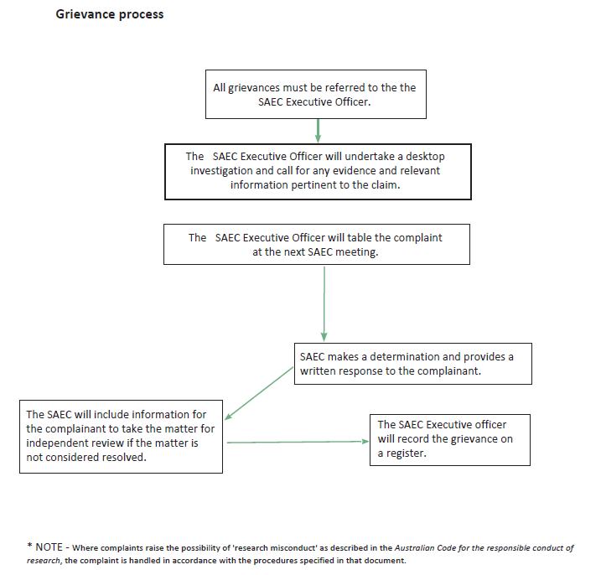

Serious Disagreements Between Members of the SAEC.
In the event that any disagreements arise between members of the SAEC the matter shall be referred to the Chairperson for arbitration. The Chairperson may refer the matter to an independent conciliator/arbitrator, a member of the DPIRD AEC, as agreed between the parties.

COMMITTEE MEMBERSHIP

The Schools Animal Ethics Committee (SAEC) acts as the animal ethics committee for public, Catholic, and independent schools (inclusive of farm schools and agricultural colleges) in Western Australia. This committee is responsible for ensuring that the use of animals in schools complies with the Animal Welfare Act (2002) and the National Health and Medical Research Council’s Australian code for the care and use of animals for scientific purposes, 8th Edition 2013 (the Code).

As per the Code, the committee must consist of representatives from 4 distinct categories.

Category A is a person with qualifications in veterinary science and with experience relevant to the activities of the institution. Veterinarians who lack this experience must familiarise themselves with the biology and clinical characteristics of the species of animals used, as outlined in the Code.

Category B is a suitably qualified person with substantial and recent experience in the use of animals for scientific purposes relevant to the institution and the business of the AEC. This must include possession of a higher degree in research or equivalent experience. If the business of the AEC relates to the use of animals for teaching only, a teacher with substantial and recent experience may be appointed, as outlined in the Code.

Category C is a person with a demonstrable commitment to, and established experience in, furthering the welfare of animals, who is not employed by or otherwise associated with the institutions, and who is not involved in the care and use of animals for scientific purposes. Veterinarians with specific animal welfare interest and experience may meet the requirements of this category. While not representing an animal welfare organisation, the person should, where possible, be selected on the basis of active membership of, and nomination by, such an organisation, as outlined in the Code.

Category D is a person who is both independent of the institution and who has never been involved in the use of animals in scientific for teaching activities, either in their employment or beyond their formal education. Category D members should be viewed by the wider community as bringing a completely independent view to the AEC and must not fit the requirement of any other category, as outlined in the Code.

The species of animals most commonly used for educational purposes in public, Catholic, and independent schools and agricultural colleges are poultry, rodents, fish, amphibians, domestic and farm animals.

The SAEC meets twice a school term, ordinarily in weeks 3 and 8 of each term from 1.00pm to 3.30pm to consider applications. The SAEC also provides expert advice about the development of processes and procedures to enhance animal welfare and to manage the SAEC.SAEC members provide advice via email to the Executive Officers of each school system and sector.

Additional information can be found on the Animal Ethics website:
https://myresources.education.wa.edu.au/programs/animal-ethics

Interested applicants need to provide a brief Curriculum Vitae via email, including contact address, employment status, details of any experience on an animal ethics committee and availability to attend meetings.

For further information, any interested party should contact:
- Department of Education, SAEC Executive Officer
- Phone 9264 5202
- Email AnimalEthics@education.wa.edu.au

STANDARD MEETING SCHEDULE
The following steps below describe the sequence of activities that take place in each meeting cycle.

- Schools Animal Ethics Committee meetings are usually held on Tuesday in week 3 and week 8 of each school term. Except by special arrangements, meetings are held from
1.00 – 3.30pm at AISWA in Osborne Park, CEWA in Doubleview or at Statewide Services, Department of Education in Padbury.

- Teachers submit applications via an online system and the SAEC Executive Officers allocate them to a scheduled meeting. Applications are available for members to download from the Friday prior to the scheduled SAEC meeting. Occasionally there are one or 2 late applications and members are notified by email when this occurs.

- The agenda, minutes of the previous meeting and other meeting papers are available for download by Friday prior to the scheduled SAEC meeting.

- The Department of Education appoints the Director, Agricultural Education as the committee chairperson. In the Chairperson’s absence, the chair is taken by the Deputy Chair, the Principal Consultant, Agricultural Education.

- The standard meeting agenda encompasses:
- Welcome by the Chairperson,
- Conflicts of Interest,
- Confirmation of minutes of the previous meeting,
- Action items list,
- Outcomes and ratification of applications from the last meeting,
- Ingoing and outgoing correspondence,
- Applications, including new applications and amendments to approved activities,
- Project Monitoring including
- Incidences of non-compliance,
- Adverse events,
- Site inspections,
- Review of SAEC documentation, and
- General business (including reminder of reimbursement for committee costs).

- The minutes are taken by the Department of Education Executive Officer unless by special arrangement, the AISWA or CEWA Executive Officer may undertake this role.

- Immediately following the scheduled SAEC meeting, the completed SAEC’s ‘Certificate of Approval’, Animal Use and Health Records, the sector specific Licence (CEWA & DOE only) and relevant standard operating procedures are emailed to teacher in charge that submitted the application. This informs the teacher whether the application was approved, obtained a conditional approval or was rejected. Applications can be approved for a maximum of 3 years.

2024 SAEC MEETING DATES

Meeting | Meeting Date | Education Sector Hosting Meeting
Term 1 (9 week term)
Meeting 1 | 13 February 2024  1:00 – 3:30 pm | Catholic Education Western Australia
Meeting 2 | 19 March 2024  1:00 – 3:30 pm | Department of Education
Term 2 (11 week term)
Meeting 3 | 30 April 2024  1:00 – 3:30 pm | Association of Independent Schools Western Australia
Meeting 4 | 4 June 2024  1:00 – 3:30 pm | Catholic Education Western Australia
Term 3 (10 week term)
Meeting 5 | 30 July 2024  1:00 – 3:30 pm | Department of Education
Meeting 6 | 3 September 2024  1:00 – 3:30 pm | Association of Independent Schools Western Australia
Term 4 (10 week term)
Meeting 7 | 22 October 2024  1:00 – 3:30 pm | Catholic Education Western Australia
Meeting 8 | 26 November 2024  1:00 – 3:30 pm | Department of Education
The meeting addresses are outlined below:

Association of Independent Schools, Western Australia (AISWA)
AISWA Conference Room,
41 Walters Drive, Osborne Park

Catholic Education, Western Australia (CEWA)
CEWA Newman Siena Centre,
33 Williamstown Road, Doubleview

Department of Education
Statewide Services
33 Giles Ave, Padbury

SAEC EXPENSES REIMBURSEMENT CLAIMS

The Department of Education highly encourage members of the Schools Animal Ethics Committee (SAEC) to submit expense claims. As community volunteer members of the SAEC, you are entitled to receive reimbursement for out of pocket expenses, e.g. fuel & parking.

The Department of Education highly value and appreciate your work and reimbursing you is one small way we can acknowledge this.

Outlined below are the steps involved for SAEC members to undertake this process. This process and all related electronic versions of the forms required will also be emailed to the SAEC members.
Steps to make a claim:
- Fill in the SAEC Invoice Template (Attachment 1).
- Complete a Statement by a supplier form (Attachment 2 in the emailed information), or you may obtain this yourself directly from the Australian Taxation Office website.
Note: You only need to do this once. This may be completed electronically, printed and signed; or printed and completed by hand.
- Send the completed invoice and statement to Department of Education SAEC Executive Officer, either by email, post, or in person.
Email: AnimalEthics@education.wa.edu.au
Address: Schools Animal Ethics Committee
Department of Education
151 Royal St, EAST PERTH WA 6004
Phone: 9264 5202

We look forward to receiving your claims in the future.

SAEC EXPENSES CLAIM FORM

To:  Schools Animal Ethics Committee  Department of Education  151 Royal St  EAST PERTH WA 6004  OR  AnimalEthics@education.wa.edu.au |  |  | Date:  Insert here
For:  Motor vehicle and parking expenses incurred attending SAEC meetings and/or school visits.  VEHICLE DETAILS:  Make and Model: Insert here |  |  | FROM:  Name: Insert here  Email address: Insert here  Phone: Insert here  BANK DETAILS:  Account Name: Insert here  BSB: Insert here  Account Number: Insert here
Engine capacity | Reimbursement rate
1600cc and under | $0.532
1601cc - 2600cc | $0.645
Over 2600cc | $0.895

Description | Km | Engine capacity | Rate | Amount
Example claims as below (Please delete as appropriate)
SAEC meeting Add date
Add sector hosting AISWA / CEWA / DOE
SAEC meeting parking expense date:  (Please add a scan or photo of the parking ticket) | N/A |  | N/A
SAEC inspection visit
Add school and date:
SAEC inspection visit parking expense date:  (please add a scan or photo of the parking ticket) | N/A |  | N/A
SAEC meeting Add date
Add sector hosting AISWA / CEWA / DOE
SAEC meeting Add date
Add sector hosting AISWA / CEWA / DOE
SAEC meeting Add date
Add sector hosting AISWA / CEWA / DOE
Other:
 |  |  | TOTAL

ANIMAL ETHICS SYSTEM GUIDE FOR COMMITTEE MEMBERS

- The Department of Education’s Executive Officer will provide each member with a log in and temporary password.

- Click on this link to log in: https://apps.det.wa.edu.au/ane/login

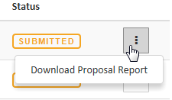
- The first screen that you see contains the applications and meeting papers for the current meeting. From this screen you may:
  - View any application or document on screen by clicking on its row; or
  - Download any application or document, individually, by clicking on the Actions button which is the square box with 3 dots at the end of the row.

- Create a meeting bundle to download the applications and files to your computer, in one action, click on the “Create a meeting bundle” button that is in the strip above the list of applications.

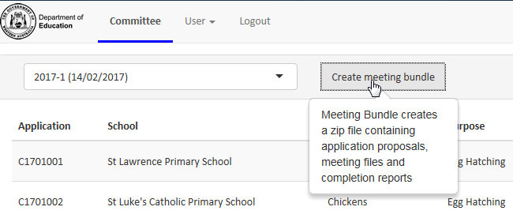

- Once you have clicked on this button you will be asked if you want to open or save
the .zip file.
  - Click on the triangle next to “Save”, select “Save as” and choose a location on your computer.
  - If you select “Open” instead of “Save” it will show you a Folder and a list of Files that you can open and read. However, this option will not save the files when you close the screen. Remember you can create a meeting bundle as many times as you like.

- Once saved, most computers will prompt you to open the folder where the .zip file is located. Double click to open.

The Meeting Bundle contains the following:
- “Files” folder: This includes any documents that have been uploaded by the Executive Officers such as the Agenda and Minutes
- Completion Reports: A single PDF document that compiles all of the Activity Completion Reports that have been submitted online since the last SAEC meeting.
- Application documents: A PDF document for each individual application to be considered at the meeting.
Viewing Annual Reports
- Annual reports from schools will appear in the meeting bundle whenever a school submits the annual report.
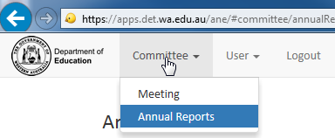
- A PDF document with all the reports submitted since the last meeting will be included in the meeting bundle.
- You can view a school’s annual report online by going to the top menu, clicking on Committee and Annual Reports. This will give you a list of all reports and you can select “View Report” for any school.

Support contact:
Department of Education
SAEC Executive Officer
Telephone: 9264 5202
Email: AnimalEthics@education.wa.edu.au

