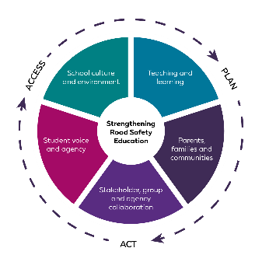  Title of landing page here (1 line) | Whole-school approach to road safety education
 | At <Insert School name> we have identified the following practices and strategies to support a whole-school approach in road safety education. This approach embeds student knowledge, skills, and understanding at a whole-school level and strengthens relationships and partnerships with parents and communities.
 | Contact Road Safety and Drug Education for resources and support on 9402 6415 or via rsde.rfa@education.wa.edu.au
Teaching and learning |  | School culture and environment |  | Parents, families, and communities | Student voice and agency | Stakeholder, group, and agency collaboration
Example:  - Use resources available from myresources.education.wa.edu.au:  - Early Years Road Safety 0-5  - Road Safety Education P-6  - Road Safety Education 7-9  - Keys4Life pre-driver education.  - Develop scope and sequences to current curriculum and review on an annual basis. |  | Example:  - Access professional learning opportunities for staff relating to road safety education.  - Create an environment that encourages road safe behaviours at school. |  | Example:  - Use RSDE resources to communicate with parents/carers about key road safety messages.  - Involve the school board/P&C in whole school planning. | Example:  - Involve students in planning activities such as:  - Road Safety Week  - Ride or walk to school days. | Example:  - Consider guest speaker guidelines prior to engaging with external agencies.
Current practice: |  | Current practice: |  | Current practice: | Current practice: | Current practice:
Actions: |  | Actions: |  | Actions: | Actions: | Actions:
Who: |  | Who: |  | Who: | Who: | Who:
When: |  | When: |  | When: | When: | When:
Prepared by: |  |  | Endorsed by: |  | Date: | Review date:

