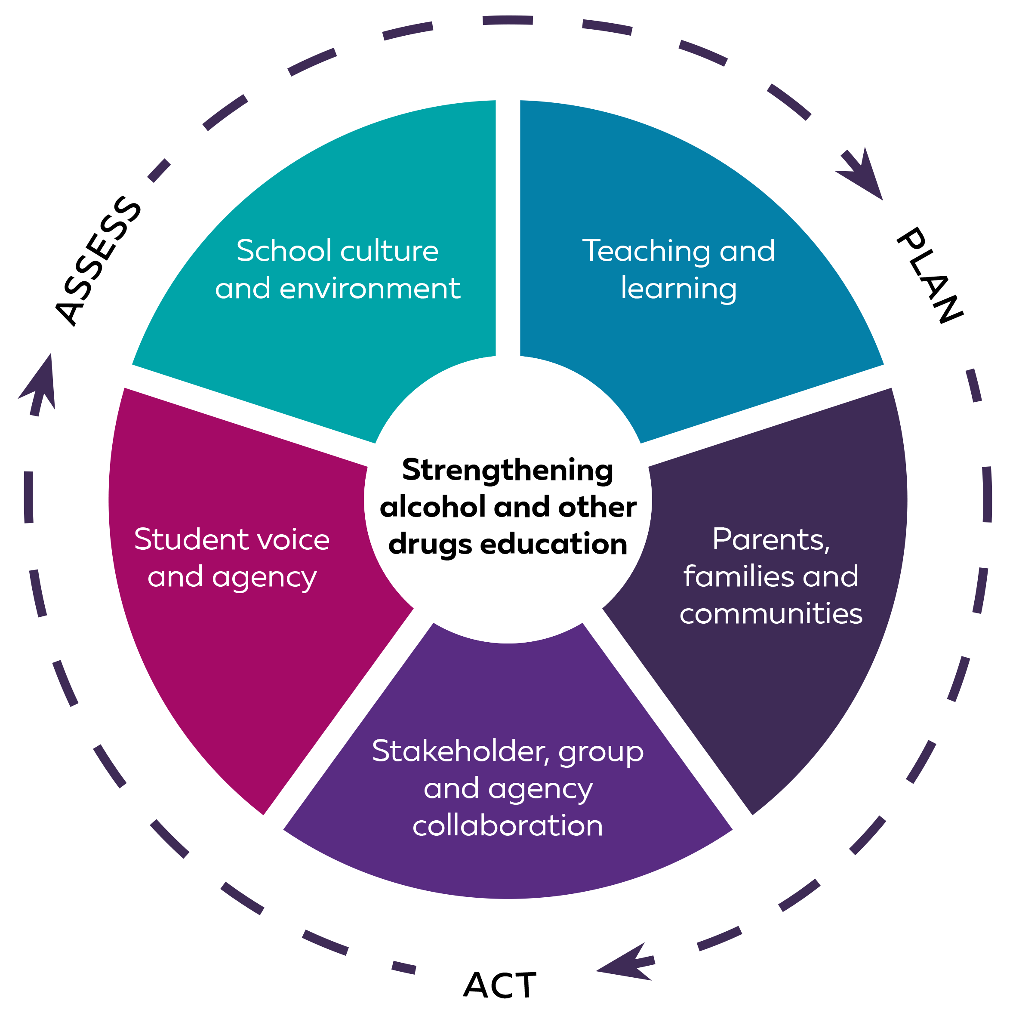  Title of landing page here (1 line) | Whole-school approach to alcohol and other drugs education
 | At <Insert School name> we have identified the following practices and strategies to support a whole-school approach in alcohol and other drugs prevention education(AOD). This approach embeds student knowledge, skills, and understanding at a whole-school level and strengthens relationships and partnerships with parents and communities.
 | Contact Road Safety and Drug Education (RSDE) for resources and support on 9402 6415 or via rsde.rfa@education.wa.edu.au

Teaching and learning | School culture and environment |  | Parents, families, and communities | Student voice and agency | Stakeholder, group, and agency collaboration
Example:  - Use resources available from myresources.education.wa.edu.au  - AOD education P-6  - AOD education 7-9  - Primary and Secondary  e-cigarettes and vaping  - WA Schools Anti-vaping Toolkit  - Develop scope and sequences to current curriculum and review on an annual basis. | Example:  - Provide professional learning:  - Primary AOD education  - Secondary AOD education  - E-cigarettes and vaping in school communities  - VSU in school communities  - Use templates from myresources.education.wa.edu.au to develop incident management and intervention support. |  | Example:  - Use RSDE resources to communicate with parents/carers about AOD education.  - Involve the school board/P&C in whole-school planning. | Example:  - Involve students in the development of a whole-school approach and process to respond to alcohol and other drugs | Example:  - Provide guidance to local community support services.  - Consider guest speaker guidelines prior to engaging with external agencies.
Current practice: | Current practice: |  | Current practice: | Current practice: | Current practice:
Actions: | Actions: |  | Actions: | Actions: | Actions:
Who: | Who: |  | Who: | Who: | Who:
When: | When: |  | When: | When: | When:
Prepared by: |  | Endorsed by: |  | Date: | Review date:

Responding to Alcohol and Other Drugs
This management and intervention template can be adapted to school context and relevant behaviour management policy requirements. School staff use this information to respond to and support students who are in possession or suspected of being under the influence of alcohol or other drugs, including e-cigarettes.
Situation
Student/s are thought to be:
- under the influence of alcohol or other drugs
- in possession of a legal drug that is restricted/not for intended purpose
- in possession of a suspected illicit drug.

 |  |  | Volatile substance use (VSU)
If VSU is suspected, action the relevant process for all WA schools to respond and report.
Access VSU resources and PL on the Education Resources website
Immediate actions all staff
When approaching the student
- Remain calm.  - Seek support from another staff member.  - Stand to the side of the student when speaking.  - Explain to the student that you are concerned about their wellbeing.  - Prioritise safety of all staff and students.  - Accompany student to appropriate support location for further discussion.  - Inform <relevant staff member/s>. |  | Do not:  - Confront, investigate, accuse or argue with the student  - try to physically restrain the student, unless there is an imminent risk of harm to student or others  - leave the student alone  - allow the student to leave the school site unaccompanied.
<Relevant staff member/s> initial follow-up actions
- Organise immediate care for the student and contact emergency services if required.
- Once the safety and wellbeing of those involved has been ascertained, establish facts.
- Confiscate the item or substance and dispose of it appropriately. Regulation 71 of the School Education Regulations 2000 (WA) prescribes the circumstances when property can be confiscated from students.
- Contact parent or caregiver to explain the situation and discuss appropriate action for the student.
- Document and report incident as per relevant school policy.
Legal drug - not allowed on school grounds or non-medical use of pharmaceuticals |  |  | Illicit drug
- Substance is legal, however use on school premises is prohibited.  - Substance is legal but sale is restricted to those over 18.  - Substance is a legal drug being used outside the parameters of the intended purpose. |  |  | - Substance is an illicit drug.  - Substance is suspected of being an illicit drug.
Follow up |  |  | Follow up
Through a restorative approach:  - Provide intervention support- refer the student to the relevant school contact  - Ensure any disciplinary actions support the student’s ongoing wellbeing and follow the school’s Behaviour Management procedures  - Document, monitor and evaluate. |  |  | Through a restorative approach:  - Consider if police involvement is required  - Provide intervention support- refer the student to the relevant school contact  - Ensure any disciplinary actions support the student’s ongoing wellbeing and follow the school’s Behaviour Management procedures  - Document, monitor and evaluate.

Intervention Support
Situation
Intervention support may be required as a result of:
- a drug related incident where a student has been:
- under the influence of alcohol or other drugs
- in possession of a legal drug
- in possession of a suspected illicit drug.
- disclosure by student or other.

Immediate Actions
Reassure student/s that their health and wellbeing is the primary concern
- Assess student wellbeing
- Seek relevant referral information.
- Explain to student/s that the focus of the intervention is to support their health and wellbeing.
- Acknowledge your role in providing support to the student.
- Consider cultural responsiveness.
- State the boundary of confidentiality.
- Gauge student willingness to engage with the intervention support process.
Raise and clarify the situation with student/s
- Clarify the situation, advise of your concerns.
- Communicate with empathy.
Support students through the referral process
- Involve students in the intervention support process according to their needs.
- Provide the student with an explanation and reassurance of the process that will follow.
- Follow the school’s reporting and record keeping procedures.

Student Wellbeing Interventions
Develop and implement an individual student intervention plan:
- Include student in the development of their wellbeing plan
- Consider student’s family circumstances and needs
- Ensure student is connected to the support they need either inside or outside the school

Contact Road Safety and Drug Education (RSDE) for resources and support on 9402 6415 or via rsde.rfa@education.wa.edu.au

