WA schools anti-vaping toolkit
E-cigarettes and vaping
Teacher resource: Year 8, 9 and 10
© 2022 Department of Education Western Australia.
This resource is part of the School Drug Education and Road Aware (SDERA) program that is funded by the Mental Health Commission and is supported by the Department of Education WA, Catholic Education WA and Association of Independent Schools Association WA.

The Department of Education WA and the WA Department of Health acknowledge NSW Health’s authorship and ownership of these materials.

The factsheets, posters and video contained in this resource have been produced by the Health Administration Corporation (ABN 45 100 538 161) of 1 Reserve Road, St Leonards, NSW 2065 and have been provided to the Department of Education Western Australia (WA) to adapt to suit the WA context. Schools may reproduce, copy and communicate use these materials for educational purposes, providing they do not modify the factsheets, posters and video content.

[CC BY-NC-ND] (unless “Excluded Material”) https://creativecommons.org/licenses/by-nc-nd/4.0/

Except in relation to Excluded Material this licence allows you to:
- Share — copy and redistribute the material in any medium or format, for non-commercial purposes providing you do not modify, adapt, transform or remix the material; and you attribute the Department of Education, Western Australia as the source of the copyright material and retain all acknowledgements associated with the material and attach the above Creative Commons logo.

Excluded Material
The Western Australian Government and Department of Education logos, other logos, student images and work examples, Microsoft content, third party works and trademark protected material are not licensed under a CC BY-NC-ND licence and may not be re-used without permission from the copyright owner.

E-cigarettes and Vaping

Teacher resource: Year 8, 9 and 10

This resource forms part of a comprehensive strategy that schools can adopt to help young people understand what is in an e-cigarette, increase their awareness of health risks and address misconceptions about vaping.

This resource contains fact sheets for:
- teachers and schools,
- parents and carers,
- young people.

Teachers are encouraged to use the fact sheets to assist with lesson planning and delivery. The fact sheets, posters, letters for parents and carers and newsletter content are available in the appendices of this resource or for download from myresources.education.wa.edu.au/vaping.

Parents play an important role in building their children’s resilience and supporting drug education messages promoted in schools. Teachers can use the letter templates and newsletter content to engage with parents and carers prior to delivering lessons on vaping. This will provide parents and carers with information about ways they can help prevent the children from vaping.

To enhance the effectiveness of prevention education delivered through this resource the following strategies should also be undertaken by the school:
- develop a whole school drug education plan (myresources.education.wa.edu.au/vaping);
- participate in professional learning for school staff about e-cigarettes and drug education provided by the Department (myresources.education.wa.edu.au/vaping);
- contact Road Safety and Drug Education for consultancy support to deliver drug prevention education.

Lessons have been developed as a supplement to the existing drug prevention education resources offered by the Department of Education.

The Department of Education acknowledges the Australian Aboriginal and Torres Strait Islander Peoples of this nation. We acknowledge the traditional custodians of the lands on which our schools are located and where we conduct our business. We pay our respects to ancestors and Elders, past and present. The Department of Education is committed to honoring Australian Aboriginal and Torres Strait Islander peoples’ unique cultural and spiritual relationships to the land, waters and seas and their rich contribution to society.

Additional information and support
The Department of Education supports public, Catholic and independent schools by providing resources, professional learning and consultancy. To access support contact:

Department of Education
Statewide Services
Road Safety and Drug Education
phone: 9402 6412
email: sdera.co@education.wa.edu.au
E-cigarettes and Vaping Teacher resources website: myresources.education.wa.edu.au/vaping
Table of Contents
E-cigarettes and Vaping ii
Teacher resource: Year 8, 9 and 10 ii
Additional information and support ii
Teacher notes 1
Preferred language 1
Setting the scene 1
Western Australian Curriculum: Health and Physical Education 2
Table 1: Year 8 E-cigarettes and Vaping – Teacher resource 3
Table 2: Year 9 E-cigarettes and Vaping – Teacher resource 4
Table 3: Year 10 E-cigarettes and Vaping – Teacher resource 5
Topic 1: Do you know what is in a vape? 6
Background information 6
Learning intentions and support notes 7
Teaching and learning experiences 7
Topic 2: How vaping can affect you? 12
Background information 12
Learning intentions and support notes 13
Teaching and learning experiences 13
Topic 3: Critical analysis of vaping marketing. 16
Background information 16
Learning intentions and support notes 18
Teaching and learning experiences 18
References 20
Appendices 21
Resources for teachers and schools 22
Newsletter content for schools 29
Letter template for schools 31
Resources for parents and carers 33
Factsheets for young people 37
Posters for young people 40
Activity sheets (classroom resource) 46
Activity sheet 1 – Vaping self-assessment 46
Activity sheet 2 – Vaping 47
Activity sheet 3 – Jigsaw 48
Activity sheet 4 – What I can do 49

Teacher notes

Preferred language

Using respectful ‘person-first’ language can create more positive ways of talking about e-cigarettes and drug use.

Examples of person-first language:
Use | Avoid
‘people who vape’ | ‘vapers’, users
‘e-cigarettes, vapes and vaping’ | referring to specific brand names
‘quitting from vapes’ | ‘quit vapes’
‘young people’ | ‘youth’
descriptions such as ‘cancer causing chemicals’ | technical terms such as ‘carcinogens’
dependence | addiction

Setting the scene

Before delivering any e-cigarette/vaping lessons, it is important to consider the following:
- respect and confidentiality;
- being familiar with your school’s policies and procedures regarding substance use, including
e-cigarettes;
- handling sensitive questions;
- being prepared for disclosures;
- referral to student support services, if required;
- safety of student; and
- strategies to support cultural responsiveness.

Western Australian Curriculum: Health and Physical Education

The lessons contained in this resource are aligned to the Western Australian Curriculum: Health and Physical Education learning area. The Health and Physical Education curriculum provides opportunities for students to develop knowledge, understanding and skills for creating and maintaining a healthy, active lifestyle, developing respectful relationships and effective communication. This aims to assist students to build resilience, make informed decisions and take personal responsibility for their own health.
The content:
- focuses on supporting students to make decisions about their own health, safety and wellbeing.
- develops knowledge, understanding and skills to enable students to critically engage with a range of health focus areas and issues. It also helps them apply new information to changing circumstances and environments that influence their own and others' health, safety and wellbeing.
- supports students to selectively access information, products, services, and environments to take action to promote the health and wellbeing of their communities.

The Health and Physical Education curriculum provides opportunities for students to develop positive attitudes and values about their own health and wellbeing, as well as respect for the rights and values of others. Through structured learning experiences, students examine their own attitudes and values, and the level of influence they have on their own and others' health. Personal and social capability is addressed through learning activities where students are given opportunities to develop self-awareness, self-management, social awareness and social management skills. Students learn to appreciate their own different strengths and abilities and those of their peers.

Focus area:
Alcohol and other drug education addresses safe practices in relation to a range of drugs, including prescription drugs, natural and alternative medicines, caffeine, tobacco (including e-cigarettes), alcohol and other synthetic drugs, cocaine, ecstasy and methamphetamines.

The content supports students to make safe decisions and behave in ways that protect their own safety and that of others. Opportunities are provided for the development of Personal and Social Capability skills that allow students to understand influences that form their sense of identity. They learn how to recognise, understand, validate and respond appropriately to their emotions, strengths and values.

Culturally responsive approaches to Health Education are critical. They are place-based and responsive to the specific needs and aspirations of the school community. Culturally responsive educators privilege Aboriginal ways of knowing, being and doing, and draw on the diversity and strengths of local communities to create opportunities to work collaboratively to set directions for students.

It is important to acknowledge that e-cigarettes use is an emerging drug issue amongst young people in WA. To ensure your students’ psychological safety is at the forefront of each lesson, check in with how students are feeling and refer to support services where appropriate.

Table 1: Year 8 E-cigarettes and Vaping – Teacher resource

Alignment to the Western Australian Curriculum Health and Physical Education Personal, social and community health

Curriculum Links |  | Topic 1 |  |  |  |  | Topic 2 |  |  |  | Topic 3
 |  | Activity |  |  |  |  | Activity |  |  |  | Activity
 |  | 1 | 2 | 3 | 4 | 5 | 1 | 2 | 3 | 1 |  | 2 | 3 | 4
Year 8 | Being healthy, safe and active
 | The reasons why young people choose to use or not use drugs (ACPPS073) | ♦ | ♦ | ♦ |  |  |  | ♦ | ♦ | ♦ |  | ♦ | ♦ | ♦
 | Communication techniques to persuade someone to seek help (ACPPS072) | ♦ |  |  |  | ♦ |  |  |  |  |  | ♦ | ♦ | ♦
 | Skills and strategies to promote physical and mental health and wellbeing in various environments, such as; assertive responses, stress management, refusal skills, contingency plans, online environments, making informed decisions (ACPPS073) | ♦ |  |  |  | ♦ |  |  | ♦ |  |  | ♦ | ♦ | ♦
 | Communicating and interacting for health and wellbeing
 | Sources of health information that can support people who are going through a challenging time (ACPPS076) |  |  |  |  |  |  |  |  |  |  | ♦ | ♦
 | Contributing to healthy and active communities
 | Health promotion activities which target relevant heath issues for young people and ways to prevent them (ACPPS077) |  |  |  | ♦ |  | ♦ |  |  |  |  | ♦ | ♦

This table is intended as a guide only.

Table 2: Year 9 E-cigarettes and Vaping – Teacher resource

Alignment to the Western Australian Curriculum Health and Physical Education Personal, social and community health

Curriculum Links |  | Topic 1 |  |  |  |  | Topic 2 |  |  |  | Topic 3
 |  | Activity |  |  |  |  | Activity |  |  |  | Activity
 |  | 1 | 2 | 3 | 4 | 5 | 1 | 2 | 3 | 1 |  | 2 | 3 | 4
Year 9 | Being healthy, safe and active
 | Skills to deal with challenging or unsafe situations: refusal skills, initiating contingency plans, expressing thoughts, opinions, beliefs, acting assertively (ACPPS090) |  |  |  |  | ♦ |  |  | ♦ |  |  | ♦ | ♦
 | Actions and strategies to enhance health and wellbeing in a range of environments, such as; the use of complementary health practices to support and promote good health, responding to emergency situations, identifying and managing risky situation, safe blood practices (ACPPS091) |  |  |  |  |  |  |  | ♦
 | Impact of external influences on the ability of adolescents to make healthy and safe choices relating to: sexuality, alcohol and other drug use risk taking (ACPPS092) |  |  | ♦ |  |  |  |  |  | ♦ |  | ♦ | ♦
 | Communicating and interacting for health and wellbeing
 | Skills to determine appropriateness and reliability of online health information (ACPPS095) |  |  |  |  |  | ♦ |  |  |  |  | ♦

This table is intended as a guide only.

Table 3: Year 10 E-cigarettes and Vaping – Teacher resource

Alignment to the Western Australian Curriculum Health and Physical Education Personal, social and community health

Curriculum Links |  | Topic 1 |  |  |  |  | Topic 2 |  |  |  | Topic 3
 |  | Activity |  |  |  |  | Activity |  |  |  | Activity
 |  | 1 | 2 | 3 | 4 | 5 | 1 | 2 | 3 | 1 |  | 2 | 3 | 4
Year 10 | Being healthy, safe and active
 | Skills and strategies to manage situations where risk is encouraged by others (ACPPS091) |  |  |  |  | ♦ |  |  | ♦ | ♦
 | Analysis of images and messages in the media related to: alcohol and other drugs, body image, relationships (ACPPS092) |  |  | ♦
 | Communicating and interacting for health and wellbeing
 | Critical health literacy skills and strategies:  evaluating health services in the community  examining policies and processes for ensuring safer behaviours  (ACPPS095) |  |  |  |  |  |  |  |  |  |  | ♦ | ♦
 | Contributing to healthy and active communities
 | Health campaigns and/or community-based activities designed to raise awareness, influence attitudes, promote healthy behaviours and increase connection to the community (ACPPS096; ACPPS097) |  |  |  | ♦ |  | ♦ |  |  |  |  | ♦ | ♦

This table is intended as a guide only.

Topic 1: Do you know what is in a vape?

Background information

Information for teachers and schools:
Fact sheets and posters

Information for parents:
Newsletter content for schools
Letter template for schools
Fact sheets for parents and carers

Fact sheets, letter templates and newsletter content are available from myresources.education.wa.edu.au/vaping

General information
Department of Education WA Education resources (myresources.education.wa.edu.au/vaping)
Healthy WA Electronic cigarettes (e-cigarettes) (healthywa.wa.gov.au)

Where can young people go for help?
- Students services (if available at their school)
- Health professional, General Practitioner
- Community health centre
- Kids Helpline 1800 55 1800
- WA Quitline 13 78 48 (13 QUIT)

Topic 1: Do you know what is in a vape?
Learning intentions and support notes |  | Teaching and learning experiences |  |  | Topic 1
 | Learning intentions |  | Key messages
Students will:  - Discuss misconceptions regarding e-cigarettes/vaping.  - Use health promotion information to inform others of the harms of using e-cigarettes.  - Identify refusal responses in a vaping situation. |  | - E-cigarettes are not safe. The aerosol inhaled is not water vapour.  - E-cigarettes can contain the same harmful chemicals found in products such as nail polish remover, bug spray, weed killer and disinfectant.  - Many e-cigarettes contain nicotine which is a highly addictive drug.  - E-cigarettes come in many flavours that make them appealing to children and young people.  - Most young people do not vape.
 | Success criteria |  |  | Activities and required resources
Students will:  - Challenge misinformation relating to vaping.  - Explore and share health information outlining how vapes are not safe.  - Discuss and share refusal responses related to vaping situations. |  | Activity 1 Student self-assessment  - Activity sheet 1  Activity 2 K-W-L  - Whiteboard and markers  - Activity sheet 2  Activity 3 Myth busting  - Computer, interactive whiteboard and internet  - Video: ‘Three alternative uses for nail polish remover’  (19 seconds, myresources.education.wa.edu.au/vaping)  Activity 4 Jigsaw  - Computer, interactive whiteboard and internet  - Activity sheet 3 and Fact sheet - The facts about vaping for young people  - Posters for young people  Activity 5 Refusal skills  - Activity sheet 4
 | Key terms
E-cigarette, vaping, aerosol, vapour, nicotine, harmful chemicals, propylene glycol, glycerol, 2-chlorophenol, acetone, pulegone, acrolein.

Teaching and learning | Topic 1

Activity 1 Student self-assessment continuum (individual activity)

Students complete a self-assessment based on Activity sheet 1 about how confident they feel about their knowledge and refusal skills regarding vaping.
Students will re-visit this self-assessment on completion of Topic 3 to reflect and compare.

Activity 2 K-W-L (individual activity)

Write the word ‘VAPING’ on the board.
Students complete the ‘K’ and ‘W’ sections of Activity sheet 2.
Discuss what students know about e-cigarettes/vaping and what they would like to learn.
Students complete the ‘L’ section of Activity sheet 2 at the end of the lesson as a reflection of knowledge and skills learnt.

Activity 3 Myth busting: heads or tails (whole class)

Students stand up, teacher reads out vaping myths below. If students agree with the myth, they put their hands on their head. If students think the statement is false, they put their hands behind their back. Briefly discuss each myth.

- E-cigarettes only contain water and flavouring.
Answer: False.
Discussion:
- The liquid in e-cigarettes (e-liquid) is not just water, and the aerosol inhaled is not just water vapour.
- The main ingredient in e-liquids is propylene glycol, vegetable glycerine or glycerol, and they often also contain nicotine, flavours and other chemicals.
- The flavours (e.g. watermelon, grape, caramel, bubble-gum, vanilla and mint) and colourful packaging used for vapes make them appealing to young people.
- E-liquids when heated and inhaled may contain many harmful chemicals that are not listed on the pack.

Teaching and learning | Topic 1
- Vaping is safe.
Answer: False.
Discussion:
- The biggest misunderstanding about vapes is that they are harmless compared to cigarettes.
- E-liquids when heated and inhaled may contain many harmful chemicals that are not listed on the pack - which can cause adverse health effects such as vomiting, shortness of breath and lung damage.
- Vapes may expose young people to chemicals and toxins at levels that have the potential to cause adverse health effects. Vapes can leave a young person at increased risk of depression and anxiety. Vaping has also been linked to serious lung disease. Importantly, many of the long-term harms of vaping are still unknown. Vapes can expose young people to:
  - harmful chemicals.
  - toxins such as formaldehyde and heavy metals.
  - ultrafine particles that can be inhaled deep into the lungs.
  - flavouring chemicals such as diacetyl (a chemical linked to a serious lung disease).
- Vapes have even been known to explode causing serious burns.

- E-cigarettes labelled as nicotine-free may contain nicotine.
Answer: True.
Discussion:
- Research has found that some e-cigarettes labelled as ‘nicotine-free’ contain nicotine.
- Tobacco companies are continuously looking for new costumers. Vapes are a new way to get young people addicted to nicotine, which is often difficult to quit.

- Nicotine is a drug.
Answer: True.
Discussion:
- Nicotine is a stimulant drug that can harm the developing adolescent brain and lead to dependence.
- Nicotine is a drug that is often present in vapes and it is especially addictive for young brains. It can cause long-lasting negative effects on brain development.
- Nicotine can change the way the brain synapses are formed in young people. The impacts can include impaired attention, learning, memory and changes in mood.

Teaching and learning | Topic 1
- Vaping is safer than smoking cigarettes.
Answer: False.
Discussion:
- E-cigarettes are similar to cigarettes in that when heated and inhaled they contain many harmful chemicals and may contain nicotine that can cause adverse health effects.
- An e-cigarette that contain nicotine, can have the same amount of nicotine as 50 cigarettes.

Discussion (whole class)
- Why do you think the myths we have discussed about vaping exist?
- Are there any other myths/facts about vaping that you would like to share?
- Now that we have busted some of the common myths about vaping, what are some strategies you can use to support your friends not to vape?

Cautionary Note

The activity below involves screening a video or displaying posters that depict common household products (e.g. nail polish remover, disinfectant, bug spray and weed killer). Vapes can contain the same harmful chemicals found in cleaning products, nail polish remover, weed killer and bug spray. The aim of the video and posters is to discourage the uptake of vaping. Many household products contain volatile substances that can be inhaled to cause intoxication. If your student cohort has experience with volatile substance use, it is recommended that you skip this activity and do not display posters depicting common household products.

If students share or disclose information about the psychoactive effects of hazardous substances it is suggested to use ‘protective interrupting’ and refocus the discussion on the activity. Follow up with the student to determine if additional support service is required. Teachers should use their professional judgement in using this activity.

Video: ‘Three alternative uses for nail polish remover’ (19 seconds, myresources.education.wa.edu.au/vaping)

- After watching the video, display the posters (Posters for young people) and reinforce the message that the aerosol inhaled from vaping isn’t just water vapour and that e-liquids when inhaled can contain harmful chemicals and additives, including nicotine. They just don’t put it on the pack.

Teaching and learning | Topic 1

Activity 4: Jigsaw – expert groups (in pairs or small groups)

Using Activity sheet 3 and Fact sheet - The facts about vaping for young people divide the class into eight (8) expert groups that will work on discussing each of the following headings:
- vapes are designed to be appealing to you
- most young people do not vape
- nicotine is harmful for your young brain
- risks to your physical and mental health
- the laws around selling vapes in WA
- the signs you are addicted to vaping
- misleading and dangerous labelling
- good reasons to not vape

Allow time for each group to read their section of expertise and paraphrase the information.
As a whole class, guide each group to share the information while students take notes. Discuss each topic.

Activity 5: Refusal skills practise (small groups)

Ask students to form expert groups as per previous activity. In groups, students read the scenario and think about a strategy that they could use to manage the situation effectively (Activity sheet 4).

As a class, reflect and discuss the strategies students came up with.
Discuss how students can seek help or support now, and in the future, if they are concerned about their or others vaping.

Reflection

Students complete the ‘L’ of the K-W-L in Activity 1, to find out what they had learned.
Encourage students to explore whether their view/opinion of vaping changed and why/why not?

Topic 2: How vaping can affect you?

Background information
Why is practising refusal skills important?
- Peer influence is a normal part of adolescent development and we are influenced in many different stages of our lives such as sport teams we support, the music we like, the food/clothes we buy and also drug use (e.g. vaping).
- Practicing refusal skills builds higher levels of resilience which is associated with a lesser likelihood of engaging in harmful risk-taking behaviours.

Information for teachers and schools:
Fact sheets and posters

Information for parents:
Newsletter content for schools
Letter template for schools
Fact sheets for parents and carers

Fact sheets, letter templates and newsletter content are available from myresources.education.wa.edu.au/vaping

General information
Department of Education WA Education resources (myresources.education.wa.edu.au/vaping)
Healthy WA Electronic cigarettes (e-cigarettes) (healthywa.wa.gov.au)

Where can young people go for help?
- Students services (if available at their school)
- Health professional, General Practitioner
- Community health centre
- Kids Helpline 1800 55 1800
- WA Quitline 13 78 48 (13 QUIT)

Topic 2: How vaping can affect you?
Learning intentions and support notes |  | Teaching and learning experiences |  |  | Topic 2
 | Learning intentions |  | Key messages
Students will:  - recognise that vaping poses harms.  - discuss six key facts about vaping.  - recognise different aspects of peer pressure. |  | - Vaping is not safe; it has been linked to lung disease.  - Vapes that contain nicotine can cause long-lasting effects on young people’s brain development.  - People who vape are three times as likely to take up smoking cigarettes.  - Many e-cigarettes contain nicotine making them addictive.  - Vapes that contain nicotine can cause long-lasting effects on young people’s brain development.  - In WA, e-cigarette devices and their parts cannot be sold by tobacco or general retailers. It is also illegal to sell vapes to friends at school or in the community.
 | Success criteria |  |  | Activities and Required resources
Students will be able to:  - pose questions relating to harms from vaping.  - analyse six key facts about vaping.  - discuss peer pressure and share effective ways to respond. |  | Activity 1 Discussion  - Whiteboard and markers  - Fact sheet – The facts about vaping for young people  Activity 2 Continuum – consequences of vaping  - Fact sheet – The facts about vaping for young people  Activity 3 Inside/outside circle
 | Key terms
E-cigarettes, vaping, risk, harm, dependence, nicotine, consequences, peer pressure, fear of missing out (FOMO).

Teaching and learning | Topic 2

Activity 1 Discussion - The facts about vaping (small group or individual)

Distribute Fact sheet – The facts about vaping for young people.

Discuss the six key messages in the fact sheet:
- many vapes contain nicotine making them very addictive,
- the nicotine in one vape can equal 50 cigarettes,
- if you vape you are three times as likely to take up smoking cigarettes,
- vaping has been linked to serious lung disease,
- vape aerosol is not just water vapour,
- vapes can contain harmful chemicals.

Students discuss and list answers to the following:
- How do you know the information in the handout is accurate and reliable?
- Is there any additional information that could be included?
- How could you share this information with others?

Activity 2 Continuum - consequences of vaping (pairs)

Form a continuum line across the classroom, ‘agree and disagree’.

Read out the following statements. Students need to decide if they agree or disagree and move to the corresponding section on the continuum. If unsure, students move to the middle of the continuum. Discuss reasons of choice and share additional information provided.

• Statement 1: Vaping can impact your health.
- Short-term health effects of vaping include nausea, vomiting, mouth and airway irritation, chest pain and heart palpitations.
- Vaping can increase the odds of being diagnosed with asthma and can weaken the immune system.

• Statement 2: The nicotine in one vape can equal 50 cigarettes.
- Nicotine is highly addictive. Research indicates that people who vape may be three times as likely to use tobacco cigarettes.
- Too much nicotine from vapes can cause nicotine poisoning. Symptoms can vary but include sweating, racing heart and increased blood pressure shaking, and vomiting. If you think someone has been poisoned by nicotine, call the Poisons Information Centre 13 11 26 or 000 if an emergency.
Teaching and learning | Topic 2
• Statement 3: Nicotine changes the way brain synapse are formed in young people.
- Adolescence is a critical period for brain development and exposure to nicotine can have long-term health consequences, impacting memory, attention and learning.
- Regular nicotine use can also worsen stress and anxiety and can make you more susceptible to mental health problems such as depression and anxiety.

• Statement 4: The batteries in vapes have been known to explode.
- Vapes have been known to explode causing serious burns (Hazards associated with the use of e-cigarette devices).

• Statement 5: Vaping can contain harmful chemicals.
- Vapes can contain harmful chemicals, heavy metals and toxins in the form of ultrafine particles that can be inhaled deep into the lungs. This can cause adverse health effects such as lung disease.

• Statement 6: It is illegal to sell vapes in WA.
- In WA, it is illegal to sell e-cigarette devices and nicotine vaping products to anyone regardless of age, unless they are prescribed by a doctor for smoking cessation purposes and obtained with a prescription from a pharmacy. This means that e-cigarette devices and their components, whether or not they contain nicotine, cannot be sold by tobacco or general retailers.

Activity 3: Inside/outside circle - responding to peer pressure (pairs)

Discuss peer influence and fear of missing out (FOMO).

Ask the following questions, students alternatively share their responses.
- What are some ways people can pressure you? What are some ways that you can resist pressure from others?
- How would you feel if someone pressured you to vape? What could you say to them?
- Why could it be hard to say ‘no’ if you are asked to vape? How could you make it easier to say ‘no’?
- Why might your peers/friends ask you to vape with them? How might knowing this would be helpful?

Topic 3: Critical analysis of vaping marketing.

Background information
Why do young people vape?
- E-cigarettes are appealing to young people as they come in a variety of flavours (estimates suggest more than 15,000 flavours are available).
- Marketing through social media and online channels has been successful in glamorising e-cigarettes.
- While the uptake of vaping by young people is increasing, it is important to emphasise that most young people do not use e-cigarettes. Research shows that in WA, 13.5% of school students aged 12 to 17 years have tried an e-cigarette. Of those who had tried 2 out of 3 (66%) had not used one in the last 30 days. (ASSAD, 2017)
- People who vape are three times as likely to take up smoking cigarettes (Banks, 2020)

Marketing tactics used by e-cigarette companies
- E-cigarettes companies use a range of marketing tactics to create attractive packaging as well as flavours and price-points to attract young people.

Information for teachers and schools:
Fact sheets and posters

Information for parents:
Newsletter content for schools
Letter template for schools
Fact sheets for parents and carers

Fact sheets, letter templates and newsletter content are available from myresources.education.wa.edu.au/vaping

General information
Department of Education WA Education resources (myresources.education.wa.edu.au/vaping)
Healthy WA Electronic cigarettes (e-cigarettes) (healthywa.wa.gov.au)

Where can young people go for help?
- Students services (if available at their school)
- Health professional, General Practitioner
- Community health centre
- Kids Helpline 1800 55 1800
- WA Quitline 13 78 48 (13 QUIT)

Topic 3: Critical analysis of vaping marketing.
Learning intentions and support notes |  | Teaching and learning experiences |  | Topic 3
 | Learning intentions |  | Key messages
Students will:  - recognise strategies that e-cigarette companies use to make vaping appeal to young people.  - investigate strategies that e-cigarette companies use to influence audience through different modes.  - recognise influential marketing modes. |  | - E-cigarettes come in many flavours that make them appealing to children and young people.  - Most young people do not choose to vape.  - There are a range of support services available through school and in the community to assist people needing help not to vape.
 | Success criteria |  | Activities and required resources
Students will:  - explain strategies e-cigarette companies use to make vaping appeal to young people.  - describe modes used by advertising companies including colour, graphics, slogan, creative movement and music.  - use advertising modes to design marketing campaign influencing young people not to vape. |  | Activity 1 Video Marketing tactics of e-cigarette companies  - Computer, internet, interactive whiteboard and markers.  - Video: ‘Kids and the Tobacco Predator’ (1:13 minutes, YouTube).  Activity 2 Design  - Fact sheet – The facts about vaping for young people and student needs to ICT devices and design software  Activity 3 Display  - Computer and interactive whiteboard  Activity 4 Student self-assessment  - Activity sheet 1
 | Key terms
E-cigarette, vaping, aerosol, vapour, nicotine, harmful chemicals, influence, FOMO, social media, marketing.

Teaching and learning | Topic 3
Activity 1 Video (whole class)

Watch video: ‘Kids and the Tobacco Predator’ (1:13 minutes, YouTube).
- Discuss the reactions that the children had about the products.
- Ask students if they think the children in the video knew what the products were or what was in them. Why/why not?
- Discuss what marketing strategies were used to influence the children to make the products appealing to them (e.g. colour, graphics, smell that children like, attractive packaging).

Activity 2 Design (small groups)

Based on the discussion from Activity 1 and using design software, students design campaign material (e.g. digital/print, voice or video advertisement) aiming to influence young people not to vape and providing information on where to seek support.

Students can choose colour, graphics, slogan, creative movement or music to influence their target audience.

Key messages can be sourced from Fact sheet – The facts about vaping for young people.

Activity 3 Display (whole class)

Each group presents their advertisement to the class. Students rate the advertisements with a score out of 5 (1 being not very appealing to youth, 5 being very appealing to youth).

Activity 4 – Student self-assessment continuum, review (individual)

Students complete the self-assessment from Topic 1, this time using the Activity sheet 1, and compare if their confidence has increased over the three topics regarding their knowledge and refusal skills regarding vaping.

References
Banks E, Beckwith K, Joshy G. Summary report on use of e-cigarettes and impact on tobacco smoking uptake and cessation, relevant to the Australian context. Commissioned Report for the Australian Government Department of Health, September 2020. Available at http://hdl.handle.net/1885/211618.

Department of Health Western Australia. (2021) Electronic cigarettes in Western Australia.
https://ww2.health.wa.gov.au/Articles/A_E/Electronic-cigarettes-in-Western-Australia.

Department of Health, New South Wales (2022) Get the facts – Vaping Toolkit https://www.health.nsw.gov.au/vaping.

Guerin, N. & White, V. (2020). ASSAD 2017 Statistics & Trends: Australian Secondary Students’ Use of Tobacco, Alcohol, Over-the-counter Drugs, and Illicit Substances. Second Edition. Cancer Council Victoria.

Videos

UNDO (2014) ‘Kids and the Tobacco Predator’ Kids and the Tobacco Predator - Tobacco Free CA (1:13min)

Appendices
All resources are available to download from:
myresources.education.wa.edu.au/vaping
Resources for teachers and schools

Fact sheets:
- The facts about vaping– Do you know what they’re vaping
- The facts about vaping – Common Types

Posters:
- What can school staff do about vaping
- Learn to spot a vape
- Key facts teachers should know about vaping

Resources for parents and carers

Newsletter content for schools:
- Longer newsletter version
- Shorter newsletter version

Letter template for schools
- Parent letter for schools to distribute

Fact sheets:
- The facts about vaping – Do you know what they’re vaping
- The facts about vaping – Common types

Resources for young people

Fact sheets:
- The facts about vaping – Do you know what you’re vaping

Posters:
- The facts about vaping
- Do you know what you’re vaping – weed killer
- Do you know what you’re vaping – nail polish remover
- Do you know what you’re vaping – disinfectant
- Do you know what you’re vaping – bug spray
- Do you know what you’re vaping – all products

Activity sheets (classroom resource):
- Activity sheet 1 – Vaping self-assessment
- Activity sheet 2 – Vaping
- Activity sheet 3 – Jigsaw
- Activity sheet 4 – What I can do

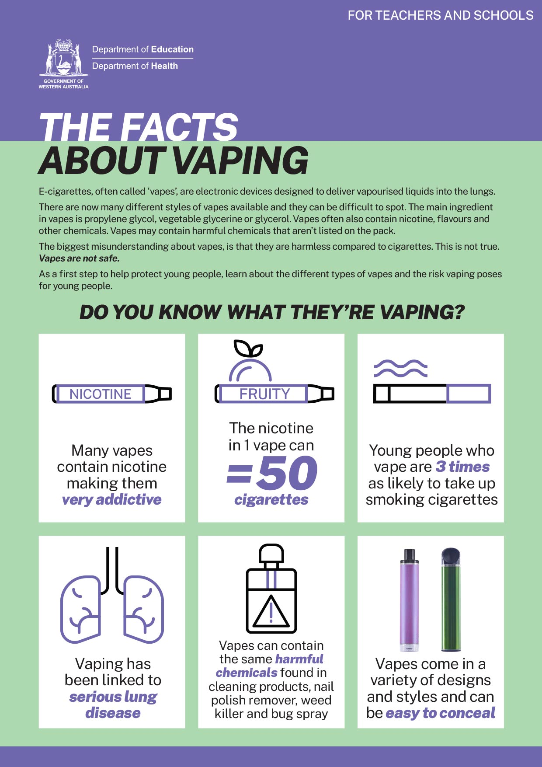
Resources for teachers and schools
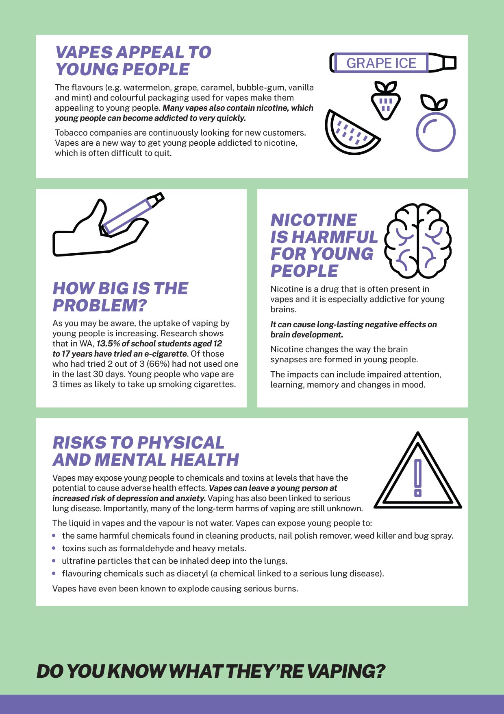
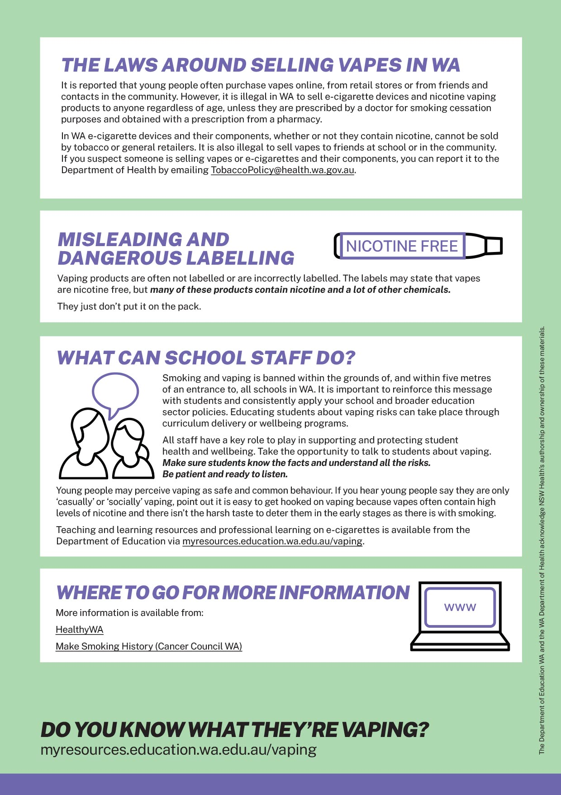
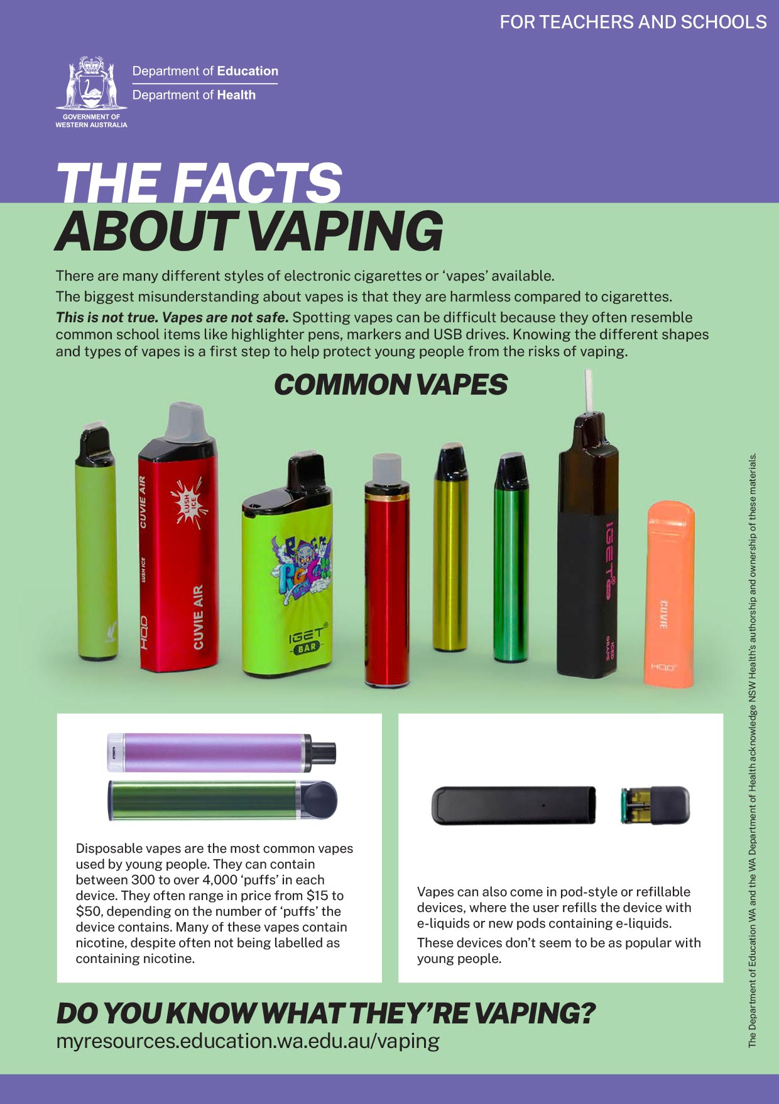
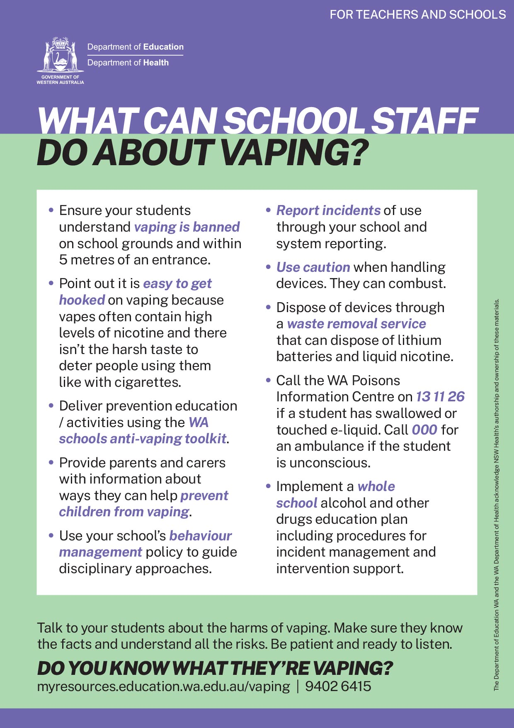
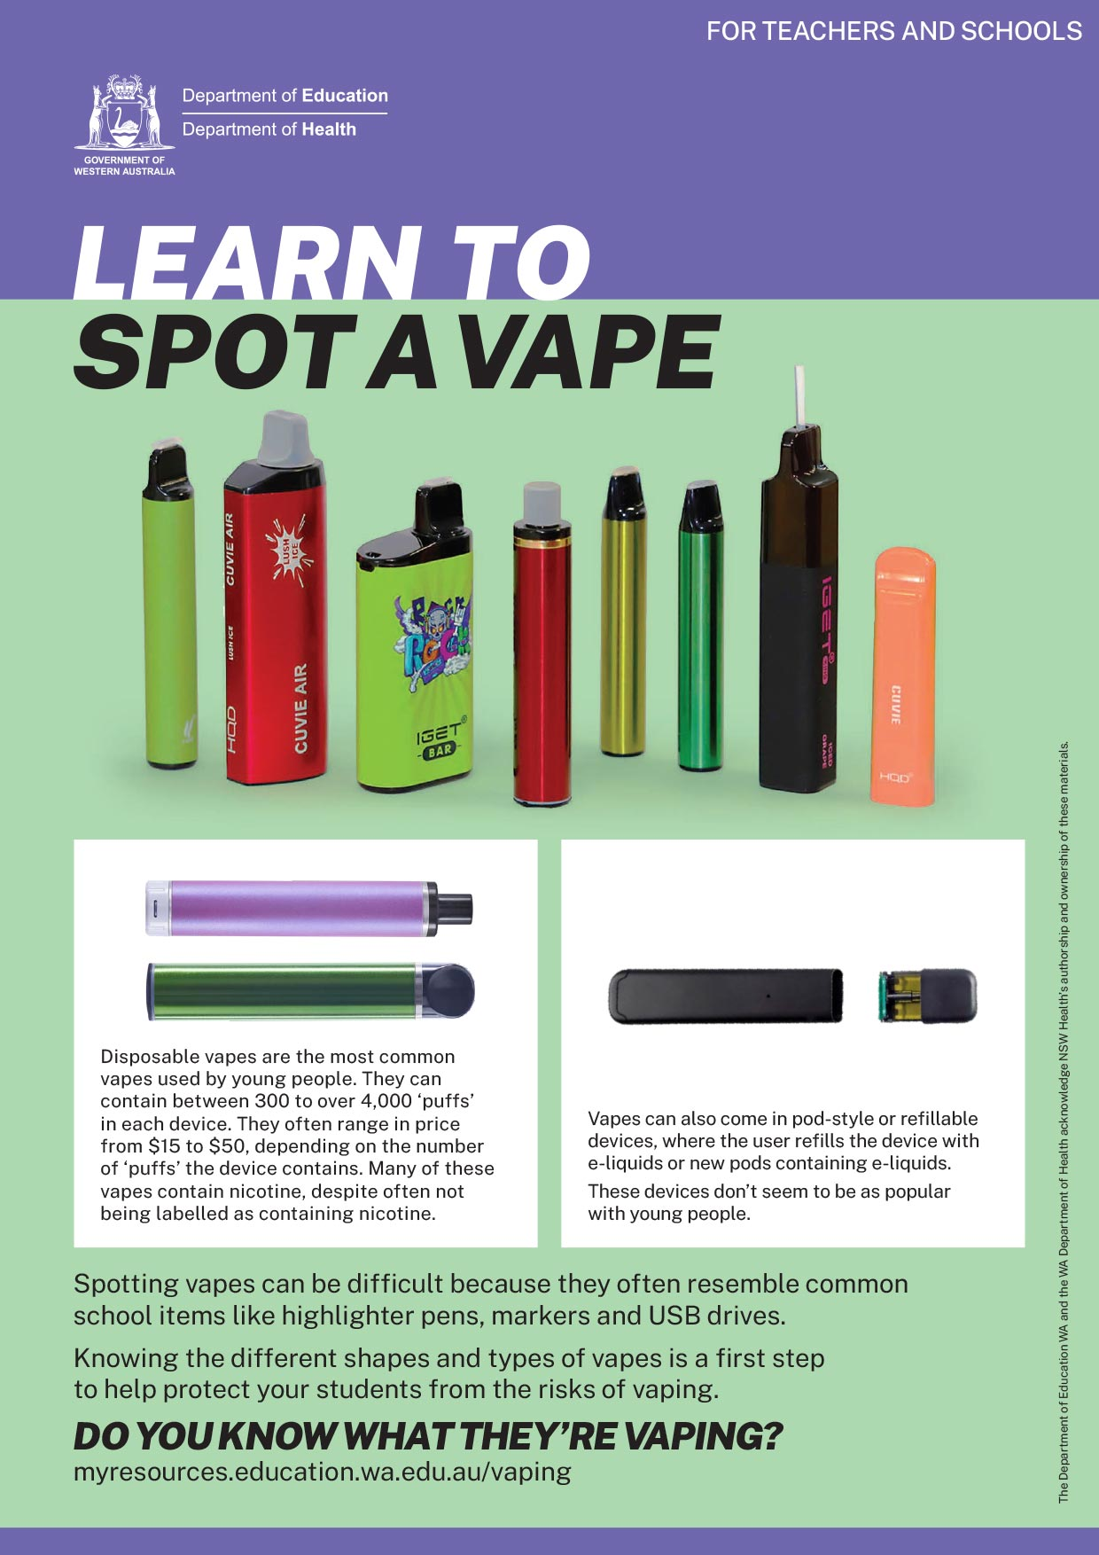
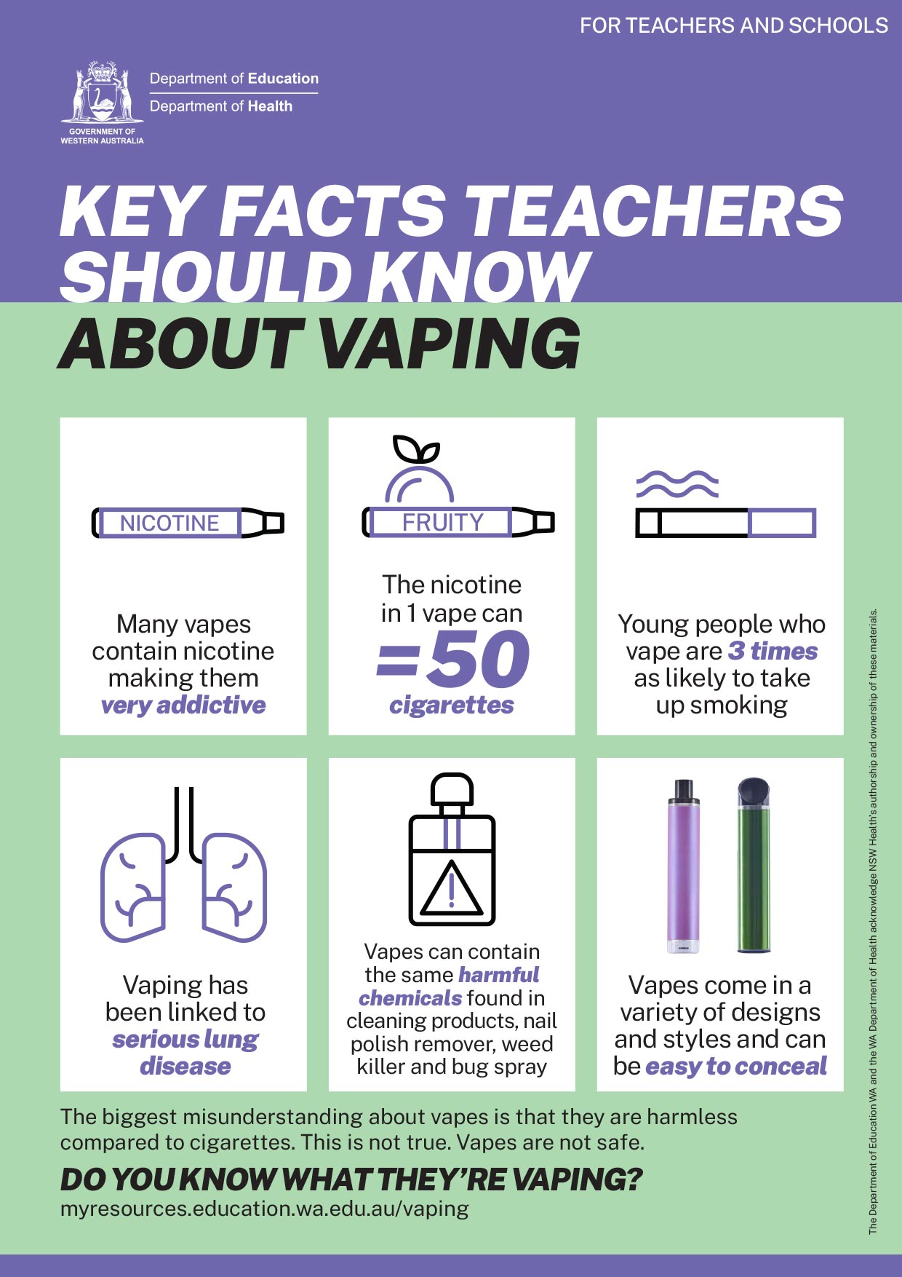

Newsletter content for schools
Longer newsletter version

Do you know what they’re vaping?

[Insert school name here], like many other schools, has seen a recent increase in young people vaping.

Electronic cigarettes or e-cigarettes, often called ‘vapes’, are electronic devices designed to deliver vapourised liquids into the lungs. There are many different styles of vapes and types of e-liquids, or e-juices, available. Vapes come in many shapes and sizes and can be made to look like everyday items including highlighters, pens or USB memory sticks.

The biggest misunderstanding about vapes is that they are harmless compared to cigarettes. This is not true. Vapes are not safe.

Vaping facts
- Many vapes contain nicotine making them very addictive.
- The nicotine in 1 vape can equal 50 cigarettes.
- Vapes can contain the same harmful chemicals found in cleaning products, nail polish remover, weed killer and bug spray. They just don’t put it on the pack.
- Vapes can leave young people at increased risk of depression and anxiety.
- Young people who vape are 3 times as likely to take up smoking cigarettes.
- Vape aerosol is not water vapour.
- Vaping has been linked to serious lung disease.
- Vapes that contain nicotine can cause long-lasting negative effects on young people’s brain development.

Signs your child might be vaping
Tell-tale signs that your child might have started vaping include the symptoms of nicotine addiction such as feeling irritable or anxious.

The laws around selling vapes
It is reported that young people often purchase vapes online, from retail stores or from friends and contacts in the community. However, it is illegal in WA to sell e-cigarette devices and nicotine vaping products to anyone regardless of age, unless they are prescribed by a doctor for smoking cessation purposes and obtained with a prescription from a pharmacy.

In WA e-cigarette devices and their components, whether they contain nicotine or not, cannot be sold by tobacco or general retailers. If you suspect someone is selling vapes or
e-cigarettes and their components, you can report it to the Department of Health by emailing TobaccoPolicy@health.wa.gov.au.

Talk to your child about vaping
Whether you suspect your child is vaping or not, take the time to talk to them about vaping and help them understand the risks. Try to start the conversation in a relaxed easy-going way, be patient, and remember your goal is to have a conversation, not deliver a lecture. Importantly, have your facts ready.

For more information
Get the evidence and facts at www.education.wa.edu.au.

Shorter newsletter version

Do you know what they’re vaping?

[Insert school name here], like many other schools, has seen a recent increase in young people vaping.

E-cigarettes, or ‘vapes’, are not safe for young people. They come in many shapes and sizes and can be hard to spot as they can look like everyday items including highlighters, pens or USB memory sticks.

Key vaping facts
- Many vapes contain nicotine. Nicotine can cause long-lasting negative effects on young people’s brain development, including impaired learning ability and altered mood, and can increase the risk of depression and anxiety.
- Vapes can contain the same harmful chemicals found in cleaning products, nail polish remover, weed killer and bug spray, which can lead to serious lung diseases.
- Young people who vape are 3 times as likely to take up smoking cigarettes.

The laws around selling vapes
It is reported that young people often purchase vapes online, from retail stores or from friends and contacts in the community. However, it is illegal in WA to sell e-cigarette devices and nicotine vaping products to anyone regardless of age, unless they are prescribed by a doctor for smoking cessation purposes and obtained with a prescription from a pharmacy. You can report suspected illegal sales of vapes to the Department of Health by emailing TobaccoPolicy@health.wa.gov.au.

Talk to your child about vaping
It’s important to take the time to talk to your child about the risks of vaping. Try to start the conversation in a relaxed easy-going way, and remember your goal is to have a conversation, not deliver a lecture. Importantly, get the facts at: www.education.wa.edu.au

Letter template for schools
Parent letter for schools to distribute
Dear parent/carer,
In recent weeks, [school name] has identified students using vapes on school premises or on their way to and from school. There has been a growing concern about the harmful effects vaping has on young people.
The take-up of vaping by young people is increasing. Research has found that in WA around 13.5% of secondary students have tried an e-cigarette.

There are many different styles of vapes and they can be difficult to spot. The biggest misunderstanding about vapes is that they are harmless compared to cigarettes. This is not true. Vapes are not safe.

Vaping facts
- Many vapes contain nicotine making them very addictive.
- Vapes contain many toxic chemicals, they just don’t put it on the pack.
- Vapes can contain the same harmful chemicals found in cleaning products, nail polish remover, weed killer and bug spray.
- Vapes can leave young people at increased risk of depression and anxiety.
- The nicotine in 1 vape can equal 50 cigarettes. Depending on the size of vape and nicotine strength, it can be much higher.
- Young people who vape are 3 times as likely to take up smoking cigarettes.
- Vape aerosol is not water vapour.
- Vaping has been linked to serious lung disease.
- Vapes that contain nicotine can cause long-lasting negative effects on young people’s brain development.

What is [school name] doing?
[School name] follows the procedures within our School Behaviour Management Policy. This will guide our disciplinary approach if there is a breach of behavioural standards.
[Insert behaviour management strategies and consequences e.g. increased supervision]

Additionally, our teachers have a range of curriculum based activities to ensure students know the facts about vaping.
[Insert curriculum based activities e.g. using the WA schools anti-vaping toolkit]

Is your child vaping?
Signs that your child might have started vaping are the usual symptoms of nicotine addiction such as feeling irritable or anxious. If they are vaping, encourage them to stop and let them know that you are there for support. Stopping can sometimes be hard and they may need advice from a GP or other healthcare professional.

What can you do as a parent?
Take the time to talk to your child about vaping and help them understand all of the risks associated with vaping. They may see it as a normal thing to do, which is not the case. Try to start the conversation with your child in a relaxed easy-going way, perhaps taking the cue from this letter, and, importantly, have your facts ready.
[Insert parent activities e.g. fact sheet for parents, information nights]

It is illegal in WA to sell e-cigarette devices and nicotine vaping products to anyone regardless of age, unless they are prescribed by a doctor for smoking cessation purposes and obtained with a prescription from a pharmacy. It is also illegal to sell vapes to friends at school or in the community. You can report suspected illegal sales of vapes to the Department of Health by emailing: TobaccoPolicy@health.wa.gov.au.

For more information
Get the evidence and facts at
www.education.wa.edu.au

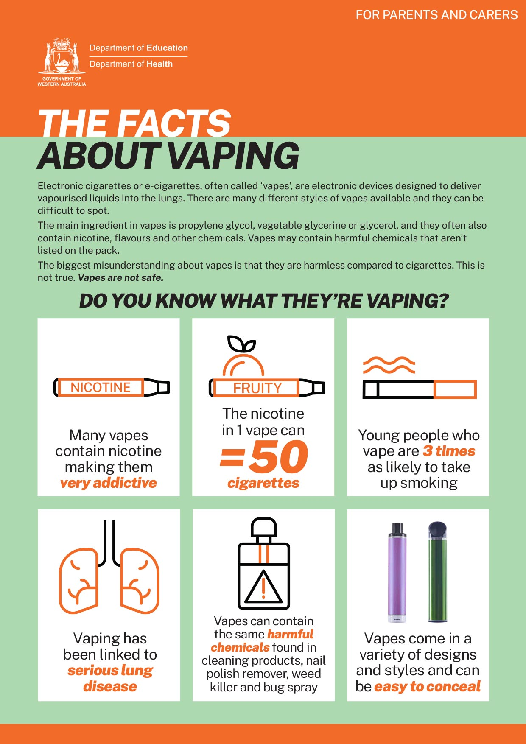
Resources for parents and carers
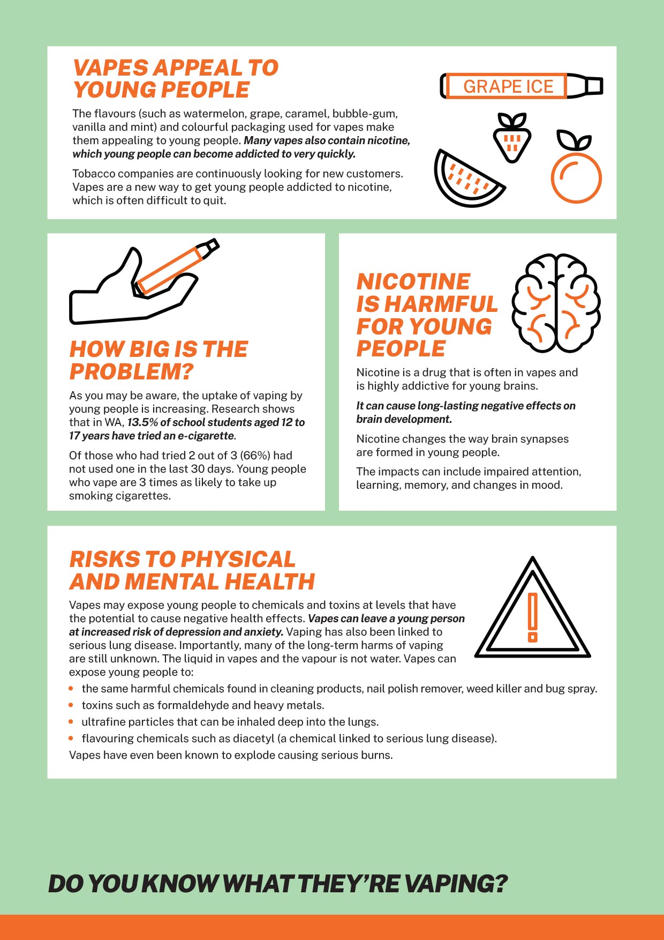
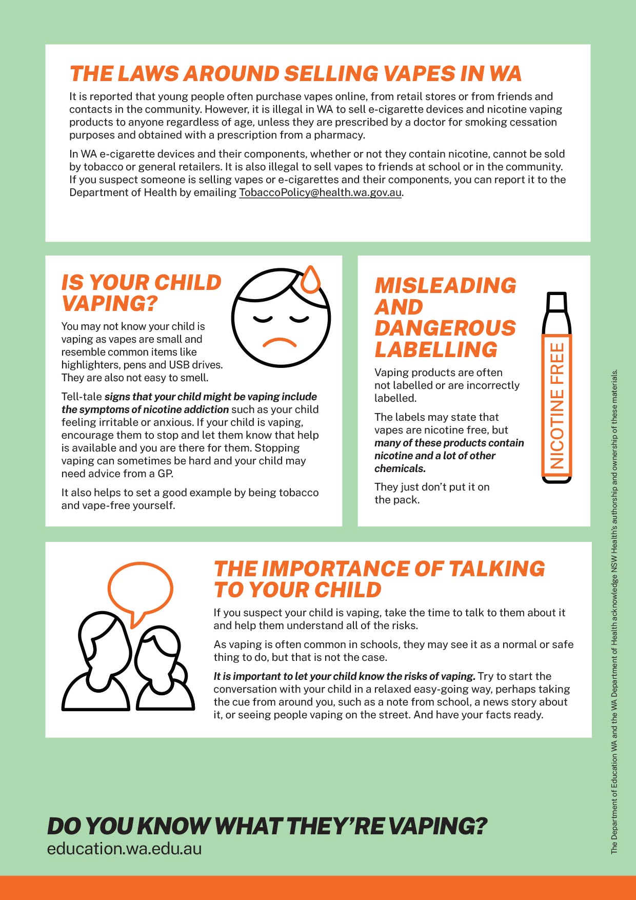
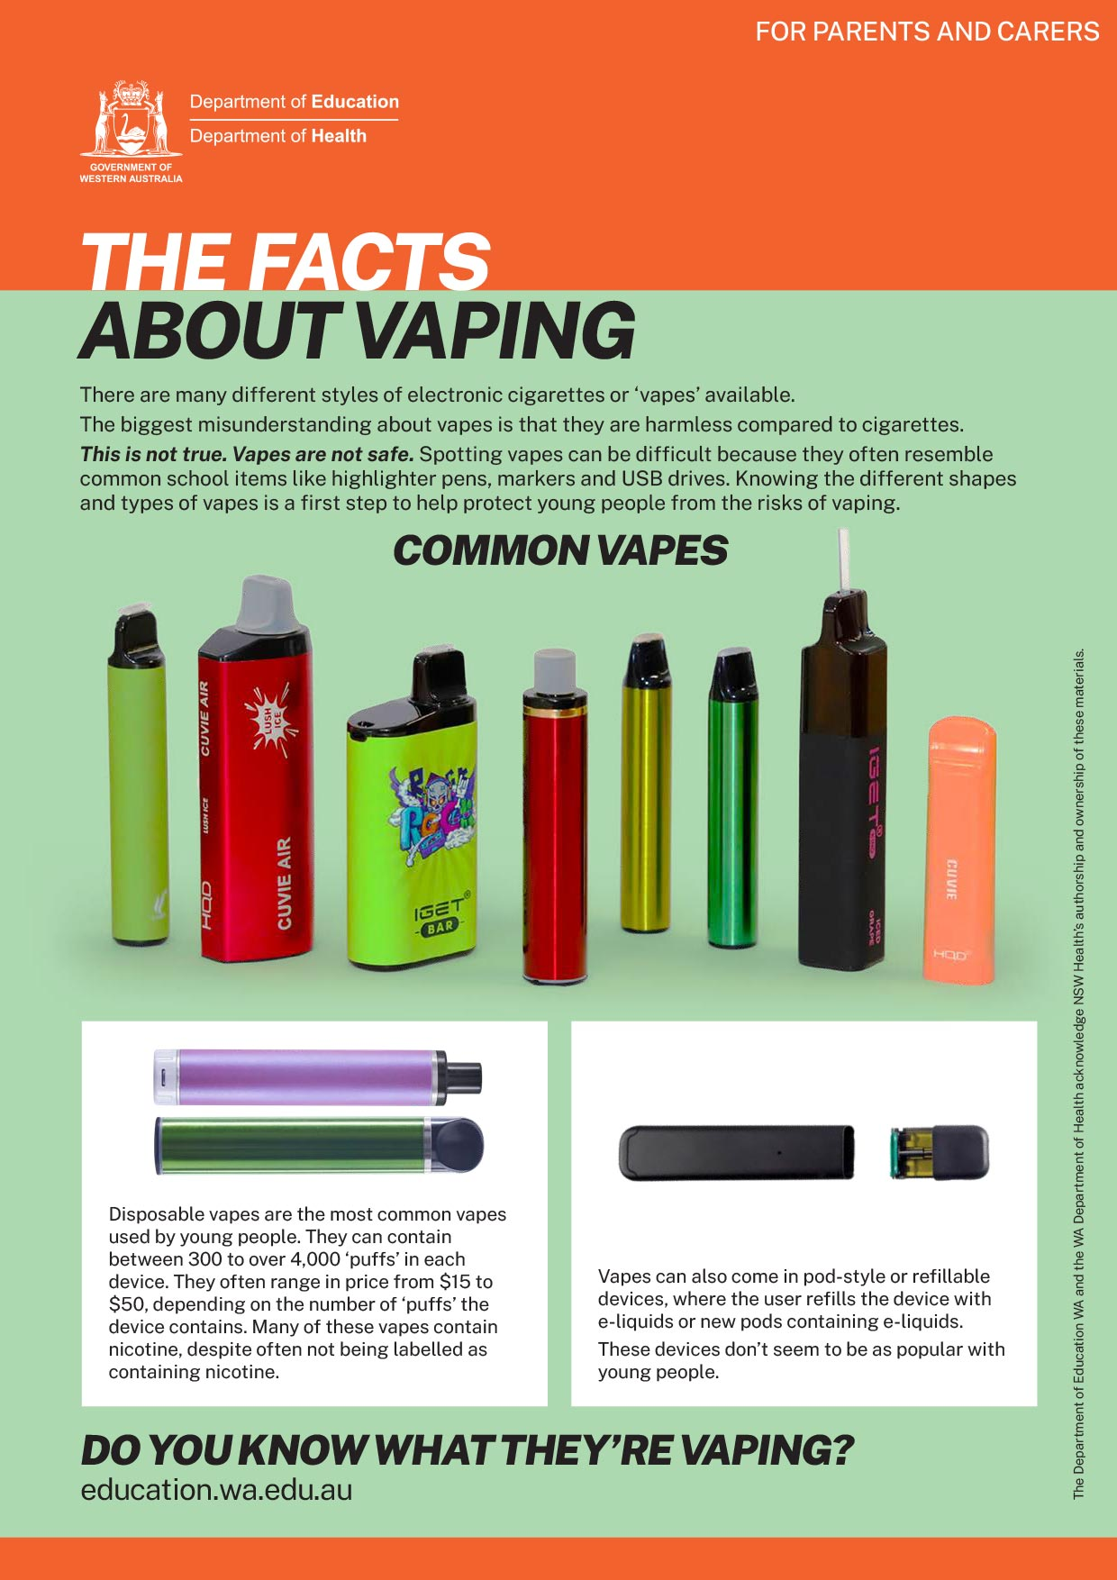

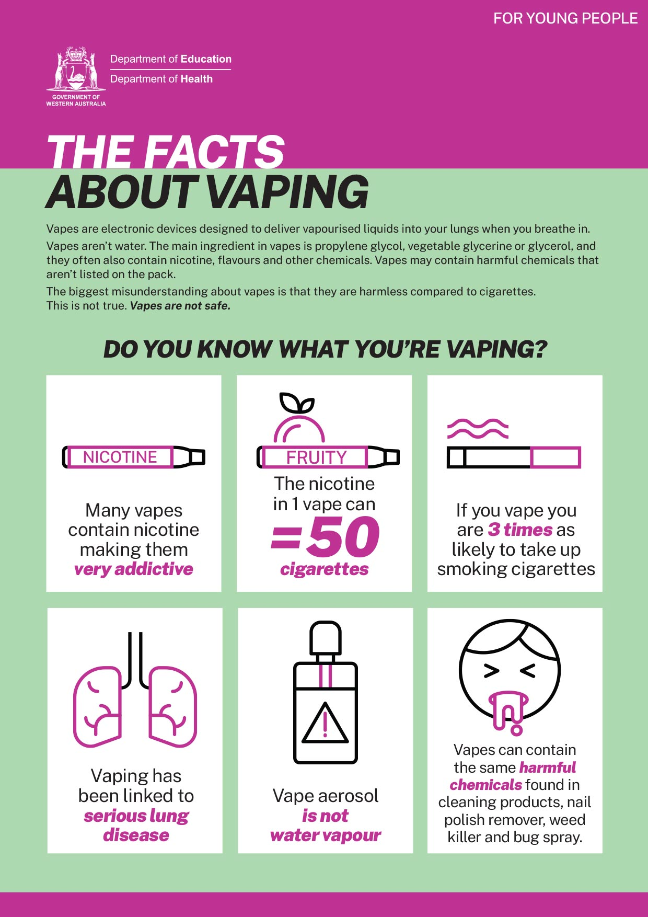
Factsheets for young people
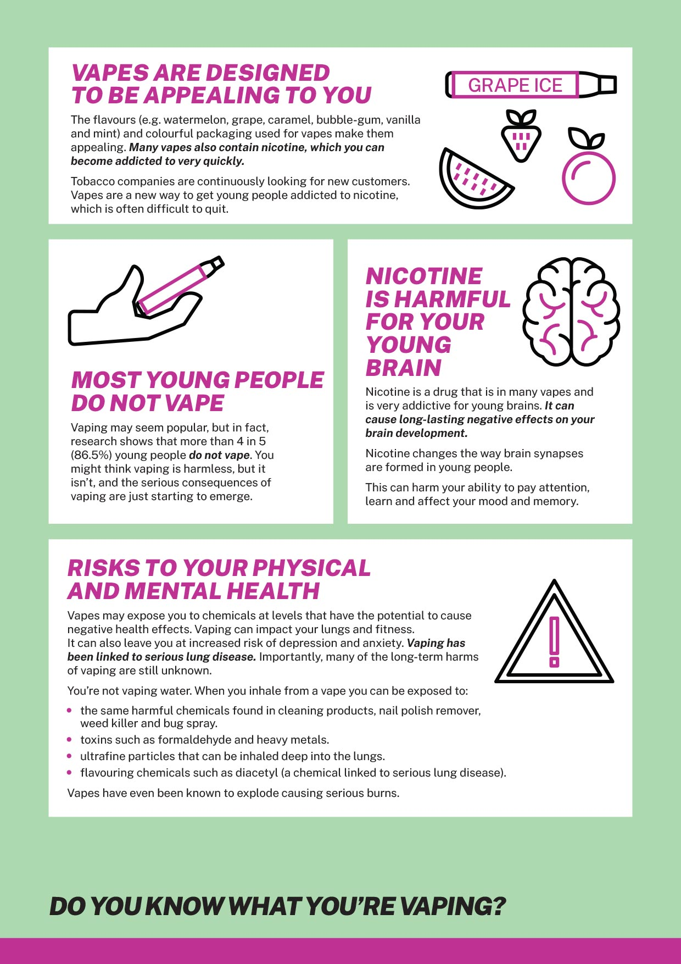
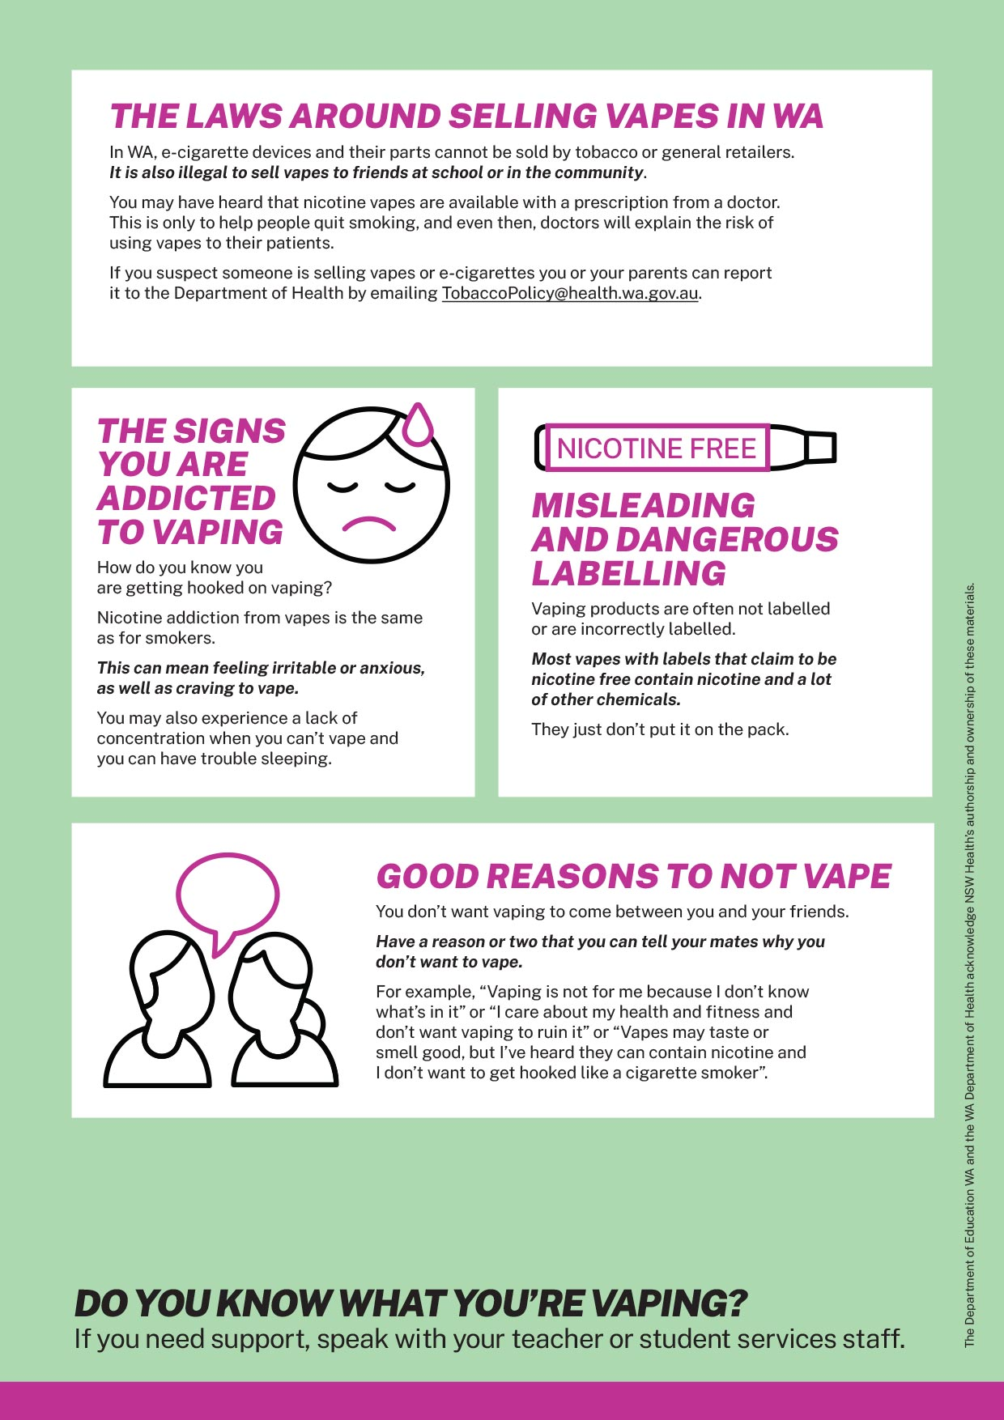

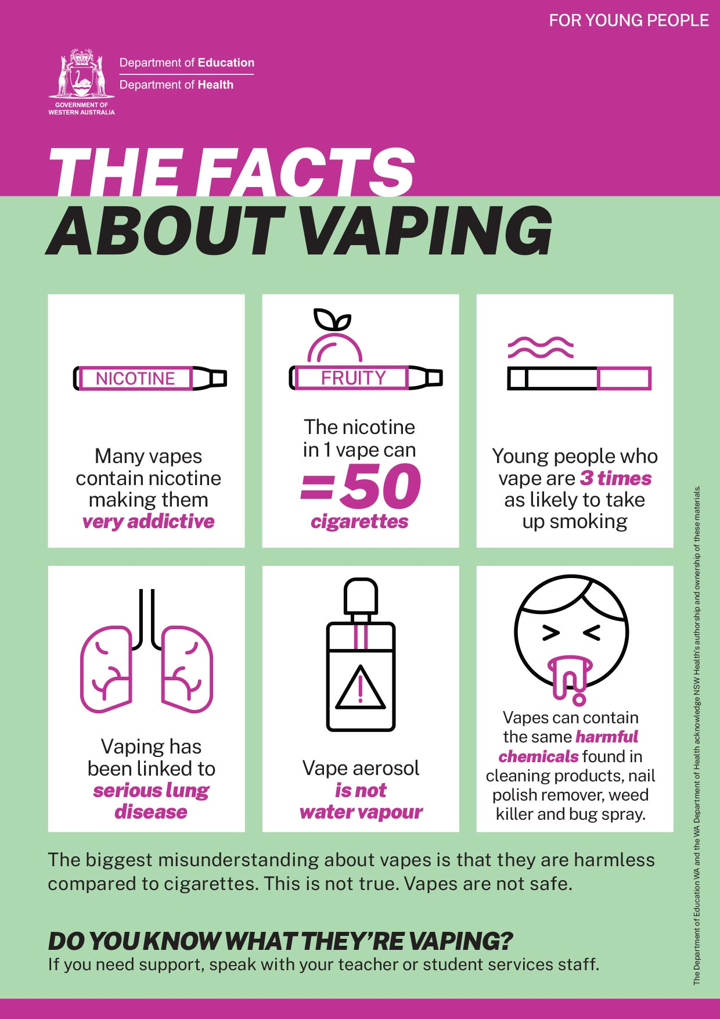
Posters for young people

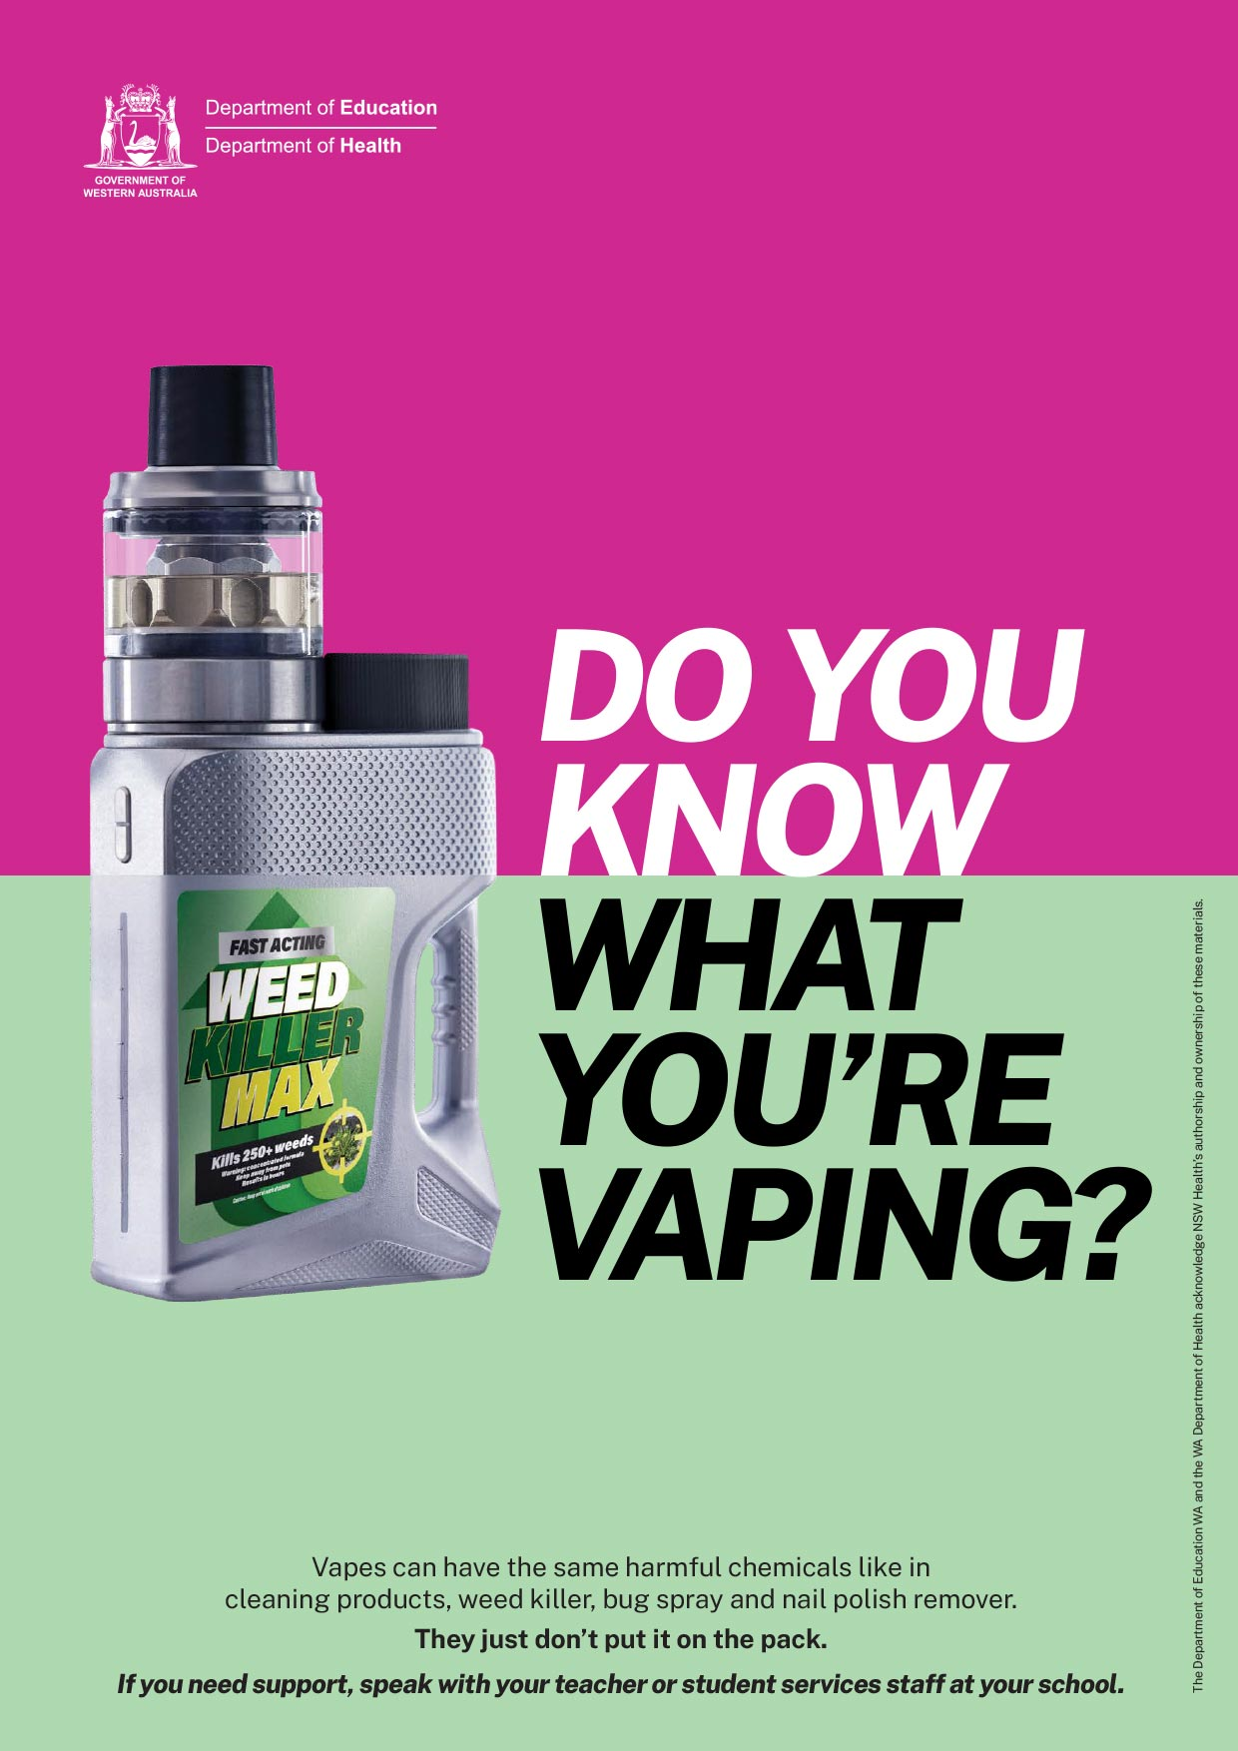
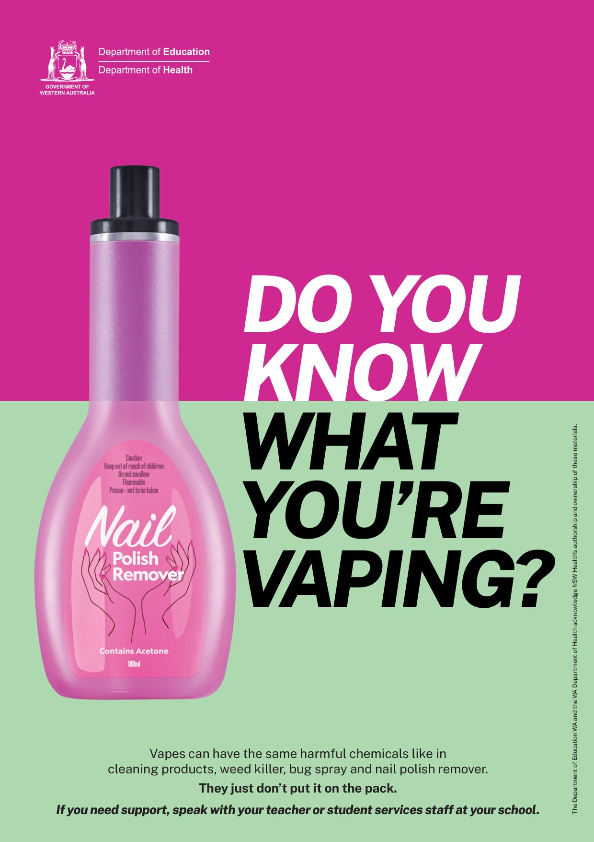
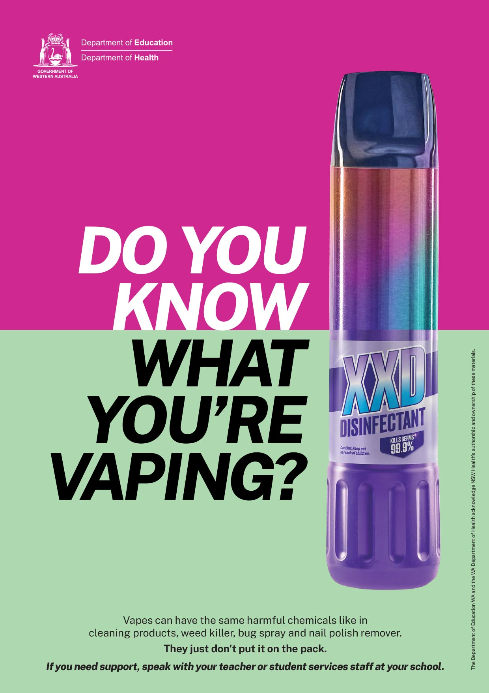
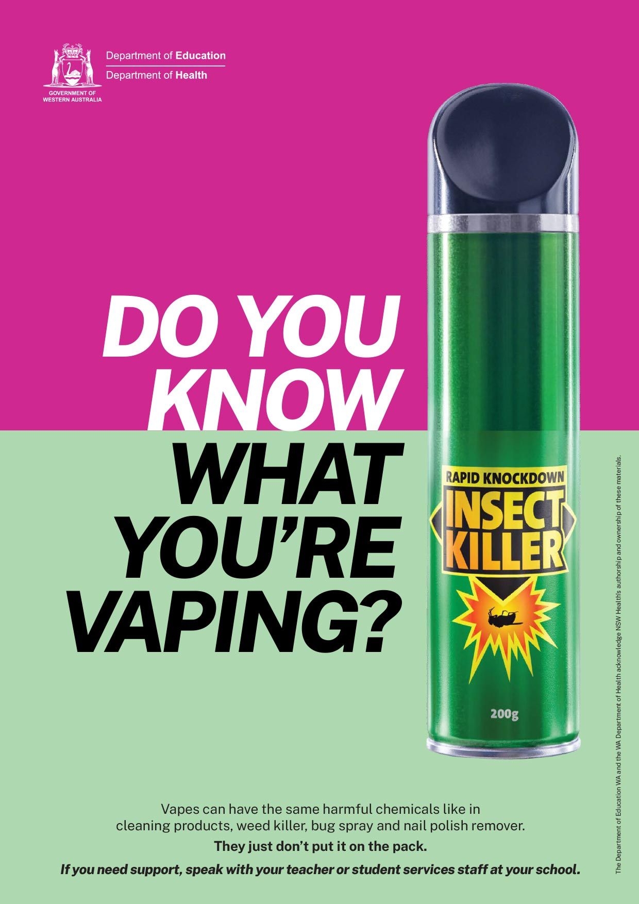
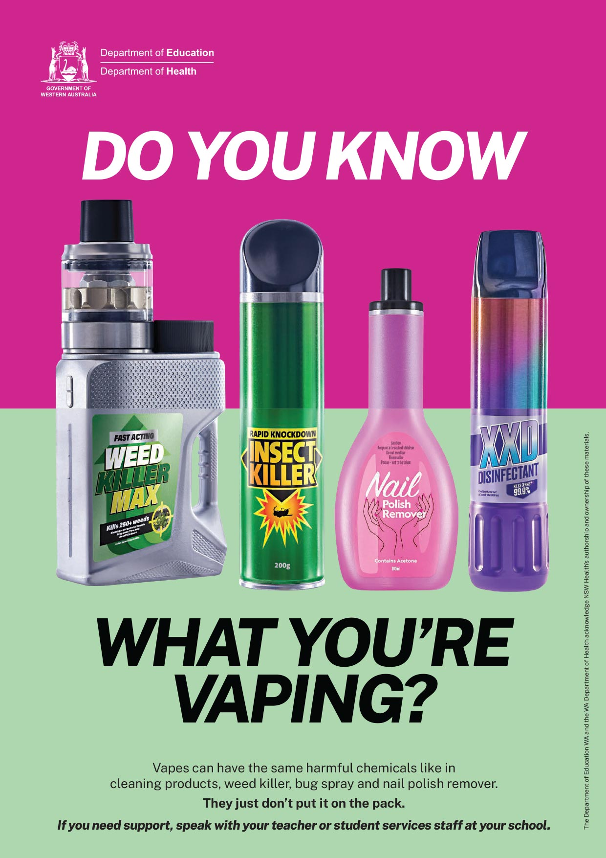

Activity sheets (classroom resource)

Activity sheet 1
Vaping self-assessment

- How confident are you that you know enough about the harms linked to vaping to make an informed decision not to vape?
Extremely Confident
Not Confident
10

0

- How confident are you that you could refuse a vape from a friend?
Extremely Confident
Not Confident
10

0

- How confident are you that you could refuse a vape when everyone else is vaping?
Extremely Confident
Not Confident
10

0

- How confident are you that you would know where to get help if you had questions about vaping?
Extremely Confident
Not Confident
10

0

- How confident are you about advising a friend if they needed help to quit vaping?
Extremely Confident
Not Confident
10

0

Activity sheet 2
Vaping

What I know  (K) | What I want to know  (W) | What I learned  (L)

Activity sheet 3

Jigsaw

Vapes are designed to be appealing to you | Most young people do not vape | Nicotine is harmful for your young brain | Risks to your physical and mental health
The laws around selling vapes in WA | The signs you are addicted to vaping | Misleading and dangerous labelling | Good reasons to not vape

Activity sheet 4
What I can do
As a group discuss strategies that could be used to manage each situation effectively.

Situation
Your friends believe that vaping is safer than smoking because they think it’s just water vapour and flavours.
Your friend has started vaping and it makes you uncomfortable when they do it around you.
Your friends are debating which vaping flavours are the best.
Your cousin is in Year 12 and is stressed out about upcoming exams and thinks that vaping will calm them down.
Your best friend is vaping every day and wants to quit but is not sure where to go for support.
You have seen young people vaping on social media.
Create your own situation.

