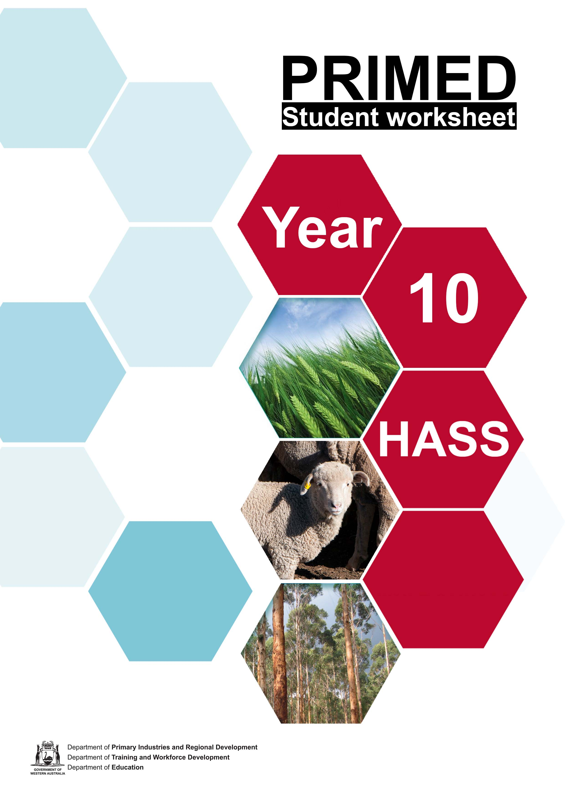

Student worksheet 1.1

Vocabulary

Word | Definition
Agribusiness
Competitiveness
Constraints
Distributors
Exporters
Innovation
Inputs
Inventory
Investment
Investors
Market drivers
Market share
Marketers
Marketing strategies
Opportunities
Outputs
Primary Industry
Processes

Processors
Producers
Productivity
Research and development
Retailers
Stakeholders
Systems Model
Technology
Training

Hexagonal thinking
Use the terms listed to demonstrate how the elements of an agribusiness system are connected.
- Cut out the hexagons and arrange on a large piece of paper
- Draw lines between the hexagons and explain the connections you have made.

Retailers
Stakeholders

Technology

Inventory

Investment
opportunities

Producers

Systems Model
Market drivers

Inputs
Training
constraints

Processors

Productivity

Market share

Processes

Research and development
Competitive- ness

Investors

Innovation
Primary Industry

Outputs
Marketing strategies
Government policy

Agribusi- nesses

Student worksheet 1.3

Frayer model

Definition Illustration

Term

Examples Non-examples

Student worksheet 2.1

Businesses associated with the supply chain
YOUR TASK:
Find examples of the types of businesses and careers associated with each element of the supply chain.
Choose one example and use the inquiry approach to investigate a business or a career in detail. Present a summary of your findings. Note: if you are researching a business, make sure you include the inputs, processes and outputs required.

PRIMARY PRODUCTION | DISTRIBUTION AND STORAGE | PROCESSING STAGE 1 | PROCESSING STAGE 2 | DISTRIBUTION AND STORAGE | ACCESS
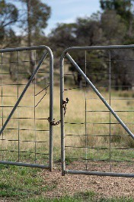 |  |  | 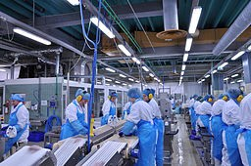 | 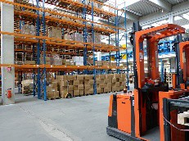
 | Transport | Grading | Manufacturing | Transport | Retail  - Shops  - Restaurants  Exports
Farm gate | Loading | Processing | Processing | Storage
 | Storage | Cleaning | Transformation | Distribution
 | Inventory | Slaughter | Wholesale | wholesale
 |  | Packaging

EXAMPLES | PRIMARY PRODUCTION | DISTRIBUTION AND STORAGE | PROCESSING STAGE 1 | PROCESSING STAGE 2 | DISTRIBUTION AND STORAGE | ACCESS | OTHER
Businesses | Sumich Group Amelia Park Wooleen Station | Sumich Group | Sumich Group | Fresh Food Industries  Sticky Fingers | Sumich Group  The Grocer Food Distributors | Sumich Group | Wooleen Station – accommodation
Careers | Farmer | Rural merchandise store worker | Processing Plant Manager | Laboratory Technician | Grains Trader | Chef | Research Agronomist  Lawyer
Reference:

Student worksheet 2.1a

Using the inquiry approach for research
Step 1: Identify and understand what the task is asking you to do. Underline the VERBS – what do you have to DO?

Highlight the CONTENT – what do you have to FIND OUT?
Step 2: Think about what you already know and jot down ideas.
Step 3: Develop a series of specific questions that will help guide your research and determine the information you need to locate.
Develop questions using WHO, WHAT, WHY, WHERE, WHEN and HOW as prompts.

Step 4: Locate appropriate sources of information.

The internet will be helpful, but can you also interview people working in primary industries in your location?
Step 5: Select relevant information from a range of sources.

Use a note-taking technique that suits your learning style to record relevant information.

Step 6: Record your references

Author Surname(s), Initial(s) | Year of publication | Chapter name | Title (italics) | Pages | Publisher | Place of publication

Author Surname(s), Initial(s)/Organisation | Title of video | Type of medium | Date published | URL | Date accessed/viewed

Author Surname(s), Initial(s)/Organisation | Year of publication | Title of webpage  (italics) | Name of sponsor | URL | Date accessed/viewed

Step 7: Present the information in a format of your choice.

For example: poster, PPT, animation, talk, short film, one page summary, advertisement

Primary Industry Plan 2020 – 2024 Strategic Initiatives
Requirements:

In your expert groups:

- read the information regarding the strategic theme
- jot down ideas to answer each question in the table below
- discuss as a group and select the key points to include on the table In your home groups:
- share your findings to complete the table

Strategic Initiative | What is the purpose of this strategy? | How does the government aim to achieve it? | How will it help primary industry businesses?
Strategic theme 1
Strategic theme 2
Strategic theme 3
Strategic theme 4
Strategic theme 5

Business case study
Step 1: Individual task

The QUESTIONER

Think of questions as you read the case study. Use some of the following starters to formulate your questions.
What is? Why is? How is? What did? How did? What can? When can? How can? Who/what would? Where/When would? What will? Where/when will? Who will?

The SUMMARISER

Select the main points from the case study. Focus on how the business has improved productivity or responded to economic conditions.
The most important ideas are… The main idea is … The ways in which … The technology utilised is…

The PREDICTOR

Predict what the future holds for the business.

I think… I wonder… I imagine… I suppose… I predict…

Step 2: Group task
Describe the business.

Explain a strategy that the business has used to increase productivity or respond to economic conditions.

List the future challenges the business may encounter.

Suggest one way in which the business could change operations to improve productivity.

Student worksheet 4.2

Extent barometer
To what extent do the case studies demonstrate commitment to the UN Sustainable development goals?
General comments:
Overall

Sustainable Development Goals | Evidence from the case studies | Rating
Goal 2: Zero hunger |  | 100%
End hunger, achieve food |  | 75%
security and improved nutrition |  | 50%
and promote sustainable |  | 25%
agriculture. |  | 0
Goal 9: Industry, innovation and |  | 100%  75%  50%  25%  0
infrastructure
Build resilient infrastructure,
promote inclusive and
sustainable industrialisation and
foster innovation.
Goal 12: Responsible
consumption and production. |  | 100%
Ensure sustainable consumption and production patterns. |  | 75%  50%  25%
 |  | 0
Goal 13: Climate action
Take urgent action to combat climate change and its impacts. |  | 100%  75%  50%
 |  | 25%
 |  | 0

100% | Totally
75% | Fairly high
50% | Medium
25% | Low
0 | Not at all

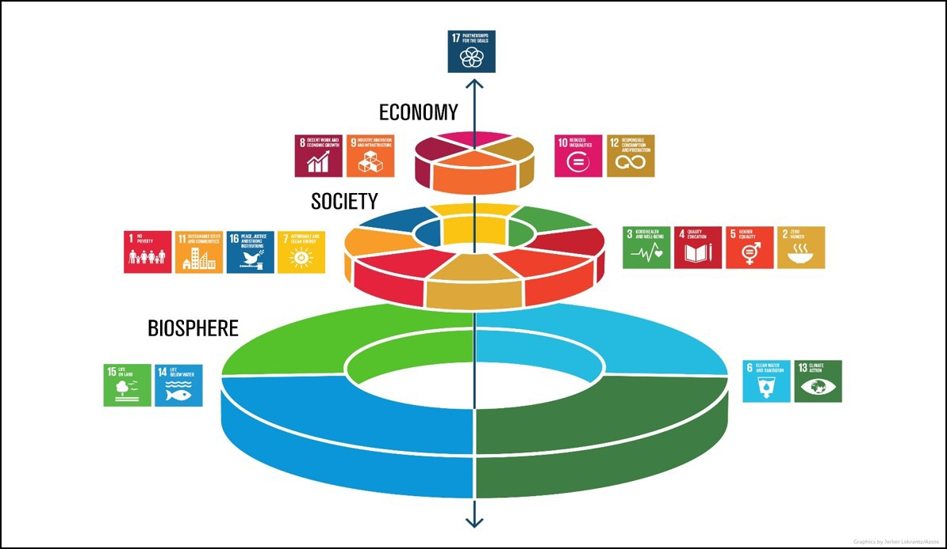

Image 4.2

Acknowledgements

Image
Image 4.2 ‘Biosphere – Society – Economy’ by Azote Images for Stockholm Resilience Centre, Stockholm Resilience Centre, Stockholm University. Accessed at <https://www.stockholmresilience.org/research/research-news/2016-06-14-how-food-connects-all-the-sdgs.html> accessed 10 August 2021

Student worksheet 5.1

Mind Map
The WA Food Innovation Precinct Media Statement from the Western Australian Government. Media Statements

Works underway on WA Food Innovation Precinct
Thursday, 20 May 2021
- Construction begins on the WA Food Innovation Precinct - a $21.7 million centre of excellence for food innovation at the Peel Business Park
- Precinct will be home to the McGowan Government's Peel Food Technology Facility
- Enterprise Support Program to provide $3.85 million in grants to support industry in activating the precinct

Work is underway on the Western Australian Food Innovation Precinct (WAFIP), the State's centre of excellence for research, development and commercialisation of new ag-tech and value-added food.
The $21.7 million precinct, located within the Peel Business Park in Nambeelup, will be an open access facility comprising research and development capabilities, an innovation centre and a production-warehouse.
It is intended to be a centre of excellence to enable commercial research and development, prototype and market testing of food and beverage products, and networking for WA food producers.
The McGowan Government has committed:
- $10 million to develop the Peel Food Technology Facility within the precinct, a 600 square metre manufacturing space to allow producers to develop and test new value-added food products; and
- $2.5 million towards a $3.85 million Enterprise Support Program, in partnership with the Shire of Murray, to help activate the precinct.
Through the Enterprise Support Program, grants will be available to businesses to support access to innovation opportunities, leading-edge research capabilities, incubation space and technologies through the WAFIP.
Other key tenants at the WAFIP include:
- Murdoch University, to run the Research and Development Facility and deliver a Food Science and Nutrition Bachelor of Science degree;
- GrowHub have signed a lease to operate the WAFIP Innovation Centre - a one-stop shop for agribusinesses and entrepreneurs featuring co- working spaces, consulting services and industry support; and
- Spinifex Brewery, to run the WAFIP warehousing facility and establish their brewery at the precinct.

The WAFIP is supported by funding from the Australian Government's Regional Growth Fund.
- Using the information from the media release and the following resources, prepare a mind map to summarise the contributions to and benefit of this project for each of the stakeholders mentioned.
  - Western Australian Food Innovation Precinct
  - Peel Business Park
  - WA Food Innovation Precinct to drive growth in premium value-added foods
  - Western Australian Food Innovation Precinct
  - WA Food Innovation Precinct

STATE GOVERNMENT

LOCAL GOVERNMENT

FEDERAL GOVERNMENT

THE WESTERN AUSTRALIAN FOOD INNOVATION PRECINCT

EDUCATIONAL INSTITUTIONS
WESTERN AUSTRALIAN ECONOMY

BUSINESSES

- Using your notes, consider the positive, negative and interesting aspects of this project for businesses in the following contexts.

Business context | Plus | Minus | Interesting
Local
Western Australian
National
Global

Acknowledgement

References
Government of Western Australia (20 May 2021) ‘Works underway on WA Food Innovation Precinct’ available
<https://www.mediastatements.wa.gov.au/Pages/McGowan/2021/05/Works-underway-on-WA-Food-Innovation-Precinct.aspx> accessed 24 August 2021
Australian Government (n.d) ‘Western Australian Food Innovation Precinct’ available at: <https://www.peel.wa.gov.au/transformpeel/wp- content/uploads/WAFIP-Flyer.pdf> [PDF 3.4 MB] accessed 24 August 2021
DevelopmentWA (n.d) ‘Peel Business Park’ available at: <https://developmentwa.com.au/projects/industrial-and-commercial/peel-business- park/overview> accessed 24 August 2021
Future Food Systems (20 May 2021) ‘WA Food Innovation Precinct to drive growth in premium value-added foods’ available at:
<https://www.futurefoodsystems.com.au/new-wa-food-innovation-precinct-to-help-produce-premium-value-added-food-products-in-australias-west/> accessed 24 August 2021
Shire of Murray (2021) ‘Western Australian Food Innovation Precinct’ available at: <https://www.murray.wa.gov.au/Shire-and- Council/Projects/Western-Australian-Food-Innovation-Precinct> accessed 24 August 2021
Government of Western Australia (n.d) ‘WA Food Innovation Precinct’ available at: <https://www.peel.wa.gov.au/transformpeel/western-australian- food-innovation-precinct/> accessed 24 August 2021

