Student worksheet 1.1

Defining needs and wants

In economics we define needs as ‘necessary for survival’. Provide examples of how we meet our needs.

Food for health | Air to breathe
Water to drink | Shelter for safety

We define wants as ‘something we would like to have as it makes life comfortable (or fun!).
Name:
- a food that you like to eat as a treat _____________________

- a drink that you like other than water _________________________

- an item of clothing you desire __________________________

- something in your house that provides comfort ________________________

- your most valuable possession _____________________________

- what you would buy with $100! ________________________________

Classifying needs and wants
Consider the items below – is each one a need or want? Provide reasons for your answer.
Item | Need | Want | Reasons
Hamburger and chips
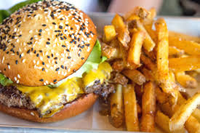
Image: available at https://pixnio.com/food-and-drink/burgers-and-sandwiches/hamburger-potato-lunch-diet-food-sandwich
Image: available at https://pixabay.com/illustrations/education-books-letters-font-2107899/
Medical and dental services
Image: ‘Health Care’ by Nick Youngson. Licensed CC BY-SA 3.0 Alpha Stock Images. Available at https://www.picserver.org/highway-signs2/h/health-care.html
Transport
Image: ‘Car emoji’ author unknown. Licenced CC by 4.0. Available at https://iconscout.com/icon/car-automobile-vehicle-personal-family-transportation-emoj-symbol
Technology
Image: https://cdn.pixabay.com/photo/2015/10/04/17/48/mobile-971480__340.jpg

Student worksheet 1.2

Characteristics of WANTS
Think about the following groups of people and the needs and wants they may have.
Image: ‘Cartoon baby crying drawing’. Licensed CC BY-NC-ND 4.0, available at: https://pixy.org/799816/ | A baby needs…  A baby wants…
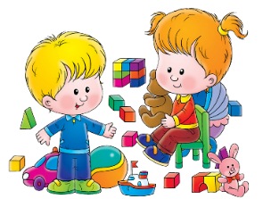  Image available at https://clipartstation.com/play-with-toys-clipart-2/ | A toddler needs…  A toddler wants…
Image available at https://pixabay.com/illustrations/search/children/ | A primary student needs…  A primary student wants…
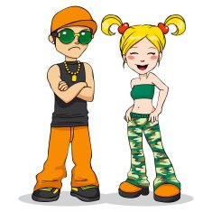  Image: ‘Cool Couple N2’. Licensed CC0. available at https://pixy.org/2712664/ | A teenager needs…  A teenager wants…
Image available at: https://pixabay.com/vectors/family-family-portrait-cartoon-5467986/ | A family needs…  A family wants…

What do all of these groups have in common?

______________________________________________________________________________

______________________________________________________________________________

______________________________________________________________________________

______________________________________________________________________________

Based on your ideas regarding wants, complete the Frayer Model graphic organiser below.

What are some alternative terms for WANTS?

Student Worksheet 1.3

Glossary activity
Use your text book or internet sources, to find definitions and examples for the terms listed below.
Key term | Definition | Example
Capital
Consumer
Economy
Enterprise
Factors of production
Goods
Labour
Land
Needs
Primary Industry
Producer
Secondary industry
Services
Tertiary industry
Wants

Student Worksheet 2.1

Satisfying needs and wants
Task 1: In order to satisfy our needs and wants, we CONSUME (USE) goods and services. In the space below, note examples of goods and services you have used this week.
Activity | Goods and/or services used
Sleeping | Sheets, pillow, duvet,
Breakfast | Cereal, milk, toast

Transport

Recess

Essential services

School supplies

Clothing

other

List some of the resources required to produce the goods and services you have used.
For example
Sheets: - cotton, thread, factory
Milk for cereal: - farm, cows, transport

Task 2:
Businesses combine a variety of resources in order to produce the goods and services consumers need to satisfy their needs and wants. They are called the factors of production: the inputs available to supply goods and services in an economy.
Factors of production.
Land | Labour
The natural resources or raw materials available for production, for example soil, plants, animals, minerals. Anything found in nature above or below the ground or oceans. | The human input into the production process. Any physical or mental labour required.
Capital | Enterprise
Goods used to create or supply other goods and services, fo0r example machinery, buildings, chemicals, computers | An entrepreneur combines the other three factors to increase supply, for example an entrepreneur

Consider milk used for cereal – think about all the resources that have been combined to create this good.
Land
Labour

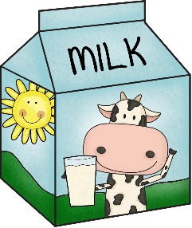

Enterprise
Capital

Image: ‘Clipart of milk carton’ available at https://pixy.org/4505443/

Student worksheet 2.2

Food supply chain
A food supply chain considers the journey of a food resource from production to consumption.

https://www.refreshedschools.health.wa.gov.au/wp-content/uploads/2020/01/Year-9-SOURCE-Understanding-Sustainable-Food-Systems-2020.pdf

Using the carton of milk as an example, consider the supply chain required to get fresh milk ‘from farm to plate’.
Supply Chain element | Primary production | Processing | Distribution | Access | Consumption | Waste
Example  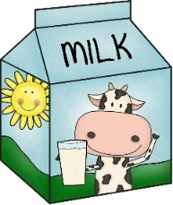 | Dairy farms | Milking  Storage  Pasteurisation, homogenisation | Transport of milk from farms to processing plants, products from factory to retail | Supermarkets, food outlets | Milk, cream | Solid waste, water waste, packaging
Examples of resources | Soil, grass, cows, farm workers, farm equipment, fences, chemicals, milking machines | Storage vats, refrigeration, laboratory equipment, packaging materials | Refrigerated tankers, petrol, drivers | Shop workers, hospitality workers, marketing and advertising | Factory equipment, workers | Water, plastic, metal, cardboard and paper
Examples of businesses in this sector | Bannister Downs Gundagai Dairy Whiterocks Farm Halls Family Dairy | Bannister Downs Brownes  Lactalis | SRH Milk Haulage  McColls | Coles  Woolworths  Aldi  IGA | Bannister Downs  Brownes Dairy | PlanetArk

SEE, THINK, WONDER
What do you ‘SEE in this example? What do you ‘THINK’ about that? What does it make you ‘WONDER’?

Choose one of the food products you listed on worksheet 2.1 and investigate the supply chain for that item. Use your own knowledge or internet resources to help you complete the table.
Supply Chain element | Primary production | Processing | Distribution | Access | Consumption | Waste
Example

Examples of resources

Examples of businesses in this sector

Share your research with your partner and discuss your findings.

Student worksheet 3.1

Interdependence of producers and consumers
Australia is a nation of consumers and producers. We have many industries that create goods and services to satisfy our needs and wants. Primary production includes food, fibre and mining of minerals. When considering food items, some primary products come straight from the farm in raw form and some are processed to create other goods. The relationship between producers, consumers and market forces is important to understand and in this lesson you will conduct research regarding various primary industries involved in food production.

A case study in horticulture: The Sweeter Bananas Co-operative
Type of producers
Horticulture/fruit
About the company
- Formed by a group of growers in 1993.
- 25 families involved in the company.
- Based in Carnarvon.
- They invented the ‘Original Lunchbox Banana™’.
- Invested in supply chain links, for example cold storage.
Selling points
- WA company
- Their bananas taste sweeter – university tested
- Banana bread introduced as a product to minimise waste
Factors
Factors beyond their control:
- Competition from Queensland banana growers
- Cyclones, floods, drought
- Growing cycle
- taste
- international markets

Factors able to control:
- Marketing strategies
- Investment in supply chain infrastructure
- Communication with retail outlets

Factors able to reduce or enhance consequences:
- Processing raw materials to create new products e.g. smoothie bananas or banana bread
- Working as a cooperative
- Different markets
- Advertising and marketing e.g. website, recipes

Working in small groups, investigate the relationship between consumers and producers and market forces from the perspective of a primary producer.
Type of farmer(s)
Description
1.
2.
3.
4.
5.
Selling points
1.
2.
3.
Factors
Factors beyond their control:

Factors able to control:

Factors able to reduce or enhance consequences:

Present your findings in a PPT to present to the class.

Student worksheet 3.2

Recap and review
Explain how consumers rely on businesses to meet their needs and wants. Refer to your research from worksheet 2.2 (Food supply chain) and worksheet 3.1 (Interdependence of producers and consumers) to support your ideas.

Student Worksheet 4.1

Business response

How do businesses respond to the demands of consumers?
The coronavirus (or COVID 19) pandemic forced a number of changes in consumer behaviour, and businesses were compelled to respond quickly to maintain their market share and remain viable.
Discuss how the following businesses may have been impacted by the restrictions placed on society due to the coronavirus pandemic.
- Teleconferencing services
Before reading | After reading | and now?

- Food delivery services
Before reading | After reading | and now?

- D.Y.I suppliers
Before reading | After reading | and now?

- Education and health services
Before reading | After reading | and now?

- Food suppliers e.g. cafes and restaurants
Before reading | After reading | and now?

PMI – Plus, Minus, Interesting
Read the article provided by your teacher and record any:
- positive aspect of corona restrictions, under ‘Plus’
- negative aspect of corona restrictions, under ‘Minus’
- interesting points, under ‘Interesting’.

Plus | Minus | Interesting

Reflection

What did you learn from this article?

Many of the changes suggested require use of a device. How will this impact different groups in society?

Which changes mentioned in the article are likely to become new habits for consumers?

Student worksheet 5.1

Food trends
Consumers today have access to a lot of information, so their decisions on what to buy are influenced by many factors, including price. For example, before buying a food product, consumers may be influenced by:
- Wanting to make a health-conscious decision,
- concerns about the natural environment and climate change
- considering the working conditions of the people producing the product.
Businesses respond to consumer demands by offering a range of products, changing the method of production or altering prices.

SWOT (strengths, weaknesses, opportunities and threats) analysis
Some of the more recent trends related to food consumption include:
- plant protein
- flexitarianism
- organic food
- line caught fish
- Native ingredients
- plant based milks
- food labelling
- buying local
- meal kits

Work in small groups to complete a SWOT Analysis chart to show the strengths, weaknesses, opportunities and threats of the option you have chosen.

Title and description:

Strengths | Weaknesses
Opportunities | Threats

Investigate companies that have responded to the trend you chose.

Food trend:  Plant based milks | Business name | Business response – tick the appropriate box
Example of product | Who produces or supplies it in WA?  Find an example(s) | Created a new product | Created a new process | Redesigned packaging
Oat milk | Wide Open Agriculture

Food trend: | Business name | Business response – tick the appropriate box
Example of product | Who produces or supplies it in WA?  Find an example(s) | Created a new product | Created a new process | Redesigned packaging

Using online resources (or visit your local shops to take photos) collect images that demonstrate the food trend you are investigating. Use the images to create an infographic summarising your findings.

Student worksheet 6.1

Mind map

Student worksheet 6.1a

Mind map example

Designer clothes, hamburger, soft drink
Food, water, shelter, air
Survival comfort
Needs and wants Businesses
purchase
have
provide

Goods and services
Consumers
Tangible items

Desk bread

Student worksheet 6.2

Recap and review
Using the mind-map you created, respond to the following:
BUSINESSES RESPOND TO THE DEMANDS OF CONSUMERS.

Student worksheet 7.1

Determining a price
Possible pricing strategies

Set a price based on PERCEIVED VALUE!
Step 1: What does an apple…….
LOOK like | TASTE like
FEEL like | SMELL like

Step 2: Taste test
After tasting the apple samples, please rate the following attributes on a scale of 0 to 10.
0
Don’t like it at all
5
Neither dislike
nor like it

10
Like it a lot

Apple | Crunch on first bite | Texture | Sweetness | Sourness
A
B
C
D

Please indicate the most you are willing to pay for ONE apple if the apples were sold in a SUPERMARKET today:
Apple | Price  ($)
A
B
C
D

Step 3: Use online catalogues, or visit your local shops, to determine the variety and price of apples available in your local area and how they compare to the class results.

Step 4: Conduct survey and interpret results.

Step 5: Research the features of the Bravo apple at https://bravoapples.com.au/
Freshness | Taste | Health benefits | Other information

Step 6: Based on your research, determine a price you think consumers would be willing to pay for a Bravo apple.
Step 7: In the space below, CREATE an advertisement for Bravo Apples. Include information about the apple variety, the benefits and determine a price that could be charged using A PERCEIVED VALUE PRICING strategy.

Student worksheet 7.2

Survey
1. Where do you currently buy the majority of your vegetables and fruit from? (Tick all that apply)
 | Vegetables | Fruit | Apples
Farmer markets
Supermarkets
(physically in store)
Online
(including online platform of physical stores)
Fruit/vegetable store
Other (please specify)
2. On a scale of 0 to 10, which of the following characteristics influence you when buying apples? (0 = least important and 10 = extremely important, tick one box per row)
 | 0:  Not at all important | 1 | 2 | 3 | 4 | 5 | 6 | 7 | 8 | 9 | 10:  Extremely important
Ripeness of the fruit
Smell
Size of the fruit
Freshness – visual appeal
Amount of blemishes
Colour of the fruit
Price
Health benefits of the fruit
Variety
Source of assurance (knowing who produced your apple)
Being certified organic
Food safety inspected
Store customer service
Good store presentation

3. How often do you or your family purchase fresh apples?
More than once a week | Once a week | Once a fortnight | Once a month | Less often
4. What is the intended use/s for the apples? (Tick all that apply)
Eat as fresh fruit | Use with other ingredients in a recipe | Other  (please specify)
5. What is the average quantity of your typical apple purchase?
One | Two to three | Four to six | More than six
6. How much are you prepared to pay for a kilogram of apples?
$2.99 - $3.99 | $4 – $4.99 | $5 - $5.99 | $6+

Survey questions based on work developed by Griffith University and The University of Adelaide.

Student Worksheet 8.1

Changes in demand and supply
Your advertising campaign for Bravo™ Apples was a success and you are now established in the market place.
Think about the factors likely to cause an increase or decrease demand and supply of your apples.
Increases in supply | Decreases in supply
Increases in demand | Decreases in demand

Which of the factors listed above can producers influence?

Do these factors apply to any good or service? Why/why not?

Student Worksheet 9.1

Imperfect fruit and vegetables
In recent years, Australia’s major supermarkets have followed the lead of European supermarkets and introduced a range of fruit and vegetables that don’t look ‘perfect’. They hope to reduce food waste. (Approximately 25 - 40% of produce is discarded each year due to cosmetic damage, the food tastes the same!).
Imperfect | Perfect
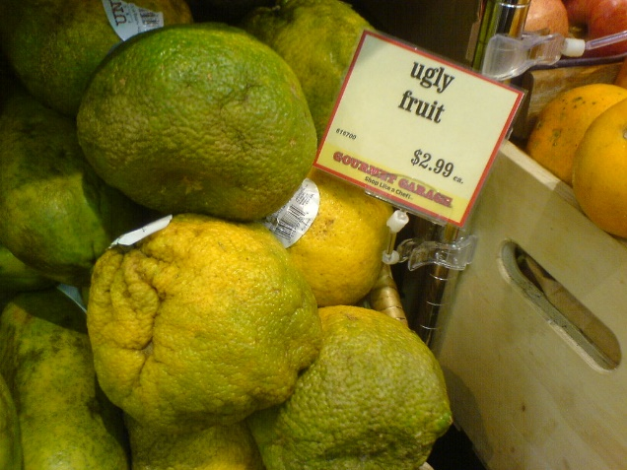 | 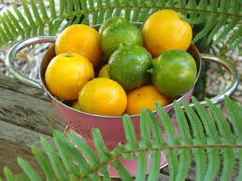
Image: ‘Ugly fruit’ by gromgull. Licensed CC BY 2.0, available at https://www.flickr.com/photos/gromgull/2368612544 | Image: ‘Mixed calamondin-calamansi’ by Calamondin laurie.  Licensed CC BY-SA 3.0, available at https://commons.wikimedia.org/wiki/File:Mixed_Calamondin-Calamansi.jpg

What are the similarities and differences between the two versions of fruit pictured above?
Consider:
- the characteristics of the fruit
- the production process and supply chain
- the factors that may affect demand and supply.

Your task: Fieldwork
Visit your local supermarket or farmers’ market to compare the prices for ‘imperfect’ and ‘perfect’ produce. Alternatively, use online shopping sites to locate the information.
Fruit or vegetable | Price per kilo
 | Imperfect | Perfect
carrots | $1.33 | $2.00
Tomatoes | $4.50 | $4.70 - $6.70

Conclusions
What did you learn from your investigation?

Where is the imperfect produce located in the store you visited?

What could businesses do to increase demand for imperfect produce?

What will happen to the price of imperfect produce if the supply increases but demand stays the same? ________________________________________________________________________

What will happen to the price of imperfect produce if the supply decreases but demand stays the same? ________________________________________________________________________

What will happen to the price of imperfect produce if the supply stays the same but demand increases? _____________________________________________________________________
What will happen to the price of imperfect produce if the supply stays the same but demand decreases? ____________________________________________________________________

Student Worksheet 10.1

From farm to café
From farm… | … to café
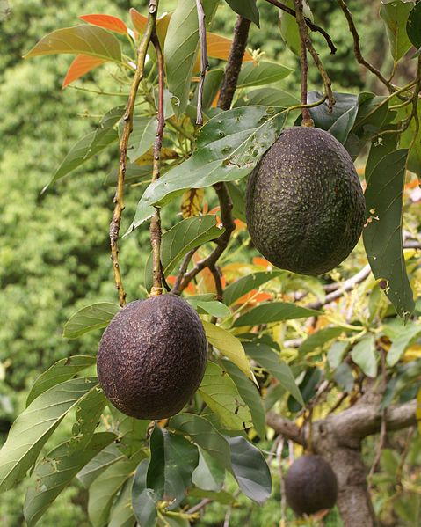 | 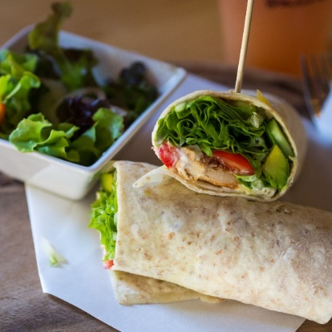
Image: ‘Persea americana fruit’ by B Navez. Licensed CC BY-SA 3.0, available at https://commons.wikimedia.org/wiki/File:Persea_americana_fruit_2.JPG | Image: ‘Smoked chicken and avocado wrap’ by Takeaway. Licensed CC BY-SA 3.0, available at  https://commons.wikimedia.org/wiki/File:Smoked_chicken_and_avocado_wrap.jpg

Scenario
You own a cafe in your local town and offer three menu items that contain avocado.

- Chicken and salad wrap $14
- Smashed avocado on sour dough $15 with poached egg $18
- B.L.A.T. wrap or roll $15 with chicken $20

The price of each item covers the cost of production and contributes to profit for the business owner.

Problem
Avocado prices have recently risen from $1.50 to $4.00 per avocado.

How can you keep all three items on the menu for the same price and maintain your profit margin?

Possible solutions

Other factors
You need half an avocado for each menu item.

There is a 30% mark up on menu items to cover the costs of the business and generate profit.

Student Worksheet 11.1

Plan your canteen menu
The school canteen management need your help to prepare a seasonal menu suitable for the students at your school. They want you to use local produce in as many menu items as possible.

Your task

- Find out what produce is available in your region, using the:
food map on the Department of Primary Industries and Regional Development website <https://www.agric.wa.gov.au/where-food-produced-western-australia-food-map>
‘In Season Now’ information on the Buy West Eat Best website <https://www.buywesteatbest.org.au/eat-local/in-season-now/>.

- Plan a lunch menu for the current season. Your menu should have at least 10 items.

- Select one item and determine a suitable price, using the following methods:

- Cost price plus a 30% margin:
You will need to work out the cost of all the raw ingredients required to produce the item, then add 30% to cover costs such as labour and electricity.

- Competition pricing methods:
You can look at canteen menus from other schools to find out how much they charge, and then use a similar price.

- Value pricing
This is based on what customers think your product is worth. Survey your class / year group / school population to find out what they are prepared to pay for your item.

- Compare the three prices you have worked out and decide which one you will use and why.

- Present your idea to the class.

Student worksheet 12.1

Entrepreneurs
Entrepreneurs are the people who combine the factors of production and produce goods or services. Some are more famous than others. You may recognise the names of the people in the table below. Name the company they own and jot down details you know.

Name | Company | What do you know about them or their companies?
Walt Disney

Simon Cowell

Richard Branson

Elon Musk

Marc Zuckerberg

Gina Rhinehart

Oprah Winfrey

JK Rowling

Disney Harpo Facebook Pottermore Publishing Virgin
Tesla And Space X Syco Entertainment Hancock Prospecting

- Have you heard of these companies before?
- Why are they familiar to you?
- What do they contribute society?

- Entrepreneurs are not always famous. Describe an entrepreneur that you know.

Student Worksheet 12.2

Characteristics of entrepreneurs
Regardless of the type of company they own, the goods or services they produce or the amount of money they make, entrepreneurs share many characteristics.
What do you think the characteristics of an entrepreneur might be?
Think  List your own ideas | Pair  Add new ideas after discussing with your ‘shoulder partner’ | Share  Add new ideas after discussing as a class

Using the information from the discussion above, create a Y-chart to identify what you think it is like to be an entrepreneur.

Feels like…
Success Hard work Enjoyment

Looks like…
Long hours Many skills Trying hard

Sounds like…
Sharing ideas A sigh of relief

Student worksheet 13.1

Character Corners
Based on the information your teacher has provided, respond to the following:
- From the four to six examples provided, name the entrepreneur you would like to meet and state why.

- From the information provided, describe the entrepreneur.

- Formulate two questions that you would like to ask this entrepreneur.

TASK: Move into groups of three to five students who have chosen the same entrepreneur as you.
Compare your responses and describe the characteristics the entrepreneur has demonstrated.
Record ideas in the space below.

Student worksheet 14.1

Agricultural innovation and invention
Before colonisation, First Australians developed many innovative farming and food gathering methods and technologies to assist in food collection. In the table below, describe the farming and food production techniques that First Australians used. Think about the purpose of each tool and how it assisted food collection.
Boomerang | Coolamons
 | 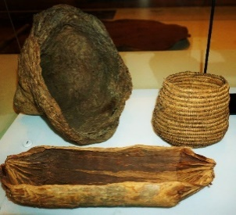
Image: available at: https://pixabay.com/vectors/boomerang-aboriginal-australia-wood-151561/ | Image: ‘Australian Museum’ by Gordon Makryllos. Licensed CC BY-SA 4.0, available at  https://commons.wikimedia.org/wiki/File:Australian_Museum_-_Joy_of_Museums_-_Coolamons_-_Aboriginal_Carrying_Vessels.jpg
Fish traps | Spears
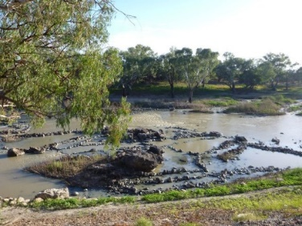 | 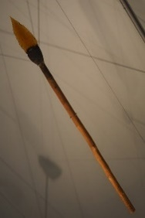
Image: by B Hanna, available at https://www.environment.nsw.gov.au/maritimeheritageapp/resources/Heritage/ shi/505/5051305b2.jpg | Image: ‘Effet boomerang’ by Rama. Licensed CC BY-SA 4.0, available at https://commons.wikimedia.org/wiki/File:Effet_boomerang-P8190505.JPG

The article ‘Agricultural innovation and food production’ on the IP (Intellectual Property) Australia website <https://www.ipaustralia.gov.au/about-us/news-and-community/blog/agricultural-innovation-and-food-production> briefly summarises the history of agricultural innovation in Australia. Read the article and complete the table below.
Heading | Main Points | Questions I now have
Indigenous innovations
Colonial experimentation
Engineering ingenuity
From pest control to food science and digital agriculture

Prepare an annotated timeline to show the innovations in agriculture before and after colonisation.

Student worksheet 15.1

Think big challenge

‘AGRICULTURAL ENTREPRENEURSHIP CHALLENGE’.

The Agricultural Entrepreneurship Challenge provides an opportunity for individuals or groups to present a new invention or an innovative idea to improve practices along the primary industry supply chain.

- Research an aspect of the primary industry supply chain to determine current practice and the contribution it makes to the WA economy.

- Develop an invention or innovation that improves practice or adds value to the industry in one or more of the following areas:
- production
- processing
- distribution
- storing
- preserving
- packaging
- reducing waste

- Prepare a presentation for the class that includes:
- a brief summary of your research
- a diagram or model of your invention/innovation
- a description of how your idea benefits the business, the environment and/or society.

Student worksheet 16.1

Body map
PREPARE a BODY MAP to summarise what you have learnt about being an ENTREPRENEUR.
Your Body map must include:
Head: What does an entrepreneur think or say? What ideas do they have?
Dialogue bubble: What would an entrepreneur tell you about their experiences?
Chest/heart: What does an entrepreneur feel?
Hands/arms: What does an entrepreneur do?
Shoulders: What are the responsibilities of an entrepreneur?
Feet/legs: Where is the entrepreneur going in the future?

