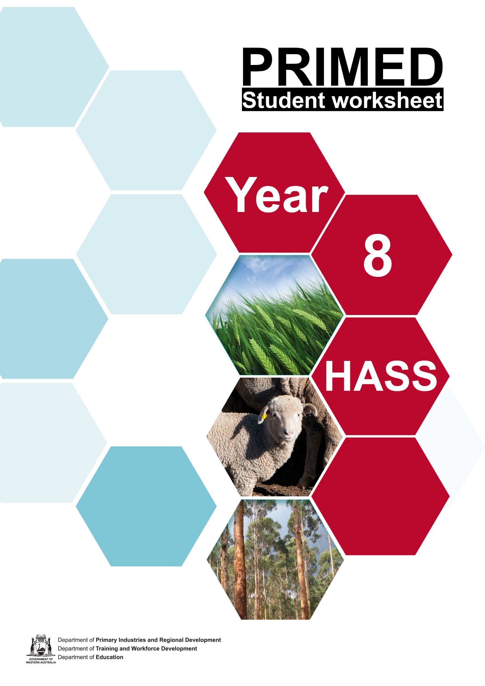

Student worksheet 1.1
PRIMED

Introduction: Types of businesses
In the space provided, list the names of all the businesses you know. It could be a shop in your local area, a business you have seen advertised or a multinational company you have heard of.

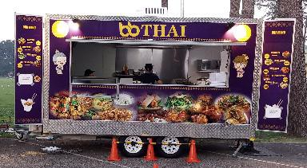
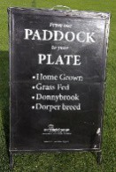

Student worksheet 2.1

Survey – the most common type of business structure
Visit your local shopping area, industrial area or main street to determine the most common type of business found. Collect data regarding (at least) 10 businesses. You can use google maps, or similar, to conduct a virtual survey.

Name of business | Goods/services provided | Business activity  (primary, secondary or tertiary) |  |  | Business structure  (sole trader, partnership, company, cooperative, multinational, trust)
 |  | Primary | Secondary | Tertiary | Sole trader | Partnership | Company | Cooperative | MNC | Trust | Unsure

Total number of businesses

Student worksheet 3.1

Business structures in Australia
Using your textbook and internet sources, complete the following table. Read the scenario and select the type of business structure you would recommend. Outline the advantages and disadvantages of the business structure you have suggested.

Scenario | Type of business structure | Advantages | Disadvantages
Sanjiya wants to set up a small business to sell honey that her partner produces on their property. She wants to make all the decisions herself and keep all the profit.
Georgia wants to set up a hamburger business but she doesn’t want to compete with well-known brands. She has a limited amount of money to invest.
A group of 6 farmers, committed to regenerative farming practices, want to share resources, knowledge and infrastructure in order to sell their products to the broader community. They all want to contribute to the running of the business.
Wyatt wants to set up a new milk processing plant in the SW of WA. He anticipates that it could become a very valuable business. He wants to register the business as a separate entity.
Jian wants to set up a business that his children will benefit from in the future.

Student worksheet 4.1

CBH case study
Using the information provided and the CBH Group website, explain how CBH address the advantages and disadvantages of a cooperative business structure.

ADVANTAGES | How much does it cost to register?
 | How do members participate in the co-operative?
 | When do General Meetings occur? What do members vote for?
 | Are there any members under the age of 18? If so, what is their contribution?
DISADVANTAGES | How does CBH attract potential members?
 | Does CBH generate profits for the cooperative or its members?
 | What education programs are available for members?
 | How much does it cost to provide ongoing education programs for members?

COOPERATIVE BULK HANDLING (CBH)
COOPERATIVES – A CASE STUDY

1920 – 1950
COOPERATIVE PRINCIPLES
CBH supports the following cooperative principles:
- Voluntary and open membership
- Democratic member control
- Member economic participation
- Autonomy and independence
- Education, training and information
- Cooperation among cooperatives
- Concern for the community
- Founded during the Great Depression on 5th April 1933
- Based on the principle of one member – one vote
- 42,565 tonnes of wheat received in the first year
- By 1943, control of company handed to growers

1950 – 1980
- 1955 – all grain port facilities under CBH control and management
- 1960s - system expanded to include 300 receival points

1980 – 2010
- 1989 – deregulation of grain market, CBH lose sole handling rights
- 2002 – CBH and Grain Pool of WA merge
- 2004 – CBH partnered with Salim Group to for Pacific Agrifoods (Interflour)
- 2007 – granted a licence to export wheat
- 2008 – bulk wheat exports deregulated
MEMBERSHIP
CBH Membership provides access to substantial savings in the storage, handling and transport of grain.

CBH Membership provides access to mordern infrastructure and a cost efficient network.

2010 – Today
- WA exports to over 20 countries
- 4 200 grower members
- 197 sites
- Four ports
- Investments in trains and flour mills
- Integrated supply chain

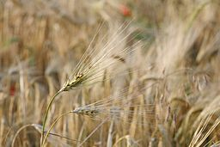
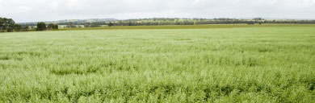
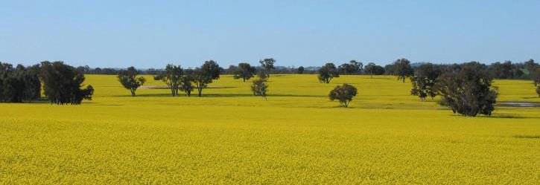

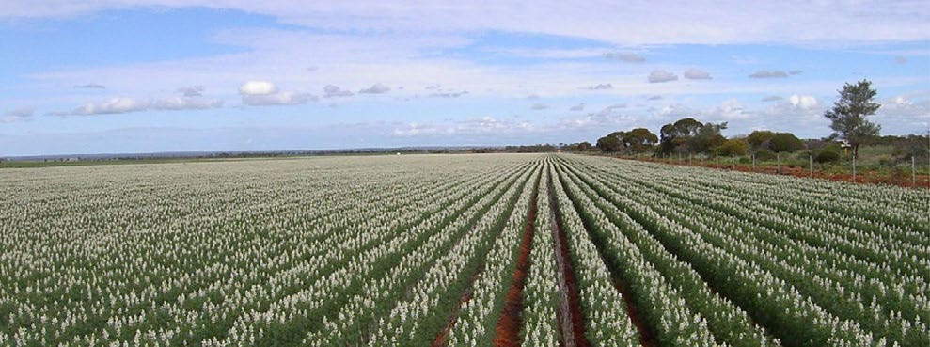
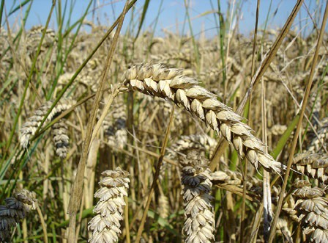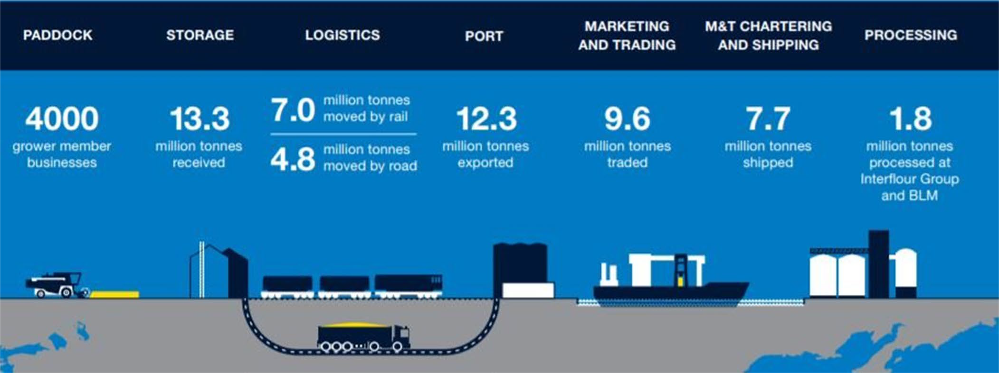Information and images from: https://www.cbh.com.au
COMMODITIES AND PRODUCTS
The CBH Group acquire and export:
- Wheat
- Barley
- Canola
- Lupins
- Oats
STRUCTURE

VALUES
CBH values:

- Sustainability
- Simplicity
- Commitment
- Courage
- Collaboration

Student worksheet 5.1
Connect Extend Challenge

CONNECT: What is most common business structure in your local area?
EXTEND: What are some of the similarities/differences between business structures?

CHALLENGE: What is an alternative business structure that could work for CBH? Give reasons for your answer.

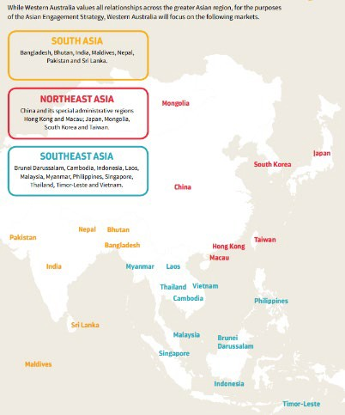
Student worksheet 6.1

Business opportunities

Imagine you own a premium food or beverage business in your local region and wanted to expand.
Jot down some ideas that will help you to increase your sales in each region.
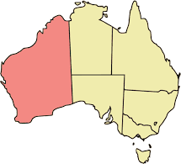

1) Selling your product throughout Western Australia
e.g. visit local shopping centres and give away free samples

2) Selling your product throughout Australia
e.g. convincing service stations to stock your product

3) Selling your product overseas
e.g. pay an ‘influencer’ to promote your product

openclipart.org

Student worksheet 7.1

Target market – Asia
The Department of Primary Industries and Regional Development (DPIRD) website provides the following information regarding The Asian Market Success Project:

In 2015-16, the (now) DPIRD commenced a three-year, $6 million Asian Market Success project funded by the State Government's Royalties for Regions program. The project provided WA agrifood businesses with the confidence to invest in accessing and developing high value, premium export markets in Asia.

The future of the WA agrifood sector is highly dependent on exporting. The Asian Market Success project provides assistance to WA agrifood businesses so that they are internationally competitive and therefore able to capture Asia’s high value, premium export markets.

Watch the video (https://youtu.be/ADf44tWuSNY ) and complete the table below:

WHO? | WHAT?
WHY? | WHERE?
WHEN? | HOW?
Suggest how the following groups benefit from this project.

WA business owners | WA Government | Asian customers

Student worksheet 8.1

Government and business
The Value Add Agribusiness Investment Attraction Fund (VAAIAF) aims to support businesses to invest in new projects or expansion opportunities in WA, which will build competitiveness, adopt innovative technologies and grow their operations.

Using information from the links provided by your teacher, and the websites of each company, complete the following table:

Business name | Products | Location | Target market | How the funds were used | Benefits to the company and/or community
Abrolhos Octopus
Lucky Bay Brewing
The Lakehouse Denmark

Ocean Grown Abalone
Ryan’s Quality Meats
Albany Sardines
Rok Kombucha
Handasyde Strawberries

https://www.agric.wa.gov.au/industry-development/value-add-agribusiness-investment-attraction-fund

What questions do you now have?

Student worksheet 9.1

Investigation
Your task is to:

- Determine the current target market for a West Australian food or beverage business.

- Decide which Actions from ‘Western Australia’s Asian Engagement Strategy, Our Future with Asia, Summary 2019-2030’ would assist the business to access new target markets.

- Present your findings to the class.

Step 1
Select a business and complete the following table:

Name of the business:
Locations
Number of employees
Products or services produced
Intended target market
Competitors

Step 2
Identify the Actions from ‘Western Australia’s Asian Engagement Strategy, Our Future with Asia, Summary 2019-2030.’ that would assist this business.

Step 3
Present your findings and suggestions to the class

Student worksheet 10.1

Persuasive writing planning
Argue for or against the proposition:

The WA government should help West Australian businesses respond to opportunities in the local, national and international markets.
Plan your response below:

Thesis/argument
Reason 1 | Details | Evidence
Reason 2 | Details | Evidence
Reason 3 | Details | Evidence
Conclusion

Student worksheet 11.1

Technology and work
Before viewing the video, complete the first part of the table.

SEE  What technology is being used in YOUR classroom by the students and the teacher? | THINK  What do you think was used prior to each technology being available? How has technology influenced how teachers and students work? | WONDER  How might ‘work’ change in the future for students and teachers?
SEE  List examples of technology you see in the video. | THINK  How have these examples influenced the way people work? | WONDER  How might technology change the way farmers work in the future?

PRIMED

Student worksheet 12.1

A range of technologies
After viewing each video, complete the table below.

Example | Plus | Minus | Ideas
Egg farming – Controlled sheds
Cattle –
Robots in the paddock
Leaf products – Modular farms
Cattle – Microchips
Intensive farming – Drones for pest control

PRIMED

Student worksheet 14.1

Research – technology in agriculture

I already know…
TASK:

Investigate how technology has impacted workers in primary industry.

The technology I have chosen is…

I want to know…

I learnt…

PRIMED

Student worksheet 15.1

Farming - before and after
Select three of the technologies discussed in class and describe the work of farmers before the technology was introduced and after the technology was introduced.

THE TECHNOLOGY | BEFORE | AFTER | IMPACT
Remote cameras | Farmers drove around the farm to visit each trough to see if there was enough water and also see the flock. | Can check water supplies and stock on the phone or computer. | Positive impact - Gives more time for other jobs, saves in fuel costs.

