Information sheet
How to create a climate graph using BOM data
Step 1) Use the link to access the Bureau Of Meteorology Climate Data Online
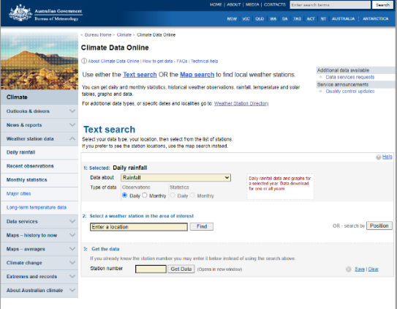
Step 2) Choose the location using the Text search option.
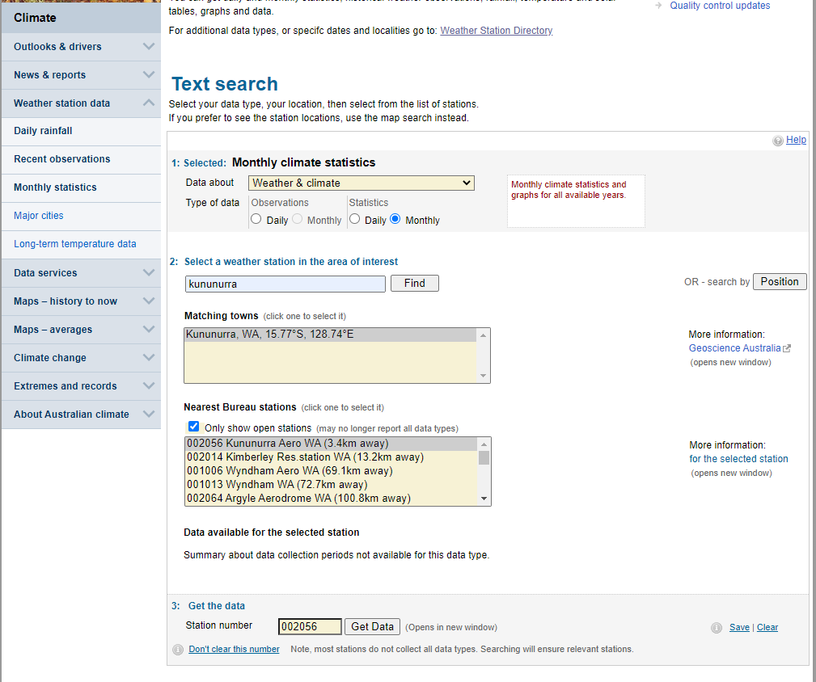
Step 3) Click on the Get Data tab – the climate statistics will open in a new tab.
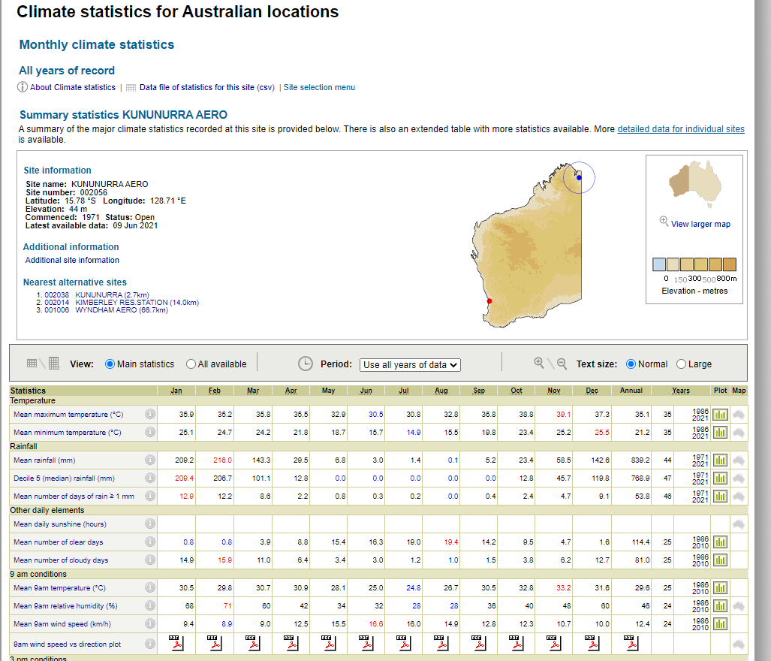
Step 4) click on the Plot column to create a graph of the element chosen (such as maximum temperature).
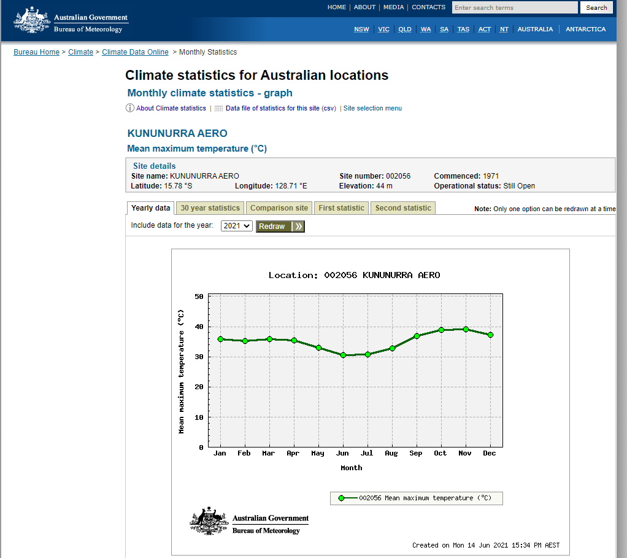
Step 5) Select second statistic, for example, rainfall and mean rainfall then select redraw.
The final graph as below.
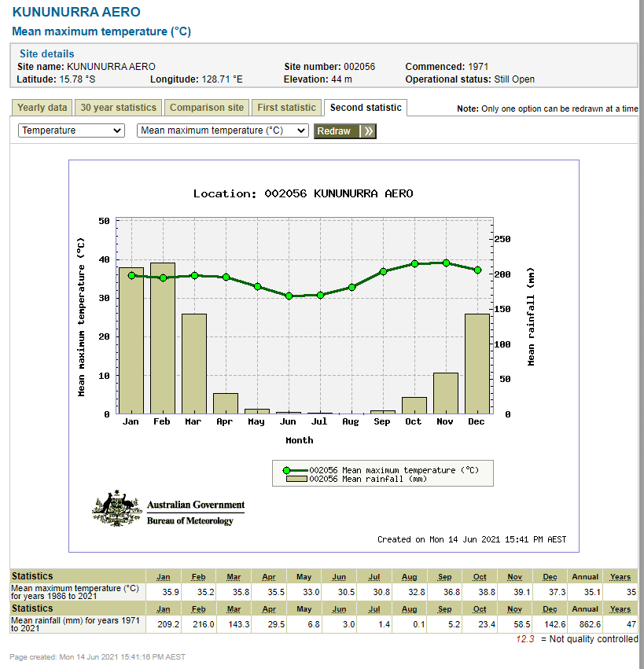

Acknowledgements

Reference
Australian Government Bureau of Meteorology (n.d) ‘Climate Data Online’ available at <http://www.bom.gov.au/climate/data/index.shtml> accessed on 15 July 2021

