Information sheet

Managing dryland salinity in south-west Western Australia
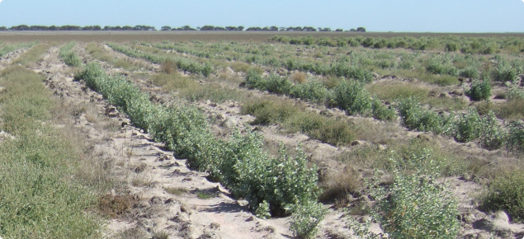
Image 1: Managing dryland salinity in south-west Western Australia
As stated on the Department of Primary Industry and Regional Development (DPIRD) website, managing dryland salinity provides many benefits, including increased productivity, reduced land degradation and protection of the landscape.
Managing salinity – options
- No active management
- Natural vegetation regeneration to protect ground from wind and water erosion
- Suitable for small areas
- Little or no cost involved
- Slow process
- Erosion risk is high
- Salt build up and spread is likely
- Use engineering options
- Dependent on the option and site
- Solutions work for many years
- Can capture water sources
- Requires extensive site assessment and detailed technical planning
- Expensive to implement, remove or change
- Discharge may cause problems
Engineering solutions can be used for surface water management or subsurface water management.
Surface water management | Subsurface water management
Grade banks  Broad based banks  Farm dams  Roaded catchments  Grassed waterways  Shallow reef basins  Evaporation basins | Open deep drains  Leveed deep drains  Pumping ground water  Desalination of ground water  Siphoning groundwater  Relief wells or bores  Evaporation basins

- Plant based options
- Does not have effluent discharge
- Can have commercial products
- Can change land use easily
- Requires good management
- Need to monitor salinity levels and impact on vegetation
Plant based options are used to adapt systems, prevent or contain salinity.
Adaptation | Prevention | Containment
- Saltland pastures  - Salt tolerant shrubs and trees | - Deep rooted nonsaline perennial pastures  - Salt tolerant shrubs and trees | - Deep rooted nonsaline perennial pastures  - Salt tolerant shrubs and trees

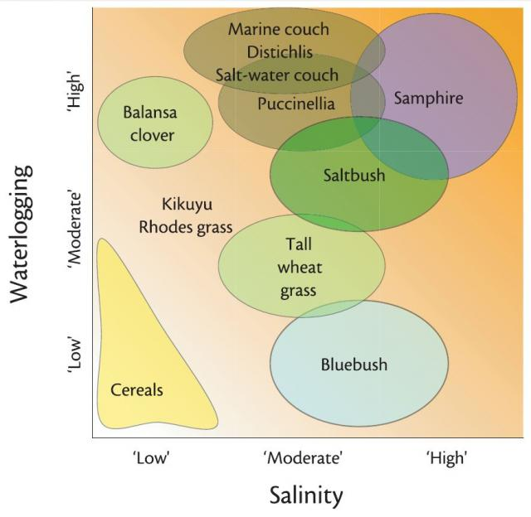
Image 2: Saltland pastures in Western Australia

- Innovative options
- Inland saline aquaculture
- Harvesting salt and minerals
- Energy production
- Desalination

Detailed information regarding these solutions can be found at: Managing dryland salinity in south-west Western Australia

Acknowledgement

References
Department of Primary Industries and Regional Development (11 May 2021) ‘Managing dryland salinity in south-west Western Australia’ available at <https://www.agric.wa.gov.au/soil-salinity/managing-dryland-salinity-south-west-western-australia> accessed on 10 August 2021

Images
Image 1 Department of Primary Industries and Regional Development (11 May 2021) ‘Managing dryland salinity in south-west Western Australia’ available at <https://www.agric.wa.gov.au/soil-salinity/managing-dryland-salinity-south-west-western-australia> accessed on 10 August 2021

Image 2 Department of Primary Industries and Regional Development (17 May 2021) ‘Saltland Pastures in Western Australia’ available at <https://www.agric.wa.gov.au/soil-salinity/saltland-pastures-western-australia> accessed on 10 August 2021

