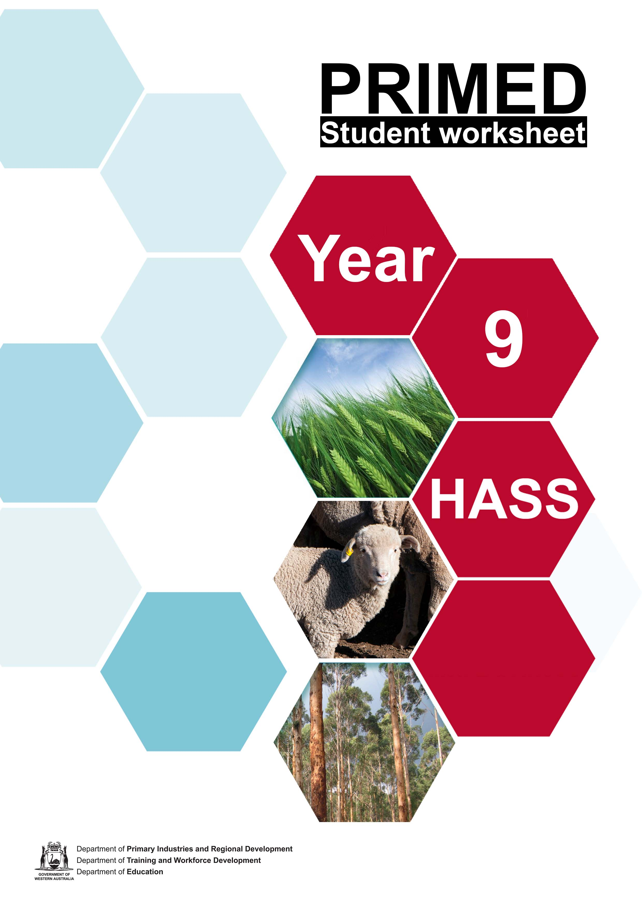

Student worksheet 3.1
Cooperative learning jigsaw template 1: Expert group

1. My expert group task is… | 3. What do we need to find out? | 5. What we learnt and the main points to share with our home group.
2. What do we already know? | 4. How can we share this information with our home group?

Cooperative learning jigsaw template 2: Home group

Natural vegetation and no grazing | Engineering options - Surface water management | Engineering options - Managing Subsurface water management
Innovative solutions – Groundwater desalination | Plant based solutions – Saltland pastures | Plant based solutions – Perennial pastures

Acknowledgement

References
Department of Primary Industries and Regional Development (4 May 2021) ‘Managing dryland salinity: natural revegetation and no grazing’ available at <https://www.agric.wa.gov.au/soil-salinity/managing-dryland-salinity-natural-revegetation-and-no-grazing> accessed on 15 June 2021
Department of Primary Industries and Regional Development (13 May 2021) ‘Surface water management in Western Australia’ available at
<https://www.agric.wa.gov.au/water-erosion/surface-water-management-western-australia> accessed on 15 June 2021
Department of Primary Industries and Regional Development (18 May 2021) ‘Managing subsurface water in Western Australia’ available at
<https://www.agric.wa.gov.au/soil-salinity/managing-subsurface-water-western-australia> accessed on 15 June 2021
Department of Primary Industries and Regional Development (23 March 2021) ‘Groundwater desalination on farms in Western Australia’ available at
<https://www.agric.wa.gov.au/water-management/groundwater-desalination-farms-western-australia> accessed on 15 June 2021
Department of Primary Industries and Regional Development (17 May 2021) ‘Saltland pastures in Western Australia’ available at
<https://www.agric.wa.gov.au/soil-salinity/saltland-pastures-western-australia> accessed on 15 June 2021
Department of Primary Industries and Regional Development (16 May 2021) ‘Perennial pastures for Western Australia’ available at
<https://www.agric.wa.gov.au/pasture-establishment/perennial-pastures-western-australia> accessed on 15 June 2021

Student worksheet 3.2

Saline bush tucker
Examine the information regarding the ‘National Landcare Program Bush Tucker Project’ on the following website Bush Tucker Project - Katanning Landcare to complete the ICON prompt below.

☺ Who stands to gain? | ☹ Who stands to lose?
$ What are the financial issues? | ? What are the unanswered questions and issues?

Discussion: Would a program such as this be suitable for the region where you live? Why/Why not?

Acknowledgement

References
Katanning Landcare (n.d) ‘National Landcare Program Bush Tucker Project’ available at <https://katanninglandcare.org.au/nlpbushtucker/#collapse- 1-4801> accessed on 15 June 2021

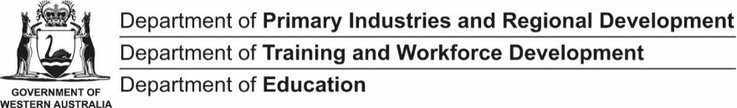

Student worksheet 4.1

Truffle industry compass
The NE, SE, SW and NW points can be used to discuss the overlap between factors. For example, how economic decisions (business profit) might impact people’s lives or the natural environment.
N = Natural environment/ecological questions E = Economic questions
S = Social and cultural questions

W = Who decides? Who benefits? (political questions)
N

W E

S

Student worksheet 5.1

Altered biomes
For the three examples provided, identify the changes to the landscapes due to the production of food and fibre.

Without agriculture | With agriculture | Changes to vegetation | Changes to soil | Changes to land use
Kimberley – savanna woodlands  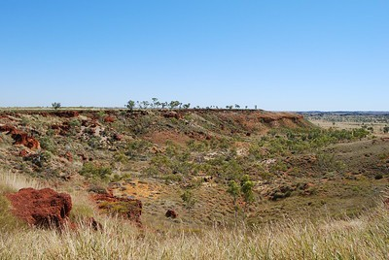  Image 5.1.1 | 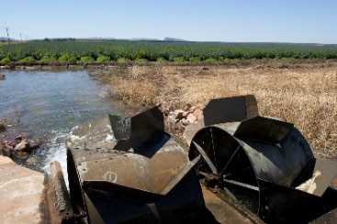  Image 5.1.2
Pilbara – spinifex grassland  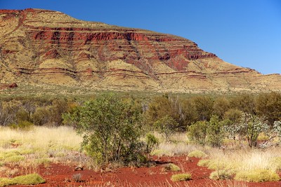  Image 5.1.3 | 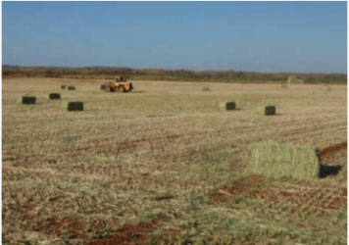  Image 5.1.4
Gascoyne – low forest and woodland  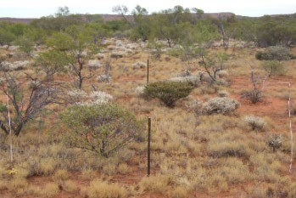  Image 5.1.5 | 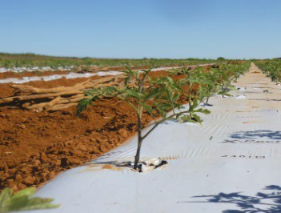  Image 5.1.6

Student worksheet 5.1

Altered biomes
For the three examples provided, discuss the consequences of altering biomes for food and fibre production. Consider the geographical concepts in your response.

Without agriculture | With agriculture | Space | Place | Interconnections | Change | Scale
Kimberley – savanna woodlands  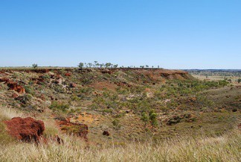  Image 5.1.1 | 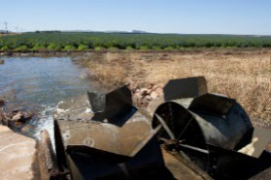  Image 5.1.2
Pilbara – spinifex grassland  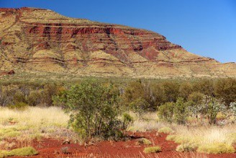  Image 5.1.3 | 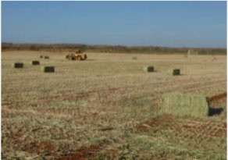  Image 5.1.4
Gascoyne – low forest and woodland  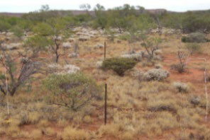  Image 5.1.5 | 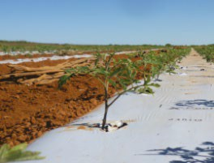  Image 5.1.6

Acknowledgement

Images
    - Tapson, N ‘Savanna Woodland Kimberley’ Licenced CC BY-NC-SA 2.0 available at
<https://www.flickr.com/photos/40325561@N04/5952709456> accessed on 15 June 2021
    - Department of Regional Development and Industry ‘Ord River development and irrigated agriculture, Western Australia’ available at
<https://www.agric.wa.gov.au/assessment-agricultural-expansion/ord-river-development-and-irrigated-agriculture-western-australia> accessed on 15 June 2021
    - Julie Burgher ‘Punurrunha’ Flickr. Licenced CC BY-NC-2.0 available at <https://www.flickr.com/photos/sunphlo/13054932145> accessed on 15 June 2021
    - Department of Primary Industries and Regional Development ‘Growing the Pilbara – A prefeasibility assessment of the potential for irrigated agriculture development’ available <https://www.agric.wa.gov.au/sites/gateway/files/DPIRD_Growing%20the%20Pilbara.pdf> [PDF 7,739 KB] accessed on 15 June 2021
    - Department of Regional Development and Industry ‘Rangeland inventory and condition survey in the Carnarvon Basin, Western Australia’ available at <https://www.agric.wa.gov.au/rangelands/rangeland-inventory-and-condition-survey-carnarvon-basin-western-australia> accessed on 15 June 2021
    - Department of Regional Development and Industry ‘Farmnote- Irrigating tomatoes in Carnarvon’ available at < https://www.agric.wa.gov.au/sites/gateway/files/Farmnote%20-%20Irrigating%20tomatoes.pdf> [PDF 4,443] accessed on 15 June 2021

Student worksheet 6.1

Food and fibre in Western Australia

Features | My region (region 1) | Region 2 | Region 3
What are the main towns in the region?
What is the size of the region in km²?
What is the most common land use in this region?
Which sector employs the most people?
What is produced in the agriculture sector?
What is produced in the fisheries sector?
What is produced in the forestry sector?
Three things I have learnt:
1.
2.
3.

Three questions I now have:
1.
2.
3.

Student worksheet 19.1

Message box

PROBLEMS?

ISSUE
BENEFITS?
SO WHAT?

SOLUTIONS?

Student worksheet 20.1
Three Ws

WHAT  (did I learn…) | About future food security? | About possible solutions for food security? | About what’s happening in Western Australia (WA)?
SO WHAT  (why is it…) | Relevant to me? | Relevant to WA? | Relevant to Australia/ the world?
NOW WHAT  (how can…) | I make a difference? | The WA Government make a difference? | Global organisations make a difference?

