Teacher resource

One-pager
One-pager instructions
A One-pager is a written or typed graphic interpretation, on a single sheet of paper, demonstrating what students have learnt from a topic. It may include dot points, diagrams and other elements that summarise the topic.
Guidelines:
- Fill the entire page.
- Use colour where possible
- Include the following:-
  - Headings and subheadings
  - The meaning of any key words in the text
  - Include a picture to show what you have learnt
  - Write 5 quiz questions (and answers)
  - Write a newspaper headline to summarise the topic
  - Tweet what you have learnt in 140 characters
  - Complete the following: Today I learnt……

A one-pager can be designed by students, created using digital tools such as PowerPoint or follow a template provided by the teacher.
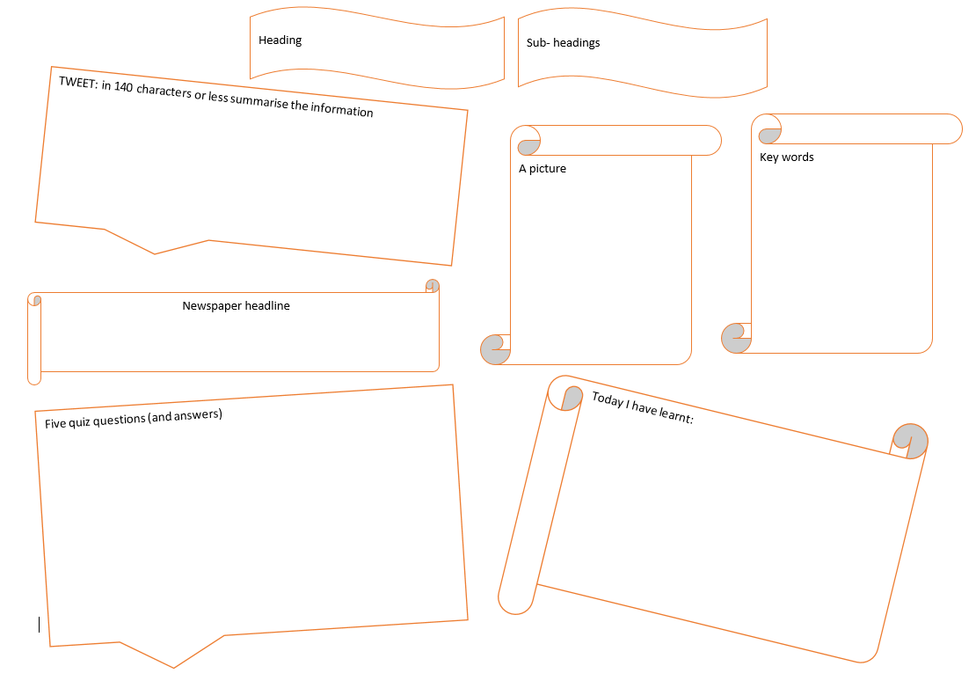
An example of a template.
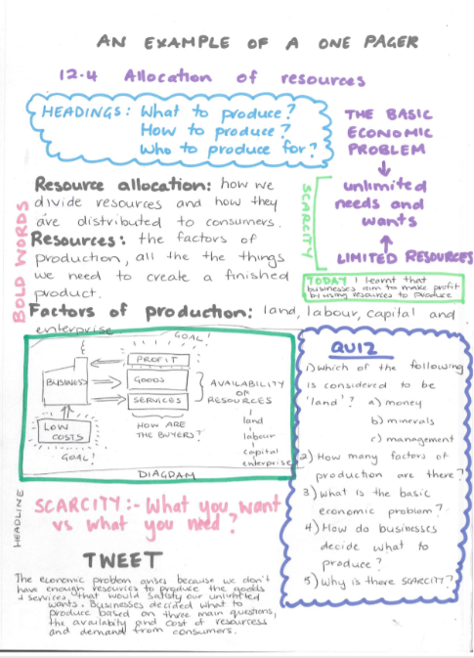
An example of a hand written, student designed one-pager summarising a section of a textbook.

