Information sheet

Primary Industry Plan 2020 - 2024 Strategic theme 2

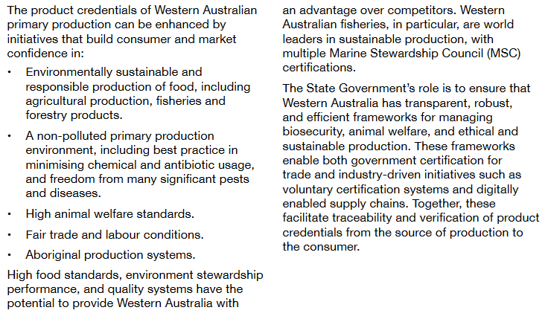

Acknowledgements

References
Department of Primary Industries Regional Development (2020) ‘Primary Industries Plan 2020-2024’ available at: <https://www.wa.gov.au/sites/default/files/2020-12/Primary-Industries-Plan-2020-24.pdf> [PDF 10.6 MB] accessed 9 August 2021

