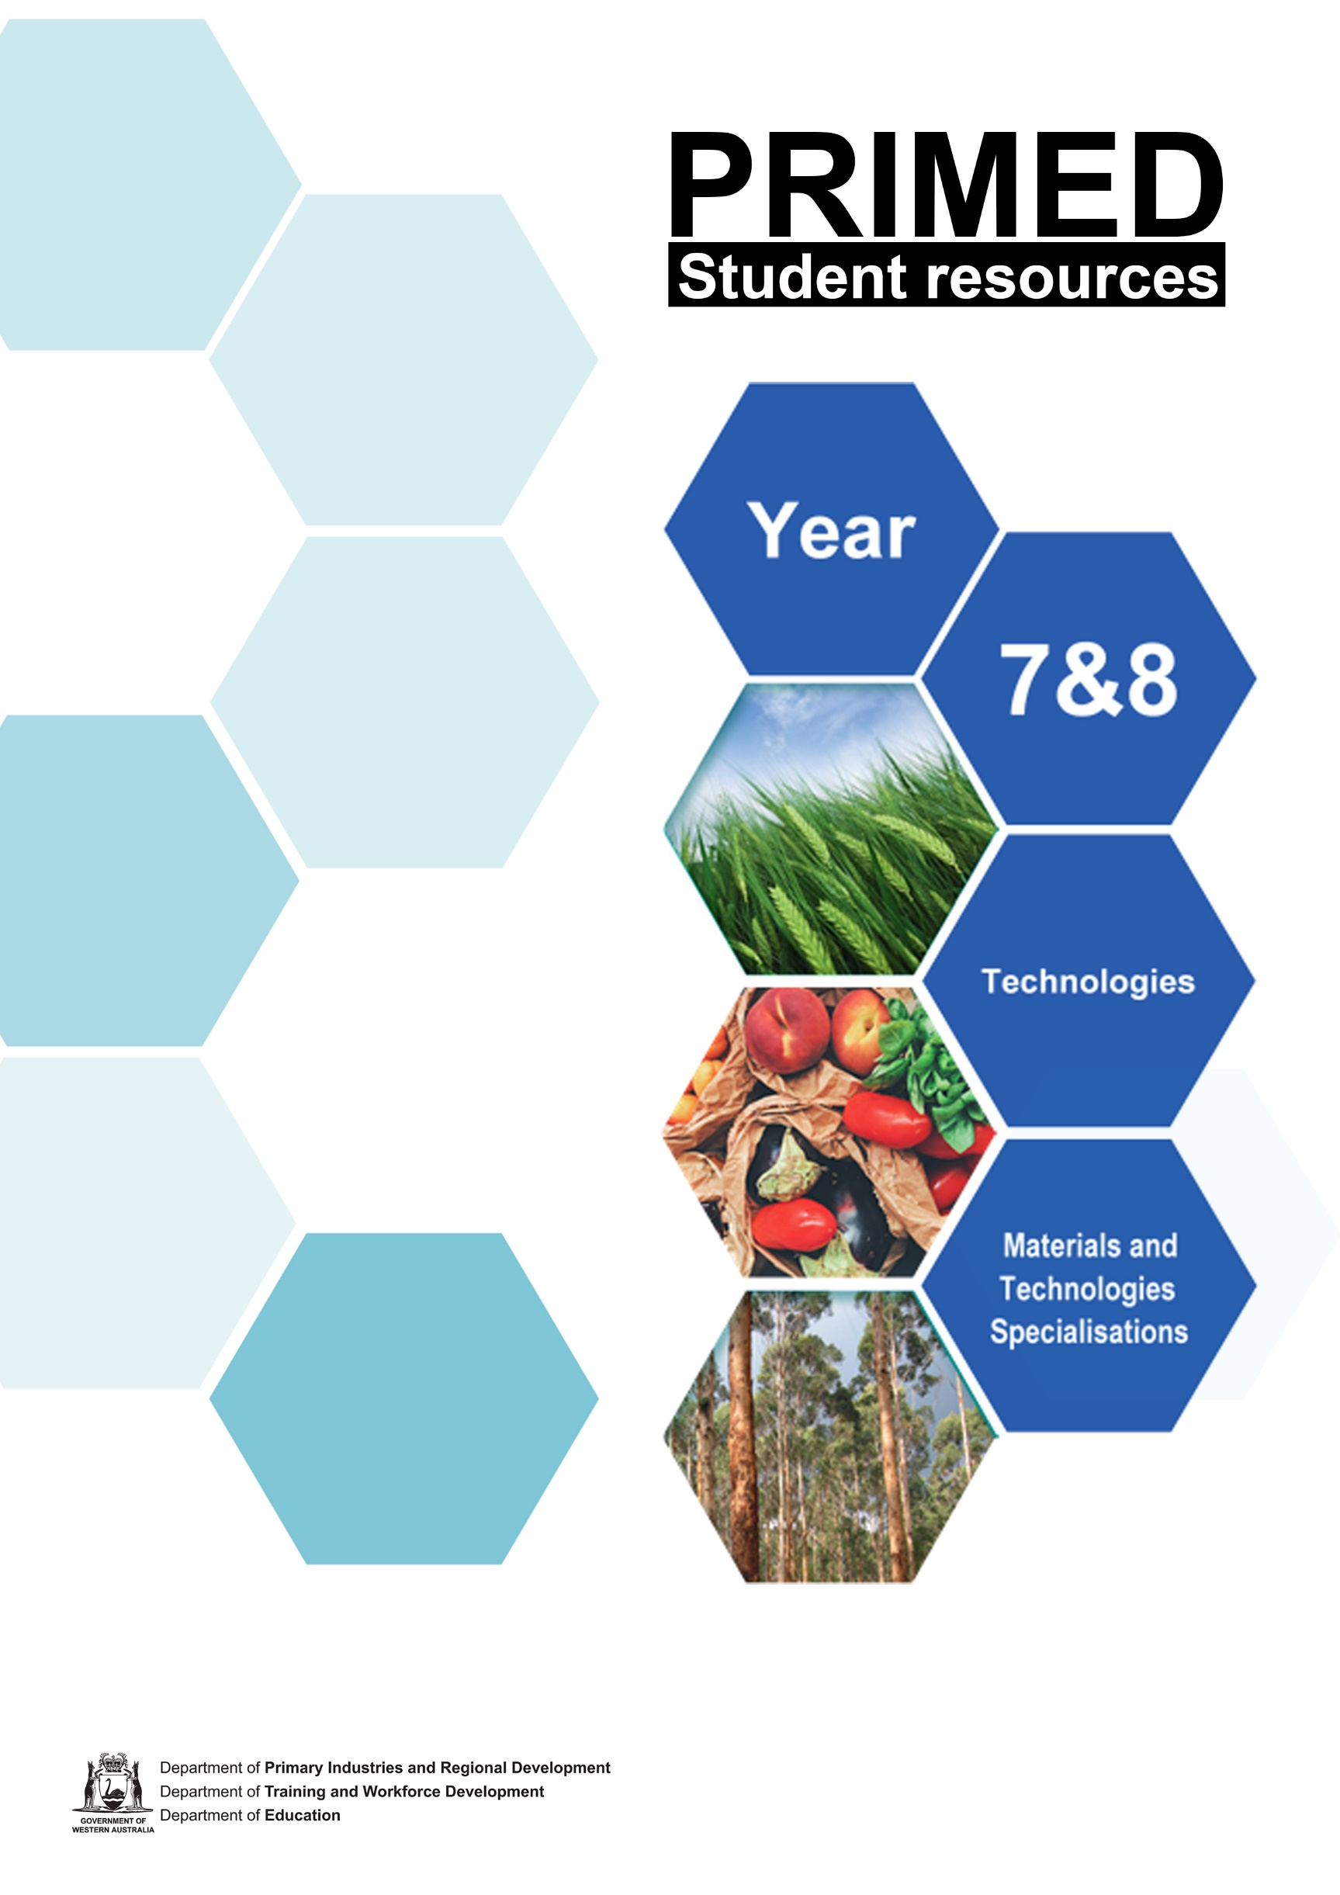

Student resource 1.1

Timeline of the Western Australian timber industry
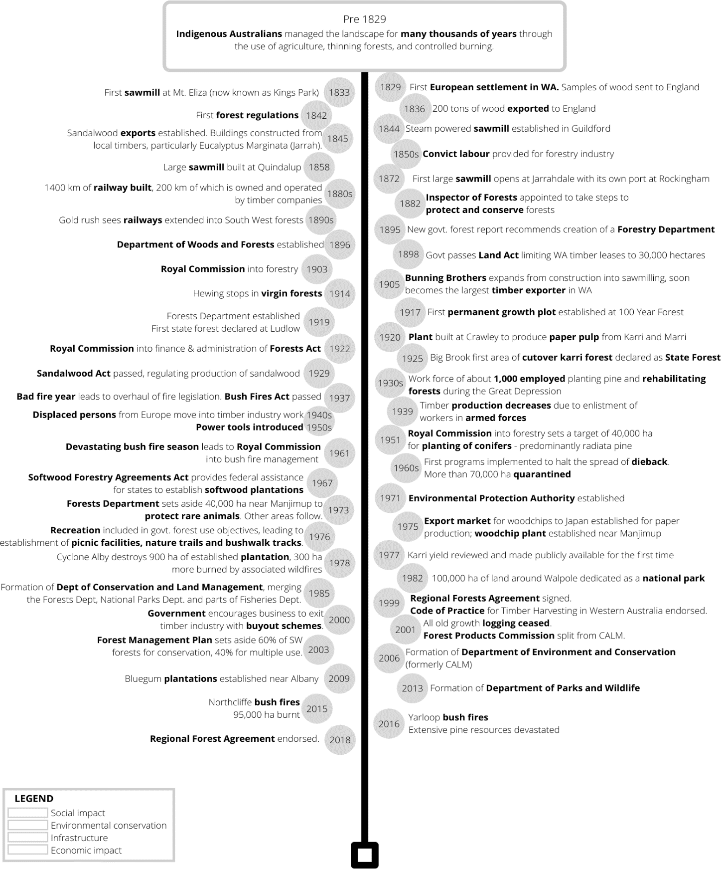

References
Forest Industries Federation (WA) Inc. Welcome Mat ‘The guided tour’ available at:
<https://welcomemat.fifwa.asn.au/guidedtour.html> accessed 11 June 2021

Student resource 2.1

Properties of timber species

 | Strength | Hardness | Durability | Stability | Growth rate | Aesthetics
Bluegum  Eucalyptus globulus | Very high | Very hard | High  Rot resistant  Susceptible to insect attack | Good | Fast | Pale yellow-brown. Attractive grain patterns
Jarrah  Eucalyptus marginata | High | Hard | Very high  Rot and pest resistant | Very good | Slow | Light red to dark purple-brown
Karri  Eucalyptus diversicolor | Very high | Very hard | Moderate  Moderately rot resistant Susceptible to termites | Good | Slow | Reddish brown
Marri  Corymbia calophylla | Moderate | Moderate | Moderate  Susceptible to pests and rot | Good | Slow | Light brown to pinkish yellow  Distinctive black gum veins are desirable for aesthetic applications but can compromise strength
Radiata Pine  Pinus radiata | Moderate | Low | Low in natural form  (Able to be treated to prevent pest attack and rot) | Moderate | Fast | Pale yellowish-white  Wide growth rings and few knots
Tasmanian Oak  Eucalyptus regnans | Moderate  / high | Moderate | Moderate Resistant to rot  Moderate insect resistance | Moderate | Slow | Medium yellow to light pinkish-brown Very straight grained
Cypress  Callitris columellaris | Moderate | Moderate | High  Pest resistant Rot resistant | High | Slow | Light tan to brown, commonly with darker reddish-brown streaks
American White Oak  Quercus alba | High | Moderate | High rot resistant Susceptible to insect attack | Moderate | Slow | Light to medium brown, commonly with an olive cast Attractive flecked ray patterns
Beech  Fagus sylvatic | High | Moderate  / high | Low  Susceptible to rot and insect attack | Moderate | Medium | Pale cream colour, sometimes with a pink or brown hue Surfaces tend to be very plain with a silvery fleck pattern
Merbau  Intsia bijuga | Very high | High | Very high  Resists rot and insect attack | Moderate | Slow | Orangish-brown colour when freshly cut, which ages to a darker reddish-brown
Meranti  Shorea spp. (multiple species) | Moderate | Very low | Low  Susceptible to rot and insect attack | Moderate | Fast | Ranges from a pale straw colour to a darker reddish-brown.

References

Jarrah
The Wood Database (n.d) ‘Jarrah’ <https://www.wood-database.com/jarrah/> accessed on 11 June 2021
Bradshaw, F.J (2015) ‘Reference material for jarrah forest silviculture’ Forest Management Series <https://www.dpaw.wa.gov.au/images/documents/conservation- management/forests/FMP/reference_material_for_jarrah_silviculture.pdf> accessed on 11 June 2021

Bluegum
The Wood Database (n.d) ‘Blue Gum’ <https://www.wood-database.com/blue-gum/> accessed on 11 June 2021
Australian Bluegum Plantation (n.d) ‘Our Story’ Australian Bluegum Plantations https://www.austgum.com.au/about-abp/our-story/ accessed 11 June 2021

Karri
The Wood Database (n.d) ‘Karri’ <https://www.wood-database.com/karri/> accessed 11 June 2021
‘WACAP towards 2005’ https://www.epa.wa.gov.au/sites/default/files/PER_documentation/A0061_R0329_ERMP_summary.pdf accessed 11 June 2021

Marri
Wood Solutions (2020) ‘Marri’ <https://www.woodsolutions.com.au/wood-species/marri> accessed 11 June 2021

Radiata Pine
The Wood Database (n.d) ‘Radiata Pine’ <https://www.wood-database.com/radiata-pine/> accessed 11 June 2021 Forests NSW (n.d) ‘The Pine Plantation Rotation’ NSW Department of Primary Industries’ [PDF 616 KB]
<https://www.forestrycorporation.com.au/ data/assets/pdf_file/0009/238473/pine-plantation-rotation.pdf> accessed 11 June 2021 The Wood Database (n.d) ‘Mountain Ash <https://www.wood-database.com/mountain-ash/> accessed 11 June 2021
Porta (2015) ‘Tasmanian Oak’ <https://www.porta.com.au/timber_type/tasmanian- oak/#:~:text=Tasmanian%20Oak%20timber%20finishes%20and,frames%20with%20appropriate%20coating%20protection> accessed on 11 June 2021
Wang Y and Hamilton F(2002) ‘Projecting stand attributes of regrowth ash eucalypts sampled in forest inventory’ [PDF 304 KB] Department of Natural Resources and Environment [http://svc043.wic023v.server-web.com/pdf/pdf-members/afj/AFJ%202003%20v66/AFJ%20June%202003%2066-2/03Wang.pdf (accessed 11/06/2021)

Cypress
The Wood Database (n.d) ‘Cypress’ <https://www.wood-database.com/australian-cypress/> accessed on 11 June 2021 Grants Sawmilling Co Ptry Ltd (n.d) ‘About Cypress’ Grants Cypress
<http://www.grantscypress.com.au/default.asp?_=About%20Cypress#:~:text=Durability%20%E2%80%93%20Australian%20Cypress%20is%20rated,resist%20termi tes%20and%20weather%20exposure> accessed on 11 June 2021
Woolshed Thrugoona Landcare Group (n.d) ‘White Cyprus Pine’ <https://wtlandcare.org/details/callitris-glaucophylla/> accessed on 11 June 2021

American White Oak
The Wood Database (n.d) ‘White Oak’ <https://www.wood-database.com/white-oak/> accessed 11 June 2021

Merbau
The Wood Database (n.d) ‘Merbau’ <https://www.wood-database.com/merbau/> accessed 11 June 2021
NexGEN (2015) ‘Merbau Decking – it’s Time to Rethink’ Fiberon <https://nexgendecking.com.au/merbau-decking-time-to- rethink/#:~:text=Many%20merbau%20trees%20are%20old,more%20to%20reach%20full%20maturity> accessed 11 June 2021 Meranti
The Wood Database (n.d) ‘Light red meranti’ <https://www.wood-database.com/light-red-meranti/> accessed on 11 June 2021
Pamoengkas, Prijanto (2011) ‘The Growth of Red Meranti (Shorea leprosula Miq) with Selective Cutting and Line Planting of Silvicultural System at the Forest Concessionaire PT. Sari Bumi Kusuma, Central Kalimantan’ Researchgate
<https://www.researchgate.net/publication/277113399_The_Growth_of_Red_Meranti_Shorea_leprosula_Miq_with_Selective_Cutting_and_Line_Planting_of_Silvicul tural_System_at_the_Forest_Concessionaire_PT_Sari_Bumi_Kusuma_Central_Kalimantan> accessed 11 June 2011

Student resource 3.1

Production processes
Different materials require different processes to produce. Timber must be harvested from its source (forests or plantations) and processed from saw logs into useable timber products, while mineral-based materials like metals and plastics must be mined and extracted before they can be made into a finished product.

The timber production process
Timber grows naturally in native forests or can be planted and managed in plantations. Trees are harvested as logs and transported to processing facilities called mills. The bark is removed, and sawyers use large saws and other machinery to break the logs down into useable pieces.
Logs can be processed into many forms, including:
- 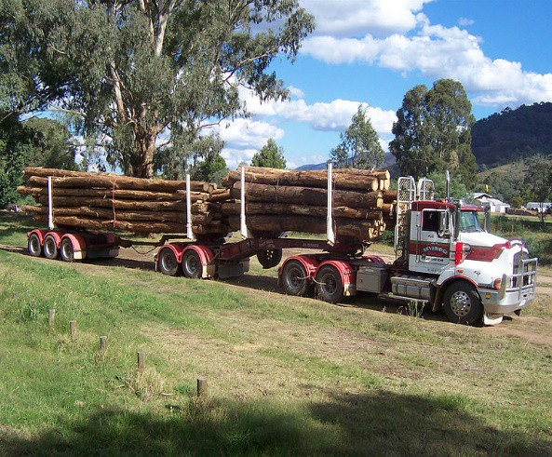Boards and posts for the construction and furniture industries

Image 3.1.1 Truck hauling sawlogs
- Wood pulp for paper production
- Woodchips, thin veneers and fibers for the production of manufactured timbers.
Sawyers aim to maximise the useable timber taken from each log, but some is lost as sawdust.
These raw materials are then sent to secondary processing facilities where they are manufactured into their final form – whether that is a chair, a sheet of writing paper, or flooring materials.

The aluminium production process:
Aluminium is a lightweight metal that has many applications. It is the most common metal on Earth but does not occur naturally in a useable from. It is most commonly found in the form
of bauxite, which is a rocky substance that contains aluminium and a number of other unwanted impurities.

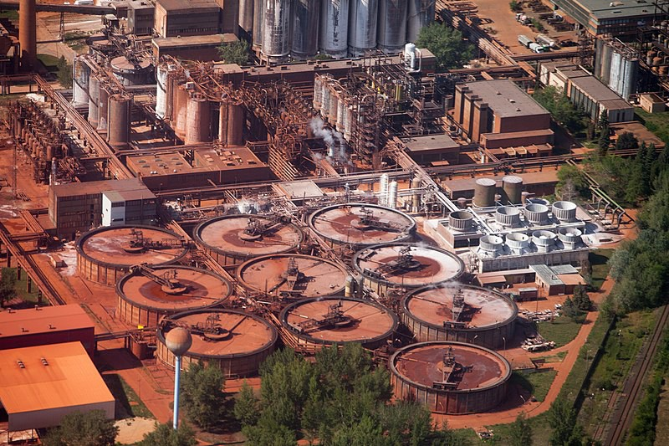small pieces called ingots

Image 3.1.2 aerial view of an alumina plant
Bauxite is mined and must be go through a number of processes in order to become pure aluminium.
First, the bauxite goes to a refinery. There it is mixed with caustic soda which removes impurities and produces alumina, a purer form of aluminium. This produces a lot of waste material, which is stored in a large lake or dam.
This alumina is transported to a smelting facility where it undergoes a process
called electrolysis. In this process, the alumina is heated to nearly 1,000 degrees Celsius and an electric current is passed through it. This produces pure molten aluminium, which is then formed into

These ingots are shipped to other facilities which turn them into all kinds of different shapes and sizes, depending on their intended use. This includes thin sheets, tubes, bars and beams. These different forms are then shipped to manufacturers to be made into finished products.

References
How Products are Made (2021) ‘Lumber’ madehow <http://www.madehow.com/Volume- 3/Lumber.html> accessed on 11 June 2021
How Products are Made (2021) ‘Aluminum’ madehow <http://www.madehow.com/Volume- 5/Aluminum.html> accessed on 11 June 2021
Aluminium Production (n.d) ‘How Aluminium is Produced’ UC RUSAL
<https://www.aluminiumleader.com/production/how_aluminium_is_produced/> accessed on 11 June 2021
Make It Wood (14 June 2020) ‘From the plantation to your place – the timber production process explained’ Make it Wood: Planet Ark <https://makeitwood.org/articles/plantation-timber-production- explained> accessed on 11 June 2021

Images
Image 3.1.1 ‘B double logging truck in Australia’ Fir0002 at the English-language Wikipedia, CC BY-SA 3.0 available at:
<https://commons.wikimedia.org/wiki/File:B_double_logging_truck_in_Australia.jpg> accessed 15
June 2021
Image 3.1.2 ‘Ajka Alumina Plant, Hungary (10759011086)’ Jeroen Komen, CC BY-SA 2.0 available at: <https://commons.wikimedia.org/wiki/File:Ajka_Alumina_Plant,_Hungary_(10759011086).jpg> accessed 15 June 2021

