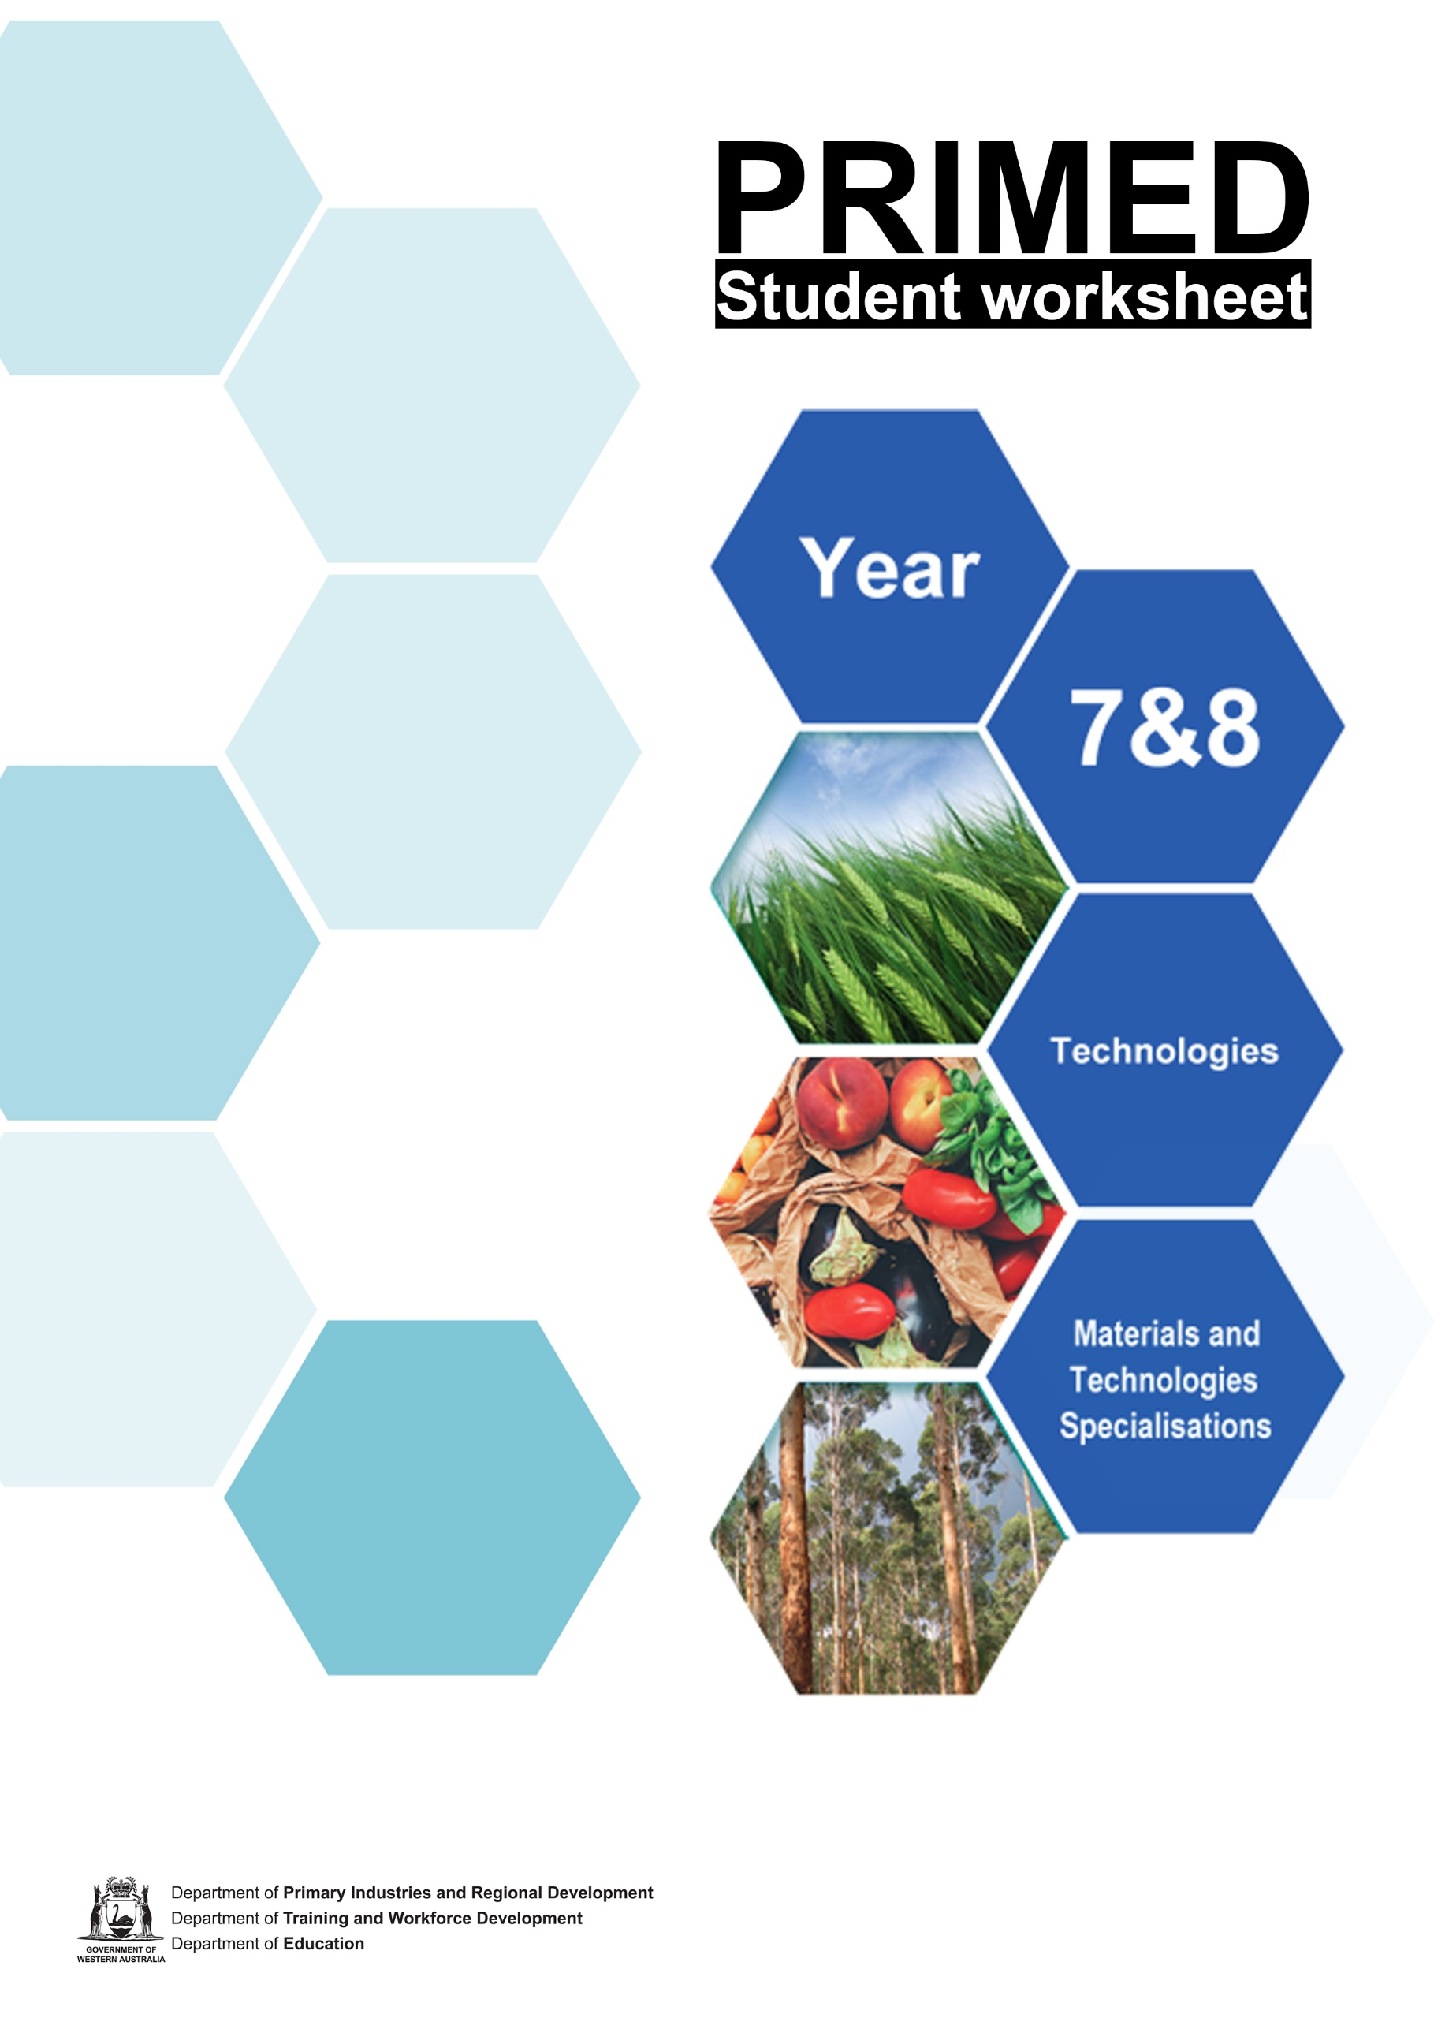

Student worksheet 1.1

Western Australian timber industry - Virtual guided tour
Visit the link below to access the Forest Industry Federation of Western Australia (FIFWA) website. https://welcomemat.fifwa.asn.au/guidedtour.html
The tour will take you through an overview of the Western Australian timber industry. As you move through the tour, answer the questions below.
When you complete the tour, you will be asked to enter your name and email address to receive a certificate of completion.

Questions
- What are the 6 main industry types within the Western Australian forestry industry?

- Approximately how many hectares of native forest are found in the south-west of Western Australia?

- 38% of native forests are available for timber production. What percentage of this area is available to be harvested each year?

- Where are the ports which handle timber and other forest products located?

- Name two timber species which are plantation grown in Western Australia.

- How many jobs does the timber industry generate in Western Australia?

- What is the total value of output of the Western Australian timber industry each year?

- How many hectares of protected forest are found in Western Australia?

- What is the purpose of a Wood Encouragement Policy?

- Describe a benefit of using timber as a construction method.

- What year was Western Australia's first timber mill constructed?

- Where was it located?

- In your own words, describe the role of one of the forestry industry workers interviewed in the "Industry Spotlight"

Don’t forget to complete the form to receive your certificate!
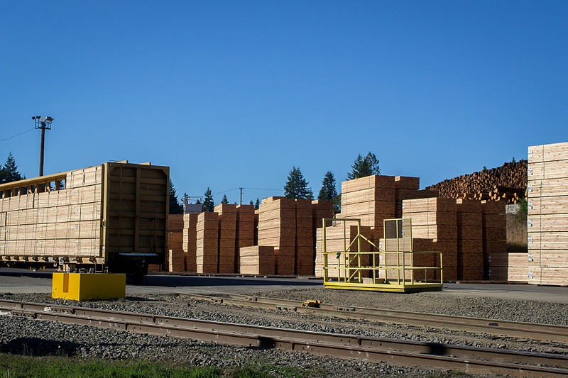
Timber at a sawmill,Tony Jin, CC BY-SA 3.0 available at:
<https://commons.wikimedia.org/wiki/File:Lumber_at_a_Sawmill.jpg> accessed 15 June 2021

References
Forest Industries Federation (WA) Inc. Welcome Mat ‘The guided tour’ available at:
<https://welcomemat.fifwa.asn.au/guidedtour.html> accessed 11 June 2021

Student worksheet 1.2

The history of the Western Australian timber industry
The timber industry played a major role in shaping the history of the South West region of Western Australia (WA). Today, the industry employs over 6,000 people and contributes 1.4 billion dollars to the WA economy.
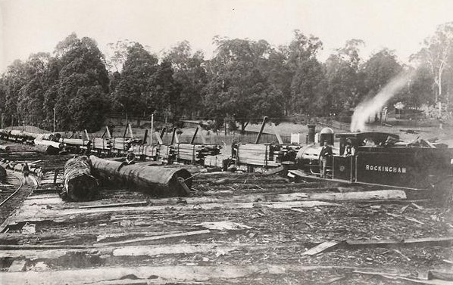
Image 1.2 Timber being moved at Jarrahdale railyard (c.1900)
<https://commons.wikimedia.org/wiki/File:Locomotive_Rockingham_shunting_wagons_at_Jarrahdale_yard.jpg#filelinks> accessed 15 June 2021

Historical events relating to the WA timber industry can be categorised in the following ways;
- Social impact
- Environmental conservation
- Infrastructure
- Economic impact
Social impact is the effect on people and communities due to an event, action or policy.
Environmental conservation involves the protection, preservation and sustainable usage of natural resources.
Infrastructure refers to the physical structures, facilities and equipment required to operate a community or industry. This includes roads, buildings, railways and many more.
Economic impacts are the financial effects an event has on a person, business or community.

You will need:
- Student resource 1.1 – Timeline of the Western Australian timber industry (A3)
- 4 different coloured pencils or highlighters

Your task:
- In the legend at the bottom left of the page, colour each category box a different colour.
- Read through the events described in the timeline. Think about the impact of each item. What caused this to happen? What was the impact of this decision?
- Decide which category each event fits best, and colour/highlight the text in the appropriate colour. Remember, some events may fit into multiple categories!

Glossary
Sawmill – a facility where logs are cut into useable boards and other products.
Royal Commission – an independent inquiry into important matters conducted by investigators who do not answer to the government.
Old growth forest – a forest that contains large, old trees and a diverse, established ecosystem. Old growth forests are typically untouched by humans for many years.
Virgin forests – Old growth forests that have never been harvested for timber.
Act – a law passed by the government
Dieback - a disease affecting plants that causes a tree or shrub to die from the tip of its leaves or roots. Dieback is causes by organisms in soil, and can be spread in a number of ways, including the transport of infected soil on car tyres, walker’s boots or animals.
Timber plantation – an area of land where specific trees are planted and grown for their timber.

Questions
- Do you notice any change in most common colour used as you move down the timeline? What does this tell us about the priorities of Western Australian society over the last 200 years?

- Where was the first area of protected forest established? In what year did this occur?

- How many years passed between the end of logging in virgin forests and the end of all old growth logging?

- The Forest Management Plan specifies a ratio between the different forest uses. What are these uses? What is the ratio stated?

- During the Great Depression (1930s), a large number of people were employed in the timber industry. Explain some of the impacts that this may have had. (These may be social, economic or environmental)

References
Forest Industries Federation (WA) Inc. Welcome Mat ‘Historical connection’ available at:
<https://welcomemat.fifwa.asn.au/history.html> accessed 11 June 2021

Student worksheet 2.1

Native forests and plantation timbers
We have a range of different timber species in Western Australian, and these come from several different sources. Our native forests provide us with high quality hardwoods, and plantations grow both hardwoods and softwoods. Different timbers are suited to specific applications, and the intended use is an important factor in the way trees are grown.

Part 1 – Timber products
In the left column of the table below, write down as many uses of timber and timber products as you can think of. The first two have been done for you!

Do not attempt to fill in the right-hand column yet – we will come back to this in Part 3!
Timber product | Type of forest
Timber framing for buildings
Toilet paper

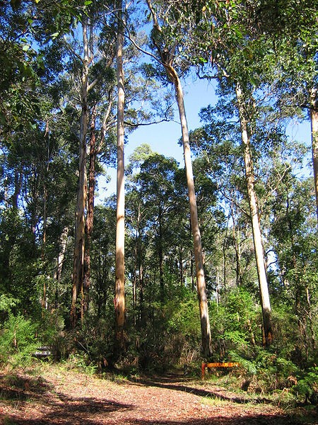
Image 2.1.1 Pemberton Karri forest
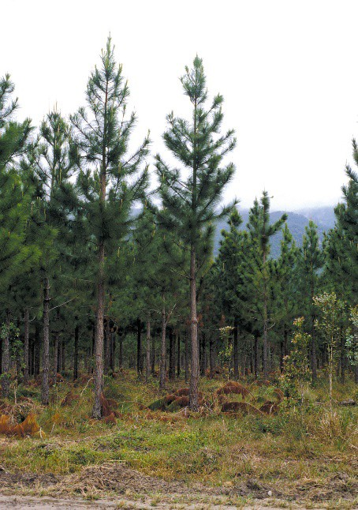
Image 2.1.2 Pine plantation

Part 2 – Plantations and native forests
Watch the video at https://youtu.be/olJyoey9p8c and answer the questions below. It may help to take notes as you go!
- The video mentions 3 different types of forest that provide wood for the forest products industry. These are:

- According to the narrator, which type of forest produces the timber at the top of the ‘value’ chain? What type of timber is he referring to?

- The narrator says typical rotation times for harvesting Australia’s native forests can stretch to more than years.
- What are the two advantages to allowing native forest trees to grow slowly?

- Around how old is the Bluegum plantation forest that the narrator and Nick walk through?

- What is the average rotation length in years for a Bluegum plantation?

- Hardwood plantations are managed for fast growing, high yielding fibre (or pulpwood). What are the main products manufactured from this pulpwood?

- What are the two types of products mentioned in the video that are used to manage the plantation forests?

- How old is the Pine plantation in the video?

- Softwood plantation timbers such as Radiata Pine have a number of uses. These include:

- Name three reasons why wood is considered "the environmental choice".

- Why does Australia continue to import wood from overseas countries? What is the major environmental concern regarding this imported wood?

- How could Australia address this deficit in wood supply?

Part 3 – Sources of timber
Once you have watched the video and answered the questions above, you should have a better idea of where our timber comes from. Using what you have learned, complete the right-hand column titled “Type of forest”.

Extension activity
Use the internet to identify a Western Australian location or area where the timber for each product/use could be produced!

References
Going Bush TV (6 March 2012) ‘3 Various demand for Victoria's plantation and native forests’ (video) YouTube available at: <https://youtu.be/olJyoey9p8c> accessed 11 June 2021

Images
Image 2.1.1 ‘Pemberton Karri forest 2’ Andrew Owens CC BY-SA 3.0 available at: https://commons.wikimedia.org/wiki/File:Pemberton_Karri_forest_2.jpg accessed 15 June 2021

Image 2.1.2 ‘Pine plantation with State forest in background, 30 Kms south of Cardwell. QLD. (Queensland forest service project)’ CSIRO CC BY-SA 3.0 available at: https://commons.wikimedia.org/wiki/File:CSIRO_ScienceImage_4042_Pine_plantation_with_State_forest_in
_background_30_Kms_south_of_Cardwell_QLD_Queensland_forest_service_project.jpg accessed 15 June 2021

Student worksheet 2.2

Properties and uses of timber
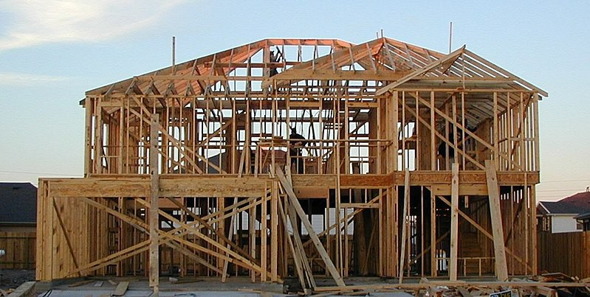Timber and timber products are used for a wide range of different applications. Certain timber species are better suited to specific uses and this depends on the properties of the wood.

Timber framed house under construction Jaksmata CC BY-SA 3.0 available at:
<https://commons.wikimedia.org/wiki/File:Wood-framed_house.jpg> accessed 15 June 2021
Properties are the physical characteristics of a material, and these affect how well it is able to perform a certain task. Different timber species have different properties, and this means we need to carefully choose appropriate timbers for specific
applications. Some timbers are hard while others are soft, some are lightweight while others are heavy and some are attractive looking while others are plain. Below are some key properties that affect timber use.

Strength | Support weight/ withstand force
Hardness | Resist scratching and denting
Durability | Resist wear and tear due to weathering and chemical processes. Includes pest and rot resistance
Pest resistance | Resist attack by pests like termites
Rot resistance | Resist rotting due to fungal attack
Stability | Resist changes in shape and size due to temperature/ moisture content
Growth rate | How fast a timber tree reaches harvestable maturity
Aesthetics | How the timber looks

Using the properties listed on the previous page, decide on at least 2 important properties and write them in the table below.
Think about what the product needs to do (its function), anything that could cause damage, and where it will be used. If the product does not need to last very long or have any other specific properties, it should be cheap to produce. Faster growing timbers are typically cheaper as they require less work to produce.
Once you have identified the specific properties that suit each product, use the Student resource
2.1 document or your own research to suggest a timber species with suitable properties.

Product | Important properties | Suitable timber types
Indoor chairs
Work surfaces (Table and bench tops)
Interior doors
Roofing beams
Flooring
Outdoor decking
Indoor furniture
Outdoor chairs
Crates and pallets
Outdoor fencing
Paper and cardboard products

Student worksheet 3.1

Understanding the production process
To help understand what happens when different materials are produced, we can organise production into:
Input: what's going in - everything that is needed.
Process: all the activities that happen, the steps taken to make a product.
Output: what's coming out (everything resulting from production) For example:

Honey production

Input | - Equipment – hive, smoker, protective clothing, extractor, strainer, glass jars packaging, advertising materials.  - Materials - bee colony, flowing plants.  - People - bee keeper, business manager, people involved in production and marketing.  - Knowledge and skills – knowledge of the process, knowledge of the requirements of bees, skills working with bees, scientific knowledge of bee health, predators and pest control. Knowledge of customers and marketing.  - Facilities – land to situate hives and carry out processing, location suitable for bee colony.  - Energy – electricity.
Process | - Prepare hives and bee colony.  - Check and maintain hives, protect hives.  - Collection of nectar and storage of honey by bees.  - Harvest honey – remove frames from hives.  - Extract honey – separate wax from honey and filter.  - Bottle honey and package. Promotion of product.
Output | - Extracted pure honey in packaged form ready for consumption.  - By-products – beeswax (can be sold to commercial manufacturers, to be used for example in furniture polish and candles. Pollen (can be used as a dietary supplement). Royal jelly used to feed the queen bee (can be used as a skin product). Propolis used by bees to maintain the hive (can be used as a disinfectant and for medical purposes).  - Pollinated plants.  - Waste – obsolete production equipment, used jars and packaging, possibly pollution from electricity generation.

Many production processes can require several repetitions of the Input-Process-Output (IPO) model. This means that the output from one process becomes part of the input for the next process.

- Match the following aspects of production to identify either input, process or output.

Input |  | The final result of production.
 |  | The steps to implement technology to create the product.
 |  | The impact of the production process, for example, on the environment.
Process |  | The series of operations to produce the product.
 |  | Finished products, by-products and waste.
 |  | The knowledge and skills. This is the knowledge and skills needed to apply technology.
Output |  | The materials – these are the ingredients that are changed during the production process into the final product.
 |  | The actual making of the product
 |  | The energy, electricity and fuel to power all the stages of production.

IPO model focus questions

Input
What materials are needed? What equipment was needed?
What prior knowledge was required?

Process
What are the steps used to produce the honey? What technology is used?

Output
Were there any by-products? Was there any waste?
Would there be any impact on the environment?

The IPO model can also be represented as a flow chart. For the example given earlier, this could look like this:

Input
- Hive
- Bees
- Flowering plants
- Beekeeper
- Suitable location

Process

- Preparing hives and bee colony
- Maintaining hives
- Harvesting and extracting honey
- Bottling and packaging

Output
  - Packaged honey
  - Byproducts - beeswax, pollen, royal jelly
  - Polinated plants
  - Waste - used packaging, pollution from electricity generation

If we were to make toast with honey using the honey from the output stage of the process, it would become part of the input stage of the new IPO model.

Input
    - Packaged honey
    - Bread
    - Butter
    - Toaster

- Read the document Student resource 3.1 – Production processes

- Using the IPO model, create a flow chart showing how timber is produced. How many times was the IPO cycle repeated?

- Using the IPO model, create a flow chart showing how aluminium is produced. How many times was the IPO cycle repeated?

Using your flow charts and the information in Student resource 3.1, answer the questions below.
- Which material requires more IPO cycles to produce?

- What does this tell us about how difficult it is to produce this material?

- Which production process do you think requires more energy? Why?

- Suggest a way to reduce the environmental impact of timber production.

- Suggest a way to reduce the environmental impact of aluminium production.

- Explain the impact that one of the materials could have on climate change.

