On-entry Assessment Program
Additional Exemplars – Pre-primary writing

This page has been left blank intentionally.
Contents
INTRODUCTION 4
Score Overview 5
Max wos jopibol Exemplar 1 6
U dod poosh in Exemplar 2 8
Max buc and fio the bol Exemplar 3 10
Max did his spin cach Exemplar 4 12
My frvrt prt is Max poosh Exemplar 5 14
He Jumpt! into the cric Exemplar 6 16
Max jumt in the rock pool Exemplar 7 18
Maxs favourite place Exemplar 8 20
Max is wathing his ball Exemplar 9 22
One dog is angi to mas Exemplar 10 24
Rani lookt up Exemplar 11 26
Max the dog loved to play Exemplar 12 28
They went to the crick Exemplar 13 30

INTRODUCTION

The 2020 Marking Writing Validation Project was undertaken following a comprehensive analysis of the On-entry data which showed that many Pre-primary students were located in the upper range of the On-entry writing scale. Due to the nature of the writing task and the structure of the marking rubric, it is reasonable to expect that the top end of the On-entry writing scale is unrealistic for Pre-primary students.

The findings of the 2020 Marking Writing Validation Project showed that marking student writing is a complex process, particularly when referencing a common rubric that covers a broad spectrum of the writing developmental continuum. It became apparent that teachers may benefit from additional support to assist them to assign accurate and consistent scores to Pre-primary students who commence the year writing text that can be read (or can mostly be read) by others.

As a result, additional Pre-primary writing samples have been marked and annotated and are available on the website for teachers to access when marking student writing. All samples were marked by multiple ‘expert markers’ and then scores were reconciled. As many of the options in the rubric require the writing to be able to be read by others without scribing, all scribed text was redacted from the samples before being marked.

These samples are intended to provide additional support to teachers to assign accurate and consistent scores to Pre-primary students who commence the year writing text that can be read (or can mostly be read) by others. Many of these scripts may be beyond what could be reasonably expected of most Pre-primary students at the beginning of the year. These samples should be used if relevant and in conjunction with the full On-entry Writing Marking Guide which contains annotated samples that exemplify the full range of the writing rubric.

When assigning scores to students’ writing, it is reasonable to observe differences in scripts that are assigned the same option, e.g., Option 4 for Purpose and Audience. That is because some students have just demonstrated the requirements for the option and other students are close to the option above (but not quite there).

Score Overview
 | Exemplar 1 - Max wos jopibol | Exemplar 2 - U dod poosh in | Exemplar 3 - Max buc and fio the bol | Exemplar 4 - Max did his spin cach | Exemplar 5 - My frvrt prt is Max poosh | Exemplar 6 - He jumpt! into the cric | Exemplar 7 - Max jumpt in the rock pool | Exemplar 8 - Maxs favourite place | Exemplar 9 - Max is wathing his ball | Exemplar 10 - One dog is angi to mas | Exemplar 11 - Rani lookt up | Exemplar 12 - Max the dog loved to play | Exemplar 13 - They went to the crick
PURPOSE & AUDIENCE | 3 | 3 | 4 | 4 | 4 | 4 | 4 | 4 | 4 | 4 | 5 | 5 | 6
PRINT ORGANISATION | 2 | 3 | 3 | 3 | 4 | 3 | 3 | 3 | 3 | 3 | 3 | 3 | 3
TEXT STRUCTURE | 2 | 2 | 2 | 2 | 2 | 2 | 2 | 2 | 2 | 3 | 3 | 3 | 4
VOCABULARY | 2 | 2 | 2 | 3 | 2 | 2 | 3 | 2 | 2 | 3 | 3 | 3 | 4
SENTENCE STRUCTURE | 2 | 2 | 2 | 3 | 2 | 3 | 2 | 3 | 3 | 3 | 3 | 3 | 3
SENTENCE PUNCTUATION | 1 | 2 | 2 | 2 | 3 | 2 | 1 | 2 | 2 | 3 | 1 | 3 | 2
OTHER PUNCTUATION | 1 | 1 | 1 | 1 | 3 | 2 | 1 | 1 | 1 | 1 | 1 | 1 | 3
SPELLING | 2 | 2 | 3 | 3 | 3 | 3 | 4 | 4 | 4 | 3 | 4 | 4 | 4

Max wos jopibol Exemplar 1
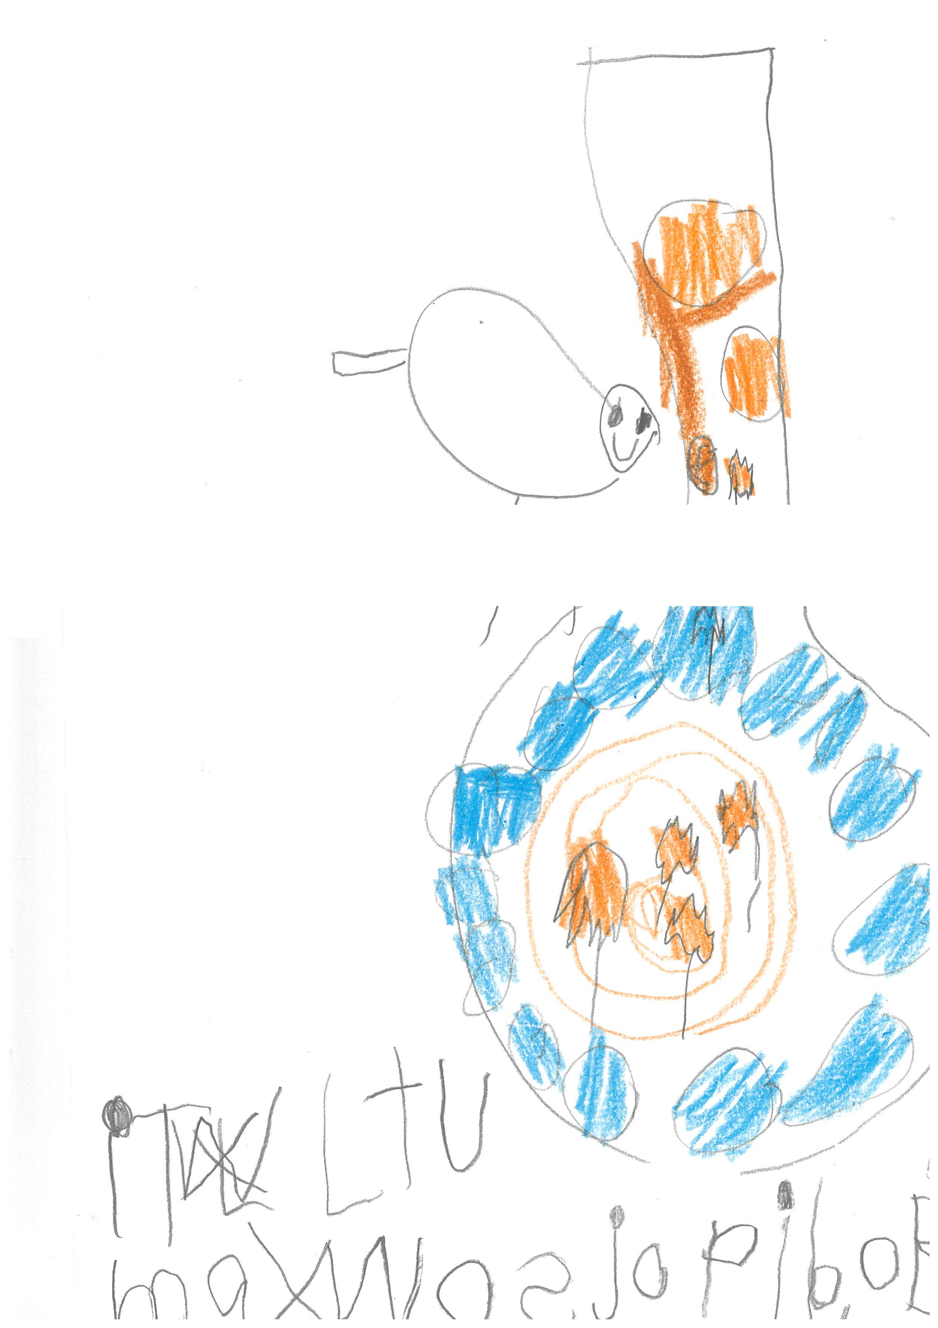

Max wos jopibol Exemplar 1

Criteria | Option | Justification
Purpose and Audience | 3 | Writing contains letters with some evidence of sound/letter relationships. Content is difficult to read/decode without scribing.  Although some words can be read, Max was dropping bol, too much of the text cannot be easily read and therefore this script is closer to Option 3 than to Option 4.
Print Organisation | 2 | Writing demonstrates a beginning awareness of print organisation.  Text is written from left to right but not top to bottom. This may be due to starting at the bottom of the page. However, there are no spaces between the words which is a requirement for Option 3.
Text Structure | 2 | Writing contains one idea, a brief message or a caption.  Although there are words in the text that can’t be read, just enough can be read to identify an idea – Max was dropping ball. This is a borderline script; however, it is closer to Option 2 than to Option1.
Vocabulary | 2 | Writing contains some simple words that can be read or decoded without scribing.  Just enough text can be read to identify some simple words.
Sentence Structure | 2 | Writing contains a brief sentence or a sentence fragment/s that conveys meaning.  A sentence fragment can be identified.
Sentence Punctuation | 1 | No correct sentence punctuation.  Exactly
Other Punctuation | 1 | Writing contains no use of other punctuation.  Exactly
Spelling | 2 | Correctly spells one or two words.  Correct simple: Max  One word spelt correctly is enough for Option 2.

U dod poosh in Exemplar 2
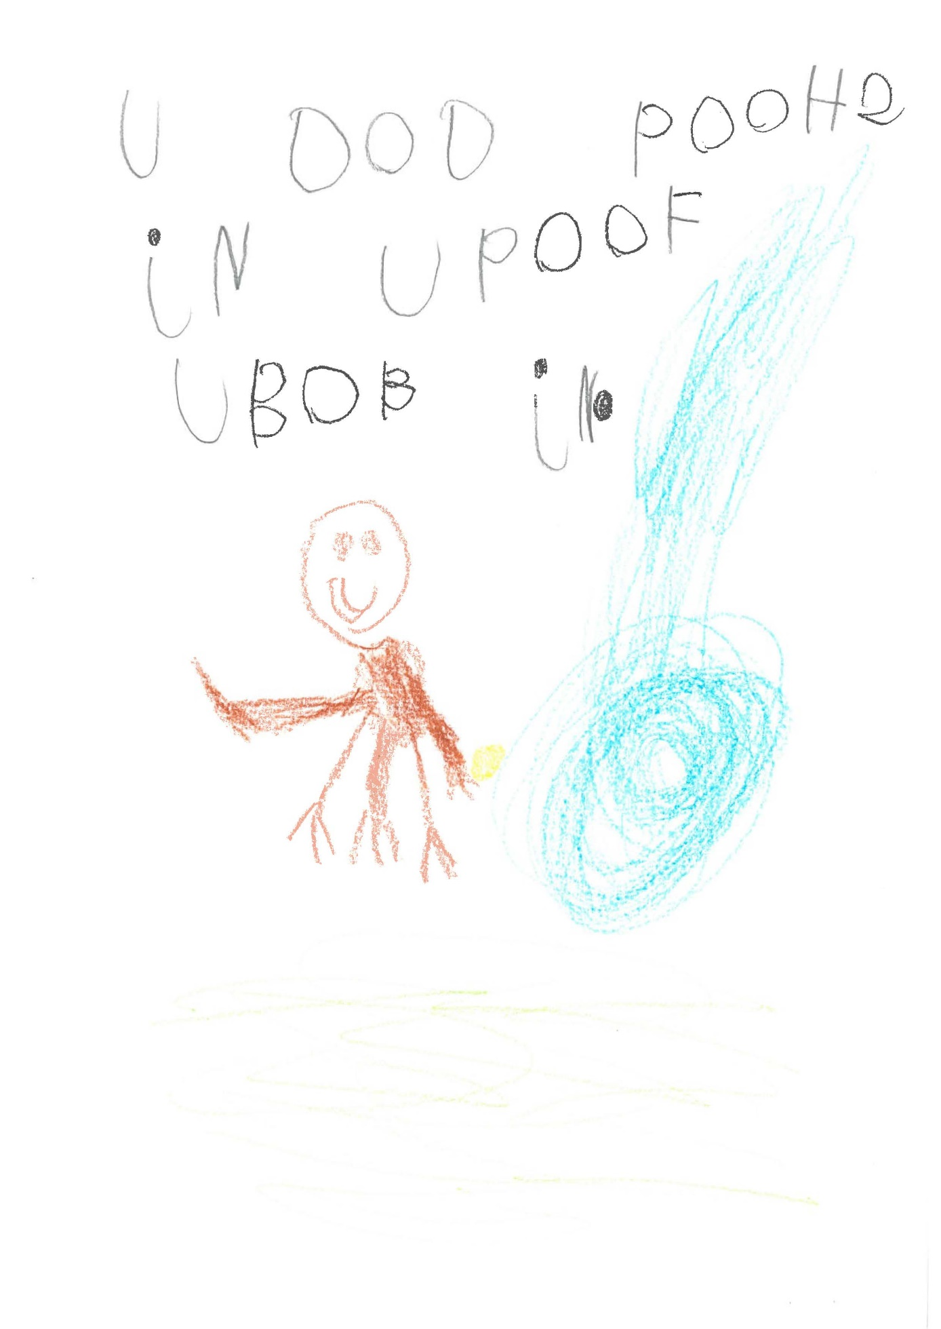
U dod poosh in Exemplar 2

Criteria | Option | Justification
Purpose and Audience | 3 | Writing contains letters with some evidence of sound/letter relationships. Content is difficult to read/decode without scribing.  Whilst some of this text can be decoded - A dog (?) push in a…- most of it can’t be read and therefore Option 4 can’t be considered. This text is borderline; however, it is closer to Option 3, than to Option 4 (text can be mostly read/decoded without scribing).
Print Organisation | 3 | Writing demonstrates some awareness of print organisation.  Writing is left to right and top to bottom. Spaces are evident between most words. Letter formation is inconsistent and therefore Option 4 cannot be considered.
Text Structure | 2 | Writing contains one or two ideas, a brief message or a caption.  Just enough meaning can be understood for Option 2. This is a borderline script; however, it is closer to Option 2 than to Option 1.
Vocabulary | 2 | Writing contains some simple words that can be read or decoded without scribing.  The words that can be read are all simple.
Sentence Structure | 2 | Writing contains a brief sentence or a sentence fragment/s that conveys meaning.  Text consists of a sentence fragment – enough of which can be read for Option 2.
Sentence Punctuation | 2 | Writing contains a capital letter to start a sentence or a correct sentence ending.  A full stop is used to end the sentence. Although the sentence starts with a capital, most of the script is written in capitals and as such this is considered random use.
Other Punctuation | 1 | Writing contains no use of other punctuation.  Text does not have any correct use of other punctuation.
Spelling | 2 | Correctly spells one or two words.  Correct words: in  There is only one correctly spelt word therefore nothing higher than Option 2 can be considered.

Max buc and fio the bol Exemplar 3

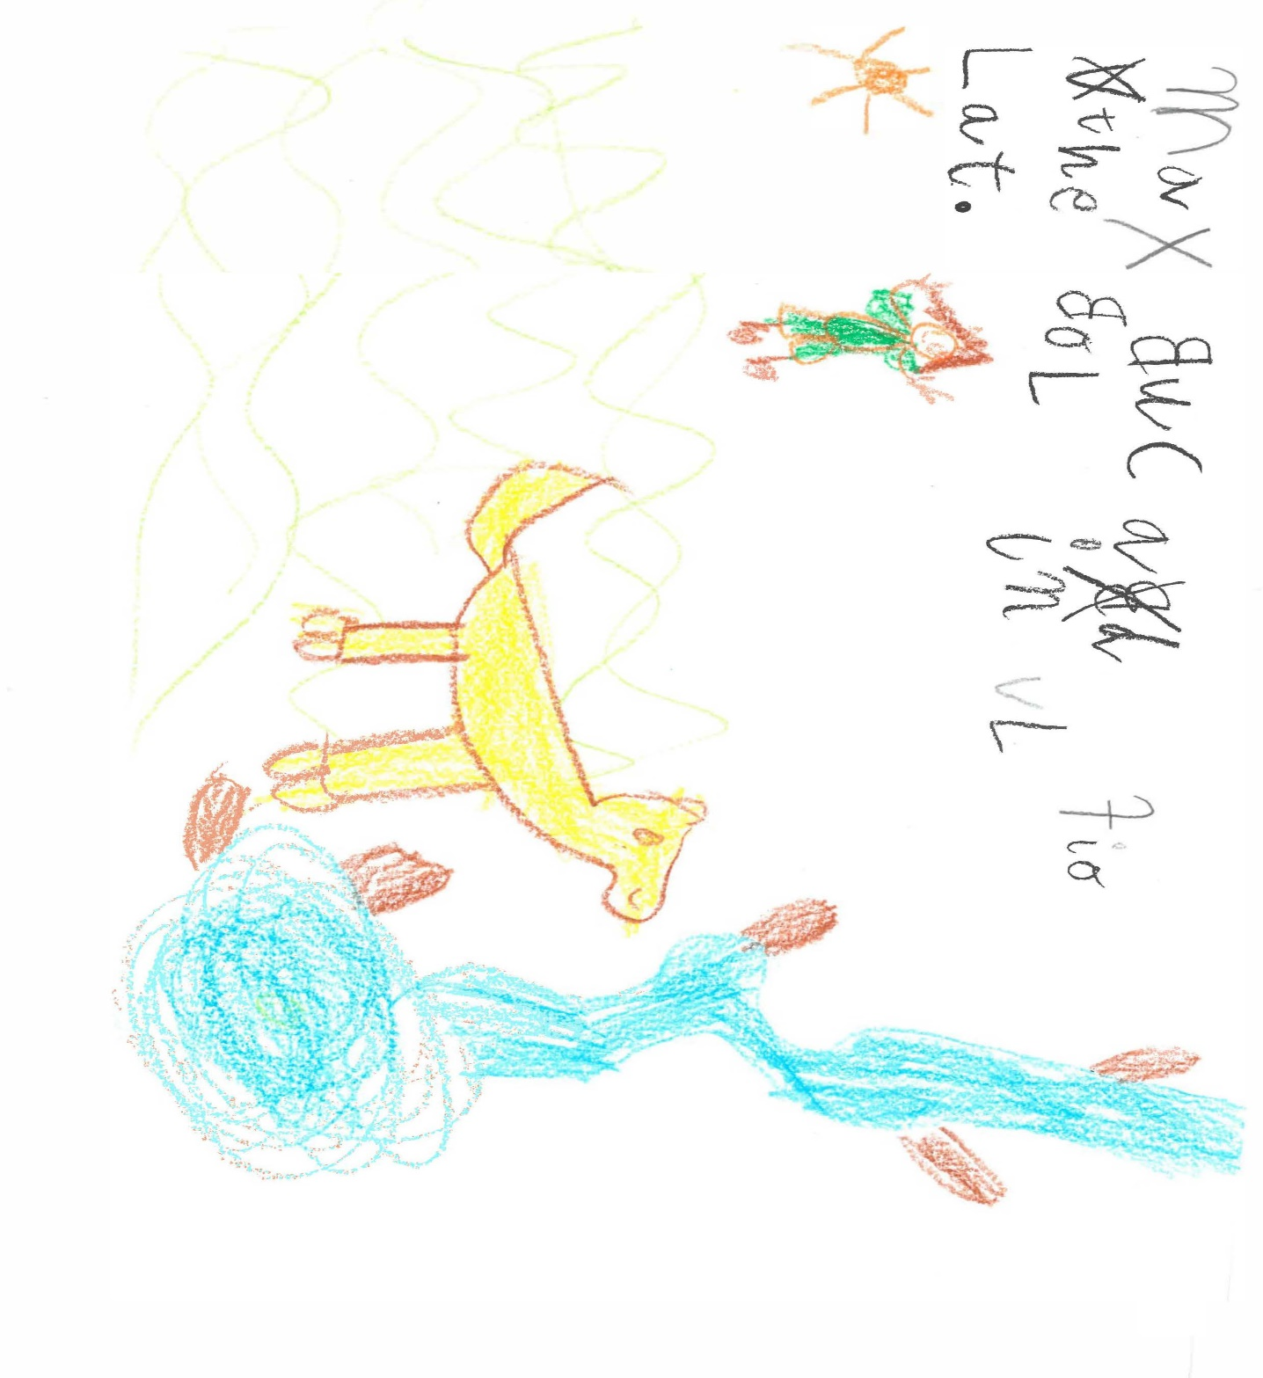
Max buc and fio the bol Exemplar 3

Criteria | Option | Justification
Purpose and Audience | 4 | Writing contains content that can be read or decoded by others without scribing. Awareness of audience is not evident.  Content can be read/decoded by others without scribing, i.e. Max barked and threw the ball in a lake. Knowledge of the story helps the reader to decode this text. This is a low Option 4.
Print Organisation | 3 | Writing demonstrates some awareness of print organisation.  Text is written from left to right and top to bottom and there are spaces between the words. The letter formation is inconsistent in size and shape and there are reversals; however, there is just enough awareness of print organisation for Option 3.
Text Structure | 2 | Writing contains one idea, a brief message or a caption.  Writing contains an idea from the story.
Vocabulary | 2 | Writing contains some simple words that can be read or decoded without scribing.  All words in the text are simple.
Sentence Structure | 2 | Writing contains a brief sentence or a sentence fragment/s that conveys meaning.  The text can be read easily enough to make meaning from the sentence. Even though this is a compound sentence, there is an error (bark). In addition, it is not sophisticated and therefore Option 3 cannot be considered.
Sentence Punctuation | 2 | Writing contains a capital letter to start a sentence or a correct sentence ending.  The sentence has a correct full stop at the end. The larger M to start the sentence is not considered to be an intentional capital letter due to the random size and capitalization of other letters in the text.
Other Punctuation | 1 | Writing contains no use of other punctuation.  Exactly.
Spelling | 3 | Correctly spells some words with simple letter patterns.  Correct simple: Max, in, the  Three correctly spelt words with simple letter patterns is just enough for Option 3.

Max did his spin cach Exemplar 4

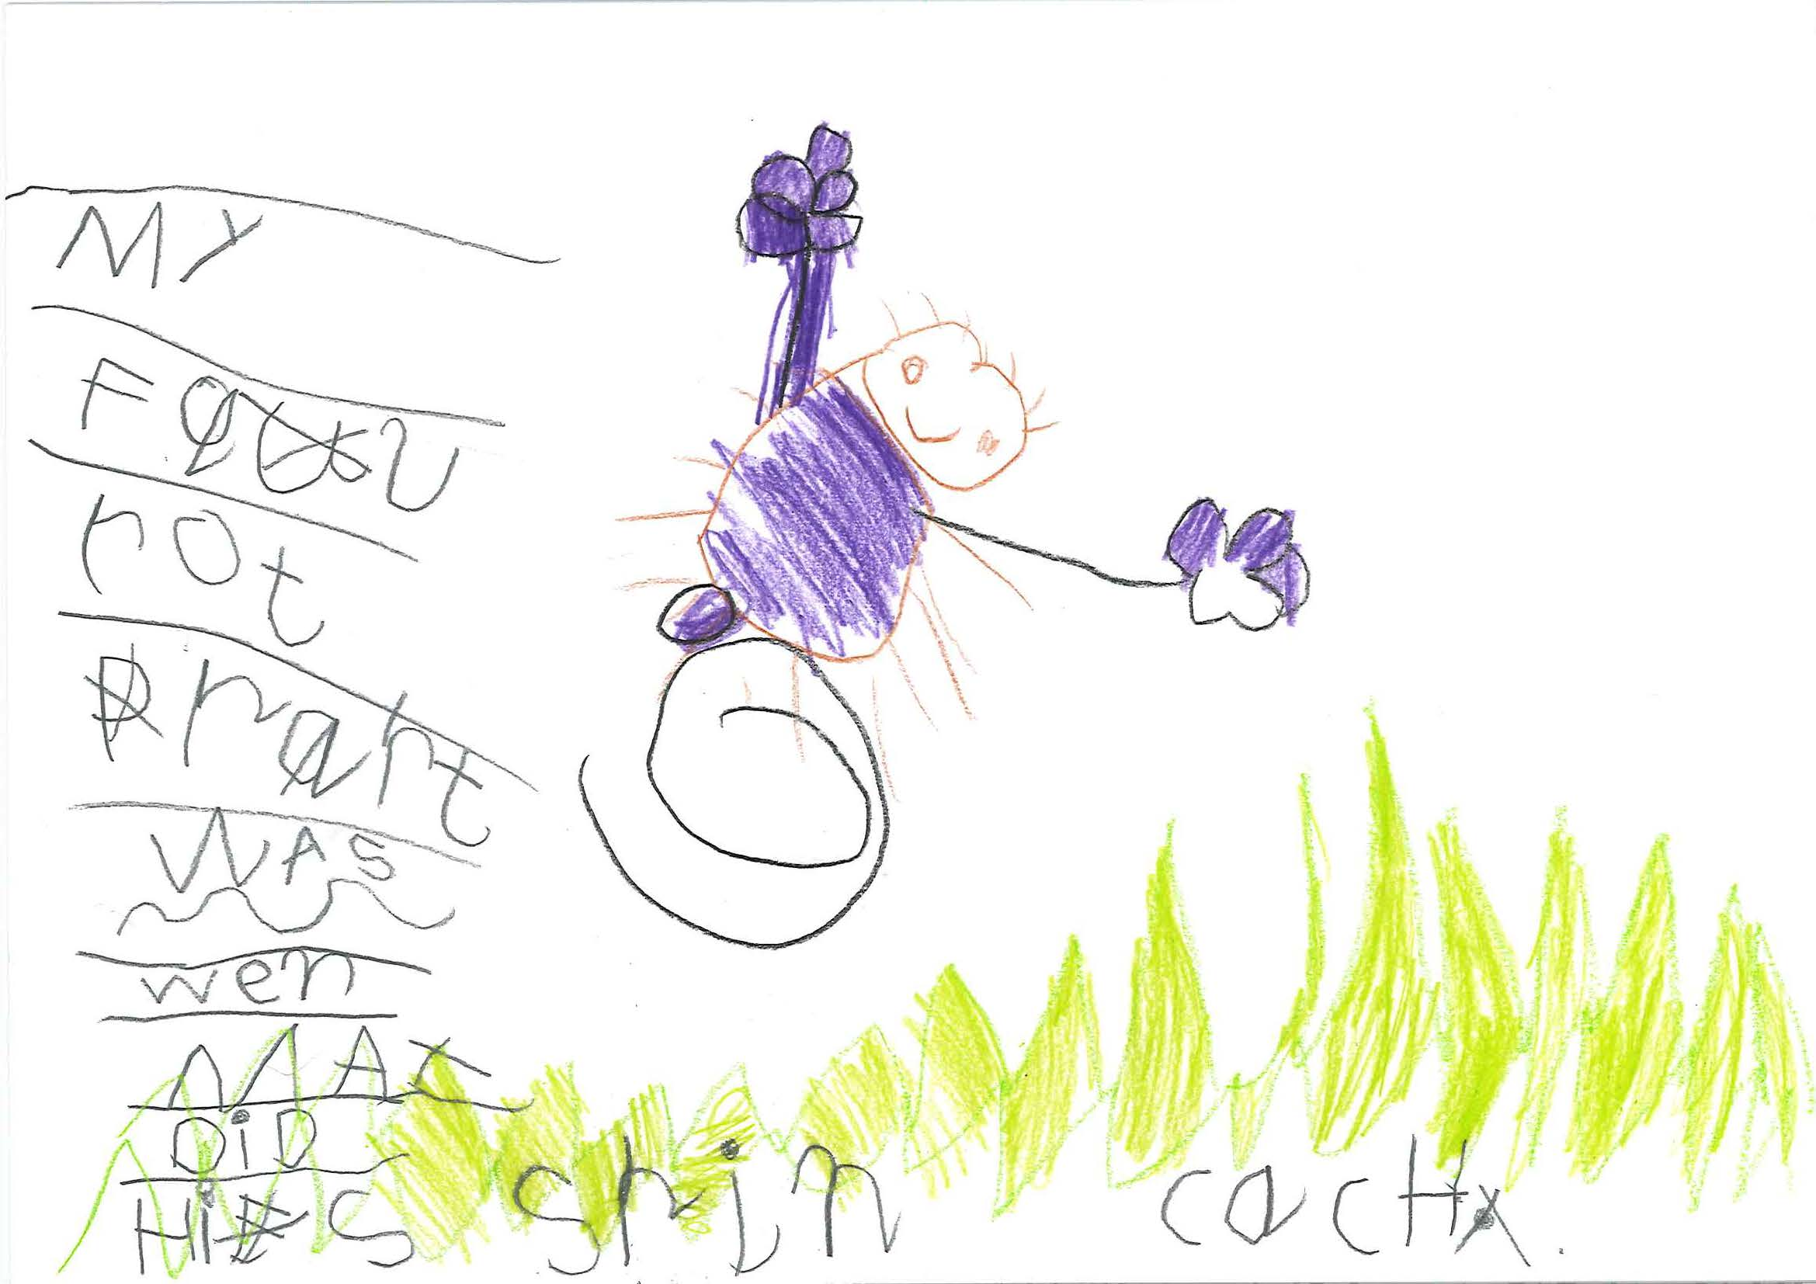

Max did his spin cach Exemplar 4

Criteria | Option | Justification
Purpose and Audience | 4 | Writing can be easily read or decoded by others without scribing. Awareness of audience is not evident.  This script can be easily read by others. My favourite part is considered a response to the writing prompt rather than demonstrating an awareness of audience. The script is closer to minimal content than brief information about character, events or setting. The ‘strengths’ of this writing are in Vocabulary and Sentence Structure.
Print Organisation | 3 | Writing demonstrates some awareness of print organisation.  Writing is top to bottom and although the script is predominantly one word per line, this is likely due to the position of the drawing. Once there is space to write more than one word per line, words are left to right and there are spaces between words. This is a low Option 3.
Text Structure | 2 | Writing contains one idea, a brief message or a caption.  The text includes one idea from the story, i.e., Max did his spin catch.
Vocabulary | 3 | Writing contains simple vocabulary that contributes to a story or message OR Writing contains one or two examples of descriptive vocabulary.  This term spin catch contributes some imagery to the message and is just enough for Option 3 to be considered. This is an example of a low Option 3.
Sentence Structure | 3 | Writing contains one sophisticated sentence.  Although only one sentence, this is a grammatically correct sophisticated complex sentence with no missing words. Although a low Option 3, this is more than a simple sentence or sentence fragment.
Sentence Punctuation | 2 | Writing contains a capital letter to start a sentence or a correct sentence ending.  Writing starts with a capital (probably). The full stop at the end of the sentence has been crossed out indicating uncertainty.
Other Punctuation | 1 | Writing contains no other punctuation marks.  Max in the middle of the sentence has a capital; however, the A is also a capital and therefore use is considered unintentional.
Spelling | 3 | Correctly spells some words with simple letter patterns.  Correct simple: my, was, max, did, his  Correct common: part, spin  Two words with common letter patterns is not quite enough for Option 4 which requires a few examples.

My frvrt prt is Max poosh Exemplar 5
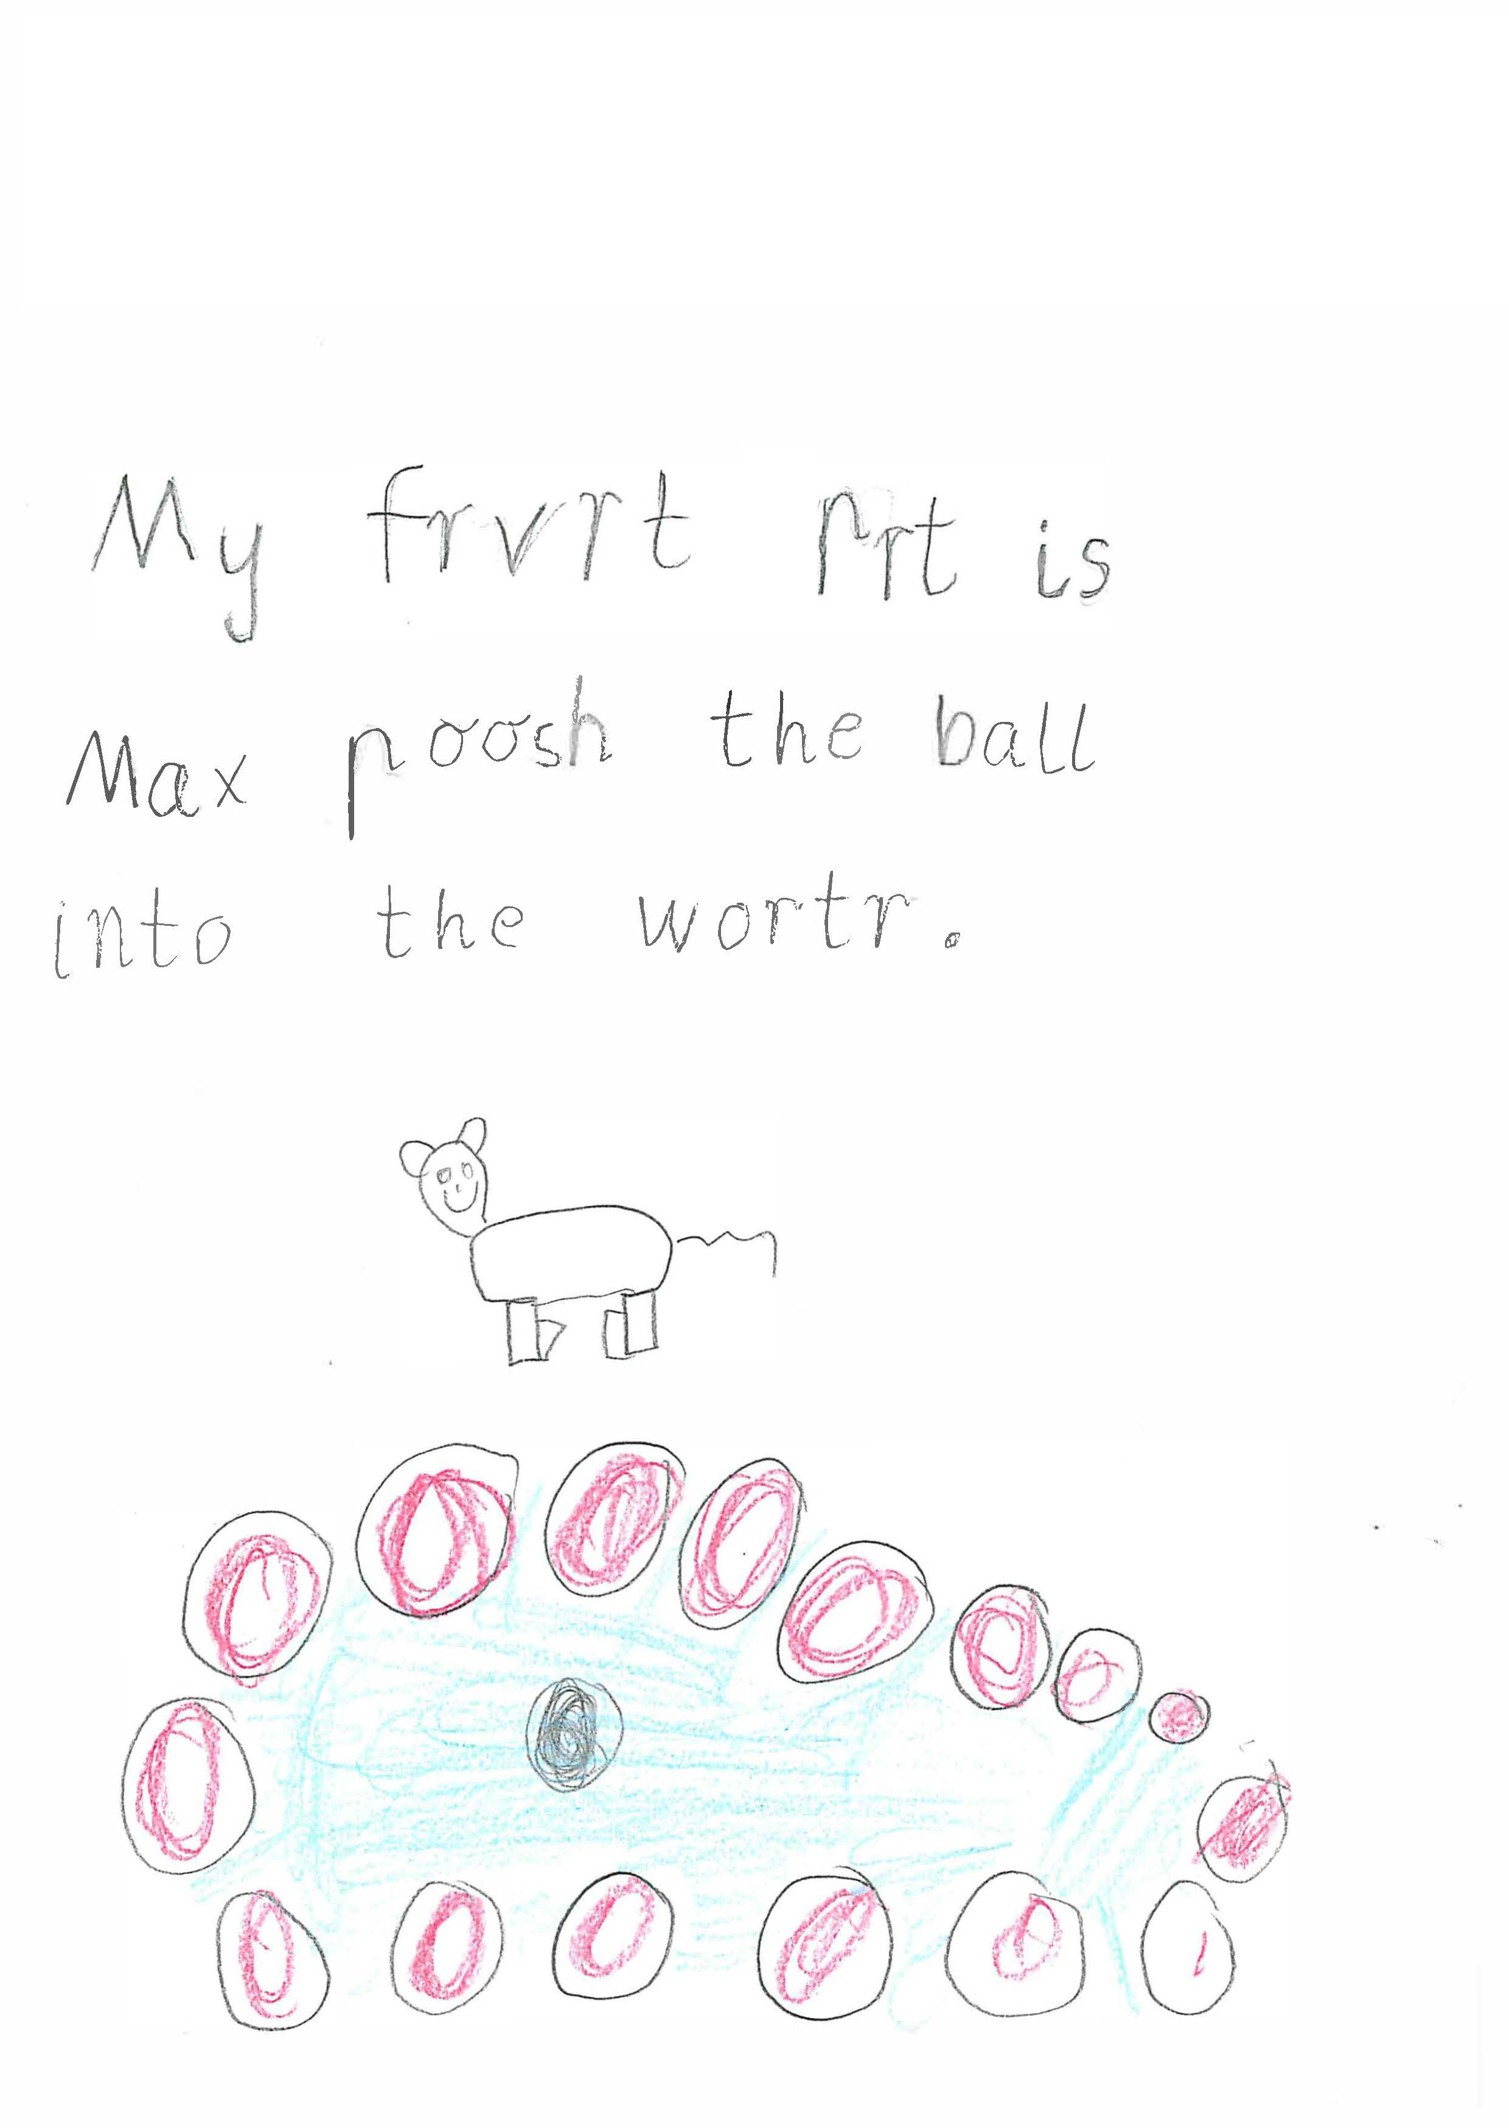

My frvrt prt is Max poosh Exemplar 5

Criteria | Option | Justification
Purpose and Audience | 4 | Writing can be easily read or decoded by others without scribing but an awareness of audience is not evident.  Writing contains minimal content all of which can be easily read by others. My favourite part is in response to the prompt rather than demonstrating an awareness of audience. In addition, Option 5 requires more information.
Print Organisation | 4 | Writing demonstrates a developed awareness of print organisation.  Writing is left to right and top to bottom. Spaces between words are consistent. Letter formation is consistent in size and shape. There are no random capital letters and no reversals. Although there is only one sentence, there is enough evidence to assign this script Option 4.
Text Structure | 2 | Writing contains one or two ideas, a brief message or a caption.  Exactly – one idea/a brief message.
Vocabulary | 2 | Writing contains some simple words that can be read or decoded without scribing.  All words are simple. Favourite part doesn’t add detail about character and there is not considered for Option 3.
Sentence Structure | 2 | Writing contains a brief sentence or a sentence fragment/s that conveys meaning.  Although this is a complex sentence, it does contain two errors – there is a missing word (when after is) and push should be pushed/pushes. These errors prevent this script from being Option 3.
Sentence Punctuation | 3 | Writing contains one or two correctly punctuated sentences.  The sentence is correctly punctuated.
Other Punctuation | 3 | 1 or 2 correct examples of other punctuation.  Writing contains one correctly punctuated proper noun – Max.  There is enough evidence, i.e., control over letter formation to determine this use is intentional.
Spelling | 3 | Correctly spells some words with simple letter patterns.  Correct simple: my, is, Max, the, into  Correct common: ball  One correct word with a common letter pattern is not enough for Option 4.

He Jumpt! into the cric Exemplar 6

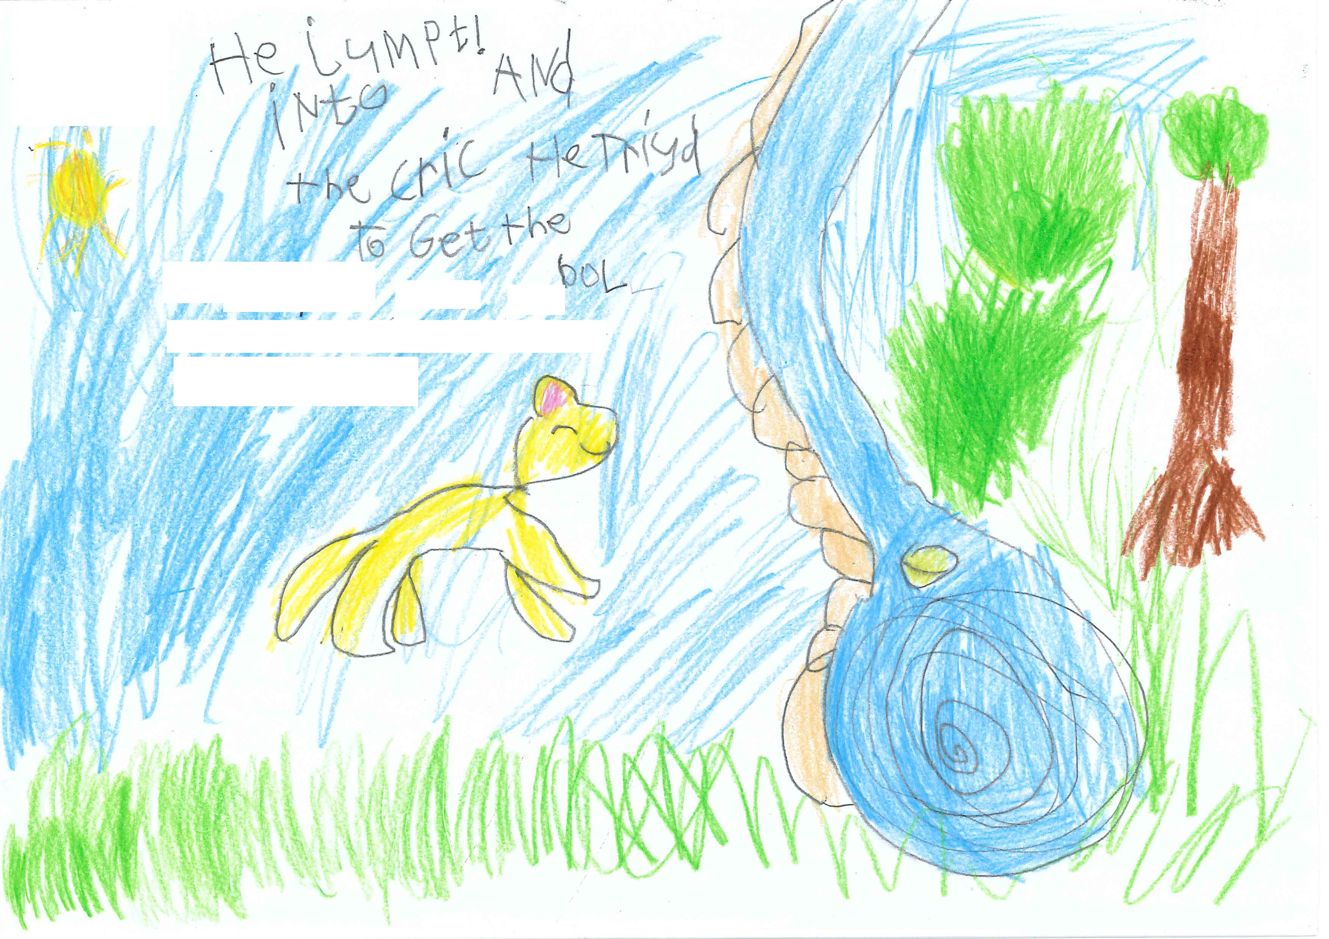

He Jumpt! into the cric Exemplar 6

Criteria | Option | Justification
Purpose and Audience | 4 | Writing can be easily read or decoded by others without scribing but an awareness of audience is not evident.  This is an example of a very good Option 4; however, an awareness of audience is not evident. In addition, there is not quite enough information about character, events or setting, for this to be Option 5.
Print Organisation | 3 | Writing demonstrates some awareness of print organisation.  Although writing is a little random on the page, it is mostly left to right and top to bottom. There are spaces between words, although they are not consistent. Letter formation is inconsistent in size and shape and reversals are evident.
Text Structure | 2 | Writing contains one or two ideas, a brief message or a caption.  The text is briefly retelling one event for the story – Max jumping into the creek to get the ball. This is a borderline script; however, it is closer to Option2 than Option 3. To get the ball is not considered an elaboration or a separate idea. A high Option 2.
Vocabulary | 2 | Writing contains some simple words that can be read or decoded without scribing.  All words in the text are simple. More evidence is required for a higher option to be assigned.
Sentence Structure | 3 | Writing contains at least two correct sentences OR one correct sentence with clauses joined by and, so or but.  Text contains one compound/complex sentence with two clauses joined by and. This is a grammatically correct, sophisticated sentence with the correct use of a conjunction.
Sentence Punctuation | 2 | Writing contains a capital letter to start a sentence or a correct sentence ending.  The sentence starts with a capital letter which appears to be intentional.
Other Punctuation | 2 | Writing contains other punctuation marks, but none are correct.  Writer has experimented with the use of an exclamation mark; however, it is not correct.
Spelling | 3 | Correctly spells some words with simple letter patterns.  Correct simple: he, into, and, the, get  There are enough words with simple letter patterns spelt correctly for Option3.

Max jumt in the rock pool Exemplar 7
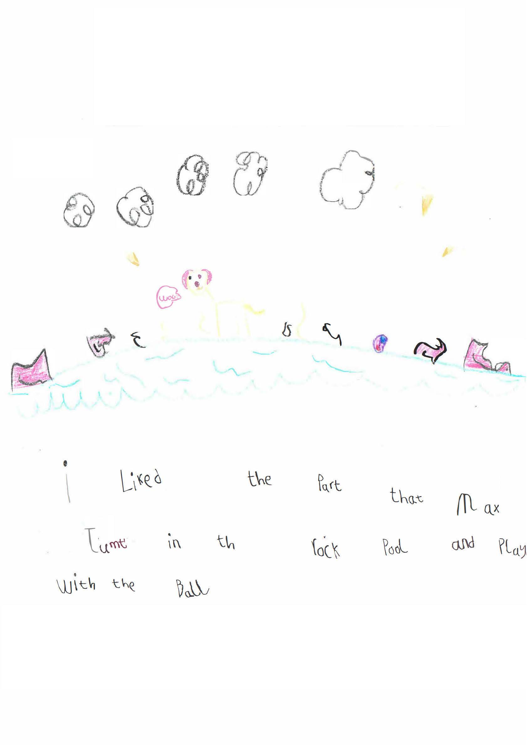
Max jumt in the rock pool Exemplar 7

Criteria | Option | Justification
Purpose and Audience | 4 | Writing can be easily read or decoded by others without scribing but an awareness of audience is not evident.  This script which expresses an idea from the story can be easily read by others. I liked the part is in response to the prompt rather than demonstrating an awareness of audience. This is a very good Option 4 but there is not enough information about character, i.e., Max is a dog, or setting, for this to be Option 5.
Print Organisation | 3 | Writing demonstrates some awareness of print organisation.  Writing is left to right, top to bottom and is also very neat. This is a very high Option 3; however, the inconsistent capital letters throughout the text prevent this script from being Option 4.
Text Structure | 2 | Writing contains one idea, a brief message or a caption.  The text is briefly retelling an event for the story, i.e., Max jumped in the water to play with the ball. This is close to Option 3; however, there is not a sequence of ideas and play with the ball is not considered an elaboration.
Vocabulary | 3 | Writing contains simple vocabulary that contributes to a story or message OR Writing contains one or two examples of descriptive vocabulary.  The vocabulary contributes to a message and rock pool provides additional detail. This is a low Option 3.
Sentence Structure | 2 | Writing contains a brief sentence or a sentence fragment/s that conveys meaning.  This is very close to an Option 3; however, the minor errors, i.e., that (should be when) and play (should be played), keeps this at Option 2. A very good Option 2.
Sentence Punctuation | 1 | Writing contains no correct sentence punctuation.
Other Punctuation | 1 | Writing contains no other punctuation marks.  Although Max starts with a capital letter, so do many words in the script and therefore the capitalization of Max appears to be unintentional.
Spelling | 4 | Correctly spells some words with simple letter patterns.  Correct common: liked, part, that, rock, pool, play, with, ball  This is close to Option 5; however, a few more examples would be required.

Maxs favourite place Exemplar 8

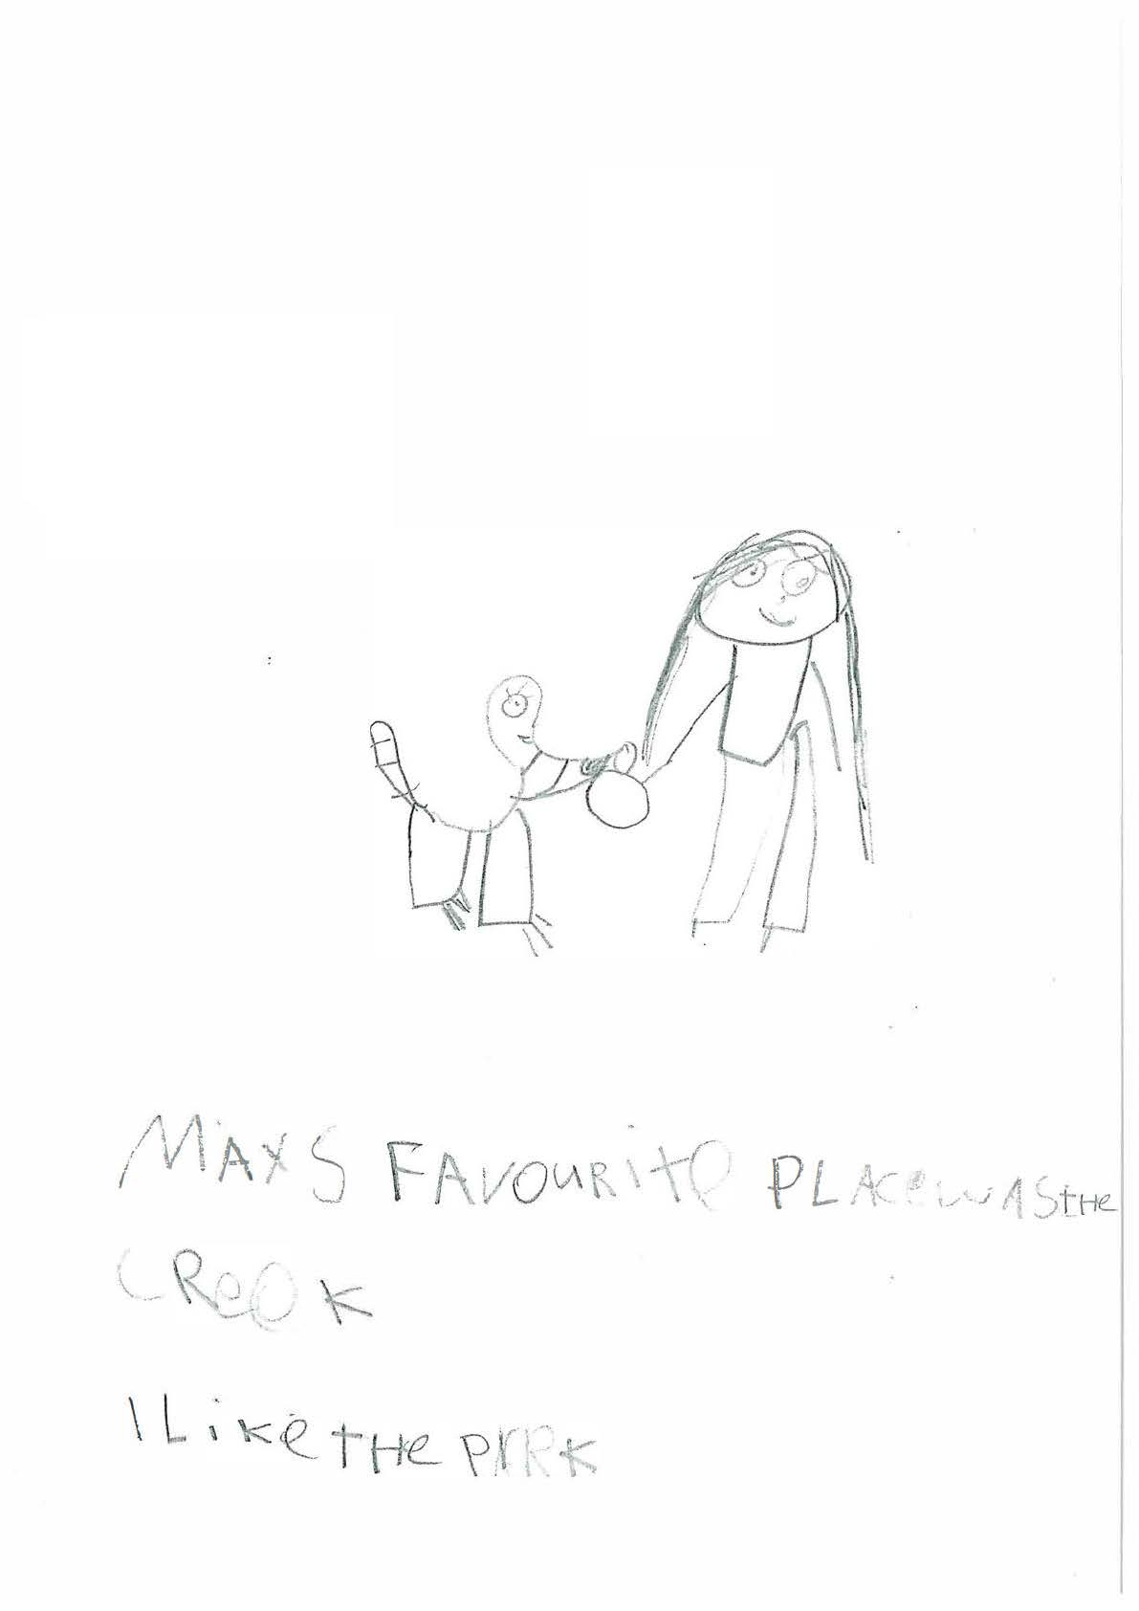

Maxs favourite place Exemplar 8

Criteria | Option | Justification
Purpose and Audience | 4 | Writing contains content that can be read or decoded by others without scribing. Awareness of audience is not evident.  This script can be easily read. This is a very good Option 4; however, an awareness of audience is not evident, e.g., the reader doesn’t know about Max. There isn’t enough information about events for Option 5 to be considered.
Print Organisation | 3 | Writing demonstrates some awareness of print organisation.  Writing is written from left to right and top to bottom; however, formation of letters is inconsistent, i.e., most letters are capitals; some are lower case.
Text Structure | 2 | Writing contains one idea, a brief message or a caption.  Whilst there are two sentences and two ideas, these ideas are not connected or sequenced, nor does the second idea provide an elaboration of the first. As such, the text doesn’t demonstrate the requirements of Option 3.
Vocabulary | 2 | Writing contains some simple words that can be read or decoded without scribing.  All words in the text are simple. More evidence is required for a higher option to be assigned.
Sentence Structure | 3 | Writing contains at least two correct sentences.  Text consists of two correct sentences that both convey meaning. The ideas are not connected but this is not a requirement for Sentence Structure.
Sentence Punctuation | 2 | Writing contains a capital letter to start a sentence or a correct sentence ending.  Both sentences start with a capital. Even though many letters are written as capital, the first letter M is larger in size than the other letters.
Other Punctuation | 1 | Writing contains no use of other punctuation.
Spelling | 4 | Correctly spells some words with simple letter patterns.  Correct simple: Max, was, the,  Correct common: Maxs, place, creek, like  Difficult: favourite  There are enough words with common letter patterns spelt correctly for Option 4 but not enough for Option 5.

Max is wathing his ball Exemplar 9

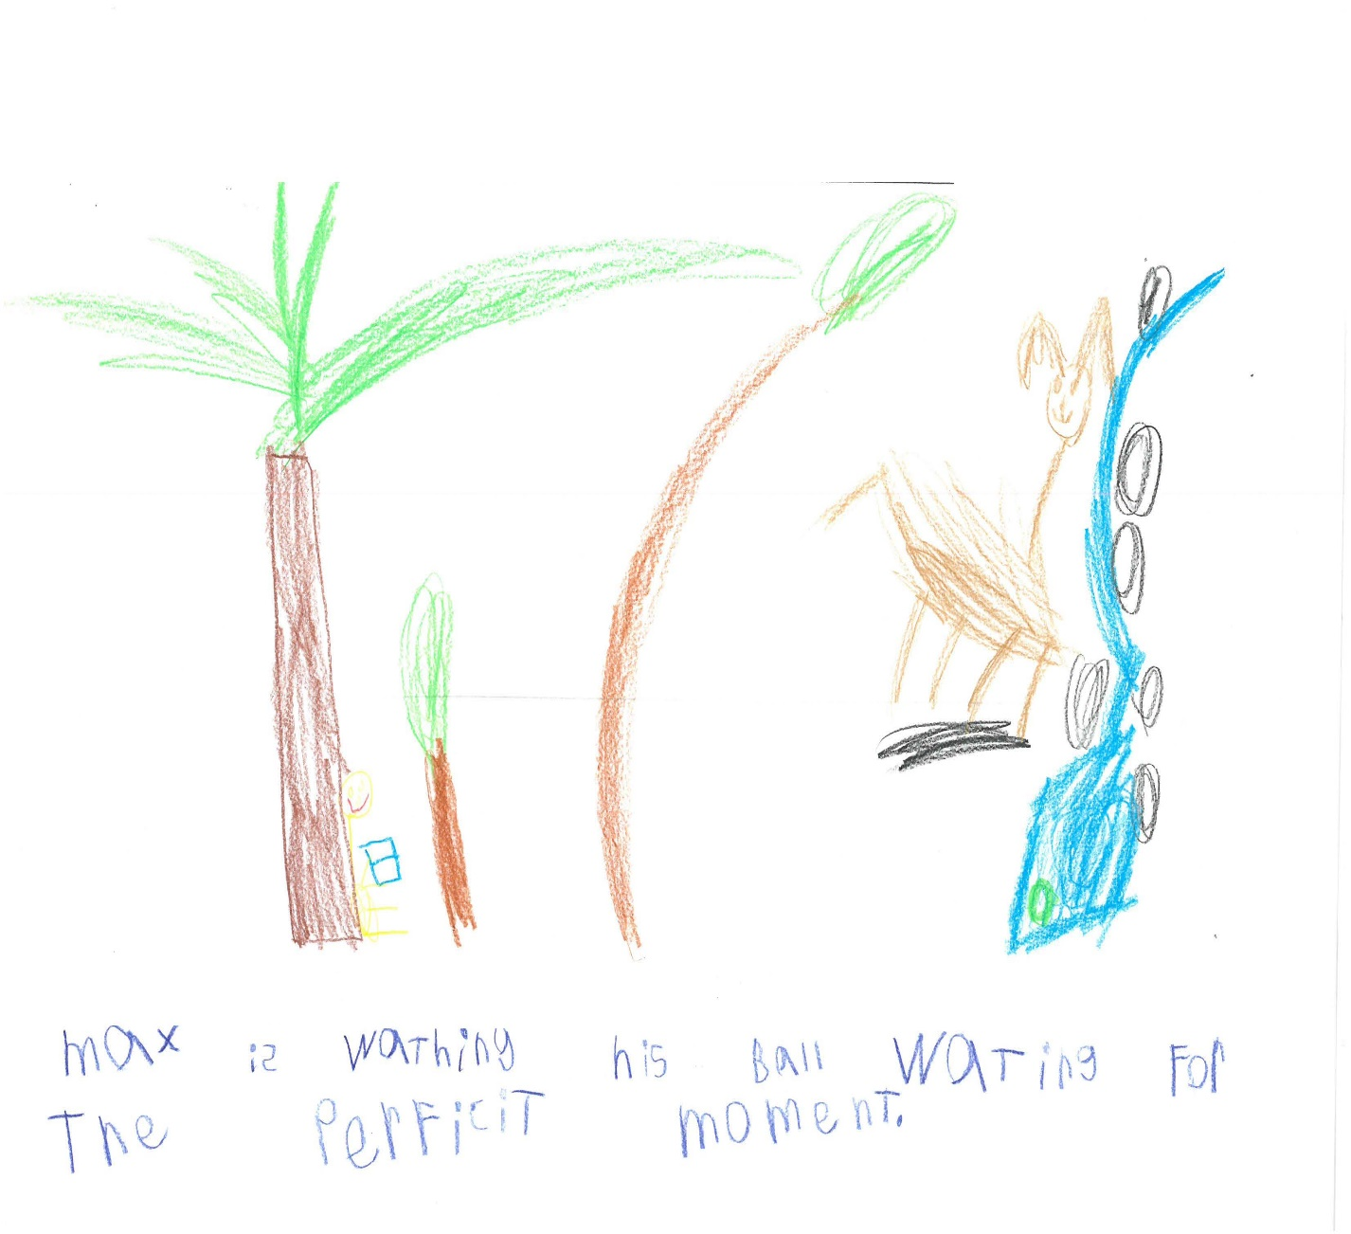

Max is wathing his ball Exemplar 9
Criteria | Option | Justification
Purpose and Audience | 4 | Writing contains content that can be read or decoded by others without scribing. Awareness of audience is not evident.  Although this text may be considered a little more than minimal content, an awareness of audience is not evident nor is there enough information about character, setting or events to consider Option 5. The reader doesn’t know that Max is a dog or about the perfect moment. This is a high Option 4.
Print Organisation | 3 | Writing demonstrates some awareness of print organisation.  Writing is left to right and top to bottom. The inconsistent letter formation, i.e. some letters written as capitals and the s reversed, keeps this at Option 3.
Text Structure | 2 | Writing contains one idea, a brief message or a caption.  Writing contains one idea from the story, i.e., Max is watching his ball. This is a borderline script; however, waiting for the perfect moment is not a separate idea or a sufficient enough elaboration to consider Option 3.
Vocabulary | 2 | Writing contains some simple words that can be read or decoded without scribing.  This is a high Option 2 but there is not quite enough descriptive vocabulary for Option 3 (perfect moment is directly from the story). The writer has been credited for watching his ball and waiting for the perfect moment in Sentence Structure.
Sentence Structure | 3 | Writing contains one sophisticated sentence.  This is a very sophisticated, complex sentence which is grammatically correct. The structure of this sentence is one of the strengths of this script.
Sentence Punctuation | 2 | Writing contains a capital letter to start a sentence or a correct sentence ending.  Sentence ends with a full stop but doesn’t start with a capital letter. The m at the start of the sentence is the same size and shape as the other m’s in the text.
Other Punctuation | 1 | Writing contains no use of other punctuation.
Spelling | 4 | Correctly spells some words with simple letter patterns.  Correct simple: Max, is, his, the  Correct common: ball, for  Correct difficult: moment  Just enough words with common or difficult letter patterns correct for Option 4. One correct word with a difficult letter pattern is not enough for Option 5.

One dog is angi to mas Exemplar 10
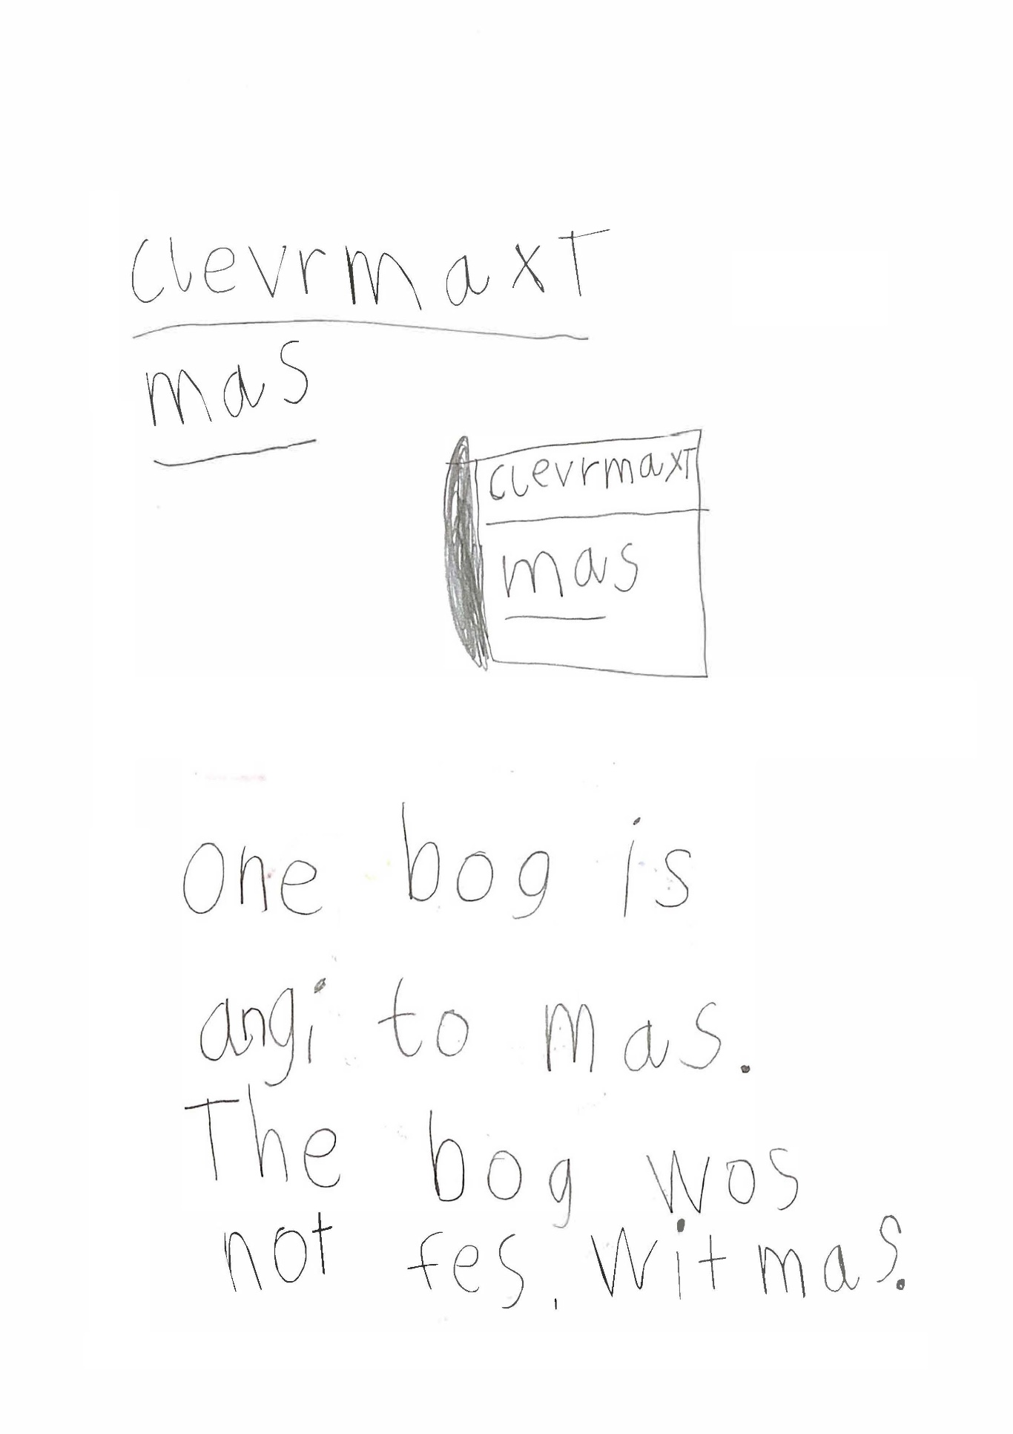

One dog is angi to mas Exemplar 10

Criteria | Option | Justification
Purpose and Audience | 4 | Writing can be easily read or decoded by others without scribing but an awareness of audience is not evident.  This script which retells an idea from the story can be easily read by others. An awareness of audience is not evident nor is there enough information for Option 5.
Print Organisation | 3 | Writing demonstrates some awareness of print organisation.  Writing is a left to right and top to bottom and there are spaces between words. Although letter formation is reasonably consistent, the d is reversed and as such, Option 4 can’t be considered.
Text Structure | 3 | Writing contains a sequence of events or ideas.  This script contains two connected sentences. The second sentence provides an appropriate elaboration of the first idea which helps the reader. This is a low Option 3.
Vocabulary | 3 | Writing contains simple vocabulary that contributes to a story or message OR Writing contains one or two examples of descriptive vocabulary.  This script contains just enough descriptive vocab for Option 3 - one dog, angry.  This script is a low Option 3.
Sentence Structure | 3 | Writing contains at least two correct sentences.  Exactly. There are two grammatically correct sentences.
Sentence Punctuation | 3 | Writing contains 1 or 2 correctly punctuated sentences.  The second sentence is punctuated correctly.
Other Punctuation | 1 | Writing contains no other punctuation marks.  Exactly.
Spelling | 3 | Correctly spells some words with simple letter patterns.  Correct simple: dog (reversed d is Print Organisation), is, to, the  Correct common: one  There are enough correct words with simple letter patterns for Option 3; however, one correct word with a common letter pattern is not enough for Option 4.

Rani lookt up Exemplar 11
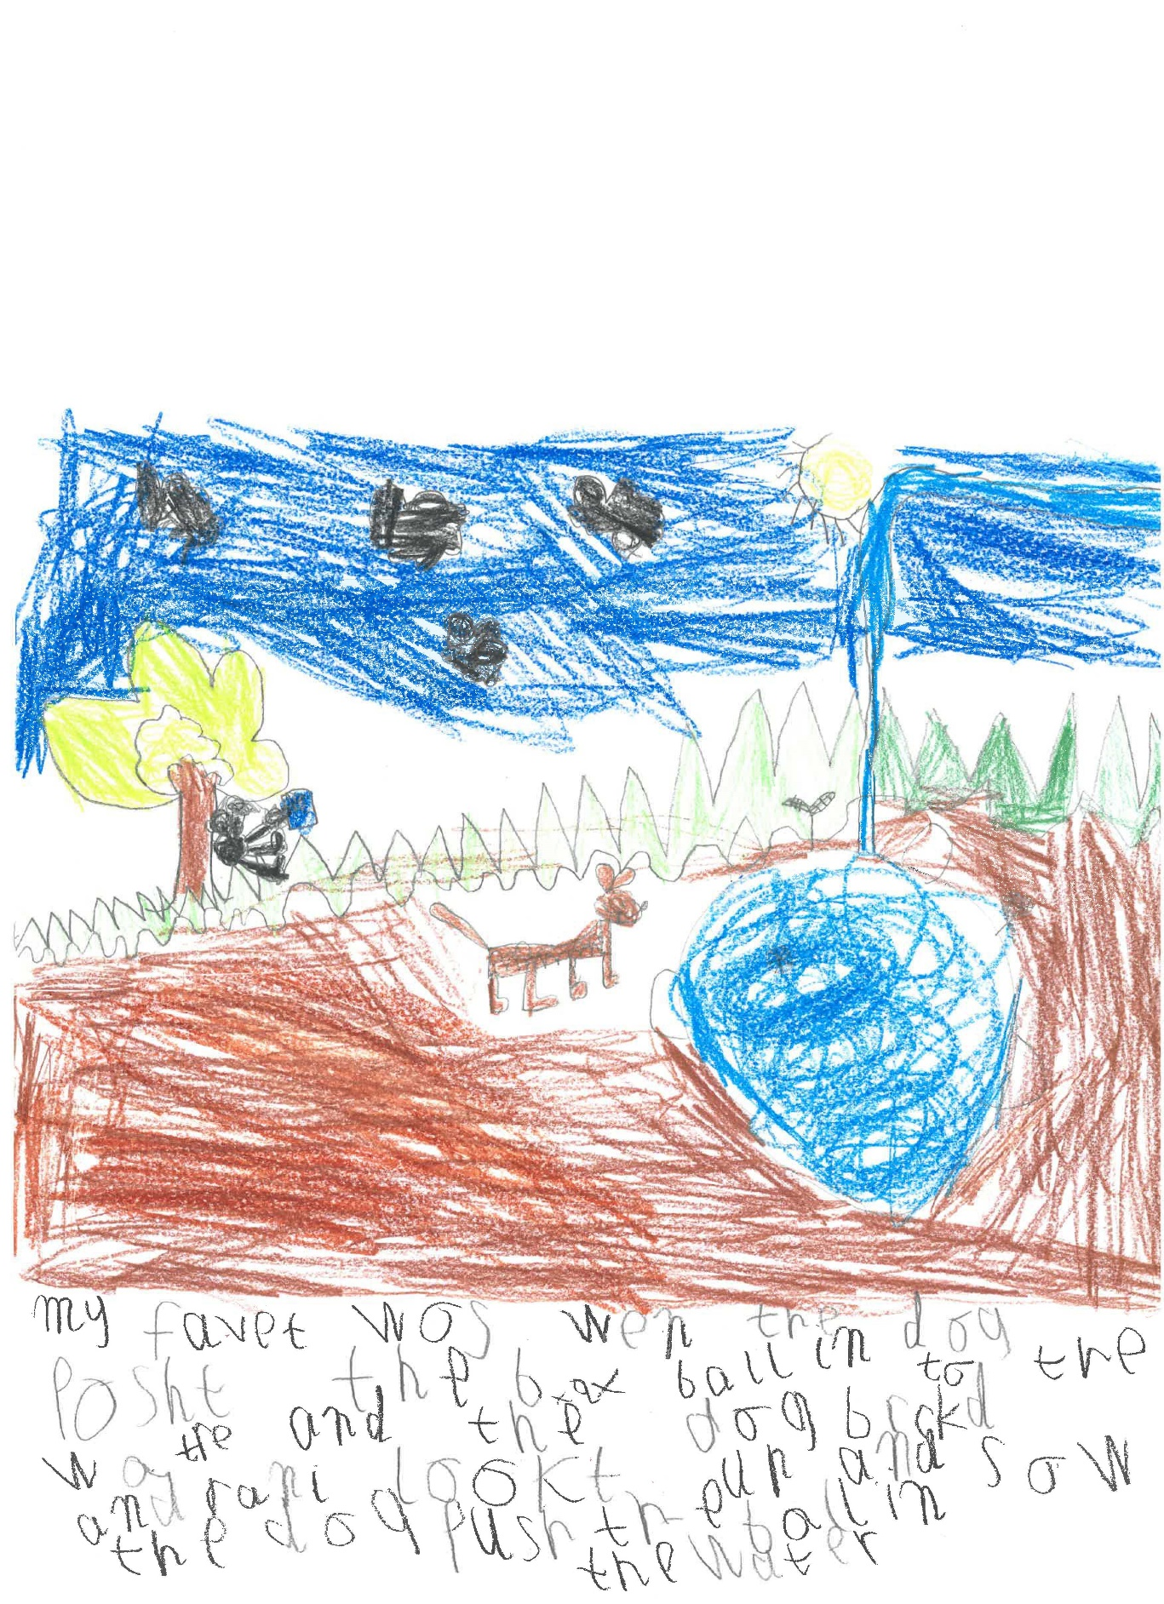

Rani lookt up Exemplar 11

Criteria | Option | Justification
Purpose and Audience | 5 | A beginning awareness of audience is evident. Writing contains information about events OR character/setting.  The writer has demonstrated an awareness of audience by including brief information events, character and setting.  Note: The writer has not been assigned Option 5 for My favourite was…which is in response to the prompt.
Print Organisation | 3 | Writing demonstrates some awareness of print organisation.  Writing is left to right and top to bottom and there are spaces between words. Letter formation is not consistent enough in size and shape, e.g., p for this to be Option 4.
Text Structure | 3 | Writing contains a sequence of events or ideas.  This text consists of a sequence of ideas about the game Max played. This isn’t considered a developed body, nor is there an orientation or ending. As such Option 4 cannot be considered.
Vocabulary | 3 | Writing contains simple vocabulary that contributes to a story or message OR Writing contains one or two examples of descriptive vocabulary.  Vocabulary is mostly simple and contributes to a brief story. Looked up provides some detail. There is not enough vocabulary that adds detail or imagery for Option 4 to be considered.
Sentence Structure | 3 | Writing contains one correct sentence with clauses joined by and, so or but.  Text consists of one sentence with clauses joined by and. Although there is a word missing - My favourite (part) was, this is not enough to keep it at Option 2.
Sentence Punctuation | 1 | Writing contains no correct sentence punctuation.  Exactly.
Other Punctuation | 1 | Writing contains no other punctuation marks.  Exactly.
Spelling | 4 | Correctly spells some words with common letter patterns.  Correct common: ball, push, water (last word)  There are just enough correct words with common letter patterns for Option 4.

Max the dog loved to play Exemplar 12

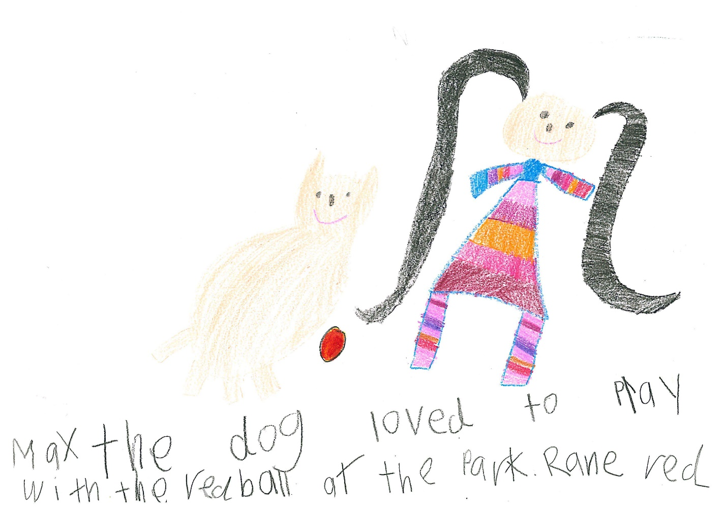

Max the dog loved to play Exemplar 12

Criteria | Option | Justification
Purpose and Audience | 5 | A beginning awareness of audience is evident. Writing contains information about events OR character/setting.  This script is highly unusual in that it demonstrates an awareness of audience in two sentences. Awareness of audience is demonstrated by including information about character, events and setting, i.e., Max is a dog; he plays ball at the park; Rani reads. In addition, the, and language choices show an awareness of audience, e.g., loved, red ball.
Print Organisation | 3 | Writing demonstrates some awareness of print organisation.  Writing is left to right and top to bottom and there are spaces between words. Letter formation is not consistent enough in size or shape for this to be Option 4.
Text Structure | 3 | Writing contains a sequence of events or ideas.  This script contains two connected ideas. This is a low Option 3.
Vocabulary | 3 | Writing contains simple vocabulary that contributes to a story or message OR Writing contains one or two examples of descriptive vocabulary.  Although there is not a lot of text, there are enough examples of descriptive vocabulary that adds imagery or detail for Option 3, i.e., loved, red ball.
Sentence Structure | 3 | Writing contains at least two correct sentences OR one correct sentence with clauses joined by and, so or but.  Text consists of one grammatically correct sophisticated complex sentence and one correct simple sentence.
Sentence Punctuation | 3 | Writing contains one or two correctly punctuated sentences.  The first sentence is correctly punctuated.
Other Punctuation | 1 | Writing contains no other punctuation marks.  Although Max and Rane both start with a capital, this has been considered in Sentence Punctuation as they are the first words in the sentence.
Spelling | 4 | Correctly spells some words with common letter patterns.  Correct common: loved, play, with, ball, park  There are enough words with common letter patterns spelt correctly for Option 4. Ten or more are required for Option 5.

They went to the crick Exemplar 13

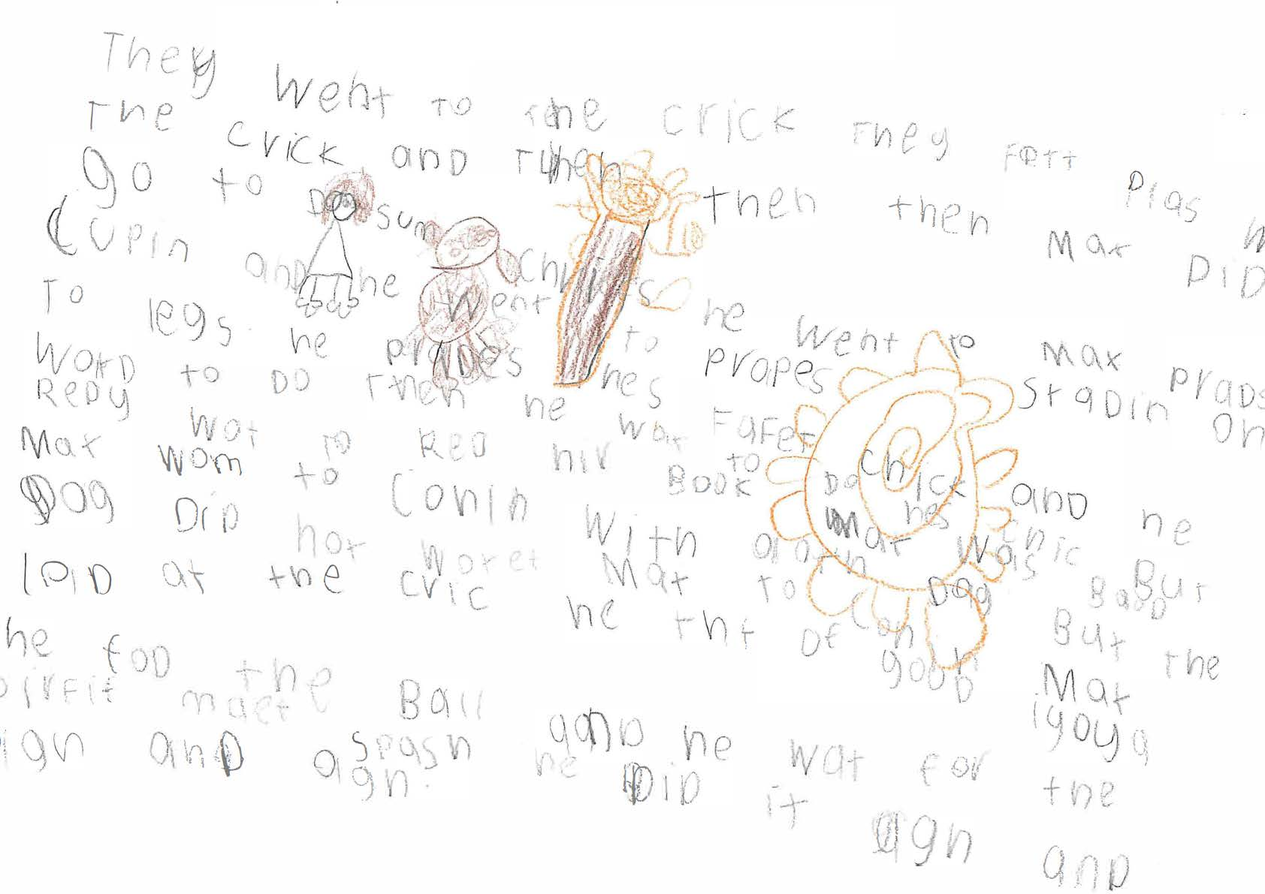

They went to the crick Exemplar 13

Criteria | Option | Justification
Purpose and Audience | 6 | Writer orients the reader by including some information about events AND character/setting. May be gaps in information.  This could be considered an uncommon piece of writing for a Pre-primary student. Although it is a little challenging to read, this is mostly due to the phonetic spelling and the non-alignment of the end and start of the lines. The awareness of audience is apparent through language choices and storytelling. There is enough information about events, character and setting to orient the reader for Option 6. There are too many gaps to consider Option 7.
Print Organisation | 3 | Writing demonstrates some awareness of print organisation.  Writing is left to right and top to bottom, top to bottom and there are spaces between words. The inconsistent spacing, the reversals and the random use of capitals prevent this from being Option 4.
Text Structure | 4 | Writing contains at least one developed structural component.  The body of this script is well developed. It contains a sequence of ideas and events which are elaborated, e.g., the tricks Max practiced, Max being bored and inventing a new game. The ending is adequate.
Vocabulary | 4 | Writing includes some vocabulary which enhances storytelling or provides imagery or detail.  Vocabulary that provides detail or imagery includes: their favourite place, standing on two legs, Max was bored, join in, good idea, splash (used to describe the sound of the ball in the water), again and again and again. There are enough examples of vocab that provides detail or enhances story telling for Option 4.
Sentence Structure | 3 | Writing contains at least two correct sentences  Although there are more than 2 correct sentences there are too sentence structure errors to consider Option 4.
Sentence Punctuation | 2 | Writing contains a capital letter to start a sentence or a correct sentence ending.  Writing starts with a capital. There are no other sentence punctuation marks.
Other Punctuation | 3 | 1 or 2 correct examples of other punctuation.  Max has a capital letter every time it is written. The name of the girl, i.e., Redy, also has a capital letter. Although there are some random capitals there is enough evidence to assume these capitals are used intentionally.
Spelling | 4 | Correctly spells some words with simple letter patterns and a few words with common letter patterns.  Correct common: they, then, went, with, book, ball,  There are enough correctly spelt words with common letter patterns for Option 4 but not enough for Option 5.

