On-entry Assessment program
Guide to Reports
AISWA and CEWA version

Contents
Section A: General Information 2
On-entry scale 3
Performance Standards 3
Support 3
Target setting 3
Section B: Accessing Reports 4
New reports in 2026 4
Generate current reports 4
Report Filters 4
Historical Reports 4
Report Summary 5
Section D: Reports in Detail 6
1. Students Details 6
2. Assessment Status 7
3. Student Distribution 8
4. Student Groups 9
5. Class Report 10
6. WA Curriculum - Planning 11
7. Individual Student Profile 12
8. Student Assessment Notes 13
9. T1 & T4 CLASS REPORT 14
10. Cohort Report 15
11. Performance Summary 15
12. Student Performance 17
13. All Assessment Overview 21
14. Student progression 22
15. Parent Summary 24

Section A: General Information
Principals, teachers and school administrators can access the On-entry assessment literacy and numeracy reports, for current and previous students at any time.

The reports are designed to:
- inform the planning and delivery of targeted programs, reflective of individual students’ skills and understandings
- identify, early in the school year, students who may require intervention or extension
- monitor the progress for students in Years 1 and 2 and
- inform whole school planning, review programs, priorities or initiatives.

Please note: The On-entry assessment provides teachers information about the skills and understandings each child in their class commences pre-primary with. Teachers use this information to plan for learning. Children have the whole year to demonstrate the end of year Achievement Standard.
On-entry assessment provides a baseline score for every student. This score is not reflective of teaching and learning under the Kindergarten Guidelines and should not be used to set targets for Pre-primary students or review Kindergarten programs.

On-entry scale

Student performance is reported as a scale score, measured against the On-entry scale. This scale measures discrimination of performance, each raw score is converted to a different scale score.
All modules are on the same scale. Regardless of the module assessed, students who achieve the same score have demonstrated the same ability. For example, a Year 1 student who scores 500 in reading using Module 2 has the same ability as another student who scores 500 using Module 1.

Writing
Writing is scored using a common marking rubric for Pre-primary – Year 2 and performance is reported on a common scale. The marking rubric and resulting scale captures the developmental continuum in writing, for most students, from the beginning of Pre-primary to the end of Year 2. It may be reasonable to expect that most Pre-primary students will be at the lower end of the scale, most Year 1 students at the lower to middle range of the scale and most Year 2 students at the middle to upper range of the scale.

Performance Standards

As On-entry assesses students in the first few weeks of the first year of compulsory schooling, it is not appropriate to set targets for the beginning of Pre-primary. However, it is appropriate to set targets for the beginning of Year 1 and the beginning of Year 2 – in terms of performance.

On-entry provides schools with a baseline score at the start of the pre-primary year, any comparisons to on-entry scores should be based on historical Term 1 data. Term 4 data should not be used to compare progress. Comparative medians for schools with similar ICSEA are available. Contact your sector administrators for this information.

Support

For further information please contact CEWA: 6380 5200 or AISWA: 9441 1669

Section B: Accessing Reports

New reports in 2026
6. WA Curriculum – Planning: This report groups students in a class by the skills assessed in the On-entry assessment and provides teachers support to plan evidence-based teaching and learning aligned with the WA curriculum.
7. Individual Student Profile: Displays each student’s achievement of WA curriculum content assessed in the On-entry assessment and can be used to plan, implement and monitor individualised teaching and learning programs.

Generate current reports
To access current reports, follow the steps below.

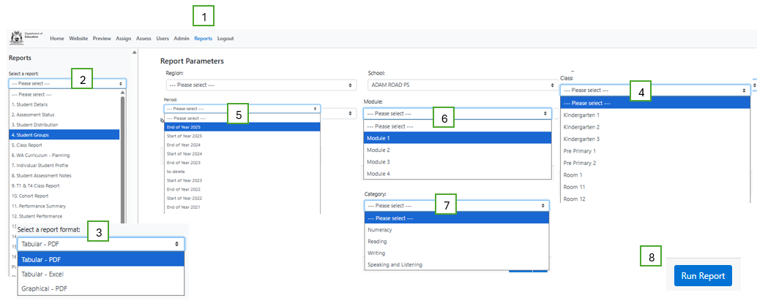

1. Click on Reports tab at the top of the screen.
2. Select the required report from the Select a report drop down menu.
3. Select the required report format, i.e. PDF, Excel or graphical, from the drop-down menu.
4. Select the required class (omit this step if cohort data is required).
5. Select the relevant assessment period, e.g. Start of 2026.
6. Select the relevant module, i.e. Module 1, 2, 3 or 4 (not required for all reports).
7. If relevant, select the required assessment from the Category drop down menu (not required for all reports).
8. Click Run Report. Open the report from the download bar at the bottom of your screen.

Report Filters
Report filters enable sub-group data to be generated, i.e. year level, gender, ATSI and/or EALD.

Note: If sub-group data is not required, leave this section blank, including year level.

Historical Reports
Reports are based on students’ current year level and class. To generate historical reports, follow the steps outlined above. Select the required assessment period, e.g. Start of 2024; but leave the Class and Year Level blank. This will generate a report for all students who completed an assessment during the selected period.

Report Summary

Report Title | Display | Target Audience
1. Student Details | Displays student details including date of birth, gender, current year level, current class, ATSI and EALD status as entered in SIS also displays completed assessments. | Teacher  Principal
2. Assessment Status | Displays the participation status for students i.e the numbers of students who have assessments finalised, not started, incomplete or exempted/withdrawn. | Teacher  Principal
3. Student Distribution | Displays each student’s name and their score at their location along the scale. | Teacher
4. Student Groups | Displays students’ names in one of five groups according to the percentage of the assessment answered correctly. | Teacher
5. Class Report | Displays the responses that each student in a class provided to all questions in the assessment. | Teacher
6. WA Curriculum – Planning* | Displays student groups linked to WA curriculum content assessed in On-entry assessment. | Teacher
7. Individual Student Profile* | Displays individual student achievement of WA curriculum content assessed in On-entry | Teacher
8. Student Assessment Notes | Displays the notes taken by the teacher/administrator during the assessment. | Teacher  Principal
9. T1&T4 class report | T1 and T4 class report displays responses in Term 1 and Term 4 for students assessed. | Teacher
10. Cohort Report | Displays the responses that each student provided to all questions in a cohort (all students assessed in the selected module). | Principal
11. Performance Summary | Displays the number, percentage and cumulative frequency of students in a class or cohort at each score range on the scale. Does not display student names. | Teacher  Principal
12. Student Performance | Displays each student’s scale score for all completed assessments. | Teacher
13. All Assessment Overview | Contains all current students’ scores for every On-entry assessment completed. | Teacher
14. Student Progression | Shows progress from one assessment to the next for all completed modules except Speaking and Listening. | Teacher
15. Parent Summary | Individual report that displays skills and understandings the student demonstrated during the assessment. | Parent
*New in 2026

Section D: Reports in Detail
This section explains each report, including the information displayed, the purpose of the report, how you can use the information, the target audience and the formats in which you can generate the reports, i.e., PDF, Excel, Graphical. Excel allows you to manipulate and sort the data. Graphical PDF provide an alternative view of the data and may assist you to contextualise performance against the scale.

Note: The reports displayed in this section are actual school reports and as such contain redacted information.

1. Students Details

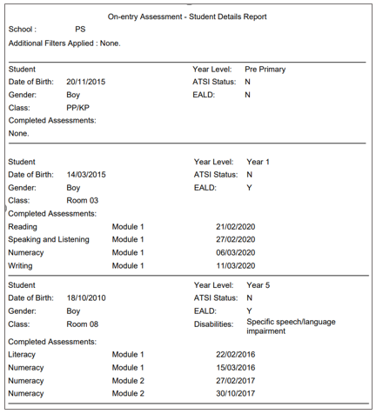

Information | Students’ details as recorded in School Information System (SIS) - including name (legal name), date of birth, gender, current year level, current class, ATSI status, EALD and disability.  In addition, the report displays all previously completed On-entry assessments.
Purpose | Verify the accuracy of student information, e.g. correct class. Any changes made in SIS will appear in On-entry the following day.

2. Assessment Status

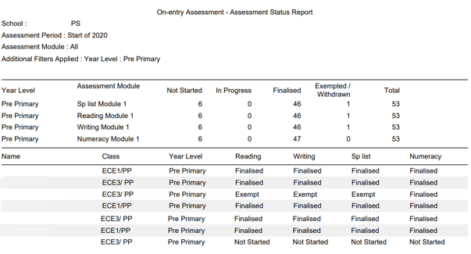

Information | Displays current participation status – not started, in progress, finalised, withdrawn or exempted at the year, class and individual level.
Purpose | Enables the user to monitor the progress of assessments to ensure that all assessments are finalised before the assessment period closes. Note that assessments recorded on hard copies may appear as Not Started. Assessment status will only change to In progress once the user has started an assessment in the system.

3. Student Distribution

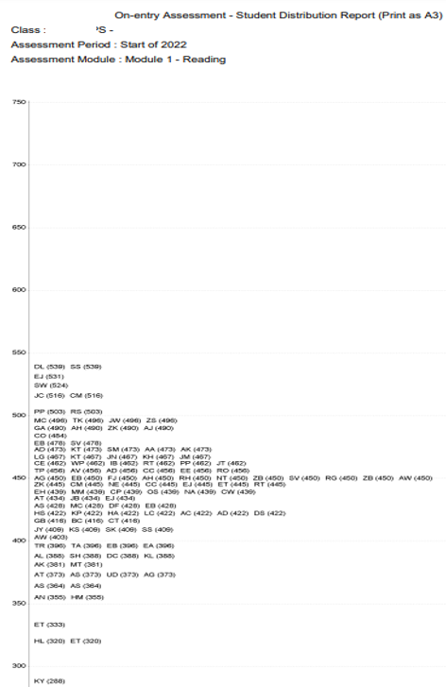
Information | Displays students’ names and their score at their location along the scale.  Note that names default to initials when there are too many characters to fit names on a line.
Purpose | Enables the user to observe the rank order of a class/cohort in relation to the scale. This report may highlight differences in student performance and may indicate students who require close monitoring, intervention or extension.

4. Student Groups

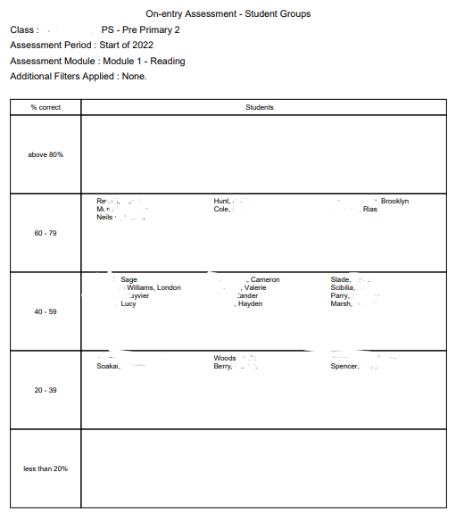

Information | Groups students with similar abilities based on the percentage of questions answered correctly. This report is available for each assessment category - Reading, Speaking and Listening, Writing and Numeracy.  Due to the nature of the Writing scale, groupings are based on raw scores.
Purpose | This report assists the teacher to deliver differentiated teaching opportunities according to the skills and undertandings of each student.  If appropriate, groups can be merged e.g. 1 student in a group. If this is the case, move the student to the most appropriate group based on their scale score.

5. Class Report

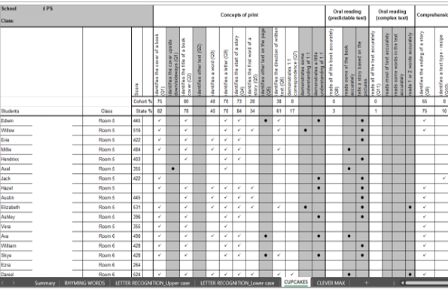

Information | Displays students’ correct responses with a , incorrect responses and no attempts are blank. Partially correct response  Each task is displayed in a different tab (shown at the bottom of the spreadsheet). The sort function can be used to sort students by score. Displays students who have not completed the assessment.
Purpose | Enables the teacher to identify the skills and understandings demonstrated by each student during the assessment and to plan teaching programs that target the needs of individuals, groups and the class as a whole.  Teachers can use the Class Report throughout the year to record students’ development in skills and understandings assessed in On-entry. In addition, the user can insert extra columns to record additional skills and understandings not assessed in On-entry where appropriate.  A blank Writing Class Report is available on the website to record students’ writing for subsequent writing activities or classes where On-entry is not administered.

6. WA Curriculum - Planning
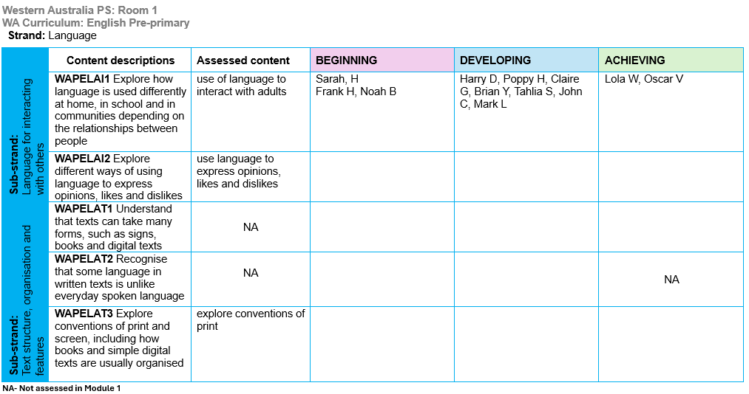

Information | Generates groups of students based on their performance and links the content assessed in the On-entry assessment to the WA curriculum content descriptions.  Matching ‘what now’ teaching resources for English and Mathematics are available in the ‘On-entry assessment’ connect community library. Join connect community to access these resources.
Purpose | Provides the teacher evidence-based planning support using on-entry assessment data. Teachers can use this to deliver differentiated teaching and learning programs for their students based on the skills and understandings demonstrated during the assessment.

7. Individual Student Profile
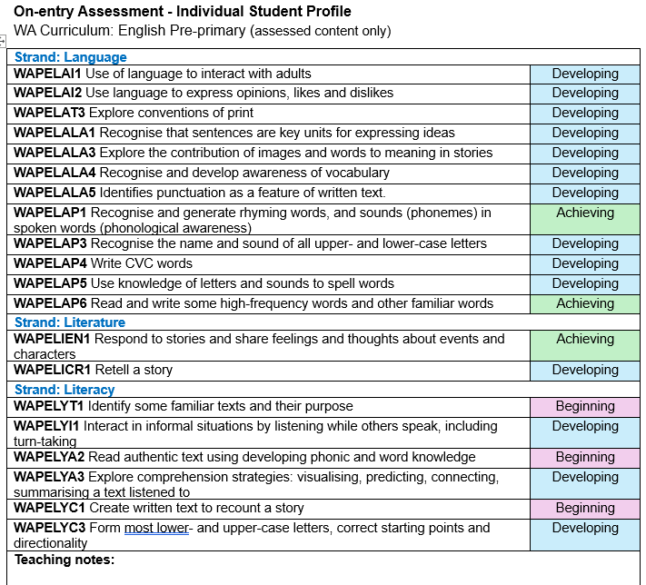

Information | Displays individual student achievement of the WA curriculum content assessed in the Module 1 On-entry assessment for English and Mathematics.
Purpose | Provides teachers with an individual student profile of assessed skills to inform targeted teaching and learning aligned directly to the WA curriculum.  Supports teacher-parent/carer conversations during one on one meetings; not intended for distribution to parents.  Enables informed collaboration with allied health professionals to support individual student needs.

8. Student Assessment Notes

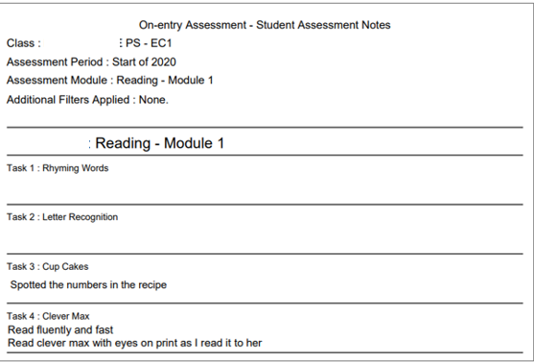

Information | Teachers can take down notes during the one-on-one interaction with their students during the assessment. These notes can be generated as report even if the assessment is not finalised.
Purpose | To support discussions regarding student performance/progress. Documentation for referrals to allied health services.

9. T1 & T4 CLASS REPORT
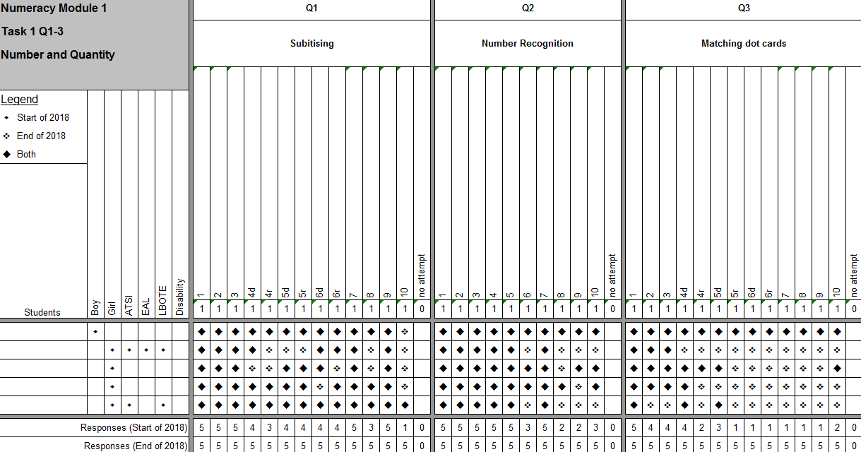

Information | This report displays the Term 1 and Term 4 responses for students who have been reassessed in Term 4.
Purpose | To compare Term 1 and Term 4 performance and measure progress. Review teaching and learning programs for individual students.

10. Cohort Report
The Cohort Report contains the same information as the Class Report for all students assessed in the period and module selected regardless of the class. Sort function can be used to sort classes and scores. This report is useful for admintrators and teachers who work across multiple classes.

11. Performance Summary

Performance Summary Report – Excel/PDF

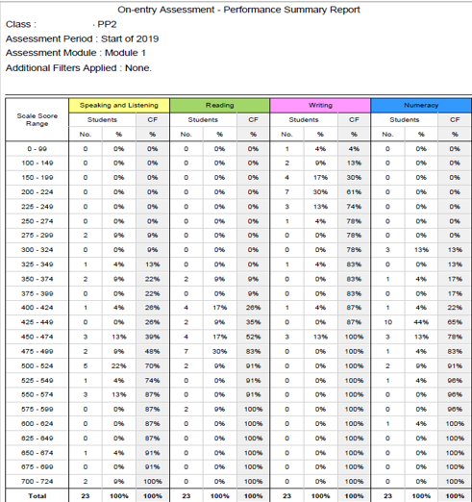

Information | Displays the number (No.) and percentage (%) of students in a class or cohort at each score range on the On-entry scale.  The Cumulative Frequency (CF) shows the percentage of students at and below each score range. The CF shows the distribution of students across the scale.
Purpose | Enables observations about the distribution of a class/cohort across the scale.  Note: the distribution of students in Writing should be made with the understanding that the Writing scale covers Pre-primary to Year 2.  A visual display of this information can be generated by selecting graphical format.

Performance Summary: graphical

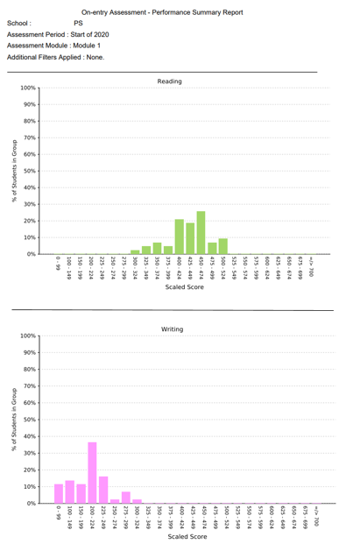

Information | Displays a visual representation of the performance summary data, i.e., percentage of students in a class or cohort at various score ranges on the scale.
Purpose | Enables the user to observe the distribution of a class/cohort against the full scale.  Note: ensure observations regarding the distribution of Writing are with the understanding that the Writing scale covers Pre-primary to Year 2. It is expected that most Pre-primary students will be at the lower ranges of the scale.

12. Student Performance

Various display options and formats are available to display students’ scores. These include displaying all or selected assessment categories and displaying the data in PDF, Excel or Graphical formats. Instructions for generating the various forms of this report are explained below.

Student Performance – more than one assessment category (PDF/Excel)

To display student scores for more than one assessment in the same report, select the required assessments from the Categories drop-down menu. If more than one assessment is selected the data will be sorted in alphabetical order.

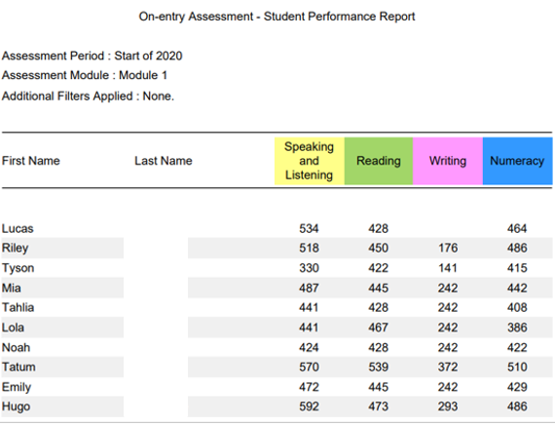

Information | Displays students’ scores for all selected assessment categories. Sorts data by surname alphabetical order. All students’ scores can be generated on one report irrespective of modules assessed. This is particularly useful students are assessed using off modules within a class or cohort.
Purpose | Enables the user to view the performance of all students in a class/cohort in more than one assessment category irrespective of the modules assessed.

Student performance – graphical more than one assessment category
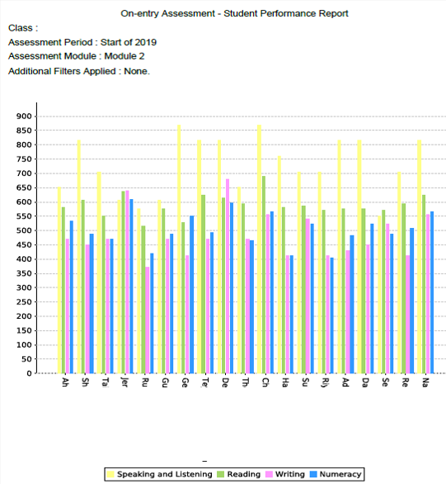

Information | Graphs students’ scores for all selected assessment categories. Names appear on the horizontal axis, sorted in alphabetical order.
Purpose | Enables the user to observe individual student performance each assessment in relation to the full scale, other assessments and other students in the class.  Note: comparisons of Writing scores with other assessment categories are not appropriate as the Writing scale covers Pre-primary to Year 2.

Student Performance – one assessment category only (PDF/Excel)

To display one assessment category only, select the required assessment in the Categories drop-down menu. This option will sort students in descending order according to score.

To compare the rank order of one assessment to other assessments, a report for each category needs to be downloaded individually.

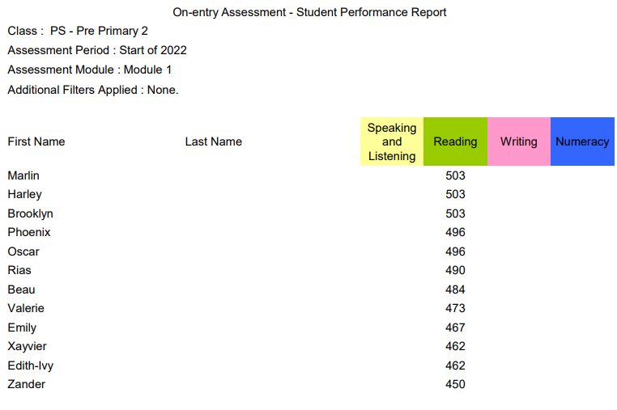

Information | Displays students’ scores for only the assessment category selected. Sorts the data from highest to lowest score.
Purpose | Enables the user to view the rank order of a class/cohort. By downloading each assessment individually, the user can compare the rank orders of each of the assessments.

Student performance – one assessment category only

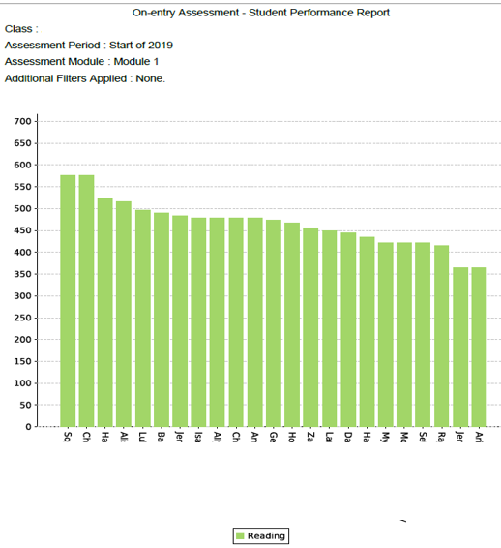

Information | Graphs students’ scores for only the assessment category selected. Sorts the data from highest to lowest score, left to right.
Purpose | Enables the user to view the rank order of a class/cohort in relation to the scale.

13. All Assessment Overview

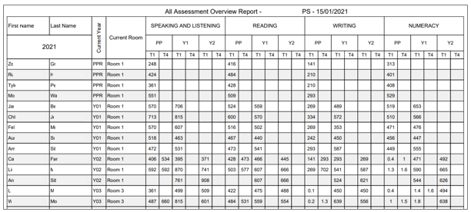

Information | Contains the scores for every completed On-entry assessment for all current students.  Note: scores for Numeracy assessments completed prior to 2019 appear as development points. Scores for Writing assessments completed prior to 2018 appear as progression points. As such, historical links are not possible prior to these dates.
Purpose | Enables the user to:  - manually calculate mean/median scores for selected groups, e.g., class/year groups  - compare the performance of students within the school, over time  - calculate individual student progress manually from one assessment to the next  - compare the progress of individual students to students with similar abilities

14. Student progression
The Student Progression report allows two different displays of the data:
- individual student report displaying progress for all completed assessments
- all students in a class/cohort - one assessment category per report

Indivdual Student progression report

To display an individual Student Progression report, follow the steps below.
- Select 15.Student Progression, graphical format.
- Select the relevant class in the Class drop-down menu.
- Students’ names will be displayed in the Students list.
- From the list of students, select all required students by holding the control key and clicking on the student’s/s’ name/’s. Note: omit this step if all students are required.
- Select the required assessment categories, i.e. Reading, Writing, Speaking and Listening, from the Assessment Categories drop-down menu by holding the the control key and clicking on the assessments.
- Select Student in the Group Chart By drop-down menu.
- Click Run Report.

1. Student Selection
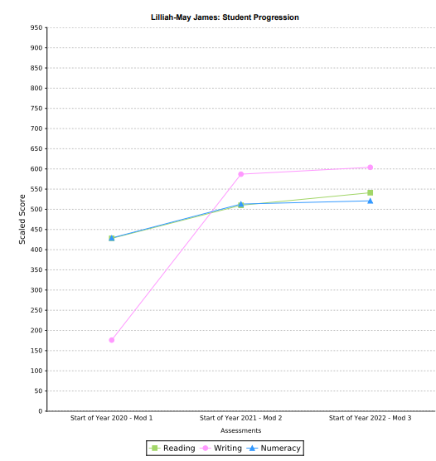
Information | Displays individual student progression from one assessment to the next for all completed modules in assessment categories selected.
Purpose | Enables the user to observe progression from one year to the next and compare progress in assessment categories.

2. Category Selection

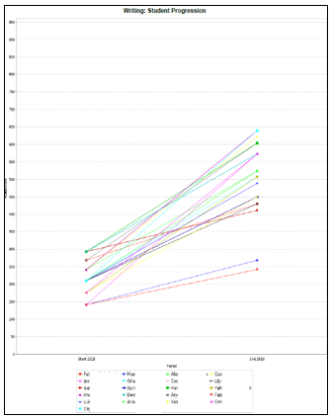

Information | Displays progression from one assessment to the next for all completed modules and one selected category for all selected students in a class.
Purpose | Enables the user to compare the progress of each student in an assessment category. User can identify students who have not made the same progress as their peers.

16. Parent Summary

Page 1 Page 2
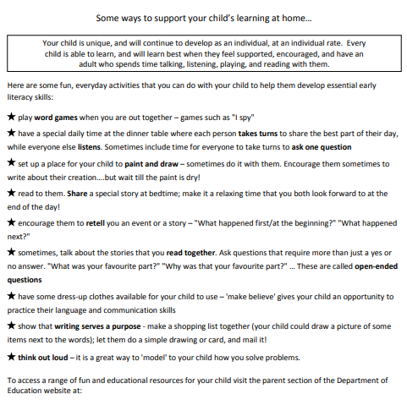
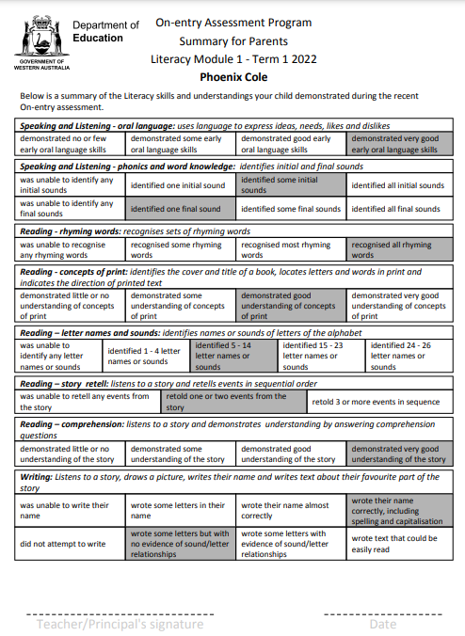

Information | Inform parents/care givers of the skills and understandings that their child demonstrated during the assessment. The summary also includes suggested activities that they can to at home to support their child’s learning. The Summary for Parents is a snapshot only and does not include all skills and understandings assessed.
Purpose | To report to their parents/caregivers the skills and understandings demonstrated by their child during the assessment and to suggest ways parents/caregivers can support their child’s learning at home.

