On-entry Assessment Program

Guide to reporting
AISWA and CEWA version
Contents
Section A: General Information 3
On-entry scale 3
Performance Standards 3
Target setting 3
Section B: Accessing Reports 4
Current Reports 4
Report Filters 4
Historical Reports 4
Report Summary 5
Section D: Reports in Detail 6
1. Students Details 6
2. Assessment Status 7
3. Performance Summary 8
4. Student Performance 10
6. Student Groups 15
8. Planning Report 17
9. Parent Summary 18
10. Student Assessment Notes 19
12. All Assessment Overview 21
13. Student progression 22
14. Cohort Report 24

Section A: General Information
Principals, teachers and school administrators can access the On-entry assessment reports literacy and numeracy reports, for current and previous students at any time.

Teachers can access reports related to their class only, principals (and staff assigned an administrator role) can access all individual, class and cohort reports.

The reports are designed to:
- inform the planning and delivery of targeted programs, reflective of individual students’ skills and understandings;
- identify, early in the school year, students who may require intervention or extension;
- monitor the progress for students in Years 1 and 2 and
- inform whole school planning, review programs, priorities or initiatives.

On-entry scale
Student performance is reported as a scale score, measured against the On-entry scale. This scale measures discrimination of performance, each raw score is converted to a different scale score.
All modules are on the same scale. Regardless of the module assessed, students who achieve the same score have demonstrated the same ability. For example, a Year 1 student who scores 500 in reading using Module 2 has the same ability as another student who scores 500 using Module 1.

Writing
Writing is scored using a common marking rubric from Pre-primary – Year 2 and performance is reported on a common scale. The marking rubric and resulting scale captures the developmental continuum in writing, for most students, from the beginning of Pre-primary to the end of Year 2. It may be reasonable to expect that most Pre-primary students will be at the lower end of the scale, most Year 1 students at the lower to middle range of the scale and most Year 2 students at the middle to upper range of the scale.

Performance Standards
There is no ‘desirable score’ or minimum standard for the commencement of Pre-primary. Median scores can be used in combination with the trends in historical data to better understand the On-entry data. Evidence shows that a low score at the beginning of Pre-primary does not predict a student’s capacity to progress through school. Additional evidence is required to make judgements about the student’s skills and understandings early in the year to determine whether early intervention is required.

Whilst there are currently no desirable scores for students in Years 1 and 2, the median scores and average progression may be used to compare individual and group performances this again may be based on trends in historical data.

Target setting
As On-entry assesses students in the first few weeks of the first year of compulsory schooling, it is not appropriate to set targets for the beginning of Pre-primary. However, it is appropriate to set targets for the beginning of Year 1 and the beginning of Year 2 – in terms of either performance.

On-entry assessment is designed for the start of the year; hence any comparison of On-entry scores should only be based on Term 1 assessments. Term 4 assessments cannot be used for any comparisons.

Section B: Accessing Reports

Current Reports
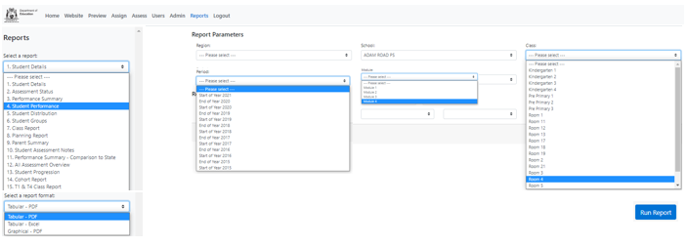
To access current reports, follow the steps below.
2

3
4
6
5
8
1

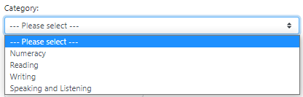
7

1. Click on Reports at the top of the screen.
2. Select the required report from the Select a report drop down menu.
3. Select the required report format, i.e., PDF, Excel or graphical, from the drop-down menu.
4. Select the required class (omit this step if cohort data is required).
5. Select the relevant assessment period, e.g., Start of 2022.
6. Select the relevant module, i.e., Module 1, 2, 3 or 4 (not required for all reports).
7. If relevant, select the required assessment from the Category drop down menu (not required for all reports).
8. Click Run Report. Open the report from the download bar at the bottom of your screen.

Report Filters
Report filters enable sub-group data to be generated, i.e. year level, gender, ATSI and/or EALD.

Note: If sub-group data is not required, leave this section blank, including year level.

Historical Reports
Reports are based on students’ current year level and class. To generate historical reports, follow the steps outlined above. Select the required assessment period, e.g. Start of 2018; but leave the Class and Year Level blank. This will generate a report for all students who completed an assessment during the selected period.

Report Summary

Report Title | Display | Target Audience
1. Student Details | Displays student details including date of birth, gender, current year level, current class, ATSI and EALD status as entered in SIS also displays completed assessments. | Teacher  Principal
2. Assessment Status | Displays the participation status for students i.e., the numbers of students who have assessments finalised, not started, in complete or exempted. | Teacher  Principal
3. Performance Summary | Displays the number, percentage and cumulative frequency of students in a class or cohort at each score range on the scale. Does not display student names. | Teacher  Principal
4. Student Performance | Displays each student’s scale score for all completed assessments. | Teacher
5. Student Distribution | Displays each student’s name and their score at their location along the scale. | Teacher
6. Student Groups | Displays students’ names in one of five groups according to the percentage of the assessment answered correctly. | Teacher
7. Class Report and  15. T1&T4 class report | Displays the responses that each student in a class provided to all questions in the assessment. T1 and T4 class report displays responses in Term 1 and Term 4 for students assessed. | Teacher
8. Planning Report | Groups students according to specific skills and undertandings demonstrated in the On-entry assessment. | Teacher
9. Parent Summary | Individual report that displays key skills and understandings the student demonstrated during the assessment. | Parent
10. Assessment Notes | Displays the notes taken by the teacher/administrator during the assessment. | Teacher  Principal
12. All Assessment Overview | Contains all current students’ scores for every On-entry assessment completed. | Teacher
13. Student Progression | Shows progress from one assessment to the next for all completed modules. Due to the nature of the Speaking and Listening assessment, progress in this category is not displayed. | Teacher
14. Cohort Report | Displays the responses that each student in a cohort provided to all questions in the assessment. Select this report to view more than one class on the same report. | Principal

Section D: Reports in Detail
This section explains each report, including the information displayed, the purpose of the report, how you can use the information, the target audience and the formats in which you can generate the reports, i.e., PDF, Excel, Graphical. Excel allows you to manipulate and sort the data. Graphical PDF provide an alternative view of the data and may assist you to contextualise performance against the scale.

Note: The reports displayed in this section are actual school reports and as such contain redacted information.

1. Students Details
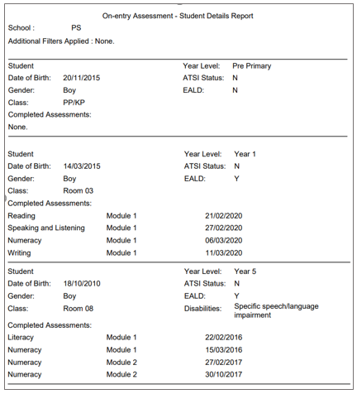

Information | Students’ details as recorded in School Information System (SIS) - including name (legal name), date of birth, gender, current year level, current class, ATSI status, EALD and disability. In addition, the report displays all previously completed On-entry assessments.
Purpose | Verify the accuracy of student information, e.g. correct class. Any changes made in SIS will appear in On-entry the following day.

2. Assessment Status

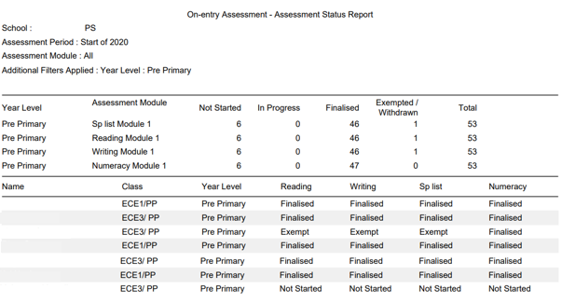

Information | Displays current participation status – not started, in progress, finalised, withdrawn or exempted at the year, class and individual level.
Purpose | Enables the user to monitor the progress of assessments to ensure that all assessments are fianlised before the assessment period closes. Note that assessments recorded on hard copies may appear as Not Started. Assessment status will only change to In progress once the user has started an assessment in the system.

3. Performance Summary

Performance Summary Report – Excel/PDF

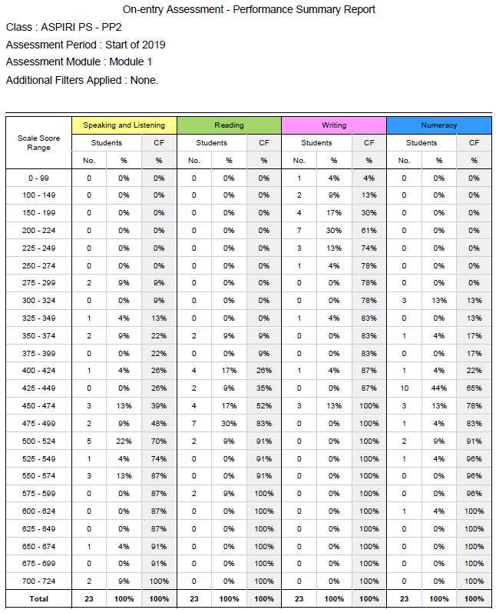

Information | Displays the number (No.) and percentage (%) of students in a class or cohort at each score range on the On-entry scale.  The Cumulative Frequency (CF) shows the percentage of students at and below each score range. The CF shows the distribution of students across the scale.
Purpose | Enables observations about the distribution of a class/cohort across the scale.  Note: observations regarding the distribution of students in Writing should be made with the understanding that the Writing scale covers Pre-primary to Year 2.  A visual display of this information can be generated by selecting graphical format.

Performance Summary: graphical

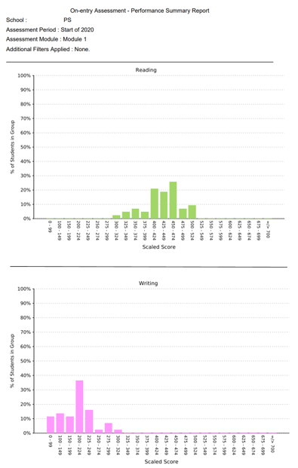

Information | Displays a visual representation of the performance summary data, i.e., percentage of students in a class or cohort at various score ranges on the scale.
Purpose | Enables the user to observe the distribution of a class/cohort against the full scale.  Note: ensure observations regarding the distribution of Writing are with the understanding that the Writing scale covers Pre-primary to Year 2. It is expected that most Pre-primary students will be at the lower ranges of the scale.

4. Student Performance

Various display options and formats are available to display students’ scores. These include displaying all or selected assessment categories and displaying the data in PDF, Excel or Graphical formats. Instructions for generating the various forms of this report are explained below.

Student Performance – more than one assessment category (PDF/Excel)

To display student scores for more than one assessment in the same report, select the required assessments from the Categories drop-down menu. If more than one assessment is selected, the data will be sorted in alphabetical order.

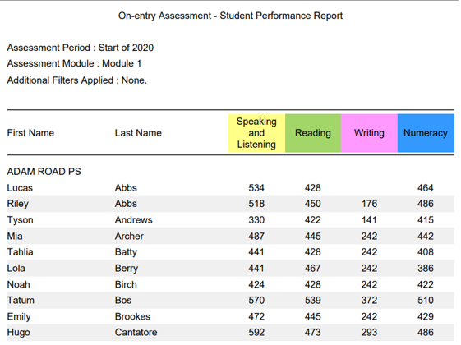

Information | Displays student’s scores for all selected assessment categories. Sorts data by surname alphabetical order.
Purpose | Enables the user to view the performance of all students in a class/cohort in more than one assessment category.

Student performance - more than one assessment category

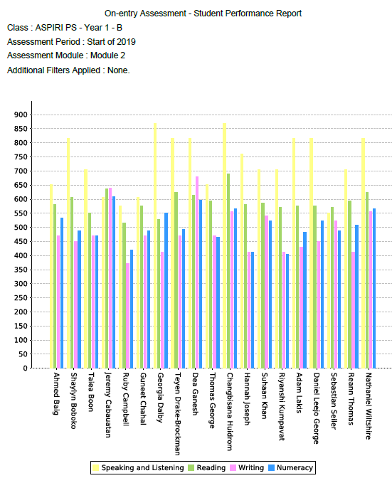

Information | Graphs student’s scores for all selected assessment categories. Names appear on the horizontal axis, sorted in alphabetical order.
Purpose | Enables the user to observe individual student performance each assessment in relation to the full scale, other assessments and other students in the class.  Note: comparisons of Writing scores with other assessment categories are not appropriate as the Writing scale covers Pre-primary to Year 2.
Student Performance – one assessment category only (PDF/Excel)

To display one assessment category only, select the required assessment in the Categories drop-down menu. This option will sort students in descending order according to score.

To compare the rank order of one assessment to other assessments, a report for each category needs to be downloaded individually.

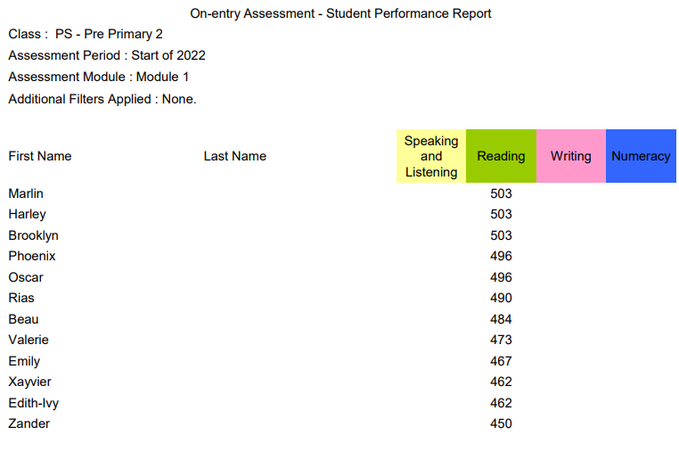

Information | Displays students’ scores for only the assessment category selected. Sorts the data from highest to lowest score.
Purpose | Enables the user to view the rank order of a class/cohort. By downloading each assessment individually, the user can compare the rank orders of each of the assessments.

Student performance – one assessment category only

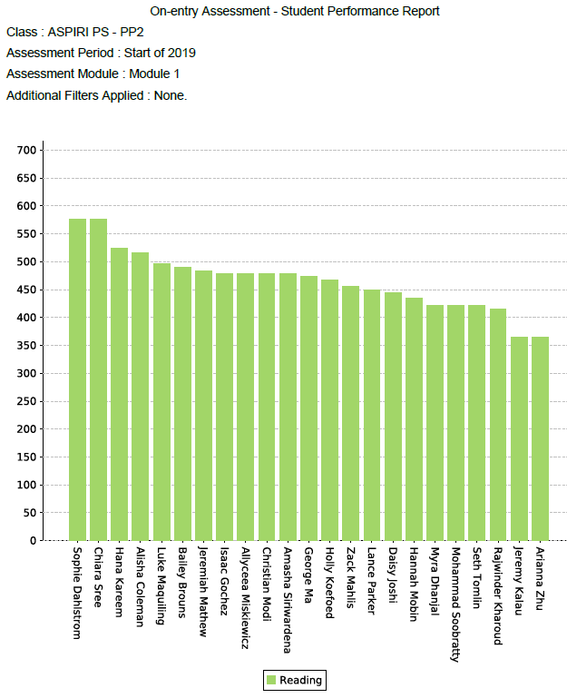

Information | Graphs students’ scores for only the assessment category selected. Sorts the data from highest to lowest score, left to right.
Purpose | Enables the user to view the rank order of a class/cohort in relation to the scale.

5. Student Distribution

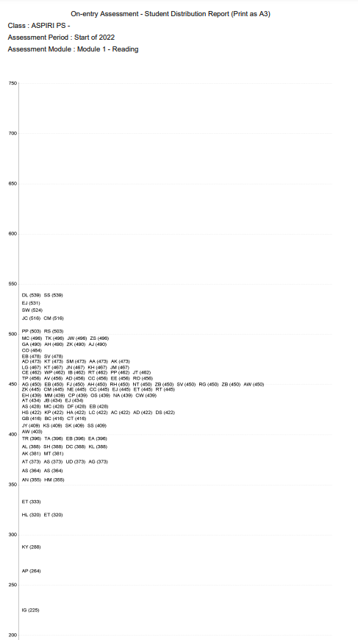
Information | Displays students’ names and their score at their location along the scale.  Note that names default to initials when there are too many characters to fit names on a line.
Purpose | Enables the user to observe the rank order of a class/cohort in relation to the scale. This report may highlight differences in student performance and may indicate students who require close monitoring, intervention or extension.

6. Student Groups

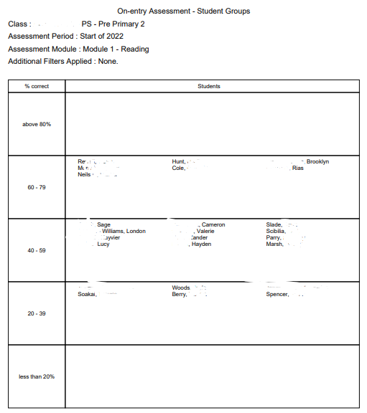

Information | Groups students with similar abilities based on the percentage of questions answered correctly.  This report is available for each assessment category - Reading, Speaking and Listening, Writing and Numeracy.  Due to the nature of the Writing scale, groupings are based on raw scores.
Purpose | This report assists the teacher to deliver differentiated teaching opportunities according to the skills and undertandings of each student.  If appropriate, groups can be merged, e.g., 1 student in a group. If this is the case, move the student to the most appropriate group based on their scale score.

7. Class Report

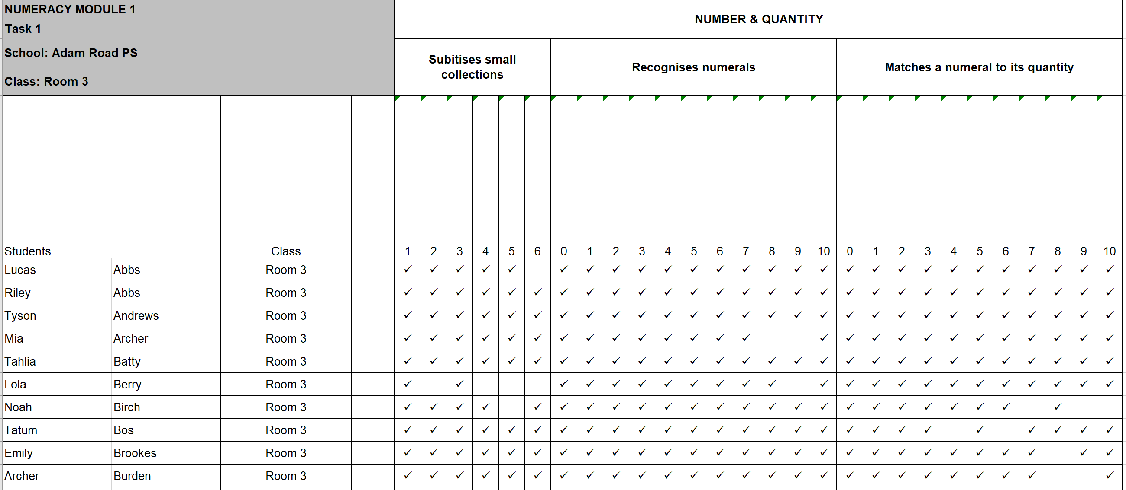

Information | Displays students’ correct responses to all questions in the assessment. Incorrect responses and no attempts are blank.  Each task is displayed in a different tab (shown at the bottom of the spreadsheet).
Purpose | Enables the teacher to identify the skills and understandings demonstrated by each student during the assessment and to plan teaching programs that target the needs of individuals, groups and the class as a whole.  Teachers can use the Class Report throughout the year to record and monitor students’ development in skills and understandings assessed in On-entry. In addition, the user can insert extra columns to record additional skills and understandings not assessed in On-entry where appropriate.  A blank Writing Class Report is available on the website (under the Literacy tab) to record students’ writing (and plan for improvement) for classes where On-entry is not administered.

8. Planning Report
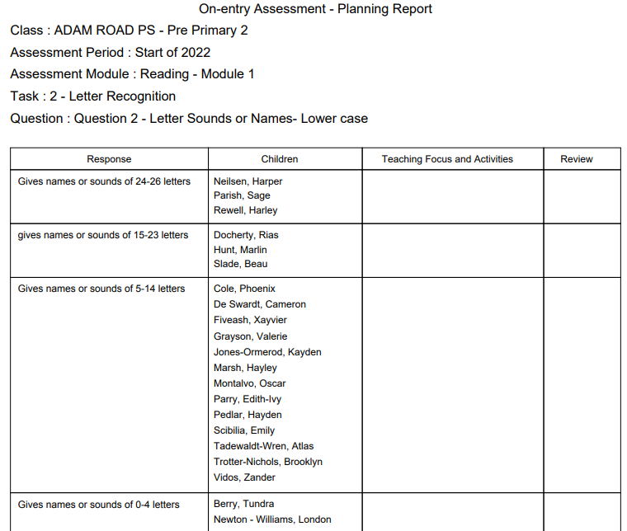

Information | Groups students with similar abilities in the specific skills and undertandings assessed.  This report is available for each set of skills and understandings assessed and for all modules in the program.
Purpose | This report assists the teacher to deliver differentiated teaching opportunities according to the skills and undertandings of each student.

9. Parent Summary

Page 1 Page 2
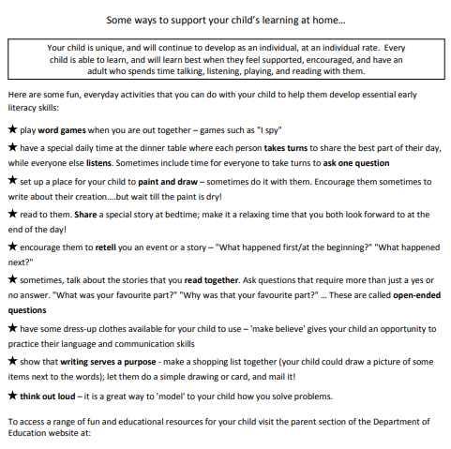
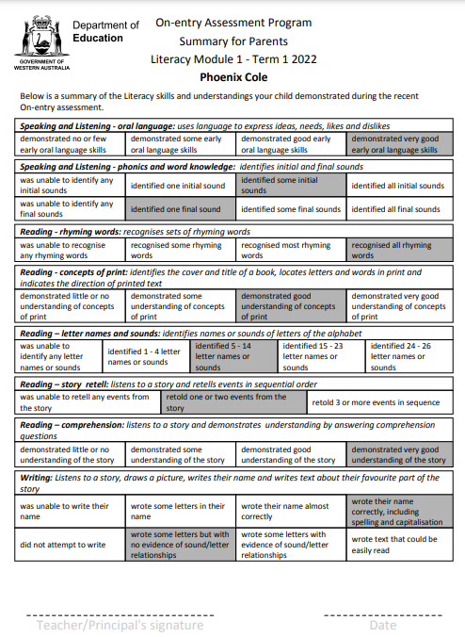

Information | Inform parents/care givers of the skills and understandings that their child demonstrated during the assessment. The summary also includes suggested activities that they can to at home to support their child’s learning. The Summary for Parents is a snapshot only and does not include all skills and understandings assessed.
Purpose | To report to their parents/caregivers the skills and understandings demonstrated by their child during the assessment and to suggest ways parents/caregivers can support their child’s learning at home.  This summary may also be used to set goals for each child, if appropriate.

10. Student Assessment Notes

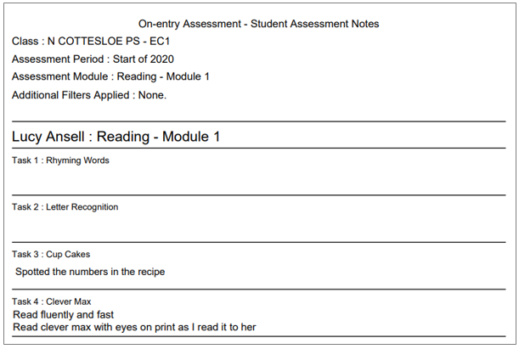

Information | Teachers can take down notes during the one-on-one interaction with their students during the assessment. These notes can be generated as report.
Purpose | To support discussions regarding student performance/progress. Documentation for referrals for allied services.

12. All Assessment Overview

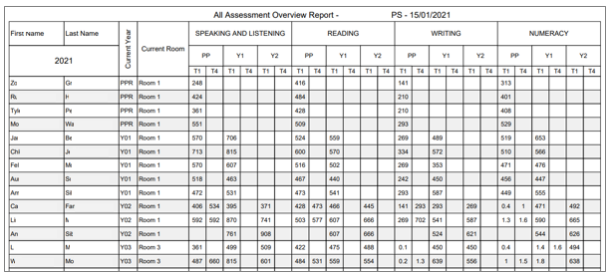

Information | Contains the scores for every completed On-entry assessment for all current students.  Note: scores for Numeracy assessments completed prior to 2019 appear as development points. Scores for Writing assessments completed prior to 2018 appear as progression points. As such, historical links are not possible prior to these dates.
Purpose | Enables the user to:  - manually calculate mean/median scores for selected groups, e.g., class/year groups  - compare the performance of students within the school, over time  - calculate individual student progress from one assessment to the next  - compare the progress of individual students to students with similar abilities

13. Student progression

The Student Progression report allows two different displays of the data:
- individual student report displaying progress for all completed assessments
- all students in a class/cohort - one assessment category per report

Individual Student progression report

To display an individual Student Progression report, follow the steps below.
- Select 13.Student Progression, graphical format.
- Select the relevant class in the Class drop-down menu.
- Students’ names will be displayed in the Students list.
- From the list of students, select all required students by holding the control key and clicking on the student’s/s’ name/’s. Note: omit this step if all students are required.
- Select the required assessment categories, i.e. Reading, Writing, Speaking and Listening, from the Assessment Categories drop-down menu by holding the the control key and clicking on the assessments.
- Select Student in the Group Chart By drop-down menu.
- Click Run Report.

1. Student Selection

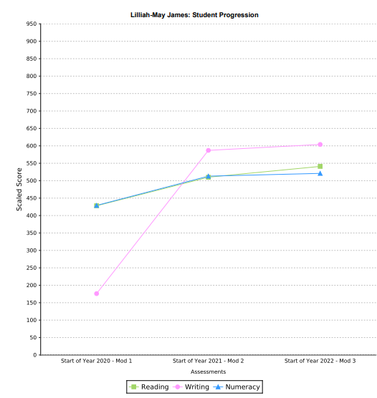
Information | Displays individual student progression from one assessment to the next for all completed modules in assessment categories selected.
Purpose | Enables the user to observe progression from one year to the next and compare progress in assessment categories.
2. Category Selection

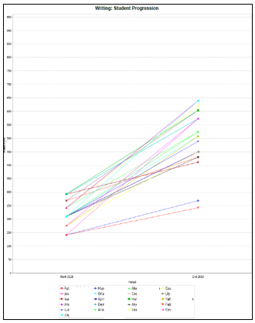

Display | Displays progression from one assessment to the next for all completed modules and one selected category for all selected students in a class.
Purpose | Enables the user to compare the progress of each student in an assessment category. User can identify students who have not made the same progress as their peers.

14. Cohort Report
The Cohort Report contains the same information as the Class Report for all students assessed in the period and module selected regardless of the class. This report is useful for teachers who work across multiple classes.

15. T1 & T4 Class Report
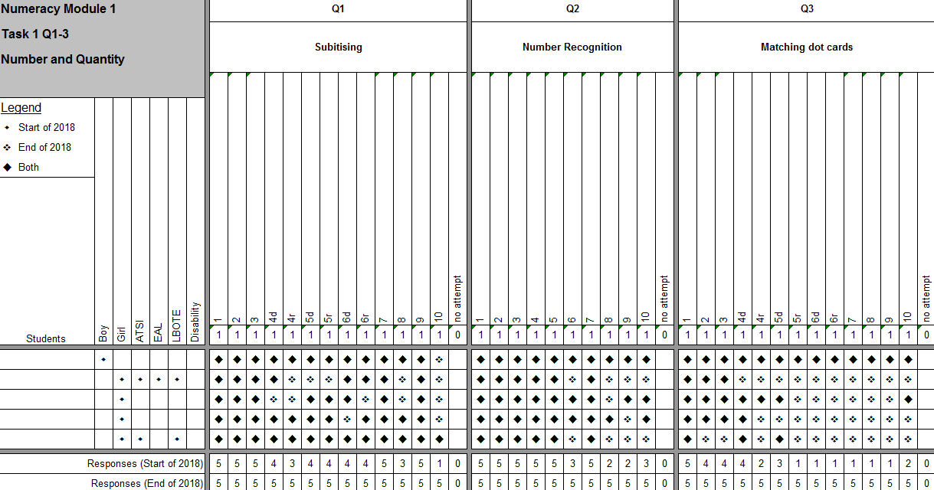

Information | This report displays the Term 1 and Term 4 responses for students who have been reassessed in Term 4.
Purpose | This report shows the development of skills and understandings assessed, in On-entry, throughout the year.  Note: The Class Report available after the Term 1 assessment can be used throughout the year to record and to monitor the development of skills and understandings. .

