

On-entry Assessment Program

What Now?

Pre primary: Mathematics
Teaching and learning resources

Table of Contents
What Now Resources 3
Purpose of this document 3
How to use this resource 4
Worked example 5
Teaching for impact 6
EAL/D Progress map – Approaches to teaching and learning 7

Strand: Number and algebra
Sub-strand: Understanding Number 8
Content Description WAPMNAUN1 – numbers to 20
Sub-strand: Understanding Number 12
Content Description WAPMNAUN2 - subitising
Sub-strand: Patterns and Relationships 15
Content Description WAPMNAP1 - Patterns

Strand: Measurement and Geometry
Sub-strand: Two-dimensional space and structures 17
Content Description WAPMMGTW1 – 2D shapes
Sub-strand: Two-dimensional space and structures 18
Content Description WAPMMGTW2 - Length
Sub-strand: Two-dimensional space and structures 19
Content Description WAPMMGTW3 - Position
Sub-strand: Non spatial measurement 21
Content Description WAPMMGN1 - Mass
Sub-strand: Non spatial measurement 23
Content Description WAPMMGN2 – Days of week

Additional links
Useful websites for additional resources 25

On-entry assessment module 1 skills assessed 26

What Now? Resources

Purpose of this document
These What Now teaching and learning resources are designed to support teachers to plan and deliver intentional teaching informed by evidence from the On-entry assessment. The activities provided in this document are intended to provide support for whole-class, small-group and individual teaching and learning.

Whilst every effort has been made to incorporate materials already available on the Department of Education WA platform, some activities are developed with the support from the Mathematical Association of Western Australia and used with permission.

Curriculum- based teaching and learning support is provided for the content assessed, see page 26 for details of the content assessed through the assessment.

Strategies and activities may be implemented collaboratively by teachers, education assistants and other adults supporting classroom instruction.

Whilst this document is intended as a starting point, teachers are encouraged to further explore additional resources to select texts and activities that best meet their students’ needs, school context and teaching priorities including:

- EYLF Learning Outcome examples – Belonging, Being & Becoming
- Play and Learn at Home activities – Department of Education Play-based Learning
- English as an Additional Language or Dialect Teacher Resource
- EAL/D Progress Map
- Connect resources

How to use this resource

Alongside WA Curriculum and whole-school programs, use On-Entry data to plan targeted teaching and learning.

- Generate Report 6: WA Curriculum – Planning via the Reports tab in the On-Entry system.

- Identify student groupings such as ‘beginning’, ‘developing’, ‘achieving’ for each content description.

- Locate content description code on contents page (page 2) for hyperlink or page number to activities.

- For individual or small group planning, use Report 7: Individual Student Profile report (Word).

- Select, adapt or develop activities using provided links and your school context.

- Monitor: After intervention, design a common assessment task with similar On-entry assessment questions (page 26), to check progress and inform next steps.

- Icons are used throughout this document to efficiently scan for activities related to student interests and school context.

🖤💛❤️ First Nations Australia  🗣️ Speaking  👂Listening  🎭 Dramatic play | 🌏 Culture  🤏 Fine motor  🎨 Art/craft  🚶 Movement | 🧑‍🏫 Adult-led  🎲 Games  📽️ Viewing  ✏️ Writing/drawing | 🧱 Construction  🎵 Music  👐 Actions  📖 Stories

Worked Example
- Identify individual or small group of students and content description code

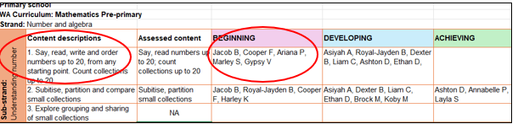

2. Locate content description code on contents page (page 2) for hyperlink or page number to activities

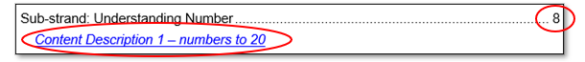

3. Select specific activities linked to this content description.

4. Copy and paste activities into the individual student profile or insert additional columns and rows in the planning report to add notes and monitor evidence of progress.

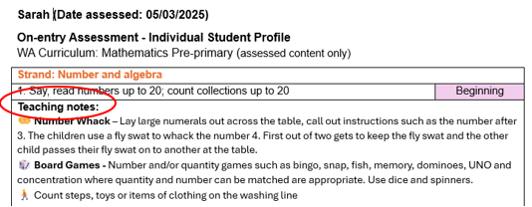
5. Monitor: After intervention, design a common assessment task with similar On-entry assessment questions (page 26), to check progress and inform next steps.

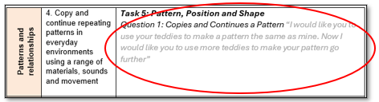

Teaching for Impact
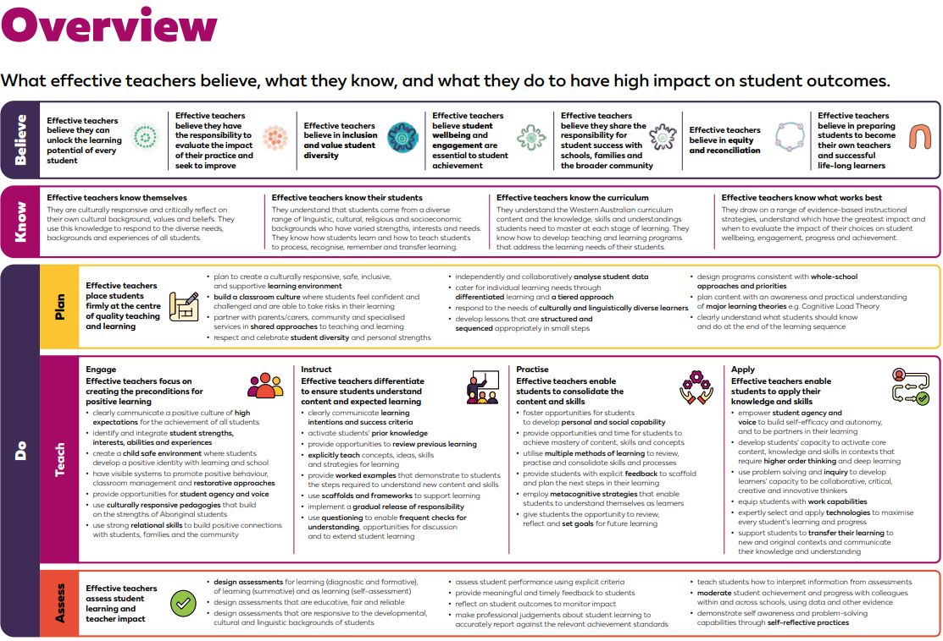
Teaching for Impact overview and resources – Department of Education link

Analyse student data (Teaching for Impact p24) “Effective teachers place students firmly at the centre of quality teaching and learning. Teachers assess what each student knows, target teaching to what they are ready to learn next and track each student’s progress over time (Grattan Institute, 2015).”

Differentiation (Teaching for Impact p27) “Effective teachers are highly adaptive, and acknowledge, respect and accommodate the background experiences students bring to the classroom…Effective teachers cater for students at different starting points. Effective teachers use data to organise students according to their needs. This assists teachers to plan and deliver differentiated lessons.”

A tiered approach (Teaching for Impact p30) “In Tier 1, effective teachers provide evidence-based explicit teaching, aligned to the Western Australian Curriculum and Assessment Outline, that is accessible to all students. Monitoring of students receiving Tier 2 and 3 interventions is essential.”

Structured and sequenced lessons (Teaching for Impact p36) “Effective teachers take into account that in each class there may be students with a range of prior achievement (below, at, and above year level expectations) and develop plans that adopt a strength-based approach, recognising, valuing and building on students’ existing knowledge and skills.”

Recognise and respect Aboriginal English (Teaching for Impact p34) Effective teachers recognise, value and accommodate Aboriginal English in the classroom. They know that sentence patterns are different, and words commonly used could have an entirely different meaning in Aboriginal English. The EAL/D Progress Map is used to plan for, monitor and report the learning of SAE as an additional language and dialect.

EAL/D Progress Map
To access EAL/D progress map, use EAL/D Progress Map. It is a planning, monitoring and assessment tool that enables teachers to cater for the additional language learning needs of EAL/D students.

When planning for EAL/D students, teachers should use the Assessment Pointers to establish the current level of students’ English language acquisition (pages 12 – 54 EAL/D Progress Map) and refer to the Assessment Pointers of the next level to inform planning. More information can be found on Ikon here:
  - Understand how to use the English as an additional language or dialect progress map
  - Access English as an additional language or dialect planning and assessment tools

EAL/D PROGRESS MAP
Approaches to teaching and learning (Beginning)
- Limit teacher-talk time and speak clearly, at a moderate pace and in short, concise sentences
- Use real-life activities, shared experiences and concrete materials to provide contexts for learning
- Provide students with visual and non-verbal cues and repetitive models of language to comprehend simple classroom instructions, directions and routine exchanges
- Teach the Standard Australian English (SAE) sound system, modelling explicitly the formation of sounds
- Develop a bank of everyday SAE vocabulary and some simple formulaic phrases which can be used in routine exchanges
- Explicitly teach and model SAE word order and sentence structure in context, with visual support
- Model and practise SAE direct questioning structures and appropriate responses
- Provide varied opportunities for talk in the home language and in SAE
- Model SAE cultural listening and speaking behaviours daily
- Model and practise SAE classroom routines, greeting and simple activities
- Provide opportunities for students to observe and join in activities without having to respond individually
- Maximise small group interactions and co-operative learning activities
- Expose student to SAE text types and structures, such as news telling or describing
- Choose simple, age-appropriate and highly visual texts
- Model and teach shared reading activities
- Support students to interpret pictures and stories in the home language, making connections with SAE
- Provide a purposeful, print and picture rich environment and allow time for students to explore this new environment
- Explicitly teach the concepts of print, model writing formation, the purpose of upper- and lower-case letters and punctuation in context
- Provide short, explicitly taught formulaic writing models with contextual and visual support, scaffolding and frameworks
- Use a variety of hands-on activities which are age appropriate, high interest and limited in length to build concentration and motivation
- Provide opportunities for students to use a variety of writing implements
- Create a comfortable, non-threatening environment where risk taking is encouraged
- Encourage ongoing maintenance and development of home language to support cognitive and linguistic skills.

Strand: Number and Algebra
Sub-strand: Understanding number
WAPMNAUN1 Say, read, write and order numbers up to 20, from any starting point. Count collections up to 20.
Examples:
- Counting for a purpose, such as counting how many children are in a group so the correct number of items can be collected.
- Counting forwards and backwards by ones from a given number.
- Internalising the principles of counting, including each object must be touched or included exactly once as the numbers are said once in order, the objects can be touched in any order from any starting point and the arrangement does not affect the count, and the last number tells ‘how many’ in the whole collection and does not describe the last object touched.
- Recognising that numbers represent quantities and ‘zero’ is the same as ‘no items’, and that adding one to the count is one more and removing one from the count is one less
- Identifying the number before and after a given number.
- Understanding and using ordinal numbers, such as ‘Abby will have her turn first, Ben will go second, and Jack will be third’.

Suggested teaching and learning strategies and activities
🖤💛❤️ 🌏 | Approaches to teaching and learning (beginning level):  - limit teacher talk time and speak clearly, at a moderate pace and in short, concise sentences  - use real-life activities, shared experiences and concrete materials to provide contexts for learning  - use a variety of hands-on activities which are age-appropriate, high-interest and limited in length to build concentration and motivation
🖤💛❤️ 🌏 | Language/cultural considerations:  - The patterns of English number words are different from other languages, and this may impact on EAL/D students’ understandings of both the number concept and the word in English (for example, in Greek 13 = ten three, 14 = ten four).  - Words have different meanings in different contexts, and this can be especially challenging for EAL/D students (for example, ‘second’ in Mathematics can refer to the ordinal number or a unit of time).
🧑‍🏫 | Daily routines and transitions:  - Use routine times to practise counting. For example, counting how many children are at school, how many children have turned 6 etc.  - Use these times to reinforce the concept of numbers before and after. For example, when doing the morning calendar pose questions such as ‘Yesterday was the 23rd of May so I wonder what day it is today. What number comes after 23?’  - Use transition times to practise positional language e.g. ‘Go under the table, through the tent and wash your hands’.
👂📽️ | Teach the patterns of number words, combining numeral, and real and pictorial representation with spoken and written words.

 | Monitor EAL/D students’ understandings of vocabulary in Mathematics. Provide explicit explanations and demonstrations of differences in the meanings of words in mathematical contexts.
🎭 | Acting out stories – Students take turns to give and follow directions using positional language. Students could be actors or use puppets, story cut outs e.g. Rosie’s Walk, We’re Going on a Bear hunt.  Role play – join in children’s play and model reasoning, predicting and reflecting processes and language.  Set up a shop or restaurant in the home corner. Have children take it in turns to place an order and count out the items required for the order. talk about everyday items such as clocks and phones.  Sand/Water Play – drawing numbers in sand, making and counting ‘mud pies’, sweep away ‘mud pies’ count backward, counting cups of water to fill bucket, measuring heavy/light etc.  - include real-life resources to promote children’s use of mathematical language  - recognise mathematical understandings that children bring to learning and build on these in ways that are relevant to each child
🤏 | Playdough – Build numerals with playdough and match objects to each numeral. Have the numerals printed on a laminated mat so children can lay playdough over a template.  Collage/Sensory/fine motor drawing & creating numbers in foam, finger paint, mud and other messy play substances, thread the correct number of beads  - provide experiences that encourage children to investigate and solve problems.  - provide opportunities for involvement in experiences that support the investigation of ideas, complex concepts and thinking, reasoning and hypothesising.
🚶 | Movement/Physical activity games – Play games such as hopscotch, number twister, “What’s the time Mr Wolf?”, follow the leader, treasure hunts, take children outside to count objects around the school such as doors, windows, steppingstones etc.  Obstacle course – Students follow the instructions given by teacher/peers. Students could design their own obstacle course and place word cards throughout with positional instructions. Count how many steps up to slide, across monkey bars etc.  - model mathematical and scientific language, e.g. count out loud and point out patterns  - count steps, toys or items of clothing on the washing line.
🎲 | Board Games - Number and/or quantity games such as bingo, snap, fish, memory, dominoes, UNO and concentration where quantity and number can be matched are appropriate. Use dice and spinners.
👂 | Counting sequences - Ask the class to form a circle. Beginning at 1, have students say in turn the next number in the counting sequence. Over time, begin the count at, say 8, 18, 25, 30, 48, 95 to extend the count into the larger numbers (FSiM: Number Bk1, p43) Adapt game depending on number focus eg skip count, count backward, starting at a number mid-decade etc. Turn into a game - at designated end number child says Buzz, next child sits down until a final winner.
🎵 👐 | Number Songs and Finger Rhymes  - e.g. 5 Little ducks, One is a Snail, Ten is a Crab, One Woolly Wombat, 5 Green Speckled Frogs, One Grey Elephant Balancing, The Ants Go Marching, ‘Ten in a bed’ and ‘3 speckled frogs’, 12345, Once I caught a fish alive, 5 Little Monkeys  - sing songs with children that involve counting to into the decades. There are many counting songs such as those in the link Jack Hartmann Math Songs .
👐 | Number Whack – Lay large numerals out across the table, call out instructions such as the number after 3. The children use a fly swat to whack the number 4. First out of two gets to keep the fly swat and the other child passes their fly swat on to another at the table.
📖 | Books: Read and share stories and songs about numbers  - ‘I Spy’ books that require the children to find and count pictures.  - read books that involve counting backwards from numbers beyond 10 e.g. One is a Snail.
🧱 | Puzzles – Complete puzzles that have a different number representation on each piece so children see that numbers can be modelled in many ways.  Block/Manipulatives Play (lego, duplo, connetix) – Opportunities to build or copy printed designs with sets of instructions using positional language. Teacher models describing the position of a block: this arch is on top of the red block, but it is underneath the yellow cube. Prompt children to describe location, shape, pattern etc.  Ten frames and MAB blocks – Match numeral cards with ten frame representations. These help to see the structure of ‘how many’. They also help to see the relationship between teen numbers and how they are written and their value.  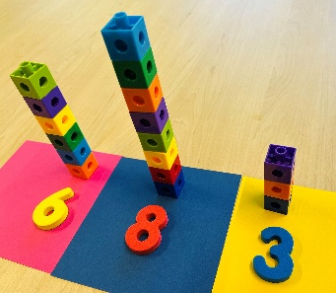  Tower Building – Use unifix blocks to build towers. Select a card from a pile with a collection of dots on them. Match it to the numeral on a game card and build the tower to cover the numeral. First person to cover all numerals wins.  Lego stacks – Write/show numerals and have children build towers  with the correct number of blocks in them.

EXTENSION – Understanding Number: Numbers to 20

Extend number knowledge to count beyond 100 working towards 1000. | - Ensure children can count the 1-9 sequence and predict and name the flowing decade.  - Build up a number grid working towards 1000.
Extend number knowledge after numbers to 100 and beyond. | - Establish children’s counting knowledge to determine how far they can be extended.  - Use large floor number tracks initially to 30 and extend beyond when ready.
Extend counting backwards from numbers beyond 10 | - Provide incidental opportunities to hear and orally count backwards from 20. e.g., counting children as they leave the room, distributing items to a group of 20.  - Counting backwards starting from any number; 4,7,11, etc
Extend number knowledge to count larger collections. Introduce the idea of counting efficiently using skip counting. | - Ensure children can understand the size of the collection and can count by ones for larger collections.  - Proceed to skip counting to count collections more efficiently.  - Provide opportunities to count larger collections using skip counting by 2’s or 5’s to ascertain how many.  - Support the principle of ‘abstraction’ by providing opportunities to count collections of random/different things (not tested).  - Model and involve students in activities counting forwards and then using the same activities to count backwards.
Extend understanding of part-part-whole relationship by focusing on recognising, recalling and recording multiple combinations of part-part-whole situations for numbers to 10 and beyond. | - Provide children with real objects to partition initially up to 10 slowly increasing  - Model partitioning of numbers in a way to generate a pattern by moving one object from one pile to another. E.g. 6 and 1, 2 and 4, 3 and 3, 5 and 1  - Expose children to activities that involve partitioning of a number in more than 2 parts.
Extend understanding of breaking and rearranging parts to partitioning collections | - Provide more experiences involving partitioning collections with a focus on visualising parts and the instant recall of number facts.  - Focus on mental strategies and instant recall of basic number facts

Sub-strand: Understanding number
WAPMNAUN2 Subitise, partition and compare small collections
Examples:
- Recognising with a quick look the number of objects in a collection and saying the number without counting
- Partitioning collections of up to 10 objects in different ways, such as partitioning a collection of six counters into four counters and two counters, or into three counters and three counters
- Comparing and describing small collections, using the language more, less and same

Suggested teaching and learning strategies and activities
🖤💛❤️ | Indigenous perspectives: Incorporate Noongar counting patterns, which include repeated groups to represent numbers. Eg: koodjal is 2, so koodjal-koodjal is 4.
🎲 | Card games – Play games such as memory, snap and concentration using dot cards.  Focus questions:  - How do you know there are …?  - What groups can you see?  - Is there another way you could see the groups?  Dominoes – Children match the number of dots (regardless of arrangement).  Dice games - Children roll the dice and count out that many of an object.  Subitising Bingo Cards – Roll a die and cover a matching picture. Pictures may be of ten frames, tally scores, Lego brick tops, fingers, dominoes – use commercial games too.
👐 | 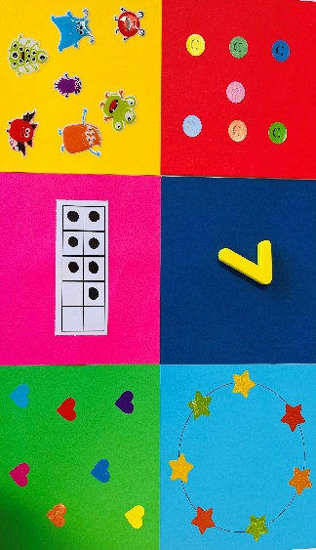  Matching games with multiple representations of dot patterns including tens frames.  Think boards – The children can use real materials, pictures, numbers and symbols to create different representations of part-part-whole situations, or to represent different ways to partition a given number.
📖 🎭 | Partitioning task – Children create partitions of the same size collection in response to a story e.g., ‘Edward the Emu’. Ask the child to show all the different ways they could put 12 emus in two yards. For further information, refer to FSM Number diagnostic Tasks p15.  Frogs in Ponds – Introduce as a story, ‘Lots of Frogs’ by Howard Calvert & Claudia Boldt. 5 frogs live in a pond. If 2 of the frogs are sitting on a lily pad, how many are hiding in the pond? How many ways are there for the frogs to be in and out of the water? Brainstorm ways to solve the problem. Drawing, equipment, acting it out. Change the numbers around e.g., 6 frogs live in the pond, three were on the lily pad, 9 frogs live in the pond, 4 were on the lily pad. Have students record their thinking.

📖 🎭 |  | Five little monkeys - Use story contexts to help students group numbers in an organised way. For example, give students five monkey templates to move from tree to tree. Begin with one monkey in a small tree and four in a large tree. Say: There are four monkeys in the first tree and one monkey in the second tree. Move one monkey so that there are three monkeys in one tree and two monkeys in the other. Then, ask: Are there still five monkeys altogether? Repeat the activity for combinations of 2 and 3, 1 and 4, and 0 and 5. (FSM – Number Book 1, Chapter 3)
🎵 |  | Charlie over the ocean – Place a small collection of pop sticks in a box and a pile of number cards on the table (up to 10 depending on ability). Make sure children know how many pop sticks there are. Teacher chants ‘Charlie over the ocean, Charlie over the sea. Charlie over the ocean, choose a number for me’. Children take turns to choose a number card from the pile. They take the number of pop sticks as their card out of the box and then they have to say how many are left in the container. For example, if there are six pop sticks and number cards to six - Child chooses number card ‘3’ so they hold up 3 pop sticks and say there are 3 in the box.
🤏 |  | 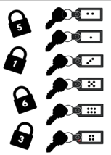  Straws - Have each student hide five straws under the desk, some in each hand. Then, invite all students to show one hand. Ask those students with the same number of straws revealed to stand up and compare their groupings. Ask: Do you all have the same number of straws in the other hand? Have students record their groupings for five straws, then try different arrangements. Focus on the part-whole relationships of the numbers. Repeat the activity and gradually include more straws. (FSM – Number Book 1, Chapter 3).  Unlock the gate – Create key tags with dot formations on them. Write the numerals on the padlocks and leave them locked. Match locks to correct keys to unlock. To encourage subitising, rather than counting, make this a race.  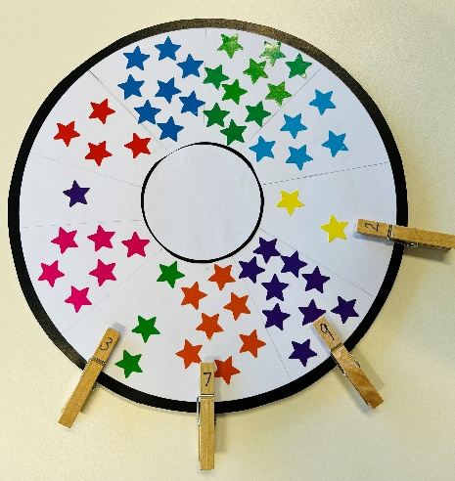  Match the Numbers – Write numerals on pegs and have children match them to subitising cards.  Farm Animals – Have a bag of farm animals. Build 2 paddocks on the mat with large blocks. Ask the children to think of all the ways you could split the 8 animals between the 2 paddocks. For example, put 3 animals in the first paddock and the rest in the second paddock. Make sure the children understand that there are still 8 animals. Continue working with the children on other combinations and change by starting with a different number of animals.
 | 🧱 | Part-part-whole – Have children use unifix cubes, character counters, MAB blocks, double sided counters, stones etc to represent part-part-whole situations.  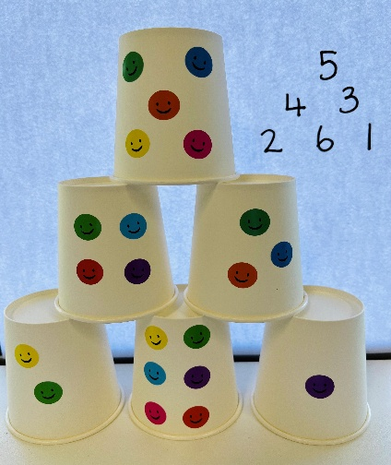  Cup Towers – Place dots on paper cups. Have children build towers matching number tower templates.

EXTENSION – Understanding Number: Subitising

Extend subitising knowledge to include larger quantities and partitioning | - Use subitising flash cards and concrete materials for quantities 7, 8, 9 and 10 including random and diced patterns to encourage students to see small quantities within the large quantities (partitions) e.g. 8 can be made up of 4 and 4.  - Provide subitising/partitioning activities with quantities to 20.

Sub-strand: Patterns and relationships
WAPMNAP1 Copy and continue repeating patterns in everyday environments using a range of materials, sounds and movement
Examples:
- Recognising familiar patterns and repetitions in the natural world and everyday life, such as noticing repeated patterns in a frieze or bunting on a class display board
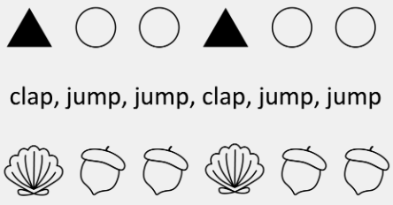
- Using objects, drawings, movement or sound to recognise that the same pattern can be represented in different ways and used to predict what comes next.

Suggested teaching and learning strategies and activities
🖤💛❤️ 🌏 | Language/cultural considerations :  - EAL/D students in the Beginning and Emerging phases of English language learning may not have had the experiences with objects that teachers may consider ‘familiar’.  - Ensure that EAL/D students have an understanding of the objects they are sorting; pre-teaching vocabulary and providing a variety of objects to sort and classify that are reflective of EAL/D students’ experiences.
🤏 | Modelling - Model how to talk about patterns e.g. ‘I can see your pattern is black, white, red, red. Or square, circle, square, circle. I am going to copy it using the pattern blocks – I know that the pattern is square, circle so I am going to use those shapes.  Pattern cards – Children can match and continue the patterns using objects (pom poms, pattern blocks, shape cards etc.) or by drawing/colouring.  Threading – Children make a pattern using 2 or 3 colours of beads e.g., ‘green, yellow, yellow, green’. Ask them to record the pattern on paper as a number sequence: 1, 2, 1, 2…  Provide children with access to a wide range of everyday materials that they can use to create patterns and to sort, categorise, order and compare
🗣️ | Pattern strips – Give children pattern strips to copy and continue. Encourage the children to verbalise the pattern then take it away and ask them to copy it.
🧱 | Light table – Children can copy and continue patterns on the light table using transparent shapes.
🎨 | Pattern snakes – Children cut out a snake and fill the body with coloured shapes by copying and continuing a given pattern.  Collage patterns – Children can create copy and continue complex patterns (ABBABB, ABCABC etc.) using cut up straws, beads, coloured pasta, sticky dots, shape cut outs etc.

EXTENSION – Patterns and relationships: Patterns
Extend using more complex pattern | - Explore more complex patterns and patterns involving numbers.  - Make sure to include activities where the pattern is copied with different media i.e.: using coloured pompoms to copy a shape pattern, or different shapes to attend to the ABAB/ABBA patterning.  - Provide opportunities to match children’s stage of development – copy, continue or create.  - Provide opportunities for children to continue patterns in both directions.  - Use the language of after/before/next

Strand: Measurement and geometry
Sub-strand: Two-dimensional space and structures
WAPMMGTW1 Sort, name and represent familiar two-dimensional shapes and recognise them within the environment
Examples:
- Sorting and naming 2D shapes, such as rectangles, squares, triangles, ovals and circles, based on chosen criteria.
- Locating shapes in the school environment, such as circles and rectangles on the netball court.

Suggested teaching and learning strategies and activities
🖤💛❤️ 🌏 | Language/cultural considerations:  - Words themselves often contain the concept being taught, and so the language and the content are often effectively taught in conjunction with one another (for example, tri-angle).  - Build picture dictionaries of mathematical terms that illustrate the meaningful parts (morphemes) of the words.
🎲 | Shape bingo - Invite each student to select a 3D object (e.g., cylinder, triangular prism, rectangular prism) and a small piece of play dough. Choose one student to be the caller and give them a cloth feely bag of small cards with 2D figures drawn on them (e.g., rectangles, circles, triangles). Have the caller take out a card and call out the shape that is on it. Encourage the rest of the students to respond by looking for that shape on their chosen object. If they have that shape, have them attach a dob of play dough to it, and when all the faces on their object are marked, call out ‘Bingo!’
🚶 | Shape hunts – Children walk around the classroom/playground with 2D shape cut-outs. They then match their shape cut out to a face of a 3D object.
🤏 | Shape sorts – Use sorting mats/bowls to categorise 3D objects by their 2D shape components e.g. all objects that have squares in one bowl and all the objects that have circles in another bowl  Playdough – Shape cutters, making shapes, shape playdough mats (can be found online)  Making shapes – Using pop sticks, string, pipe cleaners, blocks etc.
🎨 | Art activities – Collage, painting, printing shapes  Shape pictures – Students create pictures using a combination of shapes (pattern blocks, magnetic shapes, pre-cut paper shapes). Students could make monsters, robots, houses, people, vehicles, landscapes etc.
🧱 | Making 3D shapes – Use construction games such as Polydron to build 3D objects. Have children examine geometric solids to identify which 2D shapes they will need.

EXTENSION – Two dimensional space and structures: 2D Shapes
Extend - to identify and name more complex 2D shapes and identifying 2D shapes in 3D objects. | - Introduce complex shapes such as, rhombus, oval, hexagon, octagon etc.  - A square is a special type of rectangle

Sub-strand: Two-dimensional space and structures
WAPMMGTW2 Explore and directly compare the length of everyday items to say which is longer and explain reasoning
Examples:
- Recognising length as the measure of an object ‘end to end’, such as comparing two leaves side-by-side to determine which is longer
- Using everyday language and phrases, such as longer than, taller than and shorter than to explain the comparisons

Suggested teaching and learning strategies and activities
🖤💛❤️ 🌏 | Language/cultural considerations:  - The language of comparison in English includes the use of the comparative adjective forms. These include adding ‘–er’ to one- or two-syllable adjectives (for example, ‘This tower is taller’), using ‘more’ for adjectives with three or more syllables (for example, ‘This tower is more gigantic’), and the irregular comparative adjectives such as ‘better’, not ‘gooder’. For most native English speakers, this is intuitive knowledge that comes from a sense of what sounds right.  - Teach EAL/D students different forms of comparative adjectives and how to construct sentences to describe comparisons.  - Provide sentence models that students can modify by adding their own content.
🤏 | Playdough Activities – Making and comparing objects (e.g. snakes). Use playdough mats – make a snake that is longer than this one etc. (mats can be found online)
🚶 | Longer/shorter than a pop stick – Give each student a pop stick. Ask them to walk around the classroom and find an object that is longer/shorter than the pop stick.
👂🚶 | Paper aeroplane competition – Following instructions lesson to make the paper plane and then measure on the veranda in non-standard units how far each plane travels. Before starting the measuring talk about estimating distance and comparing the two measurements at the end. Explain to the students that there is no correct answer for estimation and the more we practise the better we become.

EXTENSION – Two dimensional space and structures: Length
Extend - develop confidence to compare objects using attributes of length and mass. . | - Model direct comparison of objects  - Importance of putting the objects side by side and aligning ends of each object  - Initially order three objects gradually increasing the number of objects  - Extend measurement skills to compare using other complex attributes including width, height etc. Provide sentence models that students can modify by adding their own content.

Sub-strand: Two-dimensional space and structures
WAPMMGTW3 Show and describe position and movement in familiar locations
Examples:
- Showing positions of people and objects in both practical and play-based situations, and describing using words such as in, out, under, next to, in between, etc.
- Describing movement in familiar settings using everyday language
- Describing the path to a particular location in the classroom or playground

Suggested teaching and learning strategies and activities
🖤💛❤️ 🌏 | Language/cultural considerations:  - Not all vocabulary challenges involve the technical or long words. Some of the more challenging words in English for all EAL/D students are the small words (for example, the articles ‘the’, ‘an’, ‘a’, and the prepositions ‘on’, ‘under’, ‘over’).  - Pay attention to the ways that small words such as prepositions are used in describing position and movement, and use pictures, role play and gesture to illustrate their meaning to EAL/D students in the Beginning and Emerging phases of English language learning.
📖 | Books – Read and explore books that use positional language e.g., Rosie’s walk and We are going on a bear hunt.
🎭 | Acting out stories – Students take turns to give and follow directions using positional language. Students could be actors or use puppets, story cut outs, magnetic pictures etc.
🎨 | Rosie’s walk story map – Students draw pictures to recreate the places Rosie visits then use a ‘Rosie’ figurine to retrace her movements.
🧱 | Create a scene - Using real objects (e.g., Duplo sets) children follow the directions to create a scene e.g., put the truck on the block in the house etc.
🚶 | Obstacle course – Students follow the instructions given by teacher/peers. Students could design their own obstacle course and place word cards throughout with positional instructions.  Follow the leader – Teacher/student gives the instructions and rest of group follows.  Treasure hunts – Students can make maps and give to peers to follow to find the treasure.
👂 | Transitions – Use transition times to practise positional language e.g. ‘Go under the table, through the tent and wash your hands’.  Mystery object – Students use positional language to locate the object e.g., ‘the mystery object is on the shelf near the door’.
👂 👐 | Barrier games - Teacher/child can give the instructions.
🧱 | Block Play – Opportunities to build or copy printed designs with sets of instructions using positional language. Teacher models describing the position of a block: this arch is on top of the red block, but it is underneath the yellow cube. Prompt children to describe the location of blocks, or toys located in the block play creations.
🎵 | IWB Songs – Positional language songs such as ‘Where’s the monkey’ Where's the Monkey? and ‘In On Under’ In On Under - Kids Songs
EXTENSION – Two dimensional space and structures: Position
Extend - using more complex positional language |  | - Introduce and develop an understanding of more complex positional language such as between, above, below, clockwise, beside...  - Provide opportunities to describe, listen to and follow instructions using more complex positional language.

Sub-strand: Non-spatial measurement
WAPMMGN1 Explore mass and directly compare everyday items by hefting
Examples
- Directly comparing everyday items to say which is heavier or lighter
- Manipulating objects of varying sizes and weights, such as pillows and rocks, to challenge the misconception that larger objects are heavier
- Comparing objects of similar size but different weights, such as golf balls and ping-pong balls

Suggested teaching and learning strategies and activities
🧑‍🏫 | Use cooking experiences, as well as sand and water play, to support mathematical and scientific skills such as observation, reasoning and measurement.
👐 | Comparing objects - Give the children two objects, one that is very big and light and the other very small and heavy. Give them opportunities to handle the objects. Encourage the children to use the words related to length and mass in their own conversations. Before allowing the children to pick up the objects ask predicting questions. Show the children how to heft and explain that to compare the weight of two objects we must hold them at the same time. Have the children pick up their two objects and heft as modelled.  Balance scales – Use balance scales to check accuracy of hefting. Ask children to estimate what group maybe heavier/lighter for example 5 plastic teddies or 7 unifix blocks.  Hefting closed tubs - Store construction and collage materials (e.g. matchsticks, washers, pop sticks) in identical closed tubs. Invite students to heft each tub and say what they think each tub is holding because of its weight. Open tubs for students to talk about the contents and why one tub was heavier than another. Ask: Why is the matchstick tub lighter than the washer tub? Add an empty closed tub and invite students to heft it. Ask: What do you think is inside this tub? Is this tub the lightest? As students view and handle containers, ask: How could we order the containers on a shelf from heaviest to lightest? What other ways could the containers be ordered?
🤏 | Cooking – Let children be involved in the recipe. Vocab for measuring becomes second nature – cups, half, quarter, tablespoon, teaspoon. For the Juniors: Measure ingredients to make a cake - ABC Education
🎨 | Trio of objects – Have each child take 3 objects of varying size/mass. Ask them to compare and order them by mass using hefting. Have them draw a pictorial representation of this.
☀️ | Water Trolley – Make the water trolley part of outside time. Lots of differing capacity containers encouraging students to compare which holds the most/least. This can be done with rice or bird seed if water play is not preferred.  -use containers of different shapes and sizes for filling, emptying, comparing and pouring  Sand Play - build a sandpit and add kitchen utensils, cups, trucks, spades and water to play with.  Ask questions - How much? How full? What happens if? I wonder what…? …and respond to their answers
🚶 | Lighter/heavier than – Give each child an object such as a wooden block. Have them to walk around the room and find objects that are lighter/heavier than their block.

EXTENSION – Non spatial measurement: Mass

Extend - develop confidence to compare objects using attributes of length and mass. | - Model direct comparison of objects  - Importance of putting the objects side by side and aligning ends of each object  - Initially order three objects gradually increasing the number of objects  Extend measurement skills to compare using other complex attributes including width, height etc.

Sub-strand: Non-spatial measurement
WAPMMGN2 Sequence days of the week and times of the day, making connections to routines, and compare duration of familiar events using everyday language
Examples
- Exploring the cyclical nature of days of the week, identifying routine days, such as ‘library day’
- Describing sequences of events using words, such as morning, lunchtime, afternoon, night-time, yesterday, today and tomorrow
- Sequencing familiar events, including the representation of time, with pictorial timelines
- Identifying time as a measurement for practical comparisons, such as noticing that eating a meal takes longer (more time) than brushing your teeth

Suggested teaching and learning strategies and activities
🖤💛❤️ 🌏 | Language/cultural considerations:  - Not everyone has the same ‘everyday’ routines. EAL/D students, in particular, may have routines at home that differ from the taken-for-granted routines of the classroom.  - When modelling examples of the task (for example, sequencing events in the day of a child), use a variety of possibilities for the events and the times they may occur.
🎵 | Songs – Songs make the memorising easier!  Days of the Week Song | The Singing Walrus  Days Of The Week Addams Family (Parody)
🧑‍🏫 | Calendars – Have a morning calendar that becomes routine each day in the classroom. Include the day of the week, date, month, season, the name of yesterday and the name of tomorrow, the year.  Sequencing – Make a class timetable so that children know what happens in the classroom on what day of the week. Have them think about what activities they do outside of school on which days. Swimming lessons on Mondays, ballet on Wednesday, footy training Friday’s etc.  Through the day use the language of before and after, next, etc.  Time taken getting to school - Have students order the time taken for various activities compared to ordering by other attributes. For example, invite them to work out how long it usually takes to get to school. Ask: Who takes the longest to get to school? How does that student get to school? (e.g. by car, by bus, riding a bicycle, walking). How far away does that person live? Does the student who lives closest to the school take the least time to get there?
👂👐 | Days of the week poster – Display the poster close to the entrance to the classroom and have someone each day move a small star to the current day.
🎨 | Paper chains – Using strips of paper 20cm * 4cm, have the students write Monday on the first strip and make a loop using glue or tape. Then have them add on a new day each morning. Keep them going until they have made a paper chain showing all seven days. This will help them to see that there is an order to the names of the days of the week.

EXTENSION – Non spatial measurement: Days of the week
Extend – connecting days of the week to familiar events and actions | - Model choosing events family routines  - Describing duration and sequence of events using years, months, days and hours.  - Describing duration using months, weeks, days and hours.

Additional website links:

🖤💛❤️NAIDOC Counting in Nyungar (youtube.com)

🖤💛❤️Australians Together - Curriculum resources: bringing First Nations, cultures and histories into the classroom F-year 10:
https://australianstogether.org.au/teachers/curriculum-resources

Teaching for Impact Department of Education:
https://ikon.education.wa.edu.au/-/access-teaching-for-impact/

NSW home activities:
https://education.nsw.gov.au/early-childhood-education/information-for-parents-and-carers/learning-from-home

‘Count Us In’ ABC Education:
https://www.abc.net.au/education/digibooks/count-us-in/101734332

ABC Storytime (Auslan) eg “Australia Under the Sea 1, 2, 3”:
https://www.abc.net.au/education/digibooks/abc-education-story-time-in-auslan/102759700

Learning and Teaching with Learning Trajectories (Early Math – Birth to grade 3):
learningtrajectories.org

ABC Education Game:Thundergoats (Combinations to 10)
https://www.abc.net.au/education/goat-maths-thundergoats/101903526

New Zealand Curriculum – Learning Area Resources Maths: Algebra “Mary, Mary, quite contrary
https://newzealandcurriculum.tahurangi.education.govt.nz/mary-mary-quite-contrary/5637166644.p

Meaningful Maths – Delivering Australian curriculum content informed by NZ maths pedagogy:
https://meaningfulmaths.nt.edu.au/mmws/nz/resource/pattern-makers.html

WA CURRICULUM MATHEMATICS – PRE PRIMARY
Sub-strand | Content Description | On-entry Assessment skills assessed
NUMBER AND ALGEBRA
Understanding number | WAPMNAUN1 Say, read, write and order numbers up to 20, from any starting point. Count collections up to 20 | Task 1: Number and Quantity  Question 2: “What number is on the card?”  Question 3: “Which dot card matches the number on my card?”  Task 2: Number Sequence  Question 1: “Start from 1 and keep counting until I tell you to stop”  Question 2: “What number comes straight after 7/18/39?”  Question 3: “What number comes before 3/16/30?”  Question 4: “… count backwards starting from 10”  Task 3: Principals of Counting  Question 1: “Who has more teddies?”  Question 2: “So how many teddies are there?”  Question 3: “How many teddies are there now?”  Question 4: “Count teddies starting at the yellow one”  Question 5: “Give me 17 teddies”  Question 6: “Please get enough biscuits to give to all the teddies”  Task 5: Pattern, Position and Shape  Question 2: “I would like you to point to the 3rd teddy”  Question 3: “I would like you to point to the 5th teddy”
Understanding number | WAPMNAUN2 Subitise, partition and compare small collections | Task 1: Number and Quantity  Question 1: “Tell me how many dots you see”  Task 4: Number Partitioning  Question 1: “I would like you to show me 6 fingers” - 3ways.  Question 2&3: “How many teddies are hiding under my container?” (1)(3)
Understanding number | WAPMNAUN3 Explore grouping and sharing of small collections | Not assessed in the on-entry assessment
Patterns and relationships | WAPMNAP1 Copy and continue repeating patterns in everyday environments using a range of materials, sounds and movement | Task 5: Pattern, Position and Shape  Question 1: “I would like you to use your teddies to make a pattern the same as mine. Now I would like you to use more teddies to make your pattern go further”
Financial mathematics | WAPMNAF1 Explore making purchases using coins, notes and debit cards | Not assessed in the on-entry assessment
Modelling with number | WAPMNAM1 Explore and represent familiar real-world situations involving adding, removing, grouping or sharing small collections using role-play or concrete materials | Not assessed in the on-entry assessment

MEASURMENT AND GEOMETRY
Two-dimensional space and structures | WAPMMGTW1 Sort, name and represent familiar two-dimensional shapes and recognise them within the environment | Task 5: Pattern, Position and Shape  Question 4: “Show me a circle/square/triangle/rectangle/oval”
Two-dimensional space and structures | WAPMMGTW2 Explore and directly compare the length of everyday items to say which is longer and explain reasoning | Task 6: Measurement  Question 1: “Which of these is longer – the pop stick or the string?  Question 2: Which of these objects is the tallest?”
Two-dimensional space and structures | WAPMMGTW3 Show and describe position and movement in familiar locations | Task 5: Pattern, Position and Shape  Questions 2: “I would like you to point to the 3rd/5th teddy  Question 3: “Put the teddy in/on/near/under the box”
Three-dimensional space and structures | WAPMMGTH1 Explore familiar three-dimensional objects in the environment | Not assessed in the on-entry assessment
Three-dimensional space and structures | WAPMMGTH2 Explore capacity and directly compare containers to say which holds more and explain reasoning | Not assessed in the on-entry assessment
Non-spatial measurement | WAPMMGN1 Explore mass and directly compare everyday items by hefting | Task 6: Measurement  Question 3: “Which of these objects is the lightest?”  Question 4: “Place these objects in order from heaviest to lightest”
Non-spatial measurement | WAPMMGN2 Sequence days of the week and times of the day, making connections to routines, and compare duration of familiar events using everyday language | Task 6: Measurement  Question 5: “What day will it be tomorrow”  Question 6: “What day was it yesterday”
PROBABILITY AND STATISTICS
Probability | WAPMPSP1 Identify and describe familiar events using the everyday language of chance | Not assessed in the on-entry assessment
Statistics | WAPMPSS1 Collect, group and compare data using objects and images to answer questions | Not assessed in the on-entry assessment

