LITK2TL000 | PHONICS FOR TEACHING AND LEARNING | MAKE YOUR OWN | DESK TENT

© DEPARTMENT OF EDUCATION 2017

## dog

## egg

## fan

## D dgggggdddog

## D d



## F f

## E e

## D d



*A a B b C c*

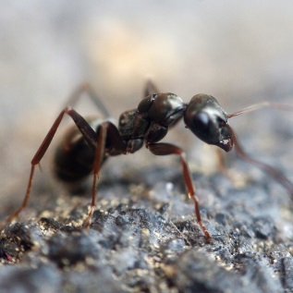



## ant

## cat

## bat

## 

**BASE**

To assemble, fold along dotted lines, cut then slide tabs into slits and stand on desk.