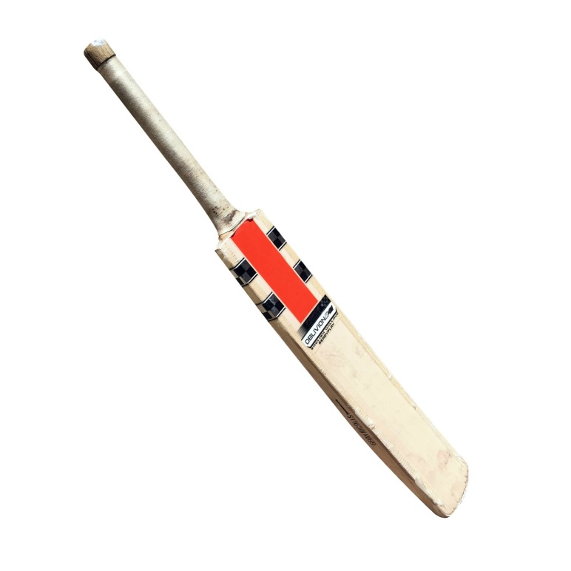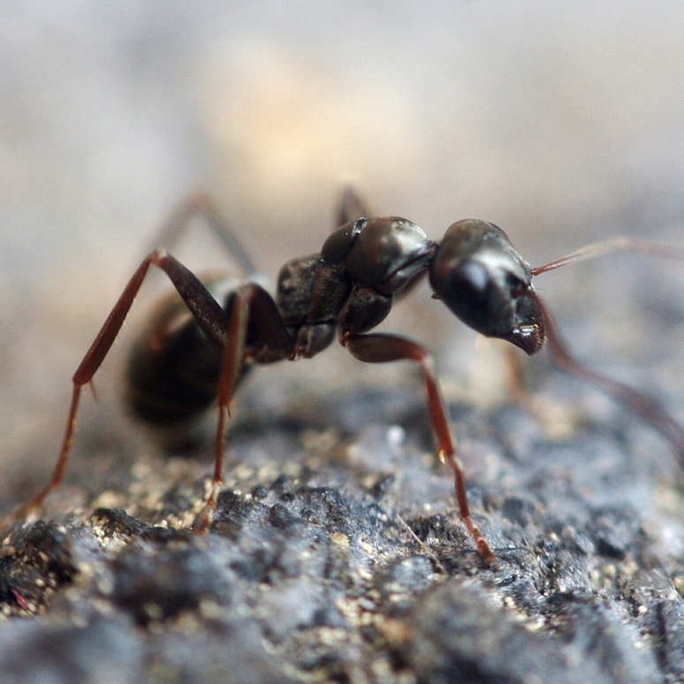

*bat*

*ant*

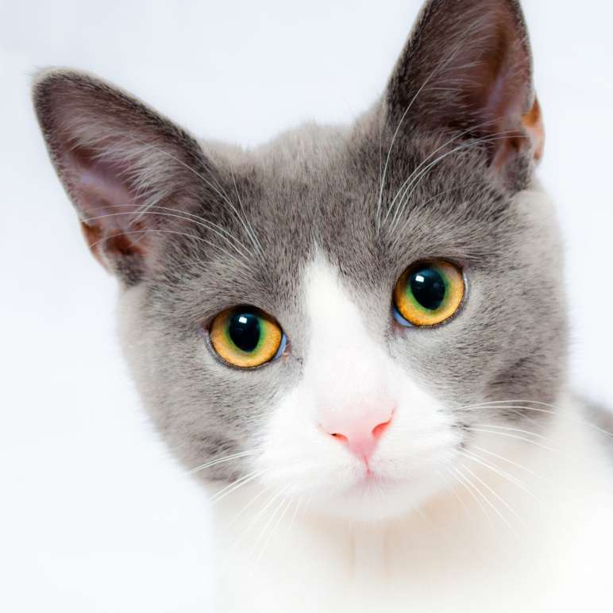

*ball*

*cat*

## 

*B b*

*A a*

*b*

*a*

*t*





LITK2TL000

PHONICS FOR TEACHING AND LEARNING MAKE YOUR OWN | FLASH CARDS

© Department of Education 2017

*t*

*n*

*a*

LITK2TL000

PHONICS FOR TEACHING AND LEARNING MAKE YOUR OWN | FLASH CARDS

© Department of Education 2017

## 

*C c*

*B b*

*a*

*t*

*c*



LITK2TL000

PHONICS FOR TEACHING AND LEARNING MAKE YOUR OWN | FLASH CARDS

© Department of Education 2017

*ll*

*b*

*a*



LITK2TL000

PHONICS FOR TEACHING AND LEARNING MAKE YOUR OWN | FLASH CARDS

© Department of Education 2017