Put an image here.

Put an image here.

*ant*

# 

*ant*

*ant*

# 

*ant*

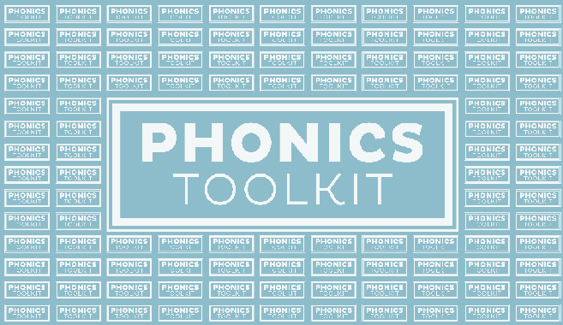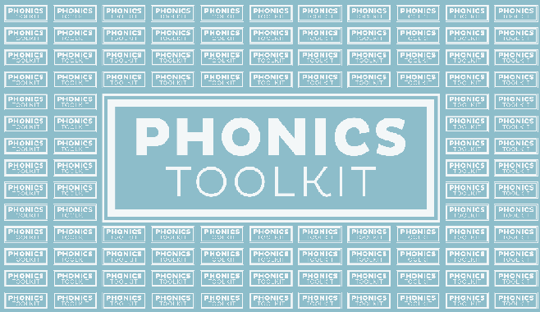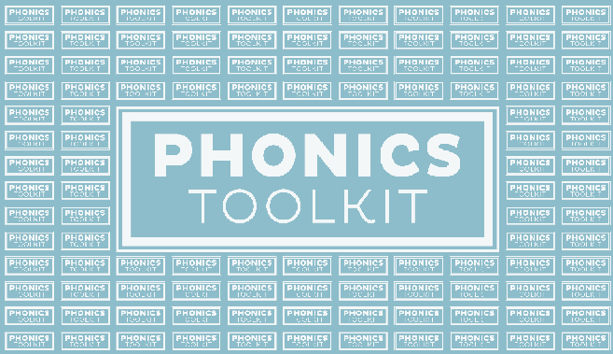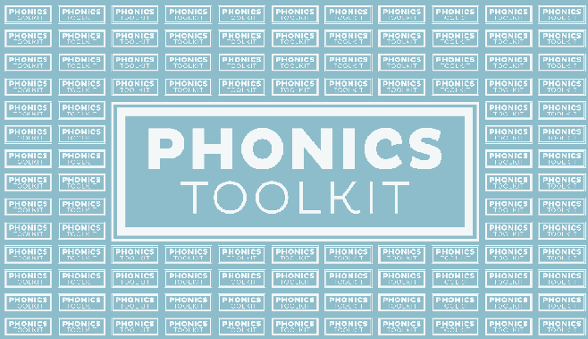

LITK2TL000 | PHONICS FOR TEACHING AND LEARNING MAKE YOUR OWN | PLAYING CARDS

© DEPARTMENT OF EDUCATION 2017

LITK2TL000 | PHONICS FOR TEACHING AND LEARNING MAKE YOUR OWN | PLAYING CARDS

© DEPARTMENT OF EDUCATION 2017

LITK2TL000 | PHONICS FOR TEACHING AND LEARNING MAKE YOUR OWN | PLAYING CARDS

© DEPARTMENT OF EDUCATION 2017

LITK2TL000 | PHONICS FOR TEACHING AND LEARNING MAKE YOUR OWN | PLAYING CARDS

© DEPARTMENT OF EDUCATION 2017

LITK2TL000 | PHONICS FOR TEACHING AND LEARNING MAKE YOUR OWN | PLAYING CARDS

© DEPARTMENT OF EDUCATION 2017

LITK2TL000 | PHONICS FOR TEACHING AND LEARNING MAKE YOUR OWN | PLAYING CARDS

© DEPARTMENT OF EDUCATION 2017