PRIMED project and resource overview

About the PRIMED project
The PRIMED project is a collaborative initiative between the Department of Education, the Department of Training and Workforce Development and the Department of Primary Industries and Regional Development.
The PRIMED project aims to prepare students in Years 7-10 for futures in primary industries in Western Australia.

With a vision to create a food secure and sustainable world, the PRIMED resources seek to engage students to build an understanding of primary industries (agriculture, fibre, fisheries, food, and forestry) to improve their understanding of the diversity within primary industries and enable them to make informed career pathway choices.
The project informs teachers of career opportunities that exist in agriculture, fibre, fisheries, food, and forestry and supports their integration in curriculum delivery

About the resource set
The teaching resources provide rich tasks suitable for face-to face and/or online use focussed on the Western Australian Curriculum within a primary industries context.
The resources are designed to support years 7, 8, 9 and 10 Humanities and Social Sciences (HASS), Science, and Technologies students in Western Australian schools.
The various activities challenge students to explore primary industries and the production of food and fibre commodities in Western Australia.
Each teaching resource includes:
- Teacher resources
- Student worksheets
- PowerPoints
- a variety of additional resources.
All resources, worksheets and PowerPoints are available on Connect via the PRIMED landing page.

What does the research say?
Western Australia’s primary industries contribute more than $10 billion to the State economy each year.
They ensure the prosperity of the State by directly supporting around 161,600 jobs across the associated value chains of Primary Industries (approximately 12% of the WA workforce). This includes 39,300 jobs in farming, fisheries and forestry, with another 19,100 directly related jobs in the food and beverage manufacturing sector.
The following image illustrates the value of primary industry to Western Australia’s economy.
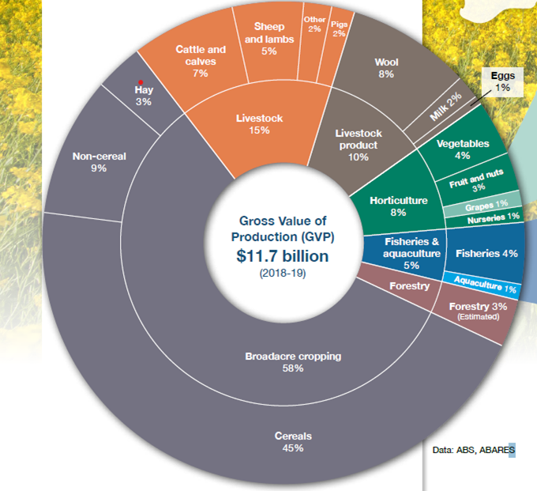
Source: Primary Industries Plan 2020 – 2024, DPIRD

General capabilities and Cross-curriculum priority links
The Western Australian Curriculum was designed with the three dimensions (Curriculum, General capabilities and Cross-curriculum priorities) as inextricably interlinked components of education. The HASS, Science and Technologies resources produced for the PRIMED project provide many opportunities to embed the cross-curriculum priorities into the curriculum as well as implicitly and explicitly incorporate the General capabilities into teaching and learning, through authentic and engaging primary industry contexts.
The local, regional and global perspectives explored through the primary industries foci will add depth and richness to student learning and provide opportunities for authentic inclusion of one or more of the cross-curriculum priorities and multiple General capabilities.
Examples of opportunities to develop General capabilities and explore the Cross-curriculum priorities within the scope of the PRIMED resources include:
Critical and creative thinking and Sustainability
Students examine a case study of an innovative and sustainable method of food production for aquaculture. Larvae of the black soldier fly larvae are being bred to convert farm wastes into various products including fish foods that are traditionally used to feed fish in commercial aquaculture, thus reducing costs and environmental impact. Students explore how critical and creative thinking are required to change traditional practices.
Intercultural understanding and Asia and Australia’s engagement with Asia
When exploring primary industry, students can see the importance of recognising cultural and economic systems of Asia to ensure a deeper understanding of the way supply and demand impacts decisions. Australian food and beverage businesses cultivate products that suit the needs and preferences of Asian markets to ensure the goods supplied suit the consumer. Students develop intercultural understanding as they explore the unique demands of consumers in Asian markets.
Ethical understanding, Aboriginal and Torres Strait Islander histories and cultures and Sustainability
As students learn about the innovative use of bush tucker and sustainable food practice, Aboriginal and Torres Strait Islander histories and cultures can be explored and students begin to appreciate thousands of years of scientific understanding of characteristics of native plants as well as explore the ethics of working to limit food waste along the supply chain.

Sustainable development goals (SDG) links
The Western Australian Curriculum emphasises sustainability as a priority for study that connects and relates relevant aspects of content across learning areas.
In 2015, the Sustainable Development Goals (SDGs) were adopted by all United Nations Member States as an urgent call for action. The Goals address 17 global challenges we face, including hunger, good health and well-being, clean water, and life on land as well as life below water.
Education for sustainability develops the knowledge, skills, values and world views necessary for people to act in ways that contribute to more sustainable patterns of living. Through a cross-curriculum focus in Western Australian schools, sustainability addresses the ongoing capacity of Earth to maintain all life.
By 2023, the PRIMED project will increase teacher capability and confidence to integrate knowledge of the career opportunities that exist in agriculture, fibre, fisheries, food, forestry and horticulture, and support the delivery of curriculum in Years 7-10. Curriculum resources have been developed in HASS, Science, and Design and Technology to integrate understandings and contexts across the State.
The following SDGs are most relevant to PRIMED:
- Goal 2 Zero hunger: achieve food security and promote sustainable agriculture
- Goal 3 Good health and well-being: ensure good health and well-being for all
- Goal 6 Clean water and sanitation: ensure availability and sustainable management of water
- Goal 8 Decent work and economic growth: promote sustained, inclusive and sustainable economic growth
- Goal 9 Industry, innovation and infrastructure: build resilient infrastructure, promote inclusive and sustained industrialization and foster innovation
- Goal 12 Responsible consumption and production: ensure responsible consumption and production patterns
- Goal 14 Life below water: conserve and sustainably use the oceans, seas and marine resources for sustainable development
- Goal 15 Life on land: sustainably manage forests
Guided by the SDGs, we can work together to shape a better future for everyone.

Resource set structure
The resource sets are structured using a 5-E’s instructional model: engage, explore, explain, elaborate and evaluate. It is designed to be flexible so that teachers can use all or parts of the resource that they consider appropriate for their students. Where appropriate the model has been adapted to suit each individual learning area:

- Engage: The purpose of the engage phase is to elicit students’ prior knowledge, stimulate interest and make connections between what they know and new ideas
- Explore: In the explore phase students carry out hands-on investigations in which they can explore key concepts or skills
- Explain: In the explain phase students are supported to develop explanations and continue to develop knowledge of concepts and demonstrate their understanding
- Elaborate: This phase provides opportunities for students to apply what they have learnt to new situations and develop a deeper understanding of the concepts or skills
- Evaluate: The final phase provides opportunity for students to review and reflect on their own learning

(Adapted from Primary Connections – linking science with literacy available at: https://primaryconnections.org.au/resources-and-pedagogies/pedagogies/5e-model-framework-guided-inquiry )

How can teachers make a difference?
For these resources to be of value to students, teacher input is essential. Teachers are the people best placed to understand the needs, interests and aspirations of their students. With this in mind the PRIMED teaching resources have been developed to assist teachers to introduce to students the many facets of Western Australian primary industries and the associated career opportunities available to students.
They have also been designed so that teachers can assist students to understand the connection between primary industries to the world they live in, learn about the full range of careers across the supply chain, and can see how these primary industries careers are involved in solving global problems such as food security and climate change.
The resources have been designed to be adapted by teachers to their local student and community context. Teachers are encouraged to connect with local primary industries in order to make the learning experiences more meaningful for students.

Framework of the resources

HASS | Year 7 | Year 8 | Year 9 | Year 10
Title: | Food production | Types of businesses | Food now and in the future | The Business of food production
Main themes: | What are you eating?  Businesses connected to food.  How much are you paying for food?  Food trends and decisions/choices  Adaptation by businesses to meet consumer markets, fresh and value-added products.  Food Entrepreneurs. | Business structures, government grants and other opportunities, use of technology in primary industry production. | Location of various primary industries in WA and associated biomes, The value of food production to the WA economy, Asia as a target market for WA produce and future food security. | Productivity, research and development and the role of government in food production.
WA curriculum links: | Knowledge and understanding: Economics and business – producing and consuming | Knowledge and understanding: Economics and business – Participation and influences in the market place | Knowledge and understanding: Economics and business – Australia and the global economy  Geography – Biomes and food security | Knowledge and understanding: Economics and business – Economic performance and living standards

Science | Year 7 | Year 8 | Year 9 | Year 10
Title: | Soils – the basis of food production | Life undercover – applying knowledge of cells and systems in food and fibre production | Ecosystems and balance – producing, protecting and conserving | WA primary producers – solving the big issues
Main themes: | Properties of soils, soil biology and ecological interactions, classification of soil invertebrates and biosecurity risk insects, soil restoration | Cell structure and function, animal and plant body systems, applications of cell knowledge and body systems in primary production | Ecosystems – sustainability, energy flow, nutrient cycling, response to change | The ‘wicked problems’ of climate change, food security and biosecurity. How the revolution in selective breeding and genetic technologies is enabling WA primary producers to address these issues.
WA curriculum links: | Science understanding – biological sciences  Science as a human endeavour  Science inquiry skills | Science understanding – biological sciences  Science as a human endeavour  Science inquiry skills | Science understanding – biological sciences  Science as a human endeavour  Science inquiry skills | Science understanding – biological sciences  Science as a human endeavour  Science inquiry skills

Design and technologies – Food and fibre production | Year 7 | Year 8 | Year 9 | Year 10
Title: | Exploring food and fibre production | Production to consumption | Agritourism – What does Western Australia have to offer? | Food and fibre frontiers: Emerging technologies
Main themes: | On farm production systems.  What, where, how, who and why we produce food and fibre commodities in Western Australia.  What do futureproof sustainable food and fibre production systems look like? | Supply chain and supply systems –  Understanding the process from “Farm to Fork”  Understanding the process from “Farm to Fashion” | Exploring what Western Australian food and fibre producers have to offer our tourism industry.  How local primary industry businesses might value add to their enterprise by providing agritourist experiences to travellers. | Food and fibre futures.  Explore technology and research to improve the ethical and sustainable production and processes relevant to food and fibre production  Innovation and start up business as a means of testing new ideas
WA curriculum links: | Context:  Food and fibre production  Knowledge and understandings:  Technologies and society  Processes and production skills:  Investigating and defining  Designing  Producing and implementing  Evaluating  Collaborating and managing | Processes and production skills:  Investigating and defining  Designing  Producing and implementing  Evaluating  Collaborating and managing | Context:  Food and fibre production  Knowledge and understandings:  Technologies and society  Processes and production skills:  Investigating and defining  Designing  Producing and implementing  Evaluating  Collaborating and managing | Context:  Food and fibre production  Knowledge and understandings:  Technologies and society  Processes and production skills:  Investigating and defining  Designing  Producing and implementing  Evaluating  Collaborating and managing

Design and technologies – Materials (timber) | Year 7/8 | Year 9/10
Title: | Forestry for the future: Timber in Western Australia | Rethinking timber waste
Main themes: | History of the Western Australian forestry industry  Social and ethical considerations surrounding the timber industry  Nature, properties and uses of timber & timber products | Industry processes and equipment including forest management, harvesting, processing & distribution  Applications and end use of timber products  Social and ethical considerations surrounding the timber industry
WA curriculum links: | Technologies and Society  Materials and Technologies specialisations | Technologies and Society  Materials and Technologies specialisations

Glossary of key terms
Agriculture | The science or practice of farming, including cultivation of the soil for the growing of crops and the rearing of animals to provide food, wool, and other products
Agronomy | The science of soil management and crop production
Aquaculture | The rearing of aquatic animals or the cultivation of aquatic plants for food.
Biosecurity | Procedures or measures designed to protect the population against harmful biological or biochemical substances.
Business | A commercial operation or company
Commodity | A raw material or primary agricultural product that can be bought and sold, such as copper or coffee
Economics | The study of how people interact with value; in particular, the production, distribution, and consumption of goods and services
Ecosystem | A biological community of interacting organisms and their physical environment
Entrepreneur | Person who sets up a business or businesses, taking on financial risks in the hope of profit
Horticulture | The intensive cultivation of plants
Natural resource | Materials or substances occurring in nature which can be exploited for economic gain
Primary industry | Food and fibre associated industries (eg wheat, beef, wool)
Primary production | The production of raw materials for industry
Product | Article or substance (such as food or fibre) that is manufactured or refined for sale
Stewardship | The job of supervising or taking care of something, such as an organization or property
Supply chain | The sequence of processes involved in the production and distribution of a commodity
Sustainability | Avoidance of the depletion of natural resources in order to maintain an ecological balance
Viticulture | The cultivation of grapes
Source:
The Oxford Press Dictionary (2021) available at Lexico.com, accessed 31 May 2021

