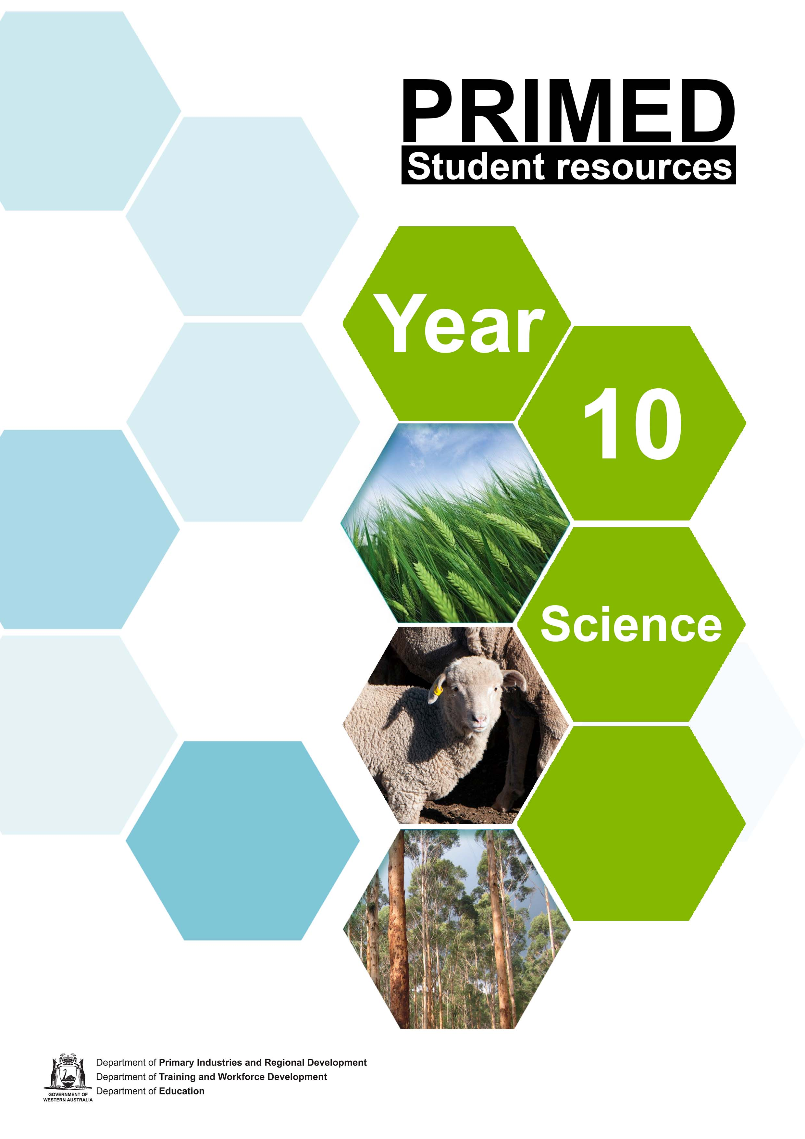

Student worksheet 1.1

Wicked problems facing Western Australian agriculture

Background

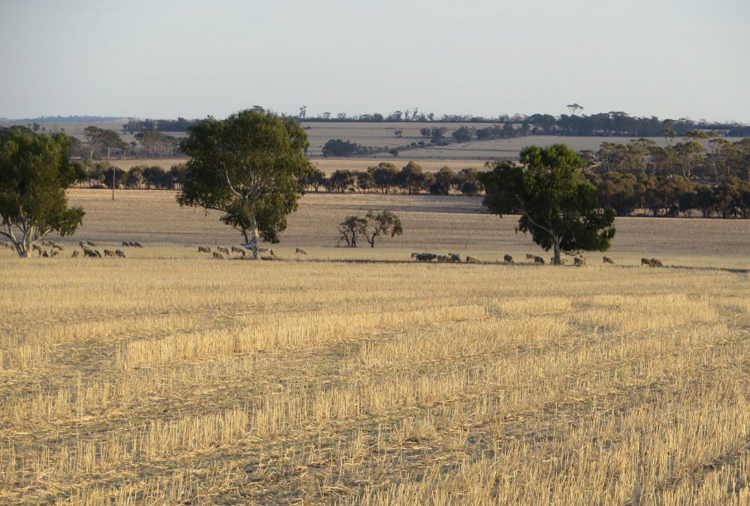
Big issues facing Western Australian agriculture include climate change, food security and biosecurity.

These are often referred to as wicked problems because they are social or cultural problems that may be difficult or seemingly impossible to solve.

This is because knowledge about the problem may be incomplete or contradictory; there may be a large number of people with differing opinions involved; there might be a large economic and/or social cost in

Image 1.1.1 Sheep grazing wheat stubble

tackling the problem; and the interconnected nature of these problems with other problems makes it very difficult to come up with easy solutions.

If you want to learn more about wicked problems, useful video information and discussion can be found at: Wicked problems: Problems worth solving.

Climate change
A changing climate is an important factor impacting agriculture in Western Australia (WA). Over the past 100 years, WA’s average temperature has increase by about 1 degree Celsius (°C) while rainfall has increased slightly in the north and interior but decreased by 20% over the southwest.
There is overwhelming scientific consensus that human activities such as increased greenhouse gas emissions are contributing to these changes.
The agricultural sector in WA is particularly vulnerable to the effects of climate change. A warmer, drier and more variable climate presents significant environmental, social and economic risks to WA. The impacts of climate change on agricultural productivity will vary regionally and by enterprise, with some regions and enterprises benefiting and some not. Changing rainfall, temperature, carbon dioxide (CO2) and other climatic variables will affect average crop and pasture productivity, quality and nutrient cycling, pest and disease activity, livestock production and reproductive rates. So far, WA primary producers have shown themselves to be innovative and adaptable in responding to these challenges.

Food security
Food security is defined by the Food and Agriculture Organization (FAO) of the United Nations as:

‘when all people, at all times, have physical, social and economic access to sufficient, safe and nutritious food that meets their dietary needs and food preferences for an active and healthy life’
Food security is critical to the world. In fact, global population is expected to increase to around 9.6 billion people by 2050. It is estimated that world agricultural production will need to expand 60% by 2050 to meet the needs of this increased population. Closer to home, in WA, the population is expected to double by 2050 to around 4.5 million people.
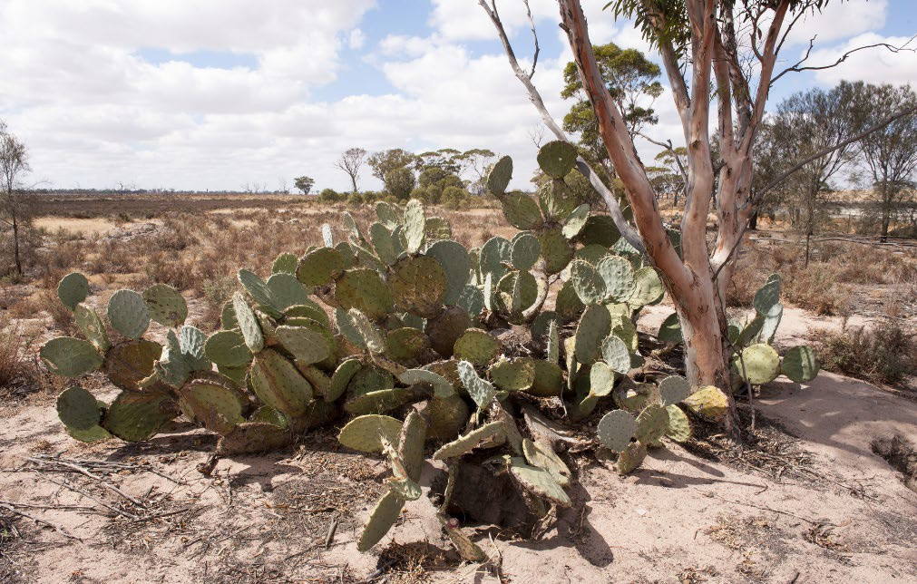
To meet our demand, enabling a future food supply becomes a strategic priority. As well as population increase there are a number of key interacting factors affecting food security. These include biosecurity, climate change, land use, salinity, soil acidity, water availability and agricultural exports.

Biosecurity
Introduced pests, diseases and weeds in WA are an ongoing threat for our natural and agricultural ecosystems. Biosecurity is the management of animal and plant pests and diseases entering, emerging, establishing or spreading. It is essential to protect our economy, environment and the community.

WA is advantaged by geographic isolation, which
Image 1.2.1 Opuntia robusta - Wheel cactus – An invasive species threatening WA

provides a natural biosecurity barrier. However, the 12 500km of mainland coastline (almost 21 000km counting offshore islands) presents significant challenges and numerous points of entry for biosecurity risks to be introduced.
While WA is currently free from a large number of pests, diseases and weeds that are found in many parts of the world, without a robust biosecurity system, agricultural production and food security will be threatened.
Further globalisation, migration, increased traffic from tourism and products entering WA borders from around the world increase threats to biosecurity. For example, it is estimated that a small outbreak of foot-and-mouth disease could cost the WA cattle industry around $10 billion in revenue losses over a 10-year period. Biosecurity is fundamental for safeguarding our valuable agricultural resources against the threat and impacts of invasive and feral species, pests, weeds and diseases.

Activity: Concept mapping – wicked problems facing WA agriculture
Create a concept map showing how wicked problems facing WA agriculture are linked. If you are unfamiliar with the purpose of a concept map or how to create one, a useful resource is the short video How to make a concept map.
Concept map – wicked problems facing WA agriculture

Acknowledgements

References
Australian Bureau of Statistics (2017) ‘Population projections, Australia’ available at:
<https://www.abs.gov.au/statistics/people/population/population-projections-australia/latest- release> accessed 28 July 2021
AC4D (nd), ‘Wicked problems: Problems worth solving’ available at:
<https://www.wickedproblems.com/1_wicked_problems.php > accessed 28 July 2021

Government of Western Australia, DPIRD (nd) ‘Biosecurity’ available at:
<https://www.agric.wa.gov.au/biosecurity-quarantine/biosecurity > accessed 6 September 2021

Government of Western Australia, DPIRD (2016) ‘Climate change: impacts and adaptation for agriculture in Western Australia’ available at:
<https://www.agric.wa.gov.au/search?search_api_views_fulltext=climate%20change > accessed 27 July 2021
Government of Western Australia, DPIRD (26 September 2017) ‘Lupin in Western Australian farming’ available at:< https://www.agric.wa.gov.au/lupins/lupin-western-australian-farming > accessed 17 June 2021
Lucid Chart, (1 June 2018) video ‘How to make a concept map’ available at:
<https://www.youtube.com/watch?v=8XGQGhli0I0 > accessed 6 September 2021

Images
Image 1.1.1 Government of Western Australia, ‘Sheep grazing wheat stubble’ © DPIRD 2021 available at: < https://www.agric.wa.gov.au/newsletters/ovineobserver/ovine-observer-issue-number-91-december-2020-1?page=0%2C1
> accessed 27 July 2021
Image 1.2.1 Government of Western Australia, ‘Opuntia robusta – Wheel cactus’ © 2021 DPIRD available at: <https://www.agric.wa.gov.au/invasive-species/cactus-month-2017 > accessed 28 July 2021

Student investigation 2.1.1

Albino barley - genetics or environment?

Background
You have already learnt about the study of inheritance of characteristics from parents to offspring (the science of genetics) first developed by Gregor Mendel. By now it is likely that you also understand the basic mechanisms of evolution by natural selection first proposed by Charles Darwin. It is also assumed that by now you are thoroughly familiar with planning and carrying out a scientific investigation.
Let’s recap some key ideas that you will need to work with in order to do this investigation:

- the work of Gregor Mendel showed that individuals inherit one copy of two factors for each genetically determined trait from each parent
- these factors both carry information about the trait or characteristic – however, the exact sequence of nitrogenous bases in the genetic code may differ
- when there is more than one factor for a particular gene, we use the term allele to refer to the alternative forms
- if an individual has two alleles that are identical, the individual is homozygous. We could also say that this individual is pure-breeding for the trait
- If the individual has two different alleles for the same trait, this individual is heterozygous
for the trait. This is also known as being hybrid for the trait
- In many cases, for individuals that are heterozygous, one allele for the trait can override the effects of the other form of the allele. The allele that overrides is said to be dominant to the ‘hidden’ or recessive allele
- we now call these factors discovered by Mendel genes
- genes are found at particular locations (loci) on chromosomes
- chromosomes are continuous, coiled and folded strands of DNA
- the allele combination for any trait is called its genotype. The observed trait is called the
phenotype
- the different alleles for traits are contained on chromosomes in the gametes (sex cells eg sperm/pollen and ova) of each parent

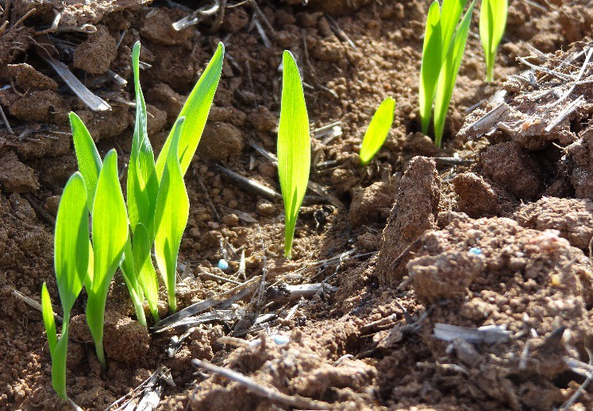
Barley
Barley is Western Australia’s second largest cereal crop after wheat – accounting for 25% of the state’s total cereal production and delivering just over $650 million in barley grain and malt export earnings each year.
Forty per cent of barley produced is delivered as malting grade destined for the Japanese, Chinese and Indian beer markets with the remaining 60% delivered as feed grade – the majority of which is sent to the Middle East.

Image 2.1.1 Emerging barley crop

The albino trait in barley
In most land plants, the leaves and stems will appear green. This green colour is due to the photosynthetic pigment chlorophyll. Sometimes due to random mutations in the DNA code, plants appear in the population lacking chlorophyll. These individuals appear white or yellow in colour and are unable to photosynthesise.
In the barley plant, there is an allele (A) that codes for the production of chlorophyll, the green pigment. This allele is dominant over the allele that produces a lack of pigmentation (a).
In most plant species, it is not just the genotype that is important - the environment can also affect the phenotype of the plant. In many plant species, the production of chlorophyll can be affected by the presence or absence of sunlight. Plants deprived of sunlight may not produce the pigment, even though they possess the genes coding for the trait.
The aim of this investigation is to determine whether the presence of chlorophyll in germinating barley seeds is the product of the genes, environment or a combination of both. This will be done by exposing germinated barley seedlings to one of two conditions: light or dark. After germinating, both sets of seeds will then be left to continue growing in the light to observe any changes.
The barley seeds used in this experiment are produced by crossing hybrid parents for the chlorophyll trait (all parents are heterozygous).

Pre-lab questions – attempt these before conducting your investigation

- Define the following key terms:

Term | Definition
allele
dominant trait
genotype
heterozygous
phenotype
gamete
mutation

- Use the punnet square below to show the possible genotypes and phenotypes if two hybrid barley plants are crossed (mated)

Symbols used for alleles: Production of chlorophyll/Green A
Absence of chlorophyll/Albino a

Genotype of parent plants in the cross: x

Genotype of gametes each parent produced: or

Punnet Square showing possible offspring genotypes:

Parent 2 | Parent 1

- From your Punnet Square, determine the ratio of offspring genotypes:

: :

- Of the possible offspring, determine the likely percentage of plants that are: Green phenotype:
Albino phenotype:

- Read over the method for this experiment. Based on this information, suggest possible:

  - independent variables:

  - dependent variables:

  - controlled variables:

Investigation: albino barley – genetics or environment?

Aim:
The aim of this scientific investigation is to examine the influence of genetics and environment on the growth of albino barley seedlings.

Materials and equipment:
- Student worksheet 2.4 – Group investigation framework (optional)
- 24 barley seeds produced from crossing hybrid barley plants
- Two petri dishes
- Cotton wool
- Metric ruler
- Metric digital scale
- Marker and labels for labelling pots
- Water (for watering seedlings)
- Access to light and dark areas

Procedure:
- In this investigation it is important that you design your own scientific procedure to test a research question or hypothesis
- Make sure that you have considered all the factors that you have previously learnt about to ensure your investigation produces accurate, valid and reliable data. One way is to follow through the set of steps that are on the Group investigation framework. Your teacher may decide, however, that you no longer need this level of scaffolding.
- Label each petri dish lid with the names of your group members and whether it is the ‘light’ (grown in the light) or ‘dark’ (grown in the dark) treatment
- Place cotton wool on the base of the two petri dishes. Add water to moisten the cotton sufficient not to flood the petri dish
- Place 12 of the barley seeds on top of the cotton wool in the ‘light’ dish. Be sure to spread seeds out as evenly as possible and then repeat for the ‘dark’ dish
- Place the cover on each petri dish and then place the ‘light’ treatment in a sunlight position (such as a windowsill) and the ‘dark’ treatment in a place without light, such as a cupboard
- After a few days, observe the number of seeds that have germinated in each treatment and tabulate the numbers of green and albino seedlings
- Combine your results with other class group results
- Place both of the Petri dishes into the same warm, light area after recording your data and leave the seeds for another 3 to 4 days. You may also need to remoisten the cotton wool
- Count the numbers of green and albino seedlings present after this period of 3 to 4 days. Record your data and that of other class members in a second data table
- Using the class data, determine the percentages of albino seedlings

Further investigation
Many other related questions arise which you may like to investigate either by experiment or research. These include:
  - Can albino barley be grown to maturity?
  - What other plants have albino varieties – are any of them useful?
  - Do different colours (wavelengths) of light affect the growth of barley seedlings?

Career exploration
If you enjoyed doing this investigation on albino barley, you may enjoy exploring these related careers:
Agricultural scientist Agricultural technical officer Botanist

Acknowledgements

Resources
Government of Western Australia, DPIRD (21 January 2021) ‘Barley’ available at: < https://www.agric.wa.gov.au/crops/grains/barley> accessed 5 August 2021
Government of Western Australia, DPIRD (21 January 2021) ‘Barley variety sowing guide for Western Australia’ available at: <https://www.agric.wa.gov.au/barley/2019-barley-variety-sowing- guide-western-australia> accessed 5 August 2021
Government of Western Australia, Department of Training and Workforce Development, available at: <https://www.jobsandskills.wa.gov.au/> accessed 16 June 2021

Images
Image 2.1.1 Government of Western Australia, (© 2017 DPIRD), (21 January 2021) ‘Emerging barley’ available at: < https://www.agric.wa.gov.au/barley/2019-barley-variety-sowing-guide- western-australia > accessed 5 August 2021

Student investigation 2.1.2

Albino barley - genetics or environment?

Second hand data analysis
The following table shows the results of a similar investigation performed by a Year 10 Science class.

 | ‘Light’ treatment |  |  | ‘Dark’ treatment
Group | Number of green seedlings | Number of albino seedlings | Albino seedlings (%) | Number of green seedlings | Number of albino seedlings | Albino seedlings (%)
1 | 9 | 3 | 25 | 0 | 12 | 100
2 | 8 | 4 |  | 1 | 11
3 | 9 | 3 |  | 0 | 12
4 | 10 | 2 |  | 0 | 12
5 | 7 | 5 |  | 0 | 12
6 | 9 | 3 |  | 0 | 12
7 | 11 | 1 |  | 1 | 11
8 | 9 | 3 |  | 2 | 10
9 | 10 | 2 |  | 1 | 11
10 | 9 | 3 |  | 0 | 12
Total
 | Ratio of Green: Albino: |  |  | Ratio of Green: Albino:

Percentages and ratios are useful ways of comparing different variables.

In the example above, the first two calculations of percentage (%) albino seedlings for group 1 have been done for you:
‘Light’ treatment

% albino seedlings = Number of albino seedlings ÷ Total seedlings × 100 = 3 ÷ 12 × 100 = 25%

‘Dark’ treatment

% albino seedlings = Number of albino seedlings ÷ Total seedlings × 100 = 12 ÷ 12 × 100 = 100%

A ratio indicates how many times one number contains another. For example, if there were 90 green seedlings and 30 albino seedlings the ratio would be:
90:30 or 3:1

- Calculate the missing totals, percentages and ratios in the table.

- Plot the percentage total of green and albino seedlings for both the light and dark treatments on separate graph paper using an appropriate graphing format.

- Suggest an appropriate hypothesis for this investigation.

- Identify at least one controlled variable in this investigation.

- Suggest a reason why the data for each group is not exactly the same.

- What conclusions can you make about the influences of genetics and environment on the occurrence of the albino phenotype in barley?

Student investigation 2.2.1

Genetically modified (GM) canola

Background
You have already learnt about the study of inheritance of characteristics from parents to offspring (the science of genetics) first developed by Gregor Mendel. By now it is likely that you also understand the basic mechanisms of evolution by natural selection first proposed by Charles Darwin. It is also assumed that by now you are thoroughly familiar with planning and carrying out a scientific investigation.
Let’s recap some key ideas that you will need to work with in order to do this investigation:

- genes contain the genetic code to produce particular proteins
- genes are found at particular locations (loci) on chromosomes
- chromosomes are continuous, coiled and folded strands of DNA
- the allele combination for any trait is called its genotype. The way in which the genotype is expressed physically is called the phenotype
- a transgenic hybrid crop is a genetically modified organism (GMO)
- transgenic hybrids are produced using recombinant DNA technology
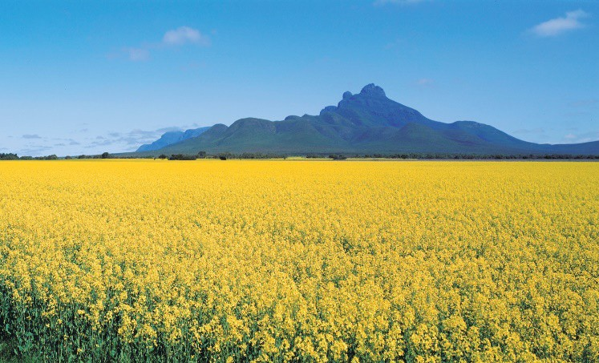
- generally, a transgenic hybrid crop contains one or more genes that have been inserted artificially either from an unrelated plant or from different species altogether

Canola
Western Australia (WA) is an important producer of canola with production in 2018/19 estimated at 1.45 million tonnes worth around $812 million to the state economy.

WA is the dominant Australian state for canola production, accounting for nearly 50% of the nation's five-year average production of 3.6

Image 2.2.1 Canola growing in the Stirling Range WA

million tonnes. WA has a reputation for producing canola with a high oil content, often 2-4% above other states.

Nearly all WA canola production is exported, predominantly into Asia for human use and to Europe for biofuel production.

The Department of Primary Industries and Regional Development (DPIRD) has a strong canola research, development and extension program with a focus on developing profitable agronomic packages and overcoming pest and disease problems.

GM canola
Canola is grown for its seed which is crushed for the oil used in margarine, cooking oils, salad oils and edible oil blends. After the oil is extracted, the by-product is a protein-rich meal used to feed livestock. About 20% of the national canola crop is genetically modified.
GM canola currently licenced to be commercially grown in Australia is resistant to various herbicides. This allows farmers better weed control and thus increase crop productivity. GM canola can only be grown with the approval of the Gene Technology Regulator who carries out a science- based risk assessment before the crop is approved for release.

Pre-lab questions – attempt these before conducting your investigation

- Define the following key terms:

Term | Definition
gene
chromosome
genotype
phenotype
transgenic
Recombinant DNA technology

- Follow the link below and read the article:
Transgenic crops: how genetics is providing new ways to envision agriculture

- What are some possible advantages and disadvantages of transgenic crops?

Advantages of transgenic crops | Disadvantages of transgenic crops

Investigation: Genetically modified (GM) canola

Aim:
The aim of this investigation is to determine whether GM canola is superior to non-GM canola in its tolerance to weeds and herbicides. This will be done by growing both GM canola and non-GM canola with a competitive weed such as mixed seed grass before application of a herbicide.

Materials and equipment:
- Student worksheet 2.4 – Group investigation framework (optional)
- 24 GM canola seeds (glyphosate tolerant)
- 24 non-GM canola seeds
- 48 mixed grass seeds
- Herbicide (glyphosate based)
- Suitable container for growing seedlings
- Potting soil
- Metric ruler
- Marker and labels
- Water (for watering seedlings)

Procedure:
- In this investigation it is important that you design your own scientific procedure to test a research question or hypothesis
- Make sure that you have considered all the factors that you have previously learnt about to ensure your investigation produces accurate, valid and reliable data. One way is to follow through the set of steps that are on the Group investigation framework. Your teacher may decide, however, that you no longer need this level of scaffolding.
- Label each container with the names of your group members and whether it is the GM canola or non-GM canola treatment
- Add water to moisten the soil sufficient not to flood the container
- Plant 12 of the GM canola seeds evenly spaced in one container and 12 non-GM seeds evenly spaced in another container.
- Plant the mixed grass seeds interspersed between the canola seeds
- After a few days, observe and tabulate the number of canola seeds that have germinated in each treatment
- Add an equal quantity of herbicide to each container (be sure to follow all safety instructions on the container)
- Record the growth of the canola seedlings daily over the next two weeks. You may also need to remoisten the soil

Further investigation
Many other related questions arise which you may like to investigate either by experiment or research. These include:
  - What happens if GM canola is subjected to increasing concentrations of herbicide?
  - Is GM canola resistant to a range of different herbicides?

Career exploration
If you enjoyed doing this investigation on GM canola, you may enjoy exploring these related careers:
Plant geneticist Plant scientist

Acknowledgements

Resources
Australian Government, Department of Health, Office of the Gene Technology Regulator (n.d.) ‘Genetically modified (GM) canola in Australia’ available at:
<http://www.ogtr.gov.au/internet/ogtr/publishing.nsf/content/9AA09BB4515EBAA2CA257D6B0015 5C53/$File/12%20-%20Genetically%20modified%20(GM)%20canola%20in%20Australia.pdf > accessed 5 August 2021
Government of Western Australia, DPIRD (1 November 2019) ‘Western Australian canola industry’ available at: < https://www.agric.wa.gov.au/canola/western-australian-canola-industry > accessed 5 August 2021
The Science Creative Quarterly (August 2003) ‘Transgenic crops: how genetics is providing new ways to envision agriculture’ available at: < https://www.scq.ubc.ca/transgenic-crops-how-genetics- is-providing-new-ways-to-envision-agriculture/ > accessed 5 August 2021
Science Buddies (n.d) ‘Plant scientist’ available at: <https://www.sciencebuddies.org/science- engineering-careers/life-sciences/plant-scientist> accessed 16 June 2021
University of Florida – Seed your future (© 2020) ‘Plant geneticist’ available at:
<https://www.seedyourfuture.org/plant_geneticist > accessed 5 August 2021

Images
Image 2.2.1 Government of Western Australia, (© 2021 DPIRD), (1 November 2019) ‘Canola Stirling Range’ available at: < https://www.agric.wa.gov.au/canola/western-australian-canola- industry > accessed 5 August 2021

Genetically modified (GM) canola

Second hand data analysis
The following table shows the results of an investigation over a 10-day period where GM and non- GM canola were grown together with mixed grass seed and a glyphosate herbicide.

 | GM canola + mixed grass seed + herbicide |  | Non-GM canola + mixed grass seed + herbicide
Day | Average height of canola seedlings (mm) | Change in height (mm) | Average height of canola seedlings (mm) | Change in height (mm)
1 | 1 | -- | 1 | --
2 | 3 |  | 3
3 | 5 |  | 5
4 | 7 |  | 6
5 | 9 |  | 6
6 | 12 |  | 7
7 | 14 |  | 8
8 | 17 |  | 8
9 | 19 |  | 9
10 | 21 |  | 9

- Calculate the missing changes in height in the table.

- Plot the changes in height of both the GM and non-GM canola treatments on separate graph paper using an appropriate graphing format.

- Suggest an appropriate hypothesis for this investigation.

- Identify the independent variable in this investigation.

- Based on this data, what conclusions can you make about the effectiveness of GM canola compared with non-GM canola when a glyphosate herbicide is used to control weeds?

Crossing wheat varieties

Background
You have already learnt about the study of inheritance of characteristics from parents to offspring (the science of genetics) first developed by Gregor Mendel. By now it is likely that you also understand the basic mechanisms of evolution by natural selection first proposed by Charles Darwin. It is also assumed that by now you are thoroughly familiar with planning and carrying out a scientific investigation.
Let’s recap some key ideas that you will need to work with in order to do this investigation:

- the work of Gregor Mendel showed that individuals inherit one copy of two factors for each genetically determined trait from each parent
- these factors both carry information about the trait or characteristic – however, the exact sequence of nitrogenous bases in the genetic code may differ
- we use the term allele when there are alternative forms of the gene that produce a trait
- if an individual has two alleles that are identical the individual is homozygous. We could also say that this individual is pure-breeding for the trait
- If the individual has two different alleles for the same trait this individual is heterozygous
for the trait. This is also known as being hybrid for the trait
- In many cases, for individuals that are heterozygous one allele for the trait can override the effects of the other form of the allele. The allele that overrides is said to be dominant to the ‘hidden’ or recessive allele
- the allele combination for any trait is called its genotype. The observed trait is called the
phenotype
- different alleles for traits are contained on chromosomes in the gametes (sex cells eg sperm/pollen and ova) of each parent
- plant scientists can produce F1 hybrids in many plant species (such as wheat) by cross pollination of two different varieties of the same species to produce progeny (offspring) that contain characteristics of both varieties

Wheat
Wheat production in Western Australia (WA) accounts for 70% of total cereal crop production. Approximately seven million tonnes of wheat are produced annually. Yields of WA-bred premium wheat varieties have risen by 1% per year during the past 30 years, a rate higher than world average. Eighty per cent of WA wheat is exported
- predominantly to Asia and the Middle East - generating $2 billion in annual export earnings.

Variety choice and variety management are key factors for profitable wheat production. The demand for new varieties that may have different

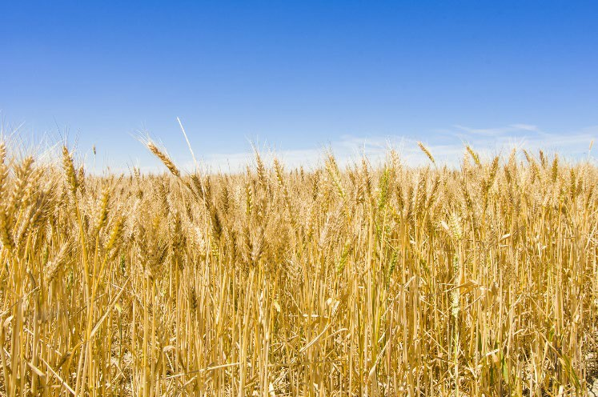
Image 2.3.1 A wheat crop in WA

desirable qualities such as pest resistance, drought or salinity tolerance, and the ability to grow in different climatic regimes means that research is ongoing.

Crossing wheat varieties
Excluding new technologies like genetic engineering, the crossing of two varieties of wheat (or any crop) represents the only real opportunity to manipulate plant genomes for the purpose of genetic improvement. The intention in making a cross between variety ‘A’ and variety ‘B’ is that some of the progeny (offspring) will have a combination of desirable characteristics from both parents that will result in a new variety that is superior to both parents. For a Western Australian company such as InterGrain, crossing forms the foundation of cereal breeding programs and it is important that crosses are designed between varieties that will maximise the identification of superior progeny.

Pre-lab questions – attempt these before conducting your investigation

- Define the following key terms:

Term | Definition
progeny
F1 hybrid
genotype
phenotype
dominant
recessive
heterozygous
genetic improvement
self-pollination
cross
trait
gamete

- Wheat breeders are looking for certain traits or features in a plant. Plants inherit traits from both of their parent plants. These traits can be dominant or recessive. Use the punnet square below to show the possible genotypes and phenotypes if two wheat plants heterozygous for the phenotype of stem height (Tt) are crossed (mated).

Symbols used for alleles: Tall stem - T Short stem - t

Genotype of parent plants in the cross: x

Genotype of gametes each parent produced: or

Punnet Square showing possible offspring genotypes:

Parent 2 | Parent 1

- From your Punnet Square, determine the ratio of offspring genotypes:

: :

- Of the possible offspring, determine the likely percentage of plants that are: Tall stem phenotype:
Short stem phenotype:

Investigation – growing F1 hybrid wheat plants from cross pollinated seed

Aim:
The aim of this scientific investigation is to examine the outcome of crossing two different varieties of wheat plants with two different phenotypes.

Materials and equipment:
- Student worksheet 2.4 – Group investigation framework (optional)
- Two varieties of wheat plant
- Tweezers
- Sharp scissors
- Pot containing moistened soil
- Clear plastic cup
- Small plastic bag

Procedure for crossing wheat varieties:
- In this investigation it is important that you design your own scientific procedure to test a research question or hypothesis about the hybrid wheat seeds you have produced
- Make sure that you have considered all the factors that you have previously learnt about to ensure your investigation produces accurate, valid and reliable data. One way is to follow through the set of steps that are on the Group investigation framework. Your teacher may decide, however, that you no longer need this level of scaffolding.

An excellent video explaining wheat anatomy and the steps for cross pollinating two wheat varieties is available at Wheat crossing protocol
It is recommended that you watch this video before attempting any of the following procedures
Although some minor differences occur compared with the InterGrain steps set out on the following page, essentially the process is the same.

Step 1: Growing (wheat varieties will need to be sown two months prior to the practical)

- Obtain two varieties of wheat. These can be sourced from the Department of Primary Industries and Regional Development (DPIRD), alternatively InterGrain can be contacted
- Ideally you need two varieties that differ (height, plant type, maturity etc.) so that you can visualise what the progeny might look like

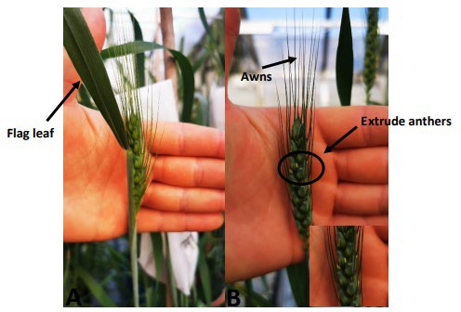
Image 2.3.2 A) Head suitable for emasculation B) Head suitable for pollination

Step 2: Emasculation

- Wheat is a self-pollinating inbred species. When crossing, we need to ensure that the variety we treat as female does not have the chance to be self-pollinated and we achieve this by removing the anthers before the pollen matures. This is called emasculation
- Emasculation – each tiller/stem of wheat should produce a head. When the head is just starting to emerge (Image 2.3.2), this is the perfect time to emasculate because the anthers are still immature (anthers will be green, yellow indicates you are too late)
- A wheat head has rows of three florets grouped together on each side. Using tweezers, remove the bottom set of three florets on each side and the terminal/final set of florets at the top of the head. Then remove the middle of the three florets in each group of florets up each side of the head; which gives more room to emasculate and pollinate (Image 2.3.3A). You will then be left with two florets in each group
- The next step is to cut the florets approximately halfway down to remove the awns (long spikes) and allow you to see inside. Inside you will be able to see three anthers in each individual floret that will be green. With tweezers, remove these three anthers completely, ensuring you do not damage them in the process. Leaving any residual anther in there could self-pollinate the plant.
- What you will be left with is the female (pistil) in the middle. It is important to be gentle when removing the anthers so as not to damage the pistil
- Repeat this step for the entire head, down both sides. If you had 30 florets remaining after removing the necessary ones as previously described, you would have 90 individual anthers that need to be removed
- Emasculated heads then look like Image 2.3.3B and they need to be covered with a small bag (Image 2.3.3C) to ensure no pollen in the air (carried by wind) has the potential to pollinate the pistil. Emasculated heads are then left for 2 to 3 days, after which the stigma of the pistil fluffs up and looks a little like cotton wool. This is now the perfect time to pollinate

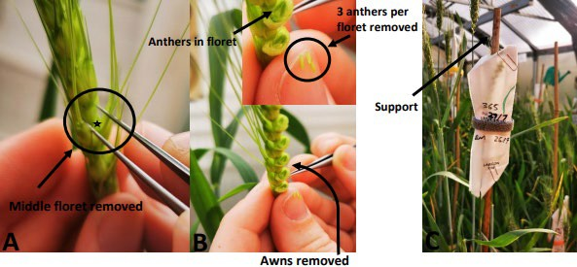

Image 2.3.3 A) Middle floret is removed during emasculation B) Florets cut halfway down to remove awns

C) after emasculation of all florets head is covered with a bag to prevent wind pollination

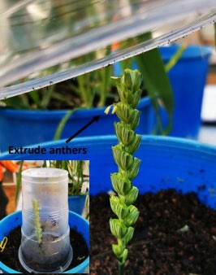

Image 2.3.4 Heads suitable for pollination have their florets cut in half. They are then cut and placed in moist soil with a plastic cup placed over the top. Anthers will begin to ‘pop’ out the top which can be seen with the naked eye. Suitable anthers will release pollen when dabbed onto thumb

Step 3: Pollination

- The most suitable heads for pollination are more mature than for emasculation. Heads should be chosen for pollination when some anthers are starting to extrude from the centre of the head (wheat anthers mature from the centre of the head and move outwards) as seen in Image 2.3.2B
- Cut the florets approximately in half, but do not remove the central floret.
- Cut off the heads, stand them in a pot full of moist soil and cover them with a clear plastic cup. Breathe into the cup prior to increase temperature and humidity. Inside the cup the mature anthers will begin to emerge from the top of the cut florets (this is called popping and can be seen in real time, making for a good time lapse video – Image 2.3.4).
- After approximately five minutes, remove the cup and use tweezers to grab individual anthers. A way to test that they are ready is to tap them on your fingernail, if you see pollen come out, they are ready to be used for pollination
- Pollinating involves tapping/rubbing the anther on the fluffed-up stigma, one anther can be used to pollinate roughly 2 to 3 florets
- After you have pollinated the entire head, replace the bag over it. After 3 to 4 days, you will know if you were successful in your pollination because you will be able to see the grain begin to develop and grow
- Once the plant has reached physiological maturity (everything has turned yellow, and the grain cannot be dented with your fingernail), the grain can be harvested. This grain will be dormant, but you can keep in an oven at ~35ºC for a week - this will break dormancy and the grain will germinate.

Career exploration
If you enjoyed doing this investigation on albino barley, you may enjoy exploring these related careers:
Plant geneticist

Plant breeder

Extension – genomic selection
Genomic selection (GS) is a promising approach where specific sequences of DNA code called molecular genetic markers are used to design novel breeding programs. In plant breeding it provides opportunities to increase the occurrence of desirable traits.
You may also wish to learn more about how genomic selection is being used to design novel breeding programs for cereal crops by InterGrain in WA.

Acknowledgements

People
Dr Calum Watt – national early generation wheat breeder, InterGrain; for wheat crossing protocol and images

Resources
Australian Government, National Skills Commission (2021), Job Outlook ‘Agricultural Technicians’ available at <https://joboutlook.gov.au/occupations/agricultural- technicians?occupationCode=3111> accessed 11 August 2021
Farm Weekly (29 October 2020) ‘New recruit will boost wheat breeding at InterGrain’ available at:<https://www.farmweekly.com.au/story/6987761/new-recruit-will-boost-wheat-breeding-at- intergrain/ > accessed 11 August 2021
Government of Western Australia, DPIRD (2021) ‘wheat’ available at:
<https://www.agric.wa.gov.au/crops/grains/wheat > accessed 10 August 2021

Government of Western Australia, DPIRD (21 January 2021) ‘Essentials for a successful wheat crop’ available at: < https://www.agric.wa.gov.au/wheat/essentials-successful-wheat-crop > accessed 10 August 2021
Illumina (2016) ‘Genomic selection in agriculture’ available at:
<https://sapac.illumina.com/content/dam/illumina- marketing/documents/products/research_reviews/genomic-selection-in-agriculture.pdf > accessed 14 September 2021
InterGrain (© 2021) ‘Source Seed’ available at: <https://www.intergrain.com/source-seeds/> accessed 11 August 2021
Science Publication Reviews (nd) ‘Genomic selection in agriculture - Illumina’ available at:
<https://sapac.illumina.com/content/dam/illumina- marketing/documents/products/research_reviews/genomic-selection-in-agriculture.pdf > accessed 11 August 2021
University of Florida – Seed your future (© 2020) ‘Plant geneticist’ available at:
<https://www.seedyourfuture.org/plant_geneticist > accessed 5 August 2021

University of Western Australia (nd) ‘Plant breeder’ available at:
<https://www.uwa.edu.au/study/careers/plant-breeder > accessed 5 August 2021

World Exploria (9 April 2020) ‘Wheat Crossing Protocol’ video available at:
<https://www.youtube.com/watch?v=IVTjSTAc76M> accessed 11 August 2021

Images
Image 2.3.1 Government of Western Australia, (© 2021 DPIRD), (21 January 2021) ‘The Industry Funding Schemes support the biosecurity of the Western Australian grains/seeds/hay; sheep/goat; and cattle sectors’ available at: < https://www.agric.wa.gov.au/wheat/essentials-successful-wheat- crop > accessed 10 August 2021
Images 2.3.2 – 2.3.4 supplied courtesy of Dr Calum Watt, National early generation wheat breeder, InterGrain

Student investigation 2.3.2

Crossing wheat varieties

Second hand data analysis – a dihybrid cross in wheat
When crossing varieties of wheat, plant breeders can also look at the effects of crossing plants with two different genes at the same time as long as their genotypes are independent of each other. This is called by geneticists a dihybrid cross which looks at two different traits that are independent of each other at the same time.
In the following example in wheat:

T is the allele for tall t is the allele for dwarf (short)

D is the allele for drought tolerant d is the allele for non-drought tolerant Possible phenotypes and genotypes are:
Phenotypes | Genotypes
Tall, drought tolerant | TTDD, TTDd, TtDD, TtDd
Dwarf, drought tolerant | ttDD, ttDd
Tall, non-drought tolerant | TTdd, Ttdd
Dwarf, non-drought tolerant | ttdd

A wheat breeder cross pollinated two groups of plants which were hybrids for both of the traits: (ie dihybrids – both parents were TtDd).
When the seeds produced from the cross were grown, approximately 1 600 progeny wheat plants grew.
Their experimental results are set out in the following table:

Phenotypes | Number of wheat plants
Tall, drought tolerant | 895
Dwarf, drought tolerant | 320
Tall, non-drought tolerant | 280
Dwarf, non-drought tolerant | 105

Percentages and ratios are useful ways of comparing different variables.

For example, imagine a dihybrid genetic cross produced 160 seedlings. Of these, 91 of these were tall, drought tolerant; 29 were dwarf drought tolerant; 31 were tall, non-drought tolerant; 9 were dwarf, non- drought tolerant.
To calculate the percentage of tall, drought tolerant seedlings:

% tall, drought tolerant seedlings = Number of tall, drought tolerant seedlings ÷ Total seedlings × 100 = 91 ÷ 160 × 100 = 57%
A ratio indicates how many times one number contains another.

For example, if there were 91 tall, drought tolerant; 29 dwarf, drought tolerant; 31 tall, non-drought tolerant; 9 dwarf, non-drought tolerant then the ratio would be:
91:29:31:9 or approximately 9:3:3:1
- Calculate the approximate percentage of each of the four different phenotypes produced by the wheat breeder

Tall, drought tolerant: % Dwarf, drought tolerant: % Tall, non-drought tolerant: % Dwarf, non-drought tolerant: %

- Express these percentages as a ratio

- Is this ratio close to what you would expect from this type of cross? Explain your answer

Student worksheet 2.4

Group investigation framework

Part 1: Questioning and predicting
What research question or problem is your group planning to investigate?

What does your group already know about this topic from personal experience and what you have studied?

Predict what do you think will be the outcome of your investigation. Justify why you think this will be so.

Part 2: Planning and conducting
What variables may affect what your group is investigating? (Have you considered both biotic
and abiotic factors?)

What is the independent variable in this investigation? (The factor that you are going to make different)

What is the dependent variable in this investigation? (The factor you are looking for as your result). How will you accurately measure the dependent variable?

What variables in your investigation need to be controlled to make it a fair test?

What equipment will your group need to carry out your investigation?

Describe in a set of steps what your group will be doing at each stage of your investigation. Include a labelled diagram to illustrate your set-up.

What special safety precautions does your group need to follow during your investigation? Why are these safety precautions important?

Part 3: Processing and analysing data and information
What data did your investigation produce? Describe your observations and record your results. If possible, organise your data for the different factors you tested into the form of a table.

Is it possible to represent your data in the form of a graph? If so, what type of graph would best suit this type of data? Construct your graph on a separate piece of graph paper and paste it in this box.

What are the relationships, patterns or trends in your group’s data?

What do the results of your group investigation tell you about the research question or
problem you were investigating? Try to use some science ideas to explain your results.

Did your results match your group predictions? Explain.

Part 4: Evaluating
Identify any sources of error that could lead to your results being less accurate.

Does your group have confidence in the quality of the data it has produced? (Are you confident your data is valid and reliable?)

What changes would your group put in place if it were to repeat this investigation or carry out further investigations?

Part 5: Communicating

Discuss with your group members the best way of communicating the findings of your investigation to the other members of your class. Some suggestions you might like to consider are a science report; a PowerPoint presentation; a poster; a leaflet; a short video. Use the space below to plan.

Student worksheet 3.1 Selective breeding and genetics Background
Humans have been selectively breeding animals and plants from their wild types for thousands of years.

This has resulted in the production of such things as:

- crops with better yields

- ornamental plants with particular flower shapes and colours

- farm animals that produce more or better-quality meat or wool

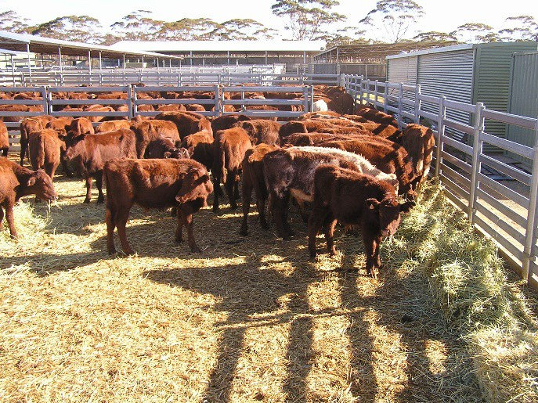
Image 3.1.1 Feed lot cattle in WA

- domesticated animals such as dogs and cats with particular physiques or temperaments suited to performing tasks such as herding sheep and cattle, hunting, finding truffles underground, or eliminating pest species such as rats and mice

The simplified steps involved in any selective breeding program are:

- decide which traits are important enough to select
- choose parents that show these characteristics
- choose the best offspring that show these characteristics to breed the next generation
- repeat the process continuously

Follow the links below to learn more about the fundamentals of selective breeding: What is selective breeding?
Selective breeding – why it is important and what does it mean? Video - Artificial selection

Activity 1: Pigeon breeding - genetics at work
In order to better understand how to selectively breed varieties of animals with specific traits it is often helpful to simulate the process. In this activity your task is to selectively breed pigeons to produce varieties of pigeons with specific characteristics. Follow the link below to play the simulation game:
Pigeonetics

Activity 2: Selective breeding for lower GHG emissions
Modern selective breeding methods are now far more based on research and data than the methods used by our ancestors. These include a thorough knowledge of the biology and the genetics (the science of genomics) of the breeds and varieties being crossed to produce todays selectively bred hybrids. This enables primary producers to maximise their resources and profitability whilst addressing wicked problems such as climate change and food security.
Follow the links below to find out more about how modern selective breeding technologies are helping address the big issues:
DPIRD - Genetics and selection

DPIRD - Carbon farming: cattle breeding for lower greenhouse gas emissions Genetic selection and using Australian Sheep Breeding Values (ASBV) CSIRO - Machine-learning for crop breeding
Pacific oyster selective breeding in Australia Video – Beef cattle crossbreeding systems
A generalised flowchart for selective breeding is available at: GCSE - Bitesize

The Department of Primary Industries and Regional Development (DPIRD) is exploring the potential to reduce methane greenhouse gas emissions from cattle. This would make a positive contribution to solving the wicked problem of climate change by selective breeding of bulls with naturally low methane emissions. Use the information you have discovered to create an illustrated flowchart of how a breed of cattle that produce lower greenhouse gas emissions could be selectively bred by a Western Australian primary producer.
Illustrated flowchart – breeding cattle for lower greenhouse gas emissions:

Activity 3: Examining the pros and cons of selective breeding
In your small group complete the following Plus Minus Interesting (PMI) chart on the use of selective breeding for food and fibre production in WA. A PMI chart is a useful thinking organiser which contains positive, negative and interesting facts or ideas:
- Positives – why the use of selective breeding is a good idea or decision
- Minus – why selective breeding won’t work or is an unwise idea and shouldn’t be used
- Interesting - refers to the position you take after balancing out all of the positives and minuses about selective breeding

Positive | Minus | Interesting

Activity 4: Career exploration
The processes of selective breeding and genetics create some interesting careers that people can pursue.
For example, an animal scientist may be involved in genetics and animal breeding for food and fibre production.
Dog breeders and dog handlers/trainers work with specifically bred dogs (such as Kelpies) that have particular characteristics that make them suitable to assist farmers in their work.

To find out more, follow the links below:

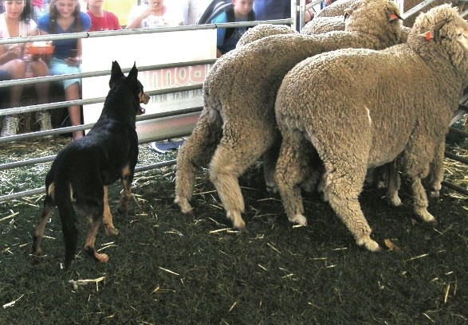

Image 3.1.2 A Kelpie herding sheep

Animal scientist Dog breeder
Dog handler or trainer

Farm working dogs breeding selection and improvement Video – Working dogs are a farmer’s best employee

Extension activity 5: Food for thought – why are some chicken eggshells white and others are brown?
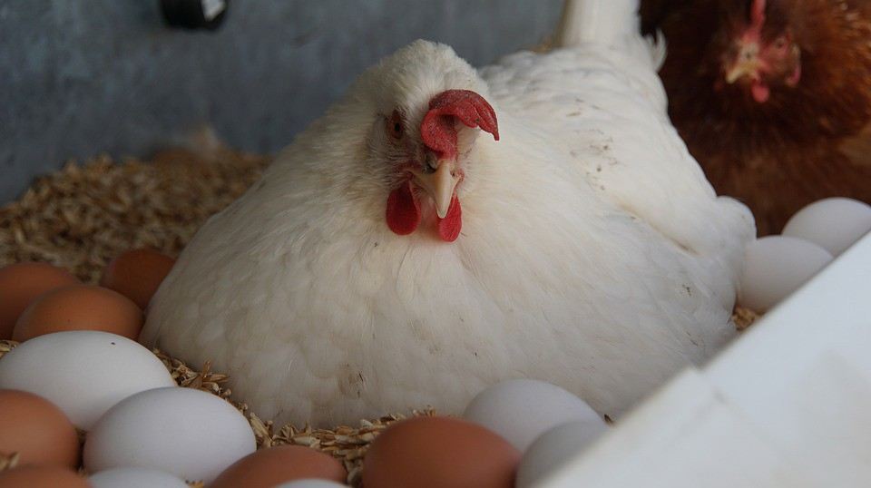
The poultry industry is an important contributor to the Western Australian agricultural sector producing both meat and eggs.
Various breeds are kept in domestic or farm environments. Chickens can be a great asset to any small landholding. They provide eggs, produce fertiliser, control insects and weeds, eat kitchen scraps and loosen soil while scratching.

Image 3.1.3 Chickens and eggs

Have you ever wondered why most of the eggshells that are produced by WA primary producers are now more often brown than white? Why are some of the eggs speckled? Does it mean that brown eggs are healthier? Does it mean that what hens are being fed is changing the colour of the eggs?
Think about this and discuss your ideas in a small group or with a partner. Try to formulate some different hypotheses that could be tested to explain the observations:
Hypotheses about eggshell colour

Test out one of your hypotheses by designing a short experiment which would support or disprove it. What data would you collect? Draw or describe your experiment in the space below:
Experiment designed to test a hypothesis about eggshell colours

You probably can’t carry out your experiment, but you can find out what actually does cause chickens to have different coloured eggs to see if any of your hypotheses were supported:
Brown vs white eggs – is there a difference

What’s the difference between brown and white eggs? The chemistry of eggshell colour explained
What then does this have to do with selective breeding? From your reading, explain below what the original question about chicken eggshell colours has to do with our overall topic of selective breeding and genetics. Include in your explanation how eggshell colour comes about.
Selective breeding of chickens

Acknowledgements

References
ABC News (19 February 2018) ‘Why some chickens lay brown eggs and some lay blue, the chemistry of eggshell colour explained’ available at: <https://www.abc.net.au/news/2018-02- 19/chemistry-of-eggshell-colour/9455660 >accessed 12 August 2021
ABC Australia (28 July 2020) video ‘Working dogs are a farmer’s best employee’ available at:
<https://www.youtube.com/watch?v=iG-k8iAlDek >accessed 13 August 2021

Australian Chicken Meat Federation (8 September 2015) ‘Selective breeding – why is it important and what does it mean’ available at: < https://www.chicken.org.au/selective-breeding-why-is-it- important-and-what-does-it-mean/ > accessed 12 August 2021
BBC Bitesize (2021) ‘Variation – Selective breeding’ available at:
<https://www.bbc.co.uk/bitesize/guides/zsg6v9q/revision/3 > accessed 9 September 2021

Career Explorer (2021) ‘What does a dog breeder do?’ available at:
<https://www.careerexplorer.com/careers/dog-breeder/ >accessed 13 August 2021

Careers with STEM (15 November 2019) ’10 cool careers you could get with an animal science degree’ available at: <https://careerswithstem.com.au/10-cool-animal-jobs-you-could-get-with-an- animal-science-degree/ > accessed 13 August 2021
CSIRO (7 January 2021) ‘Machine-learning for crop breeding’ available at:
<https://www.csiro.au/en/research/plants/crops/grains/machine-learning > accessed 9 September 2021
Gizmodo (18 February 2014) ‘What’s the difference between brown and white eggs?’ available at:
<https://www.gizmodo.com.au/2014/02/whats-the-difference-between-brown-and-white-eggs/ > accessed 12 August 2021
Government of Western Australia, DPIRD, (8 December 2020) ‘Carbon farming: cattle breeding for lower greenhouse gas emissions’ available at: <https://www.agric.wa.gov.au/climate-land- water/carbon-farming-cattle-breeding-lower-greenhouse-gas-emissions >accessed 12 August 2021
Government of Western Australia, DPIRD, (© 2021) ‘Poultry and birds’ available at: < https://www.agric.wa.gov.au/livestock-animals/livestock-species/poultry-birds >accessed 13
August 2021

Government of Western Australia, DPIRD, (16 March 2018) ‘Keeping backyard chickens’ available at: < https://www.agric.wa.gov.au/livestock-biosecurity/keeping-backyard-chickens >accessed 13 August 2021
Government of Western Australia, DPIRD, (nd) ‘Genetics & selection’ available at:
<https://www.agric.wa.gov.au/livestock-animals/livestock-management/genetics-selection > accessed 12 August 2021

Government of Western Australia, DPIRD, (1 July 2020) ‘Genetic selection and using Australian Sheep Breeding Values (ASBV)’ available at: < https://www.agric.wa.gov.au/genetics- selection/genetic-selection-and-using-australian-sheep-breeding-values-asbv > accessed 12 August 2021
Government of Western Australia, Department of Training and Workforce Development (2021) ‘Jobs & Skills WA ‘Dog handler or trainer’ available at: https://www.jobsandskills.wa.gov.au/jobs- and-careers/occupations/dog-handler-or-trainer accessed 13 August 2021
Global Aquaculture Alliance (2 May 2012) “Pacific oyster selective breeding in Australia’ available at: <https://www.aquaculturealliance.org/advocate/pacific-oyster-selective-breeding-australia/> accessed 12 August 2021
Healthline (7 March 2017) ‘Brown vs white eggs – is there a difference?’ available at:
<https://www.healthline.com/nutrition/white-vs-brown-eggs >accessed 12 August 2021

MrAdamCarlson (14 December 2014) video ‘Target B2.1 Artificial Selection’ available at:
<https://www.youtube.com/watch?v=agfIZjNEsas > accessed 9 September 2021

MSUBeefCattle (19 December 2012) video Beef cattle crossbreeding systems’ available at:
<https://www.youtube.com/watch?v=0uL5ksQwyQE> accessed 12 August 2021

The Working Kelpie Council of Australia (March 2012) “Farm working dog breeding, selection and improvement’ available at: <http://www.wkc.org.au/News-Articles/Farm-WAdorking-Dogs- Breeding-Selection-and-Improvement.php >accessed 13 August 2021
University of Utah – Teach Genetics ‘Pigeonetics’ available at:
<https://learn.genetics.utah.edu/content/pigeons/pigeonetics/ > accessed 12 August 2021

YG (nd) ‘What is selective breeding’ available at: < https://www.yourgenome.org/facts/what-is- selective-breeding > accessed 12 August 2021

Images
Image 3.1.1 Government of Western Australia, ‘Feed lot cattle’ (©2021 DPIRD), available at:
<https://www.agric.wa.gov.au/climate-land-water/carbon-farming-cattle-breeding-lower- greenhouse-gas-emissions <accessed 12 August 2021
Image 3.1.2 TTaylor “RAS Kelpie herding sheep’ CC BY-SA 1.0 available at:
<https://commons.wikimedia.org/wiki/File:RAS_Kelpie_working_sheep.JPG > accessed 13 August 2021
Image 3.1.3 Max Pixel (2016) ‘Chickens Eco Brown White Chicken Egg Bio’ CC0 1.0 available at:
<https://www.maxpixel.net/Chickens-Eco-Brown-White-Chicken-Egg-Bio-4449067 > accessed 13 August 2021

Student worksheet 4.1

Case study 1: Genetically modified (GM) crops

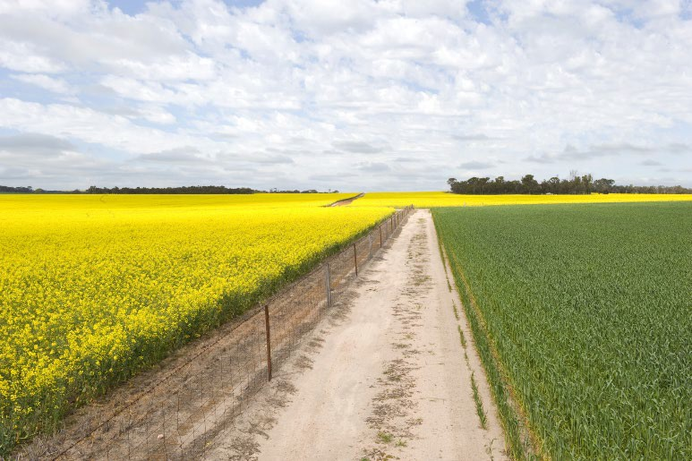
Background
Read through the following background information making notes of key ideas
In order to help address the wicked problems of food security, climate change and biosecurity genetic modifications are playing an increasingly important role in crop science. Genetically modified (GM) have are being grown crops in over 25 countries worldwide, including Australia. GM may be adopted over conventional varieties of crops

for disease resistance, herbicide tolerance or other unique characteristics that provide an advantage in our farming system or marketplace.
Image 4.1.1 Canola crop in full flower next to wheat crop

There are many reasons why specific GM crops are often preferred options to conventional crops. For example, GM cotton traits assist growers with pest and weed management and may reduce the environmental impacts of farming when compared with conventional (non-GM) cotton. GM Canola is grown for its seed which is crushed for the oil that is used in margarine, cooking oils and edible oil blends. A by-product of the oil extraction is a protein rich meal used for animal feed. GM safflower produces oil rich in polyunsaturated fatty acids and has a potential use in industrial applications such as lubricants and plastics.

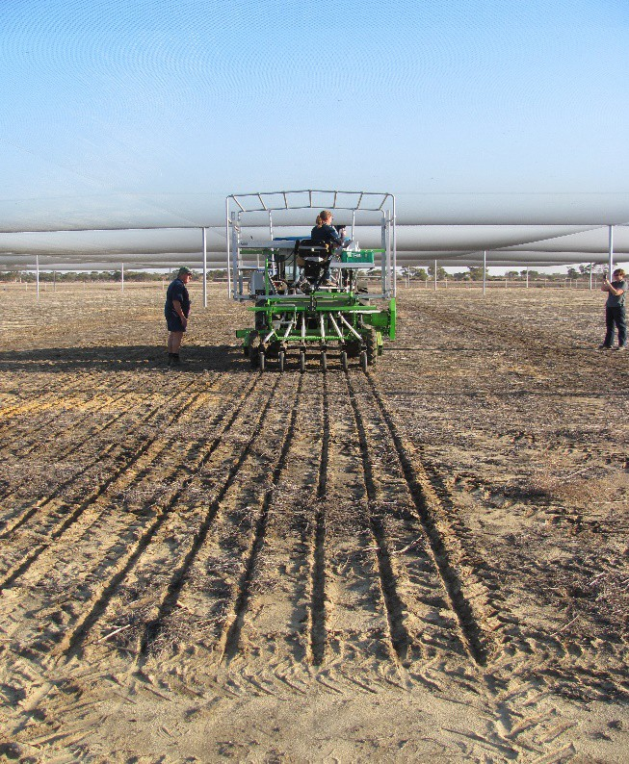
In Western Australia (WA), GM cotton, GM canola and GM safflower have been commercially planted since 2008, 2010 and 2018 respectively. The Office of the Gene technology Regulator (OGTR) maintains control of commercially grown GM material to ensure it remains safe for human health and the environment. Recently in 2018, the OTGR approved the cultivation and use of omega -3 GM canola in animal feed. Nutritionists have long recognised the health benefits of omega-3 fatty acids. Omega-3 oils are polyunsaturated fatty acids that are considered 'healthy oils’. Using gene technology, CSIRO scientists transferred the ability to produce long chain omega-3 oils from lower plants (the marine microalgae that fish consume) into canola.

Image 4.1.2 Seeding a GM wheat research trial in New Genes for New Environments
The ‘New Genes for New Environments’ research facilities at Merredin and Katanning provide relevant field conditions for genetically modified crop evaluation trials in WA under contrasting environments.

What is the problem?
Genetic modification of crops provides a means to deliver the agricultural improvements needed to ensure global food security. There is a general scientific consensus that GM technologies can increase efficiency and sustainability of agriculture. For many people though, GM food provides an ethical dilemma, with public opposition to GM being significant.
The main arguments that have been used against the use of GMOs in agriculture include potential negative effects on:
- the environment such as genes ending up in unexpected places; gene mutation with harmful effects; accidental switching on or off of other genes
- human health such as transfer of allergenic genes; mixing of GM products in the food chain; transfer of antibiotic resistance
- socio-economic factors such as loss of farmers’ access to plant material; intellectual property rights limiting research; impact of ‘terminator’ technologies

Exploring the science

Activity 1: GM research
GM foods are produced from genetically modified organisms (GMO) that have had their DNA altered through genetic engineering. The process of producing a GMO used for genetically modified foods involve taking DNA taken from one organism, modification in a laboratory, and then inserting it into the target organism's genome to produce new and useful genotypes or phenotypes. This type of biotechnology is generally known as recombinant DNA technology.
Follow the links below to find out more on the science of GM and potential impacts of GM technologies on society:
Learn Genetics – Genetically modified food

GM techniques: from the field to the laboratory (and back again) Genetic science and society
Video – What is genetically modified food?
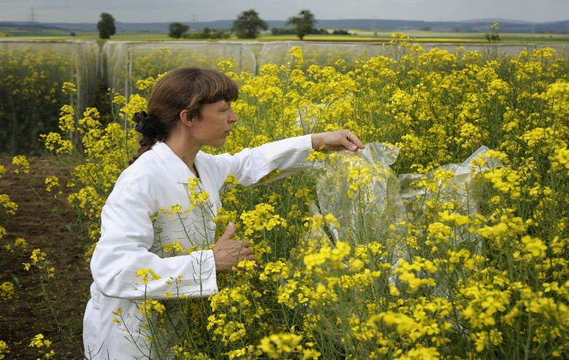

Image 4.1.3 Genetically modified canola field trial

In the space below, create an illustrated flowchart of how a GM variety of a grain crop such as wheat or canola would be produced.

Illustrated flowchart – how GM is used to produce a grain crop

Activity 2: The golden rice debate
Golden rice is a genetically modified crop, engineered to produce beta carotene, which is not normally produced in rice. This increases its nutritional value. Beta carotene is a strongly coloured red-orange pigment which is converted into Vitamin A by the human body and is required for healthier skin, immune systems, and vision.

The Golden Rice Project was first introduced in 1999 to combat vitamin A deficiency in developing countries whose diets are dependent on rice. The World Health Organisation estimates that about 250 million preschool children are affected by Vitamin A Deficiency and about 2.7 million children die as a result. Negative health effects include dryness of the eye that can lead to blindness if untreated; reduced immune system response, and an increase in the severity and mortality risk of infections.

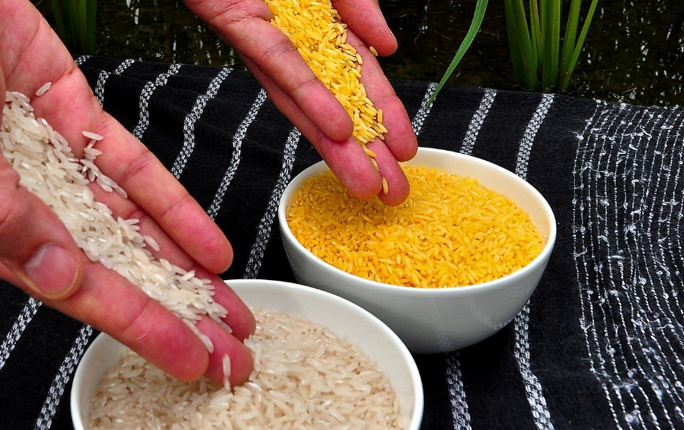
Image 4.1.4 Golden rice

Opponents to genetically modified food products have, however, been very active in slowing down and preventing the commercial production of Golden Rice.
Follow the links to discover more about how golden rice is produced and the arguments for and against the production of GM Golden Rice:

Science Update: Golden Rice

GMO debate grows over golden rice in the Philippines

What’s your opinion?
Think about the issues presented in the Golden Rice debate. What do you think should happen? Should Golden Rice be commercially developed as a possible solution to Vitamin A deficiency diseases? Discuss your ideas with others in your class. Write down your opinion - compare your ideas with other students in your class.

Activity 3: Making up your mind about GM use in WA agriculture
Ever since the development and application of GM technology to food production, there has been considerable ethical debate and often controversy. For example, in the early 2010s a dispute between two WA farmers over the growing of GM canola was settled in the WA Supreme Court. One of the farmers, who operated a certified organic farm, claimed that contamination of his canola crops by a neighbouring farmer’s GM canola crop had resulted in him losing his organic certification. To learn more about this case, follow the link:
ABC News – GM farmer wins landmark canola contamination case in WA Supreme Court

Consider the ethical issues surrounding the use of GM crops. Complete the following PMI chart on the use of GM for food and fibre production in WA.
A PMI chart is a useful thinking organiser which contains positive, negative and interesting facts or ideas (Beyond Monet p91)
- Positives – why the use of GM is a good idea or decision
- Minus – why GM won’t work or is an unwise idea and shouldn’t be used
- Interesting – refers to the position you take after balancing out all of the positives and minuses about GM

Positive | Minus | Interesting

Activity 4 – Career exploration
If you enjoyed learning about the use of GM for food and fibre production, you may enjoy exploring these related careers:
Biotechnologist

Food scientist or food technologist

Acknowledgements

References
ABC News (28 May 2014) ‘GM farmer wins landmark canola contamination case in WA Supreme Court’ available at: < https://www.abc.net.au/news/2014-05-28/landmark-gm-decision-wa- supreme-court/5482864 > accessed 13 September 2021
Australia’s Science Channel (31 May 2018) ‘Science Update: Golden Rice’ available at:
<https://australiascience.tv/science-update-golden-rice/ >accessed 29 July 2021

Bennet, B., Rolheisser, C. (2001). ‘Beyond Monet: The artful science of instructional integration’. Toronto, ON: Bookation Inc.
CSIRO (2021) ‘Omega-3 canola’ available at:
<https://www.csiro.au/en/research/production/biotechnology/omega-3-canola > accessed 10 August 2021
Food and Agriculture Organisation of the United Nations (FAO), (March 2003), ‘Weighing the GMO arguments: against’ available at: <http://www.fao.org/english/newsroom/focus/2003/gmo8.htm > accessed 29 July 2021
Golden Rice Humanitarian Board (2021) ‘The science of Golden Rice’ available at:
<http://www.goldenrice.org/Content2-How/how1_sci.php > accessed 279 July 2021

Government of Western Australia, DPIRD, (13 July 2020) ‘Genetically modified crops in Western Australia’ available at: <https://www.agric.wa.gov.au/genetic-modification/genetically-modified- crops-western-australia > accessed 29 July 2021
Government of Western Australia, DPIRD, (29 November 2017) ‘Grains research facilities: New Genes for New Environments’ available at: <https://www.agric.wa.gov.au/genetic- modification/grains-research-facilities-new-genes-new-environments > accessed 29 July 2021
Government of Western Australia, DPIRD, (13 August 2019) ‘Information on genetically modified organisms’ available at: <https://www.agric.wa.gov.au/genetic-modification/genetic-modification > accessed 29 July 2021
Mallinson, L., Russell, J., Cameron, D.D. et al ‘Why rational argument fails the genetic modification (GM) debate’ Food Sec. 10, 1145–1161 (2018). <https://doi.org/10.1007/s12571-018-0832-1 > accessed 29 July 2021
PBS NewsHour (18 September 2014) video ‘GMO debate grows over golden rice in the Philippines’ available at: <https://www.youtube.com/watch?v=Ayv_EYi43E8 > accessed 29 July 2021

Images
Image 4.1.1 Government of Western Australia, ‘Canola crop in full flower next to a leafy green what crop (©2021 DPIRD), available at: <https://www.agric.wa.gov.au/canola/farm-segregation-canola- varieties> accessed 29 July 2021
Image 4.1.2 Government of Western Australia, ‘Seeding a GM wheat research trial in New Genes for New Environments, Merredin 2021.’ (©2021 DPIRD), available at:
<https://www.agric.wa.gov.au/genetic-modification/grains-research-facilities-new-genes-new- environments > accessed 29 July 2021
Image 4.1.3 Government of Western Australia, ‘Genetically modified canola field trial’ (©2021 DPIRD) available at: < https://www.agric.wa.gov.au/genetic-modification/genetic-modification> accessed 29 July 2021
Image 4.1.4 International Rice Research Institute (IRRI) (15 February 2011) CC BY 2.0 available at: <https://commons.wikimedia.org/wiki/File:Golden_Rice.jpg>accessed 29 July 2021

Student worksheet 4.2

Case study 2: Biosecurity – control of invasive and feral species

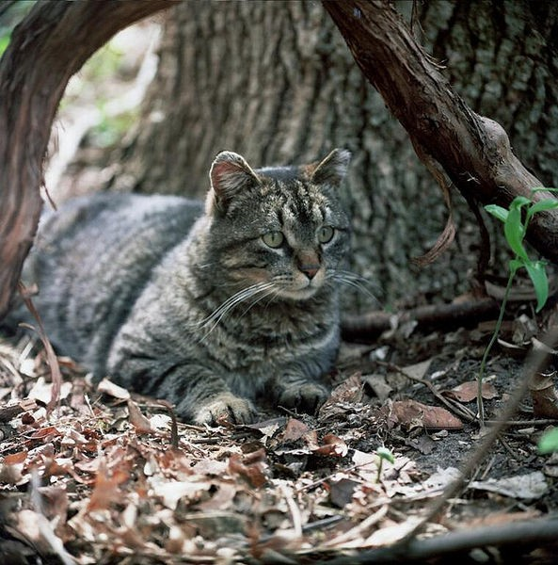
Background
Read through the following background information making notes of key ideas.
Invasive and feral species of animals and plants pose a significant biosecurity risk for our environment in Western Australia (WA).
An invasive species is an established plant or animal species that causes or is likely to cause direct or indirect environmental or economic harm within an ecosystem.

Feral species are those that have been established from domestic stock that result in self-sustaining

Image 4.2.1 A feral cat

populations. These include species such as feral goats (Capra hircus), feral cats (Felis catus), feral European rabbits (Oryctolagus cuniculus) or feral pigs, (Sus scrofa). Feral species are generally non-indigenous and often invasive.
Many exotic animals and plants become invasive species if they manage to establish populations in new areas. The ways in which these pests are introduced vary widely, but they are often the result of accidental or deliberate human activities.
Whatever their means of arrival, invasive species can have a negative and often very damaging impact on agriculture, native wildlife, the natural environment, our economy and our lifestyle.

What is the problem?

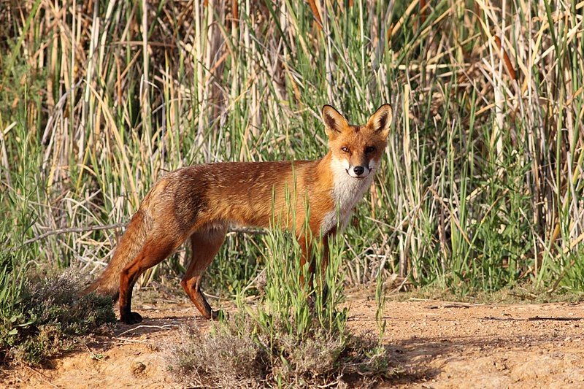
Image 4.2.2 European red fox (Vulpes vulpes)
Invasive species have a major impact on WA’s environment, reducing overall biodiversity and species abundance. They represent one of the more potent, persistent and widespread threats.
Native species are directly affected by invasive species through predation, displacement, competition and hybridisation. Invasive species can also have enormous harmful effects on the health, viability and functioning of ecological communities, ecosystems and landscapes. They alter habitat and reduce biodiversity in both land and marine environments, and can

adversely affect the recreational, social and commercial value of ecosystems.

It has been calculated that invasive and feral species have cost the Australian economy $390 billion in the past 60 years. Feral cats are the costliest species, coming in at over $18 billion. Weedy plants however are the most expensive group because they mostly affect agriculture.

Exploring the science

Activity 1: Biosecurity and invasive species in Western Australia
After habitat loss, invasive species are the greatest threat to WA’s biodiversity. How good are we at preventing the entry or spread of invasive species in WA?
WA has one of the best biosecurity systems in the world. The state is free from many animal and plant pests and diseases that occur elsewhere in Australia and the rest of the world. This is due to a history of effective programs that have either prevented entry or controlled pests and diseases once they have entered. However, the challenge of maintaining relative freedom from pests and diseases is always present.
The Biosecurity Council of Western Australia was established to advise the WA Government on any matter related to biosecurity. Follow the link and watch the video below to find out more: Biosecurity Council of WA – Invasion curve animation
In the space below create a summary of the key ideas of the four phases of the ‘Generalised Invasion Curve’ – prevention, eradication, containment, asset-based protection

Generalised invasion curve phase | Key ideas
Prevention
Eradication
Containment
Asset-based protection

Activity 2: Invasive and feral species research
Your task is to:

- research one invasive or feral species in detail (check your selection with your teacher)

- record the results of your research on the table on the next page of this worksheet

- ensure that you use a wide variety of resources during your research

Follow the links below to help you choose which invasive or feral species to research and write about:
Diseases, fungi and parasites Feral animals
Pest insects

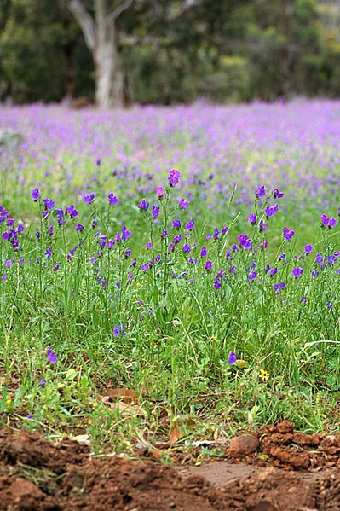
Introduced marine pests Weeds

Image 4.2.4 Patterson's curse

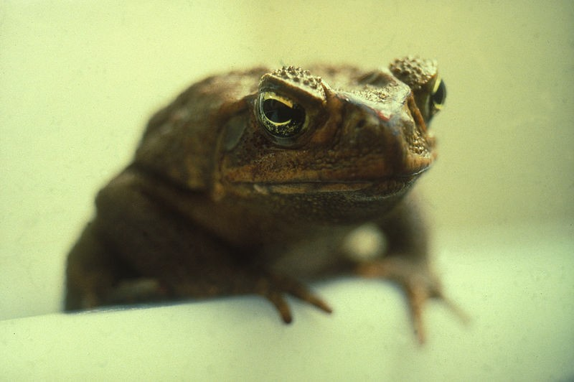
Image 4.2.3 A cane toad

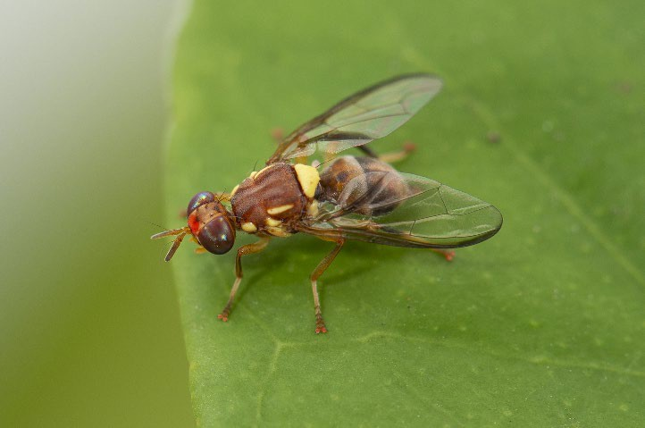
Image 4.2.5 Qfly

Use the table below to write notes on your invasive or feral species. A what, who, where, when, how and why set of questions is provided to assist your thinking. Try to come up with more.

My invasive or feral species is:
What problems are being caused by my invasive species? | Who is involved in controlling my invasive species?
Where in WA is my species causing (or likely to cause) problems? | When is my invasive species likely to cause the most problems?
How is my invasive species being managed? | Why is it important to manage my invasive species?

Activity 3: Rabbits in Australia
The introduced European rabbit (Oryctolagus cuniculus) is a serious environmental and agricultural pest throughout Australia. Rabbits can have major economic impacts on farm productivity and native ecosystems through competition and land degradation.
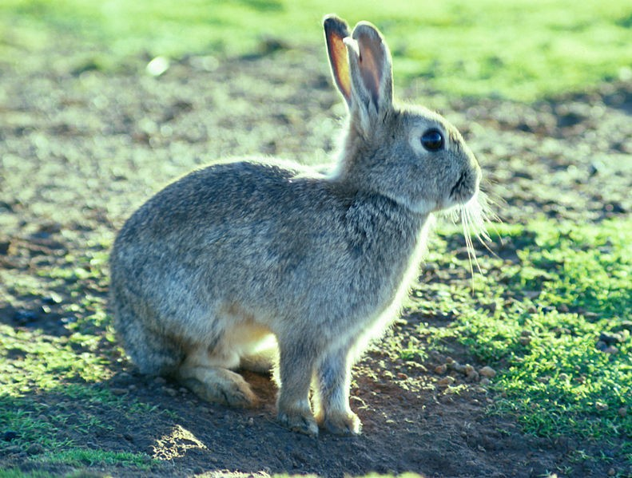
Rabbits can cause damage by:
- overgrazing native and sown pastures, leading to loss of plant biodiversity and reduced crop yields
- competing with native animals and domestic livestock for food and shelter, increasing grazing pressure and lowering the land’s carrying capacity
- building warrens, causing land degradation and erosion
- preventing or inhibiting the regeneration

of native shrubs and trees by grazing
- increasing and spreading invasive weeds
Image 4.2.6 European rabbit

- acting as a food source for introduced predators, which can lead to increased lamb losses and disease prevalence, and a decrease in small mammal diversity

Data analysis
Rabbit damage and control costs vary depending on the land use or enterprise, climate and rainfall, and control methods used.
For a wool producer for example, the cost of competition between sheep and rabbits for grazing is significant. Grazing competition between sheep and rabbits can affect wool production by reducing the quality and amount of wool produced per sheep. This cost is measured in terms of dry sheep equivalents (DSEs). In general, about 16 rabbits/ha is equivalent to one DSE. In higher rainfall areas, one DSE is about 12 rabbits per DSE. Therefore, one sheep is considered the grazing equivalent of one warren of 12–16 rabbits.
- Calculate the cost (in DSE) to a farmer area if a paddock stocked with 300 sheep already contains 10 rabbit warrens.

- When production costs, grazing pressure (DSE) and the value of the product (wool) are considered, a single rabbit can cost an individual WA wool producer $1.85 in lost production each year. Calculate the estimated cost during a rabbit plague if there were an estimated 5 000 rabbits on the wool producer’s property.

A challenge – calculating the exponential growth of a rabbit population
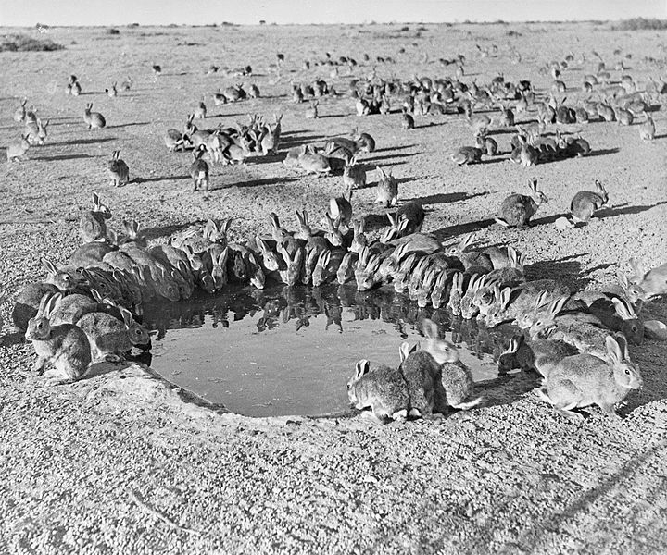
Rabbits were first introduced into mainland Australia in 1859, when a landowner named Thomas Austin released 24 rabbits for hunting.
Due to a lack of natural predators and diseases, as well as an abundant food supply, the rabbits reproduced so quickly that within 20 years, the ‘grey carpet’ of rabbits had caused significant environmental damage and agricultural losses.
In the century that followed, rabbit plagues regularly caused major damage to agricultural

production. It is estimated that by 1950, rabbit numbers in Australia reached around 600 million.
Image 4.2.7 Rabbits around a water hole during a rabbit plague in 1938

The story of rabbits in Australia illustrates the principle that if there is an abundance of food available and a lack of natural predators and diseases, the population size of an introduced or feral species can rapidly rise to become a serious agricultural and environmental problem. The ability of rabbits to breed rapidly and have multiple litters can lead to plague proportion numbers in a very short space of time.
This type of growth rate is an example of exponential growth. Exponential growth can be modelled through the use of exponential functions. For example, it is possible to model the growth of the rabbit population after Thomas Austin’s initial release of 24 rabbits in 1859. It can be estimated that if a pair of rabbits can produce 7 surviving baby rabbits per year, the rabbit population will multiply by a factor of 7/2 or 3.5 each year.

To model this situation let:

r0 = 24 (the initial rabbit population in 1859)
rn = the number of rabbits in the population
n = years after 1859

The formula for modelling this exponential growth is:
rn = r0(3.5)^{n} or rn = 24(3.5)^{n}

  - Given this information, calculate the number of rabbits in the population for the 10 years after the release of the initial 24 rabbits and enter the data in the table below. The first three calculations have been done for you.

n | rn
0 | 24
1 | 84
2 | 294
3
4
5
6
7
8
9
10

  - Plot the data as a line graph on separate graph paper

  - You probably had trouble trying to fit your data onto your graph paper. Can you think of any ways around this problem?

Rabbit plagues are relatively uncommon because this type of growth rate relies on various assumptions that are unlikely to be sustained indefinitely.
  - What are some of the assumptions that have been made?

Biological control of rabbits
Biological control is by far the most cost-effective large-scale control option for rabbits. Keeping their numbers low over long periods of time is essential for WA's biodiversity and rural industries.

The viral disease myxomatosis was introduced in 1950 and became the first successful biological control program of a mammalian pest, dramatically reducing rabbit numbers. However, by the late 1950s, host-pathogen coevolution led to a less severe form of the disease, and rabbit numbers increased again. In 1996 Rabbit Haemorrhagic Disease Virus (RHDV), a calicivirus, was officially released in Australia. RHDV again reduced rabbit numbers to very low levels, with greatest impact in arid zones and lesser impact in high rainfall areas. In 2015 an additional strain (RHDV2) was introduced.

To learn more about the impact of rabbits in Australia and their biological control follow the links: Feral European rabbit (Oryctolagus cuniculus)
Australian Government: PestSmart – Economic and environmental impacts of rabbits in Australia CSIRO – Biological control of rabbits
Video - Genetic resistance, immunity and transmission of rabbit biocontrol

  - What is host-pathogen coevolution and how is it relevant to controlling an invasive species?

Activity 4: Career exploration - what can be done and who is involved in invasive species control?
Pests, weeds and diseases pose serious risk for primary producers as they can impact on market access and agricultural production. Pest control is best achieved with an Integrated Pest Management plan using a range of biological, chemical, mechanical, physical or cultural control methods.
Biological control is traditionally the management of a pest through the use of their natural enemies using a biological control agent. A biological control agent is an organism such as a virus, insect or plant disease. A more recent practice is Sterile Insect Technique (SIT), which is a biological control method which uses the mass rearing, sterilisation, and release of sterile insects in targeted areas. Once released in the environment, the sterile insects mate with their wild counterparts which disrupts reproduction and suppresses pest population numbers.
Follow the links below to find out more about methods used to manage invasive species: DPIRD – Control methods
DPIRD case study – Carnarvon Medfly eradication project – Brett Renton (DPIRD) DPIRD case study - Carnarvon Medfly eradication project - Dudley Maslin (grower) Sterile insect technique for fruit fly control
An environmentally responsible option for invasive species management

Imagine that you are a Conservation Officer (Landcare Facilitation), Quarantine Officer or Research Scientist currently involved with controlling the spread of a highly invasive species such as Medfly or Qfly capable of causing devastating losses to our orchard industry:
- What qualifications and experience would you need to be able to carry out this work?

- What control and prevention measures could you put in place to stop these insect pests causing serious damage?

Extension

- Write a persuasive argument as to why your work should receive ongoing government support.

Extension activity 5: The question of dingoes – what’s your opinion?
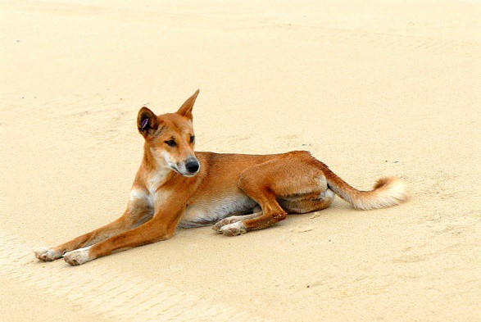
As previously described in this resource, biosecurity is considered a ‘wicked problem’ because it is a social or cultural issue that may be difficult or seemingly impossible to solve.
Knowledge about the problem may be incomplete or contradictory; there might be large economic and/or social costs in tackling the problem; and there may be a large number of people with differing opinions.
Control of wild dogs in WA is one such example. The term wild dog is used widely to describe feral/escaped domestic dogs, pure-

bred dingoes and their hybrids.
Image 4.2.8 A dingo (Canis lupus dingo)

Wild dog predation on livestock is taking a heavy economic and emotional toll on livestock producers in affected pastoral and agricultural areas. In addition to significant annual stock losses to wild dogs, their threat is a major deterrent to restocking of livestock enterprises and to associated regional development opportunities, such as transport and shearing services.
Stock losses from wild dogs in the rangelands of WA alone are estimated at $25 million per year. Wild dogs (including dingoes and their hybrids) are therefore classed as declared pests for the whole of WA under section 22 of the Biosecurity and Agriculture Management Act 2007.
The scientific community is, however, divided on whether the classification of dingoes as a wild dog is valid or appropriate. Recent studies suggest that dingoes are:
- a distinct lineage of wild living canid (Canis lupus dingo) distinct from domesticated dogs (Canis lupus familiaris)

- an important native apex predator vital for maintaining ecosystem sustainability and balance

- culturally important to First Nations Australians.

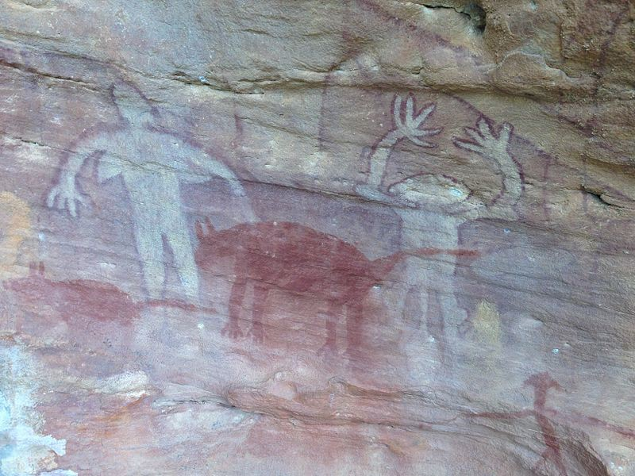
Image 4.2.9 Dingo rock painting - Split Rock Nth QLD

Discussion web: Should dingoes be eradicated or conserved?
The following activity is called a ‘discussion web’. It is designed to help you develop ideas about issues (such as whether dingoes should be eradicated or conserved) where there are opposing points of view. The steps of the discussion web are:
- Read and watch the following articles and videos:

DPIRD - Wild dogs in Western Australia Working together to combat Wild Dogs
Farmers campaign to re-set debate over dingoes

- Think about the points made and the positions taken in the readings and video

- Try to construct support for both sides of the issue using a T-chart format

- Share your ideas with a partner adding any missing ideas to your T-chart

- Next form a group of four and share your idea adding any additional ideas to your T-chart

- Decide as a group which side of the issue to support

- In a whole class discussion attempt to reach a conclusion

T-chart: Invasive species management

How should dingoes be managed?

Eradication | Conservation

Acknowledgements

References
Australian Government, Department of Sustainability, Environment, Water, Population and Communities (© Commonwealth of Australia 2011) ‘Feral European rabbit (Oryctolagus cuniculus)’ available at: <https://www.environment.gov.au/system/files/resources/7ba1c152-7eba-4dc0-a635- 2a2c17bcd794/files/rabbit.pdf > accessed 24 August 2021
ABC News Australia (22 June 2021) video ‘Farmer’s campaign to re-set debate over dingoes’ available at: <https://www.youtube.com/watch?v=a0cVPtYQpPI > accessed 3 August
Centre for Invasive Species Solutions, 2012. Economic and environmental impacts of rabbits in Australia. FactSheet, available at: <https://pestsmart.org.au/toolkit-resource/economic-and- environmental-impacts-of-rabbits-in-australia/ > accessed 24 August 2021
Centre for Invasive Species Solutions (6 August 2015) video ‘Genetic resistance, immunity and transmission of rabbit biocontrol’ available at:< https://www.youtube.com/watch?v=qsCbf8Ii43k&t=69s > accessed 24 August 2021
CSIRO (4 January 2021) ‘Biological control of rabbits’ available at:
<https://www.csiro.au/en/research/animals/pests/biological-control-of-rabbits > accessed 24 August 2021
The Wildlife Society (October 2016) ‘Final position statement – invasive and feral species’ available at: < http://wildlife.org/wp-content/uploads/2014/05/PS_InvasiveFeralSpecies2.pdf > accessed 2 August 2021
Ontario Ministry of Education (2003) ‘Think literacy: Cross-curricular approaches, grades 7-12’ (p197-199) Toronto, ON: available at:
<https://www.tcdsb.org/FORSTAFF/NewTeacherInduction/Documents/crosscurric.pdf > accessed 3 August 2021.
Career Harvest (© 2020 Primary Industries Education Foundation) available at:
<https://www.careerharvest.com.au/ >accessed 3 August 2021

COSMOS (25 March 2021) ‘Dingoes are not wild dogs’ available at:
<https://cosmosmagazine.com/nature/animals/dingoes-are-not-wild-dogs/ > accessed 3 August 2021
Government of Western Australia, DPIRD, (2021) ‘Invasive species’ available at:
<https://www.agric.wa.gov.au/biosecurity-quarantine/biosecurity/invasive-species > accessed 2 August 2021
Government of Western Australia, DPIRD, (2021) ‘Declared plants’ available at:
<https://www.agric.wa.gov.au/pests-weeds-diseases/weeds/declared-plants > accessed 2 August 2021
Government of Western Australia, DPIRD, (2021) ‘Pest insects’ available at:
<https://www.agric.wa.gov.au/pests-weeds-diseases/pests/pest-insects > accessed 2 August 2021

Government of Western Australia, DPIRD, (23 October 2018) ‘Biosecurity Council’ available at:
<https://www.agric.wa.gov.au/bam/biosecurity-council> accessed 3 August 2021

Government of Western Australia, DPIRD, (2021) ‘Control methods’ available at:
<https://www.agric.wa.gov.au/pests-weeds-diseases/control-methods > accessed 3 August 2021

Government of Western Australia, DPIRD, (2021) ‘Mechanical, physical and cultural’ available at:
<https://www.agric.wa.gov.au/pests-weeds-diseases/control-methods/mechanical-physical-and- cultural> accessed 3 August 2021
Government of Western Australia, DPIRD, (2021) ‘Biological control’ available at:
<https://www.agric.wa.gov.au/pests-weeds-diseases/control-methods/biological-control > accessed 3 August 2021
Government of Western Australia, DPIRD, (2021) ‘Chemicals’ available at:
<https://www.agric.wa.gov.au/pests-weeds-diseases/control-methods/chemicals > accessed 3 August 2021
Government of Western Australia, DPIRD, (6 September 2018) ‘Sterile insect technique for fruit fly control’ available at:< https://www.agric.wa.gov.au/medfly/sterile-insect-technique-fruit-fly- control?nopaging=1 > accessed 3 August 2021
Government of Western Australia, DPIRD, (2 April 2019) ‘Wild dogs in Western Australia’ available at: <https://www.agric.wa.gov.au/state-barrier-fence/wild-dogs > accessed 3 August 2021
Government of Western Australia, DPIRD, Department of Fisheries (January 2016) ‘Introduced marine species’ available at:
<https://www.fish.wa.gov.au/Documents/recreational_fishing/fact_sheets/fact_sheet_introduced_m arine_species.pdf > accessed 2 August 2021
Government of Western Australia, DPIRD, (2015) video ‘Invasion curve animation – Biosecurity Council of WA’ available at:< https://www.youtube.com/watch?v=Ho2oXhtGmNQ > accessed 3 August 2021
Government of Western Australia, Department of Biodiversity, Conservation and Attractions, (18 November 2015) ‘Habitat protection and foreshore management’ available at:
<https://www.dpaw.wa.gov.au/management/swan-canning-riverpark/ecosystem-health-and- management/habitat-protection-and-foreshore-management?showall=&start=5 > accessed 3 August 2021

Images
Image 4.2.1 Professor Batty (6 May 2005) ‘Feral Cat – Buster’ CC BY 2.0 available at:
<https://commons.wikimedia.org/wiki/File:%27Feral_Cat%27_%22Buster%22.jpg > accessed 2 August 2021
Image 4.2.2 Harley Kingston (3 January 2012) ‘European red fox’ CC BY 2.0 available at:
<https://commons.wikimedia.org/wiki/File:European_red_fox_(Vulpes_vulpes).jpg > accessed 2 August 2021
Image 4.2.3 CSIRO (18 November 2003) ‘Cane toad’ CC BY 3.0 available at:
<https://commons.wikimedia.org/wiki/File:CSIRO_ScienceImage_1579_Cane_toad.jpg > accessed 2 August 2021
Image 4.2.4 Martin Pot (20 October 2007) ‘Patterson’s Curse in Jarrahdale Western Australia’ CC BY 3.0 available at:
<https://commons.wikimedia.org/wiki/File:Pattersons_Curse_in_Jarrahdale_Western_Australia.jpg
- accessed 29 July 2021

Image 4.2.5 Government of Western Australia (© DPIRD) ‘A sterile Insect Technique (SIT) Qfly with pink dye as part of the department’s Queensland fruit fly eradication program (Qfly)’ available at: <https://www.agric.wa.gov.au/summerprogram > accessed 23 August 2021
Image 4.2.6 CSIRO (9 January 2004) ‘European rabbit’ CC BY 3.0 available at:
<https://commons.wikimedia.org/wiki/File:CSIRO_ScienceImage_1369_European_rabbit.jpg > accessed 23 August 2021
Image 4.2.7 CSIRO (9 January 2004) ‘Rabbits around a water trough’ CC BY 3.0 available at:
<https://commons.wikimedia.org/wiki/File:CSIRO_ScienceImage_1516_Rabbits_around_a_Water_ Trough.jpg > accessed 23 August 2021
Image 4.2.8 Sam Fraser Smith (3 February 2009) ‘Canis lupus dingo’ CC BY 2.0 available at:
<https://commons.wikimedia.org/wiki/File:Canis_lupus_dingo_2.jpg> accessed 3 August 2021

Image 4.2.9 Doug Beckers (16 July 2014) ‘Dingo painting, Split Rock, Australian Aboriginal Art Site, Laura, North Queensland’ CC BY-SA 2.0 available at:
<https://commons.wikimedia.org/wiki/File:Dingo_painting,_Split_Rock,_Australian_Aboriginal_Art_ site,_Laura,_North_Queensland.jpg> accessed 3 August 2021

Student worksheet 4.3 Case study 3: Aquaculture Background
Read through the following background
information making notes of key ideas.

Aquaculture is the farming of marine and freshwater finfish, shellfish, aquatic plants, algae and other organisms. It involves producing aquatic organisms under deliberate and controlled scientific conditions. This is different from the wild- catch fishing industry where aquatic species are extracted from their natural environment.
Aquaculture is typically performed for food production. Various aquatic species can also be

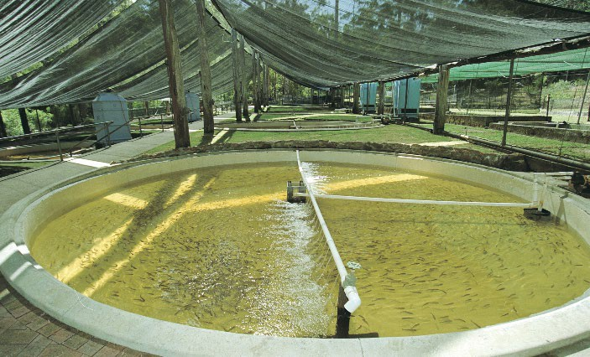
Image 4.3.1 A trout hatchery

farmed for use in aquaponics systems to restore threatened species, enhance valuable wild species or to produce non-food items like pearls, biofuel and bioplastics.
Although Australia’s aquaculture industry is small by global standards, we have a reputation for producing safe, sustainable, high-quality and high-value aquaculture products.
Western Australia (WA) has the potential for significant long-term growth in aquaculture opportunities. Our tropical to cool temperate climate is well suited to a range of fish and seafood species both inland and along our extensive coastline. In WA, the total value of commercial fisheries and aquaculture production (including pearling) in 2017–18 was $633 million with pearling contributing $52 million and aquaculture $27 million.

Is aquaculture a solution to the wicked problem of food security?
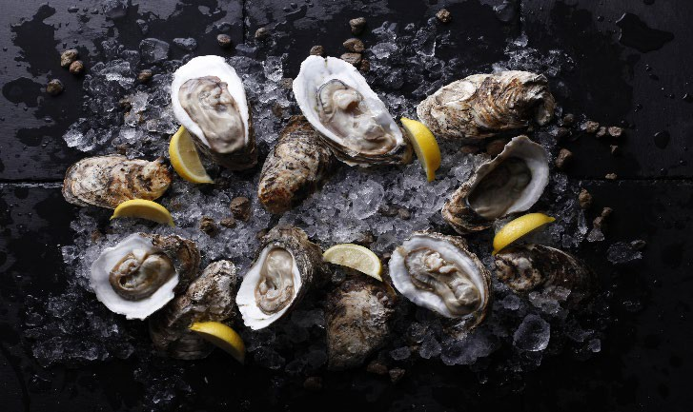
The world’s population is growing rapidly. Australia’s population is expected to reach 46 million by 2075. This population growth is fuelling a rising demand for food and is leading to the decline in wild-catch fish stocks.
This, combined with the growth in population, is affecting both Australian and world food security.
Is it possible, therefore, that aquaculture could

Image 4.3.2 Commercially farmed WA rock oysters
be an answer to the wicked problem of food

security? Even though aquaculture is one of Australia’s fastest growing primary industries, 70% of the seafood that Australians consume is imported. Worldwide, aquaculture is the world’s fastest growing food production sector. However, even though WA has a vast coastline with ideal conditions for aquaculture, the proportion of aquatic food produced by aquaculture in WA has declined compared with other parts of Australia. Considerable opportunities exist for the growth of aquaculture throughout the state.

Exploring the science of aquaculture

Activity 1: An example of selective breeding in aquaculture - the black tiger prawn
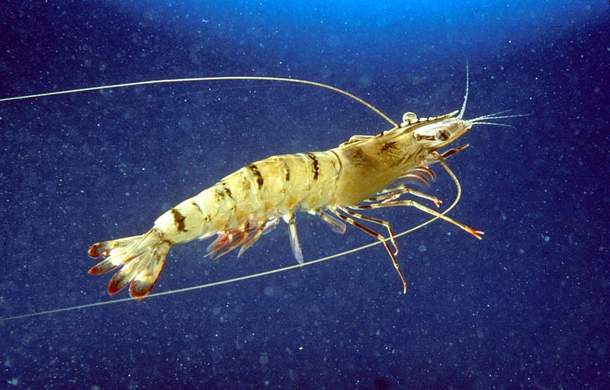
The black tiger prawn (Penaeus monodon) is a fast-growing tropical to subtropical species suited to warm, brackish (slightly salty, estuarine) waters. The black tiger prawn is the dominant prawn species farmed in Asia and Australia.
Scientists at the Commonwealth Scientific and Industrial Research Organisation (CSIRO) Marine Research, in collaboration with industry partners, have spent ten years

researching and domesticating the black tiger prawn so it can be successfully bred in captivity.
Image 4.3.3 An Australian black tiger prawn

Careful selective breeding to improve the genetics of the species in order to produce more commercially useful traits has produced the Australian black tiger prawn.
To learn more about selective breeding to produce the Australian black tiger prawn, read the CSIRO article and watch the embedded video at:
CSIRO – Black tiger prawn

Create a summary of the features that selective breeding has produced to make the Australian black tiger prawn suitable for commercial aquaculture.
Selectively bred features of the Australian black tiger prawn

Understanding the genetics of selective breeding of prawns for aquaculture
Selective breeding of aquaculture species such as the Australian black tiger prawn for commercial purposes poses a number of challenges for geneticists.
In most aquaculture species, it is impractical to track families and offspring for selective breeding purposes through physical tagging methods due to their small body size and large number of offspring produced.
For example, in Australian black tiger prawns thousands of offspring are produced with large variability in the number of offspring contributed from each family. The CSIRO geneticists were confronted with the challenges of selecting the best performing families to create the next generation, as well as maintaining the natural genetic diversity present in the population.

The following article summarises how CSIRO geneticists addressed these challenges: CSIRO – Genetics unravels the complexities of commercial prawn breeding Questions
  - Define the term ‘genetic diversity’.

  - Why do you think that the CSIRO scientists believed it was important to maintain genetic diversity in the population of Australian black tiger prawns during their selective breeding program?

  - The CSIRO article above refers to CSIRO’s parentage marker panel as a means to identify the offspring from different breeding families. This system identifies family relationships by using 120 genetic markers located across the black tiger prawn’s genome. Why do think that the CSIRO geneticists believed that using a genetic marker system was essential for their selective breeding program to be successful?

Australian black tiger prawn aquaculture in WA and the Northern Territory
The CSIRO research on the selective breeding of the Australian black tiger prawn is now being used to create economic development and job opportunities around Australia. In WA and the Northern Territory, a proposed major new venture involving the Australian black tiger prawn will see:
  - a hatchery, breeding centre and grow out farm (an aquaculture operation that farms fingerlings or juveniles to marketing size) developed in the Northern Territory

  - processing works, export facility and founder broodstock population hatchery (mature fish used in aquaculture for breeding) located in WA.
Job opportunities will be created in WA at the proposed processing plant near Kununurra and the foundation broodstock hatchery near Exmouth. The development of the large-scale prawn farm at full production would see up to 150 000 tonnes of black tiger prawns grown in 10 000 hectares of ponds.
To learn more about this exciting development, go to: FRDC - Prawn venture heralds aquaculture step-up

Activity 2: The growth of aquaculture in WA
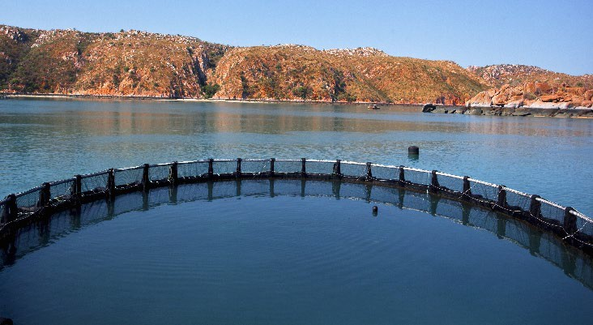
Until recently WA was considered to be behind other states in its development of aquaculture, with only three per cent of the value of its seafood being produced by aquaculture. However, aquaculture in WA is set to grow considerably over the next decade.
The State Government, through the Department of Primary Industries and Regional Development (DPIRD), is supporting the aquaculture industry growth through the implementation of the Aquaculture Development Plan for WA (Aquaculture Plan).

Image 4.3.4 Barramundi aquaculture pond

The plan focuses on the further commercial development of key aquaculture species such as barramundi; marine finfish; shellfish such as mussels, abalone and oysters; inland freshwater species such as trout and marron; marine prawns such as the Australian black tiger prawn; as well as corals and seaweed.
The map on the following page shows the Western Australian Aquaculture Development Zones as well as the species currently targeted for development in these zones.

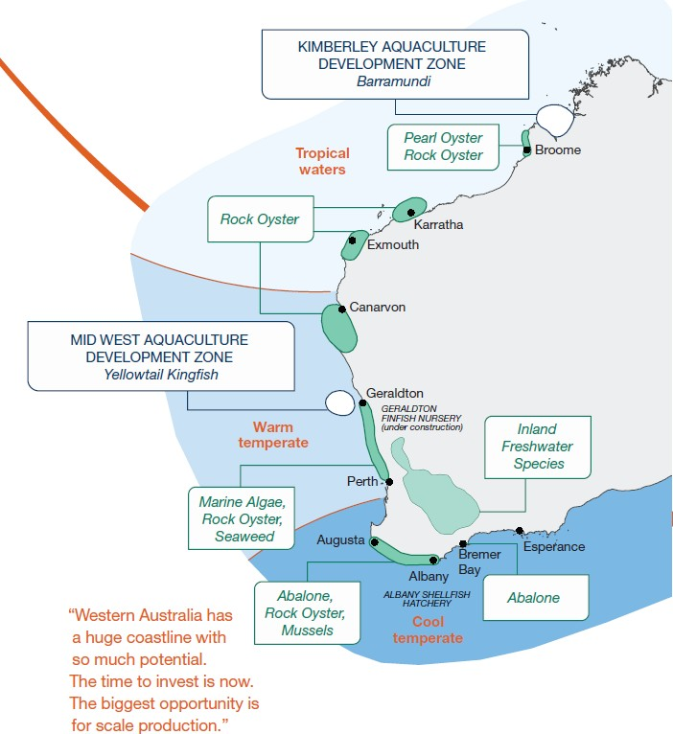

Image 4.3.5 Western Australia's Aquaculture Development Zones

To further develop your understanding of aquaculture in WA, choose one of the following activities:
Creating an aquaculture Fact Sheet

The Government of Western Australia DPIRD (Department of Fisheries) has produced a range of Fisheries Fact Sheets designed to inform people about recreational and commercial seafood species. Only some of these relate to aquaculture species.
Choose one aquaculture species that is either being grown commercially in WA or is planned to be grown commercially.
Research this species and create an educational Fact Sheet on your species that could be used by DPIRD to add to their collection. A typical fact sheet contains a range of images, diagrams and information about the biology of the species being studied.
DPIRD fact sheets you can use for ideas are located at: DPIRD – Fisheries Fact Sheets
Advertising a new aquaculture farm

Design a poster, brochure or stop motion video that could be used to advertise a new aquaculture farm in one of the Western Australian Aquaculture Development Zones.
Your poster, brochure or stop motion video needs to include the reasons why your chosen species would be suitable for that development zone and how any possible environmental considerations are being addressed.
Creating an educational podcast

Create an educational podcast highlighting the potential for the growth of aquaculture in one of the Western Australian Aquaculture Development Zones.
Your podcast needs to explore the biology of any species being considered for aquaculture as well as any possible associated environmental management issues.
Present your podcast to an audience such as your class or small student group.
There are numerous guides, such as Buzzsprout – How to Start a Podcast, available for ideas to help you get started on your podcast.

Activity 3: Making up your own mind - is aquaculture the solution to the wicked problem of food security?
The Food and Agriculture Organisation (FAO) of the United Nations believes that to counter the growing wicked problem of food security, effective fisheries management and sustainable aquaculture are essential. To learn more, follow the link:
FAO – The state of world fisheries and aquaculture 2020

There are, however, environmental and health problems associated with aquaculture that need to be considered. These include diseases which are more easily spread in crowded aquaculture farms, environmental contamination from wastes produced by farm concentrated aquaculture species; and runoff from pesticides and veterinary drugs used to treat species for diseases.
Read the following article The pros and cons of fish farming to learn more. Make a list of the various pros and cons of large scale commercial aquaculture:
Pros | Cons

Watch the following video that examines the growth of sustainable aquaculture in Northern Europe and how some of the problems associated with aquaculture are being addressed: Video – Sustainable Aquaculture

Describe some of the ways that the scientists are dealing with the issues faced by aquaculture:

What’s your opinion?
Do the pros outweigh the cons? Is aquaculture the solution to the wicked problem of food security?

Justify your conclusions.

Activity 4: Career focus on aquaculture
If you enjoyed learning about aquaculture, you may wish to explore possible aquaculture careers. The links below provide a useful starting point for your exploration:
Aquaculture workers – an overview of the requirements, employment prospects, skills and knowledge required by aquaculture workers.
Aquaculture farmer – useful information on becoming an aquaculture farmer, including an excellent video on mussel farming in WA.

Acknowledgements

References
Australian Government, Job Outlook (nd) ‘Aquaculture workers’ available at:
<https://joboutlook.gov.au/occupations/aquaculture-workers?occupationCode=8411 > accessed 16 September 2021
Buzzsprout (nd) ‘The step-by-step guide: How to start a podcast’ available at:
<https://www.buzzsprout.com/how-to-make-a- podcast?gclid=EAIaIQobChMI0e7itrSM8wIVy5pmAh1CFAG5EAAYBCAAEgJtYfD_BwE > accessed 20 September 2021
CSIRO (nd) ‘Aquaculture’ available at: <https://www.csiro.au/en/research/animals/aquaculture > accessed 14 September 2021
CSIRO (8 May 2020) ‘Genetics unravels the complexities of commercial prawn breeding’ available at: <https://research.csiro.au/aquaculture/genetics-unravels-the-complexities-of-commercial- prawn-breeding/ > accessed 15 September 2021
Encyclopaedia Britannica (2021) ‘The pros and cons of fish farming’ available at:
<https://www.britannica.com/explore/savingearth/the-pros-and-cons-of-fish-farming > accessed 20 September 2021
Fisheries Research and Development Corporation (31 may 2019) ‘Prawn venture heralds aquaculture step-up’ in FISH Vol 27 2 available at:< https://frdc.com.au/fish-vol-27-2/prawn- venture-heralds-aquaculture-step > accessed 20 September 2021
Food and Agriculture Organization of the United Nations (2021) ‘The state of world fisheries and aquaculture 2020’ available at: <http://www.fao.org/state-of-fisheries-aquaculture > accessed 16 September 2021
Government of Western Australia, DPIRD ‘Starting an aquaculture operation in Western Australia’ available at: < https://www.agric.wa.gov.au/small-landholders-western-australia/starting- aquaculture-operation-western-australia > accessed 13 September 2021
Government of Western Australia, DPIRD (23 February 2021) ‘Aquaculture’ available at
<http://www.fish.wa.gov.au/Fishing-and-Aquaculture/Aquaculture/Pages/default.aspx > accessed 14 September 2021
Government of Western Australia, DPIRD (November 2020) ‘Aquaculture Development Plan for Western Australia’ available at: <https://www.aquaculturecouncilwa.com/wp- content/uploads/2020/11/420-20-Aquaculture-Development-Plan_Digital.pdf > accessed 14 September 2021
Government of Western Australia, DPIRD, Fisheries (22 September 2016) ‘Fisheries fact sheets’ available at: < https://www.fish.wa.gov.au/About-Us/Publications/Recreational-Fishing/Pages/Fact- Sheets.aspx> accessed 14 September 2021

Government of Western Australia, DPIRD, Fisheries (19 November 2020) ‘Aquaculture research and development’ available at: < http://www.fish.wa.gov.au/Fishing-and- Aquaculture/Aquaculture/Aquaculture-Regions/Pages/default.aspx > accessed 15 September 2021
Government of Western Australia, Department of Training and Workforce Development, Jobs & Skills WA, (9 September 2021) ‘Aquaculture farmer’ available at:
<https://www.jobsandskills.wa.gov.au/jobs-and-careers/occupations/aquaculture-farmer > accessed 16 September 2021
ResponSEAble (29 May 2018) video ‘Sustainable aquaculture’ available at:
<https://www.youtube.com/watch?v=6oXtNjoqCqc > accessed 20 September 2021

Images
Image 4.3.1 Government of Western Australia (© 2021 DPIRD) (8 May 2017) ‘Outdoor trout hatchery’ available at: < https://www.agric.wa.gov.au/small-landholders-western-australia/starting- aquaculture-operation-western-australia > accessed 13 September 2021
Image 4.3.2 Government of Western Australia (© 2021 DPIRD) (16 March 2021) ‘Farmed rock oysters’ available at: < https://www.agric.wa.gov.au/investment/investing-western-australias- aquaculture > accessed 13 September 2021
Image 4.3.3 CSIRO Marine Research (16 January 2001) ‘CSIRO Science Image 2992 The Giant Tiger Prawn’ CC BY 3.0 available at:
<https://commons.wikimedia.org/wiki/File:CSIRO_ScienceImage_2992_The_Giant_Tiger_Prawn.jp g > accessed 15 September 2021
Image 4.3.4 Government of Western Australia (© 2021 DPIRD) (16 March 2021) ‘Aquaculture pond’ available at: < https://www.agric.wa.gov.au/investment/investing-western-australias- aquaculture > accessed 13 September 2021
Image 4.3.5 Government of Western Australia (© 2021 DPIRD) (16 March 2021) ‘WA aquaculture development zones’ available at: < https://www.agric.wa.gov.au/investment/investing-western- australias-aquaculture > accessed 13 September 2021

PRIMED10TL001 | Science | WA primary producers – solving the big issues | Case study 3 | Student worksheet 4.3

Student worksheet 4.4

Case study 4: A2 milk production

Background
Read through the following background information making notes of key ideas.
Could a future food such as A2 milk help address the wicked problem of food security or is it just another new dietary trend? Is it more nutritious, environmentally friendly and healthier?

As lactose-free, soy and various nut milks become more common, there is another variety of milk that is becoming increasingly popular — A2 milk.

Alternative milks are usually marketed as healthier, less allergenic and more environmentally friendly. A2 milk is promoted and sold in supermarkets as an alternative for people who struggle to digest common varieties of cows' milk. It is, however, significantly more expensive than regular cow’s milk – so is it worth people changing over to it?

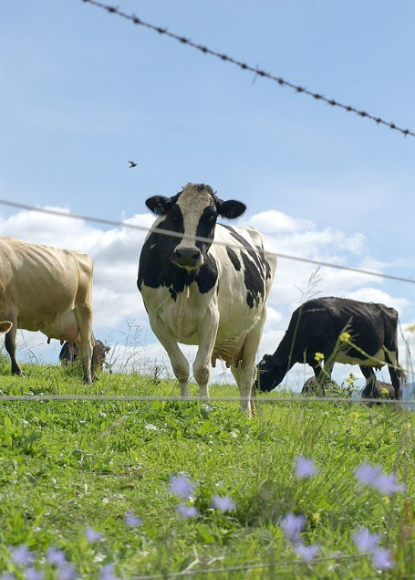
Image 4.4.1 Dairy cattle

Proponents of A2 milk claim that consuming the A1 casein protein may lead to various negative health effects. These include symptoms which may often be misdiagnosed as lactose intolerance. A2 milk may therefore allow some people who previously thought they were lactose intolerant to resume milk consumption.

What is A2 milk?
A2 milk is cows’ milk that contains only the A2 variant of beta-casein protein and not the A1 variant. The other components in A2 milk (lactose, fats etc.) do not differ from regular cows’ milk.
Genomic evidence suggests that before cows were domesticated (approximately 10 000 years ago), they produced only the A2 beta casein protein and not the A1 beta casein protein. About
8 000 years ago, a natural single-gene mutation occurred in Holstein cattle resulting in production of the A1 casein protein. The mutation was passed on to many other breeds and eventually the A1 beta casein variant became dominant in milk. While dairy herds in much of Asia, Africa, and part of Southern Europe remain naturally high in cows producing A2 milk, the A1 version of the protein is common among cattle in the Western world.
In general, milks from Guernsey, Jersey, Asian herds, human milk, and others (sheep, goat, donkeys, yaks, camel, buffalo, sheep, etc.) contain mostly A2 beta casein rather than A1.

Activity 1: The science of producing A2 milk
Before you can develop a valid opinion on whether A2 milk is superior to regular milk you need to make sure you know about the science of how it is produced and whether there is scientific evidence to support any claims made. Follow the links below to learn more:
ABC Rural News – Digesting dairy: What’s the difference between A2 and ordinary milk? A1 or A2 milk?
Cow and heifer genomics

Video – A2 milk and lactose intolerance study Video – A2 milk – not all cow’s milk is the same!
- Explain the process of the how A2 milk is produced. Be sure to include key scientific ideas and language in your summary (eg principles of mutation and selective breeding)
The science of A2 milk production

Activity 2: The genetics of cross breeding to produce an A2 cow
A1 and A2 represent two different alleles for casein protein production. All cows have two alleles for the production of casein protein, one from each parent. As the A2 allele is recessive to the A1 allele, only females with a genotype of A2A2 are capable of producing purely A2 milk. Cows not capable of producing A2 milk have the genotypes A1A1 or A1A2.

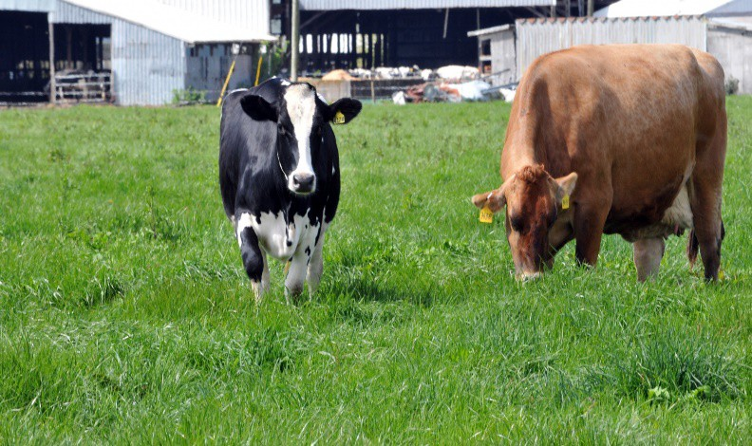
Image 4.4.2 Holstein (left) and Jersey (right) cows

A dairy farmer in the southwest of WA has a herd of Holstein dairy cattle.
Holsteins produce mainly A1 milk. The farmer realises that producing consistent quantities of A2 milk may increase the profitability of the dairy so contacts a neighbouring farmer who has Jersey dairy cattle (which produce A2 milk) and organises for one of the Jersey bulls to be mated with one of the Holstein cows. The Holstein cow becomes pregnant.

The mating is depicted in the following pedigree diagram below:

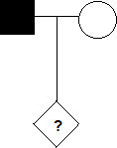
Key to symbols used:
A2 Jersey bull
A1 Holstein cow
Unknown offspring

- What is the probability that the unknown offspring of the mating of the Jersey bull with the Holstein cow is an A2 milk producing female? Set out your reasoning below – you will need to use at least one punnet square to justify your predictions:

- Describe the role that genomic testing might play in the selective breeding of A2 milk producing cows

Activity 3: Examining your thoughts on A2 milk
The following activity is called ‘Claim, Support, Question’. It is a routine for reasoning with evidence. In this activity you can either work individually, in small groups or in a whole group discussion. For more information on this routine, follow the link Claim, Support, Question
The process is:

- Make a claim (explanation, interpretation) about the topic (A2 milk)

- Identify support (things you see, feel, know) for your claim

- Ask a question related to you claim. What isn’t explained?

After going through this activity, summarise your thoughts about A2 milk below:

Acknowledgements

References
ABC Rural News (22 November 2017) ‘Digesting dairy: What’s the difference between A2 and ordinary milk?’ Available at: <https://www.abc.net.au/news/rural/2017-11-22/a2-milk-vs-ordinary- milk/9177020> accessed 4 August 2021
Harvard Graduate School of Education, Project Zero (2015) ‘Thinking routine – Claim, Support, Question’ available at: <https://pz.harvard.edu/resources/claim-support-question> accessed 4 July 2021
Science Learning Hub (2006) ‘A1 or A2 milk?’ available at:
<https://www.sciencelearn.org.nz/resources/2042-a1-or-a2-milk> accessed 4 August 2021

Dairy Australia (nd) ‘Cow and heifer genomics’ available at:
<https://www.dairyaustralia.com.au/animal-management-and-milk-quality/genetics-and- breeding/cow-and-heifer-genomics> accessed 4 August 2021
FarmingUK (9 May 2017) video ‘A2 milk – not all cow’s milk is the same!’ available at:
<https://www.youtube.com/watch?v=71PckA4S8LM> accessed 4 August 2021

University of Auckland (24 October 2017) video ‘A2 milkTM and lactose intolerance study’ available at: <https://www.youtube.com/watch?v=TICBqGJRCaA> accessed 4 August 2021

Images
Image 4.4.1 Carl Davies CSIRO (6 June 2006) ‘Dairy cattle in pasture’ CC BY 3.0 available at: https://commons.wikimedia.org/wiki/File:CSIRO_ScienceImage_3292_Dairy_cattle.jpg accessed 4
August 2021

Image 4.4.2 Linnaea Mallette (2021) ‘Holstein and Jersey Cow’ CC0 1.0 available at:
<https://www.publicdomainpictures.net/en/view-image.php?image=159371&picture=holstein-and- jersey-cow > accessed 31 August 2021

Student worksheet 4.5

Case study 5: Cereal grain crop technologies

Background
Read through the following background information making notes of key ideas.

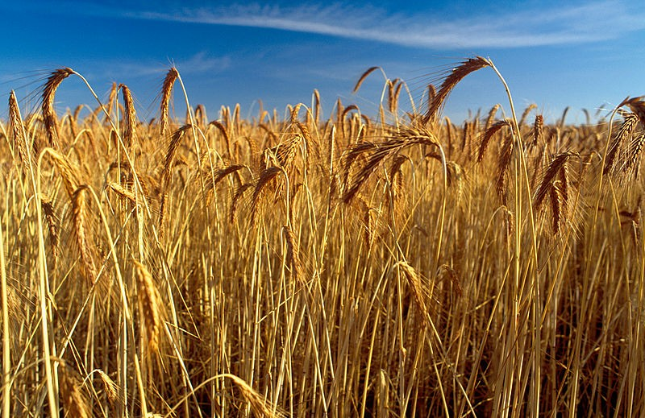
Agricultural production of foods such as cereal grain crops is extremely dependent on ideal climate conditions. However, according to the Australian Government, agriculture is responsible for at least 16% of Australia’s greenhouse gas (GHG) emissions. The scientific community is now strongly of the opinion that increasing GHG emissions is a key contributing factor to climate change.

With a rapidly growing human population, global demand for food security is increasing
Image 4.5.1 Wheat crop ready to harvest

dramatically. Plant researchers are constantly looking to breed more efficient cereal grain crops to cope with this demand.

Pests and diseases can be very damaging to our food security. Biosecurity is the management of the risk of animal and plant pests and diseases entering, emerging, establishing or spreading in Western Australia (WA), to protect our economy, environment and the community.

What are the problems and solutions?
To find solutions to the wicked problems of climate change, food security and biosecurity a range of innovative solutions are needed. These include technology, biotechnology and selective breeding initiatives. There is strong demand for science-based approaches to solving these problems.

These are challenges for both Western Australian and global primary producers, particularly in the area of cereal grain crop production. The aim of this case study is for you to examine some of the cereal grain crop options.

Exploring the science

Selective breeding of cereal grain crops
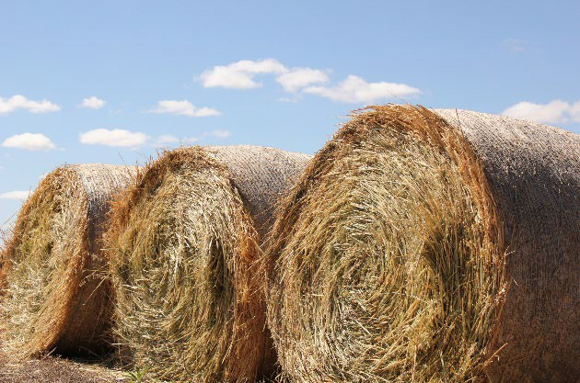
Image 4.5.2 Hay bales

Selective breeding is the process that has been used by humans for thousands of years to produce particular varieties of cereal grain crops that might have increased yield, pest resistance, tolerance to environmental conditions and increased nutritional value.

The three major cereal grain crops that are grown in WA are wheat, barley and oats.

Wheat
Wheat production accounts for 70% of total cereal production in WA with about seven million tonnes generated annually across the WA wheat belt. About 80% of WA wheat is exported - mainly to Asia and the Middle East - generating $2 billion in annual export earnings for the state.

There are many different varieties of wheat grown throughout Australia. The specific quality traits of the grain type influence how they behave when kneaded, baked, cooked, boiled or fried. Wheat varieties with hard grains and high protein are used for baked breads and noodles. Softer, lower protein grains are used for weak doughs in biscuits, pastries and cakes.

Barley
Barley is WA’s second largest cereal crop after wheat – accounting for 25% of the state’s total cereal production. It delivers over $650 million in export earnings each year. Forty per cent of barley produced is malting grade (suitable for brewing, distilling or food) for the Japanese, Chinese and Indian beer markets. The remaining 60% is delivered as feed grade for livestock.
Oats
The Western Australian oat industry generates about $200 million for the state economy each year through the production of milled (rolled) oats for human consumption and feed oats and oaten hay for livestock production.
It is very important therefore that research into selectively breeding new varieties of these cereal grain crops is carried out in order to stay in front of climate change, food security and biosecurity.

In WA, InterGrain are one of the leaders in cereal breeding in Australia. InterGrain’s highly successful wheat, barley and oat breeding programs are designed to target the major cereal growing regions of Australia. Some of the varieties of cereal grain crops produced by InterGrain are:
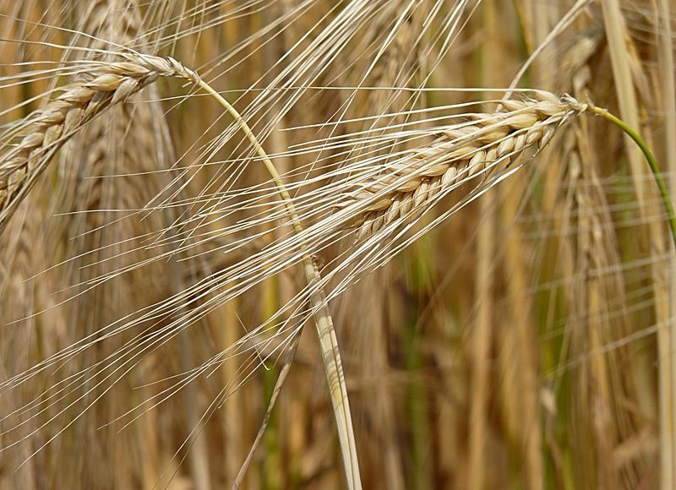
Barley varieties:
Image 4.5.3 Barley

- herbicide tolerant

- acidic soil tolerant

- high rainfall tolerant Wheat varieties:
- disease resistance - rust and yellow leaf spot

- yield stability

- suitable for udon noodles Oat varieties:
- herbicide tolerant

Activity 1: Selective breeding of cereal grain crops
To find out more about the selective breeding of cereal crops watch the following videos and read pages 8 – 10 of the Grains Research and Development Corporation (GRDC) resource –Science of crossing and crops:

Video: InterGrain – Australian Innovation in Food and Agtech

Video: GCSE Biology – Selective Breeding

GRDC – Science of crossing and crops (pages 8 – 10)

Go to InterGrain - Wheat and examine the different varieties of wheat InterGrain have developed. Imagine that you are a cereal crop scientist working for InterGrain trying to selectively breed a wheat crop that is suitable for both baking bread and noodles and is also highly tolerant to weed control herbicides.

- Which varieties would you choose to cross? Justify your choice

- What name would you give your new variety?

- Create a flowchart of the processes involved in selectively breeding the new variety
Flowchart

GM cereal grain crops
As the need for food security continues to increase, plant breeders work to breed better yielding crop varieties. They use a range of methods including conventional selective breeding, genetic modification (GM), genome editing and marker-assisted breeding to breed new crop varieties.
Genetic modification (GM) is the use of biotechnology techniques to change the genome of an organism such as a plant or animal. GM allows plant breeders to produce a crop variety with specific characteristics that could not be bred using conventional selective breeding methods.
The use of GM technologies is highly regulated in Australia. GM cereal grain crops have been approved for use in WA since 2008. At present the only grain crops approved for use by the Office of the Gene technology Regulator (OGTR) are canola and safflower.
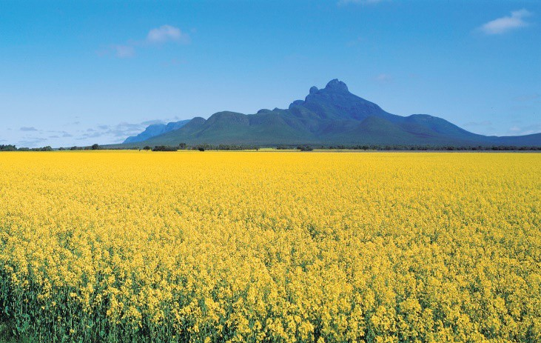
Canola is grown for the oil crushed from its seeds and is used in cooking oil, edible blend oil and margarine. GM canola is grown in preference to conventional canola in order to increase its herbicide tolerance and to increase its omega-3 oil content (increased nutritional value). The area planted to GM canola in WA has grown to 34% of total canola plantings since 2010 demonstrating grower demand for this technology.

The oils of safflower seeds have a variety of uses. Linoleic oil is an edible vegetable oil used
Image 4.5.4 Canola in the Stirling Ranges WA

in products such as salad oils and soft margarines. It also has use in pharmaceuticals, cosmetics and paint. Oleic oil has unique properties that make it of potential use in biodiesel production.
Safflower seeds can be used in bird seed mixes.

In addition to GM crops in WA, there have been a range of experiments carried out with other crops. There are currently experimental field plantings in Australia of GM banana, barley, ryegrass, mustard, sugarcane and wheat. In the past, there have also been trials of rice, clover, maize, poppy, papaya, pineapple and grapevines

Activity 2: Genome editing
In Case study 1 on GM organisms you demonstrated your understanding of conventional GM methods by creating an illustrated flowchart of how a GM variety of a grain crop such as wheat or canola would be produced. An exciting new genetic technology now available to cereal crop breeders is genome editing. Genome editing is much more specific than conventional GM techniques. Follow the links below to learn more:
Introduction to Genome Editing using CRISPR Cas9 HD Genome editing technologies could revolutionise agriculture Explainer: How CRISPR works

Summarise how genome editing technologies (such as CRISPR) might be used to assist the improvement of cereal grain crops and thus assist with solving agriculture’s wicked problems

Who first developed the genome editing technology CRISPR? | What processes are involved in a genome editing technology such as CRISPR? | When were genome editing technologies such as CRISPR first developed?
Where in agriculture do you see genome editing technologies such as CRISPR having the most impact? | How does genome editing technology differ from conventional GM?  In your opinion does it have the same ethical problems we usually associate with conventional GM? | Why is genome editing considered to be a superior approach compared with conventional GM?

Activity 3: Career exploration – cereal grain technologies
First watch this video on the important role of research and innovation in addressing the wicked problem of food security:
Australian year of the farmer’s productivity video

Cereal grain is one of Australia’s most important agricultural exports. WA has more land planted for cereal grain crops than any other state. This means there are many jobs in cereal grains research and development here in WA. A career in cereal grains can also set you up for an international career.
If you enjoyed learning about how the development and use of cereal grain technologies by WA primary producers is helping solve the wicked problems facing agriculture, you may enjoy exploring these related career profiles at:
Brett Tucker: Farm manager

Associate Professor Rachel Burton: Molecular biologist
Doctor Dan Mullen: Plant breeder

Doctor Grant Holloway: Plant pathologist
Alli Elliott: Extension and communication officer
Sarah McDonnell: Education specialist
James Barr: Agricultural engineer

Kate Wilson: Agronomist

Leighton Wilksch: Innovator and technology guru
GRDC Grains industry education resources – Industry snapshots
Other useful career links are: Agricultural scientist
Grain harvest careers

Farming – farmer, farmhand, supervisor, manager, business manager
Cereal grain crop breeder

Activity 4: Extension research activities
- Genetics is the study of genes and their role in inherited variation – the way genes code for certain proteins that produce traits passed from one generation to the next.
Genomics is study of an organism’s genome. It examines all of the DNA – genes that code for proteins as well as non-coding regions.

More recently the study of phenomics has become important. Phenomics is the study of how genetic, environmental and social factors interact to produce a phenotype.

Research how both genomics and phenomics are being used to provide innovative solutions to world food security

Useful starting resources are: Video – What is genomics?
Video – What is phenomics?

- What is marker-assisted breeding? How does this approach assist farmers?

A useful starting resource is: CSIRO – Marker assisted breeding

- What is precision agriculture? Is it a likely answer to climate change and food security?

A useful starting resource is: CSIRO – Precision agriculture

Acknowledgements

References
AgriLabour Australia (© 2021) ‘Grain harvest jobs – work in Australia’s grain harvest’ available at:
<https://www.agrilabour.com.au/candidates/grain-harvest-jobs/ >accessed 17 August 2021

Australian Government, Department of Health, Office of the Gene Technology Regulator (September 2018) ‘Genetically modified (GM) crops in Australia’ available at:
<http://www.ogtr.gov.au/internet/ogtr/publishing.nsf/Content/9AA09BB4515EBAA2CA257D6B0015 5C53/$File/11%20-%20Genetically%20modified%20(GM)%20crops%20in%20Australia.pdf > accessed 17 August 2021
Australian Government, Job Outlook (nd) ‘Agricultural scientists’ available at:
<https://joboutlook.gov.au/occupations/agricultural-scientists?occupationCode=234112 >accessed 18 August 2021
CSIRO (22 January 2021) ‘Marker assisted breeding’ available at:
<https://www.csiro.au/en/research/animals/breeding/marker-breeding > accessed 26 August 2021

CSIRO (29 March 2021) ‘Precision agriculture’ available at:
<https://www.csiro.au/en/research/plants/crops/farming-practices/precision-agriculture > accessed 26 August 2021
Government of Western Australia, DPIRD, (11 May 2021) ‘How Australia accounts for agricultural greenhouse gas emissions’ available at: < https://www.agric.wa.gov.au/climate-change/how- australia-accounts-agricultural-greenhouse-gas-emissions >accessed 16 August 2021
Government of Western Australia, DPIRD, (13 July 2020) ‘Genetically modified crops in Western Australia’ available at: < https://www.agric.wa.gov.au/genetic-modification/genetically-modified- crops-western-australia >accessed 17 August 2021
Government of Western Australia, DPIRD, (13 August 2019) ‘Information on genetically modified organisms’ available at: < https://www.agric.wa.gov.au/genetic-modification/information- genetically-modified-organisms >accessed 17 August 2021
Government of Western Australia, DPIRD, (nd) ‘Biosecurity’ available at:
<https://www.agric.wa.gov.au/biosecurity-quarantine/biosecurity >accessed 7 September 2021

Government of Western Australia, DPIRD, (nd) ‘Wheat’ available at:
<https://www.agric.wa.gov.au/crops/grains/wheat >accessed 16 August 2021

Government of Western Australia, DPIRD, (nd) ‘Barley’ available at:
<https://www.agric.wa.gov.au/crops/grains/barley > accessed 16 August 2021

Government of Western Australia, DPIRD, (nd) ‘Oats’ available at:
<https://www.agric.wa.gov.au/crops/grains/oats >accessed 16 August 2021

CSIRO (nd) ‘Food security and global farming’ available at: https://www.csiro.au/en/research/production/food/food-security > accessed 16 August 2021

Genome BC (24 March 2010) video ‘What is genomics?’ available at:
<https://www.youtube.com/watch?v=mmgIClg0Y1k > accessed 26 August 2021

Grain Research Development Corporation (GRDC) (March 2017) ‘GRDC Grow notes: Safflower’ available at: < https://grdc.com.au/ data/assets/pdf_file/0028/370576/GrowNote-Safflower-North- 0A-Introduction.pdf > accessed 17 August 2021
Grain Research Development Corporation (GRDC) (nd) ‘Grain facts for schools: Wheat’ available at: <https://grdc.com.au/ data/assets/pdf_file/0022/367042/Grain-facts-for-schools-wheat.pdf > accessed 16 August 2021
Grain Research Development Corporation (GRDC) (June 2016) ‘The science of crossing and crops - How modern science is helping produce more food in a changing climate’ available at:
<https://grdc.com.au/ data/assets/pdf_file/0031/227848/grdc-science-of-crossing-and-crops- fa.pdf.pdf > accessed 16 August 2021
Grain Research Development Corporation (GRDC) (nd) ‘GRDC Grains industry education resources – Food, farming and futures in the Australian Grain industry’’ available at: < https://grdc.com.au/ data/assets/pdf_file/0031/227569/grdc-fact-sheet-fa.pdf.pdf > accessed 19 August 2021
GSCE Biology (11 January 2019) video “Selective Breeding #53’ available at:
<https://www.youtube.com/watch?v=3B4LEssKSLs >accessed 16 August 2021

IDTechEx Research Article, Dent. M (25 September 2020) ‘Genome editing technologies could revolutionise agriculture’ available at: <https://www.idtechex.com/en/research-article/genome- editing-technologies-could-revolutionise-agriculture/21714 >accessed 17 August 2021
InterGrain (© 2021) ‘Cereal breeding for Australia’ available at: <https://www.intergrain.com/about- intergrain/breeding-operations/ > accessed 16 August 2021
InterGrain (© 2021) ‘Our people’ available at: < http://www.intergrain.com/about-intergrain/our- team/ > accessed 17 August 2021
InterGrain (15 September 2017) video ‘InterGrain – Australian innovation in food and Agtech’ available at: https://www.youtube.com/watch?v=-koEGWC4pZg accessed 16 August 2021
National Institute of Health (NIH) (20 April 2019) video ‘Introduction to Genome Editing using CRISPR Cas9 HD’ available at:
<https://www.youtube.com/watch?v=g7bkE1krgFM&t=45s>accessed 17 August 2021

Purdue Plant Sciences (10 February 2017) video ‘What is phenomics?’ available at:
<https://www.youtube.com/watch?v=HEjD1-D2KLE > accessed 26 August 2021

Rural Careers Australia (© 2021) ‘grain crops’ available at: http://www.ruralcareers.net.au/grain- crops/ accessed 17 August 2021
Science News for Students (31 July 2017) “Explainer: How CRISPR works’ available at:
<https://www.sciencenewsforstudents.org/article/explainer-how-crispr-works >accessed 17 August 2021
Year of the farmer (11 October 2011) video ‘Australian Year of the Farmer’d Productivity Video’ available at: < https://www.youtube.com/watch?v=_pb2fCoPmjw >accessed 17 August 2021

Images
Image 4.5.1 CSIRO, ‘Wheat crop ready to harvest’ CC BY 3.0, available at:
<https://commons.wikimedia.org/wiki/File:CSIRO_ScienceImage_962_Wheat_crop_ready_to_harv est.jpg> accessed 16 August 2021
Image 4.5.2 Government of Western Australia, ‘Hay bales’ (©2021 DPIRD),
<https://www.agric.wa.gov.au/hay-production/oats-hay-production> accessed 9 August 2021

Image 4.5.3 Jamain (6 July 2013) ‘Barley’ CC BY-SA 1.0 available at:
<https://commons.wikimedia.org/wiki/File:Barley_J1.jpg > accessed 16 August 2021

Image 4.5.4 Government of Western Australia, ‘Canola in the Stirling Range (©2021 DPIRD),
<https://www.agric.wa.gov.au/hay-production/oats-hay-production> accessed 17 August 2021

Student worksheet 4.6

Case study 6: Selective breeding of sheep– using ASBVs

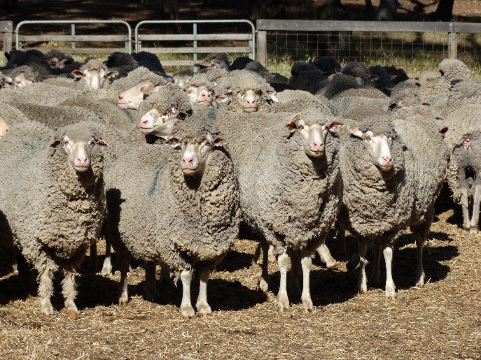
Background
Read through the following background information making notes of key ideas.
Have you ever wondered where our agricultural animals such as sheep and crops such as wheat in Western Australia (WA) originally come from? What were they like hundreds or thousands of years ago? The food we eat and grow in WA today is in fact very different from the original wild animals and plants from which they originated.

Around 12 000 years ago people around the world harvested their food from the natural
Image 4.6.1 Merino ewes

biodiversity of plants and animals that surrounded them. This type of lifestyle is called ‘hunter gathering’. Eventually people domesticated animals and crops. This period of time is described as part of the ‘Neolithic revolution’.

For example, modern wheat derives from a variety called Emmer. Emmer evolved as a type of a natural hybrid formed by the combination of the genomes of two different wild varieties. It therefore contains twice the number of chromosomes and is thus described as a tetraploid (2n = 4x = 28 chromosomes). The key feature that make it more suitable to cultivate than the wild type is that the ripened seed head remains intact, making it easier to harvest the grain.

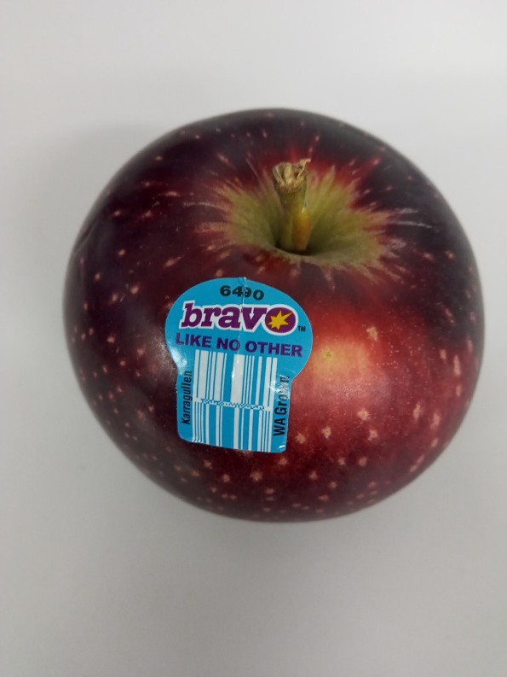
What is selective breeding?
Image 4.6.2 Bravo apple
During the process of domestication over thousands of years, people began unwittingly to select for desirable traits such as shortened growing seasons, increased resistance to diseases and pests, larger seeds and fruits, nutritional content, shelf life, and better adaptation to diverse ecological conditions. This process produced improved plants and animals for food and fibre production.

Selective breeding therefore is the process that has been used by humans for thousands of years to produce particular breeds of animals or varieties of plants. For example, farmers may choose individual cattle to mate that are better at producing meat. Fruit growers may grow particular varieties of apples (such as Bravo apples) because they have better nutritional value.

Exploring the science

Activity 1: History of agricultural selective breeding
Explore more about the history of selective breeding by following the links: Video - Foods that originally looked totally different
History of agricultural biotechnology: how crop development has evolved

Choose one plant or animal that we use today for food or fibre. Research the development of this food or fibre from its origins to the present day. Use the following question chart to assist you.

My animal or plant is:
Who first domesticated or cultivated this animal or plant? | When was the animal or plant first domesticated or cultivated? | What processes changed the animal or plant to its present form?
Where in the world was the animal or plant domesticated or cultivated? | How has the animal or plant been modified from the original? | Why was the animal or plant domesticated or cultivated?

Activity 2: Genetic selection using Australian Sheep Breeding Values (ASBV)
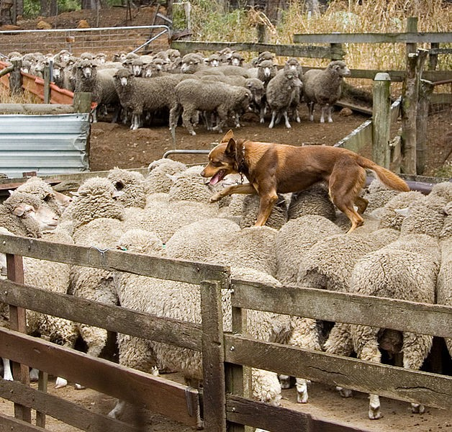
Sheep are grown across a wide range of agricultural regions in WA. The key products of the Western Australian sheep industry are wool, sheep, meat (lamb and mutton) and live sheep. The WA sheep flock consists of around 14.2 million sheep. Annually 5.7 million sheep and lambs are produced for meat and live export as well as 72 million kilograms of greasy wool (primarily for export markets).

Agricultural animal and plant selective breeding programs aim to improve specific economically important traits. An effective support tool, the Australian Sheep Breeding Values (ASBV) has been developed in Australia to support Australia sheep farmers. ASBVs are a prediction of an animal’s genetic merit for a particular trait such as fleece weight, body weight or fibre diameter.

Image 4.6.3 Kelpie walking across the back of sheep

ASBVs express the relative breeding value of sheep across different breeding flocks. They are an indication of how an animal’s progeny (offspring) will perform based on the genes they will pass on.

ASBV are available for many traits in sheep such as growth rate, wool, reproduction, internal parasite (worm) resistance, dags (locks of wool matted with dung hanging from the hindquarters of a sheep) and body conformational traits such as wrinkle and breech cover. Genetic selection using ASBVs enables both wool and sheep producers to make positive and permanent genetic gains in their flock. They are the most effective tool sheep producers can use to select rams and ewes to genetically improve their flocks.
Follow the links below to learn more:

ASBVs and Indexes explained
Video - Australian Sheep Breeding Values – Lynley Anderson
In the space below, describe how using ASBVs could be advantageous to Western Australian sheep breeders:

Activity 3: Using ABSVs to select for worm resistant sheep
Gastro-intestinal worm infections in sheep are a major cause of lost productivity to the Western Australian sheep industry.

In order to control this problem sheep are traditionally given chemicals (drenches) such as macrocyclic lactone (ML). Control has become more complex due to widespread drench resistance. Lost productivity due to drench resistance worms has been recognised as a widespread problem in WA since the 1980s. It is now thought that more than 85% of WA sheep farms are likely to have ML resistant sheep worms.

The only permanent long-term solution to help manage drench resistant worms is to breed sheep that are worm resistant. This has several advantages:

- robust and easy-care sheep
- lower production losses due to worms requiring less drenching and lower worm
- less contamination of paddocks
- less reliance on artificial control options
- off-farm benefits such as sustainable production systems

Resistance to worms in sheep is an inherited trait that can be increased by selection. The heritability of worm resistance, as measured indirectly by individual sheep faecal Worm Egg Count (WEC), is at least 25%. This means that 25% of the phenotypic superiority of an animal will be passed on to their offspring.

For example, if the average faecal WEC of a flock is 400 eggs per gram (epg) and an individual ram has a true faecal WEC of 200, then the ram's superiority is 200 epg (400 minus 200) as they are 200 epg below the flock average. Thus, if such animals are mated with each other, then it can be expected that their offspring will have a superiority of 50 epg (25% of 200) below the average, that is 350 epg.

Using ASBVs allows the process of selecting for worm resistance to occur more precisely. As with all genetic improvement programs, selecting within a flock can take several years to achieve noticeable improvements, but an increasing number of farmers who have been selecting sheep for worm resistance for some time have achieved very good results. Results from Sheep Genetics show that an increasing number of farmers have sheep that are relatively resistant to worms.

In order to increase your understanding of using selective breeding and genetics in the breeding of worm resistant sheep, watch the following video:

Video: Sheep genetics: Wiping out worms

Analysing research data on worm resistance
Since 1988 the Department of Primary Industries and Regional Development (DPIRD), with industry support, has been selecting for worm resistance in the Rylington Merino flock. Image 4.6.4 shows the genetic trend of the decline of the faecal WEC in the Rylington Merino selection line relative to that of the unselected control line.
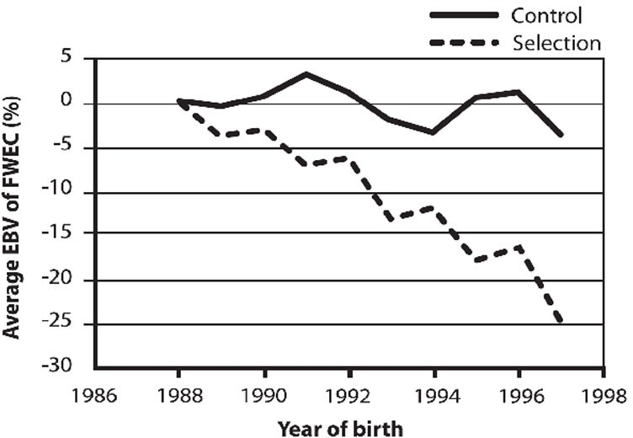
Image 4.6.4 Genetic trend of Rylington Merino sheep for worm resistance compared to the unselected control group

Image 4.6.5 shows the genetic merit of the selected line in the worm resistant Rylington Merino flock compared to compared to the industry average. The ASBV for WEC of 0% is taken to represent an actual flock average WEC of 500 epg of faeces, and the minus 100 ASBV WEC is taken to be an animal that is totally resistant to worm with a WEC of zero epg.
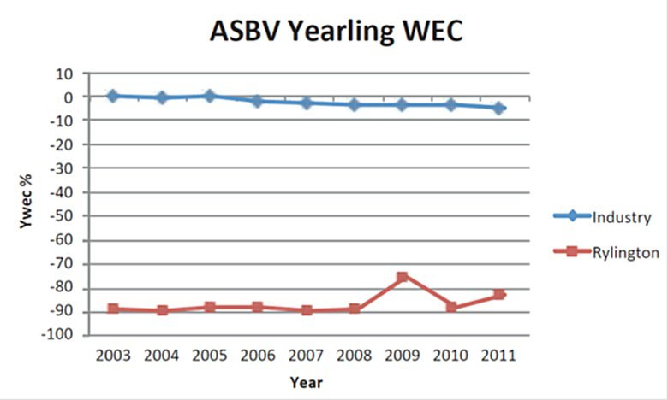

Image 4.6.5 Genetic trends of Rylington Merino for yearling worm egg count ASBV compared to tested industry flocks

The DPIRD researchers concluded that the data collected and displayed in images 4.6.4 and 4.6.5 indicates clearly that the Rylington Merino flock is a highly worm resistant flock compared with flocks that have not been selectively bred for worm resistance.
Do you agree with their findings?

Justify your opinion using data from images 4.6.4 and 4.6.5

Activity 4: What is your opinion on problems associated with selective breeding?
Read the following article: Advantages and disadvantages of selective breeding Summarise the advantages and disadvantages in the table below.
Advantages of selective breeding | Disadvantages of selective breeding

What’s your opinion - do the advantages of selective breeding outweigh the disadvantages? Why or why not?

Activity 5 – Career exploration
If you enjoyed learning about the use of selective breeding for food and fibre production, you may enjoy exploring these related careers:
Artificial insemination technician Animal scientist
Stock and station agent (Auctioneer) Veterinarian
Wool classer or valuer

Acknowledgements

References
Agcareers.com (© 2021) ‘Artificial insemination technician’ available at:
<https://www.agcareers.com/career-profiles/artificial-insemination-technician.cfm >accessed 10
August 2021

Be Amazed (17 December 2017) video ‘Foods that originally looked totally different’ available at:
<https://www.youtube.com/watch?v=M5Qly-VQfbo > accessed 10 August 2021

CareerExplorer (2021) ‘What does an animal scientist do?’ available at:
<https://www.careerexplorer.com/careers/animal-scientist/ > accessed 10 August 2021

Career Harvest (© 2020) ‘Stock and station agent’ available at:
<https://www.careerharvest.com.au/career/stock-and-station-agent/ > accessed 10 August 2021

Government of Western Australia, DPIRD, (1 July 2020) ‘Genetic selection and using Australian Sheep Breeding Values (ASBV)’ available at: <https://www.agric.wa.gov.au/genetics- selection/genetic-selection-and-using-australian-sheep-breeding-values-asbv> accessed 9 August 2021
Government of Western Australia, DPIRD, (2 March 2021) ‘The Western Australian sheep and wool industries’ available at: <https://www.agric.wa.gov.au/sheep/western-australian-sheep-and- wool-industries > accessed 9 August 2021
Government of Western Australia, DPIRD, (28 September 2017) ‘Sheep worm control in Western Australia’ available at: <https://www.agric.wa.gov.au/livestock-parasites/sheep-worm-control- western-australia > accessed 9 August 2021
Government of Western Australia, DPIRD, (30 June 2017) ‘Sheep worms – breeding worm resistant sheep’’ available at: <https://www.agric.wa.gov.au/genetics-selection/sheep-worms-
%E2%80%93-breeding-worm-resistant-sheep > accessed 9 August 2021

Government of Western Australia, DPIRD, (13 July 2015) video ‘Australian Sheep Breeding Values Lynley Anderson – Department of Agriculture and Food WA’ available at:
<https://www.youtube.com/watch?v=0TR4ajjFLm0 > accessed 26 August 2021

Government of Western Australia, Department of Training and Workforce Development (© 2021) ‘Jobs & Skills WA – wool classer’ available at: <https://www.jobsandskills.wa.gov.au/jobs-and- careers/occupations/wool-classer> accessed 10 August 2021
MLAfeedbackTV (1 March 2010) video ‘Sheep Genetics: Wiping out worms (episode 9)’ available at: <https://www.youtube.com/watch?v=DllBKIXKrXo > accessed 13 August 2021
Nesbitt, M. (2001) ‘Wheat evolution: integrating archaeological and biological evidence’ pp 37-59 in
Wheat taxonomy: the legacy of John Percival, edited by P.D.S Caligari & P.E. Brandaham. London: Linnaean Society, Linnaean Special Issue 3 available at: http://www.rbgkew.org.uk/scihort/ecbot/papers/nesbitt2001wheat.pdf > accessed 9 August 2021
Sciencing (21 September 2018) ‘Advantages & disadvantages of selective breeding’ available at:
<https://sciencing.com/advantages-disadvantages-selective-breedings-8132953.html > accessed 23 August 2021
Sheep Genetics (2020) ‘ASBVs and indexes explained’ available at:
<https://www.sheepgenetics.org.au/getting-started/asbvs-and-indexes/ > accessed 10 August 2021
Veterinary Careers (2021) “Where will your veterinary degree take you?’ available at:
<https://veterinarycareers.com.au/ > accessed 10 August 2021

Wieczorek, A. M. & Wright, M. G. (2012) ‘History of agricultural biotechnology: How crop development has evolved’. Nature Education Knowledge 3(10):9 available at:
<https://www.nature.com/scitable/knowledge/library/history-of-agricultural-biotechnology-how-crop- development-25885295/ > accessed 9 August 2021

Images
Image 4.6.1 Government of Western Australia, ‘Merino ewes’ (©2021 DPIRD), available at:
<https://www.agric.wa.gov.au/genetics-selection/genetic-selection-and-using-australian-sheep- breeding-values-asbv > accessed 9 August 2021
Image 4.6.2 Government of Western Australia, ‘Bravo apple’ (©2021 Department of Education WA), image taken 26 May 2021
Image 4.6.3 Martin Pot (19 December 2017) ‘Australian Kelpie walking across the back of sheep – the Shearing Shed, Yallingup, Western Australia’ CC BY 3.0 available at
<https://commons.wikimedia.org/wiki/File:Kelpie_walking_across_the_backs_of_sheep.jpg> accessed 9 August 2021
Image 4.6.4 Government of Western Australia, Genetic trend of Rylington sheep selected for worm resistance compared to tested industry flocks (©2021 DPIRD), available at:
<https://www.agric.wa.gov.au/genetics-selection/sheep-worms-%E2%80%93-breeding-worm- resistant-sheep > accessed 9 August 2021
Image 4.6.5 Government of Western Australia, ‘Genetic trend of Rylington sheep selected for worm resistance compared to tested industry flocks (©2021 DPIRD), available at:
<https://www.agric.wa.gov.au/genetics-selection/sheep-worms-%E2%80%93-breeding-worm- resistant-sheep > accessed 9 August 2021

Student worksheet 5.1

Gallery walk and concept map 2:

WA primary producers – solving the big issues
At the beginning of this series of activities you were asked think about what the big issues were facing Western Australian agriculture. Now it’s time to find out whether you and your other class members have built on your previous knowledge.

Step 1: Gallery walk
Your teacher will have placed a number of images around your classroom related to how primary producers are solving the big issues facing agriculture in Western Australia (WA). Under the direction of your teacher, conduct a gallery walk around the room taking notes of ideas as they come to you. You will only have a maximum of two minutes at each of the images. After you have examined all of the images, form your small group and discuss your ideas.

Step 2: Concept map 2
In Student worksheet 1.1 you created a concept map showing how wicked problems facing WA agriculture are linked. This concept map represents your level of knowledge prior to studying this series of activities. By creating a second concept map, you will be able to see whether your knowledge has grown.
Throughout this resource key terms and phrases have been bolded. It is important that you have a thorough understanding of these:
Climate change, food security, biosecurity, wicked problem, Gregor Mendel, trait, genetics, nitrogenous bases, genetic code, allele, homozygous, pure-breeding, heterozygous, hybrid, dominant, recessive, genotype, phenotype, gametes, F1 hybrid, cross pollination, progeny, genes, chromosomes, DNA, mutations, loci, genetic modification, GMO, transgenic, recombinant DNA technology, environment, human health, socio-economic factors, Neolithic revolution, tetraploid, selective breeding, Australian Sheep Breeding Values (ASBV), worm resistant, genome editing, marker assisted breeding, A2 milk, lactose intolerance, monohybrid cross, punnet square, genomics, genomic testing, phenomics, precision agriculture, invasive species, feral species, Integrated Pest Management, biological control, host-pathogen coevolution, future foods, greenhouse gas (GHG) emissions

Create a second concept map (without looking back at your first). Make sure that you include as many of the key terms and phrases as possible.

If you are still unsure of the purpose of a concept map or how to create one, re-watch the short video How to make a concept map

Compare the two concept maps – has your
depth of understanding of how WA primary producers are solving the wicked problems of climate change, food security and biosecurity grown?

Concept map 2: WA primary producers - solving the big issues

Acknowledgements

References
Facing History & Ourselves (2021) ‘Gallery Walk’ available at:
<https://www.facinghistory.org/resource-library/teaching-strategies/gallery-walk > accessed 8 September 2021
Lucid Chart, (1 June 2018) video ‘How to make a concept map’ available at:
<https://www.youtube.com/watch?v=8XGQGhli0I0 > accessed 6 September 2021

Student worksheet 5.2

Futuring – Imagining the future for Western Australia
We live in a world that is constantly changing and every day it seems to change more quickly. Western Australia (WA) is changing due to the influences of wicked problems such as climate change, food security and biosecurity.
Innovative solutions to these problems are being found by WA primary producers to adapt to these changes.

In this activity you are going to reflect on your learning by using the process of ‘Futuring’.

Futuring means thinking systematically about the future, drawing on scientific data, analysing trends, imagining scenarios (both plausible and unlikely) and thinking creatively.

Image 5.2.1 Imagining the future for WA

In your small group, discuss what you think your life will be like in WA in the future. Imagine what it will be like in 5 years, 10 years and 20 years.
Create a story, stop-motion video, a stand-alone PowerPoint presentation or a poster on how well you imagine WA will have coped with one of the wicked problems of climate change, food security or biosecurity.
Present your ideas to other members of your class in the form of an expo organised by your teacher.

Acknowledgements

References
The Conversation (31 January 2020) ‘Futuring can help us survive the climate crisis. And guess what? You’re a futurist too’ available at:<https://theconversation.com/futuring-can-help-us-survive- the-climate-crisis-and-guess-what-youre-a-futurist-too-130538> accessed 11 August 2021

Images
Image 5.2.1 School 19 Free Stock Photo (modified) - Public Domain Pictures CC0 1.0 available at:
<https://www.google.com.au/url?sa=i&url=https%3A%2F%2Fwww.publicdomainpictures.net%2Fe n%2Fview-image.php%3Fimage%3D184586%26picture%3Dschool- 19&psig=AOvVaw2U1_JJs7AKfdL Ta04Ops&ust=1627540825895000&source=images&cd=vfe& ved=0CAgQjRxqFwoTCLCa756UhfICFQAAAAAdAAAAABAL> modified and accessed 28 July 2021

