Student worksheet 1.1

What is soil and why is it important?
After you have watched the soil health animation What is in soil and what does it do? (slide 4 of the PowerPoint Soils as ecosystems) follow the following links to find relevant background information:
- Soil Science Australia, Soils in food chains (Teachers guide) and read Appendix 1 Background information pages 6 – 8 https://www.soilscienceaustralia.org.au/training/soils- in-schools/teacher-guides/

- Food and Agriculture Organization (FAO) of the United Nations article ‘Five reasons why soil is key to the planet’s sustainable future’: http://www.fao.org/sustainable-development- goals/news/detail-news/en/c/277113/

Focus questions that you need to consider when thinking about this problem are:

- What is soil and why is it important?
- How does soil form and what are the components that make up soil?
- What does soil do for our food and water supply?
- How is a healthy soil relevant to food production by primary producers (such as grain and grape and wine producers)?
- What problems are faced by Western Australia’s soils?
- How is healthy soil essential in adapting to climate change?

After discussing these with your group members, complete the following sentences or answer the questions about why soil is important for our planet’s survival.

In my opinion, soil is important because … | I think soil forms by …  The main components of soil are …

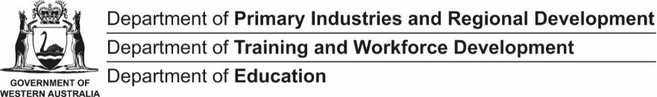
Primary producers such as grain and grape and wine producers in Western Australia rely on healthy soils because … | The biggest problem in Western Australia facing our soils is degradation. In what ways can our soils be degraded?

PRIMED

Without soil, our food and water supply in Western Australia would be affected because… | Healthy soils can help us minimise and adapt to climate change by …

Student worksheet 1.2

Glossary activity
Use the PowerPoint 1.0 Soils as ecosystems, as well as your science textbook or internet sources, to complete the key definitions below.

Key term | Etymology (origin) | Definition
Abiotic | Greek a (without) bios  (life)
Agriculture | Latin: ager (field),  cultiva (growing)
Bacteria | Latin: bacterium (staff, cane)
Biodiversity | Greek: bios (life), Latin: diversitas (variety)
Biotic | Greek: bios (life)
Community | Latin: communis  (public spirit)
Decomposers | Old French: (opposite of put together)
Ecosystem | Greek: oikos (home),  systema (system)
Food web | Old English: (fodder) (weave)
Fungi | Latin/Greek: spongos  (sponge)

Key term | Etymology (origin) | Definition
Habitat | Latin: habitare (to dwell)
Interact | Latin: inter (between),  ago (to act)
Invertebrate | Latin: in (not),  vertebra (joint)
Macroscopic | Greek: macro (large),  skopos (see)
Microscopic | Latin: micro (minute size), skopos (see)
Parasites | Greek: parasitos  (grain, food)
Predators | Latin: praedator  (plunderer)
Saprophytes | Greek: sapros (rotten, putrid), trophe (nourishment)

Student worksheet 1.3

Extension questions
You will need to review slides 6 to 16 of the PowerPoint Soils as ecosystems before attempting the following questions:
- Explain why biodiversity is important.

- Explain why a healthy population of fungi and bacteria in a soil is important.

Review the following terms from your glossary: Predator, parasite, saprophyte.

Soil nematodes
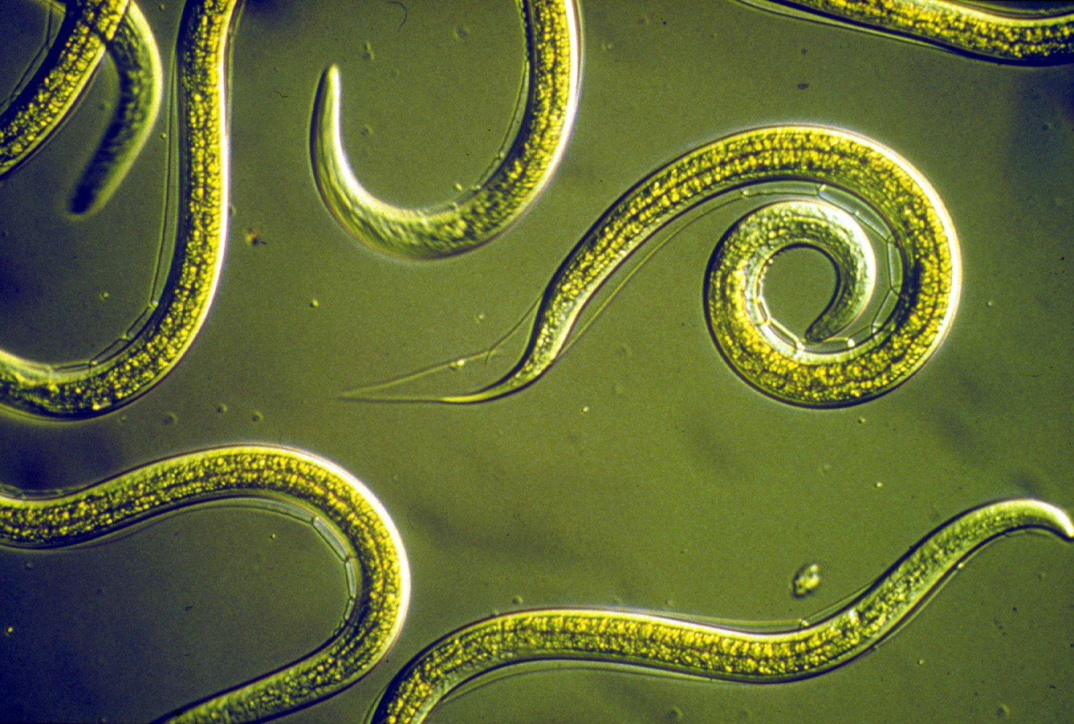
Creative Commons 3.0 image © CSIRO, available at: https://commons.wikimedia.org/wiki/File:CSIRO_ScienceImage_2818_Group_of_Nematodes.jpg

- Explain why predator nematodes are important to promote a healthy soil.

- Describe how parasitic nematodes can cause problems for soil health.

- Describe how saprophytic nematodes can contribute to a healthy soil.

The soil food web
- Watch the YouTube video by Dr Elaine Ingham What is the Soil Food Web?
<https://www.youtube.com/watch?v=uAMniWJm2vo> (6 minutes) and explain why the soil biome is important.

- List the four major groups that make up the soil biome.

- Describe at least two benefits of maintaining a healthy soil biome.

- Describe how the following have contributed to unbalanced ecosystems.
  - Ploughing of soil:

  - Use of chemical pesticides and herbicides:

Glossary exercise
The following key terms or phrases have been bolded in this worksheet:

Biodiversity Saprophytic nematodes

Healthy population Parasitic nematodes

Soil biome Predator nematodes Unbalanced ecosystems
In the space below, write a descriptive paragraph which correctly uses all of these key terms.

Student worksheet 2.1

What do soil scientists do?
Soil scientists are people who study the soil. Like environmental scientists, they focus on maintaining the overall health of soil by studying the biological, chemical and physical processes that occur in soils. The work of soil scientists helps Western Australian primary producers to improve their soil fertility resulting in more sustainable, profitable and environmentally friendly agricultural systems.
Western Australian soil scientists don’t just work with soil and in agriculture; they also examine how soil affects water, plants, animals and the atmosphere. Soil scientists can work in rural or urban areas. As science is an international activity, the knowledge that soil scientists discover is useful around the world. This means soil scientists often find themselves working in different countries.
Soil science can lead to a variety of interesting careers.

Activity

You may wish to find out more about what soil scientists do and what other careers are related to soil science before you begin the soil health investigation in the following activities. The following links provide useful background information:
Soil Health website http://www.soilhealth.com/index.htm

ABC Education video Who loves soil? Tim Does! then answer the questions that follow: https://education.abc.net.au/home#!/media/528019/who-loves-soil-tim-does

ABC Education video Who digs up black gold? then answer the questions that follow: https://education.abc.net.au/home#!/media/30609/geology-s-role-in-studying-soil-and-%1Ending- fuels

Soil Science Australia Soil Science Careers, Teachers’ Guide PDF available to download at: https://www.soilscienceaustralia.org.au/training/soils-in-schools/teacher-guides/

For a fascinating insight into how soil science is used to provide crucial scientific evidence to help solve crimes (the science of forensics):
  - Watch the YouTube Video Lorna Dawson on Forensic Soil Science: https://www.youtube.com/watch?v=EC7Mq835aYQ
  - Read the CSIRO forensic poster, which examines how Professor Fitzpatrick was able to use the soil found on a bloody shovel in a suspect’s car to solve a double murder case: http://www.clw.csiro.au/publications/cafss/ForensicPoster2006.pdf

Acknowledgements
Professor Lynnette Abbott, Head of the Soil Biology Group, University of Western Australia http://www.soilhealth.com/index.htm

Soil Science Australia – Soil Science Careers, Teachers Guide available for download at: https://www.soilscienceaustralia.org.au/training/soils-in-schools/teacher-guides/

Student worksheet 2.2

Soil health investigation: extraction and examination of soil invertebrates

Problem to investigate
Your task is to work in a group of three or four to carry out a scientific investigation comparing the diversity and abundance of soil invertebrates found in a variety of different locations.
You will use your observations to make inferences about the nature of a healthy soil. Use the student worksheet 2.3 Soil health group investigation framework to guide you through the stages of your investigation.

Background
Soil is one of the most diverse habitats on earth. Over 1000 species of invertebrates can be found in a single square metre of typical forest soils. A healthy soil contains tens of species of nematodes. (Source: Grains Research and Development Corporation 2016, The science of living soils: Investigating soil characteristics and health by identifying its macro and micro invertebrate populations, <www.grdc.com.au>).
In order to examine the health of a soil, soil scientists determine what organisms are present in a sample area by taking a series of soil samples back to the laboratory and extracting the organisms from the samples. In this investigation you and your other group members will use techniques suitable for sampling and extracting most small soil invertebrates.

Part 1: Soil sampling

Purpose
The purpose of this activity is to collect soil samples to take back to your school laboratory.

Materials required
- sampling ring (made from PVC piping or other suitable material)
- trowel
- scraper
- permanent marker pen
- plastic freezer bag and tie
- wooden or plastic cutting board
- rubber mallet
- safety equipment (safety glasses, mask, gloves)

Safety note
Your group needs to be careful when handling soil and compost. Be careful not to ingest or smell the soil or compost and avoid inhaling its dust. Harmful bacteria and fungi may be present in the soil sample. Wear gloves and wash your hands thoroughly with soap and water afterwards.

Method
- Carefully push your sampling ring into the soil until its top lip is 1 cm above the soil surface. If the ground is hard you can tap the ring into the soil by placing a plastic or wooden cutting board over the top then tapping it lightly with a mallet. If there’s a very thick layer of leaf litter above the soil, brush it off so that it’s level with the top of the ring.

- Remove the soil from around the sampling ring with your trowel.
- Slide a scraper straight underneath the ring to keep the soil inside it when you lift it out.
- Place the sample, still in its ring, into a plastic bag. Seal the bag so nothing can escape, then label it and take it back to the laboratory.

Image 1: Digging around the sampling ring
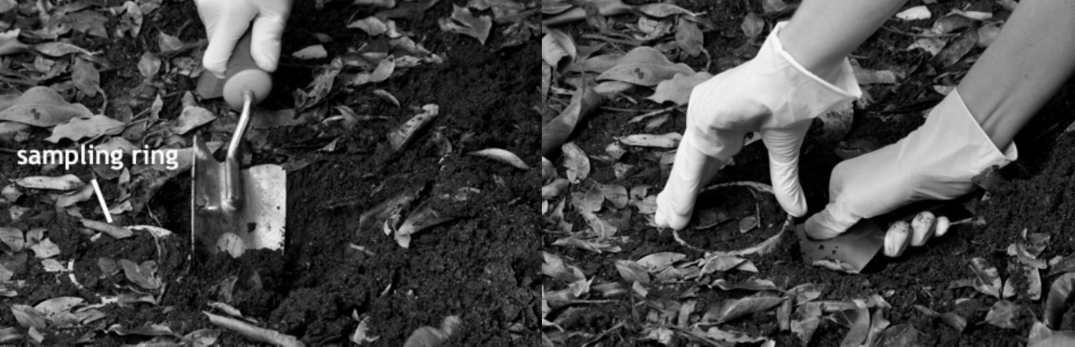

Image 2: Removing the soil sample

Images 1 and 2: SPICE Soil life 2: Soil safari (procedure sheet) available on Connect at: http://ecm.det.wa.edu.au/connect/resolver/view/K12SCI085/latest/resources/Soil%20life%202/index.html .Soil life 2: Soil safari (procedure sheet) developed for the Department of Education WA © The University of Western Australia 2011 also available at https://www.uwa.edu.au/science/-/media/Faculties/Science/Docs/Activity-Soil-safari.pdf

Part 2: Extracting soil invertebrates

Purpose
The purpose of this part of the investigation is to extract any soil invertebrates from your soil sample.
The technique used is called a Tullgren extraction. It uses the heat and light from a lamp to force soil animals to the bottom of your soil sample and into a collecting container.

Materials
- plastic funnel and large plastic beaker (made from a large plastic drink bottle)
- 70 mL collecting container with a lid, with 1 cm plaster of Paris and charcoal mix
- 1 mesh (aluminium flywire), 2 gauze swabs
- microscope or heat lamp

Method
- Place the collecting container (lid off) inside the plastic beaker and rest the funnel over the top.
- Place one layer of mesh and two layers of gauze swabs inside the funnel. These prevent chunks of soil falling into your collecting jar, but still allow the soil animals through as they move away from the lamp’s heat.
- Empty your soil sample into the funnel, shaking any loose bits of soil from the bag.
- Place the lamp about 7 cm above the funnel.
- Check the equipment daily. As the sample dries out you should start to see tiny soil animals in the collecting container underneath. Make sure the plaster of Paris base stays slightly damp.
- Examine your collected soil invertebrates using a dissecting (binocular) microscope.

Images 3, 4 and 5: Extraction set-up (diagram and photos)
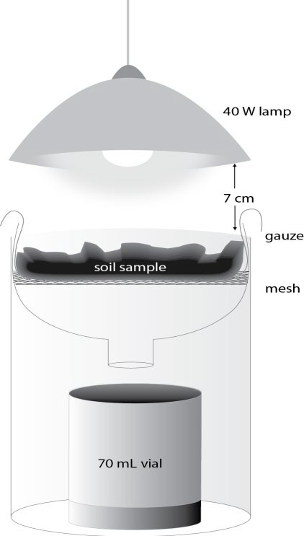
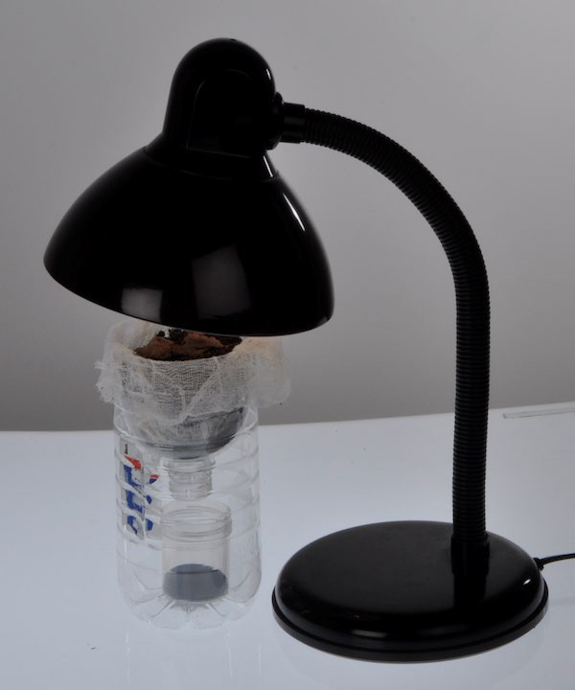

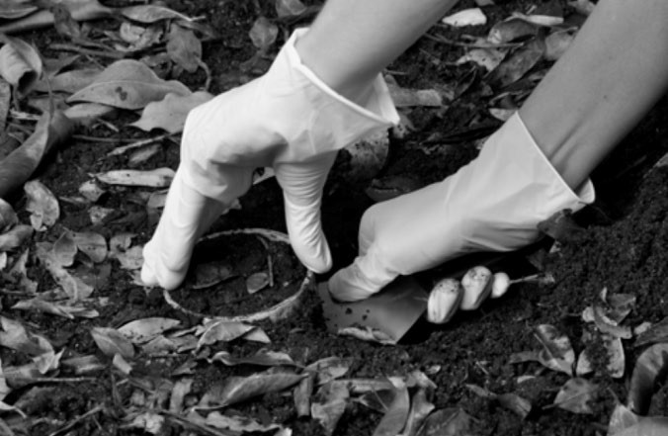

Images 3, 4 and 5: SPICE Soil life 2: Soil safari (procedure sheet) available on Connect at: http://ecm.det.wa.edu.au/connect/resolver/view/K12SCI085/latest/resources/Soil%20life%202/index.html .Soil life 2: Soil safari (procedure sheet) developed for the Department of Education WA © The University of Western Australia 2011 also available at https://www.uwa.edu.au/science/-/media/Faculties/Science/Docs/Activity-Soil-safari.pdf

Acknowledgements
  - Grains Research and Development Corporation 2016, The science of living soils: Investigating soil characteristics and health by identifying its macro and micro invertebrate populations, <www.grdc.com.au>
  - SPICE 2011, Soil life 2: Exploring soil (teachers’ guide), developed for the Department of Education WA © The University of Western Australia 2011 available on Connect
<http://ecm.det.wa.edu.au/connect/resolver/view/K12SCI063/latest/index.html>

Student worksheet 2.3

Soil health investigation framework
Part 1: Questioning and predicting
What research question or problem about soil is your group planning to investigate?

What does your group already know about this topic from personal experience and what you have studied?

Predict what you think will be the outcome of your investigation into soil health. Justify why you think this will be so.

Part 2: Planning and conducting
What variables may affect what your group is investigating about soil? (Have you considered both living and non-living factors?)

What is the independent variable in this investigation about soil? (The factor that you are going to make different.)

What is the dependent variable in this investigation about soil? (The factor that you are looking for as your result). How will you accurately measure the dependent variable?

What variables in your soil investigation need to be controlled in order to make it a fair test?

What equipment will your group need to carry out your soil health investigation?

Describe in a set of steps what your group will be doing at each stage of your soil health investigation. Include a labelled diagram to illustrate your set-up.

What special safety precautions does your group need to follow during your soil health investigation? Why are these safety precautions important?

Part 3: Processing and analysing data and information
What data did your soil health investigation produce? Describe your observations and record your
results. If possible, organise your data for the different soil sites you tested in a table format.

Is it possible to represent your data in a graph format? If so, what type of graph would best suit this type of data? Construct your graph on a separate piece of graph paper and paste it below.

What are the relationships, patterns or trends in your group’s soil health data?

What do the results of your group investigation tell you about the research question or problem
you were investigating? Try to use some science ideas to explain your results.

Part 4: Evaluating
What difficulties did your group experience in doing your soil health investigation?

Does your group have confidence in the quality of the data your investigation has produced? (Are you confident your data is reliable?)

What changes would your group put in place if it was to repeat this investigation or carry out further investigations into soil health?

Part 5: Communicating

Discuss with your group members the best way of communicating the findings of your soil health investigation to the other members of your class. Some suggestions you might like to consider are a science report, a PowerPoint presentation, a poster, a leaflet or a short video. Use the space below to plan your communication.

Student worksheet 3.1

Classifying living things
Have you ever wondered how many different types of living things there are on the Earth? Millions of species make up the global biodiversity of our planet. To make order of this complexity, common systems of classifying have been developed, such as the two-name (binomial) classification system.
Using common systems of classifying species means agricultural and soil scientists can more easily help Western Australian primary producers to:
  - identify and control pest species that may disrupt their agricultural ecosystems
  - discover new species that may help increase production
  - identify and manage the native species that are present on their properties.

Two-name (binomial) classification system
Biologists who study the classification of living things are called taxonomists. Classification is the process of putting things into groups and is useful in many areas of life. Scientific naming of organisms uses Latin or ancient Greek.
The scientific name gives information about the organism. For example, the scientific name of the black Aberdeen Angus cattle bred by Western Australian stockbreeders for beef is Bos taurus: Bos is Latin for cow (or ox) and taurus is Latin for bull.
Image 1: Aberdeen Angus cattle (red and black)
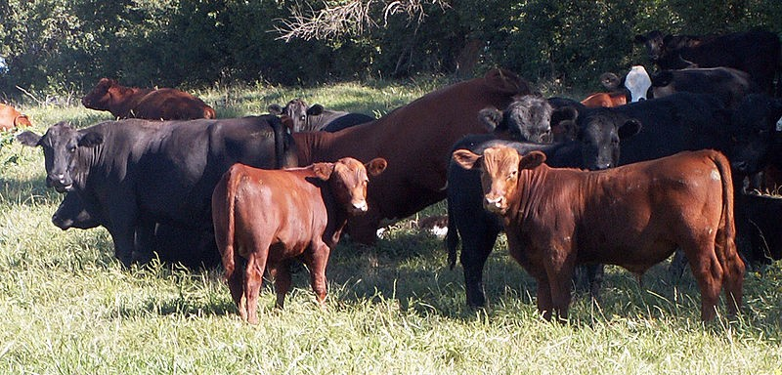

Image: Author Americasroof, Creative Commons Attribution Share Alike Unported 3.0, image and licence available at: https://commons.wikimedia.org/wiki/File:Red-angus.jpg

You will also notice that the biological name for the Angus cattle has two words. This is called binomial naming. The first word is the genus name and the second is the species name. The genus name always begins with a capital letter; the species name always begins with a lower-case letter. The full name is also written in italics.

Group discussion activity 1
Table 1 shows a small selection of some Latin or Greek root words used when naming Western Australian agricultural animal species.
Table 1: Latin or Greek root words and their English meanings

Latin or Greek word | Meaning
Lupis | Wolf
Bos | Cow or ox
Gallus | Cock or rooster
Canis | Dog
Ovis | Sheep
Indicus | From India
Aries | Fat ram
Taurus | Bull
Equus | Horse
Domesticus | Domesticated
Sus | Pig
Caballus | Horse
Capra | Billy or he goat
Aegagrus | Goat

- Form a small group of three or four.
- In your group, use the table to help you discuss what you think are likely scientific (binomial) names for the eight animals below that are bred by Western Australian primary producers for food production (or assistance with food production).
Domestic chickens
Cattle
Sheep
Goats
Pigs
Sheep dogs
Horses
Brahman cattle

- When you think you have a logical answer for each of the eight farm animals, do an internet search to see which ones are correct.
- Were there any that did not match your predictions? Try to explain why the correct scientific name didn’t match.

Levels of classification
Taxonomists use a hierarchical system of groups when classifying living things:

- The first group, the kingdom level, has the largest number of organisms in it. The kingdoms are divided into smaller groups in which the organisms are more similar.
- The second level of classification is into phyla (in plants, the phyla are called divisions).
- Phyla and divisions are then divided into classes.
- Classes are divided into orders.
- Orders are divided into families.
- Families are divided into genera (singular genus).
- Genera are divided into species.

At each new level of classification there are smaller numbers of organisms and the organisms become more similar.

Classification and forest management in Western Australia
In Western Australia the Department of Parks and Wildlife has the responsibility for the ecologically sustainable management of our forests. It is important for forest management that species of plants, animals and microorganisms (both native and non-native) are correctly identified.
Table 2 below shows the classification at each level for two closely related eucalypt species native to the South-West forests of Western Australia – jarrah and karri.
Table 2: Classification levels of the jarrah and karri species

Classification level | Jarrah | Karri
Kingdom | Plantae | Plantae
Division (phylum) | Magnoliophyta | Magnoliophyta
Class | Magnoliopsida | Magnoliopsida
Order | Myrtales | Myrtales
Family | Myrtaceae | Myrtaceae
Genus | Eucalyptus | Eucalyptus
Species | marginata | diversicolor

Image 2: Eucalyptus marginata
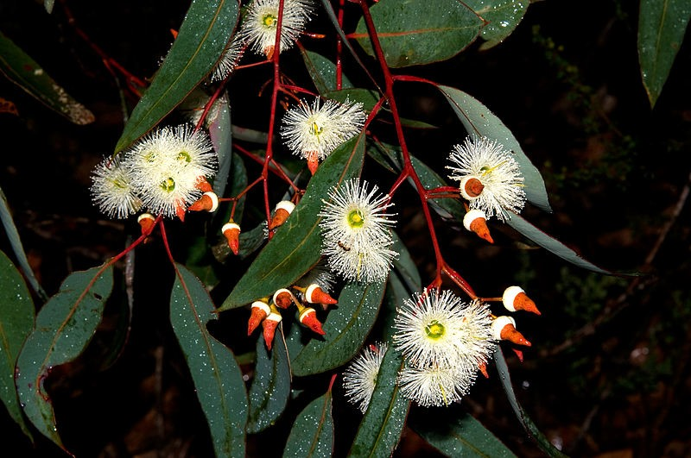

Image: Author Podiceps60, Creative Commons Attribution Share Alike Unported 3.0, image and licence available at: https://commons.wikimedia.org/wiki/File:Jarrah_-_Eucalyptus_marginata.jpg

Image 3: Karri forest
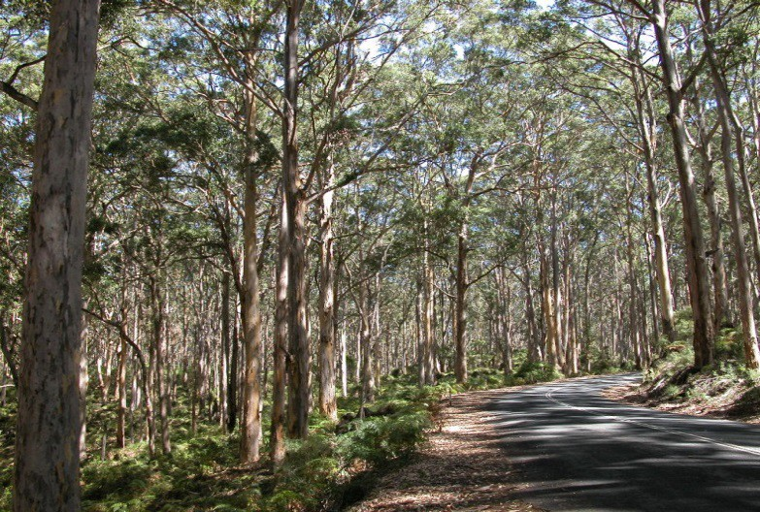

Image: Author Boundary Rider, Creative Commons Attribution Share Alike Unported 2.5, image and licence available at: https://commons.wikimedia.org/wiki/File:Karri_forest.jpg

Another closely related tree to the jarrah and karri trees is the Corymbia calophylla, commonly known as ‘marri’ – a name derived from the Noongar language of the South-West region of Western Australia.

Group discussion activity 2
Discuss in your group which of the three tree types (jarrah, karri and marri) you think are most closely related. Justify your answer and record your conclusions in the space below

Phytophthora dieback disease

The arrival and spread of Phytophthora dieback disease in Western Australia has been catastrophic for a number of ecosystems in the South-West.

Approximately 2000 of the estimated 9000 native plant species in the South-West are susceptible. Jarrah, karri and marri are all badly affected.

Image 4: Dieback disease warning sign
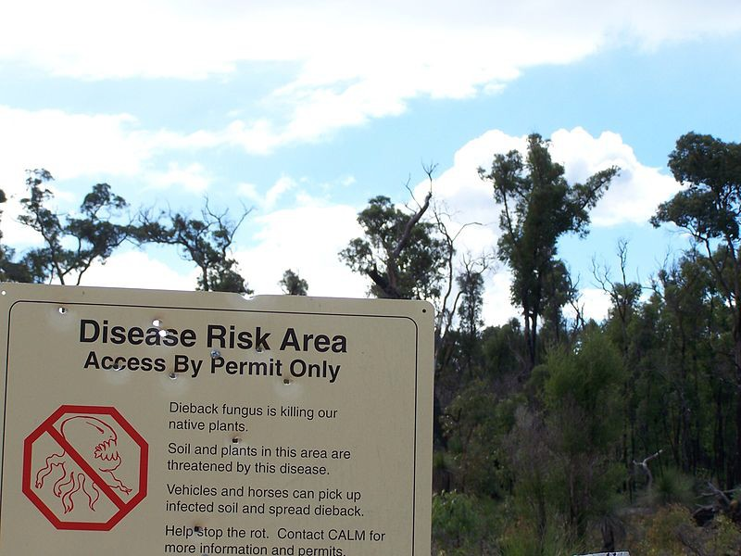

Creative Commons 2.5 photograph by Gnangarra...commons.wikimedia.org available at: https://commons.wikimedia.org/wiki/File:Dieback_sign_gnangarra.jpg

Phytophthora dieback disease is caused by a soil microorganism called Phytophthora cinnamomi, which kills susceptible plants, such as banksias, jarrah and grass trees, by attacking their root systems.

Dieback is a symptom of a Phytophthora infection, and affects more than 40 per cent of the native plant species and 50 per cent of the endangered ones in the South-West of Western Australia. The plants die because they can’t take in the water and nutrients they need.

(Information source: Government of Western Australia, Department of Biodiversity, Conservation and Attractions available at https://www.dpaw.wa.gov.au/management/pests-diseases/129- phytophthora-dieback)

Group discussion activity 3
- Follow this link to learn more about Phytophthora dieback disease: https://www.dpaw.wa.gov.au/management/pests-diseases/129-phytophthora-dieback
- In your group, discuss what role you think taxonomists would play in managing phytophthora dieback disease. Record your ideas in the space below.

Aboriginal and Torres Strait Islander classification systems
Aboriginal and Torres Strait Islander classification systems differ in some ways from conventional scientific classification systems. Aboriginal Australians recognise that there are thousands of animal and plant species in the bush.
Desert Aboriginal Australians classify these plants and animals in various ways, with the simplest being binary classifications of plants and animals as being edible or inedible, or as being totemic or non-totemic. This classification of edible plants and animals has similarities to western taxonomy in that it is hierarchical, with things being grouped in levels and each higher level containing the ones below it.

Group discussion activity 4
- Follow the links below to learn more about Aboriginal classification methods:
  - https://www.australiancurriculum.edu.au/TeacherBackgroundInfo?id=56592
  - https://ab-ed.nesa.nsw.edu.au/go/7-10/science/units/story-1/cultural- background#:~:text=The%20Aboriginal%20classification%20of%20edible,totemic%20(o r%20symbolic)%20classification
- In your small group, make a list of the similarities and differences between Aboriginal and western classification systems.

- Explain why both of these ways of looking at classifying animals and plants are important.

Glossary exercise
The following key terms or phrases have been bolded in this worksheet:

Biodiversity Class

Classifying Order

Taxonomists Family

Binomial Genus

Kingdom Species

Phyla Aboriginal classification systems

In the space below, write a descriptive paragraph which correctly uses all of these key terms.

Student worksheet 3.2

Using a dichotomous key
In Western Australian primary industry, insects can be very useful (eg as pollinators) or harmful (eg as pests such as fruit flies). Some pests and diseases can cause severe harm to agricultural industries, by reducing the quantity and quality of fresh produce and increasing production costs. They can also affect human health. By employing stringent biosecurity practices, we can help prevent harm to human populations.
Western Australia has unique ecosystems and flora and fauna. It is critically important for Western Australia’s biodiversity to protect our natural resources. Scientists called agronomists are employed to help farmers identify and manage pests within their crops. Points of entry around the country are monitored to check for signs of new pests so that they can be contained and managed as quickly as possible before they inflict damage on our environment and agricultural industries.
They monitor insects by trapping and collecting them for identification and recording. In this activity you will examine the taxonomy of insects and learn how to classify them.
When scientists are trying to identify an insect pest, they will first use a dichotomous key. This is the simplest type of key. The word dichotomous means ‘cut in two’. A dichotomous key is a series of choices that lead to the identification of the organism being studied. The choices can be written as flow charts or tables. Keys work best if the features used to make the choices are easy to observe and are precise.
The following diagram shows the standard parts of an insect that are easy to observe and are precise. As you can see, all adult insects contain three basic body parts: a head, a thorax (middle) and an abdomen. Attached to the head are the eyes (both simple and compound) and antenna.
Attached to the thorax are three pairs of legs and one or two pairs of wings. In some species (eg ants) only some individuals keep their wings as a means of establishing new colonies. The abdomen usually contains a number of subsections.

Image 1: Standard parts of an insect
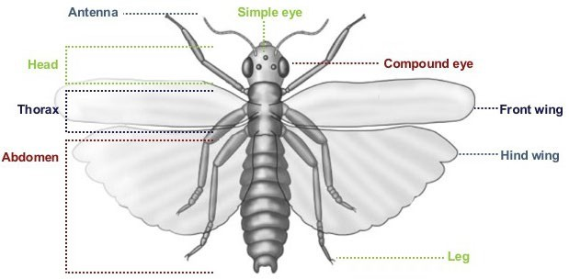

Image: Commonwealth Scientific and Industrial Research Organisation (CSIRO) Year 7 Grain Biosecurity, Lesson 2 available at: thttp://www.primezone.edu.au/uploaded_files/document_uploads/Yr7%20Grain%20Lesson%202%20InsectClassification.pdf

Directions
Use the following dichotomous key (Table 1) to identify the order or group to which the pest insects in Appendix 1 – Insect pests in Western Australia belong. Enter your information in Table 2 following this key.

Table 1: A dichotomous key for a number of orders of insects

1a | Insect has one pair of wings | Go to 2
1b | Insect has two pairs of wings | Go to 3
2a | Hind wings reduced to tiny knobs | Flies  Diptera
2b | Tip of abdomen with 2–3 thread-like tails | Mayflies  Ephemeroptera
3a | Front wings rigid to form a protective cover for clear hind wings | Go to 4
3b | Front wings do not form rigid cover over hind wings | Go to 7
4a | Sucking mouthparts that look like a beak | True Bugs  Hemiptera
4b | Chewing mouthparts | Go to 5
5a | Wings not rigid | Go to 6
5b | Wings rigid and meet in straight line down the back | Beetle  Coleoptera
6a | Head free and exposed | Go to 8
6b | Head hidden by hood-like structure | Cockroach  Blattodea
7a | Wings covered with powdery scales; mouthparts like a coiled tube | Butterflies and  moths  Lepidoptera
7b | Wings clear like a membrane | Go to 9
8a | Front legs with strong spines for grasping; hind legs long and slender | Praying mantis  Mantodea
8b | Front legs without strong spines for grasping; hind legs long and slender | Grasshoppers and  crickets  Orthoptera
9a | Front and hind wings different size; body has a narrow ‘waist’ | Wasps, bees and  ants  Hymenoptera
9b | Front and hind wings similar shape and size; antennae always short and bristly | Dragonflies  Odonata
Dichotomous key developed from the Commonwealth Scientific and Industrial Research Organisation (CSIRO) Year 7 Grain Biosecurity, Lesson 2 available at: http://www.primezone.edu.au/uploaded_files/document_uploads/Yr7%20Grain%20Lesson%202%20InsectClassification.pdf

Table 2: Insect pest identification

Refer to Appendix 1 for information about and pictures of each insert, then use the dichotomous key in Table 1 to help you fill in this table. The first one has been done for you.

Insect pest | Scientific name | Insect order (identified from dichotomous key) | Clues used to identify insect pest
Red imported fire ant | Solenopsis invicta | Wasps, bees and ants  Hymenoptera | 1b Insect has two pairs of wings  3b Front wings do not form rigid cover over hind wings  7b Wings clear like a membrane  9b Front and hind wings different size; body has a narrow ‘waist’
Queensland fruit fly
Khapra beetle
Stable fly

Insect pest | Scientific name | Insect order (identified from dichotomous key) | Clues used to identify insect pest
European wasp
Aphids
Spur- throated locusts
Small hive beetle

Questions
- Describe any difficulties you had in identifying any of the insect pests in Appendix 1.

- Describe how you could go about making the identification easier.

- Explain why it is important to Western Australian primary producers that insects are correctly classified.

- Suggest a reason why the amount of land used to grow crops is larger if insect pests are damaging crops.

Further research: Biosecurity in Australia
A useful source of information for this is the Year 7 Grain biosecurity: 2016 teaching resources secondary schools available at: http://www.primezone.edu.au/uploaded_files/document_uploads/Yr7%20Grain%20Teacher%20Re source.pdf

- Define biosecurity and explain why it is necessary.

- Describe the main goals of biosecurity.

- Many other insects are potential biosecurity risks to our agricultural crops. Choose one of the following and describe how, why and where it is a pest, and what can be done to control or eradicate it.
  - Red scale parasitoid (Aphytis melinus)
  - Glassy winged sharpshooter (Homolodisca vitripennis)
  - Citrus fruit borer (Citripestis agittiferella)
  - Bean thrips (Caliothrips fasciatus)
  - Crusader bug (Mictus profana)

Glossary exercise
The following key terms or phrases have been bolded in this worksheet:

Primary industry Agronomist

Pests Taxonomy

Diseases Dichotomous key

Biosecurity Identification

In the space below, write a descriptive paragraph which correctly uses all of these key terms.

Appendix 1: Insect pests in Western Australia
The following information is used with the permission of the Government of Western Australia, Department of Primary Industries and Regional Development (DPIRD) – Agriculture and food, available at: https://www.agric.wa.gov.au/pests-weeds-diseases/pests/pest-insects.

Biosecurity alert: Red imported fire ant (RIFA)
DPIRD detected the red imported fire ant (Solenopsis invicta) at two adjoining tenanted properties at Fremantle Ports in November 2019. An eradication program is currently underway. If RIFA became established in WA, it could severely damage the local environment, economy and Australia’s outdoor lifestyle. RIFA inflict a painful, fiery sting, which in rare cases can cause an acute allergic reaction.
Mature colonies produce a number of fertile males and females with two pairs of membranous wings that don’t form a protective layer. After mating, the male dies and the newly mated female sheds wings and begins a new colony if an appropriate nest site is found. Female fire ants can fly up to 2–5 km looking for the most suitable site.

Images 1 and 2: Red imported fire ants
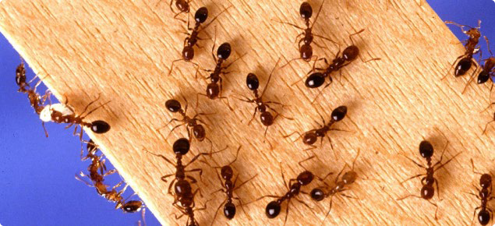

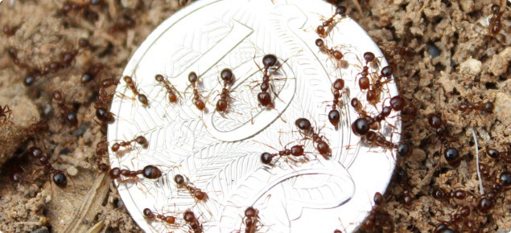

Images and information at: https://www.agric.wa.gov.au/rifa

Biosecurity alert: Queensland fruit fly
DPIRD is currently responding to an outbreak of Queensland fruit fly (Qfly) in Perth’s western suburbs. The Qfly is exotic to Western Australia.

Images 3 and 4: Queensland fruit fly
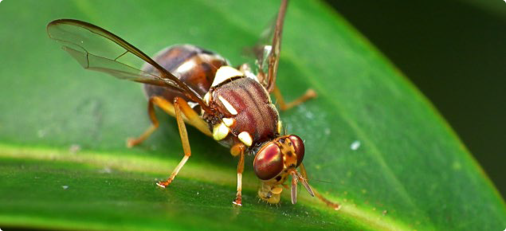

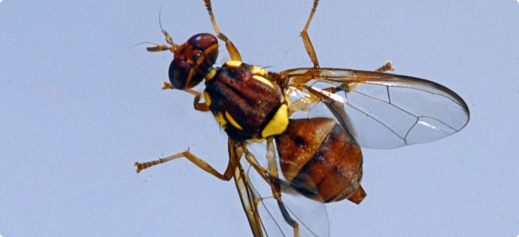

Images and information available at: https://www.agric.wa.gov.au/plant-biosecurity/biosecurity-alerts-queensland-fruit-fly- updates

Declared pest: Khapra beetle
The Khapra beetle (Trogoderma granarium) is one of the most serious pests of stored grain products, especially under hot and dry conditions. It is very resilient and can survive in stored food, packaging and transport facilities in very low numbers under difficult conditions. It is able to survive inactively for long periods. The Khapra beetle is a regulated quarantine pest in many countries and currently absent from Australia. Our international trade would be severely impacted if it became established here.

Image 5: Khapra beetle from the top
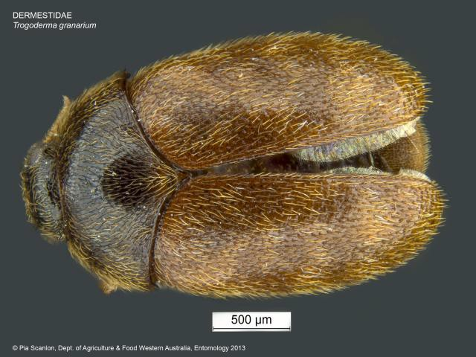

Image 6: Khapra beetle head
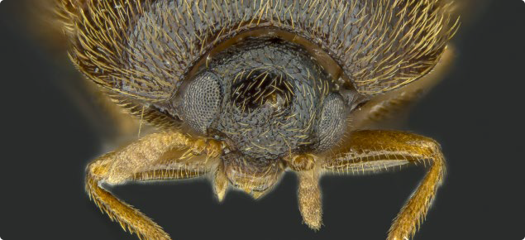

Images and information available at: https://www.agric.wa.gov.au/biosecurity/khapra-beetle-declared-pest

Declared pest: Stable fly
The stable fly (Stomoxys calcitrans) is an international insect that has become an aggravating pest in Western Australia, particularly on the coastal plains north and south of Perth. It can attack humans, domestic pets and livestock, seeking to draw blood which is essential to complete its life cycle.
On 2 September 2013 the stable fly was included as a declared pest under the Biosecurity and Agriculture Management Act 2007, administered by DPIRD. New regulations are in force to manage this pest in 14 designated local government areas.

Images 7 and 8: Stable fly
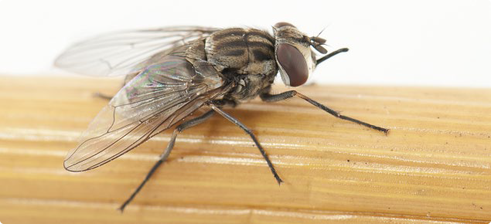

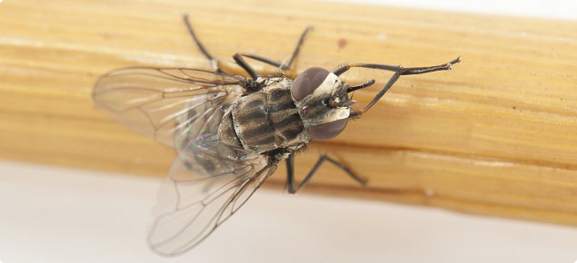

Images and information available at: https://www.agric.wa.gov.au/vegetables/stable-fly-western-australia

Declared pest: European wasp
The European wasp is considered one of the worst wasps in the world – harmful to people, our outdoor lifestyles and to our horticultural and agricultural industries. European wasps:
- pose a safety risk to land users due to their foraging activities, high aggression and hidden nests (for example, maintenance and field staff, bush walkers, picnickers, residents, café patrons, orchardists)
- have underground nests that are difficult to see, and disturbing a nest can lead to thousands of wasps attacking in defence
- pose a risk to the environment – wasps compete with and predate on native insects; this can reduce insect numbers, biodiversity and ecosystem function
- can cause a nuisance and a health concern to people and pets because they forage for human food and drink as well as pet food
- damage horticultural crops like grapes and stone fruits and predate on bees in managed apiaries – impacting home gardeners and industry alike.

Image 9: European wasp from the side
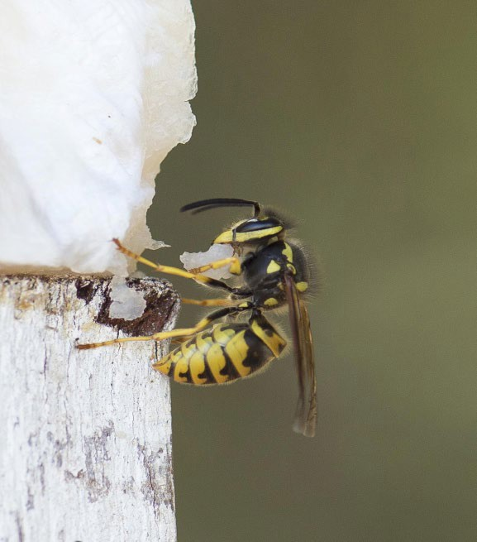

Image 10: Group of European wasps
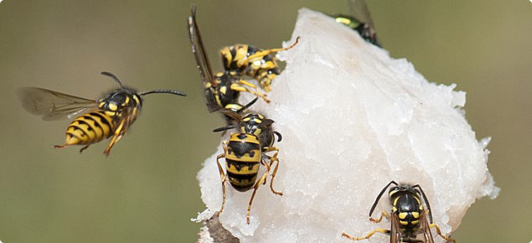

Images and information: https://www.agric.wa.gov.au/biosecurity-biosecurity-quarantineeuropean-wasp-declared-pest

Aphids
Adult and nymph aphids suck sap, with large populations limiting Western Australian grain yield and size – especially winter and spring infestations. Aphid feeding can cause direct damage, in the absence of the plant virus barley yellow dwarf virus (BYDV), by reducing yields by up to 10 per cent and by reducing seed size.
Damaging populations may develop in potentially high-yielding crops – 2.5 tonnes per hectare (t/ha) or more. Direct feeding damage occurs when colonies of aphids develop on stems, leaves and heads, from the seedling stage through to head filling.

Image 11: Oat aphids damaging cereal crops, with close-up of single aphid
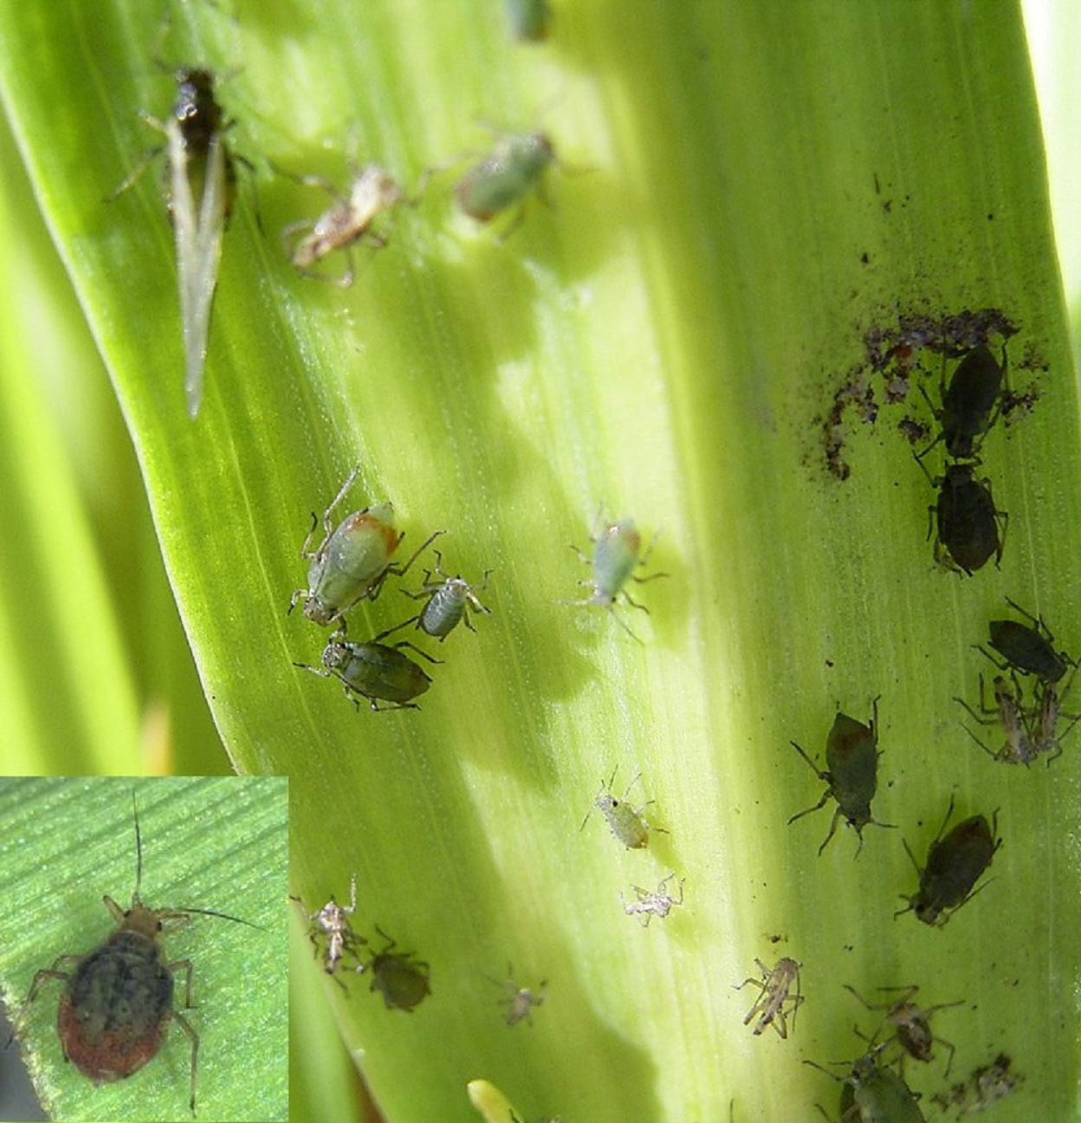

Image and information: https://www.agric.wa.gov.au/barley/aphid-feeding-damage-cereal-crops

Spur-throated locusts
The spur-throated locust (Austracris guttulosa) is a pest of pastures, crops and certain tree species. It is a subtropical species of northern Australia, but extends its habitat into areas experiencing wet summer seasons.

The spur-throated locust is readily distinguished from other pest species of locusts and grasshoppers by its large size and the presence of a spur, or throat-peg, between the front legs. The adults are pale brown in colour with white stripes and dark markings on the thorax. The hind wings are colourless or have a bluish tinge.

Images 12 and 13: Spur-throated locust
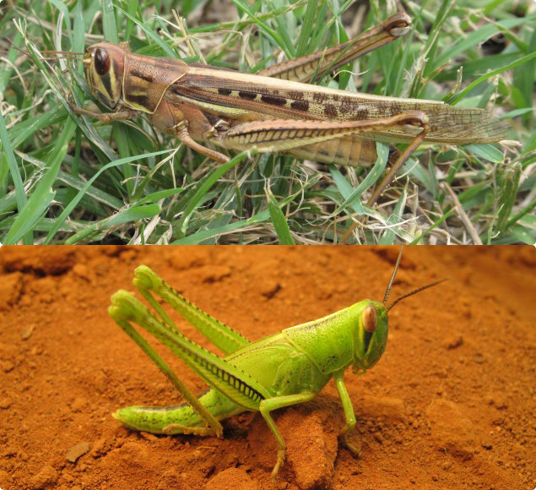

Images and information: https://www.agric.wa.gov.au/pest-insects/spur-throated-locust

Declared pest: Small hive beetle
Small hive beetle (Aethina tumida) can cause significant damage to beehives. It is important that any suspect infestations are reported to the DPIRD Pest and Disease Information Service (PaDIS). Early detection will help protect the Western Australian apiculture industry.

In Western Australia, small hive beetle has been detected in the Kimberley region (which includes the Local Government Areas of Broome, Derby–West Kimberley, Wyndham–East Kimberley and Halls Creek). The rest of Western Australia remains free of this pest.

Image 14: Small hive beetle in a beehive
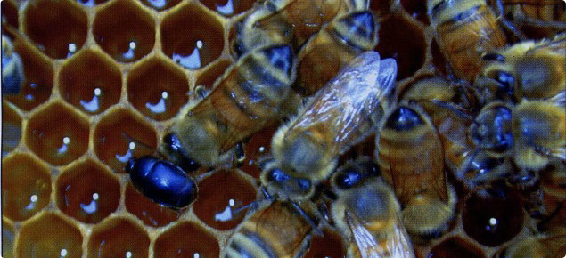

Image and information: https://www.agric.wa.gov.au/plant-biosecurity/small-hive-beetle-declared-pest

Acknowledgements
Thank you:

  - Dichotomous key developed from: CSIRO Year 7 Grain biosecurity: Lesson 2
<http://www.primezone.edu.au/uploaded_files/document_uploads/Yr7%20Grain%20Lesson
%202%20InsectClassification.pdf>
  - Appendix 1 insect pests images and information from DPIRD website
<https://www.agric.wa.gov.au/pests-weeds-diseases/pests/pest-insects>
  - Year 7 Grain biosecurity: 2016 teaching resources secondary schools
<http://www.primezone.edu.au/uploaded_files/document_uploads/Yr7%20Grain%20Teach er%20Resource.pdf>

Student worksheet 3.3

Key to soil invertebrates
If the soil sample you collected during your soil health investigation in Activity 2 is a healthy one, it should contain a wide variety of different invertebrates. Some of these are shown in Image 1.
Image 1: Sample of soil invertebrates
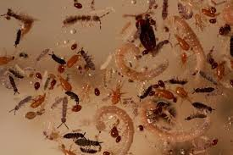
Image used courtesy of Professor Lyn Abbott (UWA)

- Using a binocular microscope, try to identify some of the invertebrates in your soil sample that are shown in the image above.
- Use the Key to adult soil and litter invertebrates on the following pages to try to identify the group to which your soil organism belongs, then enter your results in the table below.

Soil invertebrate | Classification group identified from key | Clues from the key used to identify your invertebrate
A
B
C
D

A useful article for this exercise is Key to the Invertebrates on the Commonwealth Scientific and Industrial Research Organisation (CSIRO) website, available at: https://www.ento.csiro.au/education/key/couplet_01.html

Key to adult soil and litter invertebrates

1a Soft bodied, no segmented appendages | Go to 2
1b Body with exoskeleton, segmented appendages | Go to 4
2a Body worm-like | Go to 3
2b Body not worm-like; may have coiled shell | Gastropoda (snails)
3a Body 0.1–2.5 mm long, round, non-segmented | Nematoda (round worms)
3b Body usually larger than 2.5mm, segmented, may have bristles | Annelida (segmented worms)
4a Antennae present | Go to 8
4b Antennae absent | Go to 5
5a Three pairs of legs | Protura
5b Four pairs of legs (pedipalps may appear leg-like) | Go to 6
6a Pedipalps with pincher-like claws, abdomen segmented | Pseudoscorpionida (psuedoscorpions)
6b Pedipalps without pincher-like claws, abdomen not segmented | Go to 7
7a Cephalothorax and abdomen joined by a narrow connection | Araneae (spiders)
7b Cephalothorax and abdomen joined by a broad connection | Acarina (mites)
8a Three pairs of legs (insects) | Go to 13
8b More than three pairs of legs | Go to 9
9a Distinct head followed by a series of segments | Go to 10
9b Distinct head absent | Isopoda (pillbugs)
10a Nine to 12 pairs of legs | Go to 11
10b More than 12 pairs of legs | Go to 12
11a Antennae branched | Pauropoda
11b Antennae not branched | Symphyla
12a Two pairs of legs on most body segments | Diplopoda (millepedes)
12b One pair of legs on each body segment | Chilopoda (centipedes)
13a Winged or with plate over thorax | Go to 17
13b No wings and no plate over thorax | Go to 14
14a Narrow-waisted, ant-like | Hymenoptera (ants)
14b Not narrow-waisted nor ant-like | Go to 15
15a Abdomen with two or three finger-like appendages on tail | Thysanura (bristletails)
15b Abdomen without finger-like appendages | Go to 16
16a Fork-like (two-part) jumping appendage on tail | Collembola (springtails)
16b Fork on tail absentl | Thysanoptera (thrips)
17a Front wings hard or leathery, covering hind wings | Coleoptera (beetles)
17b Front wings not hard or leathery or not present | Go to 18
18a Front wings thickened at base, membranous at tip; sucking mouth parts | Hemiptera (bugs)
18b Wings with veins, overlapping or held roof-like (if present), plate over thorax, chewing mouth parts | Orthoptera (grasshoppers)
This key is adapted from the Key to Soil and Litter Invertebrates available at: https://tiee.esa.org/vol/v3/experiments/soil/pdf/soil[Invertebrate_Key].pdf or alternatively at: https://tiee.esa.org/misc/search.html

Activity
- Describe any difficulties you had identifying the soil invertebrates.

- In the space below draw a least two of your soil invertebrates. Use pencil for the drawings and label them in pen.

- State whether you think your soil is ‘healthy’ – does it have a good variety of soil invertebrates?

Student worksheet 3.4

Extension activity

What’s in a name?
In a previous activity you learnt how taxonomists use a two name (binomial system) of scientific names for describing all species of plants, animals and microorganisms. Have you ever wondered why scientific names are often preferred rather than common names like chicken or cow?
The following example can show just how confusing common names for living things can become.

The western rock lobster
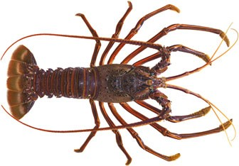
Western rock lobsters are often called ‘crayfish’ or ‘crays’, especially when consumers purchase them from local retail outlets such as supermarkets or seafood suppliers. Its scientific name is Panulirus cygnus. The species is the target of WA’s largest and most valuable fishery. The sustainable management of this fishery is the responsibility of DPIRD which uses an integrated fisheries management approach.

Activity
But are they really lobsters? Don’t lobsters have claws? Aren’t they actually crayfish?

- Follow the following link to the Western Australian Museum’s to discover the answer: http://museum.wa.gov.au/explore/articles/lobsters-rock-lobsters-and-crayfish

- Now create a summary of why it might be less confusing to use scientific names rather than common names. Try and think of examples of other animals or plants where common names might cause confusion to include in your summary.

Acknowledgements
Western rock lobster information and image source ©Government of Western Australia available at: https://www.fish.wa.gov.au/Species/Rock-Lobster/Pages/default.aspx )

Further information on DPIRD’s integrated fisheries management approach can be accessed at: http://www.fish.wa.gov.au/species/rock-lobster/lobster-management/Pages/default.aspx

Government of Western Australia, Western Australian Museum – Lobsters, rock lobsters and crayfish available at: http://museum.wa.gov.au/explore/articles/lobsters-rock-lobsters-and-crayfish

Student worksheet 4.1 Food chains and food webs Ecosystems and food chains
For Western Australian primary producers to economically and sustainably produce the food and fibres that we need, they must ensure that their agricultural soils remain healthy. Healthy soils are dynamic living systems with many different living things interacting with one another. They can be thought of as complex, agricultural ecosystems.
Ecosystems usually contain several different food chains. A food chain is usually drawn as a simple flowchart showing the direction of flow of matter and energy. For example:

Sun → grass → grasshopper → kookaburra → wedge-tailed eagle

It contains producers (usually green plants that carry out the process of photosynthesis) and consumers that must consume other organisms for their energy and nutrients. Consumers are further subdivided into herbivores, carnivores, omnivores and decomposers.
The food chain above could be rewritten (leaving out the sun, as it is not ‘food’) as:

Producer → primary consumer → secondary consumer → tertiary consumer (apex predator)

Activity 1: Food chains and food webs

Watch a YouTube video on food chains and food webs such as the Fuse School Food chains and food webs: https://www.youtube.com/watch?v=2lqhJNgn_Wg

Make notes of the key ideas then answer the questions.

Questions
- Explain why the sun is usually included as the original source of energy in food chains.

- Describe your understanding of why a producer is the first living thing in a food chain.

- Explain why the arrows in a food chain don’t flow in the opposite direction.

- Describe where you think humans fit in to food chains.

Food webs

A food web is made up of all of the food chains in an ecosystem. In a food web a living thing can be part of many different food chains.
Watch a YouTube video on food chains and food webs such Food Webs and Energy Pyramids: Bedrock and Biodiversity: https://www.youtube.com/watch?v=-oVavgmveyY

Make notes of the key ideas then answer the questions

Questions
- Define the terms autotroph and heterotroph.

- The video describes how only around 10% of the available energy from a trophic level is transferred to the next level. Predict where the other 90% goes.

- Describe your understanding of a food web.

- Describe how a food web contributes to the biodiversity and sustainability of an ecosystem.

Activity 2: The soil food web
Soil is a complex ecosystem that is essential to life on Earth. Soils are the principal resource for food production in Western Australia. They facilitate the life cycle of growth, sustenance and decay.
Usually when we think of food chains and food webs we think of plants as being at the beginning – the primary producers that carry out photosynthesis. Herbivores then consume the plants. And then various levels of carnivores and omnivores interact to complete the system. Plants depend on the soil, particularly the soil ecosystem, to help them obtain water and nutrients. The following picture shows the major groups of organisms present in soil and the complex relationships involved.

(Source: Soil Science Australia, Soils in Food Chains – Teachers Guide available at: https://www.soilscienceaustralia.org.au/training/soils-in-schools/teacher-guides/)

Image 1: The soil food web
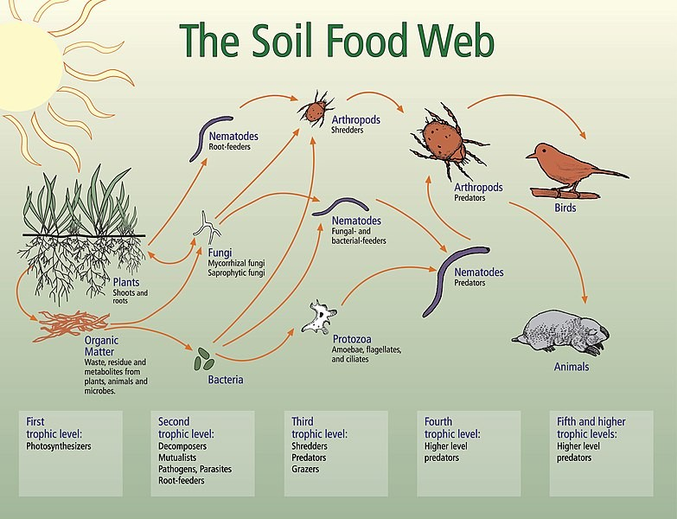
The Soil Food Web showing trophic levels. Available at: author Elaine R. Ingham, Creative Commons 4.0 image © Soil Biology Primer/USDA-NRCS website (https://www.nrcs.usda.gov/wps/portal/nrcs/main/soils/health/biology/ ) or https://commons.wikimedia.org/wiki/File:Bodennahrungsnetz.jpg

Before answering the questions below, examine Image 1 and watch the Kiss the Ground video The Soil Story on YouTube <https://www.youtube.com/watch?v=nvAoZ14cP7Q>. It examines the important connections between soil, farming, compost, and the carbon cycle on Earth.

Questions

- In the soil food web on the previous page, there are no green plants (primary producers) carrying out photosynthesis under the soil. Describe what takes their place to keep the soil food web functioning.

- Draw two different soil food chains, both starting with soil organic matter.

- Define an apex predator and name 1 in the soil food web.

- Predict a possible outcome for the birds if the soil nematode numbers were reduced.

- Humans are not depicted in the soil food web diagram. Explain where you think humans should fit within the soil food web.

- Explain why it is important to have ‘healthy’ soils.

Student worksheet 5.1 Symbiotic relationships Instructions
View slides 5 to 16 of the PowerPoint presentation 5.0 Ecosystem interactions. Make sure you watch the two Soil health animations and the video Symbiosis: Mutualism, Commensalism and Parasitism on slides 6, 9 and 10. Create a summary in the table below of the three major types of symbiotic relationships (mutualism, commensalism, and parasitism) that occur in soil and in other ecosystems.

Type of relationship | Description of relationship | Examples of relationship
Mutualism
Commensalism
Parasitism

Student worksheet 5.2

What happens when our soils are disrupted by human activity?
When humans alter natural ecosystems, the interactions occurring between different living things and between living things and their environment are often affected. The soil ecosystem is no different. When humans alter land for agricultural use, this can often have negative effects on the soil.
- Watch the Soil Health Animation – Soil disturbance effects that is embedded in Slide 18 of the
Ecosystem Interactions PowerPoint
- In your group, discuss:
  - What types of natural and human activities could cause soils to be disrupted?
  - What effects are likely to occur to soil food chains and food webs if soil is disturbed?
- Record your responses in the table below.

What types of natural and human activities could cause soils to be disrupted? | What effects are likely to occur to soil food chains and food webs if soil is disturbed?

Student worksheet 5.3

Keeping ecosystems balanced
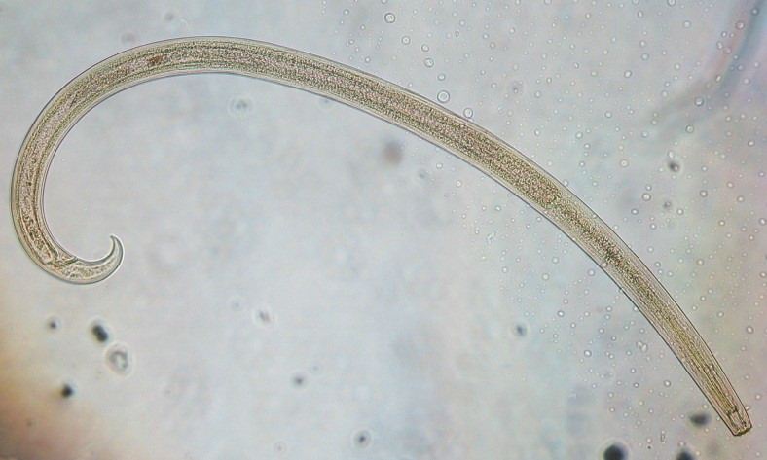
Creative Commons 3.0 image, available at: https://commons.wikimedia.org/wiki/File:Nematode,_Mononchidae_-_Soil_Fauna_Diversity.jpeg

Background: A healthy soil ecosystem
A healthy soil is more than simply dirt. It is a complex, thriving ecosystem where microscopic bacteria and fungi break down organic matter, providing nutrients for plants. The structure of the soil is improved by the interactions of insects and worms. This helps the soil hold more water, providing a better environment for plants. Plant roots provide soil stability so the soil is better able read the to cope with strong winds and heavy rain.
Western Australian soil ecosystems, however, are fragile and can quite easily become unbalanced. Unfortunately, some of the agricultural practices that were common up until the 1980s have degraded many of our soils. These practices include excessive land clearance and the overuse of fertilisers and pesticides. Conditions such as excess soil salinity, acidification and desertification in many parts of rural Western Australia have been the result. It is important for land users like farmers to take care of the health of their soil to promote the health of their crops, animals and the environment.
(Source: Grains Research and Development Corporation, 2016, The Science of Living Soils,
available at: grdc-science-of-living-soils-fa.pdf.pdf)

Activity 1: How can we improve the health of our soils?
Before answering the questions below, read the AgriWebb article How can we improve the health of our soil? <https://www.agriwebb.com/au/how-to-improve-soil-health/> to discover ways to restore and maintain a balanced soil ecosystem.

Questions
- Describe what ‘increasing organic matter inputs’ means.

- Explain how increasing organic matter inputs could contribute to maintaining a healthy soil ecosystem.

- Describe what it means for a farmer to ‘plant diverse species’.

- Explain how planting diverse species could contribute to maintaining a healthy soil ecosystem.

- Explain why reducing pesticide use may have beneficial effects on soil health.

- Explain why it is important for a farmer to manage the level of nutrients in the soil, such as nitrogen.

- Describe how controlling water flow can be of benefit to maintaining a healthy soil.

Activity 2: Case studies – How Aboriginal and Torres Strait Islander peoples help maintain balanced ecosystems

Background
Aboriginal and Torres Strait Islander peoples have relied on and used plants and animals to live healthy and prosperous lives for tens of thousands of years. Aboriginal people’s knowledge of their country includes an understanding of ecosystems and how the various plants and animals (including humans) interact with their physical environment (such as soil). Aboriginal and Torres Strait Islander peoples understand that all of the living and non-living things in an ecosystem interact with one another and each plays an essential role in a balanced ecosystem.
Many of the practices used to manage their environment before colonisation are still in place today in parts of the Western Desert region. For example, fire is used as a tool to increase the productivity of bush foods and bush medicines, and seeds are stored and scattered close to wetlands for future harvest. One way that Aboriginal people keep ecosystems healthy is by burning small sections at a time when conditions are right. This promotes healthy regrowth of plants and provides the right habitat for native animals to thrive.

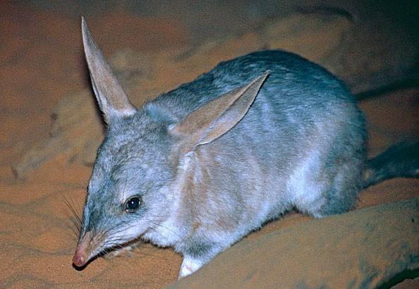

Creative Commons 2.0 image, available at: https://commons.wikimedia.org/wiki/File:Greater_Bilby_(Macrotis_lagotis)_(9996143106).jpg

(Source: Deslandes et al 2019, Two-way Science: An Integrated Learning Program for Aboriginal Desert Schools, CSIRO)
Aboriginal people understand that animals and plants can become extinct or reduced in number due to a variety of complex factors. Feral animals, such as foxes and cats, prey on native wildlife and can out-compete native predators. Horses, donkeys and camels are destructive plant eaters and can cause degradation of waterholes. Introduced weeds and the occurrence of large uncontrollable wildfires have also impacted native animals.
The ecological knowledge of country of Aboriginal people is a vital part of the management of threatened animal species and plant species.

Procedure
Follow the links below to discover more about how feral animals and invasive plants are being managed by Aboriginal people to keep ecosystems in balance.
- Indigenous hunters have positive impacts on food webs in desert Australia: https://www.sciencedaily.com/releases/2019/02/190217142522.htm

- Indigenous people and invasive species:

https://ipm.ifas.ufl.edu/pdfs/ens_et_al_2015_indigenous_people_and_invasive_species_iucn_c em_ecosystems_and_invasiv.pdf

Discussion question
Choose a feral animal or invasive plant species that is contributing to an ecosystem becoming unbalanced. Describe how the actions of Aboriginal people could help to rebalance the ecosystem.

Student worksheet 5.4

How can we conserve, restore and regenerate our soils?

Background
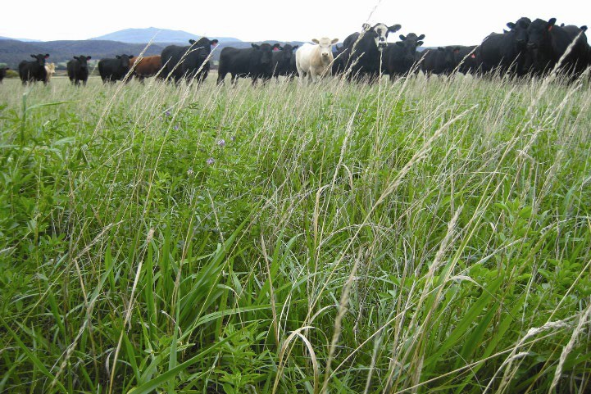
You have already learnt that healthy soils are essential for producing the food and fibre needed for everyday life. This is because soils are living, constantly changing ecosystems with a diverse range of organisms. The numerous soil organisms working together create a rich environment for agriculture.

Western Australia covers a vast area with a wide range of soil types. Many areas of the south-west of the state are characterised by soils with sandy surfaces ranging from deeps sands to sands over clays, and soils dominated by ironstone gravels. Soil type influences the capacity of the land to support

Image: © Government of Western Australia, DPIRD available at: https://www.agric.wa.gov.au/land- use/regenerative-agriculture-and-pastoralism-western- australia

agricultural production, and an understanding of their characteristics and distribution is very important for sustainable land management.
(Source: Government of Western Australia, DPIRD, available at: https://www.agric.wa.gov.au/climate-land-water/soils/identifying-wa- soils#:~:text=Western%20Australia%20covers%20a%20vast,soils%20dominated%20by%20ironstone%20gravels ).

In Western Australia land was opened up for agriculture based on the government policies of the day. Traditional agricultural practices were developed according to the knowledge available to people at the time. Unfortunately, some of these policies and practices were based on traditional English agricultural systems, unsuited to the sandy soils of Western Australia. Our soils are particularly fragile and as a consequence, soil food webs essential for a healthy soil may have in some areas been disrupted. New agricultural methods are now being used which aim to manage our soil organisms so that our soils are conserved, restored and regenerated.

Activity 1 – Learning from the past in order to do things better

Step 1

In a small group of 3-4 students examine the topic question: How can we learn from past practices to improve our soils for the future? Record your ideas in the first three columns of the KWHL chart supplied by your teacher.

Step 2

As a whole class watch the Soil health animation: What are the options for managing soil organisms? (slide 19 of PowerPoint 5.0 Ecosystem interactions). Now complete the final column of your KWHL chart.

Extension

Activity 2 – What’s happening in Western Australia?
The principle of soil regeneration is to enhance natural ecosystems, resulting in sustainable production, healthy nutrient cycling, increased biodiversity and resilience to change. In Western Australia the Department of Primary Industries and Regional Development (DPIRD) invests in many areas to support the sustainability and profitability of the agriculture sector in WA.
Follow the link to find out more about the ways that DPIRD provides support for WA primary producers:
https://www.agric.wa.gov.au/land-use/regenerative-agriculture-and-pastoralism-western- australia#:~:text=The%20principle%20of%20regenerative%20agriculture,biodiversity%20and%20r esilience%20to%20change

RegenWA is a network of committed West Australian farmers and industry stakeholders who are identifying, implementing and sharing innovative soil management practices that other farmers can adopt. The program is focused on supporting farmers who are investigating alternative production practices that aim to reduce or reverse the impact of productivity constraints, including salinity, erosion, acidification, pest/disease resistance and climate change.
Let’s look a bit more closely at what some specific WA primary producers are doing to conserve, restore and regenerate their soil. Follow the link below and read the five case studies of Western Australian primary producers: https://www.regenwa.com/resources/case-studies/

Activity 3 – Presenting your ideas
Prepare a presentation about the importance of managing our soils. You are encouraged to be creative – your presentation can be in the form of a poster, PowerPoint, Stop Motion video, or other format approved by your teacher.
Alternatively, develop a proposal for your local council on techniques to improve the soils in a particular location such as a community garden, a local park, or at home to support soil health, biodiversity and plant growth.

Acknowledgements
Professor Lynnette Abbott, University of Western Australia

Government of Western Australia, DPIRD available at: https://www.agric.wa.gov.au/land- use/regenerative-agriculture-and-pastoralism-western-australia

RegenWA available at: https://www.regenwa.com/)

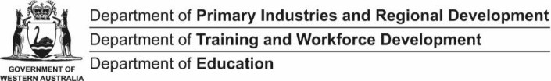
PRIMED

Student worksheet 5.5: K.W.H.L chart
A KWHL chart is used to assess what you know about a topic before, during and after you have engaged with it.
My topic is: How can we learn from past practices to improve our soils for the future?

What do I Know about this topic? | What do I Want to know? | How do I find out? | What did I Learn?

Student worksheet 5.6

Ecosystems key terminology review
Work back through the PowerPoint presentation 5.0 Ecosystem interactions and watch the video Understanding ecosystems for kids: producers, consumers and decomposers on YouTube: https://youtu.be/bJEToQ49Yjc

Make notes of the key ideas then use the following list of key terms to match the definitions in the appropriate positions on the word grid. (Note: you won’t need to use all these terms.)
Habitat; symbiosis; biotic; abiotic; commensalism; mutualism; parasitism; parasite; host; interdependence; endoparasite; ectoparasite

a)
b)
c)
d)
e)
f)
g)
h)
i)

Clues
- The term describing how living things in an ecosystem depend on each other for survival.
- A relationship where one organism benefits and the other is not affected.
- An organism that has another organism growing on or inside it.
- In this type of symbiotic relationship one organism lives on or in another organism.
- Another term used for two different types of organism that live together.
- Parasites that live on the outside of their hosts.
- An organism that lives on or in another organism, usually causing it harm.
- Parasites that live inside their hosts.
- In this symbiotic relationship both organisms benefit, in many cases neither organism can exist without the other.

Student worksheet 6.1

Self-assessment: Soils – the basis of food production

Activity 1: Key ideas
Complete the following activity by describing three key ideas you have learnt about each of the main activities in this topic.

Soils as ecosystems

1.

2.

3.

Investigating soils

1.

2.

3.

Classifying living things

1.

2.

3.

Food chains and food webs

1.

2.

3.

Ecosystem interactions

1.

2.

3.

In the space below, describe the most interesting thing you learnt during this topic.

Activity 2: Concept mapping
Try to use as many of the words in the lists of key vocabulary in the table below as possible to create a concept map that links together the following three key ideas of this topic.
If you have never made a concept map before, refer to this useful online tutorial, The Ultimate Guide to Concept Maps: From Its Origin to Concept Map Best Practices:
https://creately.com/blog/diagrams/ultimate-concept-map-tutorial/

Key idea 1 Soils as ecosystems | Key idea 2 Classifying living things | Key idea 3 Ecosystem interactions
Biodiversity Saprophytic nematodes Healthy population Parasitic nematodes Soil biome  Predator nematodes Unbalanced ecosystems Ecosystem  Community Interact Macroscopic Microscopic Biodiversity Habitat Invertebrate Fungi Bacteria Food web Agriculture Decomposers | Biodiversity Identification Classifying Kingdom Phyla  Class Order Family Genus Species Binomial Taxonomy  Taxonomists Indigenous classification systems  Primary industry Biosecurity Biosecurity officers Pests  Diseases Dichotomous key | Habitat Symbiosis Biotic Abiotic Food chain Food web  Commensalism Mutualism Parasitism Parasite  Host Interdependence Endoparasite Ectoparasite

