Student worksheet 4.1

Case study 1: Phytophthora dieback

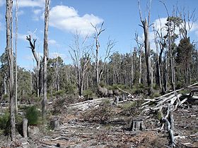
Background
Phytophthora dieback is an introduced disease caused by the water mould Phytophthora cinnamomi, which kills susceptible plants, such as Western Australian (WA) native banksias, jarrah and grass trees. It is also a major threat to many agricultural crops and garden plants. The fungus attacks the root systems and eventually causes the plants to die because they cannot take up the water and nutrients they need.
Phytophthora currently affects more than 40% of the native plant species and half of the endangered ones in the south-west of WA. The area of land infected in WA is over one million hectares, equivalent to 500 times the size of Rottnest Island. Twenty per cent of the state's jarrah forest is infected.
Image 4.1.1: Phytophthora dieback devastation

What is the problem?
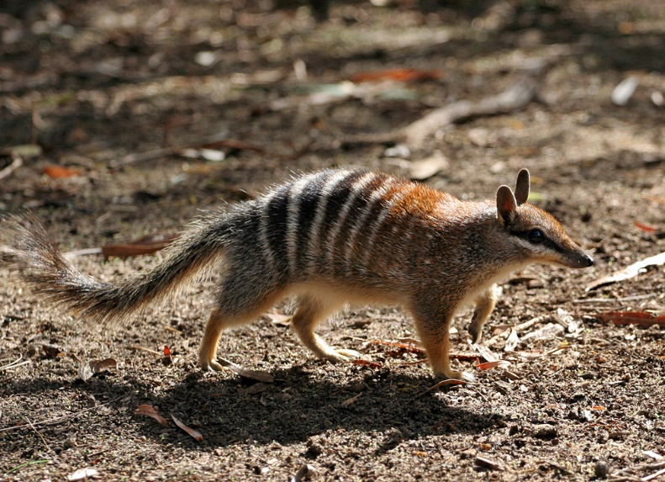
Dieback has major damaging environmental effects. It can cause problems such as loss of biodiversity, extinctions of threatened plant and animal species that rely on susceptible plants for food and habitat, loss of key understory plants, and the increased dominance of introduced weeds.
The economic impact of dieback on WA primary industries such as forestry is considerable. It also negatively impacts many other related industries. For example, commercial fruit growers of avocados and macadamias in the south-west of WA can be particularly badly affected, especially in warm, damp conditions when the pathogen travels fast. Tourism can also be negatively affected.

Image 4.1.1 The Numbat

Activity 1: Dieback research
Follow the links below to find out more on the impacts of dieback in the south-west of WA:
Phytophthora dieback
Dieback in the WA wheatbelt
Project dieback
In the space below, create a summary of how Phytophthora dieback is affecting both the environment in south-west WA and primary industry.
How Phytophthora dieback is affecting both the environment and primary industry in south-west WA

Biology - life cycle and growth

Activity 2: Understanding the life cycle of Phytophthora
Understanding the life cycle of any pest species such as Phytophthora is vitally important for eliminating or controlling it. A scientific understanding of the life cycle of a pathogen leads to understanding what conditions are most favourable for its spread and when it is most likely to be vulnerable to control measures.
Follow the links below to learn more about the life cycle of Phytophthora dieback:
Phytophthora basics
Phytophthora life cycle

In the space below, draw a life cycle diagram of Phytophthora cinnamomi.
Life cycle of Phytophthora cinnamomi

Questions
- How does phytophthora spread to infect new areas?

- Which phase of the phytophthora life cycle appears to be most the most infectious for plants?

Controlling the spread of Phytophthora

Activity 3: How humans can both spread and manage Phytophthora
There is currently no known cure for Phytophthora dieback disease. Humans are the greatest vector for the spread of Phytophthora. By moving soil and plant materials that contain the microscopic spores, humans can unwittingly spread the disease. Measures to control the movements of people, vehicles and machinery through dieback affected areas is of vital importance as a management strategy.
To learn more watch about how the threat of Phytophthora Dieback is being managed watch the videos
Managing dieback by Southcoast NRM
Managing phytophthora dieback in south-west Western Australia
The WA Departments of Primary Industries and Regional Development, and Biodiversity, Conservation and Attractions as well as Murdoch University are carrying out research into the fungicide phosphite; a biodegradable fungicide that protects plants against Phytophthora dieback.
Follow the links to learn about the use of phosphite as a chemical control agent for Phytophthora:
Control of Phytophthora root rot in avocado with phosphite - a review
Phytophthora
In the space below, describe the role of humans in both spreading and controlling the spread of Phytophthora in south-west WA.
How humans can spread Phytophthora | How humans can control the spread of Phytophthora

Activity 4 Career exploration
If you enjoyed learning about Phytophthora and its control, you may enjoy exploring these related careers:
Plant scientist
Agricultural technician

Building numeracy skills

Student activity 5: Project Dieback: second-hand data for graphing and analysis
Project Dieback is a State Natural Resource Management (NRM) Office funded project aimed at reducing the spread of Phytophthora cinnamomi within priority areas within the south-west of WA. The project identifies Priority Protection Areas (PPAs) of significant biodiverse ecosystems and communities vulnerable to Phytophthora dieback. The data collected is used to develop area specific management actions to prevent the further spread of Phytophthora dieback.
Follow the link to Project Dieback, select the ‘Mapping’ tab and open the Plant Disease Data page. Scroll down the page to the map of Perth and surrounding areas. You will see that there are actually five different species of soil borne Phytophthora identified across south-west WA. The occurrence of each species is represented on the map by a coloured dot.
Tally the numbers and calculate the percentage occurrence of each of the five species in the map.
Species | Numbers | Percentage occurrence (%)
P. cinnamomi
P. multivora
P. inundata
P. nicotianae
P. pseudocryptogea

Extension:
If you wish to investigate other regions of WA where Phytophthora dieback is a problem, follow the link to the Dieback Public Map, select a region or area you are interested in, and calculate the percentage occurrence and density of the five species in that region or area. You may also like to compare different regions to see how such factors as annual rainfall affect dieback distribution.

Acknowledgements

References
Government of Western Australia, DPIRD, ‘Control of Phytophthora root rot in avocado with phosphite – a review’ available at: <https://www.agric.wa.gov.au/avocados/control-phytophthora-root-rot-avocado-phosphite-review> accessed 3 June 2021
Government of Western Australia, ‘Phytophthora Dieback’ Department of Biodiversity, Conservation and Attractions, available at: <https://www.dpaw.wa.gov.au/management/pests-diseases/phytophthora-dieback> Accessed 3 June 2021
The Murdoch Centre for Phytophthora Science and Management (CPSM), Murdoch University, Wester Australia available at: <https://www.murdoch.edu.au/research/impact-and-engagement/dealing-with-dieback> accessed 3 June 2021
Project Dieback ‘Overview’ <https://dieback.net.au/-project-dieback/> accessed 3 June 2021
South Coast NRM available at: <https://southcoastnrm.com.au/> accessed 3 June 2021
In Shot Productions (1 December 2011) video ‘Managing phytophthora dieback in south-west Western Australia’ YouTube available at <https://www.youtube.com/watch?app=desktop&v=StP-KEGg6-0> accessed 3 June 2021
Forest phytophthoras of the world, available at: <http://forestphytophthoras.org/phytophthora-basics> accessed 3 June 2021

Images
Image 4.1.1 Phytophthora dieback devastation - Photo © Parks and Wildlife, available at: <https://www.dpaw.wa.gov.au/management/pests-diseases/phytophthora-dieback> accessed 2 June 2021
Image 4.1.2 ‘Numbat’, image Martin Pot (Martybugs at en.wikipedia), CC BY 3.0 available at: < https://commons.wikimedia.org/wiki/File:Numbat.jpg> accessed 7 June 2021

