Student worksheet 4.2

Case study 2: Queensland fruit fly (Qfly)

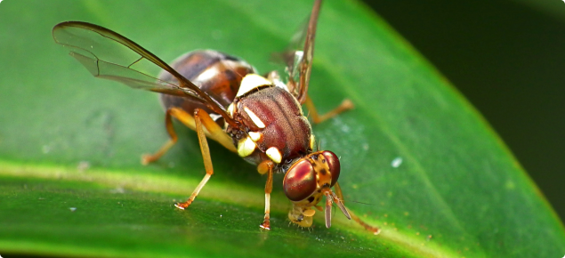
Background
Queensland fruit fly (Qfly) is an Australian fruit fly native to the tropical and subtropical rainforests of Queensland and northern New South Wales. Qfly is one of the world’s worst fruit pests, attacking a wide range of fruits, and some fruiting vegetables and ornamental plants.
Image 4.2.1 Queensland fruit fly (Qfly)
Currently Qfly is present in parts of eastern Australia but not well established in Western Australia (WA), although it has previously been detected and eradicated. Maintaining Qfly area freedom provides WA growers access to export markets, such as avocados to Japan and strawberries to Thailand, and allows for continued enjoyment of home-grown fruit and vegetables.

What is the problem?
It has been estimated that Qfly currently causes agricultural and economic losses at around $300 million across Australia each year.
Potentially, Qfly has major agricultural and economic impacts for WA. If it is allowed to invade our local fruit and vegetable growing regions, it will become a major biosecurity hazard, involving significant costs of controlling it, loss of production, postharvest treatments, on‐going surveillance for area freedom and loss or limit to domestic and international markets. It is vital that Qfly does not spread through urban gardens and horticultural areas.
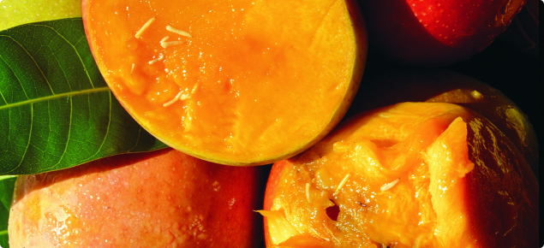

Image 4.2.2 Queensland fruit fly larvae attacking fruit

Activity 1: Qfly research
Follow the link below to find out more on the impacts of Qfly:
Agriculture WA
Invasive species compendium
In the space below, create a summary of the effects of Qfly on agriculture and the economy
How Qfly is affecting agriculture and the economy

Biology of the Qfly - life cycle and growth

Activity 2: Understanding the life cycle of Qfly
Qfly can be a problem for home gardeners and commercial growers because it attacks a large variety of fruit and vegetables, making them inedible. Qfly spreads from infested plants to nearby fruit and vegetables, and by people sharing or travelling with home grown fruit or vegetables. While fruit and vegetables may look fine from the outside, they may be rotten or have eggs or maggots hidden inside.
Understanding the life cycle of a pest species such as Qfly is vitally important for introducing biosecurity measures to eliminate or control it. A scientific understanding of the life cycle leads to understanding what conditions are most favourable for its spread and when it is most likely to be vulnerable to control measures.

Follow the links and read the descriptions of the Qfly:
Agriculture WA – Queensland fruit fly
Watch the video Queensland fruit fly in your garden to learn more about the Qfly life cycle.
In the space below, draw a life cycle diagram of Qfly
Life cycle of QFly

Questions:
- How is Qfly spread to new areas?

- What do adult fruit flies look like?

- What can you do to prevent the spread of Qfly?

Identification and control of Qfly

Activity 3: How science and technology are being used to control the spread of Qfly
In order to control Qfly, it is important that if flies are sited, they are correctly identified, otherwise beneficial insects such as hover flies may be mistakenly eliminated. The WA Government Department of Primary Industry and Regional Development has a number of resources that can be used to identify Qfly and other insects:
What fly is that?
Qfly information pamphlet - DPIRD
MyPestGuide was developed to encourage everyone (public, industry and government) to report observations of any common, interesting or possibly exotic pests, as well as the absence of pests across Australia
Sterile insect technique (SIT) is a scientifically proven biological control method to control pest insects. SIT uses the mass rearing, sterilisation, and release of Qfly in targeted quarantine areas. Once released in the environment, the sterile Qfly mate with their wild counterparts, which disrupts reproduction and suppresses pest population numbers.
To learn more about SIT and its effectiveness as a control method for Qfly, follow the links:
DPIRD Sterile Insect Technique
Sterile insects to combat Qfly in WA
Farm biosecurity

Group discussion
In a small group, compare the advantages and disadvantages of using SIT as a control measure for Qfly compared with using chemical pesticides. Record your ideas in the table below.
Advantages of using SIT to control Qfly | Disadvantages of using SIT to control Qfly

Activity 4: Career exploration
Protecting WA’s agricultural industries from invasive pest species is vital work and is one part of providing food security. Many different and interesting employment opportunities are available for people.
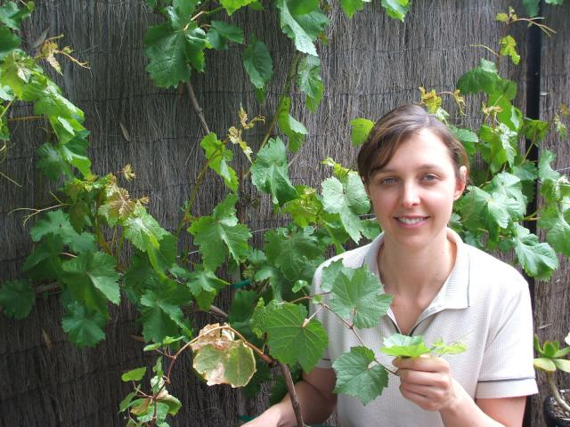
Image 4.2.3 Viticulture research officer

If you enjoyed learning about Qfly, you may enjoy exploring these related careers:
Biosecurity officer
Agricultural scientist
Agricultural technical officer
Agricultural consultant

Literacy

Student activity 5: Concept mapping
A number of different key terms and/or ideas have been introduced throughout this study of the Qfly. These include:
agriculture, economy, exotic pests, invasive species, biosecurity, quarantine, area freedom, biological control method, sterile insect technique, sterilisation, food security, employment opportunities
Review these terms and/or ideas and use them to create a concept map for the control of Qfly.
If you are unsure about how to make a concept map, watch the video tutorial How to make a concept map .

Concept map

Acknowledgements

References
Government of Western Australia, DPIRD available at: <https://www.agric.wa.gov.au/> accessed 3 June 2021
Government of Western Australia, Department of Training and Workforce Development, available at: <https://www.jobsandskills.wa.gov.au/> accessed 7 June 2021
Agriculture Victoria, Identifying Queensland fruit fly, available at: <https://agriculture.vic.gov.au/biosecurity/pest-insects-and-mites/priority-pest-insects-and-mites/queensland-fruit-fly/identifying-queensland-fruit-fly> accessed 7 June 2021
CABI, Invasive species compendium, available at: <https://www.cabi.org/isc/datasheet/17693 - tosummaryOfInvasiveness> accessed 7 June 2021
Farm biosecurity ‘Area-wide management of Queensland fruit fly and using sterile techniques’ available at: <https://www.farmbiosecurity.com.au/area-wide-management-of-queensland-fruit-fly-and-using-sterile-insects/> accessed 7 June 2021
Lucidchart (1 June 2018) video ‘How to make a concept map’ available at YouTube: <https://www.youtube.com/watch?v=8XGQGhli0I0> accessed 22 July 2021
Naturpac.org available at: <http://www.fruitnet.com/produceplus/article/183613/sterile-insects-to-combat-qfly-in-wa> accessed 7 June 2021

Images
All images © Government of Western Australia, DPIRD, available at: <https://www.agric.wa.gov.au/>
Image 4.2.1 ‘Queensland fruit fly (Qfly)’ accessed 7 June 2021
Image 4.2.2 ‘Queensland fruit fly larvae attacking fruit’ accessed 7 June 2021
Image 4.2.3 ‘Viticulture research officer’ accessed 7 Jun. 21

