Student worksheet 4.4

Case study 4: The dung beetle story

Background
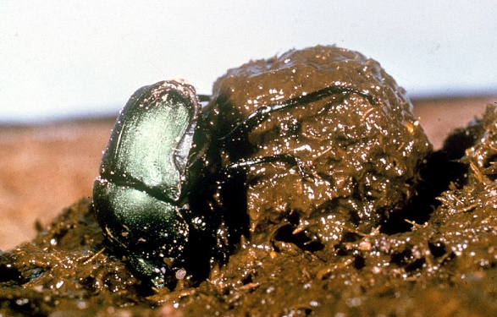
Western Australia (WA) primary industry has a herd of approximately two million head of beef cattle. There is also an extensive dairy industry located in the far south-west. All of these cattle produce a large amount of dung (solid waste), which can be the perfect breeding ground for bushflies. WA is seasonally plagued with the exceedingly abundant bush fly (Musca vetustissima). The bush fly is a native insect that has affected the lives of Western Australians since before European settlement. They survive over winter in the wheatbelt and further north-east, build up there in early spring and are pushed by easterly winds into the south-west each October to start a new season of local breeding. The adult flies lay eggs in fresh dung, where the larvae develop to the pupal stage.
Image 4.4.1 Dung beetle - CSIRO
Image 4.1.1: Phytophthora dieback devastation
Introduction of dung beetles to WA has been necessary as the native dung beetles evolved to break down much smaller droppings from animals such as kangaroos. They are therefore inefficient at breaking up the large dung pads of introduced cattle. In the south-west, native beetles are active during winter, whereas the flies that breed in dung are active during summer. Twelve species of introduced dung beetles have established in WA, with 10 doing well in the south-west. Nevertheless, there is still a period during spring and early summer in some years when bush flies cause annoyance.

What is the problem?
The average cow drops between 10 and 12 dung pads every day. This is a huge amount of dung that is produced annually. Unless the dung is buried quickly by dung beetles, pasture is smothered by dung, flies develop in that dung and nutrients flow in to waterways reducing pasture productivity. Just one large cow pad can produce up to 3000 bush flies, creating a major nuisance for people and domestic livestock.
Image 4.4.2 Australian bush flies

Activity 1: Dung beetle research
Follow the links below to find out more on the history of dung beetles and the introduction of dung beetles into Australia:
African dung beetle – National Geographic
CSIRO dung beetle program
National Museum Australia – One of God’s gifts to us as humans
In the space below, create a timeline of when, how and why dung beetles were introduced into Australia.
Timeline of when, how and why dung beetles were introduced into Australia

Activity 2: Understanding the biology of bushflies and dung beetles

Life cycle and growth
Understanding the biology of any pest species such as the native bushfly is vitally important for eliminating or controlling it. If another species (such as the dung beetle) is involved in the pest species’ biological control, then it is important to understand its biology also. Understanding both enables scientists to plan for the release of particular species of dung beetles in particular areas at different times of the year. Follow the links below to learn more about the life cycle and biology of the bush fly (Musca vetustissima):
Propagation of bush fly larvae
DPIRD Control of bush flies by dung beetles
ABC News – Saluting a great Australia: The bush fly
UWA – Why flies are particularly annoying this summer
In the space below, draw a life cycle diagram of the bush fly (Musca vetustissima)
Life cycle of the bush fly (Musca vetustissima)
Questions
- How does the bush fly obtain its food?

- Bush flies are particularly difficult to swat when they are flying. What features (adaptations) does the bushfly have that enable it to avoid being swatted?

Dung beetle biology

A relatively large number of species of dung beetles have been introduced into Australia. This is because different species of dung beetles are suited to different climatic conditions.
Follow the link below to learn about more about the biology of the various species of dung beetles introduced into Australia:
Australian Museum – Dung beetles
Complete the following table of biological information about dung beetles

Classification

Identification

Distribution

Seasonality

Life history cycle

Ecological impacts

Dung beetle behaviour – species differences

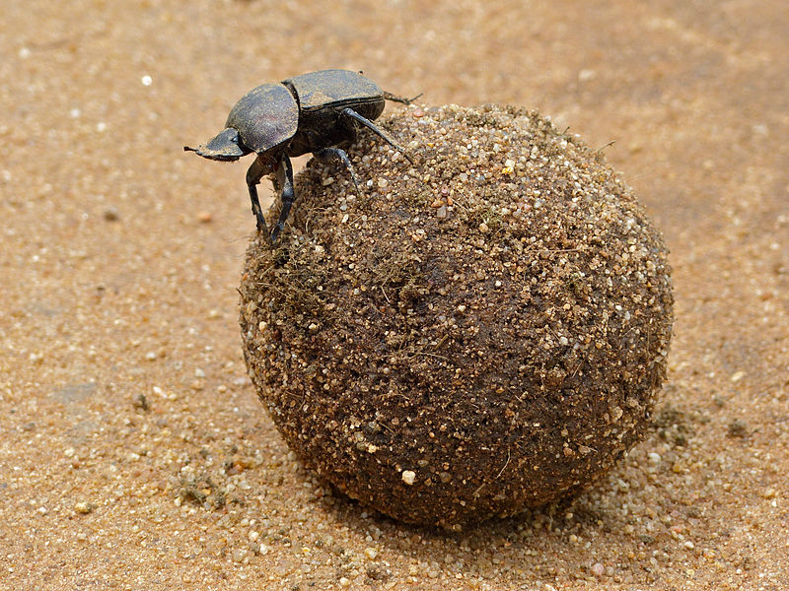
Image 4.4.3 Dung beetle on top of its dung ball
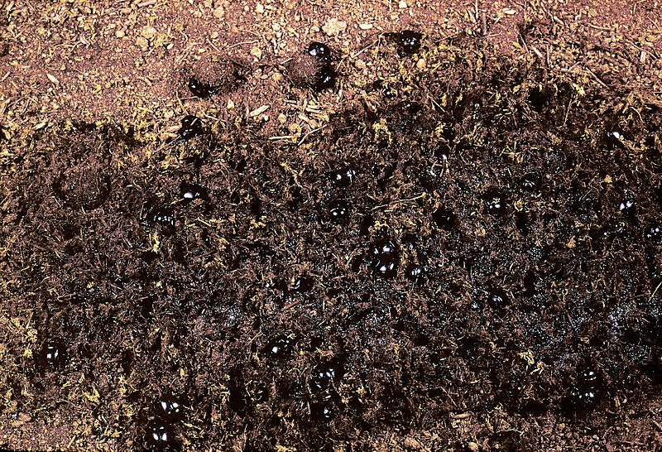

Image 4.4.4 Dung beetles burying a dung pat - CSIRO

Examine the images of a dung beetle on top of its dung ball and dung beetles burying a dung pat. The images are of two different species performing two different types of behaviours. Discuss with a partner why you think that the dung beetles are behaving as they are. Record your ideas.

We think that the dung beetle is sitting on top of a dung ball because:
We think that the dung beetles are burying a dung pat because:

Activity 3: Dung beetle biology - extension activities
- Follow the links below to learn more about the fascinating behaviour of dung beetles: DPIRD Control of bush flies by dung beetles – species differences
Video: Dung beetle facts: the poop rollers (and more!)
- Dung beetles have been introduced widely in Australia into areas called Natural Resource Management (NRM) regions. To learn about which species of dung beetles have been introduced into the various regions of WA (or Australia), follow the links to the interactive map Dung beetle – Which species are near you? and Dung beetles in the southwest of Western Australia
- The introduction of dung beetles is an example of biological control. Find out if there have been other examples of this in Australia and whether they were successful.

Activity 4: Career exploration
If you enjoyed learning about dung beetles, the control of bush flies and greenhouse gas emissions you may enjoy exploring these related careers:
Agricultural scientist
Biologist
Climatologist
Entomologist
Environmental research scientist

Environmental consultant

Activity 5: Collating and analysing data on dung beetles
Dung beetles broadly fall into two categories: summer-active and winter-active. The main breeding period for most dung beetles is spring, and some species have more than one generation a year. Follow the link Dung beetle – Introduced species in Australia to learn more about the 25 species of dung beetles. Complete the data in the table below.
Species name | Species is found in WA (Yes/No) | Length (mm) | Yearly activity

- Use the data you have entered in the table to create a histogram of the number of species of dung beetles across Australia in different length ranges:
1 – 5 mm, 6 – 10 mm, 11 – 15 mm, 16 – 20 mm, 21 – 25 mm, 26 – 30 mm.
(If you unsure which length range a species falls into, choose the middle of its range)

- Of the 25 species, how many species are present in WA?

- Of the Western Australian species, how many are mainly active in the summer and how many are winter-active?

- Bubus bison is an important species that has been established much of the southern agricultural regions of WA. Predict what could be some possible outcomes for the dung beetles and bush fly numbers if south-west WA were to experience a warmer and dryer winter than usual. Justify your predictions.

- Propose a hypothesis to account for why so many different species have needed to be established across WA.

Cattle dung and greenhouse gas emissions
Cattle farming is not only a source of dung for bush flies to breed in but is also a major source of greenhouse gas (GHG) emissions. The major greenhouse gases carbon dioxide (CO₂), methane (CH₄) and nitrous oxide (N₂O) are all released by the action of various microbes from dung as it decays. Recent research suggests that the GHG emissions from dung pats could be affected by the biotic interactions of dung beetles with the dung pads.
In a scientific study in Italy in 2017, four different species of dung beetle were tested to determine their effectiveness at removing dung and reducing the amount of GHG emissions from cattle dung pats. The four dung beetle species all had different nesting strategies (a pat-dwelling species, a roller of dung balls, a large and a small tunnelling species). Dung beetles vary in their nesting strategies, and can be divided in dwellers, tunnelers and rollers. Dwellers utilise dung pats by living inside them. The ‘tunnelers’ transport dung to tunnels dug underneath the dung pat. The ‘rollers’ first transport pieces of dung along the ground, then bury them.
Six experimental treatments (T1 – T4 with only one species of dung beetle; and two mixed species T5 – T6); and two controls (one with dung but without beetles C1, and one of soil with neither dung nor beetles C2) were used.
Figure 1: Four species of dung beetle used in the experiment
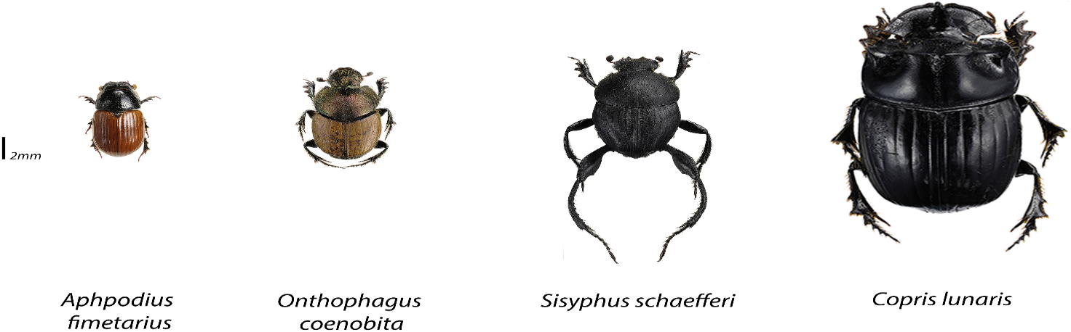
Table 1: Dung beetle species used in the experiment
The table identifies the nesting strategies, species, total number of individuals, mean individual dry body mass and number of individuals used in each experimental treatment.
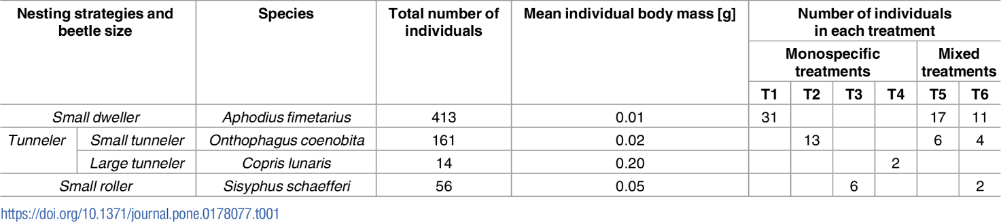

Figure 2: Dung removal in different treatments
Shown below are box plots of the dry weight of dung (in grams) left at the end of the experiment.
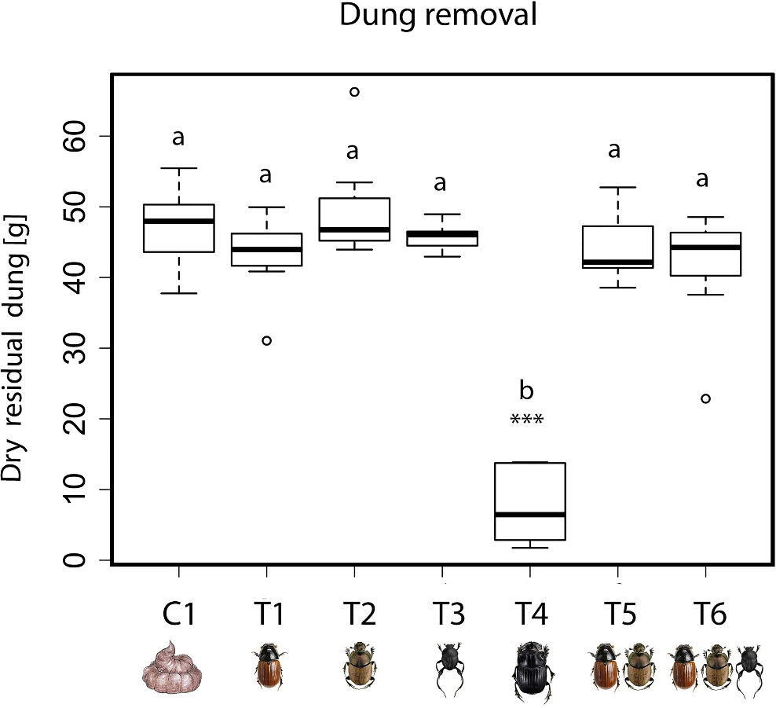
Figure 3: Greenhouse gas emissions emitted in different treatments
These following figure shows total emissions (flux) of CO₂, CH₄, N₂O with each treatment over the experiment.
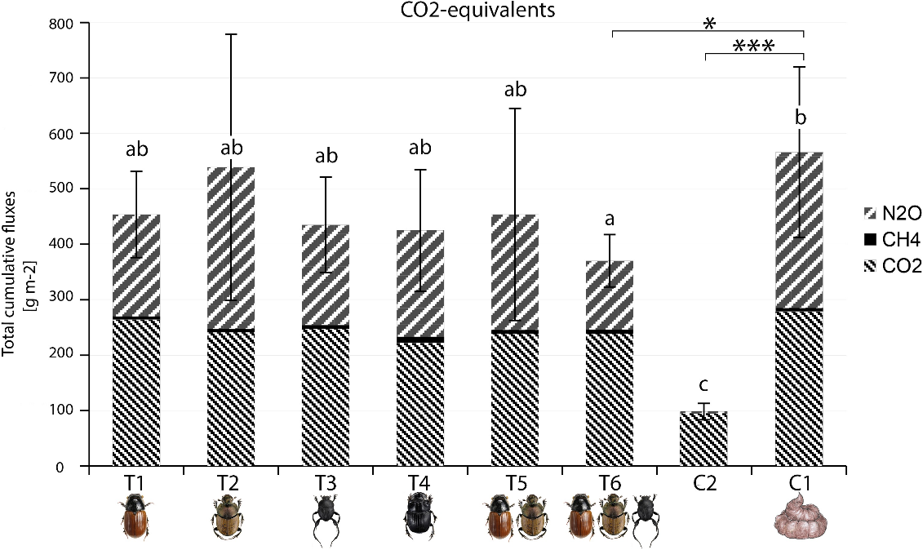
(Source: Figures 1,2 & 3; Tables 1 - Picini I, Arnieri F, Caprio E, Nervo B, Pelissetti, S, Palestrini,C et al. (2017) CC BY 4.0

Questions
- A different number of dung beetles of each species was used in the various treatments. Suggest a logical reason why this was done.

- One species of dung beetle is much more effective at removing dung from the experimental environment.

- Which species is the most effective? Use the data from figure 2 to justify your answer.

- How could this be related to the nesting strategy and beetle size?

- Examine figure 3. State two conclusions about dung beetles and greenhouse gas emissions that can be drawn from the data:

Conclusion 1:

Conclusion 2:

Acknowledgements

References
ABC News (26 January 2017) ‘Saluting a great Australian: The bush fly’ available at: <https://www.abc.net.au/news/science/2017-01-26/salute-the-great-australian-bush-fly/8211770> accessed 14 June 2021
Animal Fact Files (23 July 2020) ‘Dung beetle facts: the poop rollers (and more!)’ (video) YouTube available at: <https://www.youtube.com/watch?v=2Y2P6pnKshw> accessed 14 June 2021
Government of Western Australia, DPIRD, (29 May 2019) ‘Control of bush flies by dung beetles’ available at: <https://www.agric.wa.gov.au/land-use/control-bush-flies-dung-beetles?page=0%2C0#smartpaging_toc_p0_s0_h2> accessed 14 June 2021
Government of Western Australia, Department of Training and Workforce Development, available at: <https://www.jobsandskills.wa.gov.au/> accessed 14 June 2021
CSIRO (23 February 2021) ‘Dung beetles control buffalo and bush flies’ available at: <https://www.csiro.au/en/research/animals/livestock/dung-beetles> accessed 14 June 2021
CSIRO (21 February 2011) ‘Dung beetle program’ available at: <https://csiropedia.csiro.au/dung-beetle-program/> accessed 14 June 2021
National Geographic (15 October 2007) video ‘African Dung Beetle – National Geographic – YouTube’ available at: <https://www.youtube.com/watch?v=I1RHmSm36aE> accessed 12 July 2021
National Museum Australia, Digital Classroom – Australia’s Defining Moments, ‘One of God’s gifts to humans’ available at: <https://digital-classroom.nma.gov.au/defining-moments/dung-beetles-introduced> Accessed 14 June 2021
Picini I, Arnieri F, Caprio E, Nervo B, Pelissetti, S, Palestrini C et al. (2017) ‘Greenhouse gas emissions from dung pats vary with dung beetle species and with assemblage composition’. PLoS ONE 12(7): e0178077. https://doi.org/ 10.1371/journal.pone.0178077. Open access article CC BY 4.0 unrestricted use, distribution, and reproduction , original author and source credited. Available at: <https://www.dungbeetlessouthwest.org.au/resources> accessed 15 June 2021
University of Western Australia (7 January 2021) ‘Why flies are particularly annoying this summer’ available at: <https://www.uwa.edu.au/news/article/2021/january/why-flies-are-particularly-annoying-this-summer> accessed 14 June 2021
Pheasant and Waterfowl Society Australia ‘Propagation of bush fly larvae’ available at: <https://www.pwsa.org.au/Bush-Fly-Larvae> accessed 1 July 2021
Warren Catchments Council (2017) ‘Dung beetles in the southwest of Western Australia’ available at: <https://www.dungbeetlessouthwest.org.au/> accessed 15 June 2021

Images
Image 4.4.1 ‘CSIRO Science image 1353 Dung beetle’ CSIRO, CC BY 3.0 available at: <https://commons.wikimedia.org/wiki/File:CSIRO_ScienceImage_1353_Dung_Beetle.jpg> accessed 14 June 2021
Image 4.4.2 ‘Australian bush flies’ Menhanse, CC BY-SA 4.0 available at: <https://commons.wikimedia.org/wiki/File:Australian_bush_fly.jpg> accessed 14 June 2021
Image 4.4.3 ‘Large copper dung beetle on top of its dung ball’ Bernard DUPONT CC BY-SA 2.0 available at: <https://commons.wikimedia.org/wiki/File:Large_Copper_Dung_Beetle_(Kheper_nigroaeneus)_on_top_of_its_dung_ball_(12615241475).jpg> accessed 14 June 2021
Image 4.4.4 ‘CSIRO Science image 1090 Dung beetles burying a dung pad’ CSIRO, CC BY 3.0 available at: <https://commons.wikimedia.org/wiki/File:CSIRO_ScienceImage_1090_Dung_beetles_burying_a_dung_pad.jpg> accessed 13 June 2021

