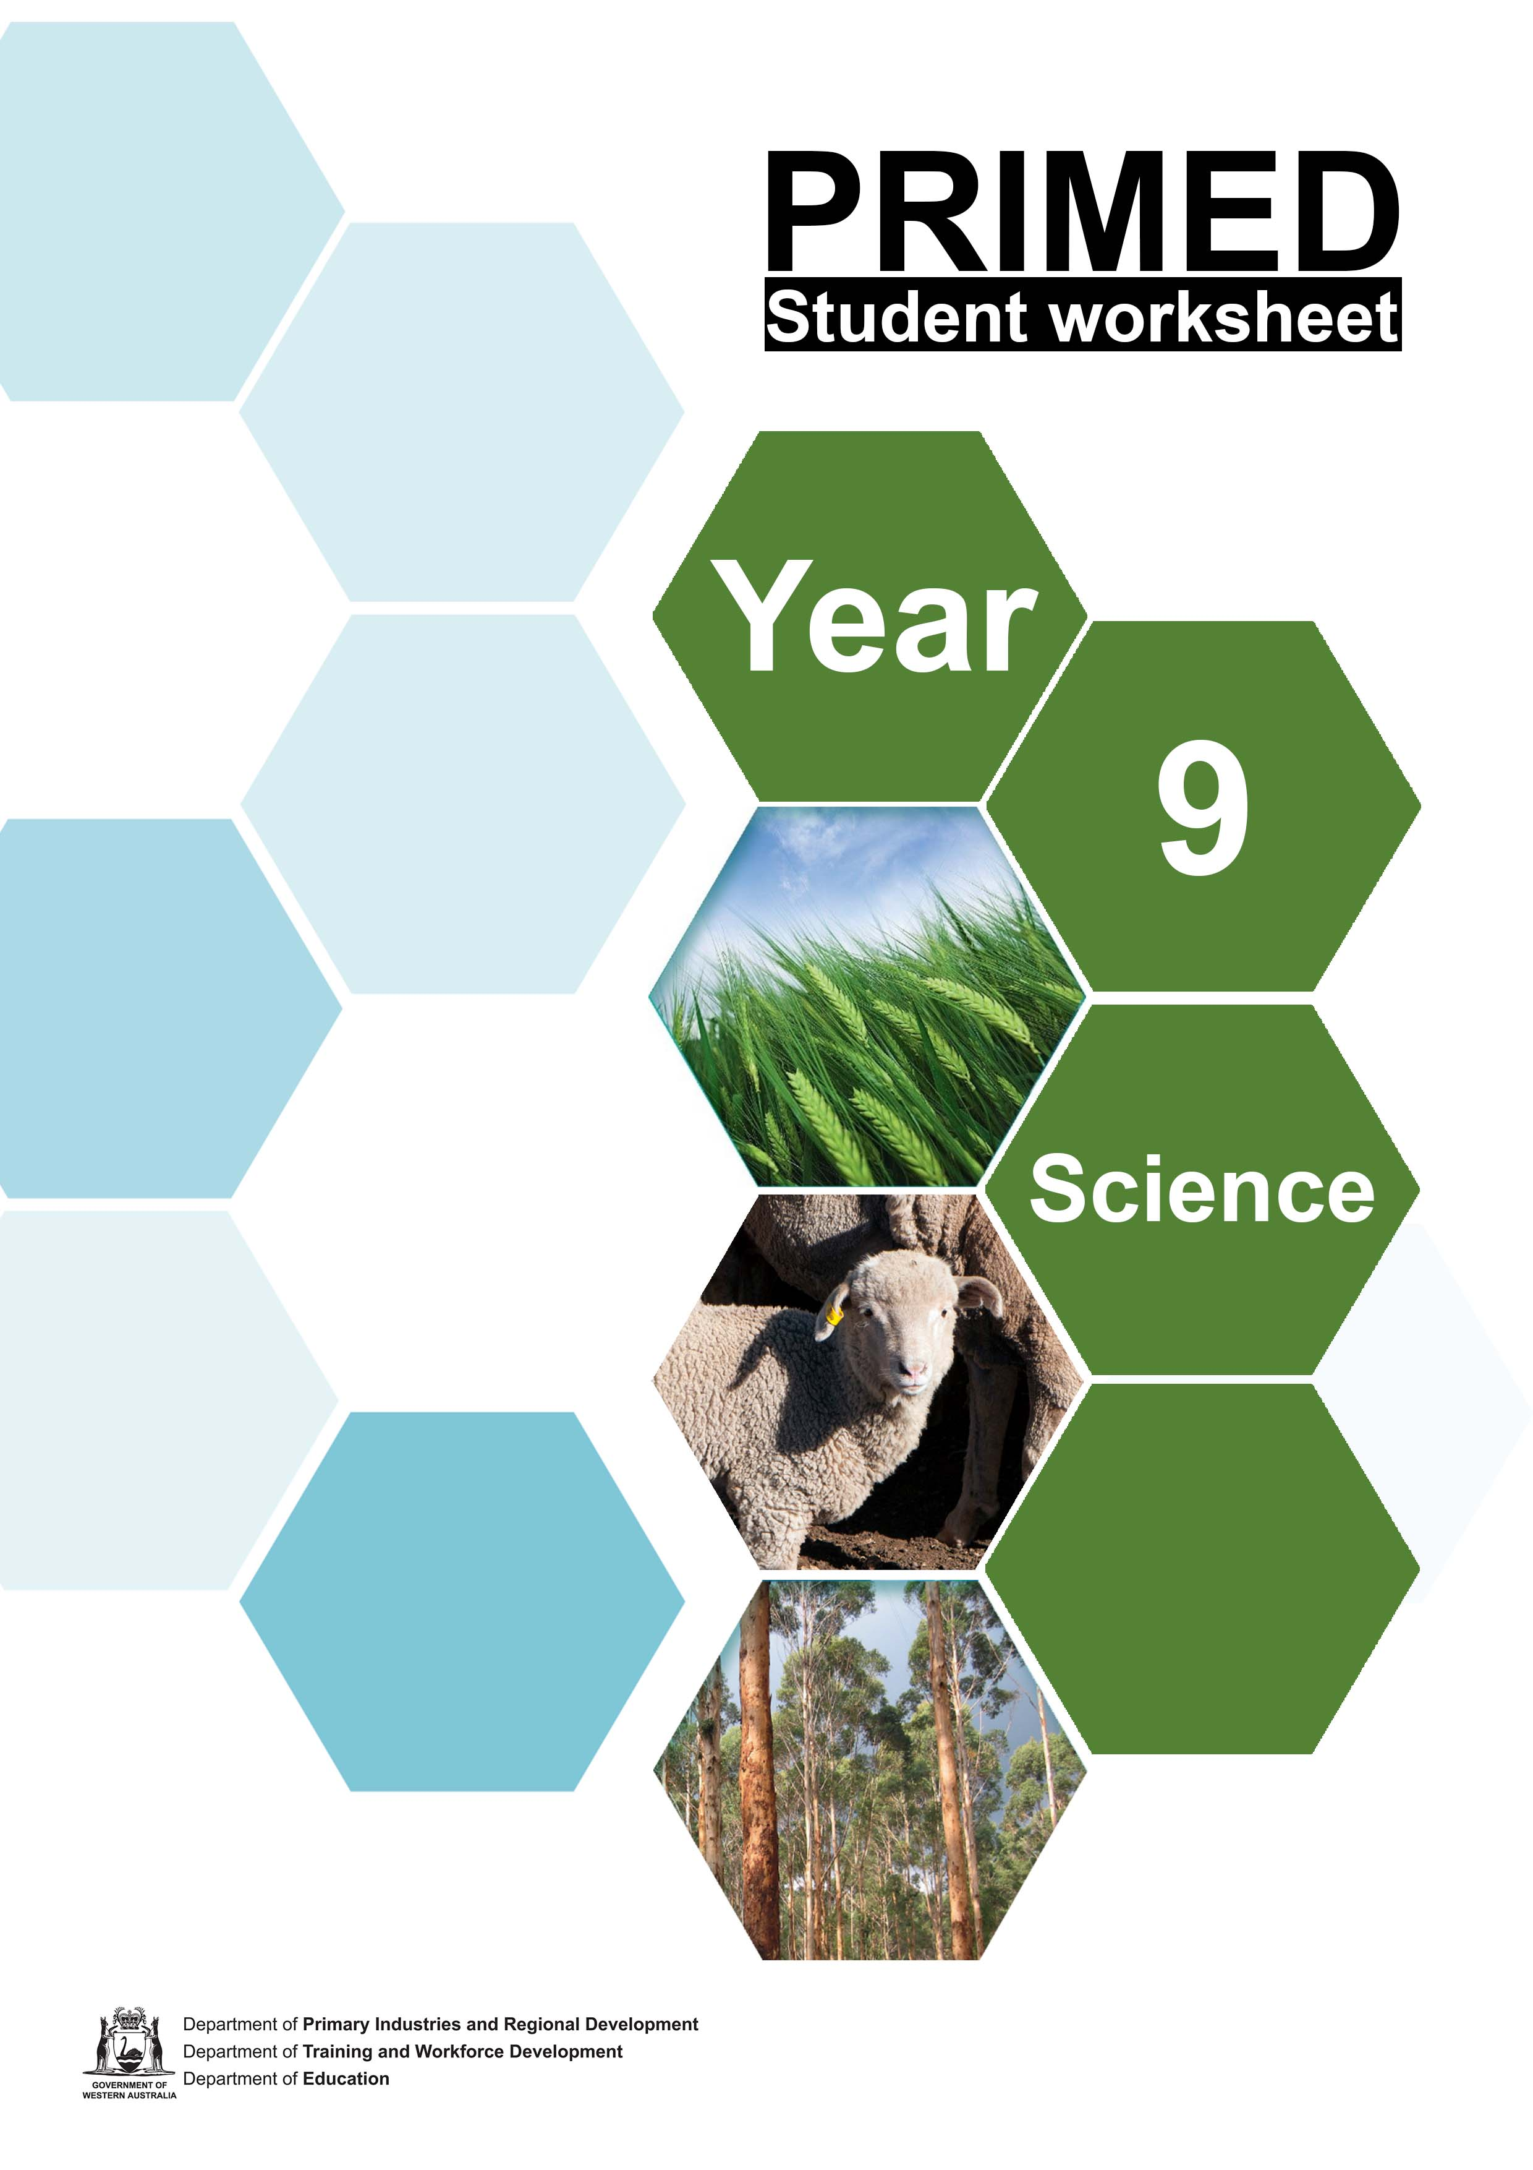

Student worksheet 1.1

Silent card shuffle
Terms

Ecology | Environment
Habitat | Natural ecosystem
Agricultural ecosystem | Abiotic factors
Biotic factors | Community
Population | Competition

Terms

Predation | Mutualism
Parasitism | Commensalism
Adaptation | Biodiversity
Sustainability | Biomass
Productivity | Primary production

A branch within biology that deals with the relationships of organisms to one another and to their physical surroundings | The natural world, as a whole or in a particular geographical area, especially as affected by human activity
The natural home or environment of an animal, plant, or other organism | A biological community of interacting organisms and their physical environment
An artificial biological community (related to agriculture) of interacting organisms and their physical environment | Factors that are physical rather than biological; not derived from living organisms
Factors relating to or resulting from living organisms | A group of interdependent plants and animals growing or living together in natural conditions or occupying a specified habitat
A community of animals, plants, or humans among whose members interbreeding occurs | Interaction between animal or plant species, or individual organisms, that are attempting to gain a share of a limited environmental resource

The preying of one animal on others | Symbiosis that is beneficial to both organisms involved
The practice of living as a parasite on or with another animal or organism | An association between two organisms in which one benefits and the other derives neither benefit nor harm
The process of change by which an organism or species becomes better suited to its environment | The variety of plant and animal life in the world or in a particular habitat; a high level of which is usually considered to be important and desirable
Avoidance of the depletion of natural resources in order to maintain an ecological balance | The total quantity or weight of organisms in a given area or volume
The rate of production of new biomass by an individual, population, or community; the fertility or capacity of a given habitat or area | The production of raw materials for industry

Acknowledgements

References
Oxford English Dictionary (online) (2021) Powered by Lexico, available at: https://www.lexico.com/ accessed 17 June 2021

Student worksheet 1.2 Ecological interactions Background
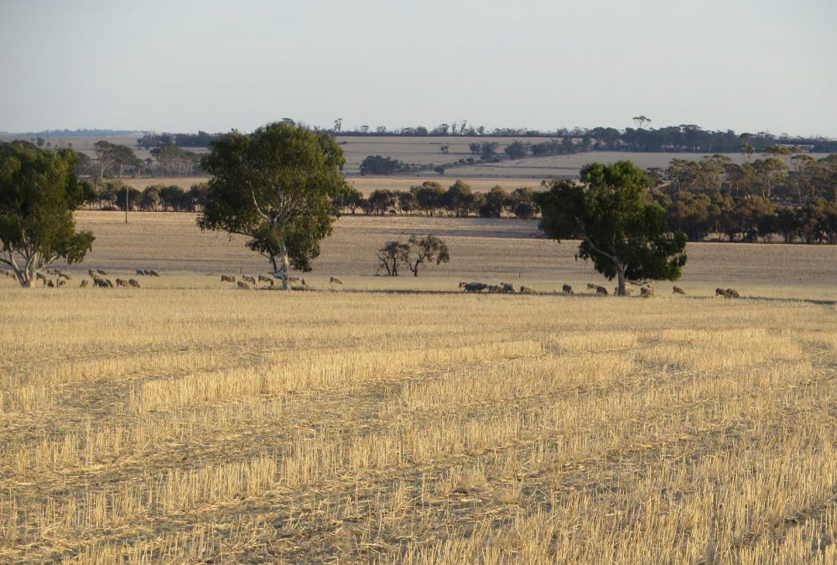
In any ecosystem (natural or
agricultural) many factors influence the overall productivity of the system.
These factors can be classified as either abiotic (physical) factors or biotic (living) factors.
If we picture a typical Western Australian agricultural ecosystem (such as a sheep station), the abiotic factors would include such things as temperature range; water availability; gases such as oxygen (O2), carbon dioxide (CO2) and methane (CH4);

Image 1.2.1 Sheep grazing wheat stubble

humidity levels; wind strength and direction; soil moisture; soil nutrients (such as nitrates and phosphates); and the presence of pollutants.
In this system the biotic factors would include available food (in this case producer organisms such as grass or wheat); other animals which might be competitors or consumers of the food (such as kangaroos); decomposing organisms (such as dung beetles), which live on the sheep droppings; and parasites or disease organisms (such as ticks and liver flukes), which live on or in the sheep.
As you can imagine, the abiotic and the biotic factors are constantly interacting with one another. For example, the sheep (biotic) requires water (abiotic) and food (biotic) and produces waste faeces (biotic), which are in turn decomposed by dung beetles (biotic), which turn the droppings into soil nutrients (abiotic).

Activity 1: Infographic – abiotic and biotic factors affecting sheep
Watch the video FuseSchool – Interactions within an ecosystem

Create an infographic of as many abiotic and biotic factors that are interacting in the life of a sheep on a sheep station. If you are unfamiliar with the purpose of an infographic or how to create one, a useful resource is Creative Educator - Infographics.

Infographic – abiotic and biotic interactions on a sheep station

Activity 2: Symbiosis – an important biotic factor
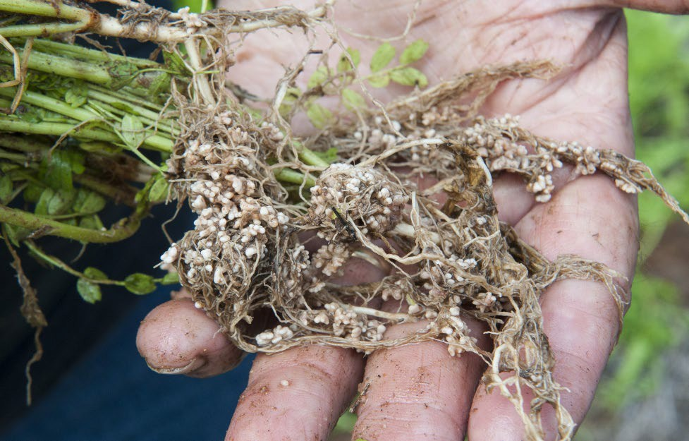
One very important factor primary producers need to consider is whether their pastures are productive and healthy.
A number of biotic interactions are important in agricultural ecosystems that involve symbiotic relationships. Pasture legumes form a symbiotic (mutually beneficial) association with specific soil bacteria (rhizobia) to meet

their nitrogen requirements. Nodules develop on the
Image 1.2.2 Legume pasture rhizobium nodules

plant roots and house millions of rhizobia bacteria that convert nitrogen from the air into a form the plant can use in a process known as nitrogen fixation.
Watch the video Legumes: Biological nitrogen fixation

The Western Australian wheat: lupin rotation
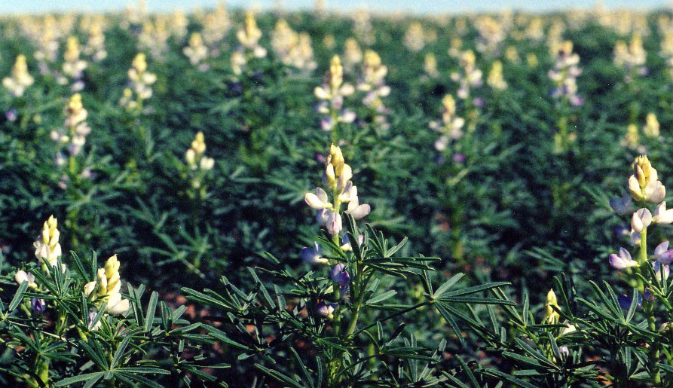
Image 1.2.3 Narrow-leafed lupin crop at flowering

Lupins are a legume that have become a critical component of a uniquely Western Australian farming system, the wheat: lupin rotation.
Follow the link Lupin in Western Australian farming and read the article.

Question
Given that WA soils are often deficient in essential nutrients, explain why and how you think WA primary producers are taking advantage of the symbiotic relationship between legumes such as the lupin and rhizobia bacteria.

Acknowledgements

References
Creative Educator (2021) ‘Infographics’ located at:
<https://creativeeducator.tech4learning.com/2013/lessons/Infographics> accessed 22 July 2021

Government of Western Australia, DPIRD (27 February 2017) ‘Inoculating pasture legumes’ available at: <https://www.agric.wa.gov.au/pasture-establishment/inoculating-pasture-legumes> accessed 17 June 2021
Government of Western Australia, DPIRD (26 September 2017) ‘Lupin in Western Australian farming’ available at: <https://www.agric.wa.gov.au/lupins/lupin-western-australian-farming> accessed 17 June 2021
Oxford English Dictionary (online) (2021) Powered by Lexico, available at:
<https://www.lexico.com/> accessed 17 June 2021

UMDHGIC (28 October 2020) ‘Legumes: Biological nitrogen fixation’ (video) YouTube available at:
<https://www.youtube.com/watch?v=X1W6PbiCeFg> accessed 17 June 2021

Images
Image 1.2.1 Government of Western Australia, ‘Sheep grazing wheat stubble’ © DPIRD 2021 available at: <https://www.agric.wa.gov.au/dry-seasons-and-drought/season-2021-%E2%80%93- information-western-australian-farmers> accessed 17 June 2021
Image 1.2.2 Government of Western Australia, ‘Legume pasture rhizobium nodules’ © DPIRD 2021 available at: <https://www.agric.wa.gov.au/pasture-establishment/inoculating-pasture- legumes> accessed 17 June 2021
Image 1.2.3 Government of Western Australia, ‘Narrow-leafed lupin crop at flowering’ © DPIRD 2021 available at: < https://www.agric.wa.gov.au/lupins/lupin-western-australian-farming> accessed 17 June 2021

Student worksheet 1.3

Student research topics - suggested links

Integrated Pest Management

What is Integrated Pest Management? – Farm Biosecurity Integrated Pest Management fact sheet – CRDC
Increasing pressure for Integrated Pest Management – DPIRD Integrated Pest Management Plan – DPAW

Biosecurity in WA

Biosecurity - DPIRD

Western Australian Biosecurity Strategy – DPIRD Biosecurity in Western Australia - WALGA Biosecurity officer – Jobs&SkillsWA

Control of invasive weeds (eg blackberry, Patterson’s curse)

Weeds - DPIRD

Weeds of national significance – DPIRD

Diseases management in WA forestry

Phytophthora dieback – DBCA

Project dieback

Disease management in WA fisheries Identifying pests and diseases – Fisheries Fish diseases – DPIRD

Maintaining soil health

How can we improve the health of our soil? Soil Health

Management of fire regimes in WA

Fire – DBCA

Indigenous fire methods - Video

Salinity management in WA

Managing dryland salinity in south-west Western Australia – DPIRD Managing salinity

Feral animal control in WA

Pest animals – DPIRD Feral animal control

Endangered species in WA

Threatened animals – DBCA

Some of Western Australia’s threatened animal species Threatened plants – DBCA
Threatened Australian species factsheets-DAWE

Acknowledgements

References
Integrated Pest Management

Farm biosecurity ‘ What is integrated pest management’ available at:
<https://www.farmbiosecurity.com.au/what-is-integrated-pest-management/> accessed 21 June 2021
Grain Research and Development Corporation (2009) ‘Integrated pest management – Fact sheet’ available at: <https://grdc.com.au/ data/assets/pdf_file/0031/225877/integrated-pest- management.pdf.pdf> accessed 21 June 2021
Government of Western Australia, DPIRD (8 March 2016) ‘Increasing pressure for integrated pest management’ available at: <https://www.agric.wa.gov.au/news/media-releases/increasing- pressure-integrated-pest-management> accessed 21 June 2021
Government of Western Australia, DPAW (July 2020) ‘Western Australian Herbarium Integrated Pest Management’ available at: <https://www.dpaw.wa.gov.au/images/documents/plants- animals/herbarium/PERTH Integrated Pest Management Plan.pdf> accessed 21 June 2021

Biosecurity in WA

Government of Western Australia, DPIRD ‘Biosecurity’ available at:
<https://www.agric.wa.gov.au/biosecurity-quarantine/biosecurity> accessed 21 June 2021

Government of Western Australia, DPIRD (21 March 2018) “Western Australian Biosecurity Strategy’ available at: <https://www.agric.wa.gov.au/biosecurity/western-australian-biosecurity- strategy> accessed 21 June 2021
Western Australian Agriculture Authority (2015) ‘Biosecurity in Western Australia’ available at:
<https://walga.asn.au/getattachment/Policy-Advice-and- Advocacy/Environment/Biosecurity/Biosecurity_Forum_Presentation_DAFWA_Feb2016.pdf.aspx?l ang=en-AU> accessed 21 June 2021
Government of Western Australia, Department of Training and Workforce Development (2021) ‘Biosecurity officer’ available at: <https://www.jobsandskills.wa.gov.au/jobs-and- careers/occupations/biosecurity-officer> accessed 21 June 2021

Control of invasive weeds (eg blackberry, Patterson’s curse)

Government of Western Australia, DPIRD ‘Weeds’ available at:
<https://www.agric.wa.gov.au/pests-weeds-diseases/weeds> accessed 21 June 2021

Government of Western Australia, DPIRD ‘Weeds of national significance’ available at:
<https://www.agric.wa.gov.au/pests-weeds-diseases/weeds/weeds-national-significance accessed 21 June 2021>

Diseases management in WA forestry

Government of Western Australia, Department of Biodiversity, Conservation and Attractions ‘Phytophthora dieback’ available at: https://www.dpaw.wa.gov.au/management/pests- diseases/phytophthora-dieback accessed 21 June 2021

South Coast NRM ‘Project dieback’ available at: https://dieback.net.au/ accessed 21 June 2021

Disease management in WA fisheries

Government of Western Australia, DPIRD ‘Identifying pests and diseases’ available at:
<http://www.fish.wa.gov.au/sustainability-and-environment/aquatic-biosecurity/identifying-pests- and-diseases/Pages/default.aspx> accessed 21 June 2021
Government of Western Australia, DPIRD (13 May 2015) ‘Fish diseases’ available at:
<https://www.agric.wa.gov.au/bam/fish-diseases> accessed 21 June 2021

Maintaining soil health

AgriWebb (2021) ‘How can we improve the health of our soil?’ available at:
<https://www.agriwebb.com/au/how-to-improve-soil-health/> accessed 21 June 2021

Abbott, L ‘Soil Health’ available at: <http://www.soilhealth.com/index.htm> accessed 21 June 2021

Management of fire regimes in WA

Government of Western Australia, Department of Biodiversity, Conservation and Attractions (2019) ‘Fire – researching fire behaviour and the impacts of bushfires in Western Australia’ available at:
<https://www.dbca.wa.gov.au/science/fire> accessed 21 June 2021

ABC Australia (3 November 2018) “Indigenous fire methods protect land before and after the Tathra fire’ (video) YouTube available at:
<https://www.youtube.com/watch?v=RM72NtXxyLs&t=20s> accessed 21 June 2021

Salinity management in WA

Government of Western Australia, DPIRD (11 May 2021) ‘Managing dryland salinity in south-west Western Australia’ available at: <https://www.agric.wa.gov.au/soil-salinity/managing-dryland- salinity-south-west-western-australia> accessed 21 June 2021
WA Landcare Network (2017) ‘Managing salinity’ available at:
<http://www.landcarewa.org.au/resources/hot-topics/managing-salinity/> accessed 21 June 2021

Feral animal control in WA

Government of Western Australia, DPIRD ‘Pest animals’ available at:
<https://www.agric.wa.gov.au/pests-weeds-diseases/pests/pest-animals> accessed 21 June 2021

Perth NRM (2 May 2017) ‘ Feral animal control’ available at:
<https://www.perthnrm.com/blog/2017/05/02/feral-animal-control/> accessed 21 June 2021

Endangered species in WA

Australian Government, Department of Agriculture, Water and Environment ‘Threatened species and ecological communities publications’ available at: < https://www.environment.gov.au/biodiversity/threatened/publications - threatenedbrochures > accessed 21 June 2021
Government of Western Australia, Department of Biodiversity, Conservation and Attractions ‘Threatened animals’ available at: <https://www.dpaw.wa.gov.au/plants-and-animals/threatened- species-and-communities/threatened-animals> accessed 21 June 2021
‘Some of Western Australia’s threatened animal species’ available at:
<https://www.fremantle.wa.gov.au/sites/default/files/Threatened Species of Western Australia.pdf> accessed 21 June 2021
Government of Western Australia, Department of Biodiversity, Conservation and Attractions ‘Threatened plants’ available at: https://www.dpaw.wa.gov.au/plants-and-animals/threatened- species-and-communities/threatened-plants accessed 21 June 2021

Student investigation 2.1

Give me space! How plant population density affects growth

Background
You have already learnt about how various biotic (living) factors are able to affect living things in any ecosystem. These include such factors as number of predators, disease causing organisms and the amount of competition for resources.

In agricultural ecosystems, particularly in Western Australia (WA) where soil conditions are not always ideal, it is often the competition that exists between members of the same species that may limit the productivity of the system. Because most plant species are rooted in the ground, they cannot move to a new environment if soil conditions decline. Unless the plant has adaptations that allow it to survive poor conditions like drought, lack of nutrients, or crowding, the plant may not be able to survive.

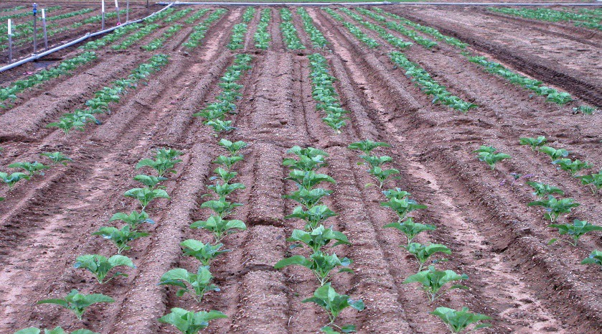
An example of where knowledge of the planting density of a crop is important is in the commercial growing of vegetables. Market gardeners, for example, must have access to up-to-date scientific data about the ideal planting density and configuration for their farms. This will depend on the soil type as well as the crop and variety grown. Plant scientists whose role is to research methods for increasing crop yields are

essential in providing this data.
Image 2.1.1 Trial cauliflower crop being grown in two and four rows per bed

Pre-lab questions – attempt these before conducting your investigation

- Define the following key terms:

Term | Definition
Biotic factor
Abiotic factor
Agricultural ecosystem
Planting density

- What mathematical units would be most appropriate to describe the planting density of a vegetable crop?

- Calculate the planting density of a tomato crop where a market gardener plants 300 000 evenly spaced tomato seedlings in a 10 hectare field (show your working).

Investigation
In this scientific investigation, your group can test the effects of the biotic factor of crowding (or
population density) on plant growth.

Materials and equipment:
- Group investigation framework (optional)
- Six plastic containers suitable for growing seedlings
- Potting soil
- Vegetable (or fruit such as tomato, capsicum) seedlings
- Metric ruler
- Metric digital scale
- Marker and labels for labelling pots
- Distilled water (for watering seedlings)

Procedure:
- In this investigation, it is important that you design your own scientific procedure to test a research question or hypothesis about the effects of population density on plant growth that your group has formulated.
- Make sure that you have considered all the factors that you have previously learnt about to ensure your investigation produces accurate, valid and reliable data. One way is to follow through the set of steps that are on the Group investigation framework. It is designed to ensure that you cover all aspects of correct investigation procedure. Your teacher may decide however that you no longer need this level of scaffolding.
- You will probably need to record the progress of your seedlings at least twice a week for the next four weeks. Some suggestions on what type of measurements of plant progress to record are:
  - the date on which the seedlings were planted
  - the number of seedlings in each pot
  - the locations of each seedling in each pot
  - the overall health of each plant
  - the height of each plant in mm
  - the number of leaves on each plant
  - the final root length of each plant
  - the final biomass of each plant
  - the total biomass of each pot

Further investigation
Many other related questions arise which you may like to investigate either by experiment or research. These include:
- Are there plants (like grasses) that are not affected by crowding?
- What happens to the soil as planting density is increased?
- How does plant density affect productivity in different soil types (eg sand v clay)?
- Are plants more susceptible to disease or pests if planting density is increased?

Career exploration
If you enjoyed doing this investigation, you may enjoy exploring these related careers: Agricultural scientist
Agricultural technical officer Botanist
Plant scientist

Acknowledgements

Resources
Government of Western Australia, DPIRD (19 October 2016) ‘Planting configuration and densities for cauliflower and broccoli’ available at: <https://www.agric.wa.gov.au/broccoli/planting- configurations-and-densities-cauliflower-and-broccoli> accessed 16 June 2021
Government of Western Australia, Department of Training and Workforce Development, available at: <https://www.jobsandskills.wa.gov.au/> accessed 16 June 2021
Science Buddies ‘Plant scientist’ available at: <https://www.sciencebuddies.org/science- engineering-careers/life-sciences/plant-scientist> accessed 16 June 2021

Images
Image 2.1.1 Government of Western Australia, DPIRD, (19 October 2016) ‘Trial cauliflower crop being grown in two and four rows per bed’ available at:
<https://www.agric.wa.gov.au/broccoli/planting-configurations-and-densities-cauliflower-and- broccoli> accessed 16 June 2021

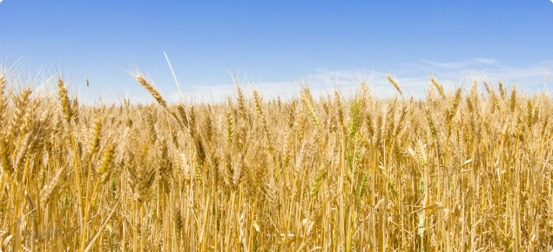
Student investigation 2.2 Factors affecting photosynthesis Background
All of the food we eat is dependent either directly or indirectly on green plants converting sunlight energy into sugars such as glucose. This process is called photosynthesis and occurs in cells within the leaves of green plants. For example, the growing of all major cereal crops (eg wheat), fruit and vegetables by Western Australian primary producers relies on photosynthesis. Various abiotic factors such as sunlight, water, gases

Image 2.2.1: Western Australian wheat crop

and temperature influence the rate at which photosynthesis can occur and thus the efficiency and economy of food production. Even the meat we eat depends indirectly on photosynthesis to produce the grasses and grain that herbivores such as cattle, sheep and chickens consume.
Photosynthesis occurs within the chloroplasts in green plant leaves. It uses sunlight, carbon dioxide and water to make glucose and oxygen. Since photosynthesis needs sunlight, it only happens during the day with the glucose plants produce being used in cellular respiration.
Although photosynthesis is quite complex and occurs in multiple stages, the overall process of photosynthesis can be summarised by a relatively simple word and chemical equation:
6CO2
6H2O
Carbon dioxide
Water
C6H12O6
6O2
Glucose
Oxygen

The leaves of plants consist of layers of cells. One layer is the spongy mesophyll which normally contains oxygen and carbon dioxide. Leaves (or disks cut from leaves) will float in water because of these gases and if you draw the gases out from the spaces, then the leaves will sink because they become denser than water. If this leaf disk is placed in a solution with a source of carbon dioxide (such as sodium bicarbonate), then photosynthesis can occur in a sunken leaf disk. As photosynthesis proceeds, oxygen accumulates in the air spaces of the spongy mesophyll causing the discs to become buoyant and float. The floating and sinking of the leaf discs can be used to observe and measure photosynthesis occurring.

Pre-lab questions – attempt these before conducting your investigation

- Define the following key terms:

Term | Definition
Photosynthesis
Chloroplast
Cellular respiration
Abiotic factor

- Construct a simple food chain demonstrating how living things (such as humans) are ultimately dependent on the sun for food (and energy).

- When conducting any scientific investigation, what factors need to be considered for it to be considered valid and reliable?

Investigation
In this scientific investigation your group of students will test the effects of various abiotic factors on the process of photosynthesis.

Materials and equipment:
- Group investigation framework (optional)
- 0.2% sodium bicarbonate (baking soda) solution
- Liquid detergent
- Plastic syringe (10 mL or larger)
- Leaf material (eg baby spinach)
- Hole punch
- Plastic cups
- Timer
- Light source
- Other materials as needed

Method for treating leaf discs:
Useful videos on the preparation of leaf discs for an investigation on photosynthesis are:

Floating Leaf Discs Lab (Photosynthesis)
Bozeman Science -Photosynthesis Lab Walkthrough

- Prepare 300mL of the 0.2% bicarbonate solution for each trial and add one drop of liquid detergent
- Using a hole punch, cut 10 or more uniform leaf discs out of spinach leaves for each trial. Avoid the major leaf veins for the best results.
- Infiltrate the leaf discs with sodium bicarbonate solution. Remove the piston or plunger from the plastic syringe and place the leaf discs into the syringe barrel. Replace the plunger being careful not to crush the leaf discs. Push on the plunger until only a small volume of air and leaf disc remains in the barrel
- Draw a small volume of sodium bicarbonate solution into the syringe. Tap the syringe to suspend the leaf discs in the solution. Holding a finger over the syringe-opening, draw back on the plunger to create a vacuum. Hold this vacuum for about 10 seconds. While holding the vacuum, swirl the leaf disks to suspend them in the solution. Let off the vacuum. The bicarbonate solution will infiltrate the air spaces in the leaf causing the disks to sink. You will probably have to repeat this procedure 2-3 times in order to get the disks to sink. If you have difficulty getting your disks to sink after about 3 evacuations, it is usually because there is not enough soap in the solution. Add a few more drops of soap to your bicarbonate solution
- Pour the discs and solution into a clear plastic cup. Add bicarbonate solution to a depth of 10 cm
- Place under the light source and start the timer. At the end of each minute, record observations and the number of floating discs. Continue for 20 minutes.

Investigation procedure:
- In this investigation, it is important that you design your own scientific procedure to test a research question or hypothesis about the effects various abiotic factors on photosynthesis that your group has formulated.
- Make sure that you have considered all the factors that you have previously learnt about to ensure your investigation produces accurate, valid and reliable data. An easy way of doing this is to follow through the set of steps that are on the Group investigation framework. These questions have been designed to ensure that you cover all aspects of correct investigation procedure. Your teacher may decide, however, that you no longer need this level of scaffolding to carry out the investigation.
- You may be asked by your teacher to communicate the findings of your scientific investigation in the form of a science report; a PowerPoint presentation; a poster; a leaflet; or a short video.

Further investigation
Many other related questions arise which you may like to investigate either by experiment or research. These include:
- Do different types of plants photosynthesise at different rates?
- What happens to the rate of photosynthesis if the concentration of carbon dioxide is increased?
- Does the colour of light falling on a leaf have any effect on the rate of photosynthesis?

Career exploration
If you enjoyed doing this investigation you may enjoy exploring these related careers: Plant scientist
Agricultural technician

Acknowledgements

Resources
This experiment was originally described in Steucek, Guy L., Robert J. Hill, and Class/Summer 1982. 1985. “Photosynthesis I: An Assay Utilizing Leaf Disks.” The American Biology Teacher, 47(2): 96–99.
Instructions for the treatment of leaf discs were adapted from Williamson, B, “The floating leaf disk assay for investigating photosynthesis.” Exploring life community available at:
<https://www.coursehero.com/file/28876313/Floating-Leaf-Disk-Brad-Williamsonpdf/>

Buss, J (5 October 2018) video ‘Floating Leaf Discs Lab (Photosynthesis)’ available at: < https://www.youtube.com/watch?app=desktop&v=4NM7kGKDk2A > accessed 15 July 2021
Bozeman Science (31 October 2011) ‘Photosynthesis Lab Walkthrough’ available at: < https://www.youtube.com/watch?app%20=desktop&v=ZnY9_wMZZWI> accessed 15 July 2021

Images
Image 2.2.1 © Government of Western Australia, DPIRD available at:
<https://www.agric.wa.gov.au/>

Student investigation 2.3

Effects of arbuscular mycorrhiza inoculum on plant growth

Background
A biotic factor which has been shown to have significant positive effects on plant growth is the symbiotic relationship between soil fungi called arbuscular mycorrhiza (AM) fungi and many common crop plants. In agricultural ecosystems, AM fungi are most important because they are capable of colonising the majority of crop plants. Known as obligate symbionts, AM fungi must associate with plant roots to survive. It is this association that begins a mutually beneficial relationship between the fungi and the plant. In return for sugars from a plant, the long thread-like structures of fungi (the hyphae) act as an extension of a plant’s root system and increase a plant’s access to soil nutrients such as phosphorus (P), zinc (Zn) and copper (Cu).
Inoculation of plants (the introduction of a microorganism into the plant) with AM fungi allows farmers to take advantage of the benefits of mycorrhizae. The AM fungi spores, pieces of colonised crop roots, and AM fungi hyphae can be used as inoculum (cells used in an inoculation) to infect other plants with AM fungi. Using inoculum may be beneficial to restoring a severely degraded soil microbial community.
Inoculum can be used to produce pre-colonised seeds and seedlings that can take advantage of mycorrhizae’s benefits from their first day in the field. Image 2.3.1 illustrates the various benefits to crops of inoculating with AM fungi.

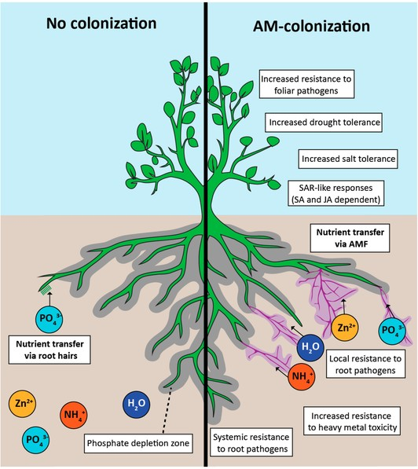

Image 2.3.1 Positive effects of arbuscular mycorrhizal (AM) colonisation

To learn more about the benefits of AM fungi on crop plants, follow the links:

Fact sheet – Arbuscular mycorrhizas – South Australia and Using Mycorrhizae in your garden – with instructional video

Pre-lab questions – attempt these before conducting your investigation

- Define the following key terms:

Term | Definition
Biotic factor
Symbiosis
Agricultural ecosystem

- Describe and provide examples of the major types of symbiotic relationships that occur in nature:

Symbiotic relationship | Description of relationship | Examples of relationship
Mutualism
Commensalism
Parasitism

Investigation
In this scientific investigation, your group of students can test the effects of using seed inoculated with AM fungi on plant growth.

Materials and equipment:
- Group investigation framework (optional)
- Six plastic containers suitable for growing seedlings from seed
- Potting soil
- Inoculated seeds
- Uninoculated seeds
- Metric ruler
- Metric digital scale
- Marker and labels for labelling pots
- Distilled water (for watering seedlings)

Procedure:
- In this investigation, it is important that you design your own scientific procedure to test a research question or hypothesis about the effects of using seed inoculated with AM fungi on plant growth that your group has formulated.
- Make sure that you have considered all the factors that you have previously learnt about how to ensure your investigation produces accurate, valid and reliable data. One way is to follow through the set of steps that are on the Group investigation framework. It is designed to ensure that you cover all aspects of correct investigation procedure. Your teacher may decide, however, that you no longer need this level of scaffolding.
- You will probably need to record the progress of your seedlings at least twice a week for the next four weeks. Some suggestions on what type of measurements of plant progress to record are:
  - the date on which the seedlings were planted
  - the number of seedlings in each pot
  - the locations of each seedling in each pot
  - the overall health of each plant
  - the height of each plant in mm
  - the number of leaves on each plant
  - the final root length of each plant
  - the final biomass of each plant
  - the total biomass of each pot

Further investigation
Many other related questions arise which you may like to investigate either by experiment or research. These include:
- Do different types of seeds require different inoculants?
- What happens to AM inoculated seeds if a fungicide is used?

Career exploration
If you enjoyed doing this investigation you may enjoy exploring these related careers: Agricultural scientist
Agricultural technical officer Botanist
Plant scientist

Acknowledgements

Resources

Government of Western Australia, DPIRD available at: <https://www.agric.wa.gov.au/> accessed 16 June 2021
Government of Western Australia, Department of Training and Workforce Development, available at: <https://www.jobsandskills.wa.gov.au/> accessed 16 June 2021
Mushroom Mountain (6 May 2020) ‘Using Mycorrhiza in your garden – with instructional video’ located at: <https://mushroommountain.com/using-mycorrhizae-in-your-garden-with-instructional- video/> accessed 22 July 2021
SoilQuality.org (2021) ‘Fact sheet: Arbuscular mycorrhizas – South Australia’ available at:
<http://soilquality.org.au/factsheets/arbuscular-mycorrhizas-s-a> accessed 16 June 2021

Images
Image 2.1.1 ‘Positive effects of arbuscular mycorrhizal (AM) colonization’ Catherine N. Jacott, Jeremy D. Murray and Christopher J. Ridout CC BY-SA 4.0 available at:
<https://commons.wikimedia.org/wiki/File:Positive_effects_of_arbuscular_mycorrhizal_(AM)_coloni zation.png> accessed 16 June 2021

Student investigation 2.4

I’m on fire! Investigating Western Australian plant adaptations to fire

Background
Bushfires in Western Australia (WA) seem to be increasingly common, possibly partly due to a changing, drying climate. They can be very damaging to both natural and agricultural ecosystems.
Forestry is one of our key primary industries that is particularly impacted by the increased frequency of fires. Bushfires can have a major effect on the productivity of our forests. For example, in January 2014 bushfires in the heavily forested Perth Hills burnt a total of 650 hectares of land and caused $15 million in damages.
Fire plays a big role in WA ecosystems and has been used by Aboriginal people for thousands of years. European settlement has affected natural fire behaviour, which in turn has changed native ecosystems. Environmental research scientists in Kings Park are assessing the impacts of varying fire and weed management approaches on plant diversity, weed cover and fuel loads in the urban Banksia Woodland.
An understanding of the adaptations of Western Australian native plants is vital for the management of forest bushland. Many of our natural ecosystems are in fact dependent on fire to maintain their productivity and sustainability. Many Western Australian plant species have adaptations to survive in this fire prone environment. Some examples include using the heat of fires to release their seeds, germination stimulated by smoke, regrowth of trees from epicormic buds and lignotubers.
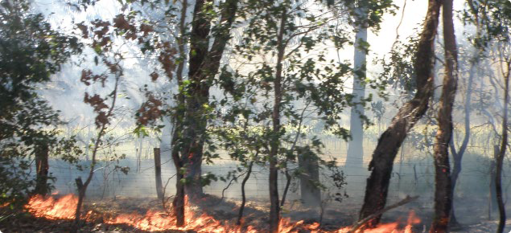
Watch the following video Adaptations: Fire ecology and meet Russell Miller, an environmental research scientist with Kings Park. His research is focused on understanding how plants in Perth's Banksia Woodland respond to fire. This knowledge will help improve the management of both our environment and a key primary

industry – forestry.
Image 2.4.1 Leaf litter burn near vineyard

For more information on the effects of climate change on the frequency of wild-fires and their impacts in WA and Australia, follow the links:
The heat is on: Climate change, extreme heat and bushfires in Western Australia Impacts of bush fires
Effects of bushfires and COVID-19 on the forestry and wood processing sectors

Pre-lab questions – attempt these before conducting your investigation

- Define the following key terms:

Term | Definition
Primary industry
Adaptation
Climate change
Environmental research scientist

- Describe some of the adaptations that Western Australian native plants have for survival in our fire prone environment

Investigation
Your group task is to design a scientific investigation looking at adaptations of Western Australian plants to fire and to try to discover the mechanisms that particular plants use in order to survive fire. The primary focus of your investigation needs to be on the seeds of Western Australian plants. Once you have carried out your investigation on seeds, you can then expand your investigation to look at other ways the plants are adapted to fire. Useful information on the use of smoke to stimulate seed germination of Australian plants can be found at Government of Western Australia, Botanic Gardens and Parks Authority: Smoke to sow and grow

Materials and equipment:
- Group investigation framework (optional)
- Six plastic containers suitable for growing seeds
- Potting soil suitable for native seeds
- Western Australian native seeds (eg Acacia, Eucalyptus …)
- Marker and labels for labelling pots
- Distilled water (for watering seedlings)
- Boiling water (to simulate intense heat of a fire)
- Smoke water (to simulate bushfire smoke)

Procedure:
- In this investigation, it is important that you design your own scientific procedure to test a research question or hypothesis about the effects of fire on Western Australian native seed germination that your group has formulated.
- Make sure that you have considered all the factors that you have previously learnt about to ensure your investigation produces accurate, valid and reliable data. An easy way of doing this is to follow through the set of steps that are on the Group investigation framework. These questions have been designed to ensure that you cover all aspects of correct investigation procedure. Your teacher may decide, however, that you no longer need this level of scaffolding to carry out the investigation.
- You will probably need to record the progress of your seeds at least twice a week for the next four weeks. Some suggestions on what measurements of progress to record are:
  - the date on which the seeds were planted
  - the number and type of seeds planted
  - the treatment regime of each pot of seeds
  - the time to germinate your seeds
  - the numbers and percentage of seeds that germinated

Further investigation
- Read the article on Aboriginal and Torres Strait Islander fire management practices Kimberley Land Council – Indigenous fire management
Related questions to investigate could include:
  - How is traditional knowledge and techniques, together with modern science and technology, used to reduce the likelihood of large uncontrolled wildfires?

- Eucalypts are an Australian tree well adapted to fire. Read the article Eucalypts and Fire: Related questions to investigate either could include:
  - How is regrowth of trees from epicormic buds and lignotubers an adaptation to fire?
  - Eucalypts have seed capsules that open up when burned. How is this an advantage?
  - How could leaf and bark shedding be a fire adaptation?

Career exploration
If you enjoyed doing this investigation, you may enjoy exploring these related careers: Environmental research scientist
Park ranger

Career and volunteer firefighter
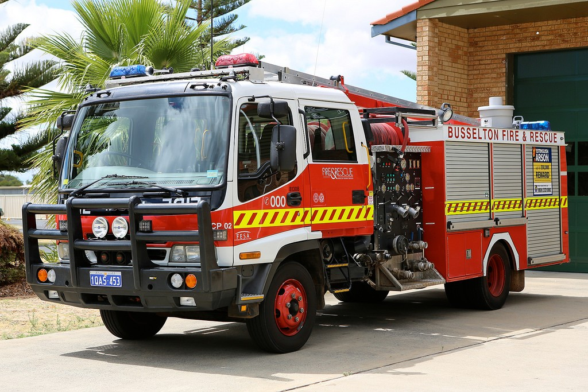
Image 2.4.2 Busselton country pumper

Acknowledgements

References
Australian Government, Department of Agriculture, Water and the Environment (13 January 2021) ‘Effects of bushfires and COVID-19 on the forestry and wood processing sectors’ available at:
<https://www.agriculture.gov.au/abares/products/insights/effects-of-bushfires-and-covid19-forestry- wood-processing-sectors> accessed 21 July 2021
Bushfire Front (2021) ‘Impacts of bushfires’ available at
<https://www.bushfirefront.org.au/home/fire-facts/impacts-of-bushfires/> accessed 14 July 2021

Climate Council (2015) ‘The heat is on: climate change, extreme heat and bushfires in Western Australia’ available at:
<https://www.climatecouncil.org.au/uploads/7be174fe8c32ee1f3632d44e2cef501a.pdf> accessed 24 June 2021
Government of Western Australia, DPIRD available at: <https://www.agric.wa.gov.au/> accessed 24 June 2021
Government of Western Australia, DTWD, available at: <https://www.jobsandskills.wa.gov.au/> accessed 24 June 2021

Government of Western Australia, DFES ‘Careers and volunteering’ available at:
<https://www.dfes.wa.gov.au/careers/> accessed 14 July 2021

Government of Western Australia, Kings Park and Botanic Gardens, available at:
<https://www.bgpa.wa.gov.au/kings-park/events/kings-park-education/teacher-resources/primary- school-bites/2780-kped-srl-primary- adaptations#:~:text=Many%20Western%20Australian%20plant%20species,from%20epicormic%20 buds%20and%20lignotubers> accessed 24 June 2021

Kimberly Land Council (2021) ‘Indigenous fire management’ available at:
<https://www.klc.org.au/indigenous-fire-management> accessed 24 June 2021

Kings Park and Botanic Gardens (9 Jun 2020) video ‘Adaptations: Fire ecology’ available at YouTube <https://www.youtube.com/watch?v=W1WMYn_V-mE> accessed 14 July 2021

National Forest Learning Centre (2013) ‘Eucalypts and fire’ available at: <http://www.forest- education.com/wp-content/uploads/2017/07/eucalypt_adaptations.pdf> accessed 14 July 2021

Images
Image 2.4.1: Government of Western Australia, DPIRD (©2021 DPIRD) ‘Wine grape effect reduction: Smoke Taint Risk calculator (STAR)’ available at:
<https://www.agric.wa.gov.au/fire/wine-grape-smoke-effect-reduction-smoke-taint-risk-calculator- star> accessed 14 July 2021
Image 2.4.2: Mathew WA (28 February 2014) ‘DFES – Busselton Country Pumper’ CC BY-SA 3.0 available at: <https://commons.wikimedia.org/wiki/File:DFES_-_Busselton_Country_Pumper.jpg> accessed 14 July 2021

Student worksheet 2.5

Group investigation framework

Part 1: Questioning and predicting
What research question or problem is your group planning to investigate?

What does your group already know about this topic from personal experience and what you have studied?

Predict what do you think will be the outcome of your investigation. Justify why you think this will be so.

Part 2: Planning and conducting
What variables may affect what your group is investigating? (Have you considered both biotic
and abiotic factors?)

What is the independent variable in this investigation? (The factor that you are going to make different).

What is the dependent variable in this investigation? (The factor you are looking for as your result). How will you accurately measure the dependent variable?

What variables in your investigation need to be controlled to make it a fair test?

What equipment will your group need to carry out your investigation?

Describe in a set of steps what your group will be doing at each stage of your investigation. Include a labelled diagram to illustrate your set-up.

What special safety precautions does your group need to follow during your investigation? Why are these safety precautions important?

Part 3: Processing and analysing data and information
What data did your investigation produce? Describe your observations and record your results. If possible, organise your data for the different factors you tested into the form of a table.

Is it possible to represent your data in the form of a graph? If so, what type of graph would best suit this type of data? Construct your graph on a separate piece of graph paper and paste it in this box.

What are the relationships, patterns or trends in your group’s data?

What do the results of your group investigation tell you about the research question or
problem you were investigating? Try to use some science ideas to explain your results.

Did your results match your group predictions? Explain.

Part 4: Evaluating
Identify any sources of error that could lead to your results being less accurate.

Does your group have confidence in the quality of the data it has produced? (Are you confident your data is valid and reliable?)

What changes would your group put in place if it were to repeat this investigation or carry out further investigations?

Part 5: Communicating

Discuss with your group members the best way of communicating the findings of your investigation to the other members of your class. Some suggestions you might like to consider are a science report, a PowerPoint presentation, a poster, a leaflet or a short video. Use the space below to plan.

Student worksheet 3.1

Energy flow in agricultural ecosystems

Background
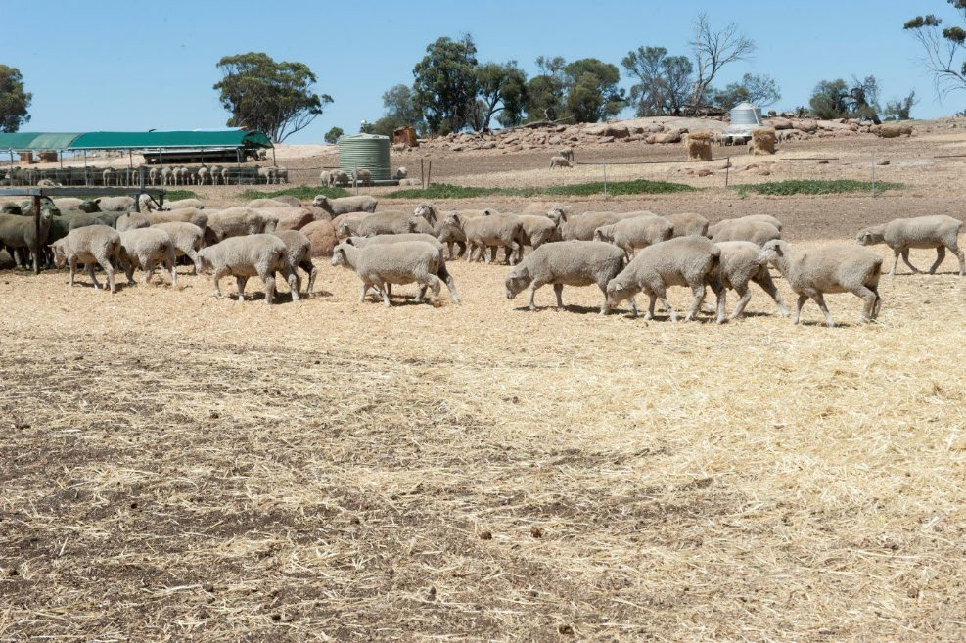
Matter and energy move into natural ecosystems via the pathways of food chains and food webs. Matter (such as carbon, water and nitrogen compounds) essential for life must be constantly recycled by decomposer organisms for the system to remain sustainable. Energy on the other hand is continually lost from food chains as waste, so there must be a continuous input.
In agricultural ecosystems, matter and energy are

continually being removed from the system as farm produce (eg
Image 3.1.1 Sheep eating hay in the dry

meat, eggs, grain, straw). Matter (eg fertilisers) and energy (eg fuel, electricity) need to be constantly inputted into agricultural ecosystems. The amount of recycling is also reduced compared with natural ecosystems.
Energy is a critical input and significant cost in agricultural production. Reducing input costs and achieving greater energy use efficiency can play an important role in improving farm profitability. Energy savings can be made through improved management practices, recovery of energy from agricultural waste and adoption of renewable energy.

Activity 1: Energy use in a piggery

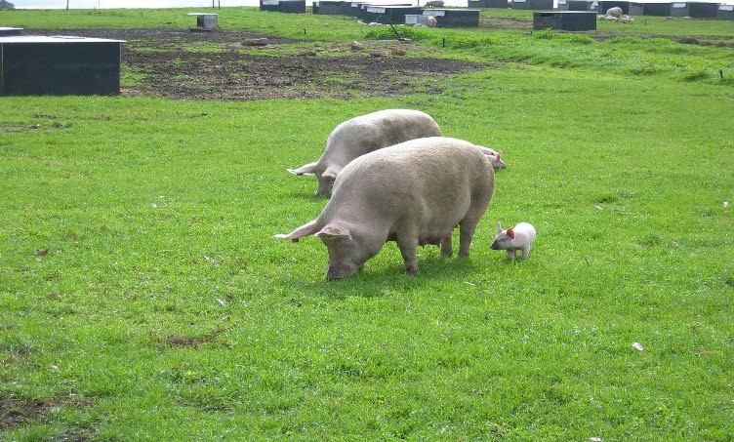
Image 3.1.2 Outdoor pork production
The Western Australian pork industry comprises 12% of the national pig herd worth approximately
$130 million and employs some 1,500 people along the supply chain. The majority of product is used as fresh pork for the domestic market with 20% exported to Singapore. The industry capitalises on the strong availability of feed grains (barley, wheat and lupins) in WA, and while the majority of pigs are housed indoors, there is a growing proportion reared outdoors.

Energy (in the form of electricity, liquid and gas fuels, feed supply) is a significant cost for WA pork producers. The cost of pork production (and therefore the cost of pork products to the consumer) vary depending on the different methods used to produce the pork.
There are three main types of pig farming methods used in Australia—indoor housing, deep litter housing and outdoor bred/free range systems. Generally, studies have shown that electricity use is the single largest energy type used in pork production.
Follow the link Production cycle – Aussie Pig Farmers and read about the pig production cycle, different farming systems and housing of pigs. Watch the two videos Story of Pork: Breeding and Story of Pork: Growing on this site.
Describe some of practices Australian pork producers are doing to:

- increase the overall efficiency of energy use in their piggeries

- produce pork ethically and humanely

- produce pork sustainability

Table 1: The total energy use at four different Australian piggeries (adapted from Australian Pork (December 2014) ‘Fact sheet – piggery total energy usage’)

Energy units kWh/day | Piggery A | Piggery B | Piggery C | Piggery D
Production system | F2F | F2F | F2F | Breeder
Farrowing shed | 150 | 1325 | 123 | 753
Bore pump | 39
Finishing shed | 36 | 1483 | 10
Feed mill |  |  | 45
Stall sheds |  |  |  | 27
Workshop | 145 |  | 9 | 121
Total site | 371 | 2809 | 187 | 900
(Note: F2F means farrow to finishing)

In the space below, create a graph of the energy usage across piggeries A, B, C and D.

The data in the table highlight the heavy use of energy in one component across all four of the piggeries.

Identify this component and suggest a hypothesis why this component would have such high energy use.

Suggest some possible ways that energy use in the piggeries might be made more efficient and sustainable.

Activity 2: Piggeries and greenhouse gas emissions
Agriculture is responsible for 14% of Australia's greenhouse gas emissions (GHG) and is the dominant source of Australia’s emissions of methane (CH4), nitrous oxide (N2O), and ammonia (NH3). The wastes produced by pigs in a piggery are a significant source of these GHG emissions, released by the action of various anaerobic microbes from the pig’s dung as it decays in effluent (sewage) pond systems on farms.
Since the 1990s, alternative systems of have been devised, which treat pig waste before it leaves the pen. Deep-litter systems use a pig pen with a ‘deep pit’ area filled with bedding material to absorb pig manure. The waste is treated with the waste-litter mix remaining in the pen before being used as a compost/fertiliser.
A scientific study in 2016 measured methane, nitrous oxide and ammonia from a deep-litter piggery in New South Wales to compare GHG emissions from housing pigs on deep litter with those of pigs from conventional housing with uncovered effluent treatment ponds. Table 2 shows some of the results.

Table 2: Greenhouse gas emissions from different waste treatment methods in a piggery. Note: Units used are expressed in ‘animal units’ where 1 AU = 500 kg live weight.
 | Nitrogen dioxide emissions (g/AU/day) |  | Ammonia emissions (g/AU/day) |  | Methane emissions (g/AU/day)
Waste treatment method | Winter | Summer | Winter | Summer | Winter | Summer
Deep litter sheds | 0.10 | 8.40 | 39.10 | 52.20 | 16.10 | 21.60
Uncovered anaerobic effluent treatment ponds | 0.15 | 12.70 | 59.20 | 79.09 | 24.39 | 32.73

In the space below, create a graph comparing the greenhouse gas emissions for the two different waste treatment methods.

The unit used in this study to measure greenhouse gas emissions was g/AU/day. What information do you think this unit is actually presenting?

What conclusion can you make on the effectiveness of using deep litter sheds compared with uncovered anaerobic treatment ponds? Use data from the table to justify your conclusion.

Propose a hypothesis to account for the observation that GHG emissions are greater in the summer compared with winter.

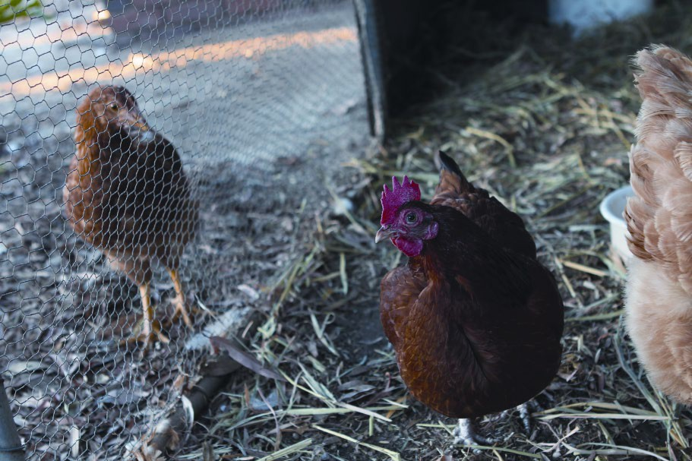
Activity 3: Energy use in a chicken farm

A chicken farm can be described as a closed system – the inputs and outputs are carefully managed.
The closed system of a chicken meat farm can be thought of as a simple system that models the interactions, flow of energy and the cycling of matter through a natural ecosystem.

Image 3.1.3 Backyard chickens

To discover how this is so follow the link: Chicken farming in the living world and watch the video Chicken farming in the real world. Take notes of the key ideas in the video – be sure to use the important scientific language (such as biotic, abiotic)

Questions:

- It is possible to think of a meat chicken rearing farm as a simple ecosystem. What are the:

  - inputs to the ecosystem?

  - outputs from the ecosystem?

- Describe the environment of the meat chicken rearing farm.

- Chicken meat farming relies on the changing and control of biotic and abiotic features of its system. What are the:

  - abiotic features that require changing and controlling?

  - biotic features that require changing and controlling?

- Ultimately chicken produced from an efficient meat farm has the lowest environmental footprint of any meat.

  - What is an environmental footprint?

  - How does this low environmental footprint come about?

- Describe what you think are the key factors involved in keeping a chicken meat farm sustainable and environmentally friendly.

Activity 4: Career exploration
If you have enjoyed learning about energy flow in agricultural ecosystems (such as a piggery), then you may wish to know more about the work that two important specialists do:
Veterinarians and animal (pig) nutritionists

Acknowledgements

References
Australian Chicken Meat Federation (nd) ‘Chicken farming in the living world Stage 5’ available at:
<https://www.chicken.org.au/resources/ACMF-chicken-farming-in-the-living-world-stage-5/> accessed 22 June 2021
Australian Pork (2021) ‘Production cycle – Aussie Pig farmers’ available at:
<https://aussiepigfarmers.com.au/pigs/our-animals/reproduction/> accessed 22 June 2021

Australian Pork (December 2014) ‘Fact sheet – piggery total energy usage’ available at:
<https://doczz.net/doc/8005635/australian-pork-fact-sheet--improvements-to-energy-effici... > accessed 22 June 2021
Government of Western Australia, DPIRD ‘Pigs’ © DPIRD 2021 available at:
<https://www.agric.wa.gov.au/livestock-animals/livestock-species/pigs> accessed 22 June 2021

Phillips F. A., Wiedemann S. G., Naylor T. A., McGahan E. J., Warren B. R., Murphy C. M., Parkes S., Wilson J. (2016) Methane, nitrous oxide and ammonia emissions from pigs housed on litter and from stockpiling of spent litter. Animal Production Science 56, 1390-1403. CSIRO publishing available at: <https://www.publish.csiro.au/an/an15650> accessed 19 July 2021

Images
Image 3.1.1 Government of Western Australia, ‘Sheep eating hay in the dry’ © DPIRD 2021 available at: <https://www.agric.wa.gov.au/management-reproduction/sheep-management-
%E2%80%93-making-good-decisions-summer-and-autumn-western-australia> accessed 22 June 2021
Image 3.1.2 Government of Western Australia, ‘Outdoor pork production’ © DPIRD 2021 available at: <https://www.agric.wa.gov.au/feeding-nutrition/salt-poisoning-or-water-deprivation-pigs> accessed 22 June 2021
Image 3.1.3 Government of Western Australia, ‘Backyard chickens’ © DPIRD 2021 available at:
<https://www.agric.wa.gov.au/livestock-biosecurity/poultry-biosecurity-checklist-small-landholders> accessed 22 June 202

Student worksheet 3.2 Marine food webs in WA Background
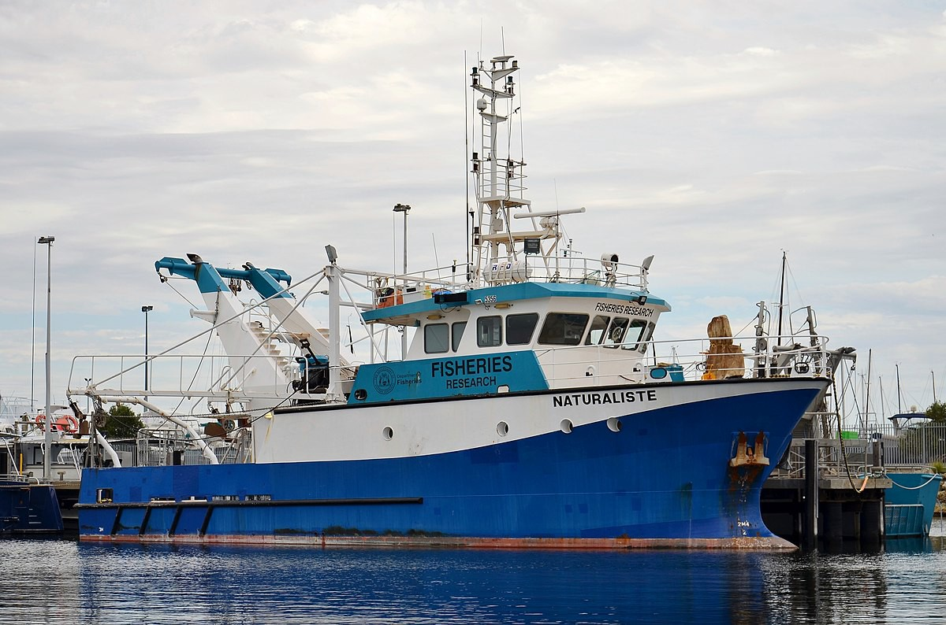
Along its extensive coastline,
Western Australia’s (WA’s) wild-catch seafood industry targets species such as prawns, squid, lobster, fish, oysters and crabs. Worth over
$500 million annually to the State economy, the industry provides employment to thousands of Western Australians.
In order to sustainably manage this wild-catch industry, the Department of Primary Industries and Regional Development (DPIRD) have developed a process to determine how fish resources

Image 3.2.1 Fisheries research vessel Naturaliste berthed in Fremantle Fishing Boat Harbour, Western Australia

can be best shared between commercial, recreational and customary fishers and aquaculture. This process involves extensive research understanding the biology of the different marine species and how they interact in the various marine food webs that occur along our coast. This knowledge helps ensure that WA’s fisheries continue to be managed sustainably for the future. In the next activity, you can learn more about WA’s marine food webs and the biology of one of the most highly prized species - the pink snapper.

Activity 1: WA marine food webs
Follow the links below to visit at least one of the following WA marine food webs from the Marine Waters resources and answer the questions which follow:
Cocos Islands Food Web Christmas Island Food Web South Coast Food Web Questions
- Every food web requires producer organisms (autotrophs) to carry out the process of photosynthesis and thus provide the initial source of energy. What are the producer organisms in your chosen food web?

- Identify at least three food chains beginning with the producer organism from your food web:

Food chain 1:

Food chain 2:

Food chain 3:

- Which organisms would you expect to have the greatest biomass in your food web? Explain why.

- Identify the apex predators in your food web. How would you expect their total biomass to compare with the other levels of the food web?

- The Australian pilchards in the South Coast food web and the baitfish in the Cocos Islands and Christmas Islands food webs are essential food for many higher-level predators. Predict what would happen to the trophic levels above and below if the numbers of these pilchards or baitfish were reduced by overfishing or disease.

- Examine slide 10 from PowerPoint 3.0, which shows a food pyramid. Construct a food pyramid for one of the food chains from your marine food web. Be sure to show where energy is lost at each trophic level.

Activity 2: Let’s examine a species in more detail – pink snapper
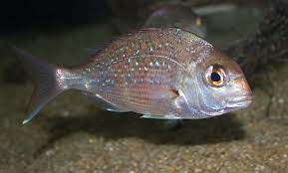
Image 3.2.2 Juvenile pink snapper

Follow the link Fisheries fact sheet – pink snapper and read the information on the pink snapper. In the space below, describe how an extensive knowledge of the biology of an important species like the pink snapper is essential if the species is to be fished sustainably as well as the ecosystem remaining in balance.

Activity 3: Extension - careers in fisheries
If you have enjoyed these activities on marine food webs in WA, you may like to discover more about careers in the fisheries management:
Careers in fisheries

Acknowledgements

References
Government of Western Australia, DPIRD, ‘Fisheries fact sheet – pink snapper’ [PDF 593 KB] available at:
<https://www.fish.wa.gov.au/Documents/recreational_fishing/fact_sheets/fact_sheet_pink_snapper
.pdf> accessed 28 June 2021

Government of Western Australia, DPIRD, ‘Careers’ available at:
<https://www.fish.wa.gov.au/About-Us/Careers/Pages/default.aspx> accessed 28 June 2021

Government of Western Australia, DPIRD, ‘Marine Waters learning resources – explore Western Australia’s amazing marine environment’ available at: <https://marinewaters.fish.wa.gov.au/> accessed 28 June 2021

Images
Image 3.2.1 ‘Naturaliste, Fremantle, 2017’ Bahnfrend CC BY-SA 4.0 available at:
<https://commons.wikimedia.org/wiki/File:Naturaliste,_Fremantle,_2017_(01).jpg> accessed 28
June 2021

Image 3.2.2 ‘Snapper (juvenile) Pagrus auratus’ (14 August 2020) Brian Gratwicke CC BY 2.0 available at: <https://www.flickr.com/photos/briangratwicke/4891702979> accessed 28 June 2021

Student worksheet 3.3 Aquaculture in WA Background
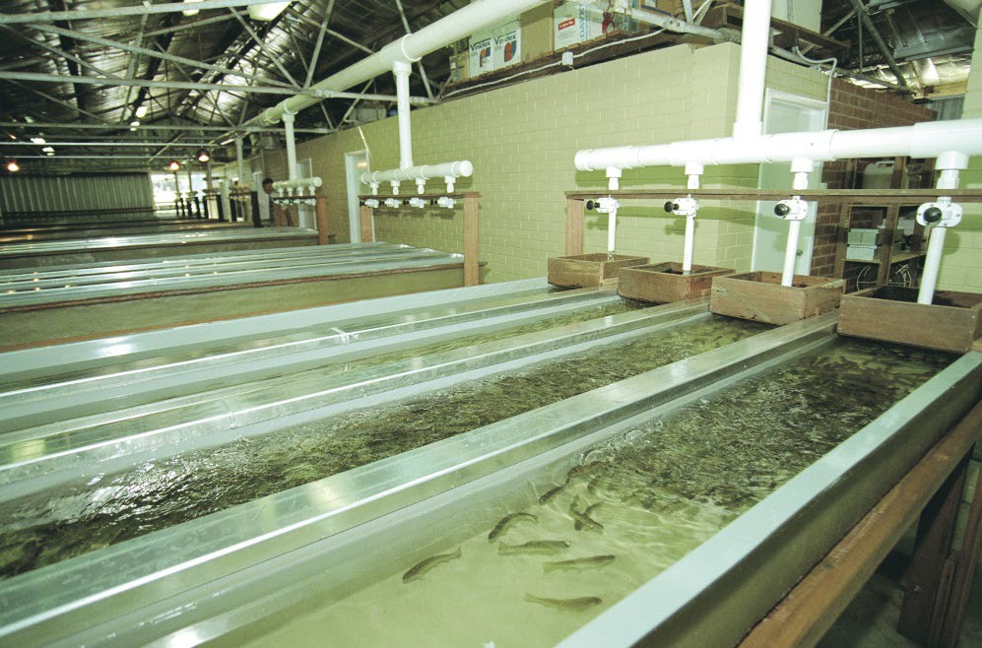
Western Australia (WA) has a
coastline of 20,788 km (mainland plus offshore islands). Despite this enormous distance, our aquaculture industry is small by global standards. It is, however, growing and diversifying.
Aside from contributing to food security, aquaculture creates employment and business opportunities in areas such as feed and equipment manufacturing. It also has direct and indirect economic benefits to the state, particularly in regional areas. In

Image 3.2.1 Commercial trout hatchery

2017-18, the total value of WA’s commercial fisheries and aquaculture production was $633 million. Of this, pearling (which is mostly commercially farmed) contributed $52 million (8%) and aquaculture $27 million (4%).

Activity 1: What are the main aquaculture species in WA?
Follow the link Fact sheet: Aquaculture in Western Australia and complete the following table:

Aquaculture species | Why is it grown? | Where is it grown?

Aquaculture species | Why is it grown? | Where is it grown?

Activity 2: Let’s examine an aquaculture species in more detail – barramundi
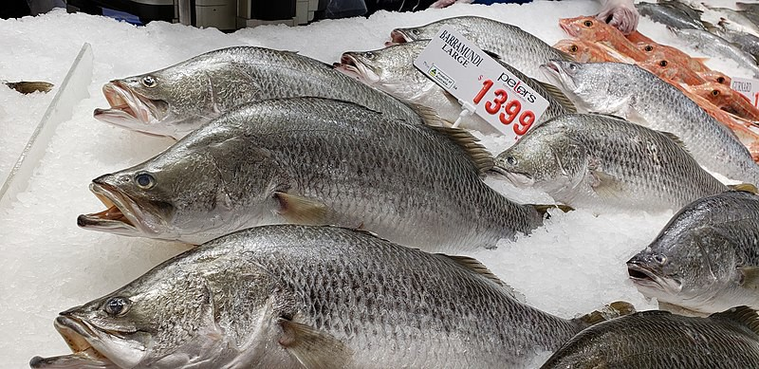
Image 3.2.2 Barramundi in the Sydney fish market

Follow the link Barramundi (aquaculture) | AgriFutures Australia

Also watch the video Investigating Australian approaches to producing fish, seafood and meat

Aquaculture of a species such as barramundi is an example of a food production system that has the potential to improve the long-term health of populations, ecosystems and environmental quality.
Use the information to create a poster or brochure that illustrates:

- where the fish species comes from and where it is produced in WA
- key biological information about barramundi that needs to be considered in the aquaculture process
- the processes and requirements involved in breeding barramundi as an aquaculture species
- the abiotic and biotic factors and interrelationships you can find that are involved
- technologies and systems used to process and distribute the barramundi before it reaches our plates
- how aquaculture of barramundi potentially leads to the long-term health of populations, ecosystems and environmental quality

Acknowledgements

References
AgriFutures (24 May 2017) ‘Barramundi (aquaculture)’ available at:
<https://www.agrifutures.com.au/farm-diversity/barramundi-aquaculture/> accessed 17 June 2021

Australian Government, Geoscience Australia “Border Lengths – States and Territories’ available at: <https://www.ga.gov.au/scientific-topics/national-location-information/dimensions/border- lengths> accessed 17 June 2021
Government of Western Australia, DPIRD ‘Marine Waters Fact sheet – Aquaculture in Western Australia’ © DPIRD 2021 available at: <https://marinewaters.fish.wa.gov.au/resource/fact-sheet- aquaculture-in-western-australia/> accessed 17 June 2021
Primary Industries Education Foundation Australia (PIEFA) (2020) ‘Farming barramundi using aquaculture (video and worksheet)’ available at:
<https://www.primezone.edu.au/resource/investigating-australian-approaches-to-producing-fish- seafood-and-meat-video-and-worksheet/> accessed 17 June 2021

Images
Image 3.2.1 Government of Western Australia, ‘Commercial trout hatchery’ © DPIRD 2021 available at: <https://www.agric.wa.gov.au/small-landholders-western-australia/starting- aquaculture-operation-western-australia> accessed 17 June 2021
Image 3.2.2 ‘Barramundi in the Sydney fish market’ (17 July 2018) Oraola CC BY-SA 4.0 available at: <https://commons.m.wikimedia.org/wiki/File:Barramundi_in_the_Sydney_Fish_Market.jpg>

Student worksheet 4.3.2

Cooperative learning jigsaw template 1: Expert group

My expert group’s task is … | Key language or vocabulary I need to use to make explanations more scientific includes … | What I learnt and plan to teach about my task is …
Things to find out about the task before I can write about it include … | Methods I might like to use to present my key information when I am teaching it are …

Cooperative learning jigsaw template 2: Home group
Scientific research into methane gas emissions from livestock:

Vaccinating livestock | Diet supplements and feed alternatives | Improving pasture management
Biological control methods | Selective breeding of livestock | Improving manure management

Student worksheet 5.1

What have I learnt?

Expo and cooperative learning jigsaw

This activity is a fun group activity where your group reviews key information on a topic that you have learnt during this series of modules on sustainable ecosystems and presents your findings to other members of your group in the form of an expo. Your presentation needs to be ‘stand-alone’ in the form of a poster, brochure or PowerPoint slideshow.

This type of activity is called a jigsaw. To assist with this activity, you will need to obtain an A3 sized copy of the Student worksheet 5.2 – Cooperative learning jigsaw templates 1 and 2 from your teacher.

You will first be allocated to a "home group" of six students. Each member of your group will be given a number (1 – 6).

Next, you will re-form into new “expert groups” by finding other students in the class with your number. Each expert group is assigned one of the topics below to become an “expert” on. How you find out your information is up to you. You will have a maximum of 50 minutes. During this time, you will need to access the various Student worksheets, PowerPoint presentations, internet links, videos provided in the resource, as well as textbook or other information.

At the end of the 50 minutes, your teacher will ask you to re-form your original home group. In the next class period, your home group task is to cycle amongst the presentations and complete the Cooperative learning jigsaw template 2 document as a summary. You may also be asked to do a peer assessment of other members of your home group.

Topics
- What key ecological terms about sustainable ecosystems do you need to know and be able to use in order to demonstrate and communicate your understanding of sustainable ecosystems?

- What are the key biological interactions occurring between different organisms and between organisms and their environment in an ecosystem? What similarities and differences would you expect to see when comparing the interactions occurring within natural and agricultural ecosystems?

- Describe the various biotic and abiotic factors that affect organisms within ecosystems. How would you set up a scientific investigation to test the effect of any of these factors on the productivity of an agricultural ecosystem (such as an aquaculture farm)?

- Energy flows whereas matter cycles in an ecosystem. What could be changed to improve energy flow and matter cycling in our agricultural ecosystems in order to help them be more sustainable into the future?

- Describe one ‘wicked problem’ facing agricultural ecosystems. Discuss some changes that are being put in place by WA primary producers to address this wicked problem

- Exciting new careers in sustainable agriculture and food systems are emerging all the time. Employment opportunities are available in numerous areas including primary production, processing, distribution and waste management. Prepare a persuasive argument convincing some of your friends why they should take up a career in sustainable agriculture and food systems.

Student worksheet 5.2
Cooperative learning jigsaw template 1 – Expert group (expand to A3 size)

My EXPERT GROUP task is … | Key language or vocabulary I will need to use to make explanations more scientific include … | What I learnt and plan to teach about my task is …
Things we will need to find out about the task before I can write about it include … | Methods I might like to use to present my key information when I am teaching it are …

Co-operative learning jigsaw template 2 – Home group (expand to A3 size)

Topic 1 | Topic 2
Topic 3 | Topic 4
Topic 5 | Topic 6

Student worksheet 5.3

Peer review template

While you are in your cooperative learning jigsaw home group, you may be asked to review the understanding of one other member of your group. Use the following assessment rubric to assess their understanding of the key topic.
Topic:

Assessment criteria | 0 = absent | 1 = limited | 2 = expected | 3 = exceeds expectations
Covers content/subject matter
Organisation
Clarity of explanations
Examples use appropriate scientific language
Presentation
Has used relevant reference sources
 |  |  | Total score | /18

