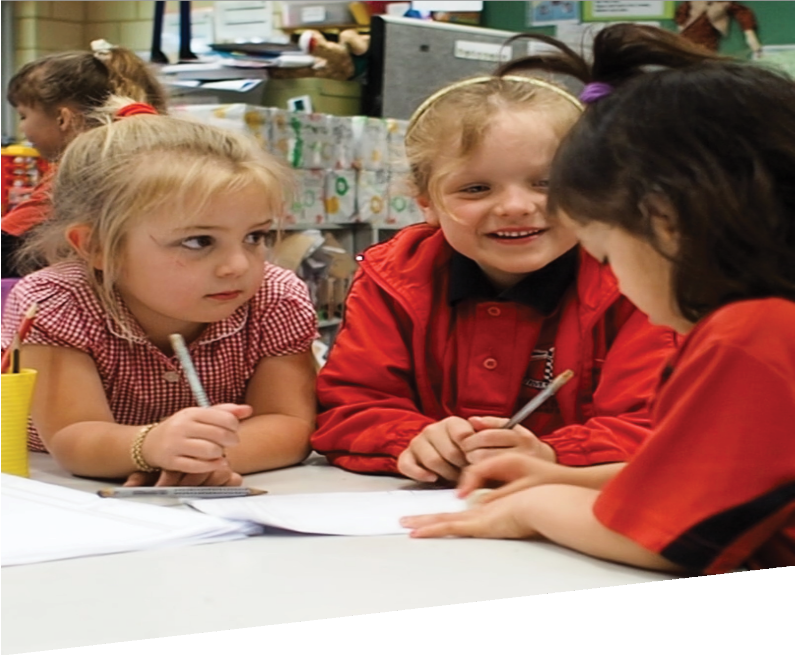

CURRICULUM RESOURCE MODULE
Chairs for bears
PRE-PRIMARY
Acknowledgements
The STEM Learning Project respectfully acknowledges the Traditional Custodians of the lands on which our students and teachers live, learn and educate.

The STEM Learning Project is funded by the Western Australian Department of Education (the Department) and implemented by a consortium in STEM education comprising the Educational Computing Association of WA, the Mathematical Association of WA, the Science Teachers Association of WA and Scitech. We acknowledge and thank the teachers and schools who are the co-creators of these resources.
Copyright and intellectual property
The copyright and intellectual property of this module remain the property of the Department.
Any Western Australian Curriculum content in this resource is used with the permission of the School Curriculum and Standards Authority (the Authority); this permission does not constitute Authority endorsement of the resource. The Authority accepts no liability for any errors or damages arising from reliance on its content.

The Western Australian Curriculum content may be freely copied, or communicated on an intranet, for non-commercial purposes in educational institutions, provided that the Authority is acknowledged as the copyright owner. Copying or communication for any other purpose can be done only within the terms of the Copyright Act 1968 or with prior written permission of the Authority. Any Australian Curriculum content in the Western Australian Curriculum is used by the Authority under the terms of the Creative Commons Attribution-NonCommercial 3.0 Australia licence.

Any content on the www.scsa.wa.edu.au domain that has been derived from the Australian Curriculum may be used under the terms of Creative Commons Attribution-NonCommercial 3.0 Australia licence.

Appendix 2: General capabilities continuum is adapted from ACARA, © Australian Curriculum, Assessment and Reporting Authority (ACARA) 2009 to present, unless otherwise indicated. This material was downloaded from the ACARA website (www.acara.edu.au accessed December 2015) and was not modified. The material is licensed under CC BY 4.0 (https://creativecommons.org/licenses/by/4.0/). ACARA does not endorse any product that uses ACARA material or make any representations as to the quality of such products. Any product that uses material published on this website should not be taken to be affiliated with ACARA or have the sponsorship or approval of ACARA. It is up to each person to make their own assessment of the product.

This resource includes references and examples of iOS, Android and other apps. The Department does not endorse or recommend any commercial products and simply provides these as examples for teachers.

The Department is committed to providing quality information to its customers. Whilst every effort has been made to ensure accuracy, currency and reliability of the information within these documents, the Department accepts no responsibility for errors, omissions or amendments made since the time of publishing. Confirmation of information may be sought from the Department or the originating bodies providing the information. The Department has no control over the content of material published on websites to which users are referred in this resource. It is the responsibility of the internet user to make their own decision as to the relevancy, accuracy, currency and reliability of information found on those sites.

Attributions: eBook, Explain Everything, iMovie, Puppet Pals, Seesaw, Class Dojo, Kidblog, Keynote, iBook.
Table of contents

The STEM Learning Project 2
Overview 3
Activity sequence and purpose 6
Background 7
Activity 1: Classifying chairs 9
Activity 2: A chair for you, a chair for me 14
Activity 3: Bears on chairs 19
Activity 4: Sharing our learning 23
Appendix 1: Links to the Western Australian Curriculum 26
Appendix 1B: Mathematics proficiency strands 27
Appendix 2: General capabilities continuum 28
Appendix 3: Materials list 30
Appendix 4: Design process guide 31
Appendix 5: Reflective journal 32
Appendix 6: Teacher resource sheet 1.1: Cooperative learning – Roles 33
Appendix 7: Teacher resource sheet 1.2: Cooperative learning – Think, Pair, Share 34
Appendix 8: Teacher resource sheet 3.1: Construction skills 35
Appendix 9: Student activity sheet 3.2: Prototype development 39
Appendix 10: Student activity sheet 4.1: Reflection 40
Appendix 11: Teacher resource sheet 4.2: Sample parent letter 42
Appendix 12: Teacher resource sheet 4.3: Sample resources request 43

The STEM Learning Project
The aim of the STEM Learning Project is to generate students’ interest, enjoyment and engagement with STEM (Science, Technology, Engineering and Mathematics) and to encourage their ongoing participation in STEM both at school and in subsequent careers. The curriculum resources will support teachers to implement and extend the Western Australian Curriculum and develop the general capabilities across Kindergarten to Year 12.
Why STEM?
A quality STEM education will develop the knowledge and intellectual skills to drive the innovation required to address global economic, social and environmental challenges.
STEM capability is the key to navigating the employment landscape changed by globalisation and digital disruption. Routine manual and cognitive jobs are in decline whilst non-routine cognitive jobs are growing strongly in Australia. Seventy-five per cent of the jobs in the emerging economy will require critical and creative thinking and problem solving, supported by skills of collaboration, teamwork and literacy in mathematics, science and technology. This is what we call STEM capability. The vision is to respond to the challenges of today and tomorrow by preparing students for a world that requires multidisciplinary STEM thinking and capability.
The approach
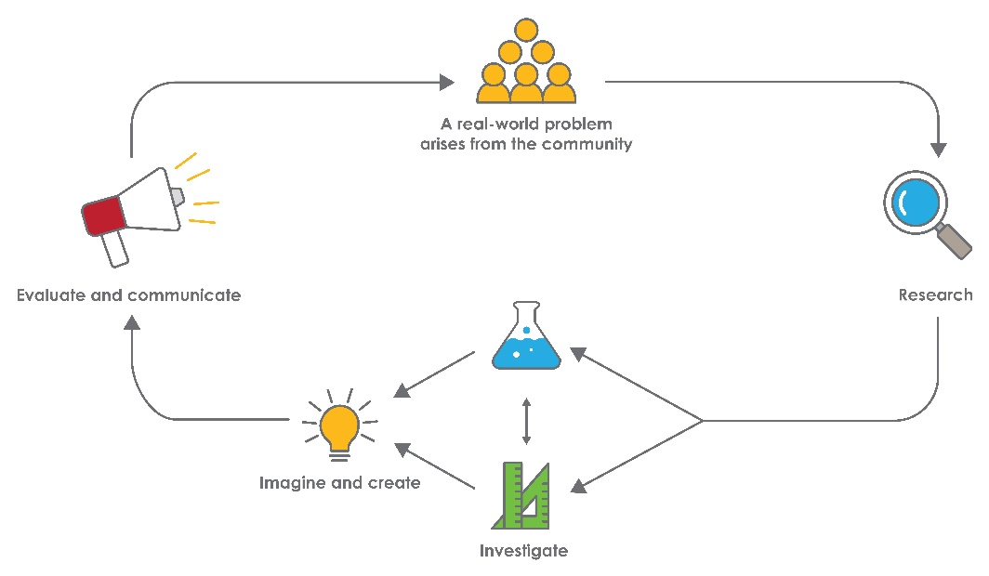
STEM capabilities are developed when students are challenged to solve open-ended, real-world problems that engage students in the processes of the STEM disciplines.

Chairs for bears
STEM Consortium

Overview
Designing furniture is a real-world problem that challenges STEM knowledge and creativity. Well-designed furniture is ergonomic, safe, comfortable, durable and pleasing to the eye.
In chair design, form and function interact very closely. While there are many factors that must be considered in the design of a chair – the main factors are its purpose and who will be using the chair. This will influence the size and shape of the chair as well as the materials used to make it.
In this module, students investigate the common design features of chairs and how different types of chairs fit different sized people and have a range of purposes. They discuss the size and shape of different toys and analyse the requirements for a suitable chair for their toy.
What is the context?
Furniture needs to be designed to be comfortable, safe and an appropriate size.
What is the problem?
How can we make a chair that is comfortable, safe and the right size for our toy?
How does this module support integration of the STEM disciplines?
In addition to providing a context in which students can develop outcomes for the Early Years Learning Framework, this module gives students the opportunity to develop skills in the STEM learning areas.
Science
Students develop science understandings when they investigate, observe and describe the properties of materials used to make chairs (ACSSU003: Objects are made of materials that have observable properties and ACSIS233: Engage in discussions about observations and represent ideas).
Technology
Students develop technology understandings as they engage in the design process and use their senses to explore the properties of materials, select appropriate materials for construction and evaluate its suitability against design criteria (WATPPS02: Generate and record design ideas through describing, drawing, modelling and/or a sequence of written or spoken steps, WATPPS04: Use personal preferences to evaluate the success of simple solutions, WATPPS05: Work independently, or with others when required, for solutions and ACTDEK004:
Characteristics of materials can be explored using senses). They analyse digital images, identify features and, with assistance, annotate images to communicate information.
The Design process guide is included as a resource to provide assistance to teachers in understanding the complete design process as developed in the Technologies curriculum.
Mathematics
Students develop mathematical understanding and proficiency when they measure lengths and compare and classify different types of chairs (ACMMG006: Use direct and indirect comparisons to decide which is longer, heavier or holds more, and explain reasoning in everyday language, ACMNA005: Sort and classify objects and explain the basis for these classifications. Copy, continue and create patterns with objects and drawings). They discuss the sizes of two-dimensional figures and three-dimensional objects for various parts of the chair (ACMMG009: Sort, describe and name familiar two-dimensional shapes and three-dimensional objects in the environment).
General capabilities
There are opportunities for the development of general capabilities and cross-curriculum priorities as students engage with Chairs for bears. In this module, students:
- Develop problem solving skills as they research the problem and its context (Activity 1); investigate parameters impacting on the problem (Activity 2); imagine and develop solutions (Activity 3); and evaluate and communicate their solutions to an audience (Activity 4).
- Utilise creative thinking as they generate possible design solutions; and critical thinking, numeracy skills and ethical understanding as they choose between alternative approaches to solving the problem.
- Utilise personal and social capability as they develop socially cohesive and effective working teams; collaborate in generating solutions; adopt group roles; and reflect on their group work capabilities through self and peer evaluation.
- Utilise a range of literacies and information and communication technologies capabilities as they collate records of work completed throughout the module in a journal; and represent and communicate their solutions to an audience using digital technologies in Activity 4.

What are the pedagogical principles of the STEM learning modules?
The STEM Learning Project modules develop STEM capabilities by challenging students to solve real-world problems set in authentic contexts. The problems engage students in the STEM disciplines and provide opportunities for developing higher order thinking and reasoning, and the general capabilities of creativity, critical thinking, communication and collaboration.
The design of the modules is based on four pedagogical principles:
- Problem-based learning
This is an underlying part of all modules with every module based around solving an initial problem. It is supported through a four-phase instructional model: research the problem and its context; investigate the parameters impacting on the problem; design and develop solutions to the problem; and evaluate and communicate solutions to an authentic audience.
- Developing higher order thinking
Opportunities are created for higher order thinking and reasoning through questioning and discourse that elicits students' thinking, prompts and scaffolds explanations, and requires students to justify their claims. Opportunities for making reasoning visible through discourse are highlighted in the module with the icon shown here.
- Collaborative learning
This provides opportunities for students to develop teamwork and leadership skills, challenge each other’s ideas, and co-construct explanations and solutions. Information that can support teachers with aspects of collaborative learning is included in the resource sheets.
- Reflective practice
Recording observations, ideas and one’s reflections on the learning experiences in some form of journal fosters deeper engagement and metacognitive awareness of what is being learned. Information that can support teachers with journaling is included in the resource sheets.
These pedagogical principles can be explored further in the STEM Learning Project online professional learning modules located in Connect Resources.

Activity sequence and purpose
Classifying chairs
Students’ interest is captured when they listen to the storybook Bears on Chairs. They find different chairs around their school and take photos for a classifying activity which identifies different users and purposes of chairs.
A chair for you, a chair for me
Using streamers, students measure people of varying heights and investigate how different sized chairs would comfortably fit them. The properties of materials used to make chairs are observed and compared. Students compare different toys and explore the design criteria for a chair for their toy.
Bears on chairs
Students design and build a chair that is safe, comfortable and the right size for their toy, and then test it to see if it meets the specified design criteria. Students are guided to complete the process of designing, constructing, testing and improving their toy’s chair.
Sharing our learning
Students evaluate the success of their design using a simple evaluation of pro forma.
Students share their designs with the class and, where possible, an audience beyond the classroom.

Background
Expected learning | Students will be able to:  - Make comparisons of sizes and use appropriate language to describe differences.  - Sort and classify familiar objects and explain the basis for these classifications.  - Discuss and compare sizes of two-dimensional figures and three-dimensional objects for various parts of the chair.  - Investigate, observe and describe the properties of materials and select appropriate ones to make chairs.  - Design a chair for their toy, document their design as a drawing, explain their design choices and construct a chair.  - Work efficiently in collaborative learning situations to generate a solution.  - Evaluate and justify design choices using simple evaluation strategies.
Vocabulary | There are opportunities during the module for students to develop the following vocabulary:  Around, behind, between, circle, construct, curves, cylinder, design, evaluate, flexible, forward, hard, heavy, height, in front, least, length, light, long, longer, longest, most, narrower, next to, on top, rectangle, rigid, short, shorter, shortest, soft, square, straight, taller, test, underneath.  Additional vocabulary resources include:  Material properties language word cards – free resource (Twinkl, 2018)  www.twinkl.co.uk/resource/t-t-1216-materials-word-cards  Positional language word cards – free resource (Twinkl, 2018)  www.twinkl.co.uk/resource/t-l-096-positional-language-word-cards
Timing | There is no prescribed duration for this module. The module is designed to be flexible enough for teachers to adapt. Activities do not equate to lessons; one activity may require more than one lesson to implement.
Consumable materials | A Materials list is provided for this module. The list outlines materials outside of normal classroom equipment that will be needed to complete the activities.
Safety notes | There are potential hazards inherent in these activities and with the equipment being used. A plan to mitigate any risks will be required.  Potential hazards specific to this module include but are not limited to:  - Possible exposure to cyber bullying, privacy violations and uninvited solicitations when using the internet.  - Construction tools.
Assessment | The STEM modules have been developed to provide students with learning experiences that require them to solve authentic real-world problems using science, technology, engineering and mathematics capabilities. While working through the module, the following assessment opportunities will arise:  - ideas recorded in the class reflective journal and individual journals;  - anecdotal records from observations and conversations about students’ models.  Appendix 1 indicates how the activities are linked to the Western Australian Curriculum.  Evidence of learning from journaling, presentations and anecdotal notes from this module can contribute towards the larger body of evidence gathered throughout a teaching period and can be used to make on-balance judgements about the quality of learning demonstrated by the students in the science, technologies and mathematics learning areas.  Students can further develop the general capabilities of Personal and social capability. A continuum is included in the General capabilities continuum but is not intended for assessment purposes.

Activity 1: Classifying chairs
Activity focus | Students’ interest is captured as they are introduced to the storybook Bears on Chairs. They explore different types of chairs around their school, take photos for a classifying activity and identify different users and purposes of chairs.
Background information | A chair is an item of furniture that consists of a raised platform to sit on and a back support and is normally supported by four legs. Chairs are commonly used to seat a single person and are used in a variety of settings, from homes (eg in living rooms, dining rooms), to schools and offices.  The history of chairs may provide an interesting discussion point for students, a brief overview can be found at chairinstitute.com/history-of-the-chair/. A discussion of interesting and unusual chairs may also prove to be a thought-provoking catalyst. Some images of interesting chars can be found at chairinstitute.com/cool-chairs.  The design of a chair is based on how it will be used. Important design considerations include comfort, size, weight, durability, stain resistance and ability to be folded away or stacked.  Chairs are made from a wide variety of materials, ranging from wood to metal to synthetic material (eg plastic), and they may be padded or upholstered in various colors and fabrics. Chair legs are usually made of wood, metal or strong plastic as they need to be strong and not break. The padding of seats is made from foam covered with fabric which squash down as a person sits so that the chair is soft rather than hard to sit on.
Instructional procedures | When students participate in Part 2: School walk it is recommended they work in small groups of three to four along with a parent helper or teacher assistant. Planning for assistance during this time will need to be considered.  As students are working in small groups, this activity could be run over a few days during morning rotation activities.
Expected learning | Students will be able to:  - Make comparisons of sizes and use everyday language to describe differences (Mathematics).  - Sort and classify chairs and explain the basis for these classifications (Mathematics).
Equipment required | For the class:  Whiteboard or interactive whiteboard  Digital camera or device for photos  A copy of Bears on Chairs by Shirley Parenteau
Preparation | Ensure cameras or devices are fully charged.  Choose a space in the classroom for the word wall.  Print a parent note for each child to take home explaining the project and type of toy that is required. Refer to Teacher resource sheet 4.2: Sample parent letter.
Activity parts | Part 1: Story time  Read students the story Bears on Chairs.  Discuss the story as a class using questioning:  - Why couldn’t two bears share one chair?  - How could we help the bears solve their problem?  - Which part of the chair stops the bear from falling?  - Do the bear’s feet need to touch the floor? Why? Because…  Use because and why as prompts to encourage deeper thinking from the students.
Part 2: Guided school walk
Explain that the students will be going on a walk around the school to look at, and take photos of, different types of chairs, stools and benches.
Students split into small groups of three to four to participate in the guided school walk.
Encourage students to take photos of different types of chairs, stools and benches found around the school.

Ask students to ‘test’ some of the chairs and discuss the features of each:
- Do your feet touch the ground? Is it comfortable if your feet don’t touch the ground?
- What is stopping you from falling backwards? (Compare chairs, stools and benches to discover which are easiest to fall off backwards.)
- Is there anywhere to rest your arms on this chair?
- Why do some chairs have padding or a cushion on the seat and others don’t? Which feel more comfortable?
- Who might use this chair? What is it used for?
Part 3: Classify photos
In the classroom display the photos taken by students on their walk. Encourage them to reflect on and participate in a discussion about different types of chairs.
Chairs might be classified by type, colour, size (ie adult or child), purpose (ie work or rest), or the material that they are made from. This is a good opportunity to start a class word wall.
Ask students:
- Which chair would you choose to sit on? Why?
- Why are there different types of chairs in our school?
- Are all the chairs made of the same material? Why?
- Why do you think the legs are made of metal or wood?
- Do you have chairs at home that are like the chairs we have at school?
Students interpret the data collected, discussing:
- Think about all the types of chairs we found. What type had the most?
- What type of chair had the least?
- Why do you think there are more of these chairs and less of others?
Part 4: Identifying users
Using the photos, students identify the different purposes of the chairs. Prompt discussion with questioning:
- What is the difference between these two chairs?
- Who might use each kind of chair? Why?
- Would every chair be a good choice for the classroom? Lounge/family room? Dining table? Garden? Beach? Why? Why not?
- When is a small chair needed? A tall chair? A wide chair? A soft chair?
- Do adults and students sit on the same type of chair? Same size of chair?
Encourage students to think of new situations where they might use different types of chairs; or to choose a chair to suit a different situation, even beyond what would be real or what they see at school.
- What might an underwater chair be like?
- What might a chair on the moon be like?
- What types of chairs do you take to the beach / on a picnic / on holidays?
- What types of chairs do people with disabilities have?
As new vocabulary is introduced, add it to the corresponding images from the classifying activity and the word wall.
Additional learning opportunity: Musical chairs
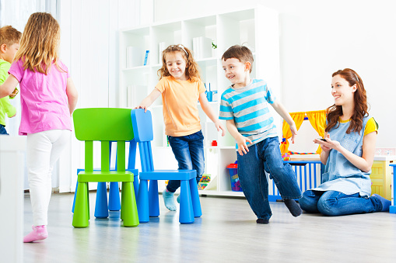
Musical chairs is a social activity, giving students the opportunity to build social skills. Through play, students develop empathy and understand how others would feel when winning or losing. The purpose is for students to experience feelings of inclusion and exclusion and to think about how they can cooperate to include others. When children listen to music and vary the speed of their movement, listening skills are developed. Listening skills are crucial to academic success.
Ask the students:
- How many chairs should we have at the start of the game? Why is that?
Encourage students to count the chairs together, explaining that for the game to work there needs to be one less chair than the number of students. Ask students to work together to organise the chairs in two straight lines, back-to-back.
Continue to encourage students to count down the number of chairs as more students are eliminated. This activity could also provide opportunity for the students to classify the chairs by other groups eg colour, purpose, size, comfort.
Part 6: Journaling
Digital journaling options could include using apps such as Kidblog, Explain Everything, Keynote or iBook which could be uploaded to Seesaw or Connect to share the students’ learning with the parent community.
A non-digital class journal could be created to record students’ learning and act as the first steps towards journaling. This would be created by the teacher and include photos of groups working together, along with annotations to capture students’ thinking and conversations.
Refer to Reflective journal for elaborations.
Resource sheets | Teacher resource sheet 4.2: Sample parent letter
Digital resources | Bears on Chairs - A Children's Book Read Aloud (The Third-Party Academy, 2018)  www.youtube.com/watch?v=F80YGIkwOOA
Connect
connect.det.wa.edu.au
Seesaw
web.seesaw.me
Kidblog
kidblog.org/home
Explain Everything
explaineverything.com
Keynote
www.apple.com/au/keynote
Literary resources | Bears on Chairs by Shirley Parenteau

Activity 2: A chair for you, a chair for me
Activity focus | In this activity students use streamers to measure people of varying heights and investigate how different sized chairs would comfortably fit them. Students compare different toys and explore the design criteria for a chair suitable for their toy.
Background information | A chair needs to be the right size and dimensions for the person who will use it. The seat of a chair needs to be deep enough so that the person’s back touches while the legs of the chair need to be long enough so that, when seated, a person’s feet can touch the floor. Arm rests need to be at an appropriate height above the seat so that arms can be rested on them comfortably.  Some people require special chairs to support their bodies. For example, wheelchairs are made to measure so they perfectly fit the person and support their body in a comfortable way.
Instructional procedures | Students will work in small groups. This activity could be run during morning rotation activities.
Expected learning | Students will be able to:  - Make comparisons of sizes and use everyday language to describe differences (Mathematics).  - Discuss and compare sizes of two-dimensional figures and three-dimensional objects for various parts of the chair (Mathematics).  - Observe and describe the properties of the materials used to make chairs (Science).
Equipment required | For the class:  Streamers, enough for two per group  Pegs or bulldog clips  Different sized chairs for comparison of adult and child requirements  Samples of materials such as wood, metal, foam and fabric  For students  A toy from home
Preparation | Create a space in the classroom to hang the streamers.
Activity parts | Part 1: Investigating chair sizes  Through investigation, students understand why chairs are made in different sizes. Taking photos during this activity is encouraged as they will be useful when journaling in Part 5.  Using streamers, groups measure the height of one of their classmates and then the height of their teacher. Peg the streamers up and compare them.  Prompt discussion by asking:  - Which streamer is the longest?  - Which one is the shortest?  - Are any streamers the same length?  - Who will need the biggest chair, me (the teacher) or … (the student)? Why?  - Who will need the smallest chair, me (the teacher) or … (the student)? Why?  Students find a chair that best fits their teacher and their classmate to sit on.  Explore the students’ choices by asking:  - Tell me why you chose this chair for me to sit on.  - Do I (the teacher) look comfortable sitting in this chair? Why?  - Why didn’t you choose the same chair for (the student)?  The teacher and the student swap chairs.  Encourage the class to look at their teacher sitting on a student chair and the student sitting on the teacher’s chair. Using this visual as a prompt, ask students to identify the design criteria for a chair that is safe, comfortable and the right size. Use the correct name for different parts of the chair as they arise through discussion (ie backrest, legs, seat, arm rests, padding).  Use questioning to direct discussion:  - Are my (the teacher) feet on the floor?  - Are (the student’s) feet on the floor?  - Is (the student’s) back against the backrest?  - Ask the student to sit back in the chair. What happened to your legs when you move backwards?  - Are my (the teacher) knees level or pointed up?  - What would happen if the chair legs were longer or shorter?  - What needs to change on the chair to make it more comfortable?  The above process should be repeated using the toys for which the students will build chairs. This will give students an opportunity to practise their indirect measurement skills.  Discuss and record the criteria students have identified as being important to chair design; ie that it is safe, comfortable and the right size. This will form the design criteria students will refer to when creating their solution in Activity 3 and will act as a guide to measure success in Activity 4. Record any new vocabulary on the board and add to the word wall from Activity 1.
Part 2: Expanding understandings
Show students a variety of images of chairs from an internet search so they can investigate other chair designs and expand their understandings from Activity 1. Try to include chairs with different shapes and purposes (eg square, round, triangular seats, a highchair, a wheelchair, a chair lift, tennis umpire, child’s car seat, sunlounge, lounge suite).
Students discuss common features of these designs such as seat, back, legs, shapes and colours. Prompt discussion with questions such as:
- Do you think the shape of the seat will make a difference to how comfortable it is?
- Do all the chairs have four legs?
- Do all stools have three legs?
- Are chairs more comfortable with arm rests?
- Is the back rest the same size on the chairs?
- Which of the chairs have a special purpose?
- Who might sit in this type of chair? Why?
- Who wouldn’t like to sit in this type of chair? Why?
Encourage students to compare and contrast the images by asking:
- I wonder why the legs on a lounge chair are shorter than a dining chair?
- How are the baby’s highchair and the tennis umpire’s chair the same? How are they different? Why do you think they are made this way?
Ask students to name different shapes and colours they see in the images. Add the names of these shapes and colours to the word wall.
Part 3: Materials
Explain to students they are going to make a chair for their toy.
Encourage students to look at the size of their toy. Prompt thinking by asking:
- Does your toy have long legs or short legs?
- Do your toy’s legs bend at the knees?
- Is your toy big or small?
Discuss how students will know what size to make the chair for their toy by asking:
- How tall will the legs of your chair need to be? Why?
- Will your chair have an armrest or back? Why?
- What shape and size do you think the seat should be? Why?
- I wonder what else will make your chair perfect for your toy.
Provide students with samples of materials such as wood, metal, foam and fabric. Encourage students to handle the samples and compare their properties by using their senses. Ask questions to generate responses about where the materials may have come from and colour, shape and texture.
Generate a list of adjectives for the word wall, such as: strong, hard, stiff, bendy, flexible, smooth and soft. Use the interactive whiteboard to complete a word matching activity where students match parts of chairs to materials used to make those parts:
Parts of chairs – legs, seat, back, armrests, cushion
Materials – wood, metal, foam, fabric, plastic
Some parts will be made of more than one material, for example the seat is often made of a strong material such as plastic for support, and soft materials such as foam and fabric for comfort.
As students match a material to the part of the chair ask them to identify which properties of the material makes it suitable for that part of the chair. This will encourage
reasoning about the relationships between the properties of materials and their uses.
Help students draw on the preceding discussions to identify what makes a good chair by asking:
- If we were chair judges, what would be on our list to check if a chair was very good?
  - Will it fall over? Why?
  - Will it break when you sit on it? Why?
  - Is it too hard to sit on? Why?
  - Is it too small for the person? Why?
Write a list of the students’ ideas. Explain that students can use the list as a guide when building a chair in Activity 3.
Part 4: Create a materials list
As a class generate a list of materials that may be needed to construct chairs for the toys. Discuss where to source these materials. Send a note home requesting materials to be brought to school. Refer to Teacher resource sheet : Sample resources request.
Materials will need to be collected before commencing Activity 3.
Part 5: Reflection
Add photos to the class reflective journal and scribe students' comments to record discussions and the thinking process.
Resource sheets | Teacher resource sheet 4.3: Sample resources request
Digital resources | Material properties language word cards – free resource (Twinkl, 2018)  www.twinkl.co.uk/resource/t-t-1216-materials-word-cards
Positional language word cards – free resource ((Twinkl, 2018)
www.twinkl.co.uk/resource/t-l-096-positional-language-word-cards

Activity 3: Bears on chairs
Activity focus | In this activity students design and build a chair that is safe, comfortable and the right size for their toy. They test the chair to see if it meets their design criteria. Students are guided to complete the process of designing, constructing, testing and improving.
Background information | This activity engages students in an engineering process to design, construct, test and evaluate a model of a chair suitable for their toy.  Designing typically progresses from understanding a need, and then imagining what might be developed to address that need. Once imagined, planning is required to identify the materials, fabrication techniques and processes that will be required for construction.  During construction, new insights may emerge which initiate revisions. Further improvements are often made to the design following feedback on the prototype.  See Design process guide for elaboration.
Instructional procedures | This activity works better with additional support from parent help or a buddy class. There would ideally be one helper per group.  Teacher resource sheet 3.1: Construction skills is a useful resource for this activity.  A labelled diagram annotated with student thinking by an adult can clarify how each component relates to others and the various specifications of the materials to be used. The labelled diagram can guide the construction process.  Photographs or videos of the construction processes should be taken for digital presentations in Activity 4.
Expected learning | Students will be able to:  - Investigate, observe and describe the properties of materials used to make chairs (Science).  - Design a chair for their toy, document their design as a drawing, explain their design choices and construct a chair (Technologies).
Equipment required | For the class:  Class reflective journal  Interactive whiteboard with internet access  Teacher resource sheet 3.1: Construction skills
For the students:
Variety of cardboard tubing, masking tape, scissors, egg cartons, shoe boxes, paper plates, plastic straws, paper cups, construction paper etc (see the Materials list)
Materials provided by parents
Toy
Student activity sheet 3.2: Prototype development
Preparation | Organise parents or a buddy class to help students with cutting tubes, paper plates and egg cartons. Alternatively, some materials could be pre-cut before the lesson.  Print Student activity sheet 3.2: Prototype development – one per student.
Activity parts | Part 1: Investigate materials  During circle time students explore the materials available. They sort and classify the materials by shape and then by type of material suitable for each part of a chair.  Encourage students to look at a range of different properties including hardness, flexibility, strength, water resistance, elasticity. Provide students with the opportunity to handle and test the materials.  Students discuss the size and properties of materials they identify as suitable for making their chairs with reference to the design criteria ie safe, comfortable and the right size for their toy. Prompt students with questioning and encourage them to elaborate and justify their answers by using ‘because’. For example, I think it should have a soft seat because… or My toy is very little so it should have… because…
Part 2: Prototype development
Working individually, students design a chair that is safe, comfortable and the right size for their toy using Student activity sheet 3.2: Prototype development.
Students make a drawing of their design and, with help, annotate the drawing to show its parts and materials.
Use questioning to prompt thinking about the design:
- How tall will the legs need to be on your chair? Why?
- Will your chair need an armrest or back? Why?
- What shape and size do you think the seat should be?
- What else does your chair need?
Part 3: Build and test
Working from their design, students build their prototype.
Students are given the opportunity to improve their design and technology skills when cutting, pasting and joining materials. See Teacher resource sheet 3.1: Construction skills for tips on construction techniques.
Students test their chair by placing their toy on it to see if it meets the design criteria (ie is it the right size, safe and comfortable?).
Part 4: Improve design
Students develop engineering design skills as they work through the design process towards a solution. Students are guided to complete the process of designing, constructing, testing and improving their chair.
While testing their chairs, students reflect on their design. Prompt their thinking with the following questions:
- Did your toy fall off the chair? Why?
- Is the chair safe?
- Is the chair the right size?
- Is the seat the right size?
- Are the chair legs the right height? Do your toy’s feet touch the floor?
- I wonder if your toy is comfortable sitting on the chair?
- Is there anything you need to change?
These reflections may lead to an iterative process of redesign and modification of the prototype to better satisfy the design criteria developed in Activity 2 Part 1).
Record student thinking as they follow the design process using anecdotal notes and by taking photos. This could be recorded onto Student activity sheet 3.2: Prototype development from Part 2.
Once students are satisfied their design has met the design criteria, they could decorate their chair.
Part 5: Reflection
Add photos to the class reflective journal and scribe students' comments to record their ideas and their descriptions.
Resource sheets | Teacher resource sheet 3.1: Construction skills  Student activity sheet 3.2: Prototype development

Activity 4: Sharing our learning
Activity focus | In this activity students evaluate the success of their design using a simple evaluation proforma and a photo of their chair.  Students share their designs with the class and, where possible, an audience beyond the classroom.
Instructional procedures | Students engage in reflection and evaluation and communicate their thinking about how their chair meets the design criteria and needs of the toy.  Modify Student activity sheet 4.1: Reflection with the design criteria students established in Activity 2. This will provide a way for the students to evaluate their design and decide whether it has successfully met the design criteria.  Students think about how the changes they made improved the design and the scientific basis of the design (ie that the chair must have certain design elements to meet the needs of the user).  The sharing of presentations provides a rich opportunity for assessing students’ understanding of the science, mathematics and technology principles and processes.  The photographs taken throughout the design process should be used in digital presentations.  Digital options include creating an eBook, Explain Everything, simple iMovie, Puppet Pals (or similar), which can then be shared through a digital portfolio platform such as Connect, Seesaw or Class Dojo.  Students will require explicit instruction and teacher-led assistance in using and creating with these apps.  If digital technology is not accessible, students could share their model through a gallery walk and oral presentation.
Expected learning | Students will be able to:  - Evaluate and justify design choices using simple evaluation strategies (Technologies and Science).
Equipment required | For the class:  Class reflective journal
For the students:
Pencils
Photo of their chair to annotate
Labels
Glue
Preparation | Print photos of the students’ chairs. Alternatively, students could draw their final design.  Print labels for parts of chairs ie legs, seat, back that students can attach to their design  Print Student activity sheet 4.1: Reflection – one per student.
Activity parts | Part 1: Review design process  As a class, reflect on Activity 3. Discuss any problems that students had and how they solved those problems (ie testing and making modifications, talking with other students to find out what they did and why).  Revisit the vocabulary from Activity 1 (eg legs, back, seat, height, materials) and add any new vocabulary to the word wall.
Part 2: Reflection
Provide students with Student activity sheet 4.1: Reflection. With support from an adult, students decide if their chair meets the specified design criteria (ie safe, right size and comfortable) and complete the checklist by ticking either yes or no. This reflection sheet should contain the design criteria students developed in Activity 2.
Provide the students with a photo of their chair to stick onto the activity sheet.
Students colour the face which best indicates how they feel about their chair design (very happy, happy or okay). This is an opportunity to assess students’ ability to evaluate the success of their designs.
Ask the students if there was a problem with their design and what they did to fix it.
- What part of your chair worked well?
- What part of your chair didn’t work well? Why?
Ask students to identify familiar two-dimensional shapes and label these on the photo.
Add these notes to students’ anecdotal notes. Record answers in the class reflective journal.
Part 3: Journaling
Review the module, recording responses in the class reflective journal. Begin by asking the class what they have learnt about chairs and making a good chair. Discuss the thinking processes about the science, mathematics and the technologies the students used. What new knowledge did the students gain about the properties of materials, the measuring techniques and the tenacity to make changes?
Ask the students what they did well and what they need to practise for the next time when they design and make a model.
See Reflective journal for elaboration on this aspect of the learning.
Part 4: Sharing
Students invite the wider community, such as parents or a buddy class, to share their learning.
As an option, resources could be made available for students to recreate the chair building process with their parent, guardian or buddy.
Resource sheets | Student activity sheet 4.1: Reflection

Appendix 1: Links to the Western Australian Curriculum
The Chairs for bears module provides opportunities for developing students’ knowledge and understandings in science, technologies and mathematics. The table below shows how this module aligns to the content of the Western Australian Curriculum and can be used by teachers for planning and monitoring.
CHAIRS FOR BEARS | ACTIVITY
 | 1 | 2 | 3 | 4
SCIENCE
SCIENCE UNDERSTANDING
Chemical sciences: Objects are made of materials that have observable properties (ACSSU003). | ● | ● |  | ●
DESIGN AND TECHNOLOGIES
KNOWLEDGE AND UNDERSTANDING
Materials and technologies specialisations: Characteristics of materials can be explored using senses (ACTDEK004) | ● | ● | ●
PROCESS AND PRODUCTION SKILLS
Designing: Generate and record design ideas through describing, drawing, modelling and/or a sequence of steps (WATPPS02) |  |  | ●
Evaluating: Use personal preferences to evaluate the success of simple solutions (WATPPS04) |  |  |  | ●
Collaborating and managing: Work independently, or with others when required, for solutions (WATPPS05) | ● |  |  | ●
MATHEMATICS
MEASUREMENT AND GEOMETRY
Using units of measurement: Use direct and indirect comparisons to decide which is longer, heavier or holds more, and explain reasoning in everyday language (ACMMG006) | ● | ●
Shape: Sort, describe and name familiar two-dimensional shapes and three-dimensional objects in the environment (ACMMG009) |  | ● |  | ●
Patterns and Algebra: Sort and classify objects and explain the basis for these classifications. Copy, continue and create patterns with objects and drawings (ACMNA005) |  | ●
Further information about assessment and reporting in the Western Australian Curriculum can be found at: k10outline.scsa.wa.edu.au/home

Appendix 1B: Mathematics proficiency strands
Key ideas
In Mathematics, the key ideas are the proficiency strands of understanding, fluency, problem-solving and reasoning. The proficiency strands describe the actions in which students can engage when learning and using the content. While not all proficiency strands apply to every content description, they indicate the breadth of mathematical actions that teachers can emphasise.
Understanding
Students build a robust knowledge of adaptable and transferable mathematical concepts. They make connections between related concepts and progressively apply the familiar to develop new ideas. They develop an understanding of the relationship between the ‘why’ and the ‘how’ of mathematics. Students build understanding when they connect related ideas, when they represent concepts in different ways, when they identify commonalities and differences between aspects of content, when they describe their thinking mathematically and when they interpret mathematical information.
Fluency
Students develop skills in choosing appropriate procedures; carrying out procedures flexibly, accurately, efficiently and appropriately; and recalling factual knowledge and concepts readily. Students are fluent when they calculate answers efficiently, when they recognise robust ways of answering questions, when they choose appropriate methods and approximations, when they recall definitions and regularly use facts, and when they can manipulate expressions and equations to find solutions.
Problem-solving
Students develop the ability to make choices, interpret, formulate, model and investigate problem situations, and communicate solutions effectively. Students formulate and solve problems when they use mathematics to represent unfamiliar or meaningful situations, when they design investigations and plan their approaches, when they apply their existing strategies to seek solutions, and when they verify that their answers are reasonable.
Reasoning
Students develop an increasingly sophisticated capacity for logical thought and actions, such as analysing, proving, evaluating, explaining, inferring, justifying and generalising. Students are reasoning mathematically when they explain their thinking, when they deduce and justify strategies used and conclusions reached, when they adapt the known to the unknown, when they transfer learning from one context to another, when they prove that something is true or false, and when they compare and contrast related ideas and explain their choices.
Source:
www.australiancurriculum.edu.au/f-10-curriculum/mathematics/key-ideas/?searchTerm=key+ideas#dimension-content

Appendix 2: General capabilities continuum
The general capabilities continuum shown here is designed to enable teachers to understand the progression students should make, it is not intended to be used for assessment purposes.
Personal and social capabilities continuum
Sub-element | Level 1A student | By the end of Foundation year students
Self-awareness element
Recognise emotions | Recognise and identify their own emotions | Identify a range of emotions and describe situations that may evoke these emotions
Recognise personal qualities and achievements | Express a personal preference | Identify their likes and dislikes, needs and wants, and explore what influences these
Understand themselves as learners | Select tasks they can do in different learning contexts | Identify their abilities, talents and interests as learners
Develop reflective practice | Recognise and identify participation in or completion of a task | Reflect on their feelings as learners and how their efforts affect skills and achievements
Self-management element
Express emotions appropriately | Recognise and identify how their emotions influence the way they feel and act | Express their emotions constructively in interactions with others
Develop self-discipline and set goals | Make a choice to participate in a class activity | Follow class routines to assist learning
Work independently and show initiative | Attempt tasks with support or prompting | Attempt tasks independently and identify when and from whom help can be sought
Become confident, resilient and adaptable | Identify people and situations with which they feel a sense of familiarity or belonging | Identify situations that feel safe or unsafe, approaching new situations with confidence
Social awareness element
Appreciate diverse perspectives | Show an awareness for the feelings, needs and interests of others | Acknowledge that people hold many points of view
Contribute to civil society |  | Describe ways they can help at home and school
Understand relationships |  | Explore relationships through play and group experiences
Communicate effectively | Respond to the feelings, needs and interests of others | Identify positive ways to initiate, join and interrupt conversations with adults and peers
Work collaboratively |  | Share experiences of cooperation in play and group activities
Make decisions |  | Identify options when making decisions to meet their needs and the needs of others
Negotiate and resolve conflict |  | Listen to others’ ideas, and recognise that others may see things differently from them
Further information about general capabilities is available at:
k10outline.scsa.wa.edu.au/home/p-10-curriculum/general-capabilities-over/general-capabilities-overview/general-capabilities-in-the-australian-curriculum

Appendix 3: Materials list
The following materials are required to complete this module.
A range of reusable items, including:
- Newspaper
- Cans
- Plastic bottles
- Ice-cream containers
- Yoghurt containers
- Shoe boxes
- Plastic wrapping
- Boxes
- Foil
- Fabric scraps
- Egg cartons
- Bottle caps.

A selection of cutting and construction tools such as:
- Tape
- Scissors
- Cutting mats
- Glue sticks
- PVA glue
- Paint brushes
- Tacks
- Cable ties
- String.

Appendix 4: Design process guide
Safe production of the final design or multiple copies of the final design.
Fine tuning the production process, such as division of labour for batch or mass production.
Use of intended materials and appropriate tools to safely make the solution to the design problem.
Reflection on the process taken and the success of the design.
Evaluation can lead to further development or improvement of the design and can be a final stage of the design process before a conclusion is reached.
Could be formal or informal and verbal or written.
Ideation
Development
Development of the design ideas. Improvements, refinements, adding detail, making it better.
Activities such as detailed drawings, modelling, prototyping, market research, gaining feedback from intended user, further research – if needed – to solve an issue with the design, testing different tools or equipment, trialling production processes, measuring or working out dimensions, testing of prototypes and further refinement.
Idea generation – turning ideas into tangible forms so they can be organised, ordered and communicated to others.
Activities such as brainstorming, mind mapping, sketching, drawing diagrams and plans, collecting colour samples and/or material samples and talking through these ideas can help to generate fu creative ideas.
Using the SCAMPER model can assist with this: www.mindtools.com/pages/article/newCT_02.htm
www.designorate.com/a-guide-to-the-scamper-technique-for- creative-thinking
Analysis
Finding useful and helpful information about the design problem.
Gathering information, conducting surveys, finding examples of existing solutions, testing properties of materials, practical testing.
Understanding the meaning of the research findings.
Analysing what the information means, summarising the surveys, judging the value of existing solutions, understanding test results.
Research
Production
Evaluation

Appendix 5: Reflective journal
When students reflect on learning and analyse their own ideas and feelings, they self-evaluate, thereby improving their metacognitive skills. When students self-monitor or reflect, the most powerful learning happens.
iStock images
Journaling may take the form of a written or digital journal, a portfolio or a digital portfolio. Early childhood classrooms may use a class reflective floor book with pictures of the learning experience and scribed conversations.
Teachers can model the journaling process by thinking aloud and showing students how they can express learning and thoughts in a variety of ways including diagrams, pictures and writing.
Journals are a useful tool that gives teachers additional insight into how students value their own learning and progress, as well as demonstrating their individual achievements.
The following links provide background information and useful apps for journaling.
Connect – the Department of Education’s integrated, online environment
connect.det.wa.edu.au
Kidblog – digital portfolios and blogging
kidblog.org/home
Edmodo – for consolidating and storing class notes and learning materials
www.edmodo.com
Explain Everything™ – a screen casting, video and presentation tool all in one
Explaineverything.com
Popplet – allows you to jot down your ideas and then sort them visually
Popplet.com
Seesaw – for capturing work completed by students in class, using a device’s camera function
Web.seesaw.me
Evernote (a digital portfolio app)
evernote.com
Digital portfolios for students (Cool tools for school)
cooltoolsforschool.wordpress.com/digital-student-portfolios

Appendix 6: Teacher resource sheet 1.1: Cooperative learning – Roles
Cooperative learning frameworks create opportunities for groups of students to work together, generally to a single purpose.
As well as having the potential to increase learning for all students involved, using these frameworks can help students develop personal and social capability.
When students are working in groups, positive interdependence can be fostered by assigning roles to group members.
iStock images
These roles could include:
- working roles such as Reader, Writer, Summariser, Time-keeper.
- social roles such as Encourager, Observer, Noise monitor, Energiser.
Teachers using the Primary Connections roles of Director, Manager and Speaker for their science teaching may find it effective to also use these roles for STEM learning.
Further to this, specific roles can be delineated for specific activities that the group is completing.
It can help students if some background to the purpose of group roles is made clear to them before they start, but at no time should the roles get in the way of the learning. Teachers should decide when or where roles are appropriate to given tasks.
iStock images

Appendix 7: Teacher resource sheet 1.2: Cooperative learning – Think, Pair, Share
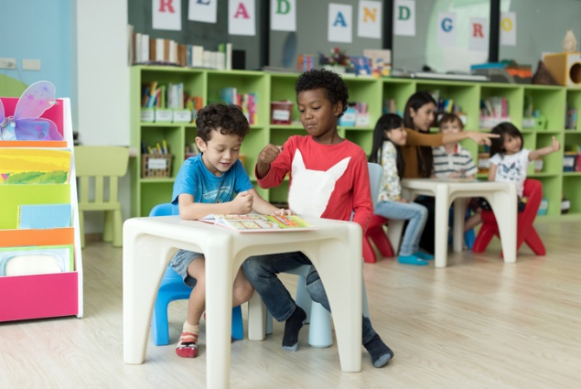
This resource sheet provides a brief outline of a cooperative learning strategy known as 'think- – pair – share'.
Cooperative learning frameworks create opportunities for groups of students to work together, generally to a single purpose.
As well as having the potential to increase learning for all students involved, using these frameworks can help students develop personal and social capability.
iStock images
In the 'think' stage, each student thinks silently about a question asked by the teacher.
In the 'pair' stage, students discuss their thoughts and answers to the question in pairs.
In the 'share' stage, the students share their answer, their partner’s answer or what they decided together. This sharing may be with other pairs or with the whole class. It is important also to let students 'pass'. This is a key element of making the strategy safe for students.
Think –- pair- – share increases student participation and provides an environment for higher levels of thinking and questioning.
iStock images

Appendix 8: Teacher resource sheet 3.1: Construction skills
Construction skills help students to generate and produce solutions for real-world problems.
This resource can be used as a visual stimulus to prompt students to develop solutions to design problems. The cards can be printed to create stations.
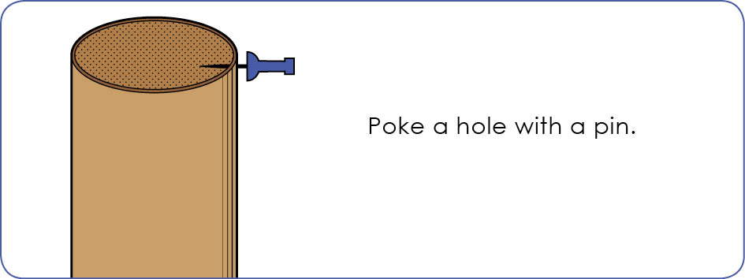
STEM Consortium
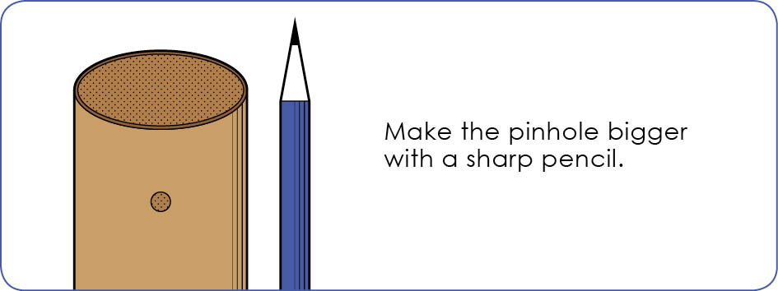
STEM Consortium
Poke a hole with a pin.

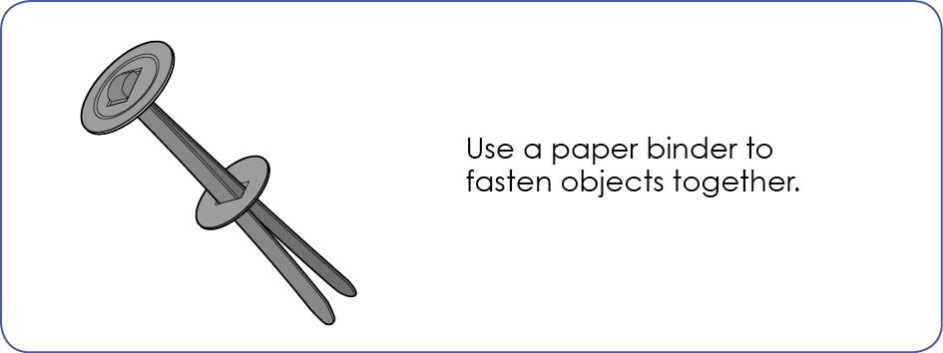
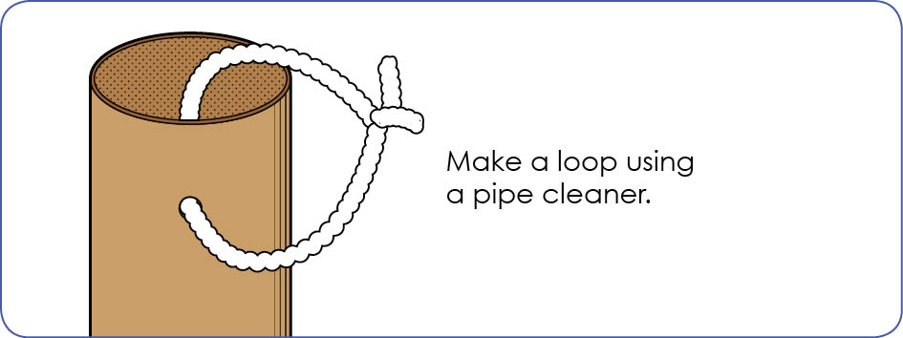
STEM Consortium
STEM Consortium
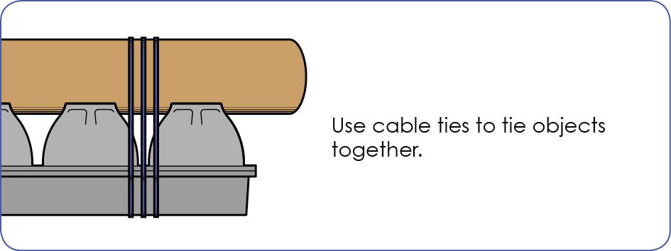
STEM Consortium

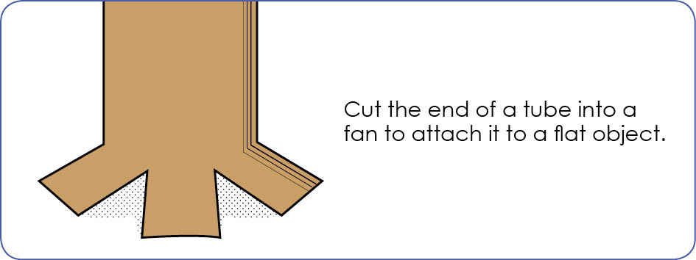
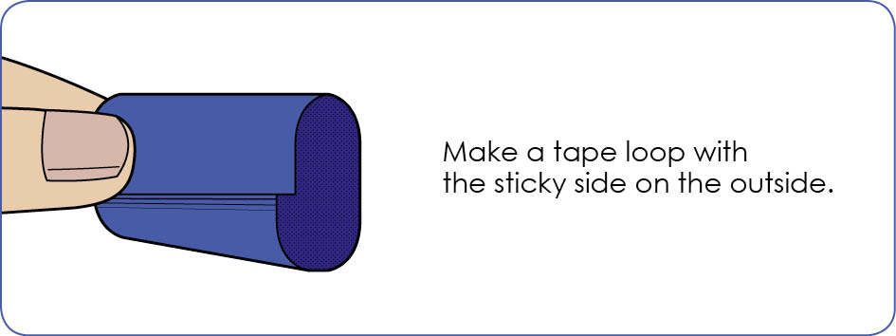
STEM Consortium
STEM Consortium
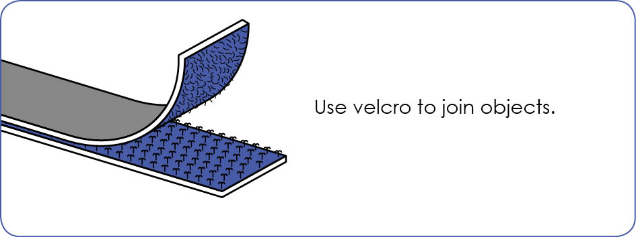
STEM Consortium

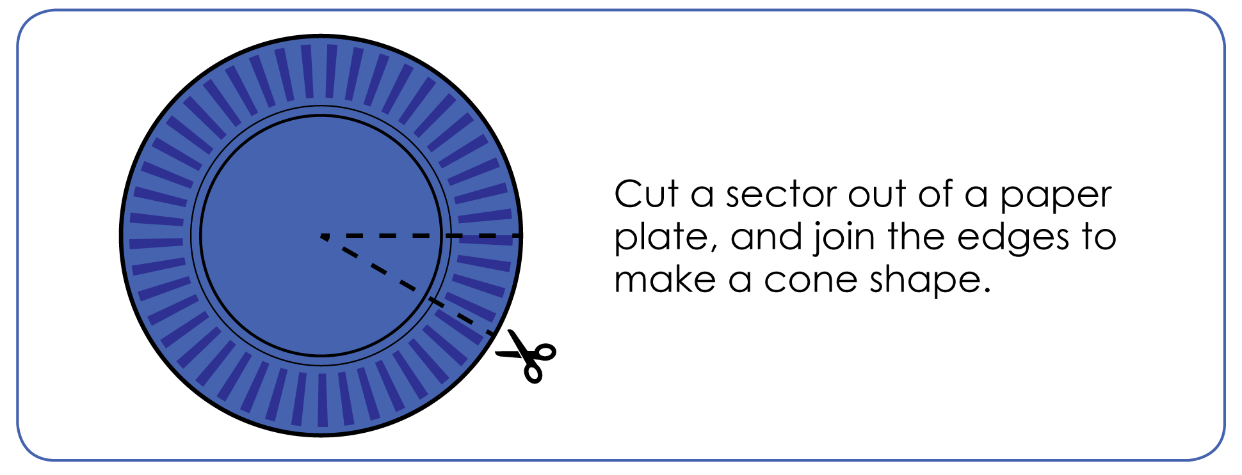
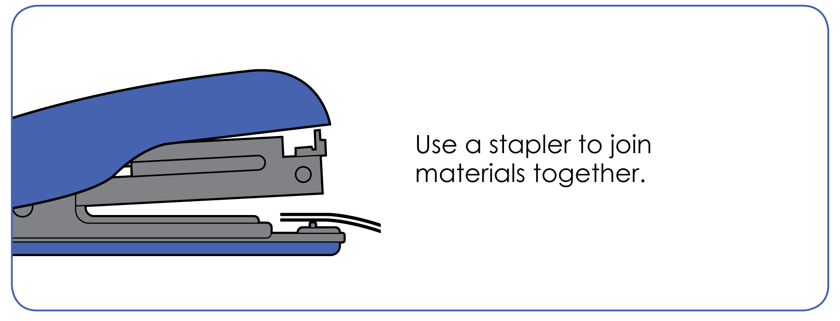
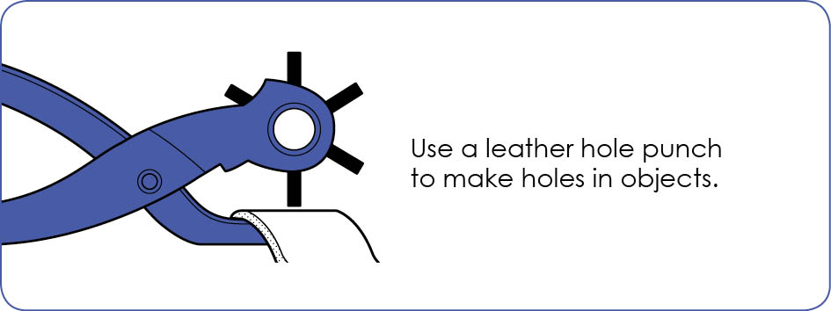
STEM Consortium
STEM Consortium
STEM Consortium

Appendix 9: Student activity sheet 3.2: Prototype development
Poke a hole with a pin.
A chair for my toy
Drawing

Materials I need (photo, drawing or words)

Appendix 10: Student activity sheet 4.1: Reflection

My chair is made from

I used this because

My chair is…
Pixabay images
safe

comfortable

the right size

Photo of my chair

Reflection
Do my toy’s feet touch the floor? Yes No

Can my toy sit up straight? Yes No

Is the seat the right size? Yes No

What would I change?

Peer evaluation
What works well?

How could it be improved?

Appendix 11: Teacher resource sheet 4.2: Sample parent letter
(School details and letterhead)
(Date)

Dear parents/caregivers

RE: CHAIRS FOR BEARS STEM PROJECT

This term, our class is undertaking a STEM (Science, Technology, Engineering and Mathematics) project called Chairs for bears, based on the fiction picture book Bears on Chairs by Shirley Parenteau. This project will involve students in our class designing and creating a chair for a bear or other toy.
This project focuses on analysing the requirements of furniture to be comfortable, safe and an appropriate size. Children will discuss the size and shape of different bears and analyse the requirements for a suitable chair for their own bear, while developing their ability to design, create and problem solve.
To enable us to create the chair at school, we would appreciate if you would please provide a bear for your child to bring into class. The bear must have legs which are bendable at the knee to enable your child to measure and design an adequate chair.
We will be starting the project on (date) and would like the bear to be brought in to class by then.
Once your child has designed their chair, they will bring home a list of materials they will need to make their chair. These materials will be common household items and should not require any expense.
We may require adult assistance during the construction phase. If you are available to help please let me know.

Thank you in advance.

(Classroom teacher)

Appendix 12: Teacher resource sheet 4.3: Sample resources request
(School details and letterhead)
(Date)
Dear parents/caregivers
RE: CHAIRS FOR BEARS STEM PROJECT
As part of our STEM (Science, Technology, Engineering and Mathematics) project called Chairs for bears this term, the students have been looking at the requirements of a chair. They have analysed, planned and designed a chair to fit the bear brought in previously and require the following items to create their project:
- ___________________________________________________
- ___________________________________________________
- ___________________________________________________
- ___________________________________________________
- ___________________________________________________
- ___________________________________________________
- ___________________________________________________
We will begin to create our chairs on [date]. Please have these items stored in a bag and bring them in before this date. If you are available to assist in construction, please let me know. Thank you in advance.
Kind regards

[Classroom teacher]

Notes
_______________________________________________________________________________________________________________________________________________________________________________________________________________________________________________________________________________________________________________________________________________________________________________________________________________________________________________________________________________________________________________________________________________________________________________________________________________________________________________________________________________________________________________________________________________________________________________________________________________________________________________________________________________________________________________________________________________________________________________________________________________________________________________________________________________________________________________________________________________________________________________________________________________________________________________________________________________________________________________________________________________________________________________________________________________________________________________________________________________________________________________________________________________________________________________________________________________________________

Notes
_______________________________________________________________________________________________________________________________________________________________________________________________________________________________________________________________________________________________________________________________________________________________________________________________________________________________________________________________________________________________________________________________________________________________________________________________________________________________________________________________________________________________________________________________________________________________________________________________________________________________________________________________________________________________________________________________________________________________________________________________________________________________________________________________________________________________________________________________________________________________________________________________________________________________________________________________________________________________________________________________________________________________________________________________________________________________________________________________________________________________________________________________________________________________________________________________________________________________

