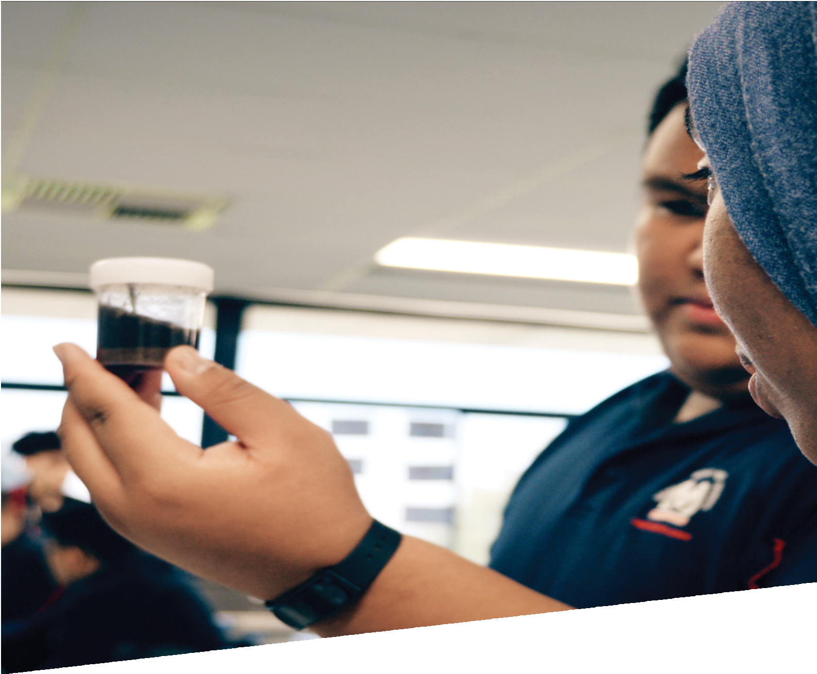

CURRICULUM RESOURCE MODULE
Template
YEAR 11 AND 12
Acknowledgements
The STEM Learning Project is funded by the Western Australian Department of Education (the Department) and implemented by a consortium in STEM education comprising the Educational Computing Association of WA, the Mathematical Association of WA, the Science Teachers Association of WA and Scitech. We acknowledge and thank the teachers and schools who are creating and sharing good STEM teaching and learning.
This curriculum resource module has been produced using a template developed through the STEM Learning Project. The content of the module not been reviewed or recommended by the Department of Education or any members of the STEM education consortium.
Copyright and intellectual property
The copyright and intellectual property of this module remain the property of the Department.
Any Western Australian Curriculum content in this resource is used with the permission of the School Curriculum and Standards Authority; this permission does not constitute Authority endorsement of the resource. The Authority accepts no liability for any errors or damages arising from reliance on its content. The Western Australian Curriculum content may be freely copied, or communicated on an intranet, for non-commercial purposes in educational institutions, provided that the Authority is acknowledged as the copyright owner. Copying or communication for any other purpose can be done only within the terms of the Copyright Act 1968 or with prior written permission of the Authority. Any Australian Curriculum content in the Western Australian Curriculum is used by the Authority under the terms of the Creative Commons Attribution-NonCommercial 3.0 Australia licence.
Any content on the www.scsa.wa.edu.au domain that has been derived from the Australian Curriculum may be used under the terms of Creative Commons Attribution-NonCommercial 3.0 Australia licence.
Appendix 2: General capabilities continuums is adapted from ACARA, © Australian Curriculum, Assessment and Reporting Authority (ACARA) 2009 to present, unless otherwise indicated. This material was downloaded from the ACARA website (www.acara.edu.au) (accessed December 2015) and was not modified. The material is licensed under CC BY 4.0 (https://creativecommons.org/licenses/by/4.0/). ACARA does not endorse any product that uses ACARA material or make any representations as to the quality of such products. Any product that uses material published on this website should not be taken to be affiliated with ACARA or have the sponsorship or approval of ACARA. It is up to each person to make their own assessment of the product.
Attributions: List in italics any trademarked products you refer to such as Google, Word etc
Kidblog, Weebly, Evernote (should be in all Yr 7 to 12 modules as part of Appendix 5.)
Autodesk, Tinkercad, SketchUp (if Appendix 4B is present)

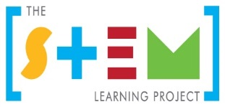
The table of contents will build itself. Simply right click and "update field".
Table of contents

The STEM Learning Project 2
Suggested process for developing a STEM curriculum resource module 3
Instructions on using the CRM template 4
Overview 5
Activity sequence and purpose 8
Background 9
Activity 1: Title 11
Activity 2: Title 13
Activity 3: Title 15
Activity 4: Title 17
Appendix 1: Western Australian Certificate of Education course syllabus links 19
Appendix 2: Materials list 20
Appendix XX: Design process guide 21
Appendix XX: Drawing in the design process 22
Appendix XX: Student journal 23
Appendix XX: Student activity sheet X.X: Journal checklist 24
Appendix X: Teacher resource sheet X.X: Cooperative learning – Roles 25
Appendix XX: Student activity sheet X.X: Prototype troubleshooting 53
Appendix XX: Student activity sheet X.X: Peer evaluation 54
Appendix XX: Student activity sheet X.X: Self-evaluation 55

The STEM Learning Project
The aim of the STEM Learning Project is to generate students’ interest, enjoyment and engagement with STEM (Science, Technology, Engineering and Mathematics) and to encourage their ongoing participation in STEM both at school and in subsequent careers. The curriculum resources will support teachers to implement and extend the Western Australian Curriculum and develop the general capabilities across Kindergarten to Year 12.
Why STEM?
A quality STEM education will develop the knowledge and intellectual skills to drive the innovation required to address global economic, social and environmental challenges.
STEM capability is the key to navigating the employment landscape changed by globalisation and digital disruption. Routine manual and cognitive jobs are in decline whilst non-routine cognitive jobs are growing strongly in Australia. Seventy-five per cent of the jobs in the emerging economy will require critical and creative thinking and problem solving, supported by skills of collaboration, teamwork and literacy in mathematics, science and technology. This is what we call STEM capability. The vision is to respond to the challenges of today and tomorrow by preparing students for a world that requires multidisciplinary STEM thinking and capability.
The approach
STEM capabilities are developed when students are challenged to solve open-ended, real-world problems that engage students in the processes of the STEM disciplines.
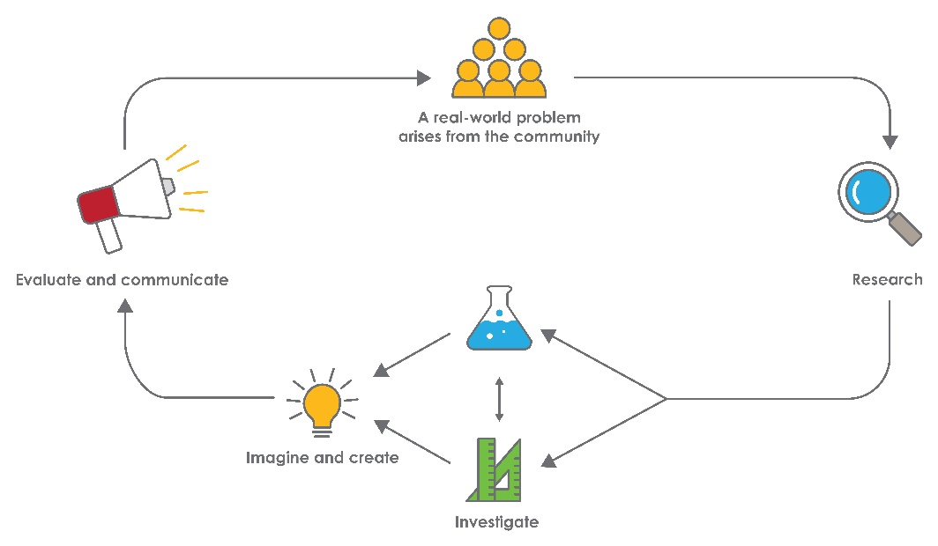
STEM Consortium

Suggested process for developing a STEM curriculum resource module
The module should encourage learning that is student-led and teacher-facilitated.
Steps to designing an effective CRM
- Consider the elements and pedagogy the module should include, such as:
- A problem-based learning pedagogy
- A real-world problem in an authentic context
- STEM learning area content
- Suitability for all learners
- Design process
- Opportunities, where possible, to use and develop ICT skills
- Opportunities for developing higher order thinking, collaborative learning skills and reflective practice.
- Develop a clear theme and the driving question you would like students to solve.
Consider current real-world problems both globally and locally. Review the United Nations Sustainable Development Goals for inspiration. Think about the big issues for Western Australia.
Bring the real-world problem down to the context of the students: How does this problem relate to important issues for the local community, students in your classroom or families at your school?
- Align student learning with the content of relevant Science, Technologies and Mathematics WACE courses. Identify opportunities for students to develop the general capabilities and the cross-curriculum priorities.
- Develop an outline for each Activity;
- Activity 1 – Research
What and how will the students research to develop their understandings of the problem? How will their prior knowledge be drawn upon?
- Activity 2 – Investigate
What science and mathematics investigations will they carry out to understand the variables that impact upon the problem?
- Activity 3 – Imagine and create
How will students enagae with technologoies and the design process to ideate their solutions?
- Activity 4 – Evaluate and communicate
How will students pitch their solutions? How could industry or other authentic audienes be involved?

Instructions on using the CRM template
When working with the template please note the following:
- The green text and the ### symbols are either instructions or examples and should be replaced as you develop your CRM.
- It may be useful to have a copy of an existing module as an example of how a module looks and what it contains.

Year X – Module title

Overview
A general overarching view of the module:

What is the context?
Describe the context in relation to the year level of the students.

What is the problem?
What is the problem the students will be solving?

How does this module support integration of the STEM disciplines?
Science
Describe how the content of the selected science WACE course/s are integrated into this module. How is the content related to the activtities in which the students will participate? What will the students learn?

Technology
Describe how the content of the selected technologies WACE course/s are integrated into this module. How is the content related to the activtities in which the students will participate? What will the students learn?
The Design process guide is included as a resource to provide assistance to teachers in understanding the complete design process as developed in the Technologies syllabus.

Mathematics
Describe how the content of the selected mathematics WACE course/s are integrated into this module. How is the content related to the activtities in which the students will participate? What will the students learn?

General capabilities
There are opportunities for the development of general capabilities and cross-curriculum priorities as students engage with module title. In this module, students:
- Develop critical and creative thinking skills as they research the problem and its context (Activity 1); investigate parameters impacting on the problem (Activity 2); imagine and develop solutions (Activity 3); and evaluate and communicate their solutions to an audience (Activity 4).
- Utilise creative thinking as they generate possible design solutions; and critical thinking, numeracy skills and ethical understanding as they choose between alternative approaches to solving the problem of …………….
- Utilise personal and social capability as they develop socially cohesive and effective working teams; collaborate in generating solutions; adopt group roles; and reflect on their group work capabilities through self and peer evaluation.
- Utilise a range of literacies and information and communication technology (ICT) capabilities as they collate records of work completed throughout the module in a journal; represent and communicate their solutions to an audience using digital technologies in Activity 4.
- Communicate and, using evidence, justify their group’s design to an authentic audience.
What are the pedagogical principles of the STEM learning modules?
The STEM Learning Project modules develop STEM capabilities by challenging students to solve real-world problems set in authentic contexts. The problems engage students in the STEM disciplines and provide opportunities for developing higher order thinking and reasoning, and the general capabilities of creativity, critical thinking, communication and collaboration.
The design of the modules is based on four pedagogical principles:
- Problem-based learning
All modules are designed around students solving an open-ended, real-world problem. Learning is supported through a four-phase instructional model: research the problem and its context; investigate the parameters impacting on the problem; design and develop solutions to the problem; and evaluate and communicate solutions to an authentic audience.
- Developing higher order thinking
Opportunities are created for higher order thinking and reasoning through questioning and discourse that elicits students' thinking, prompts and scaffolds explanations, and requires students to justify their claims. Opportunities for making reasoning visible through discourse are highlighted in the modules with the icon shown here.
- Collaborative learning
This provides opportunities for students to develop teamwork and leadership skills, challenge each other’s ideas, and co-construct explanations and solutions. Information that can support teachers with aspects of collaborative learning is included in the resource sheets.
- Reflective practice
Recording observations, ideas and one’s reflections on the learning experiences in some form of journal fosters deeper engagement and metacognitive awareness of what is being learnt. Information that can support teachers with journaling is included in the resource sheets.
These pedagogical principles can be explored further in the STEM Learning Project online professional learning modules located in Connect Resources.
Istockphoto.com

Activity sequence and purpose
Activity title
Activity 1 focus. One or two sentences that summarise the main aspects of the Activity.
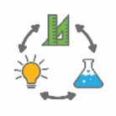  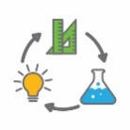 | Activity title  Activity 2 focus. One or two sentences that summarise the main aspects of the Activity.
Activity title
Activity 3 focus. One or two sentences that summarise the main aspects of the Activity.
Activity title
Activity 4 focus. One or two sentences that summarise the main aspects of the Activity.

Background
Expected learning | Expected learning from Year 11/12 science course name includes:  Expected learning from Year 11/12 technologies course name includes:  1.  2.  3.  Expected learning from Year 11/12 mathematics course name includes:  1.  2.  3.
Vocabulary | The specific vocabulary of the module can be captured here or listed in a resource sheet in the appendices.  This module uses subject-specific terminology, some of which is shown in Teacher resource sheet #.#: title title.  The following vocabulary list contains other terms that need to be understood, either before the module commences or developed as they are used.
Timing | You can use this statement or make notes on the time you anticipate it will take to complete the module.  There is no prescribed duration for this module. The module is designed to be flexible enough for teachers to adapt. Activities do not equate to lessons; one activity may require more than one lesson to implement.
Consumable materials | The specific materials required for your module that are not ordinarily found in your classroom can be captured here or listed in a resource sheet in the appendices.  A Materials list is provided for this module. The list outlines materials outside of normal classroom equipment that will be needed to complete the activities.
Safety notes | General safety notes for the teacher to consider  There are potential hazards inherent in these activities and with the equipment being used, and a plan to mitigate any risks will be required.  Potential hazards specific to this module include but are not limited to:  - Possible exposure to cyber bullying, privacy violations and uninvited solicitations when using the internet
Enterprise skills | The ######### module focuses on higher order skills with significant emphasis on expected learning from the general capabilities and consideration of what are considered to be enterprise skills.  Enterprise skills include problem solving, communication skills, digital literacy, teamwork, critical thinking and presentation skills.  Further background is available from the Foundation for Young Australians in the New Work Order six report series. A summary can be found at: www.fya.org.au/report/new-work-order-summary
Assessment | The STEM modules have been developed to provide students with learning experiences to solve authentic real-world problems using science, technology, engineering, and mathematics capabilities.  Appendix 1 – Western Australian Certificate of Education course syllabus links indicates the expected learning from WACE courses from the Science, Technologies and Mathemaics learning areas.  While working through the module, the following assessment opportunities will arise:  - List potential assessment opportunities

Activity 1: Title
Activity focus | One or two sentences that summarise the main aspects of the Activity.
Background information | Information the teacher may find useful prior to implementing the lesson. The purpose is to provide teachers with comprehensive information to reduce the need to research in areas outside their subject area expertise.
Instructional procedures | Procedures to assist in the successful implementation of the activity. For example, visualisation strategies, cooperative learning strategies, inquiry based instructional strategies, differentiation, use of technology, higher order thinking and reasoning questions, modelling of classroom discourse and behaviour management strategies.
Expected learning | List the syllabus content. These should also be included in Appendix 1  Expected learning from Year 11/12 science course name includes:  1.  2.  3.  Expected learning from Year 11/12 technologies course name includes:  1.  2.  3.  Expected learning from Year 11/12 mathematics course name includes:  1.  2.  3.
Equipment required | For the class:
 | For the students:
Preparation | List any tasks or equipment that needs to be organised prior to the start of the Activity.
Activity parts | Decide on the individual tasks students will complete and describe them here. Include some well considered open questions.  Part 1: ###
 | Part 2: ###
 | Part 3: ###
 | Part 4: ###
 | Part 5: Reflection / journaling
Resource sheets | List resource sheets you develop here.
Digital resources | Provide links to websites with information to enhance learning.

Activity 2: Title
Activity focus | One or two sentences that summarise the main aspects of the Activity.
Background information | Information the teacher may find useful prior to implementing the lesson. The purpose is to provide teachers with comprehensive information to reduce the need to research in areas outside their subject area expertise.
Instructional procedures | Procedures to assist in the successful implementation of the activity. For example, visualisation strategies, cooperative learning strategies, inquiry based instructional strategies, differentiation, use of technology, higher order thinking and reasoning questions, modelling of classroom discourse and behaviour management strategies.
Expected learning | List the syllabus content. These should also be included in Appendix 1  Expected learning from Year 11/12 science course name includes:  1.  2.  3.  Expected learning from Year 11/12 technologies course name includes:  1.  2.  3.  Expected learning from Year 11/12 mathematics course name includes:  1.  2.  3.
Equipment required | For the class:
 | For the students:
Preparation | List any tasks or equipment that needs to be organised prior to the start of the Activity.
Activity parts | Decide on the individual tasks students will complete and describe them here. Include some well considered open questions.  Part 1: ###
 | Part 2: ###
 | Part 3: ###
 | Part 4: ###
 | Part 5: Reflection / journaling
Resource sheets | List resource sheets you develop here.
Digital resources | Provide links to websites with information to enhance learning.

Activity 3: Title
Activity focus | One or two sentences that summarise the main aspects of the Activity.
Background information | Information the teacher may find useful prior to implementing the lesson. The purpose is to provide teachers with comprehensive information to reduce the need to research in areas outside their subject area expertise.
Instructional procedures | Procedures to assist in the successful implementation of the activity. For example, visualisation strategies, cooperative learning strategies, inquiry based instructional strategies, differentiation, use of technology, higher order thinking and reasoning questions, modelling of classroom discourse and behaviour management strategies.
Expected learning | List the syllabus content. These should also be included in Appendix 1  Expected learning from Year 11/12 science course name includes:  1.  2.  3.  Expected learning from Year 11/12 technologies course name includes:  1.  2.  3.  Expected learning from Year 11/12 mathematics course name includes:  1.  2.  3.
Equipment required | For the class:
 | For the students:
Preparation | List any tasks or equipment that needs to be organised prior to the start of the Activity.
Activity parts | Decide on the individual tasks students will complete and describe them here. Include some well considered open questions.  Part 1: ###
 | Part 2: ###
 | Part 3: ###
 | Part 4: ###
 | Part 5: ### Reflection / journaling
Resource sheets | List resource sheets you develop here.
Digital resources | Provide links to websites with information to enhance learning.

Activity 4: Title
Activity focus | One or two sentences that summarise the main aspects of the Activity.
Background information | Information the teacher may find useful prior to implementing the lesson. The purpose is to provide teachers with comprehensive information to reduce the need to research in areas outside their subject area expertise.
Instructional procedures | Procedures to assist in the successful implementation of the activity. For example, visualisation strategies, cooperative learning strategies, inquiry based instructional strategies, differentiation, use of technology, higher order thinking and reasoning questions, modelling of classroom discourse and behaviour management strategies.
Expected learning | List the syllabus content. These should also be included in Appendix 1  Expected learning from Year 11/12 science course name includes:  1.  2.  3.  Expected learning from Year 11/12 technologies course name includes:  1.  2.  3.  Expected learning from Year 11/12 mathematics course name includes:  1.  2.  3.
Equipment required | For the class:
 | For the students:
Preparation | List any tasks or equipment that needs to be organised prior to the start of the Activity.
Activity parts | Decide on the individual tasks students will complete and describe them here. Include some well considered open questions.  Part 1: ###
 | Part 2: ###
 | Part 3: ###
 | Part 4: ###
 | Part 5: ### Reflection / journaling
Resource sheets | List resource sheets you develop here.
Digital resources | Provide links to websites with information to enhance learning.

Appendix 1: Western Australian Certificate of Education course syllabus links
Create additional rows as required
WACE course syllabus links
Year 11/12 WACE science course name
Unit content
Year 11/12 WACE technologies course name
Unit content
Year 11/12 WACE mathematics course name
Unit content

Appendix 2: Materials list

The following materials are required to complete this module.

List materials required

Appendix XX: Design process guide
Safe production of the final design or multiple copies of the final design.
Fine tuning the production process, such as division of labour for batch or mass production.
Use of intended materials and appropriate tools to safely make the solution to the design problem.
Reflection on the process taken and the success of the design.
Evaluation can lead to further development or improvement of the design and can be a final stage of the design process before a conclusion is reached.
Could be formal or informal and verbal or written.
Ideation
Development
Development of the design ideas. Improvements, refinements, adding detail, making it better.
Activities such as detailed drawings, modelling, prototyping, market research, gaining feedback from intended user, further research – if needed – to solve an issue with the design, testing different tools or equipment, trialling production processes, measuring or working out dimensions, testing of prototypes and further refinement.
Idea generation – turning ideas into tangible forms so they can be organised, ordered and communicated to others.
Activities such as brainstorming, mind mapping, sketching, drawing diagrams and plans, collecting colour samples and/or material samples and talking through these ideas can help to generate fu creative ideas.
Using the SCAMPER model can assist with this: www.mindtools.com/pages/article/newCT_02.htm
www.designorate.com/a-guide-to-the-scamper-technique-for- creative-thinking
Analysis
Finding useful and helpful information about the design problem.
Gathering information, conducting surveys, finding examples of existing solutions, testing properties of materials, practical testing.
Understanding the meaning of the research findings.
Analysing what the information means, summarising the surveys, judging the value of existing solutions, understanding test results.
Research
Production
Evaluation

Appendix XX: Drawing in the design process
Incorporating the design process into the STEM modules will often result in the need for students to draw plans of their designs. This can be done at a simple level using hand drawn sketches or at a more technical level using computer-aided design (CAD).
istockphoto.com
By developing skills using industry standard software, students may be well-placed to explore future career pathways.
There are several CAD software options; two free examples are detailed below. Autodesk is a third package that is also free for educational use.
Tinkercad
- Format: Web-based app requiring internet access via a browser
- Purpose: A simple, online 3D design and 3D printing app
- Home: www.tinkercad.com
- Blog: blog.tinkercad.com
- Tutorials: www.tinkercad.com/learn
- Feature: Connects to 3D printing and laser cutting.
SketchUp
- Format: Can be downloaded and installed on devices, or used in a browser
- Purpose: Enables students to draw in 3D
- Home: www.sketchup.com 'Products' 'SketchUp for Schools'
- Help centre: help.sketchup.com/en
- Blog: blog.sketchup.com
- Tutorials: www.youtube.com/user/SketchUpVideo. From beginner tool tips to intermediate and advanced modelling techniques, the video tutorials help to build SketchUp skills.

Appendix XX: Student journal
When students reflect on learning and analyse their ideas and feelings, they self-evaluate, thereby improving their metacognitive skills.
This module encourages students to self-reflect and record the stages of their learning in a journal, which may take the form of a written journal, a portfolio or a digital portfolio.
istockphoto.com
Using digital portfolios can help develop students’ information and communication technology (ICT) capability.
Reflective practice and recording can be supported in classrooms by creating opportunities for students to think about and record their learning through notes, drawings or pictures. Teachers should encourage students to revisit earlier journal entries to help them observe the progress of their thoughts and understanding.
Journals are a useful tool that gives teachers additional insight into how students value their own learning and progress, as well as demonstrating their individual achievements.
The following links provide background information and useful apps for journaling.
Reflective journal (University of Technology Sydney)
www.uts.edu.au/sites/default/files/reflective_journal.pdf
Reflective writing (University of New South Wales Sydney))
student.unsw.edu.au/reflective-writing
Balancing the two faces of ePortfolios (Helen Barrett, 2009)
electronicportfolios.org/balance/Balancing.jpg
Digital portfolios for students (Cool tools for school)
cooltoolsforschool.wordpress.com/digital-student-portfolios
Kidblog – digital portfolios and blogging
kidblog.org/home
Evernote (a digital portfolio app)
evernote.com
Weebly for education (a drag and drop website builder)
education.weebly.com
Connect – the Department of Education’s integrated, online environment
connect.det.wa.edu.au

Appendix XX: Student activity sheet X.X: Journal checklist
As an ongoing part of this module, you have been keeping a journal of your work.
Before submitting your journal to your teacher please ensure you have included the following information.
- Tick each box once complete and included.
- Write N/A for items that were not required in this module.
istockphoto.com

Your name and group member's names or photographs
An explanation of the problem you are solving
Your notes from Activity 1
Your notes from Activity 2
Your notes from Activity 3
Your notes from Activity 4
Student activity sheet #.#: #############
Student activity sheet #.#: #############
Student activity sheet #.#: #############
Student activity sheet 1.0: Journal checklist

Appendix X: Teacher resource sheet X.X: Cooperative learning – Roles
Cooperative learning frameworks create opportunities for groups of students to work together, generally to a single purpose.
As well as having the potential to increase learning for all students involved, using these frameworks can help students develop personal and social capability.
When students are working in groups, positive interdependence can be fostered by assigning roles to group members.
istockphoto.com
These roles could include:
- working roles such as Reader, Writer, Summariser, Timekeeper
- social roles such as Encourager, Observer, Noise monitor, Energiser.
Further to this, specific roles can be delineated for specific activities that the group is completing. It can help students if some background to the purpose of group roles is made clear to them before they start, but at no time should the roles get in the way of the learning. Teachers should decide when or where roles are appropriate to given tasks.

istockphoto.com

Appendix XX: Student activity sheet X.X: Prototype troubleshooting
Problem | Cause | Possible changes to your design to solve the problem

Appendix XX: Student activity sheet X.X: Peer evaluation
 | Always | Usually | Sometimes | Rarely
Remains focused on tasks presented
Completes set tasks to best of their ability
Works independently without disrupting others
Uses time well
Cooperates effectively within the group
Contributes to group discussions
Shows respect and consideration for others
Uses appropriate conflict resolution skills
Comes to class prepared for activities
Actively seeks and uses feedback

Comments: __________________________________________________________________________________________________________________________________________________________________________________________________________________________________________________________________________________________________________________________________________________________

Appendix XX: Student activity sheet X.X: Self-evaluation
 | Always | Usually | Sometimes | Rarely
Remains focused on tasks presented
Completes set tasks to best of their ability
Works independently without disrupting others
Uses time well
Cooperates effectively within the group
Contributes to group discussions
Shows respect and consideration for others
Uses appropriate conflict resolution skills
Comes to class prepared for activities
Actively seeks and uses feedback

Comments: __________________________________________________________________________________________________________________________________________________________________________________________________________________________________________________________________________________________________________________________________________________________

Notes
________________________________________________________________________________________________________________________________________________________________________________________________________________________________________________________________________________________________________________________________________________________________________________________________________________________________________________________________________________________________________________________________________________________________________________________________________________________________________________________________________________________________________________________________________________________________________________________________________________________________________________________________________________________________________________________________________________________________________________________________________________________________________________________________________________________________________________________________________________________________________________________________________________________________________________________________________________________________________________________________________________________________________________________________________________________________________________________________________________________________________________________________________________________________________________________________________________________________

