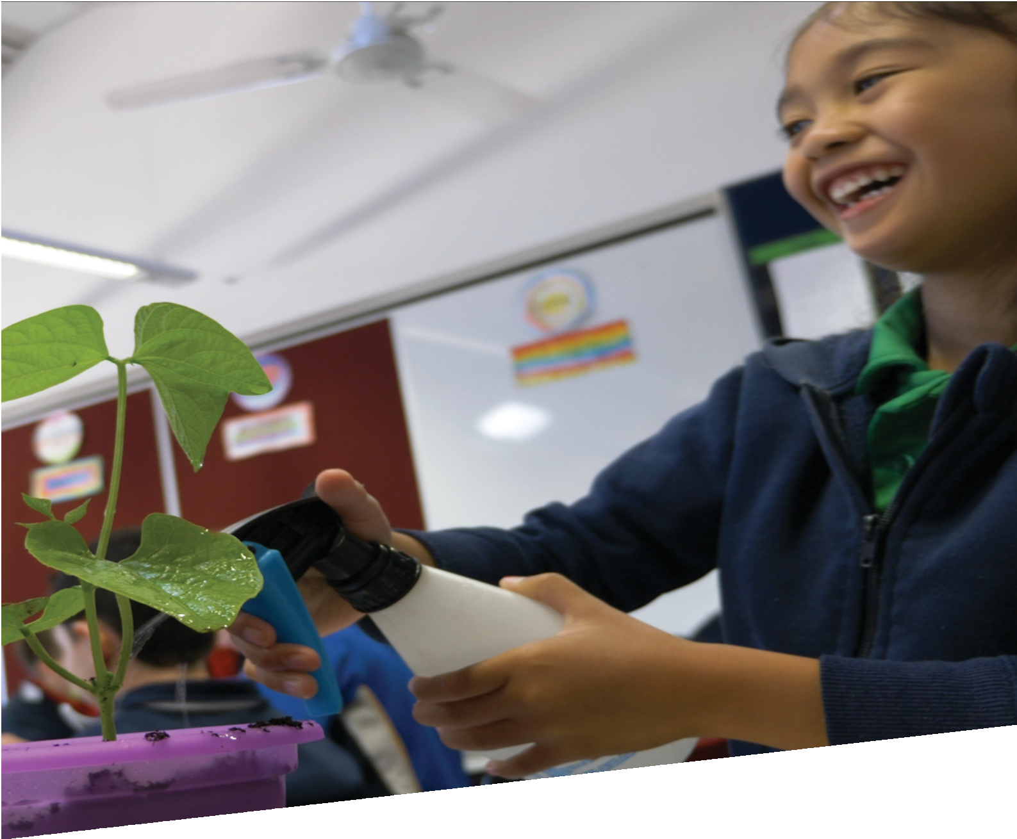

CURRICULUM RESOURCE MODULE

**Growing food**

YEAR 1

**Acknowledgements**

The STEM Learning Project respectfully acknowledges the Traditional Custodians of the lands upon which our students and teachers live, learn and educate.

The STEM Learning Project is funded by the Western Australian Department of Education (the Department) and implemented by a consortium in STEM education comprising the Educational Computing Association of Western Australia, the Mathematical Association of Western Australia, the Science Teachers Association of Western Australia and Scitech. We acknowledge and thank the teachers and schools who are the co-creators of these resources.

**Copyright and intellectual property**

The copyright and intellectual property of this module remain the property of the Department.

Any Western Australian Curriculum content in this resource is used with the permission of the School Curriculum and Standards Authority (the Authority); this permission does not constitute Authority endorsement of the resource. The Authority accepts no liability for any errors or damages arising from reliance on its content.

The Western Australian Curriculum content may be freely copied, or communicated on an intranet, for non-commercial purposes in educational institutions, provided that the Authority is acknowledged as the copyright owner. Copying or communication for any other purpose can be done only within the terms of the Copyright Act 1968 or with prior written permission of the Authority. Any Australian Curriculum content in the Western Australian Curriculum is used by the Authority under the terms of the Creative Commons Attribution­ NonCommercial 3.0 Australia licence.

Any content on the [www.scsa.wa.edu.au](http://www.scsa.wa.edu.au) domain that has been derived from the Australian Curriculum may be used under the terms of Creative Commons Attribution-NonCommercial 3.0 Australia licence.

Appendix 2: General capabilities continuums are adapted from ACARA, © Australian Curriculum, Assessment and Reporting Authority (ACARA) 2009 to present, unless otherwise indicated. This material was downloaded from the ACARA website (www.acara.edu.au) (accessed December 2015) and was not modified. The material is licensed under CC BY 4.0 (https://creativecommons.org/licenses/by/4.0/). ACARA does not endorse any product that uses ACARA material or make any representations as to the quality of such products. Any product that uses material published on this website should not be taken to be affiliated with ACARA or have the sponsorship or approval of ACARA. It is up to each person to make their own assessment of the product.

This resource includes references and examples of iOS, Android and other apps. The Department does not endorse or recommend any commercial products and simply provides these as examples for teachers.

The Department is committed to providing quality information to its customers. Whilst every effort has been made to ensure accuracy, currency and reliability of the information within these documents, the Department accepts no responsibility for errors, omissions or amendments made since the time of publishing. Confirmation of information may be sought from the Department or the originating bodies providing the information. The Department has no control over the content of material published on websites to which users are referred in this resource. It is the responsibility of the internet user to make their own decision as to the relevancy, accuracy, currency and reliability of information found on those sites.

Attributions: *Microsoft Word, Google, Google Earth*



Table of contents

The STEM Learning Project 2

Overview 3

Activity sequence and purpose 8

Background 9

Activity 1: The needs of plants 11

Activity 2: Sunny or shady 17

Activity 3: Planting time 22

Activity 4: Presentation 28

Appendix 1A: Links to the Western Australian Curriculum 31

Appendix 1B: Mathematics proficiency strands 33

Appendix 2: General capabilities continuums 34

Appendix 3: Materials list 37

Appendix 4: Design process guide 38

Appendix 5: Reflective journal 39

Appendix 6: Teacher resource sheet 1.1: Cooperative learning – Roles 40

Appendix 7: Teacher resource sheet 1.2: Cooperative learning – Think, Pair, Share 41

Appendix 9: Teacher resource sheet 1.4: Vocabulary word wall 42

Appendix 10: Student activity sheet 1.5: Recording observations 43

Appendix 11: Student activity sheet 2.1: Level of light 44

Appendix 12: Teacher resource sheet 3.1: Construction skills 45

Appendix 13: Student activity sheet 4.1: Design review 50

# The STEM Learning Project

The aim of the STEM Learning Project is to generate students’ interest, enjoyment and engagement with STEM (Science, Technology, Engineering and Mathematics) and to encourage their ongoing participation in STEM both at school and in subsequent careers. The curriculum resources will support teachers to implement and extend the Western Australian Curriculum and develop the general capabilities across Kindergarten to Year 12.

**Why STEM?**

A quality STEM education will develop the knowledge and intellectual skills to drive the innovation required to address global economic, social and environmental challenges.

STEM capability is the key to navigating the employment landscape changed by globalisation and digital disruption. Routine manual and cognitive jobs are in decline whilst non-routine cognitive jobs are growing strongly in Australia. Seventy-five per cent of the jobs in the emerging economy will require critical and creative thinking and problem solving, supported by skills of collaboration, teamwork and literacy in mathematics, science and technology. This is what we call STEM capability. The vision is to respond to the challenges of today and tomorrow by preparing students for a world that requires multidisciplinary STEM thinking and capability.

**The approach**

STEM capabilities are developed when students are challenged to solve open-ended, real-world problems that engage students in the processes of the STEM disciplines.

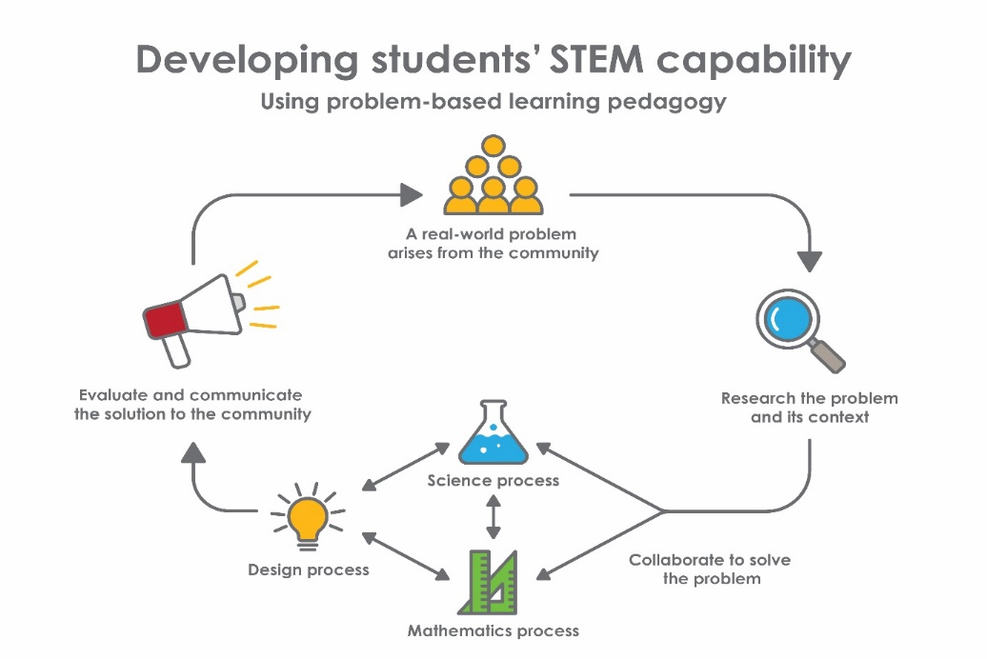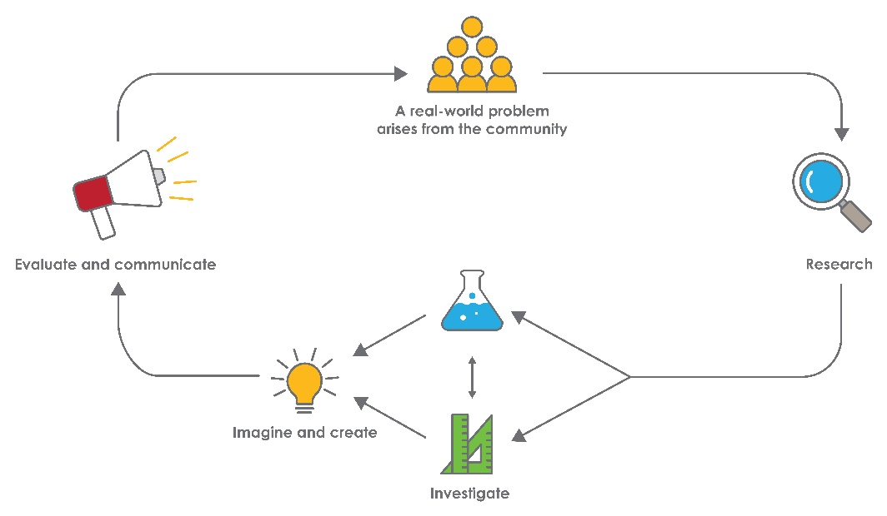

**Year 1 – Growing food**

# Overview

|  |
| --- |
| In Australia, increased salinity occurs due to rising water tables often caused by the clearing of natural vegetation. This has a significant impact on agricultural production, water quality, terrestrial biodiversity and soil erosion. Arable farmland for growing crops and land for native flora and fauna is also affected by climate change and urban development. The design of urban communities has also changed over time and many families now live on small blocks with limited space for gardens.  **What is the context?**  Plants are living organisms essential to human existence. They have five basic needs for survival - sunlight, nutrients, water, air and a suitable temperature.  To meet environmental challenges and trends in new communities, innovative spaces and ways of growing food plants need to be developed.  **What is the problem?**  How can we optimise the growth of our plants? |
| **How does this module support integration of the STEM disciplines?**  **Science**  The science understandings relevant to this module (*ACSSU017: Living things have a variety of external features and ACSSU211: Living things live in different places where their needs are met*) are explicitly developed in Activities 1 and 2. To benefit from the new learning in this module it is assumed that students are aware, from Pre-Primary, that living things have basic needs, including food and water and that they have had experience in observing living things. The science in Activity 2 is designed to introduce students to the needs of plants and the idea that plants must have these needs met in the environment in which they grow.  While most young students recognise the stem, leaves, and flowers of plants, fewer identify roots as a common structure. Students may need experiences observing root systems of various plants.  Students at this age tend to give plants human characteristics, especially when it comes to considering the things plants need to grow. They may describe plants as eating, drinking, or breathing or believe that plants need things that are provided by people. The role of light and nutrients in plant growth is difficult for young students who may view sunlight as useful, but not essential, for plant growth or that the main benefit of sunlight is warmth rather than energy. Young students may  also believe that plants must have soil for support and nutrients. They may need to experience activities involving plants in a range of environments, including soil free environments, before they come to understand the needs of plants.  Initially students’ understanding may be influenced by the way words like ‘plants’ are used in everyday language. Students will often hear the word ‘plants’ in reference to small, decorative plants in gardens and nurseries and therefore may not recognise that trees, vegetables and grass are also plants. Fertiliser, often called “plant food,” may add to the confusion if students misinterpret the name to mean that it is essential for plant survival. Young students may believe that because plants cannot move independently that they cannot be alive. They may also overgeneralise and believe that if something is in the ground, it is alive and extend the concept to non-living objects such as rocks.  Young students may think of a fair test as being one where ‘everyone gets a turn’ and find the concept of controlling variables whilst manipulating just one difficult to grasp. They need to be guided to investigate answers to questions (*ACSIS025: Participate in guided investigations to explore and answer questions*) and to record their observations. Students will need to experience many measuring activities using informal uniform length units *(ACSIS026: Use informal measurements to collect and record observations, using* [*digital technologies*](https://k10outline.scsa.wa.edu.au/home/p-10-curriculum/curriculum-browser/science-v8/overview/glossary/digital-technologies) *as appropriate*) and physical centimetre units before they will come to understand how the numbers on a ruler mark intervals of standardised centimetre lengths.  Activity 3 provides opportunities to challenge students’ thinking about the places in which plants live and allows them to choose, and investigate, the optimum environment for their plant. They collect data about the growth of their plants and record and describe the changes they observe (*ACSHE021: Science involves observing, asking questions about, and describing changes in, objects and events*).  By the end of Year 1 most students would be expected to be able to describe how the environment meets the needs of living things. While direct experience with the growth and reproduction of plants is not expected in Year 1, discussions may arise as students’ observe their plants that will position students for future learning in this area.  **Technology**  Students design and create a solution to the problem of growing food plants (ACTDIP003) and use digital technology to create a presentation to communicate their findings to an audience beyond the classroom.  The Design process guide is included as a resource to assist teachers in understanding the complete design process as developed in the technologies curriculum.  **Mathematics**  The mathematics curriculum content descriptions relevant to this module (*ACMMG019: Measure and compare the lengths and capacities of pairs of objects using uniform informal units*and *ACMSP263: Represent data with objects and drawings where one object or drawing represents one data value. Describe the displays*) are explicitly developed in Activity 3. Students measure and record plant growth using uniform informal units of length such as paper clips, blocks or matchsticks. Data from their observations are represented by drawings and in physical displays and students make simple inferences about the data, using their displays to help describe and justify influencing factors.  To benefit from the new learning in these modules, it is assumed that students are aware of length as an attribute of objects and have had experience directly comparing two objects to say which is longer. They should also have used a non-numerical go-between (such as a piece of string) to indirectly compare lengths (Pre-primary ACMMG006*).* While there is no pre-primary content description specific to data displays, it is assumed that students will have had some experience comparing collections of at least 20 items to say which has more, and so have the number knowledge needed to represent small quantities of informal units.  The mathematics in Activity 3 is designed to introduce students to the concept of length units and the way numbers are used to measure and compare length. While students at this level may appear to measure lines with a centimetre ruler, they typically do not yet understand how the numbers on the ruler relate to units of length. They may place the ruler on a line and read the number near the end of a line, but not know why they must match the start of the line with the zero mark. If the ruler is placed upside down, they may read ‘9’ as ‘6’. They need to experience many measuring activities using informal uniform length units (including creating their own measuring tape) and then physical centimetre units before they come to understand how the numbers on a ruler mark intervals of standardised centimetre lengths (and then how millimetres, metres, and kilometres relate to these).  Initially students will only focus on ‘how many objects fit’ and not understand that measuring with units is about subdividing the length of the object being measured with repeated equal lengths of a unit. Only when they understand this will they recognise the necessity for uniformity of unit length and that there must be no gaps or overlaps when repeating the unit. Activity 3 provides opportunities to challenge students’ thinking about these ideas by allowing students to choose different sized units and then making sense of the inconsistencies they will find when trying to compare heights using their ‘numbers’. They often discover for themselves the importance of using the same sized units and carefully lining them up when asked to try and explain why their comparisons with numbers do not match what they observe from the relative lengths of string.  By the end of Year 1 most students would be expected to understand why the same informal uniform length units are needed to make an accurate comparison between two objects, but they may continue to be less aware of the effects of leaving some gaps and overlaps in their lining up of the units. These experiences focus on the *Understanding* and the *Fluency* proficiencies, with aspects of *Problem solving* and *Reasoning* included if students are given opportunity to confront the issues that will arise when trying to compare lengths when different units are chosen.  While direct experience constructing formal graphs is not an expectation in  Year 1, the teacher’s modelling of a simple bar graph based on one (or more) student’s informal displays is designed to set students up for future learning in this area. They are given the opportunity to see how a formal bar graph can provide a visual impression of relative quantities before they will be expected to construct such graphs in later years. |
| **General capabilities**  There are opportunities for the development of general capabilities and  cross-curriculum priorities as students engage with *Growing food*. In this module, students:   * Develop problem solving skills as they research the problem and its context (*Activity1*); investigate parameters impacting on the problem (*Activity 2*); imagine and develop solutions (*Activity 3*); and evaluate and communicate their solutions to an audience (*Activity 4*). * Utilise creative thinking as they generate possible design solutions; and critical thinking, numeracy skills and ethical understanding as they choose between alternative approaches to solving the problem. * Utilise personal and social capability throughout the module as they develop socially cohesive and effective working teams; collaborate in generating solutions; adopt group roles; and reflect on their group work capabilities. * Utilise a range of literacies and information and communication technology (ICT) capabilities as they collate records of work completed throughout the module in a journal; and represent and communicate their solutions to an audience using ICT in *Activity 4.* |
| **What are the pedagogical principles of the STEM learning modules?**  The STEM Learning Project modules develop STEM capabilities by challenging students to solve real-world problems set in authentic contexts. The problems engage students in the STEM disciplines and provide opportunities for developing higher order thinking and reasoning, and the general capabilities of creativity, critical thinking, communication and collaboration.  The design of the modules is based on four pedagogical principles:   * Problem-based learning   This is an underlying part of all modules with every module based around solving an initial problem. It is supported through a four-phase instructional model: research the problem and its context; investigate the parameters impacting on the problem; design and develop solutions to the problem; and evaluate and communicate solutions to an authentic audience.   * Developing higher order thinking   C:\Users\johanna.stalley\AppData\Local\Microsoft\Windows\INetCache\Content.Outlook\69X9GOFC\SP1140 - STEM Learning Project Question mark Icon (002).pngOpportunities are created for higher order thinking and reasoning through questioning and discourse that elicits students' thinking, prompts and scaffolds explanations, and requires students to justify their claims. Opportunities for making reasoning visible through discourse are highlighted in the modules with the icon shown here.   * Collaborative learning   This provides opportunities for students to develop teamwork and leadership skills, challenge each other’s ideas, and co-construct explanations and solutions. Information that can support teachers with aspects of collaborative learning is included in the resource sheets.   * Reflective practice   Recording observations, ideas and one’s reflections on the learning experiences in some form of journal fosters deeper engagement and metacognitive awareness of what is being learnt. Information that can support teachers with Journaling is included in the resource sheets.  These pedagogical principles can be explored further in the STEM Learning Project online professional learning modules located in Connect Resources. |



# Activity sequence and purpose

|  |  |
| --- | --- |
|  | The needs of plants  Students participate in a school walk to explore plants in their local environment, identifying where and how well they are growing. Students describe conditions necessary for plant growth and choose a seedling of an edible plant for their investigation. |
|  | **Sunny or shady**  Students collect data about sunlight at set times and locations around the school. Students work collaboratively to interpret and analyse the data to justify the best locations to plant their seedling. |
|  | **Planting time**  Students design a solution to enhance the conditions at their site for the growth of the seedling.  They measure, record and display the height of their plant and update this over a period of weeks. |
|  | **Presentation**  Students choose appropriate media to present their findings to an audience beyond the classroom. Students reflect on their learning and hypothesise about how this investigation could work as a larger scale project at school, in the community or as a farming exercise. |

# Background

|  |  |
| --- | --- |
| **Expected learning** | The students will be able to:   1. Identify the basic needs of plants and describe how growing conditions meet these needs. 2. Make and record observations. 3. Analyse observations to make simple inferences. 4. Present information using a variety of digital tools. 5. Measure, record and compare the growth in height of plants using informal uniform units of length. 6. Create data displays representing plant heights physically and in drawings. 7. Develop, represent and explain a design solution to enhance the growing conditions for seedlings. |
| **Vocabulary** | This module uses subject-specific terminology, some of which is shown in Teacher resource sheet 1.4: Vocabulary word wall*.* |
| **Timing** | There is no prescribed duration for this module. The module is designed to be flexible enough for teachers to adapt. Note that sufficient time between activities is needed to achieve measurable plant growth. Activities do not equate to lessons; one activity may require more than one lesson to implement. |
| **Consumable materials** | A Materials list is provided for this module. The list outlines materials outside of normal classroom equipment that will be needed to complete the activities.  Please note that this module involves growing plants and measuring growth over time. In order to have seedlings available for the activities, it is suggested that seeds are planted in small pots at least three weeks before commencing the module. |
| **Safety notes** | There are potential hazards inherent in these activities and with the equipment being used, and a plan to mitigate any risks will be required.  Potential hazards specific to this module include but are not limited to:   * Allergic reactions to plant material * Construction tools and equipment * Accidents using equipment * Exposure to sunlight * Pathogens in soil and potting mix * Spilt water * Contaminated water |
| **Assessment** | The STEM modules have been developed to provide students with learning experiences to solve authentic  real-world problems using science, technology, engineering and mathematics capabilities. While working through the module, the following assessment opportunities will arise:   * Anecdotal records of:   + Group and class discussions   + Science inquiry skills throughout the activities   + Measuring, comparing, and counting. * Collecting, representing and analysing data displays * Explaining how the needs of their plant were met and how the design solution enhanced the environment * Developing criteria for classifying successful and unsuccessful solutions.   The STEM modules have been developed to provide students with learning experiences that solve authentic real-world problems using science, technology, engineering and mathematics capabilities. Appendix 1 indicates how the activities are linked to the Western Australian Curriculum.  Evidence of learning from Journaling, presentations and anecdotal notes from this module can contribute towards the larger body of evidence gathered throughout a teaching period and can be used to make on-balance judgements about the quality of learning demonstrated by the students in the Science, Technologies and Mathematics learning areas.  Students can further develop the general capabilities of Information and communication technology capability, Critical and creative thinking and Personal and social capability. Continuums for these are included in the *General capabilities continuums* but are not intended to be for assessment purposes. |

# Activity 1: The needs of plants

|  |  |
| --- | --- |
| **The Activity 1 icon consists of a magnifying class.Activity focus** | This activity is designed to engage students in investigating the variables that influence plant growth.  Students participate in a school walk to explore plants in their local environment, identifying different species, and where and how well they are growing. Students describe the conditions necessary for plant growth. |
| **Background information** | All plants have specific needs including sunlight, nutrients, water, air and a suitable temperature. The extent to which these conditions are met will vary from site to site. Each site represents a different habitat with unique soil and weather conditions. Most food plants grow well in deep, well-drained soils containing some organic matter.  Green plants use the energy of sunlight to convert water from the soil and carbon dioxide from the air into sugars through photosynthesis. Sugars are converted into other molecules required for plant growth or broken down in cellular respiration to release energy for the plant’s metabolism.  North facing locations are exposed to full sun but can be too hot for plants in summer. Hot winds in summer dehydrate plants so shelter from wind and a regular supply of water can be necessary for plants to thrive. By contrast, south facing locations are often in shade, particularly in winter, and can be too cold.  By growing food plants at our homes, the vegetables, herbs and fruit are fresh and if the soil is good may be more nutrient rich. Growing food locally reduces our carbon footprint less fuel is not required for transport.  This lesson supports students interacting with nature and provides them with a framework for their observations by offering opportunities to explore, question, and document similarities and differences among plants as well as observing and noting the health of plants. |
| **Instructional procedures** | Student observations and thinking from the lesson should be recorded as annotations in a class reflective journal, along with copies of photos that have been taken. An alternative is to record using a digital platform; see Reflective journal  for elaboration. It is recommended that students work in pairs for the activities. Mixed ability pairings will encourage peer tutoring and collaboration in problem solving. Collaboration is an important STEM capability. There are many solutions to this problem and negotiation is encouraged. See Teacher resource sheet 1.1: Cooperative learning – Roles.  In all activities, Bloom’s question stems can be used to scaffold questioning and encourage higher order thinking and reasoning.   |  |  | | --- | --- | | Remember /knowledge | What is…?  How would you show…?  Where did you…?  Which one…? | | Understand/ comprehend | How would you explain…?  How are these alike? Different?  What is the pattern in the graph/table?  Which does not belong? | | Apply/ application | Predict what would happen if…?  Why does … work?  Using what you have learnt, how could you…? | | Analyse/ analysis | What could have caused…?  What are the positive and interesting…?  Explain why it is not possible for…?  How would you order…?  How can you use your data in your conclusion about…? | | Evaluate | How well did your solution work?  How would you improve…? | | Create/ synthesise | How would you design an X to do Y? | | *Wilson (2006* | | |
| **Expected learning** | Students will be able to:   1. Observe and sort plants that are healthy or unhealthy at different locations around the school (Science). 2. Explain how the environment meets the needs of a plant (Science). |
| **Equipment required** | **For the class:**  Access to local garden areas  The book *One Bean* by Anne Rockwell  Interactive whiteboard  Cards for word wall |
| **For the students**:  A variety of plants to explore, some of which are edible  Digital cameras |
| **Preparation** | Photograph of a seedling growing in a CD case.Plant seeds at least three weeks before commencing the module. Plant about 20 seeds in small pots so there will be sufficient seedlings for Activity 3. Zip lock bags or pots made of newspaper will be economical.  Choose a plant that grows vertically as students will be measuring growth in height. An alternative to pots is to use plastic tubes as demonstrated in the DIY Science: Bean growing experiment video at <https://tenplay.com.au/channel-eleven/scope/extra/season-4/diy-science-bean-growing-experiments>.  In the weeks leading up to starting this module, it is suggested students record observations as scientific drawings of the growth of the plant in their science journals.  Schedule time for a school walk to examine the gardens for plants that healthy and unhealthy.  Organise for parent helpers or buddy class to assist on the school walk. Organise digital cameras for the school walk.  Prepare cards for the word wall using Teacher resource sheet 1.4: Vocabulary word wall.  Source edible plants and bring into the classroom for *Part 1*. Suitable plants include root vegetables such as potatoes and carrots, leafy green vegetables such as cabbage and broccoli, and fruit such as oranges and apples. It would be good to include some whole plants, such as herbs growing in pots or some baby carrots with the foliage still attached. |
| **Activity parts** | **Part 1: Vocabulary word wall**  Read the text One Beanby Anne Rockwell or similar and discuss how the bean grew.  Watch some of the stimulus videos in the *Digital resources* section. Start a word wall in a place that is visible and accessible to all students. See Teacher resource sheet 1.4: Vocabulary word wall. |
| **Part 2: Observing different plants**  Introduce the class to a variety of edible plants. Working in pairs students move around the room to study the plants at different stations. Provide magnifying glasses for students to use to observe the plants.  Encourage students to explore the plants’ appearance, texture and smell. Note: care should be taken with plant selection to avoid allergens.  After the students have observed the plants, convene a class discussion in which students share their observations and discuss the importance of plants as a food source. Prompt discussion using questions such as:   * Which parts of these plants do we eat? * Are there some plants you haven’t seen or tasted before? Which ones? * What part of the plant does this food come from? * What questions do you have about these plant parts? * What do these plant parts remind you of? * How did the plants look when you used the magnifying glasses? * Why do you think plants have different parts? * How are plants helpful to people? * What more do you want to know about these plants or plant parts?   Students discuss the words healthy and unhealthy, developing definitions and identifying criteria to distinguish between plants that are healthy and those that are unhealthy. |
| **Part 3: Investigating plants on a school walk**  Working in pairs with an adult or their buddies, students participate in a school walk to observe various plants. Students identify where each plant is growing and signs that the plant is healthy or unhealthy. Discuss with the students the factors influencing plant health. A detective scenario could be established where students role play as scientists, taking magnifying glasses on their walk.  Encourage students to take photos of the plants, ensuring they capture the environment around the plant. Use questioning to focus the students’ observations of the plants and the location. Ideas for questions include:   * What type of plant is this? * Is this plant healthy or unhealthy? How can you tell? * Is the soil moist or dry? * Does the plant get enough sunlight? * Is this spot sheltered from wind? * Is there any visible life in the soil?   The adult helper or buddy should assist students in taking notes using Student activity sheet 1.5: Recording observations or alternatively, video record students’ conversations and ideas. |
| **Part 4: Identifying healthy and unhealthy plants**  Using the photos of plants from the walk in *Part 2*, students work as a class to classify the photos into two categories – plants that were healthy and those that were not.  Identify one plant that was healthy and ask students to report their observations about the soil, moisture, sunlight and shelter. Compare these observations with those for a plant that was unhealthy.   * Which plant was healthy? Where was it growing? Why was it healthy? …*because*… * Which plant was unhealthy? Where was it growing? Why was it struggling to grow? …*because*…   Identify the conditions that are needed for many plants to be healthy using prompt questions such as:   * What do plants need to grow and be healthy? * Why do they need that? …*because*… |
| **Part 5: Reflection**  Students reflect on learning through a teacher-led class discussion and document new understandings in the class Reflective journal.   * How would you describe plants which are healthy and unhealthy? What does a plant need to be healthy? |
| **Resource sheets** | Student activity sheet 1.5: Recording observations  Teacher resource sheet 1.4: Vocabulary word wall |
| **Literary resources** | *One Bean* by Anne Rockwell (1999) |
| **Digital resources** | The Vegie Guide (ABC Television, Gardening Australia, 2018) provides some background information for teachers.  [www.abc.net.au/gardening/vegieguide](http://www.abc.net.au/gardening/vegieguide/) |
|  | *DIY Science: Bean growing experiment (Channel 10, 2018)*  [tenplay.com.au/channel-eleven/scope/extra/season-4/diy-science-bean-growing-experiment](https://tenplay.com.au/channel-eleven/scope/extra/season-4/diy-science-bean-growing-experiment) |
| *Peppa Pig – Gardening* (The Home of Peppa Pig, 2014)  [www.youtube.com/watch?v=V-4J_0vpszM](https://www.youtube.com/watch?v=V-4J_0vpszM) |
| *The Needs of a Plant song* (Harry Kindergarten Music, 2014)  [www.youtube.com/watch?v=dUBIQ1fTRzI](https://www.youtube.com/watch?v=dUBIQ1fTRzI) |
| *How does a seed become a plant?* (SciShow Kids, 2015)  [www.youtube.com/watch?v=tkFPyue5X3Q&list=PL_J-AyLJZjWCV8hONkunXn6RdvQfVX65N](https://www.youtube.com/watch?v=tkFPyue5X3Q&list=PL_J-AyLJZjWCV8hONkunXn6RdvQfVX65N) |
| *Time lapse of Pea Shoot / Root Growth* (mortrek, 2010)  [www.youtube.com/watch?v=eDA8rmUP5ZM](https://www.youtube.com/watch?v=eDA8rmUP5ZM) |
| *Supermarket Botany (PBS Learning Media, 2018)*  [www.pbslearningmedia.org/resource/lsps07.sci.life.oate.plantparts/supermarket-botany/?#.Wx3P1E2wepq](https://www.pbslearningmedia.org/resource/lsps07.sci.life.oate.plantparts/supermarket-botany/?#.Wx3P1E2wepq) |
|  | *How a seed grows (Stephaney Eberhard, 2012)*  <https://youtu.be/czRUxCJwVjw> |
|  | *Tomato plants turning toward the sun - timelapse video*  <https://www.youtube.com/watch?v=j-dZ3VKjJEw> |
|  | *Needs of a Plant - Early Learning | Preschool Song For Kids*  <https://www.youtube.com/watch?v=eWodhBfnRto> |
|  | *What do plants need to grow?*  <https://www.youtube.com/watch?v=Nffg3GlSuXg> |
|  | *What a Plant Needs to Stay Alive | Springtime Song | Science Song for Kids | Jack Hartmann*  <https://www.youtube.com/watch?v=DPL0F2V9_gY> |

# Activity 2: Sunny or shady

|  |  |
| --- | --- |
| The Activity 2 icon consists of images of maths equipment, a beaker, and a light bulb to represent design. **Activity focus** | In this activity students collect data about sunlight at set times and locations around the school and record findings using ICT. Students work collaboratively to interpret and analyse the data to identify the best locations for plant growth. |
| **Background information** | Selecting the position for a plant will depend on a number of factors including local climate, microclimates, soil and plant choice. Some plant types thrive in hot sunny locations while others prefer partial shade during the hottest part of the day.  To be healthy, plants need a steady supply of nutrients from the soil. Too many nutrients or an undersupply of any particular nutrient can affect plant growth. The availability of nutrients can be affected by the pH of the soil.  Microclimates of a location change according to their orientation (ie north, south, east or west), wind exposure and the other objects in the environment like buildings or large trees.  The orientation of a plant’s location will determine the amount of light it will receive. North facing locations are exposed to sunlight for most of the day, whereas south facing locations may be shaded for most of the day. The amount of light a plant is exposed to affects its growth as plants get their energy from light using the process of photosynthesis.  The height of a plant will not always be a good indicator of plant health. |
| **Instructional procedures** | If seedlings were not grown for *Activity 3* then source punnets of suitable seedlings from a garden centre. Choose a plant that grows vertically as students will be measuring growth in height.  Students continue to work in pairs.  Students use this information to create a poster either using software (eg *Keynote, Canva, Piktochart*). See *Digital resources.* |
| **Expected learning** | Students will be able to:   1. Identify the basic needs of plants and describe how the placement of their plant meets these needs (Science and Technologies). 2. Pose questions, make predictions and respond to questions about the placement of plants and their growth (Science). |
| **Equipment required** | **For the class:**  Four markers to indicate the different sites students can choose to plant their seedlings  Digital devices for students to make posters |
| **For the students**:  Student activity sheet 2.1: Level of light (one per pair) |
| **Preparation** | Access a digital device to record students' activities.  Determine the north, south, east and west directions at the school. It is important to have four sites with different orientations as well as a variety of sunlight and shade throughout the day. Students will investigate these sites, choosing one to plant their seedling. Mark the four sites and take photos of each site to print out. |
| **Activity parts** | **Part 1: How plants grow game**  Review, from *Activity 1,* the conditions required for plants to grow well*.* Consolidate this information with the interactive game, *How plants grow* (see *Digital resources*). |
| **Part 2: Design your own poster**  Working in pairs, students create an information poster showing the factors necessary for plant growth.  Present the students with examples of informational posters and, as a class, identify their key features such as types of text (headings, information etc) and graphics. Students can use software (eg *Publisher, Comic Life, Canva, Keynote, Numbers, Easy Chart*) to create the poster. |
| **Part 3: Investigating the planting sites**  Introduce the problem to the students:  *How can we optimise the growth of our plants?*  Explain that you want to grow some plants but you don’t know the best site at your school to grow them.  Show students a stimulus video such as *Sesame Street: Grover talks about plants* to stimulate curiosity and excitement. See *Digital resources*.  Take the students outside to investigate the four different planting sites they will choose from. Colour coding the sites will work well for site identification in later discussion. Prompt student discussion and thinking using questioning:   * How much sunlight do you think the plants will get? * Would it be sunny here all day? * Is this site windy? Is there enough shelter for the plants? * Will the plants be protected against lots of human traffic? * Will the plant get any water here?   Back in the classroom, use the four corners critical thinking framework. Place a photo of each site or matching colour code card in each corner of the classroom. Using photos is a good way to help students to remember the sites they investigated around the school.  Ask each pair to stand in the corner they think will be the best site to plant their seedling.   * Encourage students to discuss why they have chosen this site. * Ask one student from each group to explain why theirs is the best site for plant growth. Allow other pairs to disagree and give their reasons. Use the … *because* … prompt to elicit reasoning. * If students change their mind give them the opportunity to change corners. |
| **Part 4: Observing and recording data**  Explain to students they will continue to work in their pairs to gather and record data about the amount of sunlight at their chosen location over the next three days.  Through class discussion set times for data collection. Students can use Student activity sheet 2.1: Level of lightor create their own method for recording. Students take turns in their pairs to measure and record the data. |
| **Part 5: Reviewing and reporting the data**  At the end of the three days, review the data through class discussion.  Students return to the four corners they selected in *Part 3* of this activity and report on the conditions at their site to the class.  Have students analyse the data and ask:   * What does this organisation of the information show? * How else could we organise this information? * Can you use the data to tell the time of day with the most sun? The least sun? * Can you use the data to tell which day was the sunniest?   Discuss which site was the sunniest and which was the shadiest.  Students identify which site they think will be best for plant growth and record ideas in the class reflective journal. If students wish to move to a new location they may do so. |
| **Resource sheets** | Teacher resource sheet 1.1: Cooperative learning – Roles  Teacher resource sheet 1.2: Cooperative learning – Think, Pair, Share  Student activity sheet 2.1: Level of light |
| **Digital resources** | Science Games for Kids - How plants grow (Science Kids, 2016)  [www.sciencekids.co.nz/gamesactivities/plantsgrow.html](http://www.sciencekids.co.nz/gamesactivities/plantsgrow.html) |
| *Sesame Street: Grover talks about plants* (Sesame Street, 2016)  [www.youtube.com/watch?v=ZDjFZVqiLvY](http://www.youtube.com/watch?v=ZDjFZVqiLvY) |
| *How does a seed become a plant?* (SciShow Kids, 2015)  [www.youtube.com/watch?v=tkFPyue5X3Q&list=PL_J-AyLJZjWCV8hONkunXn6RdvQfVX65N](https://www.youtube.com/watch?v=tkFPyue5X3Q&list=PL_J-AyLJZjWCV8hONkunXn6RdvQfVX65N) |
| *Peep plants a seed* (Peep and the Big Wide World, 2011)  [www.youtube.com/watch?v=Yxs7P7LWzDg](https://www.youtube.com/watch?v=Yxs7P7LWzDg) |
| *Sid The Seed* (pagnal, 2009)  [www.youtube.com/watch?v=jm12JKhNnWY](https://www.youtube.com/watch?v=jm12JKhNnWY) |
| *Franklin – Franklin Plants a Tree / Franklin the Hero - Ep, 32* (Treehouse Direct, 2013)  [www.youtube.com/watch?v=EEaEvdU0XiE](https://www.youtube.com/watch?v=EEaEvdU0XiE) |
| *The Berenstain Bears: Bears For All Seasons / Grow It Ep. 39* (Treehouse Direct, 2015)  [www.youtube.com/watch?v=jk3NGE0wWPc](https://www.youtube.com/watch?v=jk3NGE0wWPc) |
| *How Do Plants Grow? Knowsy Nina Wants to Know (Knowsy Nina 2016)*  <https://youtu.be/89QRrnnYPNw> |
| *Keynote*  www.apple.com/au/keynote/ |
| *Canva*  www.canva.com/en_au/ |
| *Piktochart*  piktochart.com |

# Activity 3: Planting time

|  |  |  |  |
| --- | --- | --- | --- |
| **The Activity 3 icon consists of a light buld representing imagine, design and create.Activity focus** | In this activity students design a way of optimizing the growing conditions at their chosen site.  They measure and record the height of their plant and update this over a period of weeks. | | |
| **Background information** | It is worthwhile noting that light is an important part of the growth of a plant and if insufficient light is available plants may grow taller. Plants may become taller in as they search for light, but are likely to have fewer leaves, in the short term, they may appear to outperform plants living in more optimal positions.  By observing other aspects of the plant such as its colour, size of leaves and thickness of stem, it is easy to see that one plant is healthier than another.  Designing typically progresses from understanding a need to imagining what might be developed to address that need. The Design process guide is included as a resource to assist teachers in understanding the complete design process as developed in the technologies syllabus. Students should be guided to follow a design process as they participate in this activity.  Once the design is determined, planning is required to identify the materials, fabrication techniques and processes that will be required for construction. A labelled diagram can clarify how each component relates to others and the various specifications of materials required. The labelled diagram can guide the construction process.  During construction, new insights may emerge which initiate revisions. Further improvements are often made to the design following feedback on the prototype.  Photographs or videos of the construction processes can be taken for digital presentations in *Activity 4*.  Student thinking from the lesson should be recorded as annotations in the class reflective journal, along with printed copies of photos that have been taken. | | | |
| **Instructional procedures** | There are many possible options for designing a solution for growing food plants. Choosing a suitable one will depend on the context. Those in agricultural areas may choose to grow wheat seedlings and/or trial different treatments that might enhance plant growth. The school gardener might be a useful class visitor to talk about how they keep plants healthy in the school grounds*.*  In this activity students will be tracking the growth of their plant over a two to three-week period. | | | |
| **Expected learning** | Students will be able to:   1. Develop a design solution to optimise the growing environment and produce a clearly labelled drawing (Technologies). 2. Measure and record the height of plants using informal uniform units of measurement (Science and Mathematics). 3. Create data displays representing plant heights on a poster using one-to-one correspondence between units and their representation. (Mathematics). | | | |
| **Equipment required** | **For the class:**  Materials suitable for creating design solutions (eg plastic containers, pop sticks, shade cloth, plastic bottles).  Potting mix, gloves, seedlings.  Construction tools and materials.  A range of uniform informal units to choose from, such as, paper clips, matchsticks, small blocks and counters. | | | |
| **For the students**:  Pop-sticks labelled with group names.  String or tape and scissors.  Camera. | | | |
| **Preparation** | Prepare an area where pairs can present their drawings of plant height displays.  Organise parent helpers, education assistant, or buddy class to be available when students are planting seedlings.  Refer toMaterials list for suggested materials and tools. | | | |
| **Activity parts** | **Part 1: Design solution**  Classify the four sites using language such as ideal, too hot and sunny, too shady and cool, poor sandy soil, too windy etc.  In pairs, students design a way to improve the conditions at their site. Prompt questions might include:   * How could you provide shade? * How could you increase exposure to sunlight? * How could you provide shelter? * How could you improve the soil? * Will your plant need a support to grow up? * Will the plants need to be watered?   Each pair is to design and annotate a diagram of their optimal conditions, labelling the materials and outlining the construction process. Students also justify how their solution and choice of materials will improve the environment for the seedling. | | | |
| **Part 2: Build solution**  Working in pairs, students build their solution, taking photos of the process which can be used when reporting in *Activity 4*. Refer to Materials list and Teacher resource sheet 3.1: Construction skills*.* | | | |
|  | | **Part 3: Plant and measure seedlings**  Each pair plants their seedling at the site chosen in  *Activity 2*. Students then install their design solution. Pop sticks with group names can be placed next to the seedlings to help with identification. Students water their plant as needed. Students could take turns for this task.  Students cut a length of string to match the initial height of their seedlings. Discuss in advance how they will do this – with one end of string touching the ground, one student to hold the string taught, partner to use their eye to match the height of the plant and cut the string.  Students take their pieces of string back to the class and are asked to compare the height of their plant (length of string) with others in the same class to say whether their plant is taller, the same height or shorter than the others This will help to revise concepts of direct comparison.  Suggest that another way we could talk about the height of our plants is to find out how many paper clips, or little blocks or matchsticks fit along the piece of string.  Ask students to ‘measure’ their string with objects (they could choose from a range) and show what they did on a page so that we can see the height of their plant. They could glue their string to the page and then draw their measuring units next to their string. Ask “How tall is your plant?” and model saying how many and which type of unit they used, e.g. “My plant is six paperclips tall”.  Year 1 students are not likely to notice the effect of gaps and overlaps, or the importance of choosing uniform units. You can assist students to begin to understand this by asking them to compare their measurement with others, drawing attention to anomalies through focus questions.   * How do you know your plant is taller than that plant? * How do the numbers help? * What would happen to the number if you used matchsticks instead of paper clips to measure your plant? * Why does it matter if you used different sized paper clips?   Explain to students that they will record the height of the plant over a period of time. Measurements taken once a week or fortnight should provide enough growth.  Each time provide a new sheet of paper for students to repeat the process of gluing on the string, then choosing informal units to measure and record by drawing the units.  When finished, return their previous recording. Ask them to compare the new height with their previous measurement. Ask focus question, such as:   * Does it matter if you used a different unit this time? * How much has your plant grown? How do you know?   Students could also take a photograph of the plant each time it is measured. |
|  | **Part 4: Recording the data over time.**  After students have collected and recorded several measurements over time, challenge them to make a poster to show all their measurements together and the growth of their plant over time. Suggest they draw the units they used each time next to each so people can see how their plant has grown. This will result in a range of informal drawings, which may not look anything like a standard graph. If the instruction is given in this open-ended way their posters will provide opportunity to assess aspects of ACMSP263 (Represent data with objects and drawings where one object or drawing represents one data value. Describe the displays). If taken, photos could be included on their poster.  When their posters are complete and displayed, discuss how the numbers can tell us something about the way the plants have grown. Encourage comparisons between students’ plants and draw out the need to say what the unit is when using numbers, and that the numbers don’t help if different units are used.  To begin to develop students’ understanding of graphs model the creation of a simple bar graph showing one student’s plant growth, making clear the one-to-one correspondence between the unit used and the squares on the grid paper (see example below)  There is no need to introduce the vertical axis at this stage. It is enough new learning for students to recognise the connection between the number of paper clips and the number of coloured squares.  To further challenge their thinking, students could be asked to pedict how tall they think the plant might have been if Andrew had measured the plant at week 2, as well as week 3. Ask how the graph could help us think about that.  Students individually record observations about the plant or the environmental conditions in their learning journal and on their posters. These can be drawings, photos or written observations. | | | |
| **Part 5: Discussing the data**  At different points use the data collected by students, to hold a class discussion about plant growth. Prompt questions can include:   * How do you know if your plant is healthy? * What does an unhealthy plant look like? * What are some reasons for the difference? * Which plants were healthy? Why? * Which plant had the most growth? Which plant had the least? How can you prove this? * How are the plants in each location different? * Which treatments to the locations produced the best plant growth? Why? Can we really know this from the investigation? * Do you think this is the best way to represent data? What other ways could be used? * How can you use your data to describe your plant’s growth? | | | |
| **Part 6: Reflection**  Students reflect on learning through a teacher-led class discussion. New learnings are documented in the class Reflective journal. Students begin thinking about any changes they may like to make to their design solutions. | | | |
| **Resource sheets** | Teacher resource sheet 3.1: Construction skills | | | |

# Activity 4: Presentation

|  |  |
| --- | --- |
| **The Activity 4 icon consists of a megaphone to represent the communication part of this stage.Activity focus** | In this activity students choose appropriate media to present findings about their plant growth. In pairs, students share their findings with their classmates, teacher and the wider community such as the school gardener, local horticulturalist or agricultural scientist. |
| **Background information** | Students will need support to prepare and give their presentation. This could be scaffolded into three phases:   * Phase 1: deciding on the content of the presentation. * Phase 2: selecting appropriate media and preparing the posters or slides. * Phase 3: giving the presentations.   To support collaborative work it is suggested that each student has a particular role and responsibility. This will provide an opportunity to develop leadership and collaboration skills associated with the Personal and social capability.  Time may need to be dedicated to developing presentation skills.  Students will make their presentation using applications they are familiar with such as *Microsoft PowerPoint*, *iMovie* or *Puppet Pals*. These can be shared by the teacher through a digital portfolio platform such as *Connect,* *Seesaw* or *Class Dojo*, added to a class blog, or shared on the interactive whiteboard.  If ICT is not accessible, students could share their project using a traditional poster or recount.  For the design process to be completed, students should be given time to reflect on their work after feedback has been received from the audience. Time should be taken to discuss how to give constructive feedback and how to receive feedback positively.  Students should be encouraged to use the class word wall when talking about the changes in the plants. |
| **Expected learning** | Students will be able to:   1. Explain and justify their design solution for enhancing plant growth (Technologies and Science). 2. Share observations about the growth of their plant (Science). 3. Present data using a variety of digital tools (Technologies). |
| **Equipment required** | **For the class:**  Media and technology for presentations  Digital devices for reflection |
| **Preparation** | Ensure required technology is accessible.  Prepare Student activity sheet 4.1: Design review(one for each pair)*.*  Presentations will be made by pairs.  Decide on a length restriction for the presentation. Two minutes is a good length for speaking, with two minutes for questions and two minutes swap over between pairs.  Invite members of the community to join the audience for the presentations. |
| **Activity parts** | **Part 1: Designing the presentation**  Presentations will be prepared by each pair. To scaffold cooperative group work, each member of the pair could have a specific role and responsibility. For example, one student could be the Content Director and one the Presentation Director. Both students would contribute to the three phases, however, one student may have overall responsibility for managing each phase of the task.  Decide on the content of the presentations:   * Conditions at the location * Improvements that were made to the conditions (ie design solutions) * Displays and photos of the plant over time * Evaluation and reflection. |
| **Part 2: Deciding on the media**  Decide on the media to be used for the presentations. Options include:   * Talk using the model, photos or a poster * Speak to slides that include photos. |
| **Part 3: Making the presentation**  Ensure each student has a role in the presentation. Students might take turns in speaking, or one student might give the presentation and another answer any questions. |
| **Part 4: Feedback**  Feedback is given to the students by the audience in the form of *two stars and a wish*. Facilitated by the teacher, two sticky notes of different colours are used; one to represent the wish and the other the stars. Using this method, members of the audience will each choose two designs on which to give feedback. |
| **Part 5: Reviewing the design**  Students *complete* Student activity sheet 4.1: Design reviewin their pairs. |
| **Part 6: Reflection**  Students reflect on feedback through a *think-pair-share* activity by buddying up with another pair. Using a digital device to record conversations, they share and reflect on feedback. Students hypothesise about how this investigation could work as a larger scale project at school, in the community or as a farming exercise. |
| **Resource sheets** | Student activity sheet 4.1: Design review |
| **Digital resources** | *iMovie*  [www.apple.com/au/imovie](https://www.apple.com/au/imovie/) |
| *Puppet Pals*  [itunes.apple.com/au/app/puppet-pals-hd/id342076546?mt=8](https://itunes.apple.com/au/app/puppet-pals-hd/id342076546?mt=8) |
| *Microsoft PowerPoint*  [itunes.apple.com/au/app/microsoft-powerpoint/id586449534?mt=8](https://itunes.apple.com/au/app/microsoft-powerpoint/id586449534?mt=8) |

# Appendix 1A: Links to the Western Australian Curriculum

The *Growing food* module provides opportunities for developing students’ knowledge and understandings in science, technologies and mathematics. The table below shows how this module aligns to the content of the Western Australian Curriculum and can be used by teachers for planning and monitoring.

| **GROWING FOOD**  Links to the Western Australian Curriculum | ACTIVITY | | | |
| --- | --- | --- | --- | --- |
| **1** | **2** | **3** | **4** |
| **SCIENCE** |  |  |  |  |
| SCIENCE UNDERSTANDING |  |  |  |  |
| Biological sciences:Living things have a variety of external features (ACSSU017) | ● | ● |  |  |
| Biological sciences:Living things live in different places where their needs are met (ACSSU211) | ● | ● |  |  |
| SCIENCE INQUIRY SKILLS |  |  |  |  |
| Planning and conducting: Participate in guided investigations to explore and answer questions (ACSIS025) |  | ● |  |  |
| Planning and conducting: Use informal measurements to collect and record observations, using [digital technologies](https://k10outline.scsa.wa.edu.au/home/p-10-curriculum/curriculum-browser/science-v8/overview/glossary/digital-technologies) as appropriate (ACSIS026) |  | ● | ● |  |
| Nature and development of science: Science involves observing, asking questions about, and describing changes in, objects and events (ACSHE021) |  | ● | ● |  |
| **DESIGN AND TECHNOLOGIES** |  |  |  |  |
| PROCESS AND PRODUCTION SKILLS |  |  |  |  |
| Designing: Develop and communicate design ideas through describing, drawing, modelling and/or a sequence of written or spoken steps |  |  | ● |  |
| TECHNOLOGIES CONTEXTS |  |  |  |  |
| Food and fibre production:Plants and animals used for production have basic needs, such as food/nutrients, water, space, protection ([ACTDEK003](http://www.scootle.edu.au/ec/search?accContentId=ACTDEK003)) | ● |  | ● |  |

| **GROWING FOOD**  Links to the Western Australian Curriculum | ACTIVITY | | | |
| --- | --- | --- | --- | --- |
| **1** | **2** | **3** | **4** |
| **MATHEMATICS** |  |  |  |  |
| MEASUREMENT AND GEOMETRY |  |  |  |  |
| Using units of measurement: *Measure and compare the lengths and capacities of pairs of objects using uniform informal units (ACMMG019)* |  |  | ● |  |
| STATISTCIS AND PROBABILITY |  |  |  |  |
| Data representation and interpretation: *Represent data with objects and drawings where one object or drawing represents one data value. Describe the displays (ACMSP263)* |  |  | ● |  |

Further information about assessment and reporting in the Western Australian Curriculum can be found at: <https://k10outline.scsa.wa.edu.au/home>

# Appendix 1B: Mathematics proficiency strands

**Key ideas**

In Mathematics, the key ideas are the proficiency strands of understanding, fluency, problem-solving and reasoning. The proficiency strands describe the actions in which students can engage when learning and using the content. While not all proficiency strands apply to every content description, they indicate the breadth of mathematical actions that teachers can emphasise.

**Understanding**

Students build a robust knowledge of adaptable and transferable mathematical concepts. They make connections between related concepts and progressively apply the familiar to develop new ideas. They develop an understanding of the relationship between the ‘why’ and the ‘how’ of mathematics. Students build understanding when they connect related ideas, when they represent concepts in different ways, when they identify commonalities and differences between aspects of content, when they describe their thinking mathematically and when they interpret mathematical information.

**Fluency**

Students develop skills in choosing appropriate procedures; carrying out procedures flexibly, accurately, efficiently and appropriately; and recalling factual knowledge and concepts readily. Students are fluent when they calculate answers efficiently, when they recognise robust ways of answering questions, when they choose appropriate methods and approximations, when they recall definitions and regularly use facts, and when they can manipulate expressions and equations to find solutions.

**Problem-solving**

Students develop the ability to make choices, interpret, formulate, model and investigate problem situations, and communicate solutions effectively. Students formulate and solve problems when they use mathematics to represent unfamiliar or meaningful situations, when they design investigations and plan their approaches, when they apply their existing strategies to seek solutions, and when they verify that their answers are reasonable.

**Reasoning**

Students develop an increasingly sophisticated capacity for logical thought and actions, such as analysing, proving, evaluating, explaining, inferring, justifying and generalising. Students are reasoning mathematically when they explain their thinking, when they deduce and justify strategies used and conclusions reached, when they adapt the known to the unknown, when they transfer learning from one context to another, when they prove that something is true or false, and when they compare and contrast related ideas and explain their choices.

Source: ACARA - [*www.australiancurriculum.edu.au/f-10-curriculum/mathematics/key-ideas/?searchTerm=key+ideas#dimension-content*](https://www.australiancurriculum.edu.au/f-10-curriculum/mathematics/key-ideas/?searchTerm=key+ideas%23dimension-content%20)

# Appendix 2: General capabilities continuums

The general capabilities continuums shown here are designed to enable teachers to understand the progression students should make with reference to each of the elements. There is no intention for them to be used for assessment.

**Information and communication technology (ICT) capability learning continuum**

|  |  |  |  |
| --- | --- | --- | --- |
| **Sub-element** | **Typically by the end of Year 2** | **Typically by the end of Year 4** | **Typically by the end of Year 6** |
| **Create with ICT**  **Generate ideas, plans and processes** | use ICT to prepare simple plans to find solutions or answers to questions | use ICT to generate ideas and plan solutions | use ICT effectively to record ideas, represent thinking and plan solutions |
| **Create with ICT**  **Generate solutions to challenges and learning area tasks** | experiment with ICT as a creative tool to generate simple solutions, modifications or data representations for particular audiences or purposes | create and modify simple digital solutions, creative outputs or data representation/ transformation for particular purposes | independently or collaboratively create and modify digital solutions, creative outputs or data representation/transformation for particular audiences and purposes |
| **Communicating with ICT**  **Collaborate, share and exchange** | use purposefully selected ICT tools safely to share and exchange information with appropriate local audiences | use appropriate ICT tools safely to share and exchange information with appropriate known audiences | select and use appropriate ICT tools safely to share and exchange information and to safely collaborate with others |

**Critical and creative thinking learning continuum**

|  |  |  |  |
| --- | --- | --- | --- |
| **Sub-element** | **Typically by the end of Year 2** | **Typically by the end of Year 4** | **Typically by the end of Year 6** |
| **Inquiring – identifying, exploring and organising information and ideas**  **Organise and process information** | organise information based on similar or relevant ideas from several sources | collect, compare and categorise facts and opinions found in a widening range of sources | analyse, condense and combine relevant information from multiple sources |
| **Generating ideas, possibilities and actions**  **Imagine possibilities and connect ideas** | build on what they know to create ideas and possibilities in ways that are new to them | expand on known ideas to create new and imaginative combinations | combine ideas in a variety of ways and from a range of sources to create new possibilities |
| **Generating ideas, possibilities and actions**  **Seek solutions and put ideas into action** | investigate options and predict possible outcomes when putting ideas into action | experiment with a range of options when seeking solutions and putting ideas into action | assess and test options to identify the most effective solution and to put ideas into action |
| **Reflecting on thinking and processes**  **Transfer knowledge into new contexts** | use information from a previous experience to inform a new idea | transfer and apply information in one setting to enrich another | apply knowledge gained from one context to another unrelated context and identify new meaning |

**Personal and social capability learning continuum**

|  |  |  |  |
| --- | --- | --- | --- |
| **Sub-element** | **Typically by the end of Year 2** | **Typically by the end of Year 4** | **Typically by the end of Year 6** |
| **Social management**  **Work collaboratively** | identify cooperative behaviours in a range of group activities | describe characteristics of cooperative behaviour and identify evidence of these in group activities | contribute to groups and teams, suggesting improvements in methods used for group investigations and projects |
| **Social management**  **Negotiate and resolve conflict** | practise solving simple interpersonal problems, recognising there are many ways to solve conflict | identify a range of conflict resolution strategies to negotiate positive outcomes to problems | identify causes and effects of conflict, and practise different strategies to diffuse or resolve conflict situations |
| **Social management**  **Develop leadership skills** | discuss ways in which they can take responsibility for their own actions | discuss the concept of leadership and identify situations where it is appropriate to adopt this note | initiate or help to organise group activities that address a common need |

Further information about general capabilities is available at:

[*k10outline.scsa.wa.edu.au/home/p-10-curriculum/general-capabilities-over/general-capabilities-overview/general-capabilities-in-the-australian-curriculum*](https://k10outline.scsa.wa.edu.au/home/p-10-curriculum/general-capabilities-over/general-capabilities-overview/general-capabilities-in-the-australian-curriculum)

# Appendix 3: Materials list

You will need the following materials to complete this module.

**For the seedlings:**

* gloves
* trowels
* plants – 20 seedlings
* If potting seedlings, 20 small pots and enough soil.

**A range of recyclable items, including:**

* newspaper
* cans
* plastic bottles
* Ice cream containers
* yoghurt containers
* shoe boxes
* plastic wrapping
* boxes
* foil
* fabric scraps
* egg cartons
* bottle caps.

**A selection of cutting and construction tools such as:**

* tape
* scissors
* cutting mats
* glue sticks
* paint brushes
* hot glue guns (to be used by adults)
* tacks
* cable ties
* string.

**Measurement equipment**

* String or tape
* Paper clips (different sizes)
* Blocks (different sizes)
* Matchsticks (cut some up so not all are uniform length)
* Counters (different sizes)

# Appendix 4: Design process guide

**Safe production of the final design or multiple copies of the final design**.

Fine tuning the production process, such as division of labour for batch or mass production.

Use of intended materials and appropriate tools to safely make the solution to the design problem.

**Reflection on the process taken and the success of the design.**

Evaluation can lead to further development or improvement of the design and can be a final stage of the design process before a conclusion is reached.

Could be formal or informal and verbal or written.

**Ideation**

**Development**

**Development of the design ideas. Improvements, refinements, adding detail, making it better.**

Activities such as detailed drawings, modelling, prototyping, market research, gaining feedback from intended user, further research – if needed – to solve an issue with the design, testing different tools or equipment, trialling production processes, measuring or working out dimensions, testing of prototypes and further refinement.

**Idea generation – turning ideas into tangible forms so they can be organised, ordered and communicated to others.**

Activities such as brainstorming, mind mapping, sketching, drawing diagrams and plans, collecting colour samples and/or material samples and talking through these ideas can help to generate more creative ideas.

Using the **SCAMPER** model can assist with this: [www.mindtools.com/pages/article/newCT_02.htm](http://www.mindtools.com/pages/article/newCT_02.htm)

[www.designorate.com/a-guide-to-the-scamper-technique-for-](http://www.designorate.com/a-guide-to-the-scamper-technique-for-%20) creative-thinking

**Analysis**

**Finding useful and helpful information about the design problem.**

Gathering information, conducting surveys, finding examples of existing solutions, testing properties of materials, practical testing.

**Understanding the meaning of the research findings.**

Analysing what the information means, summarising the surveys, judging the value of existing solutions, understanding test results.

**Research**

**Production**

**Evaluation**

# Appendix 5: Reflective journal

When students reflect on learning and analyse their own ideas and feelings, they self-evaluate, thereby improving their metacognitive skills. When students self‑monitor or reflect, the most powerful learning happens.

Journaling may take the form of a written or digital journal, a portfolio or a digital portfolio. Early childhood classrooms may use a class reflective floor book with pictures of the learning experience and scribed conversations.

Teachers can model the Journaling process by thinking aloud and showing students how they can express learning and thoughts in a variety of ways including diagrams, pictures and writing.

Journals are a useful tool that give teachers additional insight into how students value their own learning and progress, as well as demonstrating their individual achievements.

The following links provide background information and useful apps for Journaling.

|  |
| --- |
| Kidblog – digital portfolios and blogging  [*kidblog.org/home*](https://kidblog.org/home) |
| Edmodo – for consolidating and storing class notes and learning materials  [*www.edmodo.com/*](https://www.edmodo.com/) |
| Explain Everything™ – a screen casting, video and presentation tool all in one  [*explaineverything.com*](https://explaineverything.com) |
| Popplet – allows you to jot down your ideas and then sort them visually  [*Popplet.com*](http://popplet.com/) |
| Seesaw – for capturing work completed by students in class, using a device’s camera function  [*web.seesaw.me*](https://web.seesaw.me) |
| Connect – the Department of Education’s integrated, online environment  [*connect.det.wa.edu.au*](http://connect.det.wa.edu.au) |
| Evernote (a digital portfolio app)  [*evernote.com*](https://evernote.com/) |
| *Digital portfolios for students* (Cool tools for school)  [*cooltoolsforschool.wordpress.com/digital-student-portfolios*](https://cooltoolsforschool.wordpress.com/digital-student-portfolios/) |

# Appendix 6: Teacher resource sheet 1.1: Cooperative learning – Roles

Cooperative learning frameworks create opportunities for groups of students to work together, generally to a single purpose.

As well as having the potential to increase learning for all students involved, using these frameworks can help students develop personal and social capability.

When students are working in groups, positive interdependence can be fostered by assigning roles to group members.

These roles could include:

* working roles such as Reader, Writer, Summariser, Time-keeper.
* social roles such as Encourager, Observer, Noise monitor, Energiser.

Teachers using the *Primary Connections* roles of Director, Manager and Speaker for their science teaching may find it effective to also use these roles for STEM learning.

Further to this, specific roles can be delineated for specific activities that the group is completing.

It can help students if some background to the purpose of group roles is made clear to them before they start, but at no time should the roles get in the way of the learning. Teachers should decide when or where roles are appropriate to given tasks.



# Appendix 7: Teacher resource sheet 1.2: Cooperative learning – Think, Pair, Share

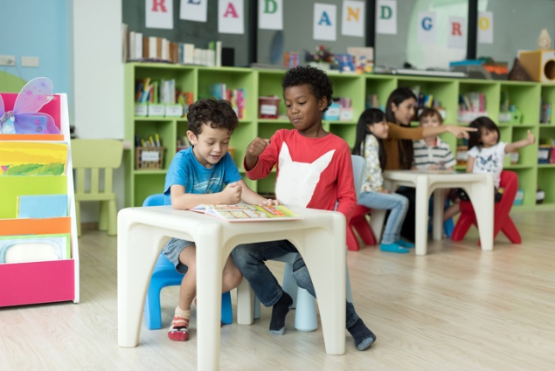This resource sheet provides a brief outline of a cooperative learning strategy known as 'think – pair – share'.

Cooperative learning frameworks create opportunities for groups of students to work together, generally to a single purpose.

As well as having the potential to increase learning for all students involved, using these frameworks can help students develop personal and social capability.

In the 'think' stage, each student thinks silently about a question asked by the teacher.

In the 'pair' stage, students discuss their thoughts and answers to the question in pairs.

In the 'share' stage, the students share their answer, their partner’s answer or what they decided together. This sharing may be with other pairs or with the whole class. It is important also to let students 'pass'. This is a key element of making the strategy safe for students.

Think – pair – share increases student participation and provides an environment for higher levels of thinking and questioning.



# Appendix 9: Teacher resource sheet 1.4: Vocabulary word wall

**Vocabulary word wall**

|  |  |  |
| --- | --- | --- |
| **soil** | **leaves** | **rain** |
| **stem** | **plant** | **wind** |
| **roots** | **growth** | **seed** |
| **water** | **height** | **seedling** |
| **light** | **germination** | **hot** |
| **shade** | **unhealthy** | **sunlight** |
| **measure** | **predict** | **compare** |
| **survive** | **thrive** | **healthy** |
| **cold** | **hypothesis** | **measure** |

# Appendix 10: Student activity sheet 1.5: Recording observations

**Plants and where they grow**

Site: ________________________________________

Type of plant/s: ___________________________________________________________

|  |  |  |  |
| --- | --- | --- | --- |
| **Statement** | **Tick one of these for each question** | | |
| Is the plant healthy? | ☹ | 😐 | ☺ |
| Is the soil moist? | ☹ | 😐 | ☺ |
| Does this spot get plenty of sunlight? | ☹ | 😐 | ☺ |
| Is this spot sheltered from the wind? | ☹ | 😐 | ☺ |

# Appendix 11: Student activity sheet 2.1: Level of light

Site: ________________________________

|  |  |  |  |
| --- | --- | --- | --- |
| **Day and time** | **Tick one box for each time** | | |
| **Full sun** | **Some shade** | **Full shade** |
| Day 1 |  |  |  |
| 9.30 am |  |  |  |
| 12.30 pm |  |  |  |
| 2.30 pm |  |  |  |
| Day 2 |  |  |  |
| 9.30 am |  |  |  |
| 12.30 pm |  |  |  |
| 2.30 pm |  |  |  |
| Day 3 |  |  |  |
| 9.30 am |  |  |  |
| 12.30 pm |  |  |  |
| 2.30 pm |  |  |  |

# Appendix 12: Teacher resource sheet 3.1: Construction skills

Construction skills help students to generate and produce solutions for real-world problems.

This resource can be used as a visual stimulus to prompt students to develop solutions to design problems. The cards can be printed to create stations.

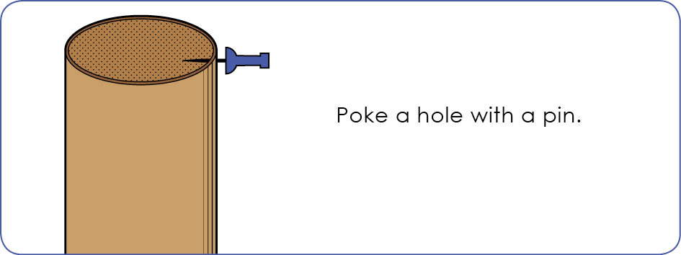

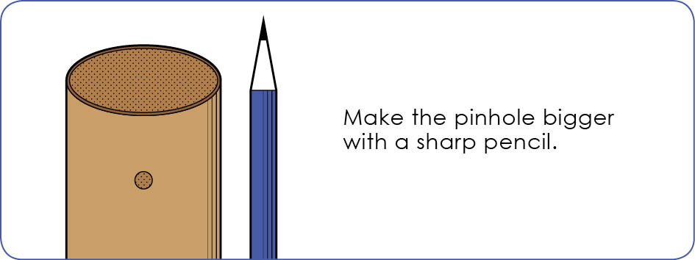

Poke a hole with a pin.

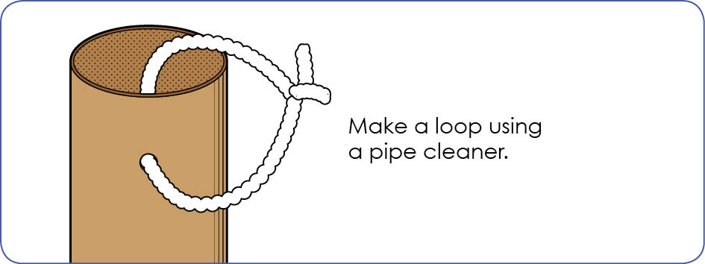

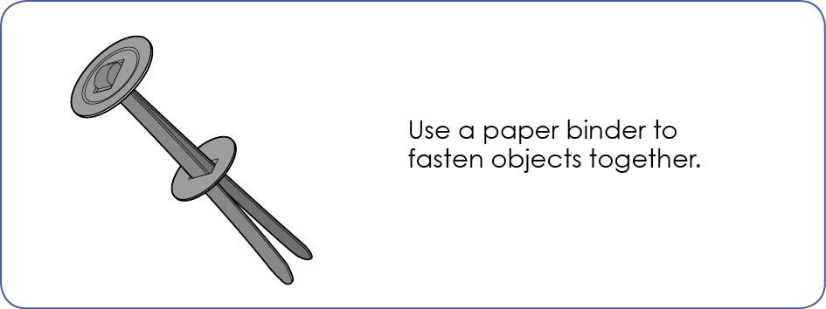

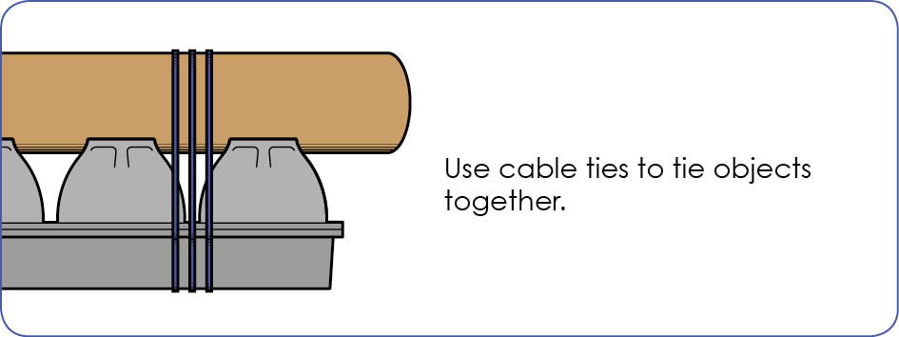

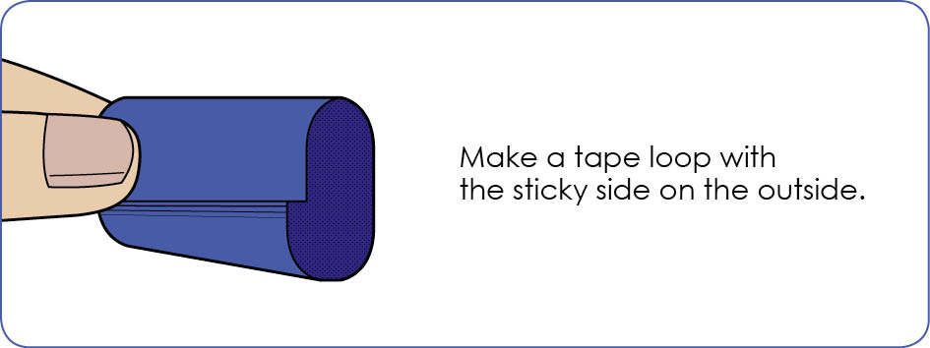

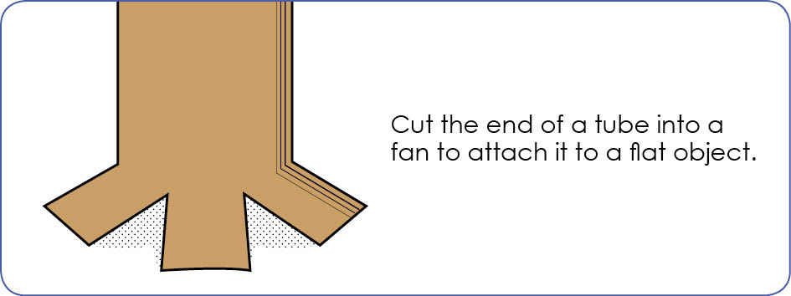

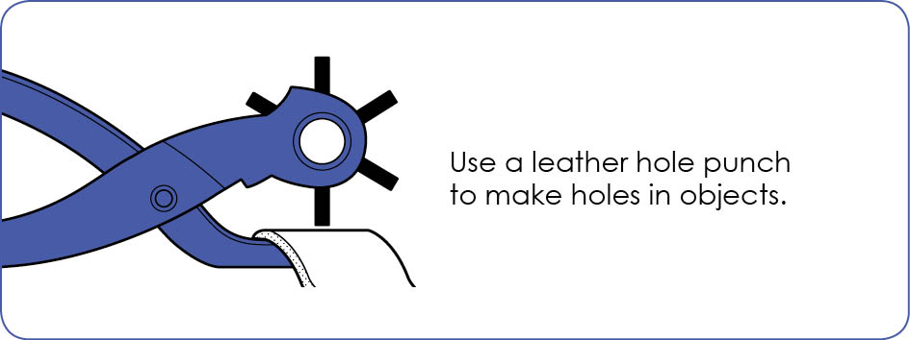

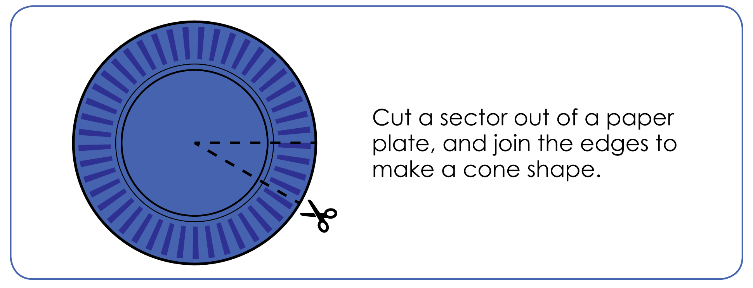

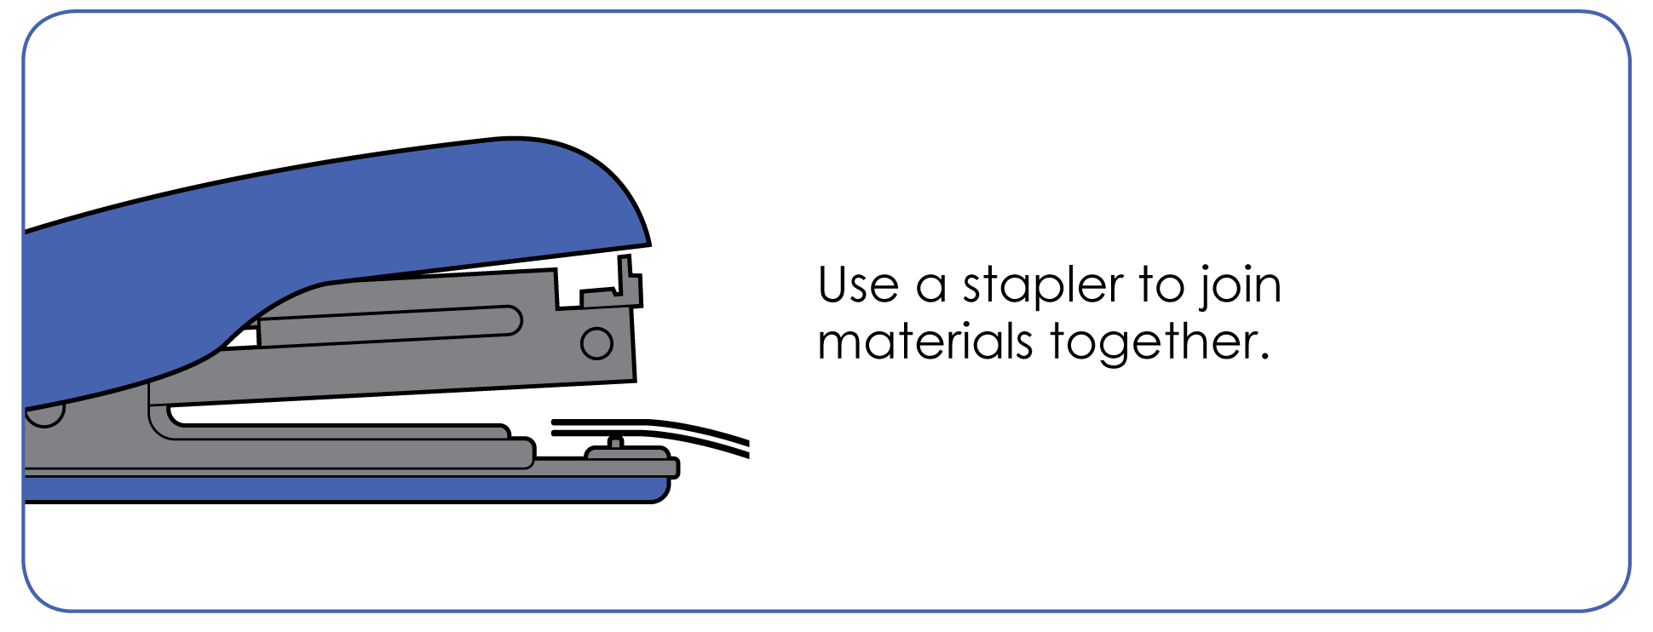

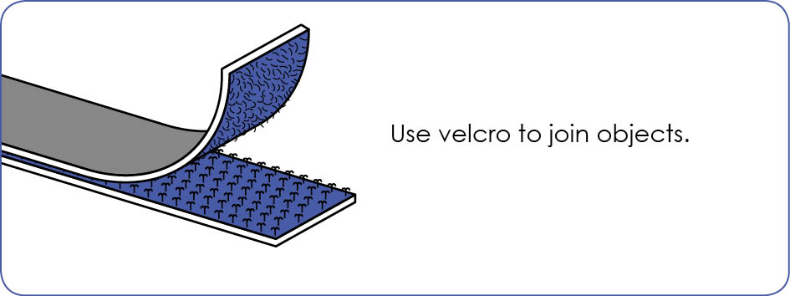

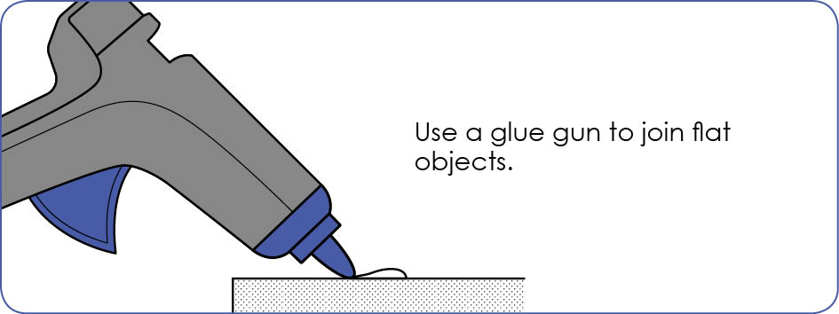

# Appendix 13: Student activity sheet 4.1: Design review

**Things I would keep the same _____________________________________________**

**Things I would change**

**_____________________________________________**

**Photograph or drawing**

# Notes

_______________________________________________________________________________________________________________________________________________________________________________________________________________________________________________________________________________________________________________________________________________________________________________________________________________________________________________________________________________________________________________________________________________________________________________________________________________________________________________________________________________________________________________________________________________________________________________________________________________________________________________________________________________________________________________________________________________________________________________________________________________________________________________________________________________________________________________________________________________________________________________________________________________________________________________________________________________________________________________________________________________________________________________________________________________________________________________________________________________________________________________________________________________________________________________________________________________________________

# Notes

_______________________________________________________________________________________________________________________________________________________________________________________________________________________________________________________________________________________________________________________________________________________________________________________________________________________________________________________________________________________________________________________________________________________________________________________________________________________________________________________________________________________________________________________________________________________________________________________________________________________________________________________________________________________________________________________________________________________________________________________________________________________________________________________________________________________________________________________________________________________________________________________________________________________________________________________________________________________________________________________________________________________________________________________________________________________________________________________________________________________________________________________________________________________________________________________________________________________________

# Notes

_______________________________________________________________________________________________________________________________________________________________________________________________________________________________________________________________________________________________________________________________________________________________________________________________________________________________________________________________________________________________________________________________________________________________________________________________________________________________________________________________________________________________________________________________________________________________________________________________________________________________________________________________________________________________________________________________________________________________________________________________________________________________________________________________________________________________________________________________________________________________________________________________________________________________________________________________________________________________________________________________________________________________________________________________________________________________________________________________________________________________________________________________________________________________________________________________________________________________